
On the Radar
Issue 748
22 June 2026

On the Radar is a summary of some of the recent publications in the areas of safety and quality in health care Inclusion in this document is not an endorsement or recommendation of any publication or provider Access to particular documents may depend on whether they are Open Access or not, and/or your individual or institutional access to subscription sites/services Material that may require subscription is included as it is considered relevant.

On the Radar is available online, via email or as a PDF or Word document from
https://www.safetyandquality.gov.au/news-and-media/newsletters/on-the-radar

If you would like to receive On the Radar via email, you can subscribe on our website https://www.safetyandquality.gov.au/news-and-media/newsletters/on-the-radar
or by emailing us at mail@safetyandquality.gov.au.
You can also send feedback and comments to mail@safetyandquality.gov.au.

For information about the Commission and its programs and publications, please visit https://www.safetyandquality.gov.au

On the Radar
Editor: Dr Niall Johnson
Contributors: Niall Johnson

Reports

Improving quality of care through the OECD Patient Reported Indicator Surveys (PaRIS): Using patient-reported data to support health policy
OECD
Paris: OECD Publishing; 2026. p.43.
DOI | https://doi.org/10.1787/2a9d5b13-en
Notes | This report from the OECD is the latest from the PaRIS (Patient Reported Indicator Surveys) project. This report suggests that the PaRIS project demonstrates ‘the value of patient-reported outcomes and experiences in strengthening people-centred primary care. Drawing on evidence from the 19 countries which participated [including Australia] in the first cycle of PaRIS, the report shows how results are already informing reforms in care co-ordination, digital health and quality monitoring. The report highlights key enablers such as early engagement, clear governance, communication planning and sustained investment to integrate patient-reported outcome and experience measures (PROMs and PREMs) into healthcare system performance assessment.’

Journal articles

Words and Language Matter: Improving Older Person's Healthcare Outcomes Through Use of Age-Positive Language
Alsaba N, Hullick C, Heath R, Hobson D, Mulholland B, Burkett E
Emergency Medicine Australasia. 2026;38(3):e70295.
DOI | https://doi.org/10.1111/1742-6723.70295
Notes | Paper reflecting on the importance of language and communication in health care, in this case examining impacts on the care of older people. The authors observe that ‘The language and words used by healthcare providers both directly and indirectly impact patient experience and health outcomes.’ While the focus here is on older patients and ageism, these are true for all patients, but perhaps especially so for those who may be more vulnerable for a multitude of reasons. There is a recognition of the importance of patient-centredness and acknowledging the patient’s rights, including those outlined in the Australian Charter of Patient Rights. Health care is an inherently human activity and thus communication and language are fundamental. As the authors of this piece conclude, ‘Words and language matter. Ageism exists. It is time to change the way we speak to and about older people and recognise that the language we use can directly and indirectly impact the patient experience and influence healthcare outcomes. Ageism can significantly influence the attitudes and actions (or inactions) of the community, the healthcare system, and government decision-making bodies.’  Disclosure: One of the co-authors of this piece, Dr Hullick, is also the Commission’s Chief Medical Officer.

Towards sustainable implementation of robotic surgery: an interregional strategic framework from Norway
Basso T, Bjerke LM, Bretthauer M, Christiansen O, Dahl T, Fosse E, et al
Journal of Robotic Surgery. 2026;20(1):585.
DOI | https://doi.org/10.1007/s11701-026-03521-3
Notes | Paper describing the approach to evaluating and implementing robot‑assisted soft‑tissue surgery (RAS) undertaken in Norway. The Norwegian approach included establishing am ‘interregional expert group’ that developed ‘a strategic framework for sustainable implementation of RAS within a publicly funded specialist healthcare system’. The expert group’s ‘Core recommendations comprise prioritisation of procedures with demonstrated clinical value, standardised lifecycle cost assessment, coordinated procurement, accredited training pathways, and mandatory data registration.’ The authors suggest that this ‘framework illustrates how governance, evidence generation, and workforce planning can be aligned to promote sustainable implementation of robotic surgery.’  Evaluating, implementing and supporting change in health service organisations can be challenging whether this is done on a regional, service or facility level. The Australian Commission on Safety and Quality in Health Care released guidance on the Introduction of new interventional procedures and clinical practice innovations in 2024.
Low Back Pain: A Review
Cashin AG, Chou R, Weimer MB, McAuley JH
JAMA. 2026.
DOI | https://doi.org/10.1001/jama.2026.9631
Notes | Review article in JAMA on ‘the leading cause of years lived with disability worldwide’, low back pain. This piece, which includes Australian authors, ‘summarizes current evidence on the epidemiology, pathophysiology, clinical evaluation, prognosis, and treatment of nonspecific low back pain in the outpatient setting’.  The authors conclusions include:  - ‘Acute nonspecific low back pain is often self-limited, whereas chronic nonspecific low back pain has a less favorable prognosis.  - For patients with acute nonspecific low back pain, first-line treatments include selected nonpharmacological therapies and medications (such as NSAIDs and skeletal muscle relaxants).  - For patients with chronic nonspecific low back pain, first-line treatment consists of exercise, psychological therapies (such as CBT), and combined multidisciplinary care.’

For information on the Commission’s work on low back pain, including the Low Back Pain Clinical Care Standard, see https://www.safetyandquality.gov.au/clinical-care-standards/low-back-pain

Australian Journal of Primary Health
Volume 32, Issue 3, June 2026
URL | https://connectsci.au/py/issue/32/3
Notes | Recent articles in the Australian Journal of Primary Health include:  - Applying indigenous Māori Pasifika research methodologies to frame Queensland Māori Pasifika experiences of child health service delivery: an exploration of a lack of uptake of health services (Wani Annabelle Erick; Villi Hapaki Nosa; Carol Anne Windsor)  - Feasibility study of a colorectal cancer e-care plan for shared follow-up survivorship care (Jane Taggart; Melvin Chin; Winston Liauw; David Goldstein; Kerry Uebel; Kylie Vuong; Phil Mendoza-Jones; Mark F Harris)  - Enhancing diabetes management in rural and remote areas through academic–clinical partnership: an innovative workshop model for primary healthcare professionals (Shanshan Lin; Lynn Sinclair; Sharif Bagnulo; Katherine Keenan; Leah Pascoe; Susan Carbone; David Sibbritt; Wenbo Peng)  - ‘…you can’t work singular when you’re working with families’: co-creating strategies for fetal alcohol spectrum disorder prevention and support with an Aboriginal and Torres Strait Islander primary healthcare service: a baseline mixed methods study (Vivian Lyall ; Nicole Hewlett; Charlie Rowe; J Clarke; K Scofield; D Askew; L Wolfson; V Spiller; K Liddle; P Abbott; K Lee; N Reid)  - Exploring knowledge, attitudes and misconceptions influencing the use of long-acting reversible contraception among females in Australia: a scoping review (Neha Shibu; Robin Cheah ; Sharinne Crawford; Vera Camões-Costa)  - Navigating care pathways: a case study of integrated sexual and reproductive health services at a statewide sexual and reproductive health agency in South Australia (Farina Gul; Jessica Willis; Zohra S Lassi; Gizachew A Tessema; Mohammad Afzal Mahmood)  - Acceptability of an integrated care program to identify patients at risk of advanced chronic liver disease in Australian primary care settings (C O’Callaghan ; M Williamson; D Prince; A D M Putra; J Miller; P Chomley; M Barr)  - Women’s perspectives of community pharmacists’ resupplying and prescribing contraceptive methods (Zaynah Zureen Ali; Helen Skouteris; Safeera Yasmeen Hussainy; Yi Ling Low; S Pirotta; A Rojanapenkul Assifi)  - Barriers and enablers to the implementation of national quality and safety standards within Australian private dietetics services (Amy Kirkegaard; Harry Li; Lauren Ball)  - Are dental policies in Australia inclusive of children with intellectual and developmental disabilities in the state of Victoria? A grey literature review (Rahila Ummer-Christian; Mark Gussy; Hanny Calache)  - Qualitative evaluation of a social inclusion program for Karen and Karenni refugees in Victoria, Australia (Emma Tam; Lester Mascarenhas; Alison Mynard; Meredith Temple-Smith)  - Integrating a whānau-ora approach in primary care to mitigate the impact of syndemics: whānau and key informant views (Cheryl Davies; Carmen Timu-Parata ; Virginia Signal; M Baker; R Firestone; A Kvalsvig; B Robson; A Waa)  - Towards assessment of culturally safe general practitioners: co-designing with Aboriginal and Torres Strait Islander peoples’ perspectives, the Calgary–Cambridge guide and clinical yarning (Kay Brumpton; Rebecca Evans; Tarun Sen Gupta; Raelene Ward)  - Integrating rural community screening initiatives into general practice: a qualitative evaluation of the Care2U rural outreach pilot program (Kam Cheong Wong; Uchechukwu Levi Osuagwu ; Edweana Wenkart; Yash Bapat; Timothy McCrossin; David Mahns)  - Using social return on investment to evaluate services that support the health of people experiencing homelessness in Australia: a scoping review (Cate McKenna; Christopher Rouen; Mary O’Loughlin)  - Chat to PAT – an outreach service providing comprehensive primary health care to marginalised people (Benjamin Harkness; Christopher Ayres; Anna Olsen; Stephanie Stephens; Bronwyn Hendry; Elizabetj Sturgiss)  - Pacific families’ experiences of intergenerational diabetes in New Zealand – a qualitative interpretive case study (Christine Barthow; Hansa Patel; Abby Dunlop; Tutangi Amataiti; Eileen McKinlay)  - How a community-engaged therapeutic garden immersion shapes rural intentions among medical students and strengthens student–community partnerships (Anett Nyaradi; Keith McNaught)

The Lancet Primary Care
Volume 2, Number 5, May 2026
URL | https://www.thelancet.com/journals/lanprc/issue/vol2no5/PIIS3050-5143(26)X2005-2
Notes | The Lancet Primary Care is a relatively new open access journal. Articles in this issue of The Lancet Primary Care include:  - Editorial: Primary care is essential to disability inclusion (The Lancet Primary Care)  - Potential use of patient expectation data for primary care improvement (Shona M Bates)  - World Family Doctor Day 2026: compassionate care in a digital world (Viviana Martinez-Bianchi)  - HEARTS 2.0: an implementation-oriented clinical pathway for integrated care of hypertension and cardiovascular–kidney–metabolic conditions in primary health care in the Americas (Pedro Ordunez, Andres Rosende, Sonia Y Angell, Esteban Londoño, Paul K Whelton on behalf of the HEARTS 2.0 Clinical Pathway Writing Group)  - Integrating non-communicable disease care into primary health systems in the Horn of Africa: opportunities and challenges (Ayodele A Falobi, Omar O Hersi, Lawrence Tan, Lilling Tan, Yusuf A Ali, Opeolu O Ojo on behalf of the Health Systems Network for the Horn of Africa)  - Chemical adherence testing-guided intervention versus standard of care in patients with hypertension who are non-adherent to antihypertensive treatment in the UK (OUTREACH): a multicentre, randomised controlled trial (Maciej Tomaszewski, Pankaj Gupta, Philip Chowienczyk, Baptiste Leurent, Shadi Hames-Fathi, Luana Lenzi, Luca Faconti, S M L Abrams, Marc George, Heather Buchanan, Andrew Jordan, Stephen Walsh, Victoria Robinson, Ahmed Adlan, Anthony Heagerty, Iain Squire, Robert Horne, Eileen Jones, Ewan McFarlane, David Collier, Isla S Mackenzie, Prashanth Patel, Thomas M MacDonald, A Thompson, P Lacy, P A Swift, B Williams)  - Association between antihypertensive treatment and hospitalisation or death due to falls according to sex, ethnicity, and social deprivation status: an observational cohort study in English primary care electronic health-care records (Florien S van Royen, Ariel Wang, Geert-Jan Geersing, Constantinos Koshiaris, S Swain, A Banerjee, A Clegg, R A Payne, B K Bellows, F D R Hobbs, R McManus, J P Sheppard on behalf of the STRATIFY Investigators)  - Evaluation of a co-designed, low-resource intervention to improve antibiotic prescribing for upper respiratory tract infections in Aotearoa New Zealand: a prospective, pre–post intervention study (Stephen R Ritchie, Bruce A Arroll, Emma J Best, Amy H Y Chan, Lily Fraser, Susan Reid, Susan Wells, Carla White, Robyn Whittaker, Zhenqiang Wu, Mark G Thomas)  - Population expectations of primary care quality in 18 countries: a cross-sectional analysis of data from the People’s Voice Survey (Todd P Lewis, Shalom Sabwa, Joao Breda, Susanne Carai, Emma Clarke-Deelder, Svetlana V Doubova, Günther Fink, Patricia J Garcia, Ezequiel Garcia-Elorrio, Hwa-Young Lee, Sailesh Mohan, Inbarani Naidoo, J Oh, E A Okiro, A Tadele, R Tarricone, Marius-Ionuț Ungureanu, X Wang, D (Roman) Xu, M E Kruk)  - Models of health care for responding to the complex health needs of refugee and asylum-seeking children: a scoping review (Natasha O’Sullivan, Gemma Whyatt, Sophie Esnouf, Hanan Abukmail, Adnaan Ghanchi, Lopamudra Banerjee, Francesca Maraschin, Michelle Heys, S Eisen, S Nagraj)  - Reviving the promise of primary care: redesigning service delivery to promote core functions (Michael A Peters, Todd P Lewis, Rodrigo Bazua-Lobato, Lia Tadesse Gebremedhin, E Garcia-Elorrio, Z A Bhutta, M E Kruk)

Journal of Health Services Research & Policy
Volume: 31, Number: 3, July 2026
URL | https://journals.sagepub.com/toc/hsrb/31/3
Notes | A new issue of the Journal of Health Services Research & Policy been published. Articles in this issue of the Journal of Health Services Research & Policy include:  - Editorial: Beyond mitigation: Adaptation, policy and resilience for health services facing climate change (John Richmond and Cheryl Mitchell)  - Double-checking in the safe administration of medicines: Policy and practice in English hospitals (Daisy Halligan, Hana Shamsan, Francesca Wilson, Robbie Foy, David Phillip Alldred and Rebecca Lawton)  - The impact of congenital cytomegalovirus infection among families and caregivers: A qualitative analysis of responses to a public consultation on newborn screening in the UK (Rosamund Greiner, Sarah Dewar, Christine E Jones, Marthe Le Prevost, Tushna Vandrevala, Cristina Visintin and H Bailey)  - Staff experiences of implementing patient-initiated follow-up (PIFU) in the NHS in England: findings from a rapid qualitative evaluation (Cyril Lobont, Rachel Hutchings, Stuti Bagri, Nadia Crellin, Theo Georghiou, S Kumpunen, J Negus, P Li Ng, C Oung, A I G Ramsay, S Reed and C Sherlaw-Johnson)  - Persistent use of body mass index policies as a barrier to surgery: Prevalence and analysis of policies across England in 2025 (Kevin Ofosu, Katie Whale and Joanna McLaughlin)  - Factors influencing the match between patient needs and primary care services: Patient and healthcare provider perspectives from two Canadian provinces (Emilie Dufour, Maria Mathews, Emily Gard Marshall, Mylaine Breton, Jennifer E Isenor and Dana Ryan)  - Pharmacist personas: A tool to guide learning and career development (I McDermott, J Shields, N Tse, E Schafheutle, P Higginson and M Shaw)  - A scoping review of how the candidacy framework has been used in research on access to general practice (Carol Sinnott, Akbar Ansari, Evleen Price, Sarah Ball, Stephanie Stockwell, Jessica Dawney, Jennifer Newbould, William D Phillips, Jake Beech, Hugh Alderwick and Mary Dixon-Woods)

Pediatric Quality & Safety
Volume 11, Issue 3, May/June 2026
URL | https://journals.lww.com/pqs/toc/2026/05000
Notes | A new issue of Pediatric Quality & Safety has been published. Articles in this issue of Pediatric Quality & Safety include:  - Improving the First-hour Breastfeeding Rate in Cesarean Deliveries: A Quality Improvement Initiative (Nalina Amuji, Clive Martin Rodrigues, Harshitha M Swamy, Lakshmi Parvathi Bandlamudi, Tinu Krishna vilasam Regunath, Chandrakala Bada Shekharappa)  - Accuracy of Various Methods for the Surveillance of Hospital-acquired Venous Thromboembolism in a Children’s Hospital (R M T Huibonhoa, E V S Faustino, K Burkiewicz, P Oelkers, S Ravishankar, S Tripathi)  - Antibiotic Stewardship Quality Improvement Project for Neonatal Sepsis in a Tertiary NICU in Lima, Peru (Carmen R Dávila-Aliaga, Elina R Mendoza Ibañez, Elsa Torres Marcos, Julia R Hinojosa Pérez, Claudia V Saldaña-Diaz, Andres Campaña-Acuña, Mary E Davila Peña, Maria Gabriela Soza Bieli Bianchi, C G Pariona Sulluchuco, Y M Martínez Ortiz, M E Macedo Villegas, W L Mendoza Jamanca, E E Guibert Casós, R Paucar Zegarra, A F Pantoja)  - A Framework for Building an Inclusive Quality Program in a Pediatric Heart Center (Judson A Moore, Jennifer Marietta, Adam L Ware, David K Bailly, Kevin Hummel, Aaron W Eckhauser, Chuck G Pribble, Melissa M Winder, Tina Wadhwa, Emilee T Glenn, A Gardner, M Wichser, H Francione, C Heyrend, C Buckalew, B Marullo, V Amula, A Husain, A G Cabrera)  - Diagnostic Stewardship to Optimize Blood Culture in a Pediatric Cardiac Intensive Care Unit (Jun Sasaki, Angela Sorensen, Kristen Ferlisi, Lauren Shaw, Maryellen Horgan, Catherine Mareiro, Sarah A Teele)  - Multidisciplinary Timely Debrief Sessions after Cardiac Arrests and Endotracheal Intubations in the Pediatric Emergency Department (Jonathan A. Hermel, Yvette Wang, J M Klapp, A Bryl, M Pannepacker, E Zimmerman)  - Standards of Care to Practice: Redefining Type 1 Diabetes Care within Learning Health Systems (Melissa Leonard, M K Kamboj, O Ebekozien)

BMJ Quality &Safety online first articles
URL | https://qualitysafety.bmj.com/content/early/recent
Notes | BMJ Quality &Safety has published a number of ‘online first’ articles, including:  - Economic evaluation of deimplementation interventions: a systematic review (Comlan Lucien Hountongbé, Jason Robert Guertin, Soualio Gnanou, Blanchard Conombo, Pier-Alexandre Tardif, Lynne Moore)  - Editorial: Please document the nature of the medical emergency (Jeffrey A Gold)

International Journal for Quality in Health Care online first articles
URL | https://academic.oup.com/intqhc/advance-articles
Notes | International Journal for Quality in Health Care has published a number of ‘online first’ articles, including:  - Why has continuity of general practitioner care been neglected? (Denis Pereira Gray, Kate Sidaway-Lee, Nada Khan, Philip Evans)  - What is a Mortality Committee for? Autopsy as a quality indicator (Francisco Ortuño-Andériz, María Jesús Fernández-Aceñero, Natividad Calvo-Romero , Hospital Mortality Review Committee)  - Psychological safety is a quality-of-care issue, not merely a workforce wellbeing concern (Stevi Becher Sengkey, Tellma Mona Tiwa, Marssel Michael Sengkey, Tesalonika Pandolos, Raup Padillah)

Online resources

[UK] NICE Guidelines and Quality Standards
https://www.nice.org.uk/guidance
The UK’s National Institute for Health and Care Excellence (NICE) has published new (or updated) guidelines and quality standards The latest reviews or updates include:
- Quality Standard QS69 Ectopic pregnancy and miscarriage https://www.nice.org.uk/guidance/qs69
- NICE Guideline NG126 Ectopic pregnancy and miscarriage: diagnosis and initial management https://www.nice.org.uk/guidance/ng126

Infection prevention and control resources
The Australian Commission on Safety and Quality in Health Care has developed a number of resources to assist healthcare organisations, facilities and clinicians These resources include:
- Poster – Combined contact and droplet precautions https://www.safetyandquality.gov.au/publications-and-resources/resource-library/infection-prevention-and-control-poster-combined-contact-and-droplet-precautions
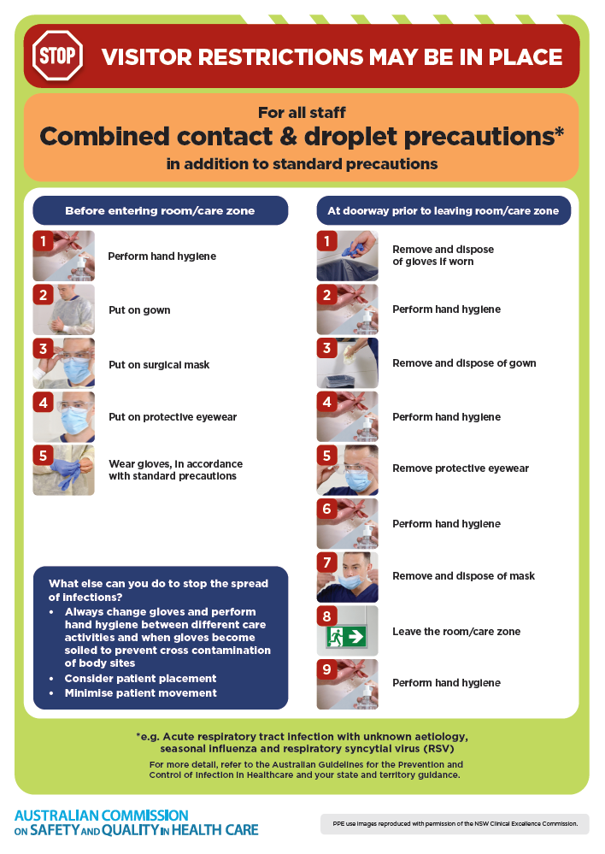
- Poster – Combined airborne and contact precautions
https://www.safetyandquality.gov.au/publications-and-resources/resource-library/infection-prevention-and-control-poster-combined-airborne-and-contact-precautions
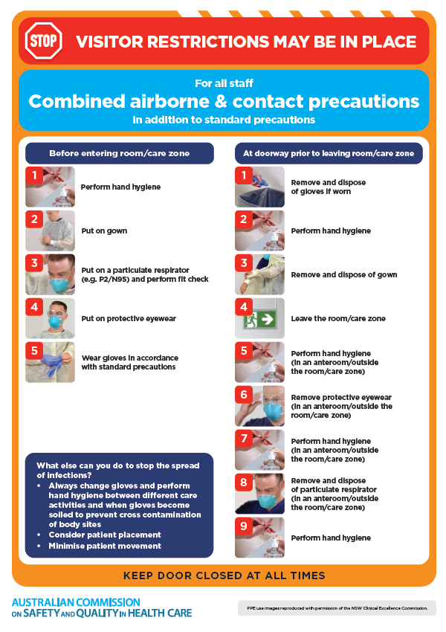
- Environmental Cleaning and Infection Prevention and Control www.safetyandquality.gov.au/environmental-cleaning
- Break the chain of infection poster
https://www.safetyandquality.gov.au/publications-and-resources/resource-library/break-chain-infection-poster
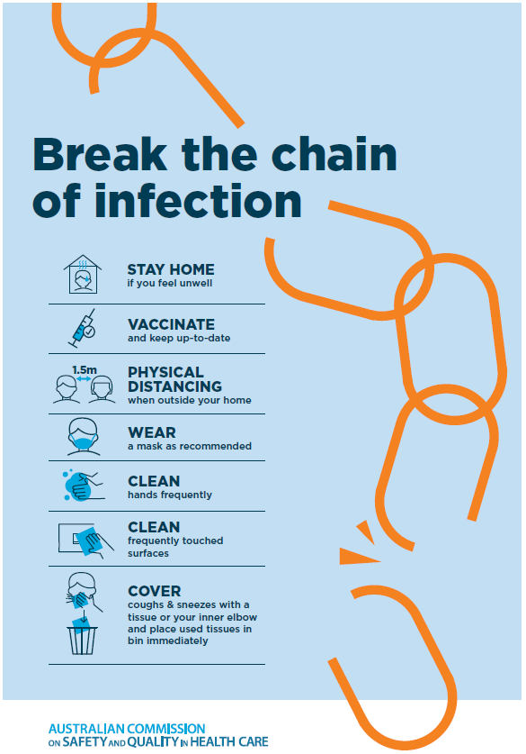
Disclaimer
On the Radar is an information resource of the Australian Commission on Safety and Quality in Health Care. The Commission is not responsible for the content of, nor does it endorse, any articles or sites listed. The Commission accepts no liability for the information or advice provided by these external links. Links are provided on the basis that users make their own decisions about the accuracy, currency and reliability of the information contained therein Any opinions expressed are not necessarily those of the Australian Commission on Safety and Quality in Health Care.

