
On the Radar
Issue 749
29 June 2026

On the Radar is a summary of some of the recent publications in the areas of safety and quality in health care Inclusion in this document is not an endorsement or recommendation of any publication or provider Access to particular documents may depend on whether they are Open Access or not, and/or your individual or institutional access to subscription sites/services Material that may require subscription is included as it is considered relevant.

On the Radar is available online, via email or as a PDF or Word document from
https://www.safetyandquality.gov.au/news-and-media/newsletters/on-the-radar

If you would like to receive On the Radar via email, you can subscribe on our website https://www.safetyandquality.gov.au/news-and-media/newsletters/on-the-radar
or by emailing us at mail@safetyandquality.gov.au.
You can also send feedback and comments to mail@safetyandquality.gov.au.

For information about the Commission and its programs and publications, please visit https://www.safetyandquality.gov.au

On the Radar
Editor: Dr Niall Johnson
Contributors: Niall Johnson, Ally Kerr, Elise King, Catalina Dowd

National Consensus Statement: Essential elements for safe and high-quality paediatric end-of-life care
Second ed.
Australian Commission on Safety and Quality in Health Care
Sydney: ACSQHC; 2026. p. 40.
https://www.safetyandquality.gov.au/resources/national-consensus-statement-essential-elements-safe-and-high-quality-paediatric-end-life-care

The Australian Commission on Safety and Quality in Health Care has updated the National Consensus Statement: Essential elements for safe and high-quality paediatric end-of-life care with the latest guidance for clinicians and health services.
The Consensus Statement describes how end-of-life care for a child should be approached and delivered effectively across healthcare settings.

This second edition updates national guidance first published in 2016, and reflects contemporary evidence, clinical practice and consultation with the paediatric palliative care sector, experts, clinicians and consumers.

The Consensus Statement includes:
- a focus on neonates, First Nations children, and children with disability
- guidance for care in regional, rural and remote areas
- a culturally responsive, child and family-centred approach
- nine guiding principles
- ten essential elements with key actions.

The purpose of the Consensus Statement is to describe the elements that contribute to a best practice, culturally safe, child and family-centred approach to end-of-life care.

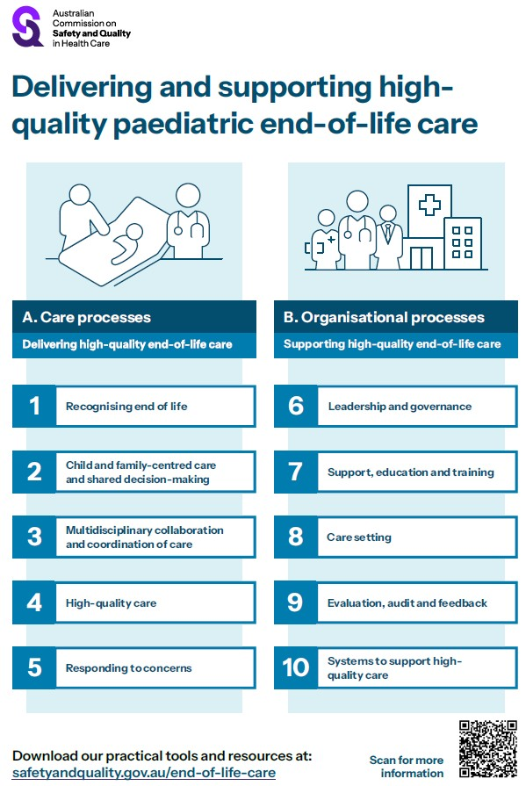

Australian Open Disclosure Framework
Australian Commission on Safety and Quality in Health Care
Sydney: ACSQHC; 2026. p. 39.
https://www.safetyandquality.gov.au/clinical-topics/open-disclosure

The Australian Commission on Safety and Quality in Health Care has revised the Australian Open Disclosure Framework, which now applies across all healthcare settings.
The revised Framework supports all healthcare professionals in Australia to communicate openly with patients when things go wrong in health care.

Originally released in 2014, the updated Framework reflects contemporary clinical practice and strengthens its focus on person-centred care.

The Framework sets out a nationally consistent approach to open disclosure, supporting clear, timely and compassionate communication with patients when things do not go to plan.

Reports

Exploring Aboriginal women’s experiences of hospital maternity care in NSW
Crook C, Nixon J, Kalucy D, Sherriff S, Winch S, Bailey S
Sydney: Sax Institute for the NSW Ministry of Health; 2025. p. 48.

Exploring Aboriginal people’s experiences of hospital care
Kalucy D, Crook C, Nixon J, Sherriff S, Bailey S
Sydney: Sax Institute for the NSW Ministry of Health; 2025. p. 46.
URL | https://www.saxinstitute.org.au/resource/exploring-aboriginal-womens-experiences-of-hospital-maternity-care-in-nsw/
Notes | Crook et al is a report on a qualitative study of Aboriginal women’s experiences of public hospital maternity care in New South Wales. This study was conducted by the Sax Institute for the NSW Ministry of Health and included ‘In-depth qualitative interviews… with Aboriginal maternity patients who had given birth in the last 5 years’. The report’s authors made a number of recommendations, including:  - Build cultural capability and safety  - Address child protection concerns  - Ensure that cultural models of maternity care are embedded within NSW Health.  A companion study examined Aboriginal patients’ experiences of hospital care (excluding maternity care), using similar qualitative approaches, including in-depth interviews with patients. The recommendations proposed by the authors related to communication, engagement, racism, unconscious bias, cultural safety and accountability.

Patient safety across regional care pathways: learning from an HSSIB investigation pilot
Learning report
Health Services Safety Investigation Body
Poole: HSSIB; 2026.
URL | https://www.hssib.org.uk/patient-safety-investigations/patient-safety-across-regional-care-pathways-learning-from-an-hssib-investigation-pilot/learning-report/
Notes | The latest from the Health Services Safety Investigation Body (HSSIB) in the UK is this ‘learning report’ that was undertaken to ‘test a process for rapid investigation of patient safety issues and to use the learning to help develop HSSIB’s investigation methods’. The pilot examined ‘patient safety issues within a regional system where multiple organisations were involved in providing care across a care pathway.’ The report examined the redesigned regional care pathway. The pathway had been redesigned to help reduce health inequalities, improve patient outcomes and ensure efficient use of resources. The investigation ‘found that the integrated care board (ICB) and NHS trusts involved lacked a shared understanding of how the pathway should operate in practice and identified gaps in how safety is managed across organisational boundaries. Risks were not always shared, accountabilities were unclear and oversight arrangements were limited, reducing the ability of the ICB to take a proactive approach to managing patient safety.’ The HSSIB argues that there is a need to ‘clarify accountability, improve data sharing and support a more coordinated approach to managing patient safety across regional care pathways.’

Journal articles

Updated International Patient Decision Aid Standards (IPDAS version 5.0): modified Delphi, evidence informed consensus process
Volk RJ, Lewis KB, Smith M, Carley M, Barry MJ, Bekker HL, et al
BMJ. 2026;393:e088116.
DOI | https://doi.org/10.1136/bmj-2025-088116
Notes | Paper in BMJ reporting on the update to the International Patient Decision Aid Standards (IPDAS). The authors state that ‘IPDAS 5.0 includes seven qualifying criteria (necessary to be a patient decision aid), 10 essential criteria (necessary to reduce biased decisions), and 54 enhancing criteria (additional criteria that might improve the quality of a patient decision aid).’

BMJ Quality & Safety
Volume 35, Issue 7, July 2026
URL | https://qualitysafety.bmj.com/content/35/7
Notes | A new issue of BMJ Quality & Safety has been published. Many of the papers in this issue have been referred to in previous editions of On the Radar (when they were released online). Articles in this issue of BMJ Quality & Safety include:  - Editorial: Thinking and organising in systems: reframing the long problem of learning from incidents (Carl Macrae)  - Editorial: We need a new paradigm to think about generative AI (Adam Rodman, Laura Zwaan)  - Do patient safety incident investigations align with systems thinking? An analysis of contributing factors and recommendations (Lorelle Bowditch, Charlotte Molloy, Brandon King, Masoumeh Abedi, Samantha Jackson, Mia Bierbaum, Yinghua Yu, Louise Raggett, Paul Salmon, Jeffrey Braithwaite, Johanna I Westbrook, Robyn Clay-Williams, Raghu Lingam, Sandy Middleton, Farah Magrabi, Virginia Mumford, Peter Hibbert)  - Artificial intelligence chain-of-thought reasoning in nuanced medical scenarios: mitigation of cognitive biases through model intransigence (Jonathan Wang, Donald A Redelmeier)  - Impact of COVID-19 on incidence and trends of adverse events among hospitalised patients in Calgary, Canada: a retrospective chart review study (Guosong Wu, Cathy A Eastwood, Cheligeer Cheligeer, Danielle A Southern, Yong Zeng, William A Ghali, Jeffrey A Bakal, Bastien Boussat, Ward Flemons, Alan Forster, Yuan Xu, Hude Quan)  - Grand rounds in methodology: four key things to know about the reliability of measurement (Timothy P Hofer)  - Bridging diagnostic safety and mental health: a systematic review highlighting inequities in autism spectrum disorder diagnosis (Abirami Srivarathan, Andrea Bradford, Sara Shearkhani, Layla Heimlich, Sheryl Jefferson, Kristen E Miller, Kelly Smith, Helen Haskell, Traber D Giardina)  - Thinking critically about AI documentation quality in primary care (Gordon D Schiff, Maram Khazen)

Public Health Research & Practice
Volume 36, Issue 2, June 2026
URL | https://connectsci.au/pu/issue/36/2
Notes | A new issue of Public Health Research & Practice has been published. Articles in this issue of Public Health Research & Practice include:  - Consumer and community involvement in health research in Australia: evaluation of researcher training workshops (Ella G McGahan, Emily DeBortoli, Jo Maxwell, Belinda Frank, Anne McKenzie, A M McInerney-Leo)  - Building trust in policy: Cancer Council Australia’s lessons on real-world integration of community and lived experiences (Drew Meehan, Sally Kriel, Shona Edwards, Amanda McAtamney, Megan Varlow)  - Evaluation of a lead screening program in children aged younger than 5 years at an Aboriginal Community Controlled Health Organisation in New South Wales, Australia (Adelaide Morgan, Garth Alperstein, Hugh Burke, Richard Weston, Lavinia Henderson, Cath Kennedy)  - The impact of locally led community score cards on improved health services in a low- and middle-income country: an evaluation study (Jonathan Drewry, Tsegaye Tilahun, Y Mussema, N Ali, W Bizuneh, E Girma, L Reves)  - Conducting a repeated cross-sectional survey of demographic, social, and health trends in a disadvantaged Australian community over 24 years: the Miller Household Survey (1999–2023) (Andrew Reid, Mark Harris, M Barr, K Meikle, K Jaques, S Mazumdar, E Harris, B Harris-Roxas, V Rose, P Harris)  - Facilitating meaningful consumer and community engagement in research: co-designing plain language guides for applied health research projects (Julie Ayre, Natasha C Pocovi, Kirsty Galpin, Anna C Singleton, Melody Taba, Rebecca Raeside ,Sara Wardak, Julieta Ruiz, Olivia Mac, Kathleen McFadden, Marguerite Tracy, Karina Chalouhi, Christine Mitchell, Geoffrey Edlund, Ivan C K Ma, Waren Nadesan, Julia Yan, Cheryl Knight, Danielle M. Muscat)  - Pharmacist-administered vaccinations for children and adolescents in Australia: a review of policies, legislation and lessons learnt (Ashenafi Kibret Sendekie, Petra Czarniak, Leanne Chalmers, Tin Fei Sim)  - To what extent is air pollution associated with cardiorespiratory hospitalisations across Australia? A whole-of-population ecological study (Kate Lycett, Mojtaba Lotfalian, Yichao Wang, Clare Walter, Louis Irving, Mengjiao Liu, Sarath Ranganathan, David Burgner, Adrienne O’Neil, Jeremy D Silver, Richard O Sinnott, Craig A Olsson, Mallery Crowe, S Mavoa, L D Knibbs)  - Deadly developments: smoking cessation medicines accessed by Aboriginal and Torres Strait Islander peoples in Australia, 2006–2019 (Daniel Odo, Christina Heris, Raymond Lovett, Lisa Whop, Nicola Ball, Joanne Thandrayen, Michelle Kennedy, Raglan Maddox)  - Viral hepatitis notifications: a cohort study of enhanced local follow-up in Victoria, Australia (Phongsakone Inthavong, Emma Beavon, Michael Muleme, Shweta Bohora, Christine Roder, Tiffany Pe, Naomi E Clarke, J A Richmond, M A Hussain, A Titulaer, J S Doyle, A Tai, E Athan, A N Wilson, A J Wade)  - Cancer Council’s Tackling Tobacco program: an Australian initative building partnerships for public health research impact (L Twyman, T Vourliotis, S Walsberger, E Skelton, A Guillaumier, J Bryant, A Brooks, B Bonevski)  - Tuberculosis transmission in an Australian healthcare setting: lessons learnt from a coordinated public health response (M Plymoth, E Ulbricht, K Camat, T Crighton, S Chen, G Sullivan, V Sintchenko, E Donnan, T Hasan)  - It’s time to invest in our future: include early promotion of optimal child growth as part of general practice funding schemes (Li Ming Wen, Eve T House, Philayrath Phongsavan, Dimity Dutch, Rachel Laws, Lisa Simone, Elizabeth Denney-Wilson, L A Baur)  - Ultraviolet arrows signal immediate, ever-present danger: development and evaluation of a skin cancer prevention campaign to improve young adults’ sun protection in Australia (Philippa Maynard, Nicola Scott, Shamieka Dubois, Cameron Sugden, Erin Furestad, Sarah McGill, Tracey A O’Brien)  - Optimising SMS content for bowel cancer screening participation in Australia: cross-sectional national survey findings (Nicole Perry, Michael J Ireland, Kirstie Daken, Carlene Wilson, Mark Jenkins, Driss Ait Ouakrim, Jennifer G McIntosh, Nancy N Baxter, Emma Pearse, Belinda C Goodwin)  - Failing those who most need support to quit smoking: Australia must do better (Elizabeth Greenhalgh, Lisa Wood)  - Delirium: an urgent health priority in Australian hospitals (Layla M Edwards, Alison Mudge, Amy Montgomery, Meera R Agar)  - Safeguarding quality in health and medical science information today (Scott C Ratzan, Rebecca K Ivic, Kenneth H Rabin, Ruth M Parker, Sara Rubinelli, Rafael Obregon, Lawrence O Gostin, Michael G Baker, Samantha Thomas, Don Nutbeam, Ilona Kickbusch, J Gregory Payne, Vivianne Ihekweazu, Kristen J McCaffery, Richard L Street, Cary Cooper)

Healthcare Quarterly
Volume 29, Number 1, April 2026
URL | https://www.longwoods.com/publications/healthcare-quarterly/27855/
Notes | A new issue of Healthcare Quarterly has been published with articles on integrated care, mental health, etc. Articles in this issue of Healthcare Quarterly include:  - Editorial: From the Editors (Anne Wojtak and Richard Lewanczuk)  - Using Data to Drive Policy Action: An Urgent Call for Funding Interdisciplinary Team-Based Rheumatology Care (Jessica Widdifield, Lauren K King, Celia V Laur, T S H Kwok, J Purvis, P Baer, J C Thorne, B Kuriya, V Ahluwalia, L Passalent, C Hofstetter, J Yang and C T Appleton)  - Inside the Pharmaceutical Data Tool’s Numbers: Drivers Behind Canada’s Pharmaceutical Spending (Shveta Bhasker, Sandy Morrison and Jeff Proulx)  - A Pharmacist and a Physician Walk Into a Clinic: The Case for the Virtuous Duo (Neil Seeman)  - Reducing Gaps, Improving Outcomes: Sunnybrook-to-Home Program (Hend Al-Fayez, Courtney Bean, Kelly Bishop, Shelby Fisch, Brigette Hales, Stacy Landau, Zedrick Laure, H Mal, D Nazarov, N Ziegler and L Brady)  - Integrating Geriatric Teams in Primary Care: Transforming Aging Care Through Collaborative Models in Ontario (Kelly Kay, Katie Bingham, Melanie Briscoe, Cailin Campbell, Sandra Easson-Bruno, Jacobi Elliott, N Gallagher, A Gardhouse, S Goldhar, G Heckman, A Hewitt, M Lachmann, H MacLeod, C Mensink, A Morrison, M Nicula, J Smith, F Wolfe and K J Young)  - Amplifying Patient and Caregiver Voices in Academic Conferences: Reflections From a Conference on Integrated Care (Natasha Y Sheikhan, Terrence Ho, Philiz Goh, Y Macaulay, S Urbanik, W Wodchis and J Goldhar)  - Cross-Pollinators and Boundary Spanners: Contributions of Ontario Health Team Fellows to Quality Improvement and Evaluation Capacity for Health Systems (Rosanra Yoon, Jennifer Lake, Mulugeta Bayisa Chala, Adora Chui, Robert Barnett, R Abdelhalim, S Xiao, É Côté-Boileau and C Anderson)  - An “Early Warning” Risk Assessment Strategy to Enable Proactive Management of Supply Shortages in Canada (Anne W. Snowdon, Alexandra Wright, Rick Prinzen, Christian Leuprecht, Cindy Ly and S Ghadiri)  - Advancing a Digitally Enabled Supply Chain as a Strategy to Strengthen Resilience of Canada’s Healthcare Supply Chain (Anne W. Snowdon, Alexandra Wright, Colleen J. Metge, Nancy L Pakieser, C Ly and S Ghadiri)  - Toward a Quality Standard for Emergency Departments: A Commentary on Improving Mental Health and Substance Use Care for Youth in Canada (Roxanne Turuba, Violet Cameron, Chantal Brasset, Tara Harper, Angela Stacey, Frank Scheuermeyer, Eddy Lang, S Mondoux, K Marchand, A Dhillon, R Cormier, G Dimitropoulos, J Hews-Girard, S Mathias and S Barbic)  - Optimizing Opioid Addiction Treatment in Correctional Centres: Learnings From Alberta, Canada (Kevin Wipf, Angela Draude, Shelly Vik, Shannon Gravely and Nathaniel Day)  - Ambient Artificial Intelligence Scribes in Healthcare: A Governance Imperative for Canadian Health System Leaders (Frank Vounasis)  - Population Avoidable Days: A Novel Approach to an Old Problem (Paul Woods, Tyler Chalk, Sukumar Gugananthan and Matthew Meyer)

Journal of Patient Experience
URL | https://journals.sagepub.com/home/jpxa
Notes | As with a number of journals the Journal of Patient Experience has moved to a more continuous publication model rather than discrete issues with a single ‘volume’ each year. 2026 is Volume 13 https://journals.sagepub.com/toc/jpxa/13  Recent articles from the Journal of Patient Experience include:  - Impact of Visitor Restrictions on Patient and Family Perceptions of Care in Canadian ICUs During the COVID-19 Pandemic: A Qualitative Descriptive Study (Christine Patterson, Jennifer M O’Brien, Salima Suleman, Faith A Bae, Eileen Reimche, Candace A Abramyk, Caitlyn Kitts, Sana Mohamad, Yolanda Palmer-Clarke, Joann Kawchuk and Sabira Valiani)  - Civility and Academic Advancement: Evaluating Its Roles in United States Medical School Appointment, Promotion, and Tenure Policies (Divya Shankar and Maya S Iyer)  - Designing Artificial Intelligence Tools to Strengthen Human Connection in Healthcare: The CoCo Experience (Richard M Elias, Shawn M Grimsley, Brooke L Werneburg, Sheila K Stevens and Sunanda Kane)  - Understanding Platelet Donor Experience in Greece: Satisfaction Drivers, Service Gaps, and Implications for Service Design (S Karakolias and A Palla)  - Development of a Patient Journey Map for Metabolic Dysfunction–Associated Steatohepatitis: A Comprehensive Assessment of the Patient Journey in North America (David O Garcia, Roberto A Calle, Abhinav Seth, Thomas D Norton, D J Lederer, A Richardson, J Berg, M Betel, H Chang, H Daniels, W Eskridge, J McIntyre, G Villiotti Madison, T Villiotti and R Sellati)  - “Treat us Like Human Beings”: Messages and Recommendations to U.S. Policymakers and Veterans Health Administration Providers from a Qualitative Inquiry Into the Health Experiences of Gulf War Veterans With Gulf War Illness (Kara A Montague, Megan Lafferty, Michael Graham and Shannon M Nugent)  - Social Determinants of Health and Patient Experiences During Transitions From Inpatient Rehabilitation to Home (Hanadi Y Hamadi, C E Bailey, M R Manes, T Paris, H A Kendall, S Park, J Xu, K Hicks-Roof and A Spaulding)  - Building Patient Capabilities for Using Virtual Care: A Document Analysis of Patient Support Resources and Guidance (Ramya Walsan, Ashfaq Chauhan, Rebecca Mitchell, Corey Adams, Sagda Osman, Elizabeth Manias, Anita Vandyke, Prince Peprah, Bronwyn Newman, N Elkabbout and R Harrison)  - Language Access in Healthcare: Aligning Policy and Evidence to Improve Patient Experience Through Professional Interpretation and Language- Concordant Care (Gabriela Plasencia, Zachary Predmore, Danielle Schlang, Nabeel Qureshi and Denise D Quigley)  - Evaluation of Patient Experience in Inpatient Rehabilitation Setting: An Australian Perspective (Haeyoon Ryu, Krystal Song, B Amatya and F Khan)  - A Family Caregiver Perspective on Fragmented Continuity of Care for an Elderly Female Patient With Upper Limb Fracture (Nor Islafatun and Moh Heri Kurniawan)

BMJ Quality &Safety online first articles
URL | https://qualitysafety.bmj.com/content/early/recent
Notes | BMJ Quality &Safety has published a number of ‘online first’ articles, including:  - Development and pilot evaluation of the implementation of a whole-team training pack to improve the effectiveness, efficiency, safety and equity of remote general practice (Joseph Clift, Francesca Helen Dakin, Anwar Khan, Nicholas Woodier, Trisha Greenhalgh, Rebecca Payne)  - Mapping Theories, Models and Frameworks from implementation science for evaluating quality improvement initiatives: a scoping review (Klaudia A Arizmendi-Barrera, Jafet Arrieta, Tamara Nevarez Tinoco, Priyanka Chahal, Pierre Barker)

International Journal for Quality in Health Care online first articles
URL | https://academic.oup.com/intqhc/advance-articles
Notes | International Journal for Quality in Health Care has published a number of ‘online first’ articles, including:  - Exploring quality and patient safety competencies and competency frameworks: A scoping review (Dimuthu Rathnayake, Sahar Hammoud, V Hanlon, L Hendrick, M Browne, G Moore, J Fitzsimons, A De Brun)  - Operational inefficiency and perceived quality in a Paediatric Day Hospital: a Lean-informed study of patient flow, caregiver and staff perceptions (M Casolino, L Benedetti, G Gioiello, D Mascia, M Vardabasso)  - From compliance to prediction: Clinical Laboratories as digital infrastructure for health-system quality and safety (Shruti Gupta and P Mitra)  - Improving Stroke Care and Outcomes through AHA/ASA Primary Stroke Certification: A Pre-Post Study in Jordan (Mohammad R Alosta, Elham H Othman, Tareq Afaneh, Fawzi Al-Hammouri, Sahar Al-Masri, Taher Janbek, Morad Rashid, Hamzeh Odeh, Mohammad Azzouqa, Mohammad Alhammouri, Aseel Al-Najar, Loay Sahawneh, Farah Qutashat, Suha Al-Beshawi, Tasneem Al-Amoush, J Mora, R Khattar, K Shkair, M Al-Mzayen)  - The four main domains of the concept of return-on-investment from healthcare quality improvement programmes (S'thembile Thusini, Tayana Soukup, Claire Henderson)

Online resources

[USA] Effective Health Care Program reports
https://effectivehealthcare.ahrq.gov/
The US Agency for Healthcare Research and Quality (AHRQ) has an Effective Health Care (EHC) Program. The EHC has released the following final reports and updates:
- Systematic Review: The Performance of Fusion and Interventional Pain Procedures for Degenerative Diseases of the Lumbar Spine https://doi.org/10.23970/AHRQEPCSR_LUMBAR
https://effectivehealthcare.ahrq.gov/products/lumbar-spinal-fusion/research

Infection prevention and control resources
The Australian Commission on Safety and Quality in Health Care has developed a number of resources to assist healthcare organisations, facilities and clinicians These resources include:
- Poster – Combined contact and droplet precautions https://www.safetyandquality.gov.au/publications-and-resources/resource-library/infection-prevention-and-control-poster-combined-contact-and-droplet-precautions
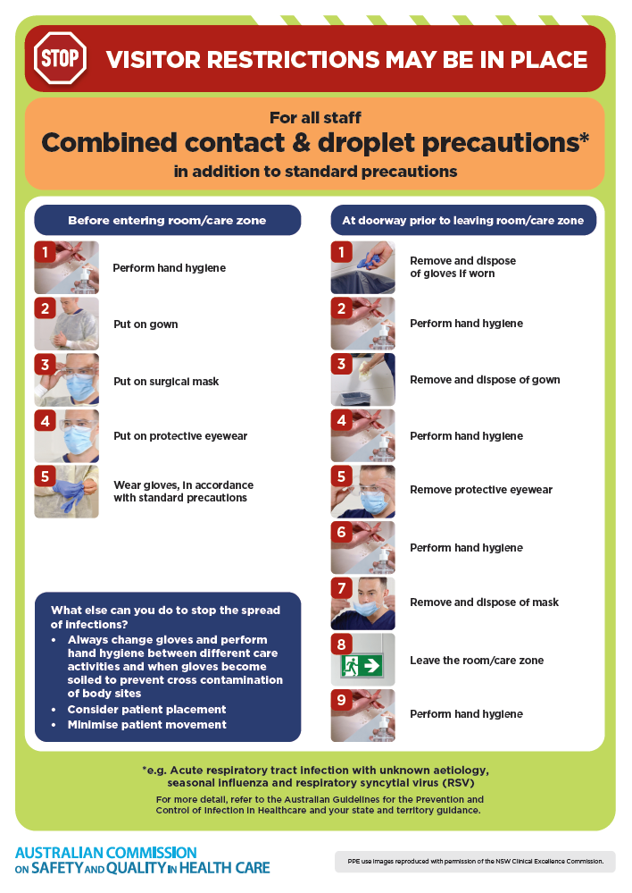
- Poster – Combined airborne and contact precautions
https://www.safetyandquality.gov.au/publications-and-resources/resource-library/infection-prevention-and-control-poster-combined-airborne-and-contact-precautions
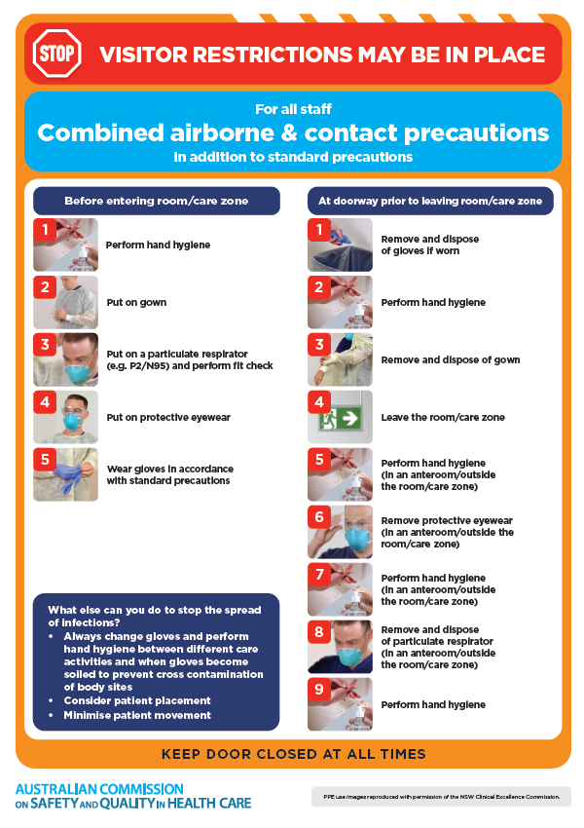
- Environmental Cleaning and Infection Prevention and Control www.safetyandquality.gov.au/environmental-cleaning
- Break the chain of infection poster
https://www.safetyandquality.gov.au/publications-and-resources/resource-library/break-chain-infection-poster
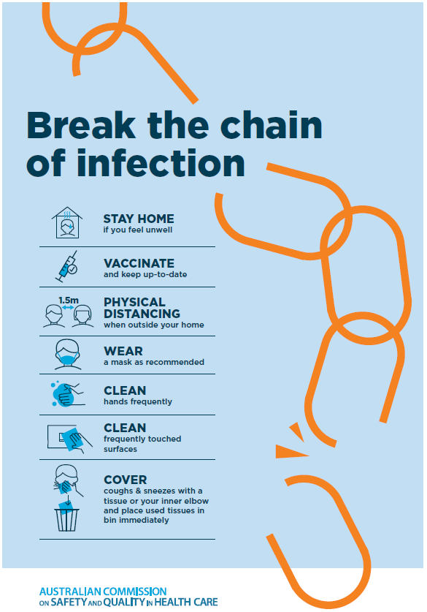
Disclaimer
On the Radar is an information resource of the Australian Commission on Safety and Quality in Health Care. The Commission is not responsible for the content of, nor does it endorse, any articles or sites listed. The Commission accepts no liability for the information or advice provided by these external links. Links are provided on the basis that users make their own decisions about the accuracy, currency and reliability of the information contained therein Any opinions expressed are not necessarily those of the Australian Commission on Safety and Quality in Health Care.

