
On the Radar
Issue 746
8 June 2026

On the Radar is a summary of some of the recent publications in the areas of safety and quality in health care Inclusion in this document is not an endorsement or recommendation of any publication or provider Access to particular documents may depend on whether they are Open Access or not, and/or your individual or institutional access to subscription sites/services Material that may require subscription is included as it is considered relevant.

On the Radar is available online, via email or as a PDF or Word document from
https://www.safetyandquality.gov.au/news-and-media/newsletters/on-the-radar

If you would like to receive On the Radar via email, you can subscribe on our website https://www.safetyandquality.gov.au/news-and-media/newsletters/on-the-radar
or by emailing us at mail@safetyandquality.gov.au.
You can also send feedback and comments to mail@safetyandquality.gov.au.

For information about the Commission and its programs and publications, please visit https://www.safetyandquality.gov.au

On the Radar
Editor: Dr Niall Johnson
Contributors: Niall Johnson, Helen Signy, Liz Manfredini, Pranavan Sothirajah

National Model for Clinical Governance. The foundations of high-quality care
Australian Commission on Safety and Quality in Health Care
Sydney: ACSQHC; 2026. p. 32.
https://www.safetyandquality.gov.au/clinical-topics/clinical-governance/national-model

The Australian Commission on Safety and Quality in Health Care has released a new National Model for Clinical Governance (national model) that aims to drive high-quality care and better outcomes for patients in acute health services. The national model replaces the 2017 National Model Clinical Governance Framework.

The national model is a short, simple principles-based document structured around six foundations of clinical governance (see diagram below). Health ministers have urged all health services to implement the national model. A practical guide to implementation and other resources are available on the Commission’s website.

The model’s release signals a strategic shift in how clinical governance is understood, led and embedded in health services. It elevates clinical governance to the highest level of organisational leadership and oversight, and shifts the main focus from complying with accreditation requirements to building the leadership, culture and systems to support delivery of high-quality care every day.

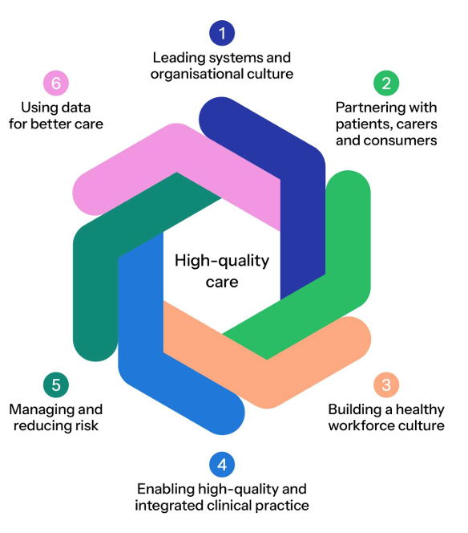
Figure 1. The six foundations of clinical governance

CARAlert annual report: 2025
Australian Commission on Safety and Quality in Health Care
2025. Sydney: ACSQHC; 2026. p.48.
https://www.safetyandquality.gov.au/resources/caralert-annual-report-2025

The Australian Commission on Safety and Quality in Health Care has released the 2025 CARAlert annual report, which provides analyses of data submitted to the National Alert System for Critical Antimicrobial Resistances (CARAlert). CARAlert collects information on priority organisms that have critical resistance to last-line antimicrobials and are uncommon in Australia (CARs). The report shows seasonal and geographic trends in CARs across both acute and community settings, based on data voluntarily reported by participating laboratories.

Key findings include:
- The majority of CARs were reported from hospitals (53.8%), with carbapenemase-producing Enterobacterales (CPE) continuing to be the most frequently reported.
- There were changes in community-onset CARS from 2024 to 2025, with increases in Neisseria gonorrhoeae and Salmonella species and an overall decrease in reports of Shigella species.
- There were ongoing reports of CARs in aged care home residents, albeit at very low levels

Although the increasing annual rate of reports to CARAlert has slowed (up 10% in 2025; compared to 25% in 2024 and 87% in 2023), ongoing reports of CARs is concerning and particularly so for vulnerable populations, such as residents of aged care homes. Given the threat that CARs pose to antimicrobials effectiveness and patient safety, this report underscores the importance of ongoing surveillance of antimicrobial resistance and infections, as well as continued focus on antimicrobial stewardship and infection prevention and control programs.

Visit the CARAlert Data Explorer to explore the data and trends in CARs across Australia.

Books

Human Factors and Ergonomics
Elements of Improving Quality and Safety in Healthcare
Sujan M, Pickup L.
. Cambridge: Cambridge University Press; 2026.
URL | https://doi.org/10.1017/9781047755993
Notes | This volume is the latest release in the Elements of Improving Quality and Safety in Healthcare series from The Healthcare Improvement Studies Institute (the THIS Institute) in Cambridge, England. This volume examines Human Factors and Ergonomics (HFE, particularly in the health context.  From the abstract: ‘Human Factors and Ergonomics (HFE) is a discipline concerned with designing interactions in sociotechnical systems to improve both system performance and human well-being. This Element introduces the core principles of HFE … to its current application in healthcare improvement. The Element acknowledges the growing role of HFE in areas such as the design of the physical environment, medical device design, learning from patient safety incidents, and safety investigations. A critical reflection highlights persistent challenges, including conceptual ambiguity, structural and practical barriers to HFE integration, and the need both for a stronger evidence base and a compelling business case. The Element concludes by identifying future priorities for advancing HFE in healthcare, including continuing professional development and career pathways, embedding HFE in regulation and policy, and adopting evaluation approaches suited to complex systems.’
Reports

U.S. Health Care from a Global Perspective, 2026: Expanded Edition
Gunja MZ, Gumas ED, Williams II RD
New York: Commonwealth Fund; 2026
DOI | https://doi.org/10.26099/2egm-8b76
Notes | The latest comparison report from The Commonwealth Fund in the USA offers a comparison of 20 OECD nations ‘across four key areas: insurance coverage and access to care, affordability of care, delivery of care, and equity of health outcomes.’. The authors note that ‘Although the United States spends more on health care than any other country, it consistently underperforms’ as the ‘Findings from this international comparison highlight a persistent failure of the U.S. health system: Americans pay more for health care, get less in return, and remain far more exposed to illness, debt, and insecurity than their peers.’  As is usually the case in these comparison studies from The Commonwealth Fund, Australia generally compares favourably with these peer high-income nations with higher life expectancy, lower rates of avoidable deaths, but also with higher rates of out-of-pocket payments for pharmaceuticals.

Journal articles

Australian Prescriber
Volume 49, Issue 3, June 2026
URL | https://australianprescriber.tg.org.au/volumes/49/issues/3.html
Notes | A new issue of Australian Prescriber has been published. Content in this issue of Australian Prescriber includes:  - Cardiovascular-kidney-metabolic (CKM) syndrome (KM Dwyer, PE Figtree, K Oetsch, A Gupta)  - Sodium valproate: balancing benefits and risks especially in people of childbearing potential (D McLaughlin)  - Emergency contraception: an overview (D Mazza, J Gross)  - Diagnosis and management of irritable bowel syndrome (S Morrison, N Talley)  - Stopping antidepressants: when and how (KA Wallis)  - Dual antihypertensive fixed-dose combinations approved for first-line use on the Pharmaceutical Benefits Scheme  - New drugs:  – Bulevirtide for hepatitis D infection  – Capivasertib for locally advanced or metastatic breast cancer  – Eflornithine for neuroblastoma

Health Affairs
Volume 45, Number 6, June 2026
URL | https://www.healthaffairs.org/toc/hlthaff/45/6
Notes | A new issue of Health Affairs has been published with themes of ‘Price Transparency, Medicare, Medicaid & more’. Articles in this issue of Health Affairs include:  - The Opacity Of Price Transparency (David V Wehrly, Maximilian J Pany, and Michael E Chernew)  - Medicare’s Hospital Wage Index Exceptions Grew By Nearly 60% From 2016 To 2024 (Geoffrey J Hoffman and Jun Li)  - Private Equity Acquisitions In Primary Care: Changes In Utilization, Spending, And Workforce (Yashaswini Singh, Meehir N Dixit, Amal N Trivedi, and Christopher M Whaley)  - Third-Party Convener Firms And The Rise Of Geographically Dispersed, High-Earning Medicare ACOs (Adam A Markovitz, Jay Shroff, Andrew Zhang, Hayden Rooke-Ley, Pedro L Gozalo, and Andrew M Ryan)  - State Medicaid Programs Face Increased Spending On Medicare Premiums (Sharon Fernandez, Jennifer Bunker, Cyrus M Kosar, Stephanie Nothelle, Laura J Samuel, Kali S Thomas, and Laura M Keohane)  - Medicaid Tobacco And Nicotine Cessation Treatment Rates Remained Low, 2019–24 (Lisa Clemans-Cope, Maya Payton, and Victoria Lynch)  - Medicaid Expansion Through Ballot Initiatives Increased Medicaid Enrollment And Reduced Uninsurance Among Adults (Fredric Blavin, Michael Karpman, and Noah Kennedy)  - Coverage Among Lawfully Present Immigrants Increased Briefly After Medicaid Threshold Met In Florida, Georgia, And Texas (Marvin Chowdhury, and Arturo Vargas Bustamante)  - Rhode Island’s Affordability Standards Led To Substantial Reductions In Hospital Staffing And Labor Costs By 2022 (Neil Mehta, Jason D Buxbaum, Christopher M Whaley, Daniel R Arnold, Roslyn C Murray, and A M Ryan)  - Points-Based Attendance Systems Associated With Presenteeism Despite Paid Sick Leave Protections (Meredith Slopen, Kess Ballentine, Kristen Harknett, and Daniel Schneider)  - Pre-Claim Review And Traditional Medicare Home Health Spending: Evidence From 4 States (Jeffrey Marr, David J Meyers, and Andrew M Ryan)  - Hospice Enrollments From The Emergency Department Feature Short Admissions And High-Acuity Hospice Care (Helen P Knight, Kourosh Ravvaz, Alexander Fiksdal, Lin Shen, Isaac S Chua, Claire K Ankuda, Haiden A Huskamp, Hojjat Salmasian, Joan M Teno, and David W Bates)  - Medicaid Asset Limits And Enrollment Among Older Adults And People With Disabilities (Andrew Anderson, Chau Huynh, and Catherine K Ettman)  - Not enough time (Jeane Garcia Davis)

Health Affairs Scholar
Volume 4, Issue 5, May 2026
URL | https://academic.oup.com/healthaffairsscholar/issue/4/5
Notes | A new issue of Health Affairs Scholar has been published. Articles in this issue of Health Affairs Scholar include:  - Patient and staff safety implications of emergency department boarding: a systematic review (Marisa K Dowling et al)  - How lack of subsidized prescription drug coverage affects medication use by low-income Medicare beneficiaries (F Ellen Loh et al)  - Exposure to the new Medicare Advantage risk adjustment model varies across insurers (Jeffrey Marr et al)  - Invisible staffing churn in nursing homes: CMS turnover metrics miss a growing short-term workforce (Stephen Petterson et al)  - Comparing patient and provider perspectives on a rural, multilevel, community-engaged Food is Medicine intervention (Danielle M Krobath et al)  - Variation in time to payment in Medicaid managed care: evidence from national TAF data, 2022 (Jane M Zhu et al)  - Freestanding emergency department compliance with consumer protections: evidence from Texas (Daniel Marthey et al)  - Patterns in malpractice payments for anesthesia-related claims among CRNAs and physicians (Christine M Tracy et al)  - U.S. policy research funded by the National Institute of Mental Health, 1993-2024 (Briana S Last et al)  - Tablets and telehealth: expanding care reach by closing the digital divide (Britni Wilcher et al)  - Trends in medical debt in the United States by imputed borrower race and ethnicity, 2016-2022 (Alexander C Adia et al)  - When ambulances wait at the emergency department: hospital factors and offload times in California (Esmeralda Melgoza et al)  - Focus on postpartum care transitions: a pathway to improve perinatal health (Brianna Van Stekelenburg et al)  - The decentralized academic health center: a 21st-century model for rural health innovation (Patrick C Hardigan and Johannes Vieweg)  - Dementia diagnostic deserts: workforce and geographic inequities in the diagnostic pathway for cognitive impairment (Zhijing Xu et al)  - Social and experiential factors linked to concern about climate-related health harm in the United States (Jim P Stimpson and Alexander N Ortega)  - Primary care workforce structural inertia and Medicaid participation during the COVID-19 pandemic, 2020-2021 (Mandar Bodas et al)  - Building a behavioral health crisis response program: a qualitative implementation case study (Teja Pattabhiraman et al)  - Personalized prevention for all: changing how we approach the future of prevention (Robb Rowley and Nephi A Walton)  - Five ways to get a grip on using the Corruption Perceptions Index to support internationally trained physicians (Nigel Ashworth et al)  - Substance use disorder treatment cost-sharing in the 2025 Affordable Care Act Individual Marketplace (Olivia M Hinds et al)

BMJ Quality &Safety online first articles
URL | https://qualitysafety.bmj.com/content/early/recent
Notes | BMJ Quality &Safety has published a number of ‘online first’ articles, including:  - Editorial: Professional support is an important lifeboat, but let’s also stop people falling into the water (Alison Pearson, Kathryn Bamforth, Alice Miller)  (Refers to a paper describing the development of A Guide to Optimise the Delivery of Professional Support in the NHS)  - Shifting boundaries of risk-work in virtual wards in North-West England: a multisite qualitative evaluation (Kelly Howells, Fay Bradley, Norina Gasteiger, William Whittaker, Emma Vardy, Dawn Dowding, Thomas Blakeman, Caroline Sanders)  - Grand rounds in methodology: four key things to know about the reliability of measurement (Timothy P Hofer)  - Editorial Healthcare provision in prisons: an ongoing challenge (Emma Plugge, Caroline Watson)  - Welcome to the jungle: collection and evaluation of quality indicators with the QUALICATOR instrument (Jonas Backes, Justus Vogel, Alexander Geissler, Michael M Havranek, Sarah P Schladerer, David Ehlig Swiss Quality Monitoring Research Group)  - Building capacity for change: developing an evidence-based competencies framework to power champions (Harveer Punia, Giulia Zucal, Patricia Julian, Katherine Wallace, Susan McNeill, Doris Grinspun)

International Journal for Quality in Health Care online first articles
URL | https://academic.oup.com/intqhc/advance-articles
Notes | International Journal for Quality in Health Care has published a number of ‘online first’ articles, including:  - Progress with accreditation and standards in the Middle east: the cases of the Jordanian Health Care Accreditation Council (HCAC) and Egyptian General Authority for Healthcare Accreditation and Regulation (GAHAR) (Jeffrey Braithwaite, Salma Joauni, Ahmed A Taha, Rehab Mahmoud, Rabab Diab, Thaira Madi, Toqa Jamhawi, Omaima Nassar, Worood Al Khub, Rania Medhat, Doaa Elsherif, Carsten Engel, Ellen Joan van Vliet, E Garcia Elorrio)  - The outcomes of Lean management in a large academic hospital in Finland in 2018–2023: a qualitative study (Irmeli Hirvelä , Elina Reponen , Mervi Javanainen , Riikka Lämsä , Vesa Niskanen , Paulus Torkki)

Online resources

Australian Living Evidence Collaboration
https://livingevidence.org.au/
- The Australian Pregnancy Care Guidelines include new and updated recommendations for:
Psychological birth trauma
Human papillomavirus
https://app.magicapp.org/#/guideline/11034
- Australian Postnatal Care Guidelines include new and updated recommendations for:
Psychological birth trauma
Perineal health and healing
https://app.magicapp.org/#/guideline/jW0ZbL/section/Lql69J

Redressing Long-Term Antidepressant Use (RELEASE) in Primary Care
https://www.releasetoolkit.com.au/
The RELEASE toolkit provides a range of resources designed to help patients in primary care safely discontinue long-term antidepressant use. Developed collaboratively by researchers at The University of Queensland and individuals with lived experience, the toolkit supports informed decision-making and provides step-by-step guidance for safely stopping through hyperbolic tapering to minimise withdrawal symptoms.
RELEASE resources are freely accessible online and include drug-specific tapering schedules offered in ‘faster’, ‘slower’, and ‘even slower’ options. Additional materials include a decision aid, informational brochures such as “Stopping antidepressants” and “How family and friends can help,” as well as short explanatory videos to guide patients and their support networks.

[UK] NICE Guidelines and Quality Standards
https://www.nice.org.uk/guidance
The UK’s National Institute for Health and Care Excellence (NICE) has published new (or updated) guidelines and quality standards The latest reviews or updates include:
- NICE Guideline NG220 Multiple sclerosis in adults: management https://www.nice.org.uk/guidance/ng220

Infection prevention and control resources
The Australian Commission on Safety and Quality in Health Care has developed a number of resources to assist healthcare organisations, facilities and clinicians These resources include:
- Poster – Combined contact and droplet precautions https://www.safetyandquality.gov.au/publications-and-resources/resource-library/infection-prevention-and-control-poster-combined-contact-and-droplet-precautions
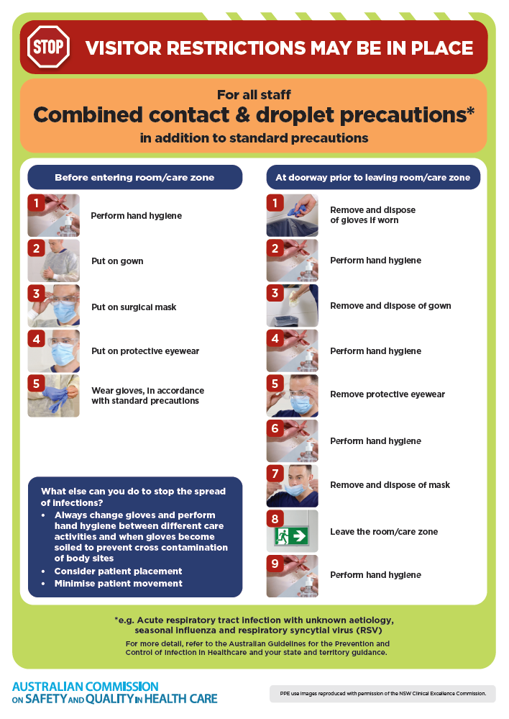
- Poster – Combined airborne and contact precautions
https://www.safetyandquality.gov.au/publications-and-resources/resource-library/infection-prevention-and-control-poster-combined-airborne-and-contact-precautions
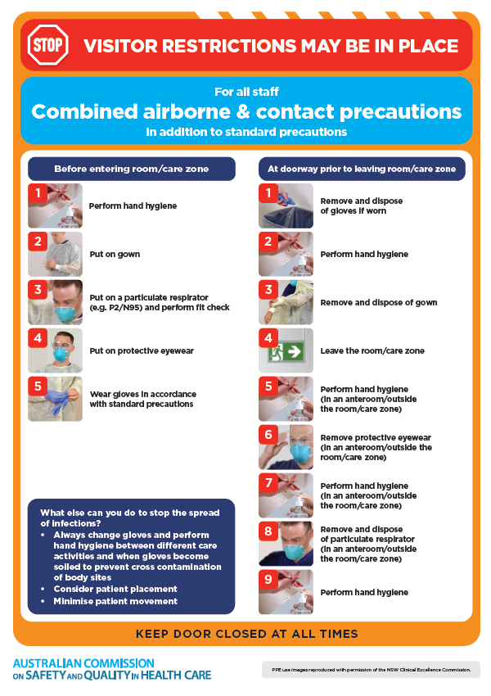
- Environmental Cleaning and Infection Prevention and Control www.safetyandquality.gov.au/environmental-cleaning
- Break the chain of infection poster
https://www.safetyandquality.gov.au/publications-and-resources/resource-library/break-chain-infection-poster
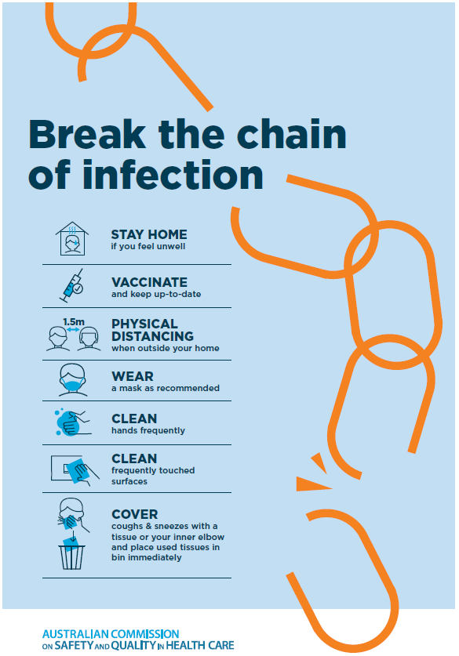
Disclaimer
On the Radar is an information resource of the Australian Commission on Safety and Quality in Health Care. The Commission is not responsible for the content of, nor does it endorse, any articles or sites listed. The Commission accepts no liability for the information or advice provided by these external links. Links are provided on the basis that users make their own decisions about the accuracy, currency and reliability of the information contained therein Any opinions expressed are not necessarily those of the Australian Commission on Safety and Quality in Health Care.

