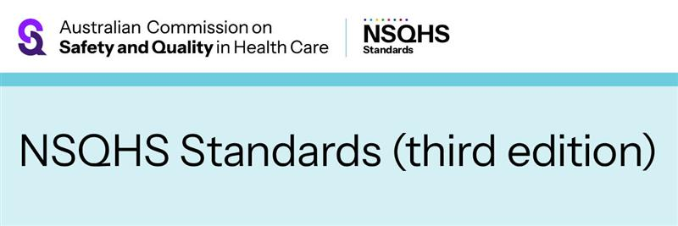
NEWSLETTER CONTENT – FOR INTERNAL AND EXTERNAL USE
July 2026
Have your say on the future of Australia’s healthcare standards
The Australian Commission on Safety and Quality in Health Care (the Commission) has begun public consultation on the initial draft of the National Safety and Quality Health Service Standards (third edition).
The draft Standards reflect a strengthened focus on patient’s experience of care, while reinforcing expectations for clinical governance, person-centred practice and safe clinical systems across services. They embed culturally safe, respectful and inclusive care, clear communication and shared decision making.
The Commission is gathering feedback on the health sector’s needs to inform the development of the next edition of the Standards. The consultation period is from 20 July to 25 September 2026.
Have your say on whether the draft Standards:
- reflect current and emerging safety and quality risks, including whether risks are appropriately captured and addressed
- support better quality of care and improve coordination across services, settings and providers
- support learning, continuous improvement and better outcomes, including the extent to which they shift the focus away from compliance
- are clear, usable and able to support care delivery in real settings and at the point of care
- can be streamlined, including identifying areas of duplication or unnecessary burden.
Health professionals and consumers can provide feedback in several ways, including online surveys, written submissions and at online information forums.
Consultation feedback will inform the next version of the draft Standards, which will be piloted by health services in 2027, ahead of final release in 2028 and assessment to the third edition from 2030.
Visit the NSQHS Standards (third edition) Engagement Hub to get involved: safetyandquality.gov.au/NSQHSS-thirdedition
To stay up to date, subscribe to receive news updates on the NSQHS Standards (third edition).

ENDS

