
On the Radar
Issue 754
3 August 2026

On the Radar is a summary of some of the recent publications in the areas of safety and quality in health care Inclusion in this document is not an endorsement or recommendation of any publication or provider Access to particular documents may depend on whether they are Open Access or not, and/or your individual or institutional access to subscription sites/services Material that may require subscription is included as it is considered relevant.

On the Radar is available online, via email or as a PDF or Word document from
https://www.safetyandquality.gov.au/news-and-media/newsletters/on-the-radar

If you would like to receive On the Radar via email, you can subscribe on our website https://www.safetyandquality.gov.au/news-and-media/newsletters/on-the-radar
or by emailing us at mail@safetyandquality.gov.au.
You can also send feedback and comments to mail@safetyandquality.gov.au.

For information about the Commission and its programs and publications, please visit https://www.safetyandquality.gov.au

On the Radar
Editor: Dr Niall Johnson
Contributors: Niall Johnson, Yulina Walker

Australian Passive AMR Surveillance: Resistance trends in Streptococcus pneumoniae – 2006 to 2025
Australian Commission on Safety and Quality in Health Care
Sydney: ACSQHC; 2026.
https://www.safetyandquality.gov.au/resources/australian-passive-amr-surveillance-resistance-trends-streptococcus-pneumoniae-2006-2025

The Australian Commission on Safety and Quality in Health Care has released a new report on antimicrobial resistance trends in Streptococcus pneumoniae. Data were analysed from the Australian Passive AMR Surveillance (APAS) system, which collects de-identified, routine susceptibility test results from participating public and private pathology services across Australia. These data are sourced from hospitals, aged care homes and the community.

The focus of this report was trends in resistance to penicillin, macrolide, and tetracycline antibiotics in S. pneumoniae, primarily for 2016 to 2025, with some analyses from 2006. Findings show that resistance to macrolides was most common across all specimen types for S. pneumoniae, followed closely by tetracyclines.

Increasing AMR in S. pneumoniae may limit available treatment options and increase treatment failure for empirical monotherapy regimens. This may lead to greater reliance on broader spectrum antimicrobials such as fluoroquinolones or carbapenems, which can increase selection pressure for AMR in other bacteria, not only pneumococcus.

This report highlights the importance of continuing surveillance of antimicrobial resistance and infections, along with antimicrobial stewardship and infection prevention and control programs.

Visit the APAS Data Explorer to explore the latest AMR patterns across Australia for S. pneumoniae and other key pathogens.

Reports

Risk reduction of cognitive decline and dementia: WHO guidelines, second edition
World Health Organization
Geneva: WHO; 2026. p. 168.

Dementia in Australia
Australian Institute of Health and Welfare
Canberra: AIHW
URL | WHO https://www.who.int/publications/i/item/9789240123557  AIHW https://www.aihw.gov.au/reports/dementia/dementia-in-aus/contents/about
Notes | The World Health Organization (WHO) has published this report recognising the importance and scale of the challenges posed by cognitive decline and dementia. This is an update of the 2019 guidelines and ‘provides updated evidence-based recommendations on interventions to reduce the risk of cognitive decline and dementia. The guidelines are designed to help health-care providers, policy-makers and other stakeholders strengthen action on dementia risk reduction as an essential public health strategy, especially given the absence of widely available curative treatment.’ This edition ‘reflects the considerable growth of the evidence base since the publication of 2019 guidelines and expands the scope of guidance on dementia risk reduction.’  The Australian Institute of Health and Welfare (AIHW) has updated their Dementia in Australia report in the last few days. This report has been published as a web report since 2021 and is updated regularly. Among the findings in the latest update:  - An estimated 439,000 Australians are living with dementia in 2025 (projected to reach 459,000 in 2026 and more than 1 million by 2066)  - Dementia remained the leading cause of death in Australia in 2024, responsible for 1 in 10 deaths  - $6 billion of Australia’s health and aged care expenditure in 2023–24 was spent directly on dementia.

Comparing patient‑reported outcome and experience measures in international health surveys
OECD
Paris: OECD Publishing; 2026. p. 39.
DOI | https://doi.org/10.1787/acf46da9-en
Notes | This policy paper is the latest output from the OECD’s PaRIS (Patient-Reported Indicator Surveys) project. The policy paper recognises that ‘patient-reported data have become central to assessing health system performance.’ The PaRIS ‘initiative supports international comparison and cross-country learning by developing, standardising and collecting harmonised data on patient-reported outcome and experience measures (PROMs and PREMs) from primary care users and their practices’. The paper also examines how other activities use patient-focussed data and the commonalities and differences with the PaRIS approach.  Disclosure: The Australian Commission on Safety and Quality in Health Care coordinated Australia’s participation in the PaRIS project. For more information, see  https://www.safetyandquality.gov.au/data-and-measurement/patient-reported-measures/patient-reported-indicator-survey-paris

Who needs emergency care in the year after giving birth?
Taylor B, Georghiou T, Scobie S, Dodsworth E, Raleigh V
London: Nuffield Trust; 2026. p. 78.
URL | https://www.nuffieldtrust.org.uk/research/who-needs-emergency-care-in-the-year-after-giving-birth
Notes | Following two major reports into maternity services in the UK (the Ockenden report examining maternity services at Nottingham University Hospitals NHS trust and the Amos report, the Independent Investigation into Maternity and Neonatal Services in England) is this research report from the Nuffield Trust. The report uses data on nearly 1.6 million deliveries across England over three years to examine postnatal emergency hospital care. The authors report that ‘More than one in five of those deliveries (22%) were followed by at least one emergency hospital contact in the year after birth’. Furthermore, the authors found ‘striking variation in who is affected and the context in which those people visit hospital as a matter of urgency.’

Journals

Nursing Leadership
Volume 39, Number 1, July 2026
URL | https://www.longwoods.com/publications/nursing-leadership/27877
Notes | A new issue of Nursing Leadership has been published. Articles in this issue of Nursing Leadership include:  - The Spirit and Strength of Nursing Leadership (Ruth Martin-Meisener)  - The Canadian Nurses Association Today: Advancing Nursing Leadership and Health System Transformation Through Five Professional Domains (Valerie Grdisa)  - Supporting the Integration of Internationally Educated Nurses in Nova Scotia: Insights From Health System Leaders (Annette Elliott Rose, Anna Marenick, Nancy MacConnell-Maxner, Anita Nickerson, Alyson Lamb, Carla MacDonald, Lauren Murphy, Jackie Spiers, Treena Campbell, Angela Foote, Kate Mason, Sue Blair, Janet Rigby and Caroline Chamberland-Rowe)  - Transition and Integration of Internationally Educated Nurses Into Acute Care Practice in Northwestern Ontario (Sarah Lynne Myllyaho and Andrea Raynak)  - Book Review: Globalization and Integration of Internationally Educated Nurses: A Comprehensive Analysis (Edward Venzon Cruz)  - Artificial Intelligence in Nursing: The Leadership Readiness Gap (Lynn Nagle, Gillian Strudwick, Lianne Jeffs, Lorie Donelle and Margaret Edwards)  - Building Leadership in Home Health Nursing Practice in Canada: Updating the Home Health Nursing Competencies (Karen Curry, Cheryl Reid-Haughian, Barbara Chyzzy, Leinic Chung-Lee, Benedicte Franquien, Nancy Lefebre, Jennifer Little, Corey MacKenzie and Margaret Saari)  - The Impact of a BSN Perioperative Learning Pathway on Nurse Recruitment and Retention (Lenora Marcellus and Maureen O’Connor)  - Perceptions of the Current and Desired Brand of Nursing: Magnifying the Voice of Registered Nurses (Kathleen Miller and Leanne Topola)

The Joint Commission Journal on Quality and Patient Safety
Volume 52, Issues 8, August 2026
URL | https://www.sciencedirect.com/journal/the-joint-commission-journal-on-quality-and-patient-safety/vol/52/issue/8
Notes | A new issue of The Joint Commission Journal on Quality and Patient Safety has been published. Articles in this issue of The Joint Commission Journal on Quality and Patient Safety include:  - Assessing Clinicians with Persistent and Severe Professionalism Concerns: Implications of a Statewide Physician and Professional Health Program Evaluation for Quality, Safety, and Professional Culture (William O Cooper, Gerald B Hickson)  - Complex Factors Associated with Disruptive Medical Professional Behavior (Lori A Crane, Sarah R Early, Amanda L Kimmel, Joyce M Davidson, Laura F Martin, M H Gendel, D C Gundersen, S A Humphreys)  - Stakeholders’ Attitudes on Automating Data Abstraction in a Surgical Quality Improvement Program (Trenton M Haltom, Tracey Rosen, Patricia V Chen, Laura A Petersen, Alex H S Harris, Nader N Massarweh)  - Virtual Practice Facilitation and Implementation of Cardiovascular Quality Improvement Strategies in Primary Care Clinics: A Descriptive Study (Megan McHugh, Jennifer E Bannon, Ann Kan, Amy Krefman, Carrie Butt, J D Smith, Anya Day, Theresa L Walunas)  - Predicting the Sustainability of Quality Improvement Initiatives in Healthcare: A Data-Driven Study (Jiun-Yih Lee, Jui-Ting Chang)  - Bridging Language Gaps in Emergency Care: Expanding Qualified Bilingual Staff and Evaluating Interpreter Modalities (Amy Mu, Kristin S Alvarez, Wendy Young, Abeer Abdelrahim, Jillian Smartt, L Roy, C Mirus)  - A Comparative Analysis of Hospital-Acquired Complications and Sentinel Event Reporting Across Australia, Canada, New Zealand, England, and the United States (Lauren T Southerland, James D van Oppen, Lucas B Chartier, Samuel F Allingham, Alasdair M J MacLullich, Carolyn Hullick)  - Using Large Language Models to Determine Reasons for Missed Colon Cancer Screening Follow-Up (Christopher Y K Williams, Urmimala Sarkar, Julia Adler-Milstein, Lisa Rotenstein)  - Effect of an Institution-Specific Guideline on Adherence to the 2021 American Academy of Pediatrics Guidelines for Febrile Infants at a Community Emergency Department: A Quality Improvement Initiative (Alisha Ching, Allison Cator, Michele Carney, Ruoer Bei, Yaseen Rafee, Nesma Ghanim, Tim Tomy, Adenike Fatiregun, Mai Elhadi, C W Mangus)  - Using Artificial Intelligence to Detect Housing Status in Unstructured Electronic Health Record Data (Abbott Gifford, Shraddha Pandey, Hannah Decker, Margot Kushel, Logan Pierce, Elizabeth Wick)

BMJ Quality &Safety online first articles
URL | https://qualitysafety.bmj.com/content/early/recent
Notes | BMJ Quality &Safety has published a number of ‘online first’ articles, including:  - Editorial: Beyond the competent champion: reconsidering how champions’ success is defined, measured and supported (Emily R George, Kendra Bird, Rosemary Raymundo)  - When documentation changes but behaviour persists: de-implementation in a neonatal intensive care unit (Mohammad Adawi, Matthew Garber, Padma Nandula, Vasantha H S Kumar, Ida Alami, Sanket D Shah)  - Identifying latent safety threats through varied modalities: bottom of form (Mireille T Gharib, Patricia Trbovich, Walter Tavares, Andrew Petrosoniak, Seona Dunbar, Alison Dodds, Jabeen Fayyaz, Jonathan Pirie, Trevor Dell, Catharine M Walsh)

International Journal for Quality in Health Care online first articles
URL | https://academic.oup.com/intqhc/advance-articles
Notes | International Journal for Quality in Health Care has published a number of ‘online first’ articles, including:  - A perspective on Value-Based Healthcare implementation: successes and challenges (Azhar Ali, Reem Fahad AlBunyan , David Greenfield)  - Hospital at Home vs conventional hospitalization: good clinical outcomes with lower cost and nosocomial complications (Eulalia Balbina Villegas Bruguera, Ana María Torres Corts , Sergio Oleaga Pérez Mendiguren , Joan Enric Torra Bou, Joan Blanco Blanco)  - The Circular Supply Chain: A Strategic Framework for Hospital Operations in the Era of Value-Based Care (Soo Hoon Lee, Nicholas M Dalesio, Phillip H Phan)

Online resources

Australian Living Evidence Collaboration
https://livingevidence.org.au/

Health Innovation Series - e-Medication Safety
https://www.mq.edu.au/faculty-of-medicine-health-and-human-sciences/departments-and-schools/australian-institute-of-health-innovation/healthcare-tools-and-resources/health-innovation-series
The Health Innovation Series from the Australian Institute of Health Innovation at Macquarie University has had a number of recent issues added, including:
- Mind the denosumab gap: residents put at risk of fracture due to dose delays
- Don't be naïve to the dangers of fentanyl patches
- Decisions, decisions! Reducing alert fatigue through alternative decision support strategies

[UK] NICE Guidelines and Quality Standards
https://www.nice.org.uk/guidance
The UK’s National Institute for Health and Care Excellence (NICE) has published new (or updated) guidelines and quality standards The latest reviews or updates include:
- Quality Standard QS149 Osteoporosis https://www.nice.org.uk/guidance/qs149
- NICE Guideline NG259 Osteoporosis: risk assessment https://www.nice.org.uk/guidance/ng259
- NICE Guideline NG59 Low back pain and sciatica in over 16s: assessment and management https://www.nice.org.uk/guidance/ng59

Infection prevention and control resources
The Australian Commission on Safety and Quality in Health Care has developed a number of resources to assist healthcare organisations, facilities and clinicians These resources include:
- Poster – Combined contact and droplet precautions https://www.safetyandquality.gov.au/publications-and-resources/resource-library/infection-prevention-and-control-poster-combined-contact-and-droplet-precautions
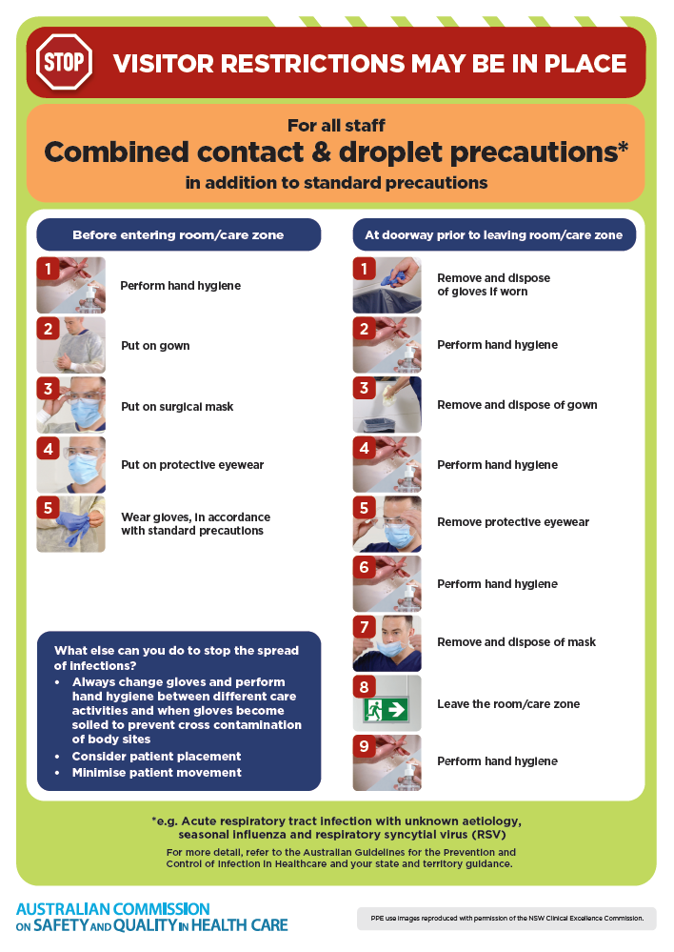
- Poster – Combined airborne and contact precautions
https://www.safetyandquality.gov.au/publications-and-resources/resource-library/infection-prevention-and-control-poster-combined-airborne-and-contact-precautions
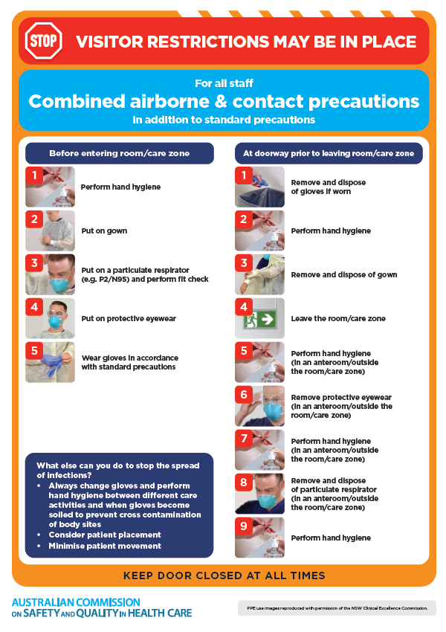
- Environmental Cleaning and Infection Prevention and Control www.safetyandquality.gov.au/environmental-cleaning
- Break the chain of infection poster
https://www.safetyandquality.gov.au/publications-and-resources/resource-library/break-chain-infection-poster
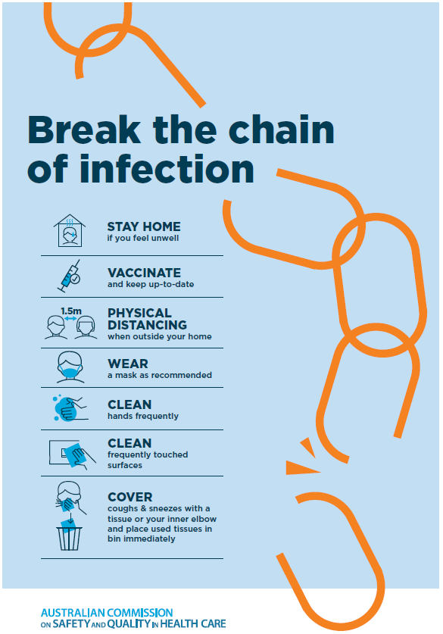
Disclaimer
On the Radar is an information resource of the Australian Commission on Safety and Quality in Health Care. The Commission is not responsible for the content of, nor does it endorse, any articles or sites listed. The Commission accepts no liability for the information or advice provided by these external links. Links are provided on the basis that users make their own decisions about the accuracy, currency and reliability of the information contained therein Any opinions expressed are not necessarily those of the Australian Commission on Safety and Quality in Health Care.

