
On the Radar
Issue 750
6 July 2026

Sixteen years of On the Radar
The first issue of On the Radar appeared on 5 July 2010 – just after I returned to work after the birth of my daughter. Initially produced as an internal resource for Commission personnel it quickly developed an audience beyond the Commission. 750 issues later my editorial task remains much the same – compiling a succinct synopsis of recent material relevant to safety and quality in health care. I hope you find it useful and relevant to your work.
Dr Niall Johnson
Editor

On the Radar is a summary of some of the recent publications in the areas of safety and quality in health care Inclusion in this document is not an endorsement or recommendation of any publication or provider Access to particular documents may depend on whether they are Open Access or not, and/or your individual or institutional access to subscription sites/services Material that may require subscription is included as it is considered relevant.

On the Radar is available online, via email or as a PDF or Word document from
https://www.safetyandquality.gov.au/news-and-media/newsletters/on-the-radar

If you would like to receive On the Radar via email, you can subscribe on our website https://www.safetyandquality.gov.au/news-and-media/newsletters/on-the-radar
or by emailing us at mail@safetyandquality.gov.au.
You can also send feedback and comments to mail@safetyandquality.gov.au.

For information about the Commission and its programs and publications, please visit https://www.safetyandquality.gov.au

On the Radar
Editor: Dr Niall Johnson
Contributors: Niall Johnson

Reports

Summary of Aboriginal and Torres Strait Islander health status – selected topics 2025
Anderton E, Barrett M, Eshghabadi A, Poynton M, Uink B
Perth: Australian Indigenous HealthInfoNet; 2026. p. 48.
URL | https://healthinfonet.ecu.edu.au/learn/health-facts/summary-aboriginal-torres-strait-islander-health/52294/
Notes | The Australian Indigenous HealthInfoNet has published this report as ‘a concise visual summary of the Australian Indigenous HealthInfoNet's statistical publication, the Overview of Aboriginal and Torres Strait Islander health status 2025.’ This summary report is part of a suite of resources that include the Overview report and PowerPoint slides.  The Summary and Overview reports have been structured around the domains of connection outlined in the Aboriginal and Torres Strait Islander Social and Emotional Wellbeing Model. This new structure reflects the holistic nature of Aboriginal and Torres Strait Islander health and wellbeing.  The publications present data on connection to culture, Country, community, family and kinship, alongside indicators of physical health (connection to body) and mental health (connection to mind and emotions).

Online prescribing: opportunities to improve patient safety
Investigation report
Health Services Safety Investigation Body
Poole: HSSIB; 2026.
URL | https://www.hssib.org.uk/patient-safety-investigations/online-prescribing-challenges-and-opportunities-to-improve-patient-safety/investigation-report/
Notes | The latest investigation report from the Health Services Safety Investigations Body (HSSIB) in the UK examines patient safety issues around ‘independent online prescribing’ as it is used in the UK and the gaps in information access and availability between the National Health Service (NHS) and independent prescribers. The investigation report ‘focuses on challenges for independent prescribing organisations in accessing clinical information held by the NHS to inform safe prescribing decisions for the patients who use their services. It also explores how gaps in NHS patient information about medication prescribed by independent prescribing organisations creates risks for the delivery of safe care. For both NHS and independent prescribing organisations, having limited information about a patient’s medical history and the medications they are being prescribed creates a challenge to making safe decisions about ongoing care and treatment.’ The report highlights that limited access to patient records creates risks where prescribers are unable to check for potential interactions, contraindications or previous medical history. The report includes findings, safety recommendations, observations and learnings that are applicable at various levels.

Findings, conclusions and essential actions from the Independent Review of Maternity Services at Nottingham University Hospitals NHS Trust
London: Department of Health and Social Care
URL | https://www.gov.uk/government/publications/ockenden-review-into-maternity-services-at-nottingham-university-hospitals-nhs-trust-final-report
Notes | Final report of the independent review of maternity services at the Nottingham University Hospitals NHS Trust in the UK. The review examined the quality of care relating to newborn, infant and maternal harm at the trust. Informed by a review of more than 2,500 cases, the report outlines local actions for learning along with system-wide learnings and immediate and essential actions to improve maternity and neonatal care.
The Case for Integrated Primary Care Across 10 Countries
Findings from the 2025 Commonwealth Fund International Health Policy Survey
Gunja MZ, Shah A, Lewis C
New York: The Commonwealth Fund; 2026.
URL | https://doi.org/10.26099/02ke-n005
Notes | The Commonwealth Fund in the USA has for a number of years conducted surveys of various aspects of health care systems in a number of high-income nations, including the USA and Australia. This report uses data from their 2025 survey to examine issues in primary care, particularly the potential for better integrated care to deliver better care. The authors highlighted that:  - ‘There is wide variation in the types of providers that make up a primary care practice across countries.  - Most primary care physicians across countries feel well prepared to manage their patients’ chronic conditions.  - While roughly half of physicians across countries feel well prepared to manage their patients’ mental health needs, few are prepared to handle addiction-related issues.  - About half or more primary care physicians in nearly all countries said “a lot” of the health conditions they treat are related to mental health, followed by unmet social needs and inadequate preventive care.’

Beyond the Clock: Improving the Human Experience of Waiting in Healthcare
Nashville: The Beryl Institute; 2026.
URL | https://theberylinstitute.org/product/beyond-the-clock-improving-the-human-experience-of-waiting-in-healthcare/
Notes | The latest from the Beryl Institute is this examination of the ‘human experience of waiting in healthcare’. According to the Institute, the report examines how some health organizations are  - Improving patient flow and reducing delays through system-wide approaches to access and capacity  - Strengthening communication and transparency during periods of waiting  - Creating alternative pathways to care that improve access and reduce congestion  - Leveraging technology to enhance navigation, information sharing, and real-time updates  - Supporting patients, families, and caregivers through the emotional burden of waiting  - Advancing equity by addressing language, accessibility, and navigation barriers.

Journal articles

Surgical Conflicts of Interest: Are They a Problem?
Vo A, Woo H, Maddern GJ
ANZ Journal of Surgery. 2026.
DOI | https://doi.org/10.1111/ans.70776
Notes | Review article in the ANZ Journal of Surgery examining issues around conflicts of interest for surgeons, both financial and non-financial. The authors review the literature and policies around conflicts of interest in surgical practice. The authors observe that conflicts of interest ‘are an inevitable and multifaceted aspect of modern surgical practice, arising across clinical care, research, innovation and industry collaboration.’ They recognise that current policies ‘provide a foundation of ethical principles and disclosure requirements’ but note ‘practical guidance on the identification, evaluation and management of conflicts remains variable and often lacks specificity’. They also suggest that ‘The integration of structured disclosure processes, context-specific examples and clear management strategies into a surgery-specific framework can enhance consistency, support ethical decision-making and ensure patient care remains central’ and that ‘a comprehensive and practical approach to the management of COI is essential to uphold professional integrity, maintain public trust, and support ethical decision-making and accountability within surgical practice.’

Journal of Primary Health Care
Volume 18, Issue 2, June 2026
URL | https://connectsci.au/hc/issue/18/2
Notes | A new issue of the Journal of Primary Health Care has been published. Articles in this issue of the Journal of Primary Health Care include:  - Editorial: Workload in general practice: the importance of quantifying ‘seen’ and ‘unseen’ work (Felicity Goodyear-Smith; Tim Stokes)  - Implementing an equity-focused model for early pregnancy care in general practice (J P McMenamin; G White)  - Primary health care utilisation in Aotearoa New Zealand: a descriptive study of trends from 2008 to 2023 (Mona Jeffreys; Maite Irurzun Lopez; Claire O’Loughlin; Tessa Senior; Jacqueline Cumming)  - The seen and unseen work of general practice: a national diary study of New Zealand General Practitioners (Luke Bradford; Simon Wright; Jordan Schulde; Samantha Murton)  - The journey of people accessing first trimester abortion in Aotearoa New Zealand: health consumers’ perspectives (Emma Macfarlane; Helen Paterson; Michael Stitely; Pauline Dawson)  - Temporary work absence for parental leave: a qualitative study of New Zealand general practitioners’ parental leave experiences (Rachel Roskvist; Emily Gill; Jess Ho; Fiona Moir)  - Consumer’s experiences with emergency contraception in Aotearoa New Zealand: a qualitative study (Emma McKay; Ragnar Anderson; H Paterson)  - Opportunities to flip the narrative from burden to action for young women joining the National Cervical Screening Programme in Aotearoa New Zealand: a Kaupapa Māori qualitative exploration of experiences and knowledge of cervical screening for 18–30 year olds (Tania Slater; Kendall Stevenson; Anna Adcock; Mary-Ann Clueard; Koha Aperahamaha, Carissa Thompson, Charles Lambert, E Jane MacDonald, Melanie Gibson, Stacie Geller, Matthew Bennett, Maxine Schmidt, Varsha Parag, Jo-Ann Stanton, Alison Carlin, K Wolff, M Hibma, P Sykes, M Saville, D Hawkes, B Lawton)  - The long and short of it: a qualitative descriptive analysis of self-identifying fat people’s experiences of Aotearoa New Zealand’s COVID-19 vaccination centres (Erica Stolte ; George Parker; Lesley Gray)  - ‘We just need to make sure this vaccine gets to the right place’: a qualitative study exploring vaccinators’ approaches to needle-length selection for big-bodied patients (Sally B Rose; C Timu-Parata; A Gillon; G Parker; L Gray)  - Factors influencing needle-length selection for adult deltoid intramuscular vaccination: an online survey of New Zealand vaccinators’ practice (Sally B Rose; Carmen Timu-Parata; George Parker; Ashlea Gillon; Lesley Gray)  - Newborn enrolment, engagement, and immunisation in primary care: a qualitative study of healthcare providers’ perspectives (Amber Young; Christine McIntosh ; Felicity Ware; Emma Best; Nikki Turner )  - Views on vaccination in a New Zealand rural Pasifika community: a qualitative study (Jo Hilder; Jane Taafaki; Maria Stubbe)  - Can vitamin D supplementation prevent respiratory infections in young children? (Vanessa Jordan)  - New Zealand green-lipped mussel (kuku) (Joanne Barnes; B McIntosh)

BMJ Leader
Volume 10, Issue 2, June 2026
URL | https://bmjleader.bmj.com/content/10/2
Notes | A new issue of BMJ Leader has been published. Articles in this issue of BMJ Leader include:  - Succession planning in nursing management: a scoping review (Mohammadsaeed Mirzaee, Tahmine Salehi, Mansoureh Ashghali-Farahani)  - Mattering at work: a scoping review with implications for the healthcare work environment (Katy Hall, Amanda Datesman, Julie Haizlip, Beth Epstein)  - 4Ps framework: practical actions to protect individual health in the current climate crisis (Hugh Montgomery, Amir Baniassadi, Wenjia Cai, Ali Kubba, Li Li, Rossella Nappi, Amanda Stucke)  - Impact and outcomes of the Emerging Leaders Programme: a mixed-methods evaluation of a leadership development programme for healthcare professionals (Oscar Lyons, Juliette Phillipson, Mary Fenwick, Thomas Swinburn, J Charles B Kotze, J R Galante, K Nandra, N Fahy, R Canter)  - Well-being initiatives for hospital employees provided by the Dutch University Medical Centres: an exploratory study (Amber Boskma, Leontien Sturms, Arie Franx, Maarten van der Laan)  - Investigating the relationship between nurse managers’ leadership style and predicted nurses’ turnover (Kawthar Alsaleh, Taibah Mohammed Ali, Fatimah Alhalafi, Faten Ali, Mashael Alfotais, Olfat Salem)  - Effects of education based on ethical leadership on moral distress, perceived organisational justice and clinical competence among nurses (Fatemeh Mansouri, Leili Rabiei, Reza Masoudi, Shahram Etemadifar, Soleiman Kheiri)  - Planetary health leadership to drive climate action across pharmaceutical supply chains: insights from qualitative research and a call to action (Amy Booth, Liz Breen, Sietse Wieringa, Sara Elizabeth Shaw)  - Work styles and career development of hospital pharmacists in Japan: a cross-sectional questionnaire survey (Masami Tsuchiya, Hitoshi Kawazoe, Hirotake Ohashi, Akemi Ogasawara, Yukiko Miyoshi, M Sasuga, K Kasashi)  - Contemporary diversity trends among matched ophthalmology residents in the USA (Camryn Thompson, Pratap Challa, Sandra S Stinnett, Sharon Fekrat)  - Proposed model of empathic leadership to address crises in contemporary management (Jeremy Howick, Sean Heneghan, Jodi Halpern, Sue Carr, Sheona MacLeod, Rich Withnall)  - Burning to the edge: healthcare leadership in a time of climate-driven wildfires (Dana Mathew, Attila J Hertelendy, Gregory R Ciottone)  - Redefining the primary role of healthcare boards: to advance careful and kind care (Leonard Berry, Dominique Allwood, Sheila Delaney Moroney, Maggie Breslin, Richard M Levy, Donald M Berwick, Victor M Montori)  - Moving beyond net-zero to a nature-positive healthcare sector (Sara Soraya Eriksen, David Vernon Brasfield, Ola Løkken Nordrum, Trond Heir)  - Blending internal and external consultancy in the NHS: towards smarter use of management expertise (Andrew Sturdy, Kirsten Armit, Ian Kirkpatrick)  - Enhancing mentorship/sponsorship opportunities for pulmonary, critical care and sleep fellows through structured alumni engagement (Andres Leonardo Mora Carpio, Richard A Matthay, Carolyn D’Ambrosio, Brian Clark, Margaret Pisani, Andres Martin, Ghada Bourjeily, James K Stoller)  - Optimising doctor–administrator leadership dyads in healthcare organisations (Vilert Loving)  - ‘Planetary health’ leadership at a time of a triple planetary crisis and breached planetary boundaries (Michelle McLean)  - Student leadership in planetary health: insights from the planetary health report card leadership team (James Lee, Jessica Mo, Shivam Singhal, Arya Pontula, Aghna Wasim, Emily May Coady, Roma A Kankaria, Monisha Chinthala, R McEwen, P Pattanaik, S Gürbüz, E Ifechukwude Benyeogor)  - Transcending geographic and disciplinary borders: leadership lessons from a century of the Harkness Fellowship (Molly Fitzgerald, M Kelley, R Williams)  - My COVID ‘planetary health’ epiphany: restoration of our planet requires an Indigenous lens in health professions education and healthcare (Michelle McLean)  - Transformative leadership in physiotherapy education: breaking norms, embracing change (Shahina Hanif, Helen Batty)  - Learning to lead by listening: an autoethnographic reflection from my early months as a health and social care CEO (Paul Newman)  - Shared decision-making in radiology: leadership levers for patient-centred imaging (Rakhshan Kamran, Andrea S Doria)

American Journal of Medical Quality
Volume 41, Issue 4, July/August 2026
URL | https://journals.lww.com/ajmqonline/toc/2026/07000
Notes | A new issue of the American Journal of Medical Quality has been published. Articles in this issue of the American Journal of Medical Quality include:  - Disproportionate Use of Security Response Codes on Black Patients in a Quaternary Academic Center (Emily Mitchell, Ravneet K Waraich, Sophie Goldman, Jacob T Luty, Jeff Gold, Andrea Smeraglio)  - Improvement in Huddle Participation Among the Child Health Patient Safety Organization (Anne Dykes, Matthew Hall, Emily Tooley, Stephanie Burrus, Kelly Johnson, Autumne Harding, Sandip A Godambe)  - Reframing “No-Show”: Patient-Reported Barriers for Missed Post-Hospital Discharge Primary Care Follow-Up Visits (Jessica J Zhang, Brian Le, Erin Dowling, Rosie Brown, Antonio Villarama, Sharon Ramirez, Wendy Simon)  - Advancing Patient Experience and Doctor Communication Excellence Through Targeted Multidisciplinary Intervention: A Quality Improvement Study (Farzana Hoque, Richard H Savel, Payam Benson)  - Increasing Advance Care Planning in a Community Internal Medicine Clinic (Asrita Vattikonda, Mohamed Ibrahim, Dylan Scott, Emily Gansert, Jordan Phillipps, R Christopher Chase, Catherine Madaffari, Jose Raul Valery)  - Reducing Surgical Instrument Contamination Through Multidisciplinary Quality Improvement: A Systems Approach at an Academic Medical Center (Kamga Nkouli, Emily Tally, James Lutz, Nina Dao, Robert Rusco, Kaitlin Marshall, Wendy Seiger, Lisa Case, Michael Morrey, Andrew Jea)  - Quality Improvement and Patient Safety in Graduate Medical Education (Des’ree Garvin, William Hart, Nayda Parisio-Poldiak)  - Intersectionality: Race, Place, and Dead Ends (Meghan B Brennan)  - Protecting Pediatric Patients From X-Ray Overutilization: A Study on Compliance for NG/OG Tube Placement Verification (Leah Riese, Caroline Gearin, Riley Hall, Patrick Colmenero, Josie Denzin, Rachel Olson, Gina Rohlik, Yves Ouellette, N Nordling, T Kirkpatrick, Y Kawai, D O’Laughlin)  - Management Modality of Thoracoabdominal Aortic Aneurysms is Associated with Lower Rates of Follow-Up (Melissa Chen Xu, Devi Schwartz, Justin Do, Babak Abai, Dawn Salvatore, Paul Dimuzio, Michael Nooromid)  - Improving Obstructive Sleep Apnea Screening in Patients With Atrial Fibrillation: Bridging the Gap (Warda Naqvi, Enad Haddad, Alyssa Campbell, Fnu Pooja, Kavya Khota, Zaineb Alhassani)

The Joint Commission Journal on Quality and Patient Safety
Volume 52, Issues 7, May–July 2026
URL | https://www.sciencedirect.com/journal/the-joint-commission-journal-on-quality-and-patient-safety/vol/52/issue/7
Notes | A new issue of The Joint Commission Journal on Quality and Patient Safety has been published. Articles in this issue of The Joint Commission Journal on Quality and Patient Safety include:  - Anxiety, Experience, and the Hidden Drivers of Quality (Laura Cooley)  - Digital Health Safety Surveillance: Improving Patient Support Throughout the Diagnostic Trajectory (Brett Moran, Jenny L Weon, M Hinshelwood, V Polineni, R Power, L SBrown, A Karam, A Turicchi, A Palumbo, M Case)  - When Patients’ Feelings During Their Hospital Stay Affect Their Level of Experience and Satisfaction with Quality of Care (Hélène Lazareth, Caroline Prunet, Marie Gloanec, Sandrine Morin, Laetitia May-Michelangeli)  - Implementation of a Prenatal Hemorrhage Risk Screening Tool: A Quality Improvement Initiative (Andrea Sanchez Velazquez, Adriane Burgess, Michelle Erickson, Julia Wheeling, Aimee Fleischman, Kelley Clark )  - Harm Among Reported Patient Safety Incidents Across Age Groups in Mexican Tertiary Care Hospitals (Rosa A Zárate-Grajales, Luis A Benítez-Chavira, Sandra Hernández-Corral, Judith Barrientos-Sánchez, Paula Rodríguez-León, Gustavo Nigenda, Edson Serván-Mori)  - Implementing the SSKIN Bundle in Home Healthcare: A Tool Tutorial for Reducing Pressure Injuries (Mohammed Aldhoun, Maryam Ali K M Al Tamimi, Hanadi Al Hamad, Nadya Al-Rauili, Fatima Ali B Bouladi, Maqsood Ibrahim Adam, Sybil Binu George, Latha Ayyar Thevar, Cini Joseph, Enas Abdrabo Mohamed SA Elgezery, Amira Abdelsalam A/Elmotalab, Mervat Khader Mahmoud Hammoudeh, Kalpana Singh, Fatima Ahmad Ajaj)  - Patient-Reported Diagnostic Excellence in Emergency Care: Cross-Site Score Variation and Purpose-Dependent Interpretation (Vadim Dukhanin, Kathryn M McDonald, Diane Kuhn, S W Heinert, E B Wood, K T Gleason)  - Large Language Models as Physician Recommenders: Limitations, Alternatives, and the Path Toward Hybrid AI Systems (Mohammad Mahdi Bagheri Asl, Alejandro M Spiotta)  - Toward a Learning Hospital: The Case for Quality Intelligence Systems (Kedar S Mate, Justin D Norden, Marc Lachs)

Health Expectations
Volume 29, Issue 3, June 2026
URL | https://onlinelibrary.wiley.com/toc/13697625/2026/29/3
Notes | A new issue of Health Expectations has been published. Articles in this issue of Health Expectations include:  - ‘I Want Everyone to Have It, and Everyone to Be on It’: A Feasibility Study of the Transforming Long Covid Intervention (Sarahjane Belton, Hannah Goss, Enda Whyte, Noel McCaffrey, Sophie Gibney, Kate Sheridan)  - Co-Development and Validation of a Patient-Reported Experience Measure for Trans and Gender Diverse Young People: A Multi-Stage Participatory Study Protocol (Sasha Bailey, Isabel Zbukvic, Alex Dalton, Steph Odoi, Emily Clarke, K A McKercher, Ken Pang, Alessandra Chinsen, Maria Pallotta-Chiarolli, Alan Bailey, Penelope Strauss, Kate Filia, Caroline Gao, Skye Barbic, Sarah Bendall, Sian Lloyd, Andrew Chanen, Nicholas Fava, Eóin Killackey, Susanne Prosser, Vikki Ryall, L Kerley, C T Sullivan, M Simmons)  - Exploring Medication Safety in Transitions From Prison to Community: A Qualitative Study (Claire Planner, Richard N Keers, Denham Phipps, Ozlem Eylem van Bergeijk, Natasha Tyler, Jennifer Shaw, D Ashcroft, M Panagioti)  - Towards Establishing Shared Terminology for Person-Centred Care: A Modified Delphi Study With Consumers and Health Professionals (R Barnden, T A Collyer, D A Snowdon, N A Lannin, V Srikanth, S Harvey, N E Andrew)  - A Qualitative Study to Explore the Influence of Condition Prioritisation in People With Coexisting Diabetes and Hypertension on Medication Adherence (Pauline Tendai Maniki, Betty Bouad Chaar, Parisa Aslani)  - ‘Home Is Where You Are Together’: Qualitative Systematic Review and Meta-Synthesis of Homeless People's Description of Home (Leila Thornhill, Ben Sellar, Gabrielle Rosa Hernandez, Carolyn M Murray)  - Shared Experiences in Post-Rehabilitation COPD Care Management: A Qualitative Study From Patient and Care Manager Perspectives (Espérance Moine, Mathis Brusseau, François Alexandre, Sophie Gendrault, N Heraud)  - The Impact of Social Isolation on Treatment Burden Among Community-Dwelling Adults With Disability and Multimorbidity: A Longitudinal Qualitative Study in Urban China (Jiahui Dong, Ming Yan, Andrew Farmer, Leyi Jiang, Junhai Zhen, Yuling Tong, Yin Dong, Gaofeng Zhang, Lingyan Wu, Yi Guo, Xuejun Yin, Lizheng Fang, Zhijie Xu)  - Seeing Anxiety: Ecological Video Ethnography and Simulation to Understand Anxiety and Decision-Making in Dental Care (Mona Nasser, Hannah Drayson, Sally Hanks, Nicholas Peres, Michael Punt)  - Developing Public-Friendly Visualisations to Improve PPIE Glossaries for Statistical Methodology Research (Clareece R. Nevill, Hannah Cooper, Barbara Czyznikowska, Louise Fairgrieve, Justin Greenwood, Gurpreet Grewal-Santini, Janion Nevill, Lucy Teece, Molly Wells, Suzanne C. Freeman, Sarah Booth)  - Frameworks to Evaluate the Quality of Public Involvement in Health and Social Care Research: A Scoping Review (Rose Hutton, Alice Moult, Dereth Baker, Anthony A Fryer, Andrew Meakin, Opeyemi Babatunde)  - Constructs, Predictive Factors and Measures: Insights From the Mental Health in the Moment (MHIM) Co-Production Panel (Luke Power, Dejla Hoxha, Lorna Caddick, Tong Xie, Hannah Coulstock, Alex Crocker, Katie Dryburgh, Daria Melashenko, Dacian Astilean-Style, Heather Bryson, Eva Drummond, S Ehimen, P Fairbairn, R Kelly, P Sinclair, Y-W Tan, A Murray)  - What Matters Most: The Top 10 Child and Adolescent Cancer Research Priorities in Australia (Gayani De Silva, Eden G Robertson, Alison Bowers, Clarissa Schilstra, Sheila K Patel, Maria C McCarthy, Jordana McLoone, Jason D Pole, Ursula M Sansom-Daly, Sabina Oppelaar, J Cummings, N Bradford)  - Exploring Lived Experiences of Men Diagnosed With Prostate Cancer in Oman: A Qualitative Study (Khalood Al-Abri, Mazin Hamood Al-Louyahi, Hassan Said Al-Samani, Mohammed Juma Al-Ghanboosi, Khadem Hamed Al-Junaibi, Nasser Hamood Al-Adawi, Debby Syahru Romadlon)  - Assessing Unmet Social Needs in Multiple Sclerosis Care in Australia: A Qualitative Assessment of Feasibility, Barriers and Enablers (Megan R Hawkins, Yvonne C Learmonth, Isabelle Weld-Blundell, Darshini Ayton, Jodi Haartsen, Anne Kavanagh, Tomas Kalincik, Marlena Klaic, Claudia H Marck)  - From Participation to Evidence: Listening-Informed Policies and the Epistemic Role of Lived Experience in Population Health (Serena Barello, Michela Monaci, Sarah Bigi, Beatrice Credi, Marko Korenjak)  - Expectations Shaped Elsewhere: Refugee Experiences of Healthcare in Aotearoa New Zealand (Molly George, R Kennedy, L Richard, P Norris)  - A Qualitative Exploration of Unanticipated Effects Experienced By People With Chronic Obstructive Pulmonary Disease Who Participated in Interventions Designed to Reduce Sedentary Behaviour (Fiona Coll, Vinicius Cavalheri, Daniel F. Gucciardi, Kylie Hill)  - Development and Psychometric Evaluation of the TOGETHER Family-Reported Experience Measure of Nurse-Facilitated Family Engagement in Adult Acute Care (Julie Cussen, Michael J Ireland, Georgia Tobiano, Amanda Corley, Anne M. Eskes, Whitney Kelly, Lachlan Kelly, Jolanda M Maaskant, Benjamin R Mackie, Thom J T Westdorp, Andrea P Marshall)  - Co-Producing an Intervention Involving Dental Professionals Providing Oral Health Support in a Mental Healthcare Setting (Masuma Pervin Mishu, Natalia Kika, Emma Tkach, Piyali Sarkar, A Krayer, M Horspool, E Peckham)  - “Cold Hard Cash”: The Value of Direct Unconditional Compensation for People With Lived Expertise of Homelessness (Jeff Rose, Steffine Amodt, Yixiao Burke, Sarah L Canham, Natalie Clark, Shawn Clay, Herbert Elliott, Rob Ferris, Ruby Gary, Lawrence Horman, Danielle Littman, M Martinez)  - Co-Designing a Care Pathway for Healthcare Professionals to Recognise and Respond to Human Trafficking Victims in Emergency Departments (Leanne van Rooy, Celia J Filmalter)  - Mental Health Experiences and Needs of Women With Congenital Heart Disease in Pregnancy and Postpartum: A Qualitative Participatory Study (Caroline J Huxley, Nigel E Drury, Anna C Lavis, Donna Giles, Jo Harrison, Katharina Kaplan, Joanne Lloyd, Tracey Nugent, Charlene Powell, Pameljit Rama, Debbie Rigby, Heather Still, Imogen Tacey-Green, Karin Eli)  - Co-Design With Mothers and Professionals to Enhance Care for Mothers Experiencing Adversity: Development of the METIC Model (Lauren Elizabeth Lines, Amelia G Scott, Tiffany Conroy, Sarah Hunter)  - Socio-Demographic Inequalities in COVID-19 Health Care Access and Experiences in the United Kingdom: Intersectional and Mixed-Methods Analyses of Open and Closed Questions in a Prospective Cohort Study (Nathan J Cheetham, Anoushka Beattie, Alastair B Comery, V Bowyer, The COVID Symptom Study Biobank Consortium, J D Carpentieri, C J Steves)  - How Do Collaborative Approaches Shape Power Dynamics in Therapeutic Relationships? Evidence From Recovery-Oriented Mental Health Services (Elena Faccio, Michele Rocelli, Lorenzo Binaggia, Elisa Giolli, Diego Romaioli, Giacomo Chiara, Claudio Agostini, Roberto Vitelli, Ludovica Aquili)  - Between Hope and Skepticism: Parent and Provider Expectations of Artificial Intelligence as a Bridge to Human-Centered Care for Children With Chronic Illness (Atefeh Shamsi, Mahboobeh Namnabati, Asghar Ehteshami, Hamed Zandi Esfahani)  - Navigating Long-Term Co-Creative Research With Young Adults Diagnosed With Cancer: A Qualitative Study (Sarah Marklund, Rebecca Skog, Lars Sjödin, Johanna Rose, Marit Silén, Lena Wettergren, Claudia Lampic)  - Evolving Roles for Patients as Partners in a National Kidney Health Research Network: A Qualitative Study (Mark Melika-Abusefien, Nicolas Fernandez, Keila Turino Miranda, Jocelyn M Jones, Melanie D Talson, Letitia Pokiak, Selina Allu, Julie Wysocki, Matthew T James, Meghan J Elliott)  - Promoting Family/Friend Involvement in Care Planning in Care Homes: A Qualitative Exploration of the Usefulness and Relevance of an Information Resource (Thaïs Caprioli, J Taylor, Y Hamashima, A Charles, J Damant, C Giebel, M Peters, M Toma, A Ferguson Montague, L Wright, N Smith)  - Assessing Shifts in Research Priority Areas From the Neurological Community Before and After the COVID-19 Pandemic (Leah Dempsey, Travis Cruickshank, Mitchell Turner, Manja Laws, Danielle Bartlett, Barby Singer, Onno van der Groen, Moira Sim, Mandy Stanley)  - Critically Exploring Self-Harm Through Lived Experience Perspectives: A Survivor-Controlled Integrative Review Employing Participatory Methodology (C C da Cunha Lewin, M Leamy, S Baldoza, G Jerwood, E Miles, U Foye, A Sweeney)  - An Age-Adapted Co-Design Methodology for Community Health Research Involving Older Adults With Type 2 Diabetes (Jiangpan Niu, Yuanyuan Yin, Shan Wang)  - Beyond ‘The Squeaky Wheel’: The Passion, Precarity and Potential of the Family/Carer Lived Experience Workforce in the Queensland Mental Health System (Katherine Reid, L Downes, V Stewart, K Sellick, M Wyder)  - Co-Designing an Easy-Read Adult Social Care Outcomes Measure for Older People: Approach to and Reflections on Involving People Living With Dementia and Their Supporters (Rasa Mikelyte, Keith Oliver, Rosemary Oliver, James Caiels, Stacey Rand, Elizabeth Field, L Webster, A-M Towers)  - ‘I Would Feel Failed By the Medical Community Entirely’: Transgender Americans' Calls for Advocacy From Health Professionals in a Care-Restricted World (Kay Wallace, Jayne Reynolds, Jesse Krikorian, Gaines Blasdel, Mary Byrnes, Daphna Stroumsa)  - Model Development on Adherence to Aspirin in Pregnancy: A Co-Produced Qualitative Systematic Review and Meta-Ethnography (Raya Vinogradov, Eleanor Holden, Mehali Patel, Rowan Grigg, Linda Errington, Andy Husband, Judith Rankin, Vera Araujo-Soares)  - For Me, Quality of Life Is When I Get Through the Day Without Thinking: I Won't Make It: A Participatory Qualitative Study of Health-Related Quality of Life in Rare Liver Diseases (Anouck Alary, Jane Sattoe, Lynda Sifer-Rivière, Isabelle Aujoulat, José Mira, Guenda Bernegger, G Danesi, E Gil-Hernández, P Ballester, M Guilabert, D Nipius, J Kousemaker-Nieuwdorp, K van der Meer-Kuiper, S Cannavò, C Drossart, L Veniat, M Caiata Zufferey, A Dumas)  - Co-Creation of a Study Protocol to Assess the Effect of Transcranial Direct Current Stimulation in the Management of Fatigue in Children and Young People With Acquired Brain Injury (Fatiguebrain-tDCS) (C Rathinam, G Heath, Rt Gupta, E Wassmer, E McElroy, H Horn, D Fernandez-Espejo)  - ‘I Battle With This Gambling Addiction Every Day’. Learning From Lived Experiences of Recovery to Guide Gambling Harm Prevention Strategies (Simone McCarthy, Hannah Pitt, Paul Fung, M Potter, G Arnot, S Thomas)  - How Lived Experience Advisory Groups Contribute to the Design and Conduct of Mental Health Research (Jo Evans, Samuel Keightley, Angela Sweeney, Rosie Hill, Ezekiel Khayri, Sarah Markham, Til Wykes)  - ‘We're the Eyes and Ears… out There’: A Qualitative Exploration of the Perceptions and Experiences of Polypharmacy Amongst Home Care Providers (Anum Iqbal, Liam Mullen, Adam Todd, Barbara Hanratty)  - A Co-Produced Health Literacy Programme for Pregnant Women Whose First Language Is Not English: A Qualitative Study of Women's Experiences (Madeleine Benton, Ngawai Moss, Ruksana Begum, Gemma Cartwright, Phoebe Baxendale-Smith, Arti Dave, Mandeep Kaler)  - Building the Capacity of Adolescents as Researchers: The Co-Creation of the Health Hive Online Course (Allyson R Todd, Sara Wardak, K Connor, E Soo, E Wang, D Mautner, D Wardak, P Novi A Dharmayani, A C Singleton, J Chau, S Mihrshahi, R Raeside, S R Partridge, The Health Hive Team)  - Exploring Patient and Caregiver Work and Continuity of Care During Hospital-to-Home Transitions of Care in the Canadian Context (Hardeep Singh, Michelle L A Nelson, Terence Tang, Kerry Kuluski, Anie Udofia, Hedieh Molla Ghanbari, Ingryd Cunha Ventura Felipe, Jason Nie, Kednapa Thavorn, Robert J Reid, Walter Wodchis, Carolyn Steele Gray)  - Diabetes and Foot Health Among South Asian People Seeking Asylum in the United Kingdom: A Theory-Informed Scoping Review (Nadera Assim, Catherine Bowen, Michelle Myall)  - Development, Suitability and Comprehensibility of a QR Code–Enabled Educational Package to Improve Self-Care Practices Among Patients With Type 2 Diabetes: A Multimethod Study in Iran (Solmaz Mohammadi, Mehrnoosh Zakerkish, Ali Montazeri, Zeinab Bahrami, Marzieh Araban)  - Why Do They Return? A Phenomenological Study of the Lived Experiences and Ethical Dimensions of Revision Rhinoplasty in Iran (Habib Azimi, Zeinab Habibpour, Abbas Khalilpour, Leila Mokhtari)  - How Did Women From South Asian Backgrounds and People Seeking Asylum and Refugees Look After Their Health and the Health of Others During the COVID-19 Pandemic? A Community Research Approach (Olivia Joseph, Nadia Ait Yahya, Lilly Butt, Amana Khan, Sabiya Khan, Jane K. O'Hara, Abigail Albutt, Ryan Carter, Rameen Haq, Gemma Louch)  - Evaluating the Use of Anxiety Patient-Reported Outcome Measures (PROMs) in Dementia Clinical Trials: A Systematic Review (Jason Domingo, Ana Alves, Julie Sanders)  - “We Don't Normally Go Down This Avenue; This Is Normally Taboo”: Using Co-Design to Develop a Training Intervention for Spiritual Health in Primary Care (Ishbel Orla Whitehead, Mark Adley, Alexandra Thompson, Elizabeth Westhead, Marina Politis, Philip Mordue, A O'Donnell, B Hanratty)  - Embedding Multiperspective Reflections in Co-Producing a Training Intervention for Care Home Staff: Understanding Group Members' Journeys and Impacts (Tamara Backhouse, Scarlett Fountain, Peter Davis, Peta Cremer, Anne Francis, Linda Adams, Peter Jackson, Michelle Kiddell, Katie Fray, Gabby Meadows, Revathy Madhav, Anne Killett)  - Cultural Adaptation and Implementation Strategy of a Recovery-Oriented Mental Health Training Intervention (REFOCUS-THAIREC) for Healthcare Workers in Thailand: An Experience-Based Co-Design (Natthapon Inta, Annmarie Grealish, Mary Leamy)  - The Terminal Diner: Serving up a Novel Knowledge Exchange Methodology via Participatory Design Installation (Aria Wills, Kate Wilkes, Karen Oikonen, Nyanna Flynn, S Hafid, A Fernandes, M Howard, S R Isenberg)

Emergency Medicine Australasia
Volume 38, Issue 3, June 2026
URL | https://onlinelibrary.wiley.com/toc/17426723/2026/38/3
Notes | A new issue of Emergency Medicine Australasia has been published. Articles in this issue of Emergency Medicine Australasia include:  - Mental Health Assessments and Models of Care in the Emergency Department: A Narrative Review (Samantha E Russell, Darlene L Cole, Margaret M Clarke, Michael Mennen, S Rebis, L Horgan, K Vakil, J Choi)  - The Impact of the Geriatric Emergency Department Initiative on Older Community Dwelling Adults Presenting to the Emergency Department With a Completed Delirium Screen (Kendall Williams, Alison Craswell, Henry Tsao, Salih A. Salih, Tania Quaglio, Andrea Taylor)  - Optimising Retraining Frequency for a Paediatric Emergency Department Admission Prediction Model: Development and Temporal Validation Using Real-World Data (Ethan Williams, Toshi Sinha, Mark Lyttle, Y Kanagasingam)  - Recent Onset Atrial Fibrillation: What's in a Name (Joe Anthony Rotella, Diana Egerton-Warbuton, Lisa Kuhn)  - Evaluation of an AI Scribe Tool in the Emergency Department: A Single-Arm Observational Study (Hamed Akhlaghi, Sam Freeman, Kevin Sun, Neo Nie, John Ding, Leo Chen, Eden Pham, Brendan Morrissey, Jonathan Karro)  - The Use of Cognitive Aids to Assist With the Resuscitation of Emergency Department Patients: A Scoping Review (John Paul Smiles, Colleen Cheek, Elizabeth Austin, Catherine A McIntosh, C Greenwood, R Clay-Williams)  - “Stuck” on the Ramp: What Factors Influence Patient Comfort and Satisfaction While Waiting on Emergency Department Ramps? A Qualitative Analysis (Vicki Binnie, Robert Eley, Andrew Staib)  - Reducing Post-Fall Emergency Department Transfer From Residential Aged Care Homes: The Falls Outreach and Residential Mobile Assessment Team (FORMAT) Before-and-After Study (Patrick J Owen, Andrea Bee, Donna Pattison, Joseph Miller, Liam Hackett, Paul Buntine)  - Chasing Aortic Dissection—Balancing Risk and Cost (Anne-Maree Kelly)  - Emergency Department Overcrowding: Towards a New Conceptual Framework (Michael Dinh)  - The Future of Trauma Care in Aotearoa New Zealand: Towards a Collaborative Model (Max Raos, James E. Moore)  - Aetiology of Traumatic Shock in an Australian Level 1 Trauma Centre (Michael Noonan, Fraser Francis-Pester, Gerard O'Reilly, Joseph Mathew, Chris Groombridge, Dinesh Varma, Mark Fitzgerald)  - Recreational Drug Use Amongst Children and Adolescents Presenting to Australian Emergency Departments With Acute Behavioural Disturbance: A Secondary Analysis of a Randomised Controlled Trial (Elyssia M Bourke, Kate Klein, Chris J Selman, Katherine J Lee, Amit Kochar, Deborah Shellshear, Meredith L Borland, Shane George, Shefali Jani, Doris Tham, M Gordon, Chidambaram Prakash, Andrew Davidson, Catherine L Wilson, N Phillips, G Nieva, J C Knott, F E Babl, S S Craig, on behalf of the Paediatric Research in Emergency Departments International Collaborative (PREDICT) network)  - Shared Care Between Trauma Surgeons and Geriatricians for Older Trauma Patients (Katherine Gregorevic, Rebecca Tai)  - Coordinating Expertise: Defining the Role of the Modern Trauma Specialist (Jennifer Jamieson, Adam Mahoney)  - Emergency Physicians as Inpatient Specialists: Evolving Models of Trauma Care (Joshua I Smith, Thomas A G Shanahan)  - Optimal Care for the Polytrauma Patient: The Importance of Surgical Leadership (Katherine Martin)  - Identifying Symptom Clusters Predictive of Acute Myocardial Infarction for Aboriginal and Torres Strait Islander and Non-Indigenous Australians (Jaimi Greenslade, William Parsonage, Laura Stephensen, Jeremy Rigney, Katrina Starmer, Gregory Starmer, Virginia Campbell, Emma Hall, Niranjan Gaikwad, Siegfried Perez, Louise Cullen, on behalf of the Legend investigators)  - Analytically Confirmed Opioid Detections From the Emerging Drugs Network of Australia (J Soderstrom, C Weber, S Greene, K Isoardi, S Alfred, V Tran, P Stockham, J Schumann, A Thompson, D Fatovich, on behalf of the EDNA Investigators)  - Fifteen Years Since the Head Injury Retrieval Trial: What Have We Learned? (Alan A Garner)  - Cervical Spine Immobilisation Following Stab Wounds to the Neck Is Unnecessary (Leon Kong, Victor Kong, Jonathan Ko, Howard Wain, Jim Wang, Jonah Qi, John Bruce, Grant Laing, Damian Clarke)  - Droperidol for the Management of the Undifferentiated and Agitated Trauma Patient (Frances Williamson, Claire Bertenshaw, Shea Roffey  - Suspected Pulmonary Embolism Exclusion With D-Dimers in Emergency Departments: Pregnancy (SPEED-ED Pregnancy). A Retrospective Evaluation of the Pregnancy-Adapted YEARS Guideline (Colin Banks, Bianca De Florian, Bryony Bennett, James Chia, V Gangathimmaiah)  - Words and Language Matter: Improving Older Person's Healthcare Outcomes Through Use of Age-Positive Language (Nemat Alsaba, Carolyn Hullick, Rebecca Heath, Denise Hobson, Bridie Mulholland, Ellen Burkett)  - The Influence of Hypocalcaemia on Trauma Patients Experiencing Post-Induction Hypotension: A Retrospective Observational Study (Andy Kwok, Chris Selman, Kellie Gumm, David J Read, Ned Douglas, Elyssia M Bourke)  - Development of a Binational Clinical Registry for Emergency Care: Data Completeness Across 11 Australian and Aotearoa New Zealand ED Networks (G M O'Reilly, P Buntine, J Furyk, L Hannon, A Hermiz, P G Jones, A Rogan, E Tan, D Tham, A Wong, L Hackett, M John-White, N Lowry, M Slaa, J Stella, S Craig)  - Distribution and Accessibility of Hospital-Based Emergency Departments for Paediatric Patients in Rural and Remote Western Australia: A Geographic Analysis (Hanin Bakhaider, S Azimi, M Tennant, E Kruger)  - Developing and Designing an Evidence-Informed Serratus Anterior Plane Block Education Program for Emergency Medicine (Christopher Partyka, Timothy Manion, Daniel Gaetani, Anthony Delaney, Kate Curtis)  - Delirium Screening in the Emergency Department: Barriers, Enablers and Alignment With Clinical Standards—A Mixed-Methods Study (Barbara Zangerl, Jared-Tyrell Ah-Leong, Joshua Wilcox, Michelle Jory, Faye Jordan)  - Low-Value Blood Culture Use in Adult Emergency Department Patients: A Scoping Review (A Weber, U Galappaththie, J V Moxon, V Gangathimmaiah)  - Medical Staffing Models of Inpatient Major Trauma Services in Australia and New Zealand (Haania Abbasi, Elyssia M Bourke, Mohsin Ejaz, A Buck)  - Screening for Asymptomatic Sexually Transmitted Infections in Emergency Departments: An Integrative Review of Public Health Outcomes (Joshua Wilcox, Faye Jordan)

BMJ Quality &Safety online first articles
URL | https://qualitysafety.bmj.com/content/early/recent
Notes | BMJ Quality &Safety has published a number of ‘online first’ articles, including:  - Editorial: Widening of the ‘technical/practical’ divide: New advances in statistical process control bring new capabilities and new challenges (Brant J Oliver)  - Priorities for improving paediatric diagnosis: findings from a modified Delphi study (Irit R Rasooly, Katherine Wu, Meghan Galligan, Morgan Congdon, Anna Costello, Yasaman Fatemi, Courtney Gidengil, Joseph A Grubenhoff, Harry Hoar, Cara T Jefferies, Amarpreet Kaur, Jillian Krause, Prashant Mahajan, Sanjiv D Mehta, Jonathan G Sawicki, Trisha Marshall, Kenneth A Michelson, Ursula Nawab, Andrew P J Olson, Michael Perry, Grant Joseph Dat Chiu Shafer, Kathy N Shaw, Hardeep Singh, Kathleen Walsh, Christina L Cifra)  - Brief mindfulness-based intervention to improve clinician mindful behaviours and well-being at two US hospitals: a randomised controlled, mixed methods trial (M Todd Greene, Nathan Houchens, Virginia Sheffield, Prathit A Kulkarni, Karen E Fowler, David Clive, Molly Harrod, Martha Quinn, Barbara Trautner, Sanjay Saint)  - Paradox of engagement: precautionary public health alerts and gender inequality in cancer diagnosis—a quasi-experimental study (I-Hua Chen, Juifen Rachel Lu, Ya-Chen Tina Shih, Chang-Xi Kung, Chun-Ying Wu, Li-Lin Liang)

International Journal for Quality in Health Care online first articles
URL | https://academic.oup.com/intqhc/advance-articles
Notes | International Journal for Quality in Health Care has published a number of ‘online first’ articles, including:  - Also a feeling–how frontline health care professionals construct patient safety (Axel Ros, Catarina Tingsvik, Johan Bergström)  - The Right to Play in Paediatric Healthcare: Policy and Practice in Chile (Aleksandra Glos, Alejandra Santana López, Javiera Celedón Juricic)

Online resources

Australian Living Evidence Collaboration
https://livingevidence.org.au/

Guidance
A number of guidelines or guidance have recently been published or updated These include:
- Suicide and Non-Suicidal Self-Injury in Children and Adolescents: Evidence-Based Clinical Practice Guideline
Melbourne Children’s Suicide and Non-suicidal Self-injury Guideline Development Group. Melbourne: Melbourne Children’s; 2026. p. 84.
https://medicine.unimelb.edu.au/school-structure/paediatrics/research/developmental-mental-health/research/projects/suicide-and-nssi-cpg

[UK] NICE Guidelines and Quality Standards
https://www.nice.org.uk/guidance
The UK’s National Institute for Health and Care Excellence (NICE) has published new (or updated) guidelines and quality standards The latest reviews or updates include:
- Quality Standard QS216 Perioperative care in adults https://www.nice.org.uk/guidance/qs216
- Quality Standard QS12 Breast cancer https://www.nice.org.uk/guidance/qs12
- Clinical Guideline CG81 Advanced breast cancer: diagnosis and treatment https://www.nice.org.uk/guidance/cg81

[USA] Effective Health Care Program reports
https://effectivehealthcare.ahrq.gov/
The US Agency for Healthcare Research and Quality (AHRQ) has an Effective Health Care (EHC) Program. The EHC has released the following final reports and updates:
- Systematic Review: The Performance of Fusion and Interventional Pain Procedures for Degenerative Diseases of the Lumbar Spine https://doi.org/10.23970/AHRQEPCSR_LUMBAR
https://effectivehealthcare.ahrq.gov/products/lumbar-spinal-fusion/research

Infection prevention and control resources
The Australian Commission on Safety and Quality in Health Care has developed a number of resources to assist healthcare organisations, facilities and clinicians These resources include:
- Poster – Combined contact and droplet precautions https://www.safetyandquality.gov.au/publications-and-resources/resource-library/infection-prevention-and-control-poster-combined-contact-and-droplet-precautions
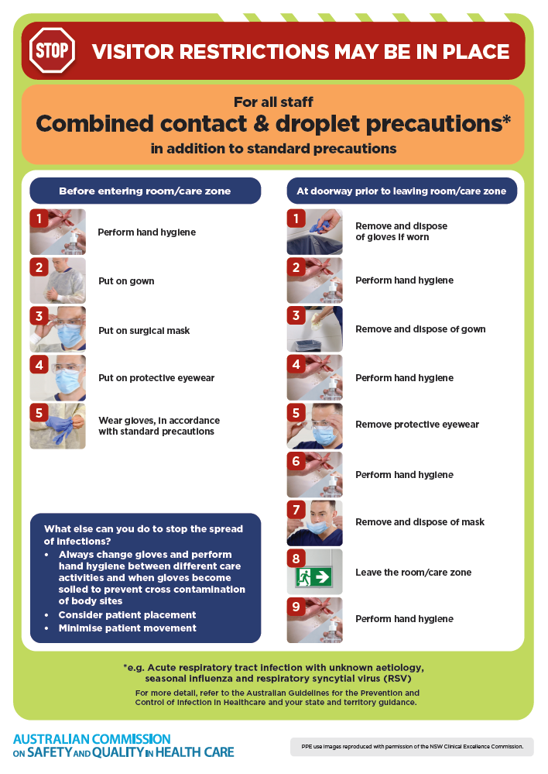
- Poster – Combined airborne and contact precautions
https://www.safetyandquality.gov.au/publications-and-resources/resource-library/infection-prevention-and-control-poster-combined-airborne-and-contact-precautions
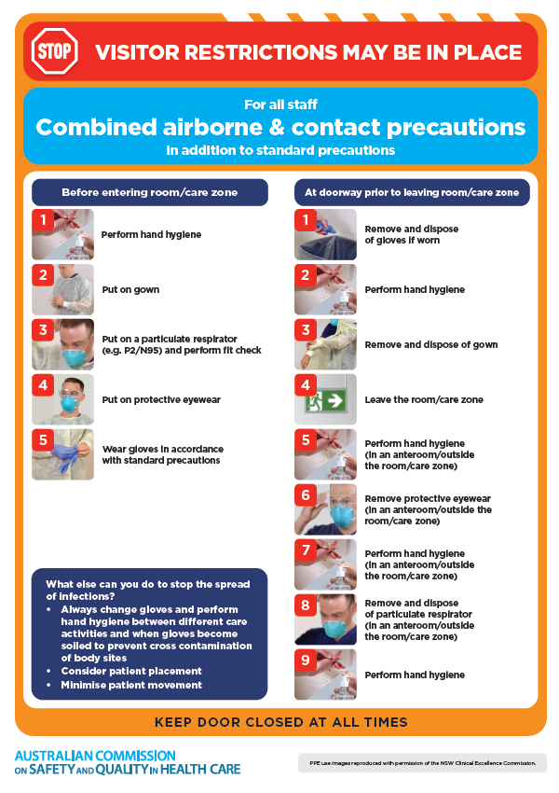
- Environmental Cleaning and Infection Prevention and Control www.safetyandquality.gov.au/environmental-cleaning
- Break the chain of infection poster
https://www.safetyandquality.gov.au/publications-and-resources/resource-library/break-chain-infection-poster
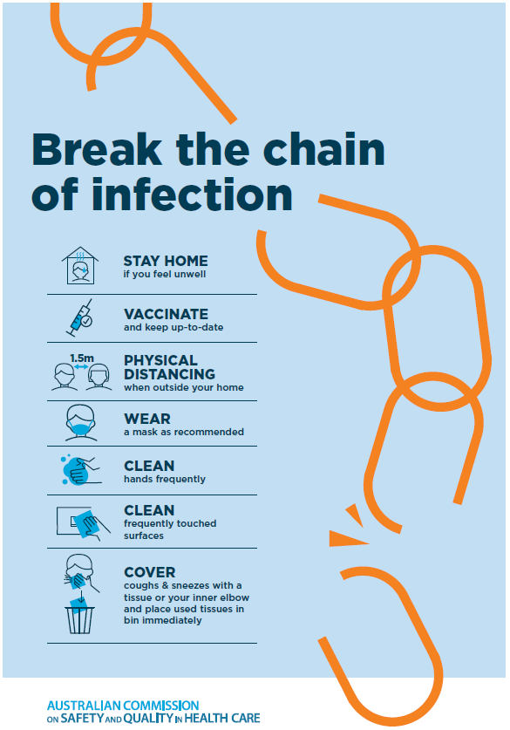
Disclaimer
On the Radar is an information resource of the Australian Commission on Safety and Quality in Health Care. The Commission is not responsible for the content of, nor does it endorse, any articles or sites listed. The Commission accepts no liability for the information or advice provided by these external links. Links are provided on the basis that users make their own decisions about the accuracy, currency and reliability of the information contained therein Any opinions expressed are not necessarily those of the Australian Commission on Safety and Quality in Health Care.

