
On the Radar
Issue 751
13 July 2026

On the Radar is a summary of some of the recent publications in the areas of safety and quality in health care Inclusion in this document is not an endorsement or recommendation of any publication or provider Access to particular documents may depend on whether they are Open Access or not, and/or your individual or institutional access to subscription sites/services Material that may require subscription is included as it is considered relevant.

On the Radar is available online, via email or as a PDF or Word document from
https://www.safetyandquality.gov.au/news-and-media/newsletters/on-the-radar

If you would like to receive On the Radar via email, you can subscribe on our website https://www.safetyandquality.gov.au/news-and-media/newsletters/on-the-radar
or by emailing us at mail@safetyandquality.gov.au.
You can also send feedback and comments to mail@safetyandquality.gov.au.

For information about the Commission and its programs and publications, please visit https://www.safetyandquality.gov.au

On the Radar
Editor: Dr Niall Johnson
Contributors: Niall Johnson, Andrew Ross

Reports

Australia’s health 2026
Australian Institute for Health and Welfare
Canberra: AIHW; 2026. p. 99.
URL | https://www.aihw.gov.au/reports-data/australias-health
Notes | Australia’s Health is the Australian Institute of Health and Welfare’s flagship biennial report on the health of Australians. This edition, Australia’s Health 2026, is the 20th such biennial report. According to the AIHW, ‘The Australia’s health 2026 product suite comprises 2 products:  - Australia’s health 2026 report: presents the latest key findings and a selection of short topic-based narratives, offering insights into contemporary health and wellbeing issues.  - Australia’s health topic summaries: a collection of 65 web pages providing comprehensive statistics on health, the health system and health services, as well as key data improvement activities.’

Best practice for glaucoma services
Getting It Right First Time (GIRFT)
London: NHS England; 2026. p.83.
URL | https://gettingitrightfirsttime.co.uk/clinical-framework-supports-better-glaucoma-care-to-prevent-avoidable-sight-loss
Notes | In the UK the Getting It Right First Time (GIRFT) initiative has developed this guidance aimed at reducing the risk of avoidable sight loss through a clinical framework for the delivery of glaucoma care in England. The framework prioritises early detection, accurate referrals, and lifelong continuity of care. The authors observe that ‘Glaucoma is a lifelong condition with the potential to cause irreversible blindness. Moreover, it is the second most common cause of blindness in the United Kingdom, with an incidence that is growing significantly and expected to reach more than 1.6 million by 2060. Ensuring consistently high-quality, safe and equitable care for glaucoma patients is critical.’

Competency frameworks and standards for digital health: a landscape analysis
World Health Organization
Geneva: WHO; 2026. p. 52.
URL | https://www.who.int/publications/i/item/9789240119765
Notes | Report from the World Health Organization (WHO) that ‘analyses the landscape of digital health competency frameworks and standards developed to strengthen health workforce education and practice in increasingly digitalized health systems. It examines how digital health competencies are defined, structured and applied across different professional, educational and organizational contexts, with a focus on supporting the effective use of digital technologies in health service delivery and learning.’

Blueprint for strengthening responses to fungal disease and antifungal resistance: implementation guidance
World Health Organization
Geneva: WHO; 2026. p. 40.
URL | https://iris.who.int/handle/10665/386517
Notes | The World Health Organization (WHO) have published this implementation guidance that ‘provides a practical framework to strengthen national and regional responses to fungal disease and antifungal resistance by translating the WHO fungal priority pathogens list into feasible, context-adaptable actions. … Aligned with the Global action plan on antimicrobial resistance, universal health coverage and One Health principles, the guidance supports countries in integrating fungal disease into existing public health programmes and coordinated national strategies.’
Future Directions in Personalised Medicine: A Horizon Scan for Artificial Intelligence, Genomics Based HealthTech
Forsythe I, Lanyi K, Green E, Katie Twentyman, Barnabas J, Mkwashi A
NIHR Innovation Observatory: Newcastle upon Tyne; 2025. p. 28.
URL | https://io.nihr.ac.uk/resources/reports/future-directions-in-personalised-medicine-a-horizon-scan-for-artificial-intelligence-genomics-based-healthtech/
Notes | This report funded by the National Institute for Health and Care Research (NIHR) in the UK is described as ‘A horizon scanning report to identify and analyse the use of artificial intelligence-based MedTech within personalised medicine.’ Having ‘identified 104 unique technologies primarily focused on personalised treatment planning (68%) and precision diagnostics (26%)’, the authors conclude that ‘AI technologies are essential for implementing personalised medicine but face regulatory and ethical challenges. Low regulatory approval rates and complex GDPR [General Data Protection Regulation] requirements for genomic data may hinder adoption. Addressing these barriers through streamlined regulatory frameworks and equity-focused design principles is critical to ensuring these technologies fulfil unmet needs and reduce health inequalities.’

Australian Mental Health Access Report 2026
Therapy Near Me Editorial Team
Brisbane: Therapy Near Me; 2026. p. 194.
URL | https://therapynearme.com.au/australian-mental-health-access-report-2026/
Notes | This report from a private mental and allied provider presents a perspective on the access to mental health issues. The report is accompanied by a Research Addendum. The report’s executive summary states ‘Australia is experiencing sustained demand for mental health support across Medicare-funded care, private practice, community services, telehealth, schools, workplaces and disability-related supports. National prevalence data, Medicare service use, workforce evidence and regional access data indicate that demand is high, access is uneven and workforce availability is a central constraint.’

Journal articles

Audit and feedback: effects on professional practice
Ivers N, Yogasingam S, Lacroix M, Brown KA, Antony J, Soobiah C, et al.
Cochrane Database of Systematic Reviews. 2026;3(3):CD000259.
DOI | https://doi.org/10.1002/14651858.CD000259.pub5
Notes | Updated Cochrane Review examining the impacts of audit and feedback (A&F).This review sought to ‘assess the effects of A&F on the practice of healthcare professionals and to examine factors that may explain variation in the effectiveness of A&F.’ The review authors report that ‘A&F can be effective in improving professional practice, but effects vary in size. A&F is most often delivered along with co‐interventions which can contribute additive effects. A&F may be most effective when designed to help recipients prioritise and take action on high‐priority clinical issues’ and with a number of characteristics:

“Everyone's Responsibility and No-One's Responsibility”: A Thematic Analysis of a Roundtable on the Complex Problem of Secondary Stroke Prevention in Australia
Barker S, Cadilhac D, Cameron J, Bird M-L, Johnson L, English C, et al.
Health Expectations. 2026;29(4):e70755.
DOI | https://doi.org/10.1111/hex.70755
Notes | Recent paper published m Health Expectations that reported on a roundtable and follow-up groups discussions on stroke secondary prevention. The authors conclude that ‘Stroke secondary prevention is a complex problem with interacting system elements that make improvement challenging. A model of care for stroke secondary prevention in Australia is needed that accounts for this complexity while building upon shared priorities.’  The Australian Commission on Safety and Quality in Health Care recently released the updated Stroke Clinical Care Standard. The 2026 update reflects current evidence and clinical guidelines, with a stronger emphasis on rehabilitation, coordinated multidisciplinary care, personalised discharge planning and follow-up. The Standard emphasises continuity of care beyond the acute hospital, including review and support within six months of a stroke.

MedicineInsight primary care research – latest publications
MedicineInsight is a national program aimed at improving quality in primary care. Data from participating MedicineInsight practices is used to create personalised Practice Reports and GP Snapshots that provide targeted feedback and meaningful insights for participating practices to support quality improvement - in addition, the data contributes to a resource for use by independent research teams around Australia.
A selection of recent publications based on MedicineInsight data includes:
- Trends in anticholinergic drug exposure and associated risk factors in older Australian patients with dementia https://doi.org/10.1016/j.jpsychires.2026.01.048
- Angiotensin II-stimulating versus inhibiting antihypertensives and risk of dementia: a nested case–control study using Australian general practice data https://doi.org/10.1038/s41598-026-46974-0
- Thyroid Monitoring and Amiodarone-Induced Thyroid Disease in Australian General Practice: A Retrospective Cohort Study https://doi.org/10.3390/clinpract16030050

For a full list of approved projects and links to associated manuscripts and presentations see the MedicineInsight Projects Register at https://www.safetyandquality.gov.au/data-and-measurement/medicineinsight/medicineinsight-program-outputs/medicineinsight-projects-register

The Lancet Primary Care
Volume 2, Number 6, June 2026
URL | https://www.thelancet.com/journals/lanprc/issue/vol2no6/PIIS3050-5143(26)X2006-4
Notes | The Lancet Primary Care is a relatively new open access journal. Articles in this issue of The Lancet Primary Care include:  - Editorial: A call for investment in primary care data  - When pharmacogenomics meets primary care reality (Elisa J Houwink)  - Primary health care for sustaining immunisation services in a war-affected setting: the experience of Ukraine (Yevgenii Grechukha, Ihor Kuzin, Volodymyr Kurpita, Stanislav Gaievskyi, Denys Deineha, Oksana Koshalko, Yaroslava Chaikivska, Oleg Benes, Shahin Huseynov, Dene Cairns, J Habicht)  - Mainstreaming neglected tropical disease interventions into primary health care: accelerating elimination and sustaining gains (K Deribe, E Habtamu)  - Embedding One Health into primary care in Somalia (Halima Mohamed, John Woods, Khadra Jama-Alol, Omar Salad Elmi, Hassan Sh Abdirahman Elmi, Ali Jimale Mohamed, Mohamed Hussien Adam ,Mohamoud Abdulahi, Javier Guitian, Abdinasir Yusuf Osman, Luke N Allen)  - Integrated therapist and online cognitive behavioural therapy in addition to usual care versus usual care for depression in primary care in England (INTERACT): a two-group, parallel, multicentre, randomised controlled trial (Debbie Tallon, Laura Thomas, Sally Brabyn, Brian C F Ching, Jane S Hahn, Berry Jude, Jinshuo Li, Mekeda X Logan, Alex Burrage, Simon Gilbody, Paul Lanham, Glyn Lewis, Stephanie J MacNeill, Irwin Nazareth, Steve Parrott, Tim J Peters, Roz Shafran, Katrina Turner, C Williams, D Kessler, N Wiles)  - Pharmacogenomic-informed antidepressant prescribing for moderate-to-severe depressive symptoms in Australian general practice (PRESIDE): a double-blind, randomised controlled trial (Jon D Emery, Sibel Saya, Patty Chondros, Mary-Lou Chatterton, Cathrine Mihalopoulos, Melanie Galea, Timothy Chen, Thomas M Polasek, Adrian Laughlin, Luke B Hesson, Joahna Kevin Perez, Elise Dettmann, Anastasia Abela, Jamie J M Liew, Philip Ly, Georgia Ramsay, M Thoenig, M Luke, F La Rocca, J Gunn, C Bousman)  - Association between tachyarrhythmia and gout flare in people with gout in England and Sweden: nested case–control studies and self-controlled case-series analyses (Edoardo Cipolletta, Tatiana Zverkova Sandström, Georgina Nakafero, Davide Rozza, Panagiota Drivelegka, Gianluca Moroncini, Anthony J Avery, Laila J Tata, Mamas A Mamas, Mats Dehlin, Abhishek Abhishek)  - General practitioner consultations and hospital admissions among women in England after stillbirth or neonatal death: an observational, population-based, electronic health record study (Pensée Wu, Muhammad Usman, James Bailey, Marian Knight, Carolyn A Chew-Graham, Kelvin P Jordan)  - The general practice workforce crisis in Europe: scale of the challenge and available policy responses (Giuliano Russo, Martin McKee, Tomas Zapata, Alba Llop Girones, Sulakshana Nandi, Sara Ares-Blanco)  - Policies and interventions aiming to improve equitable access to primary care: a scoping review (Jialing Lin, Alexandra Knighton, Roosa Sofia Tikkanen, Marco Antonio Catussi Paschoalotto, Matthew E Berman, Heshmiha Christy, Amadea Turk, Nia Roberts, Michael Kidd, Luke N Allen)

JBI Evidence Synthesis
Volume 24, Issue 7, July 2026
URL | https://journals.lww.com/jbisrir/toc/2026/07000
Notes | A new issue of JBI Evidence Synthesis has been published. Articles in this issue of JBI Evidence Synthesis include:  - Editorial: Leveraging artificial intelligence for evidence synthesis (Barbara Nussbaumer-Streit, Marc Streit, Kylie Porritt)  - Hospital initiatives to involve patients and carers in recognizing clinical deterioration and escalating concerns: a scoping review including considerations for culturally and linguistically diverse populations (Sarah Rooney, Gavin D Leslie, Huaqiong Zhou, Eileen Boyle, Fenella J Gill)  - Effectiveness and safety of intranasal fentanyl for pain management in infants aged 0 to 6 months: a systematic review (Helen McCord, Cameron Bruce, Nadeana Norris, Lior Goldchtaub, Daria Hughes, Melissa Rothfus, K Jones, T Disher, S Mitra, L Kristoffersen, M Syverud, M Campbell-Yeo)  - Virtual music therapy during the COVID-19 pandemic: an updated scoping review (Monika Bucharová, B Hořejší, J Kantor, L Perimal-Lewis, M Klugar)  - Association of genetic polymorphism with intra-articular and masticatory muscle temporomandibular disorders: a systematic review protocol (Maria Raju, Achyutha Chandra, Saranya Sreekumar, Renju Jose, Bindhu Paul-Prasanth, Limor Avivi-Arber, Chandrashekar Janakiram, Anil Mathew)  - Barriers to outpatient mental health services experienced by adult Medicaid recipients: a scoping review protocol (Navdep Kaur, Katherine M Keyes, Charles C Branas, Ramin Mojtabai, Mark Olfson)  - Association between nomophobia and health consequences among university students: a systematic review protocol (Shwetha Ashok, Bhargavi Gongati, Denny John)  - Surrogacy birth care practices in the hospital setting: a scoping review protocol (Jutharat Attawet, Yunjing Qiu, Leo Ng, Myles Ojabo, Evie Kendal, Sarah Jefford, Micah DJ Peters)  - Impact of dashboard utilization in the emergency department on the quality of health care: a mixed methods systematic review protocol (Happy Indah Kusumawati, I Made Yanuar Saifudin, Bayu Fandhi Achmad, Syahirul Alim, Luluk Lusiantoro, Martina Sinta Kristanti, Adi Utarini)  - Simulation to evaluate and test cognitive aids for acute and critical health care contexts: a scoping review protocol (Velouria Wild, Danielle Pollock, Zachary Munn, Benjamin Symon, Ellen Davies)  - Effectiveness of care bundles for preventing surgical site infections following primary, elective weight-bearing joint replacement: a systematic review protocol (Ut T Bui, William Wu, Rosie Glynn, K Kynoch, C Parker)  - Delivery of preregistration palliative care nurse education: a scoping review protocol (Geraldine Purcell, L Bennett, P Hunt, P Larkin, M Gooney)

Health Affairs
Volume 45, Number 7, July 2026
URL | https://www.healthaffairs.org/toc/hlthaff/45/7
Notes | A new issue of Health Affairs has been published with themes of ‘Spending, Prior Authorization, Health Equity, & more’. Articles in this issue of Health Affairs include:  - National Health Expenditure Projections, 2025–34: Strong Utilization Growth Initially, Legislative Impacts Later (Jacqueline A Fiore, Andrea M Sisko, John A Poisal, Sheila D Smith, Gigi A Cuckler, Andrew J Madison, Sean P Keehan, Kathryn E Rennie, and Nicholas J Feehley)  - Trends In US Health Care Spending By Income, 2005–23 (Betsy Q Cliff, and Giacomo Meille)  - IRA Reforms To Medicare Part D Reinsurance Were Associated With Plan Exits And Higher Premiums, 2024–25 (Paul H S Kim, and Colleen M Carey)  - Nonprofit Hospital Investments At $300 Billion In 2023 With Rising Complexity, Volatility (Cal Chengqi Fang, and Joseph Dov Bruch)  - Prior Authorization In Medicare Advantage: Beneficiary Exposure And Plan Disenrollment In 2021 (Jeffrey Marr, Amal N Trivedi, and David J Meyers)  - Access To Community Pharmacies Associated With Reduced Racial And Ethnic Disparities In Use Of Prescription Drugs, 2010–19 (Maitreyi Sahu, Tyler D Wagner, Drew DeJarnatt, Haley Lescinsky, Meera Beauchamp, Sawyer W Crosby, Kayla Taylor, Azalea Thomson, Maxwell S Weil, Rachel Wittenauer, Laura Dwyer-Lindgren, Annie Haakenstad, Dima Mazen Qato, Andy Stergachis, Jonathan D Campbell, and Joseph L Dieleman)  - Black Patients Underdiagnosed With Long COVID In The US Compared With White Patients (Zachary Butzin-Dozier, Yunwen Ji, Sarang Deshpande, A Jerrod Anzalone, Lin-Chiun Wang, Eric Hurwitz, Manav Kumar, Rena C Patel, Jing Sun, McKaylee Robertson, Andrew Mertens, Marlene Camacho-Rivera, John M Colford, Alan E Hubbard, and Charisse Madlock-Brown)  - The Extent Of Gender/Sex Variables Included In Clinical Algorithms Across Medical Specialties (Seetha H Davis, Ann Caroline Danielsen, Ivan Yi-Fan Hsiao, Kendra K Albert, Maggie K Delano, Carmel Shachar, Sarah S Richardson, David S Jones, and Nancy Krieger)  - Trends In Care Needs Among Older US Adults Diverged By Age, 2011–22 (Vicki A Freedman, Sarah EPatterson, Jennifer C Cornman, and J L Wolff)  - The South Had The Lowest Rates Of Hospice And Palliative Medicine–Certified Providers In The US, 2024 (Brystana G Kaufman, Rui Qu, Yurika Sakai, Dorian Ho, Cassandra Dictus, and Jessica Ma)  - Share Of Physicians With J-1 Visas Training In The US Increased Steadily, 2016–24 (Darshali A Vyas, Michael Liu, Jingyi Gong, and Rishi K Wadhera)  - Workforce Projections For Physicians, Nurse Practitioners, And Physician Associates (Monica O’Reilly-Jacob, Lusine Poghosyan, Susan Kelly-Weeder, Sean Clarke, and David Auerbach)  - Long-Acting Injectable Buprenorphine: Uptake Was Rapid But Uneven, 2021–24 (Arthur Robin Williams, J Hua, M Olfson, H Samples, and S Crystal)  - Two Years Of Online Harassment Shook My Faith In Medicine (Isabela Wen-Chi Chang)

Health Affairs Scholar
Volume 4, Issue 6, June 2026
URL | https://academic.oup.com/healthaffairsscholar/issue/4/6
Notes | A new issue of Health Affairs Scholar has been published. Articles in this issue of Health Affairs Scholar include:  - Mapping the landscape of state Medicaid policy (Grace Beals and others)  - The impact of Medicaid expansion on coverage among those lacking housing basics, 2010-2019 (Chengcheng Zhang and others)  - Preventive service use among Medicaid expansion adults, 2014–2019 (Michelle Bronsard and others)  - Why and how is private equity involved in assisted living community development and operations? (Paula Carder and others)  - Pharmacist participation as providers in Ohio Medicaid: an analysis of claims, services, and billing patterns, 2021-2025 (E Michael Murphy and others)  - Modification patents across multiple NDAs in pharmaceutical protections (Robin Feldman and others)  - The need to protect older immigrants’ health in a changing policy landscape (Darrell J Gaskin and others)  - Medicaid funds direct care for one in four dual-eligible older adults nationally, but state variation is 4-fold (Karen Shen and others)  - Racial and ethnic disparities in GLP-1 prescriptions among veterans with obesity across direct and community care settings (Rebekah I Stein and others)  - Paid time off and cardiovascular disease events: the Health and Retirement Study, 2010–2022 (Samuel L Swift and others)  - Public attitudes toward cascade genetic screening in the United States (Hadley Stevens Smith and others)  - Generics in Medicaid increased in price and shifted to larger manufacturers amid 2022-2023 amphetamine shortage (Anthony Yu and others)  - The launch and diffusion of new patented medicines by therapeutic value (Wei Zhang and others)  - A national description of emergency medical services patient utilization patterns (Antonio R Fernandez and others)  - Redesigning Medicaid frailty algorithms: improved identification of medically frail adults under community engagement (Sanjay Basu and Seth A Berkowitz)  - The financial implications of selective disenrollment from Medicare advantage (Richard Kronick and others)  - Using prescription drug data for timely assessments of state insurance coverage rates: a validation study (Benjamin N Rome and others)  - Effect of an out-of-pocket insulin cap in Medicare part D (Yevgeniy Feyman and Thomas Buchmueller)  - Randomized communication nudges to increase primary care engagement among Medicaid enrollees in Maine (Sarah H Gordon and others)  - Caregiver experiences of healthcare-related administrative burden: a scoping review (Tess Thompson and others)  - Protecting safety-net equity monitoring after federal sexual orientation and gender identity data rollbacks (Dhruv Khurana and Andrew Short)  - Beyond biomedical interventions: social vaccinology as a framework for vaccination policy and public governance (Jose Tuells)  - Dynamic copay health plans, AI-enabled price transparency, and member experience (Arindam Debbarma and Bryan E Dowd)  - The Rural Health Transformation Program: trends in projected scores and actual awards (Adrianna McIntyre and others)  - Healthcare exceptionalism in patient perspectives on AI: implications for policy and practice (Paige Nong and others)  - Prescription stimulant consumption in the United States compared with 35 other countries (Marcus A Bachhuber and others)  - Drivers of frontline registered nurse turnover: evidence from the 2022 National Sample Survey of Registered Nurses (Amy Witkoski Stimpfel et al)  - Association of 340B entity eligibility with changes in hospital financial performance (Neal Masia and others)  - Employee preferences in health plan design: results from a national survey (Robert M Kaplan and others)  - The European Union's Civil Society Strategy: a welcome milestone that now requires sustained operational support (Dheepa Rajan)  - Medicare coverage choice is not neutral: how policy design shapes beneficiary enrollment (Angela Liu and Isabelle Jouve)  - Scaling evidence: national causal evaluation of perinatal quality collaboratives needs better data (Rachel Nesbit and others)  - Forty years of changes in scientific publishing: from conflict of interest to generative AI (Howard Bauchner)  - Governing autonomous AI in clinical care: the window is narrowing (Katherine W Eisenberg and Kavita K Patel)  - The gap between appointments is where child health is won or lost (Zillul Karim)  - The hidden costs of becoming a nurse: how student debt deepens inequities in the nursing workforce pipeline (Ulrike Muench and others)  - Capturing incarceration in the medical record: we cannot manage what we cannot measure (Justin Berk and others)

BMJ Quality &Safety online first articles
URL | https://qualitysafety.bmj.com/content/early/recent
Notes | BMJ Quality &Safety has published a number of ‘online first’ articles, including:  - Mapping Theories, Models and Frameworks from implementation science for evaluating quality improvement initiatives: a scoping review (Klaudia A Arizmendi-Barrera, Jafet Arrieta, Tamara Nevarez Tinoco, Priyanka Chahal, Pierre Barker)  - Development and pilot evaluation of the implementation of a whole-team training pack to improve the effectiveness, efficiency, safety and equity of remote general practice (Joseph Clift, Francesca Helen Dakin, Anwar Khan, Nicholas Woodier, Trisha Greenhalgh, Rebecca Payne)  - Carrying the torch: Dr Lucian Leape’s enduring legacy in patient safety – lessons from dentistry (Elsbeth Kalenderian, Rachel Ramoni, Joel White, Muhammad Walji)  - Differences in physician task load are associated with gender variance in physician well-being metrics (Elizabeth Harry, Julie Evans, Hanhan Wang, Jane M Liebschutz, Jennifer Berliner, Chen-Tan Lin, Mariah Quinn, Tait D Shanafelt)

International Journal for Quality in Health Care online first articles
URL | https://academic.oup.com/intqhc/advance-articles
Notes | International Journal for Quality in Health Care has published a number of ‘online first’ articles, including:  - Factors Influencing Perceived Risk of Lonely Death Among Older Adults Living Alone: Analysis of the 2024 Seoul Senior Citizen Survey (Hye Jin Nam , Sujin Lee , Han Nah Park)

Online resources

Unique Device Identification (UDI) requirements
https://www.tga.gov.au/news/news-articles/new-udi-requirements-medical-devices-commence-1-july-2026
From 1 July 2026, some medical devices supplied in Australia must meet Unique Device Identification (UDI) requirements. The introduction of UDI will begin with higher-risk medical devices (Class IIb and Class III) followed by lower-risk medical devices (Class IIa, Class Is and in vitro diagnostic devices).

My Health Record privacy guidance
https://www.oaic.gov.au/privacy/privacy-guidance-for-organisations-and-government-agencies/health-service-providers/my-health-record
The Office of the Australian Information Commissioner (OAIC) notes that changes to My Health Record system, including the move to ‘sharing by default’ for pathology and diagnostic imaging reports, commenced on 1 July 2026. These changes increase the importance of:
- strong privacy governance
- secure handling of health information
- preparedness across the healthcare sector.
To support health care providers understand and meet their privacy obligations, the OAIC encourage providers to access the Australian Digital Health Agency's My Health Record Checklist. The Checklist helps organisations assess their privacy and security practices and identify areas requiring attention before implementation of the new arrangements.
The OAIC also provides guidance on mandatory data breach notification in My Health Record.

[UK] NICE Guidelines and Quality Standards
https://www.nice.org.uk/guidance
The UK’s National Institute for Health and Care Excellence (NICE) has published new (or updated) guidelines and quality standards The latest reviews or updates include:
- Quality Standard QS17 Lung cancer in adults https://www.nice.org.uk/guidance/qs17
- NICE Guideline NG88 Heavy menstrual bleeding: assessment and management https://www.nice.org.uk/guidance/ng88

Infection prevention and control resources
The Australian Commission on Safety and Quality in Health Care has developed a number of resources to assist healthcare organisations, facilities and clinicians These resources include:
- Poster – Combined contact and droplet precautions https://www.safetyandquality.gov.au/publications-and-resources/resource-library/infection-prevention-and-control-poster-combined-contact-and-droplet-precautions
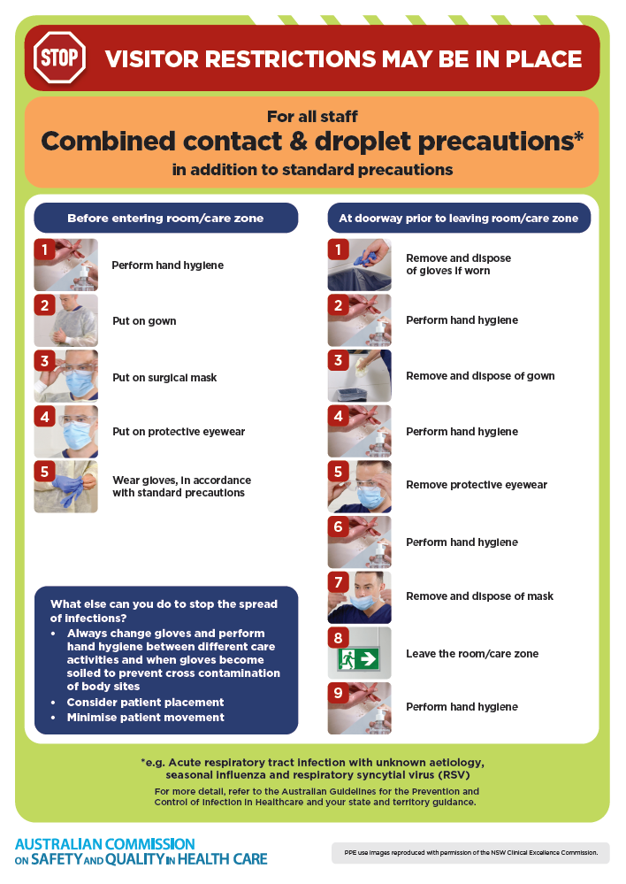
- Poster – Combined airborne and contact precautions
https://www.safetyandquality.gov.au/publications-and-resources/resource-library/infection-prevention-and-control-poster-combined-airborne-and-contact-precautions
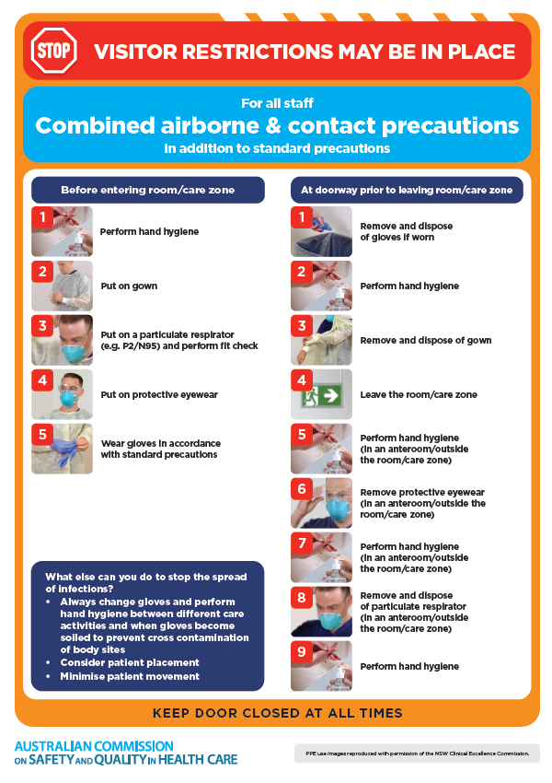
- Environmental Cleaning and Infection Prevention and Control www.safetyandquality.gov.au/environmental-cleaning
- Break the chain of infection poster
https://www.safetyandquality.gov.au/publications-and-resources/resource-library/break-chain-infection-poster
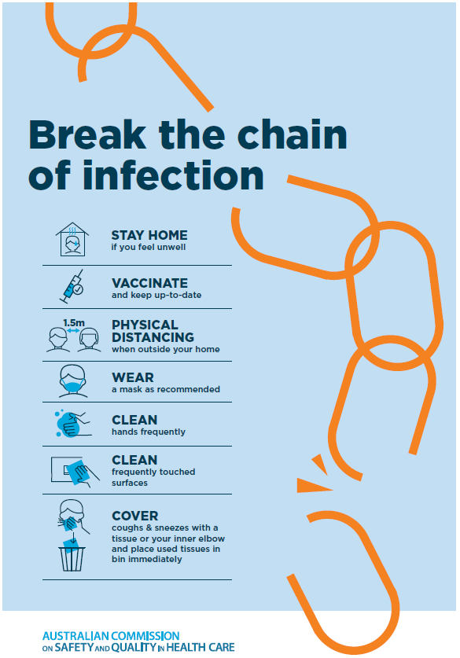
Disclaimer
On the Radar is an information resource of the Australian Commission on Safety and Quality in Health Care. The Commission is not responsible for the content of, nor does it endorse, any articles or sites listed. The Commission accepts no liability for the information or advice provided by these external links. Links are provided on the basis that users make their own decisions about the accuracy, currency and reliability of the information contained therein Any opinions expressed are not necessarily those of the Australian Commission on Safety and Quality in Health Care.

