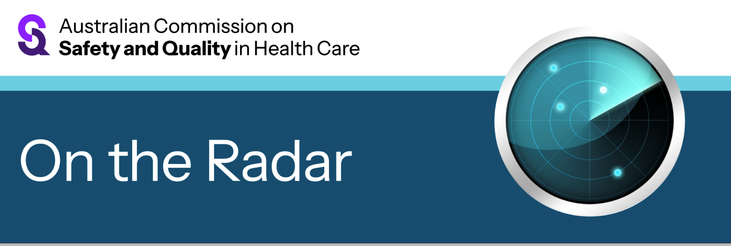
On the Radar
Issue 752
20 July 2026

On the Radar is a summary of some of the recent publications in the areas of safety and quality in health care Inclusion in this document is not an endorsement or recommendation of any publication or provider Access to particular documents may depend on whether they are Open Access or not, and/or your individual or institutional access to subscription sites/services Material that may require subscription is included as it is considered relevant.

On the Radar is available online, via email or as a PDF or Word document from
https://www.safetyandquality.gov.au/news-and-media/newsletters/on-the-radar

If you would like to receive On the Radar via email, you can subscribe on our website https://www.safetyandquality.gov.au/news-and-media/newsletters/on-the-radar
or by emailing us at mail@safetyandquality.gov.au.
You can also send feedback and comments to mail@safetyandquality.gov.au.

For information about the Commission and its programs and publications, please visit https://www.safetyandquality.gov.au

On the Radar
Editor: Dr Niall Johnson
Contributors: Niall Johnson

Reports

NHS Leadership and Management Framework
London: NHS College of Leadership and Management
URL | https://lmframework.leadershipacademy.nhs.uk/
Notes | Framework developed by the NHS College of Leadership and Management in the UK that seeks to establish expectations for all NHS leaders and managers. The framework is designed to apply across clinical and non-clinical leadership and management roles and defines the principles, behaviours and skills the NHS expects from all its leaders and managers. The framework includes a code of practice along with leadership and management standards. A self-assessment tool for evaluation against the standards is also available.
Global status report on cancer 2026: The future we choose together
World Health Organization
Geneva: WHO; 2026. p. 280.
URL | https://www.who.int/publications/i/item/9789240123977
Notes | Report from the World Health Organization (WHO) that offers an assessment of the global burden of cancer, progress in cancer prevention and control, and the systemic challenges that continue to limit equitable outcomes. It includes new data on the burden of disease, the capacity of health systems to respond, and the lived experiences of people affected by cancer. The report examines trends in incidence, mortality, survival, risk factors and health system performance, as well as the human, social and economic consequences of cancer.  The authors observe that ‘although the cancer burden is near-universal in its reach, people’s lived experience of the disease is highly inequitable, with significant variation both between and within countries.’ This variation reveals ‘profound inequity’ and the authors assert that ‘The future of cancer control will be shaped by the choices we make together as we define what we value, what we measure, whom we listen to, and what we are willing to finance.’

Journal articles

Quality in Australian Health Care Study 2: a national imperative for safer care
Hibbert PD, Westbrook JI, Braithwaite J
Internal Medicine Journal. 2026.
DOI | https://doi.org/10.1111/imj.70485
Notes | Paper calling for ‘a second Quality in Australian Health Care Study (QAHCS2), 30 years after the original landmark study.’ The authors note that ‘The original Quality in Australian Health Care Study (QAHCS), published in the Medical Journal of Australia in 1995, remains the most cited article in that journal's history.1 It found that 16.6% of hospital admissions were associated with patient harm (adverse events), with about half felt to be preventable, placing patient safety firmly on the national agenda.’ That original study led to ‘Subsequent milestones included establishing a National Expert Advisory Group (1998), the Australian Council for Safety and Quality in Health Care (2000), and, later, as the quality of care and patient safety field matured, the Australian Commission on Safety and Quality in Health Care (ACSQHC) in 2006, legislated in 2011.7 The introduction of the National Safety and Quality Health Service (NSQHS) Standards in 2013 and the creation of state-based safety bodies such as the Clinical Excellence Commission (NSW) and Safer Care Victoria illustrate the enduring influence of QAHCS’  The authors assert that ‘A second national study is overdue’ and that a new study would provide:  - ‘A benchmark across 30 years…  - Contemporary relevance: expanding to primary care would recognise the central role of general practice and out-of-hospital care.  - Methodological innovation: with digitised records, automated algorithms and trigger tools can be evaluated alongside manual review.  - International comparison…  - Evaluation of existing metrics: e.g. comparing HACs with manual review would test the robustness of current national mechanisms for safety monitoring and incentivising hospitals to improve via punitive pricing signals.’  Disclosure: One of the co-authors of this piece is an Australian Commission on Safety and Quality in Health Care Board member.  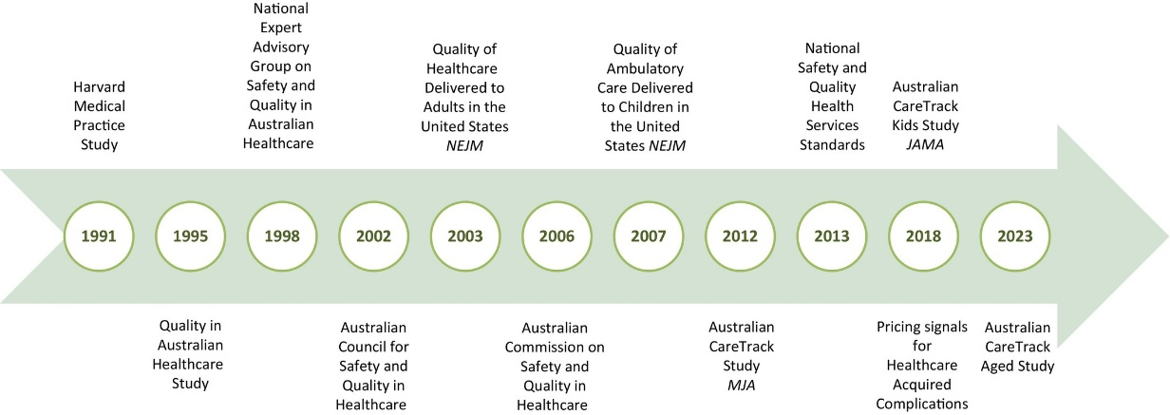

More than an ally: becoming an accomplice to cultural safety for Australian First Nations people and Indigenous knowledge
Rix E, Brown SL, Rotumah D
Critical Public Health. 2026;36(1):2674389.
DOI | https://doi.org/10.1080/09581596.2026.2674389
Notes | Piece calling for those working in health to be more than allies in the drive for cultural safety. While recognising that ‘Culturally safe practice is a foundational requirement of all Australian health professionals and is now mandated within their codes of practice’, the authors offer four guiding principles to influence a ‘journey towards accompliceship’: ‘(1) reality is complex, (2) Ready to learn, (3) Action and being brave, and (4) Reflection.’  As the authors observe, a health system that offers cultural safety, equity, inclusion and rights, is a better system for everyone involved: ‘Racism and discrimination towards any minority have no place in healthcare. Instead, ethics of dignity, respect and fair treatment create conditions for improving health outcomes for those with the worst statistics and outcomes in Australia. As health settings become increasingly diverse, culturally safe professional skills are crucial. Not just in relationship with First Nations peoples, for all minorities. This includes wellbeing in the workplace for both recipients of care and practitioners.

Towards responsible digital health implementation: A mixed-methods exploratory study developing a tool to assess workforce experience
Tom B, Oerbekke MS, Heus P, Kusters MPT, Dongelmans DA, Visser A, et al.
DIGITAL HEALTH. 2026;12:20552076261450419.
DOI | https://doi.org/10.1177/20552076261450419
Notes | Report of a Dutch project that sought to ‘To develop a tool to support policymakers, hospital administrators, and implementation teams in considering workforce experience and well-being implications of DHTs [Digital Health Technologies] on HCPs [healthcare professionals].’  The paper reports on a ‘mixed-methods study conducted in three Dutch university medical centres that included the re-analysis of a scoping review, a prioritisation survey and focus groups and interviews with stakeholders, including healthcare workers. This all contributed to the development of a ‘reflective checklist to support structured consideration of conditions shaping workforce experience in DHT-implementation’ that has 14 items in 6 themes.

Norwegian clinical dashboard: updated and expanded versions may lead to further Nordic collaboration
Tjomsland O, Thoresen C, Ingebrigtsen T, Jensen JW, Møller H, Frich JC, et al
BMJ Leader. 2026:leader-2026-001581.
DOI | https://doi.org/10.1136/leader-2026-001581
Notes | Paper in BMJ Leader describing the development and possible future direction for the Norwegian clinical dashboard. This is ‘a national safety, quality and utilisation dashboards… developed from routinely reported data to be used by executive boards and senior leaders’. The dashboard ‘dashboard focuses on two core domains: (a) effective care and patient safety and (b) preference-sensitive and supply-sensitive care’. The article describes the first and subsequent versions of the dashboard as the topics included expanded along with the ‘experience with its use in governance within the South-Eastern Norway Regional Health Authority (HSO) and the growing national and international interest in its application.’

BMJ Quality &Safety online first articles
URL | https://qualitysafety.bmj.com/content/early/recent
Notes | BMJ Quality &Safety has published a number of ‘online first’ articles, including:  - When emergency physicians meet patients displaying irritable behaviours: a randomised vignette-based experiment investigating physicians’ emotions and clinical reasoning (Linda M Isbell, Nathan R Huff1 Guanyu Liu1, Howard Bessen, Vincent Kan, Isabella Levesque, Matthew Bird, Peter Smulowitz)  - Editorial: Interprofessional learning as a mechanism for quality improvement and patient safety (Andreas Xyrichis, Merrick Zwarenstein)

International Journal for Quality in Health Care online first articles
URL | https://academic.oup.com/intqhc/advance-articles
Notes | International Journal for Quality in Health Care has published a number of ‘online first’ articles, including:  - Patient and Family Activated Escalation Systems: a systematic review (Noémie Déom, John Welch, Cecilia Vindrola-Padros)

Online resources

Guidance
A number of guidelines or guidance have recently been published or updated These include:
- National Guidance Working Group. National guidance for doctors assessing workers exposed to respirable crystalline silica dust. Canberra: Australian Centre for Disease Control; 2026. p. 64.
https://www.cdc.gov.au/resources/publications/national-guidance-doctors-assessing-workers-crystalline-silica-dust-practice-guide
- Council of Australian Therapeutic Advisory Groups. Rethinking medicines decision-making: Guiding Principles for the off-label use of medicines in Australian healthcare settings. Version 2. CATAG, 2026. p.44. https://catag.org.au/resource/off-label-guiding-principles/
- Monash Centre for Health Research and Implementation, International Evidence-based Guideline for the assessment and management of polyendocrine metabolic ovarian syndrome (formerly PCOS) https://www.monash.edu/medicine/mchri/pcos/guideline

Infection prevention and control resources
The Australian Commission on Safety and Quality in Health Care has developed a number of resources to assist healthcare organisations, facilities and clinicians These resources include:
- Poster – Combined contact and droplet precautions https://www.safetyandquality.gov.au/publications-and-resources/resource-library/infection-prevention-and-control-poster-combined-contact-and-droplet-precautions
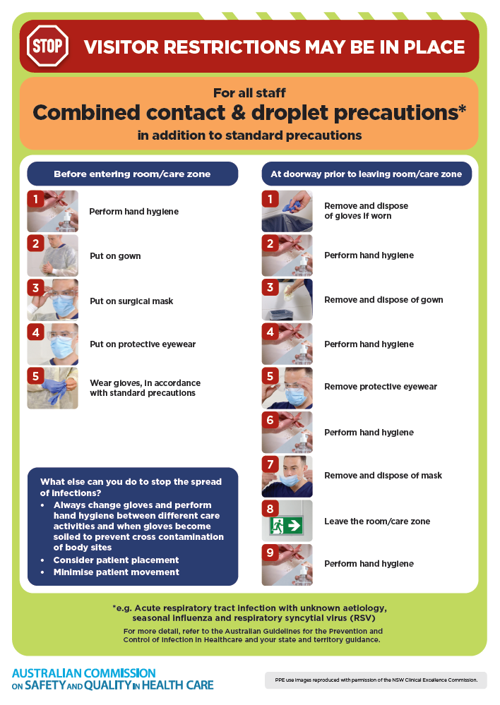
- Poster – Combined airborne and contact precautions
https://www.safetyandquality.gov.au/publications-and-resources/resource-library/infection-prevention-and-control-poster-combined-airborne-and-contact-precautions
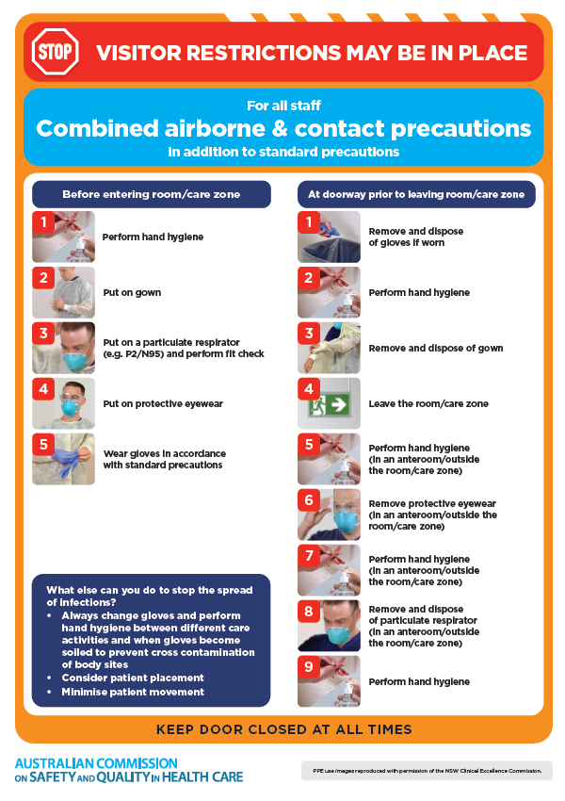
- Environmental Cleaning and Infection Prevention and Control www.safetyandquality.gov.au/environmental-cleaning
- Break the chain of infection poster
https://www.safetyandquality.gov.au/publications-and-resources/resource-library/break-chain-infection-poster
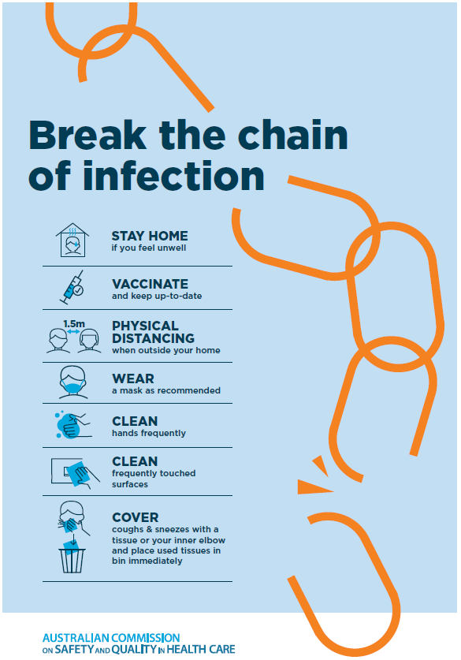
Disclaimer
On the Radar is an information resource of the Australian Commission on Safety and Quality in Health Care. The Commission is not responsible for the content of, nor does it endorse, any articles or sites listed. The Commission accepts no liability for the information or advice provided by these external links. Links are provided on the basis that users make their own decisions about the accuracy, currency and reliability of the information contained therein Any opinions expressed are not necessarily those of the Australian Commission on Safety and Quality in Health Care.

