
On the Radar
Issue 753
27 July 2026

On the Radar is a summary of some of the recent publications in the areas of safety and quality in health care Inclusion in this document is not an endorsement or recommendation of any publication or provider Access to particular documents may depend on whether they are Open Access or not, and/or your individual or institutional access to subscription sites/services Material that may require subscription is included as it is considered relevant.

On the Radar is available online, via email or as a PDF or Word document from
https://www.safetyandquality.gov.au/news-and-media/newsletters/on-the-radar

If you would like to receive On the Radar via email, you can subscribe on our website https://www.safetyandquality.gov.au/news-and-media/newsletters/on-the-radar
or by emailing us at mail@safetyandquality.gov.au.
You can also send feedback and comments to mail@safetyandquality.gov.au.

For information about the Commission and its programs and publications, please visit https://www.safetyandquality.gov.au

On the Radar
Editor: Dr Niall Johnson
Contributors: Niall Johnson

Reports

Injuries occurring among admitted patients
Australian Institute for Health and Welfare
AIHW; 2026.

Injury hospitalisations among health care workers
Australian Institute for Health and Welfare
AIHW; 2026.
URL | https://www.aihw.gov.au/reports/injury/injuries-admitted-patients/  https://www.aihw.gov.au/reports/injury/injury-hospitalisations-workers
Notes | A pair of reports from the AIHW (Australian Institute of Health and Welfare) that looks at injuries that occur in hospitals. The first examines injuries that occurred to admitted hospital patients, while the second examines injuries suffered by health care workers that required hospitalisation. Its notable that falls were a leading cause of injury for both groups.  Injuries occurring among admitted patients ‘provides insight into injuries that occur during a period of hospitalisation, referred to as hospital-onset injuries. It examines hospital-onset injuries among admitted patients in Australian hospitals from 2015–16 to 2024–25. The report also explores the types and causes of injuries, as well as differences in patient outcomes between those who sustained injuries during their hospital stay and those who did not.’  Injury hospitalisations among health care workers looks at injuries among health care workers that were serious enough to require hospitalisation. Using data from 2015–16 to 2024–25, it explores the most common types and causes of injury and highlights the groups most likely to be injured.

Don't Walk. Run. AI in healthcare - The 3rd National Policy Roadmap
Coiera E, Magrabi F, Silvera-Tawil D, Tyagi S, Chan A
Sydney: Macquarie University; 2026.
DOI | https://doi.org/10.25949/1ENY-WY41
Notes | The Australian Alliance for Artificial Intelligence in Healthcare has released the third iteration of their roadmap for AI in Australian health care. The roadmap identifies a number of activities that a number of actors could or should undertake ‘to translate AI into effective and safe clinical services’. The roadmap includes 28 recommendations across eight priority areas including leadership, governance, sovereign capability, workforce development, consumer engagement, industry and research.  While in this roadmap the Alliance calls for an ‘orderly but energetic adoption of AI’, this is an area where there is much literature, with some divergence of views. Recent examples include:  - Iacobucci G. AI medical tools need stricter checks to protect patients, safety commissioner says. BMJ. 2026;393:e100018.  - Bavli I, Lexchin J, Galea S, King N, Davidovitc N. Artificial intelligence as a new commercial determinant of health. BMJ. 2026;394:e100272.  - Car J, Wong TY, Atun R. The recursive care law: artificial intelligence reinforcing feedback loops and health inequity. The Lancet. 2026; 407(10546): 2354-2356.  - Abulibdeh R, Agyemang GO, Celi LA, Gorijavolu R, Kalema NL, Kleinlein R, et al. Who's really in the loop? Rethinking oversight in AI-assisted health care. The Lancet. 2026;407(10545):2340-2344.  - Selvan R. Sustainability of large-scale artificial intelligence models in health care. The Lancet Digital Health. 2026;8(6).  - Al-Anezi FM. Generative Artificial Intelligence in Healthcare: Automation Bias, Deskilling, and Cognitive Implications – A Systematic Review. Journal of Healthcare Leadership. 2026;18:590498.  - Ajunwa I, Parikh RB, Cohen IG. When Patients Share Everything With an AI Chatbot: Risks and Opportunities of Large Language Models. JAMA. 2026.  - Schmidt J, Carter A, McGuire A, Mossialos E, van Kessel R. A systematic review of economic evidence of artificial intelligence in healthcare. Health Policy. 2026:105715.  This is an area where there is activity being undertaken by various actors. For example, Ahpra and the National Boards have produced guidance for practitioners Meeting your professional obligations when using Artificial Intelligence in healthcare. Jurisdictions have been developing frameworks for AI use in health care, for example, Artificial Intelligence in Victorian Public Health Services and the NSW Health Artificial Intelligence Framework.

For information on the Commission’s work on artificial intelligence, including the Pragmatic AI guidance for health professionals, see https://www.safetyandquality.gov.au/clinical-topics/digital-health/artificial-intelligence

Sepsis modern service framework
London: NHS England and Department of Health and Social Care
URL | https://www.england.nhs.uk/publication/sepsis-modern-service-framework/
Notes | From NHS England and the Department of Health and Social Care this framework sets out how the UK’s National Health Service (N)HS and its partners will improve sepsis care by 2035. The framework is structured around 6 themes:  - A personalised approach  - Supporting people to understand sepsis: our staff and the population  - Prevention of severe infection and sepsis where possible  - Identification of severe infection and sepsis  - Escalation of care  - Response that is timely, appropriate and effective.

For information on the Commission’s work on sepsis, including the Sepsis Clinical Care Standard and the model of care framework, see https://www.safetyandquality.gov.au/clinical-topics/sepsis-hub

Model discharge pathway
London: NHS England
URL | https://www.england.nhs.uk/publication/model-discharge-pathway/
Notes | This document describes a model to make timely, clinically-led discharge routine. The model applies to hospital and community bedded care and addresses:  - in‑hospital discharge planning and delivery  - daily ward-based practices within the control of hospital teams  - standardising basic processes to reduce variation.

National maternity triage specification
London: NHS England
URL | https://www.england.nhs.uk/publication/national-maternity-triage-specification/
Notes | NHS England's 10 Point Plan for maternity and neonatal services requires all NHS trusts to commit to delivering safe and effective maternity triage. Each NHS trust need to an audit to identify any gaps and ensure services are consistently safe, responsive and appropriately resourced. This national maternity triage specification will support local services in achieving this. This specification aims to:  - set a high-level framework for what good maternity triage services should look like  - improve safety and experience for women by reducing variation  - reduce inequalities through consistent access and care  - support accountability through a clear measurement strategy  - provide a practical approach to implementation.

NHS Staff Standards
London: NHS England and Department of Health and Social Care
URL | https://www.gov.uk/government/publications/nhs-staff-standards
Notes | Developed by the UK Department of Health and Social Care (DHSC) and NHS England these staff standards outline national (UK) minimum employment requirements to improve staff experience.

Conversations that matter most: improving communication in end of life care
Parliamentary and Health Service Ombudsman
Manchester: PHSO; 2026. p. 36.
URL | https://www.ombudsman.org.uk/publications/conversations-matter-most-improving-communication-end-life-care-0
Notes | Report from the UK’s Parliamentary and Health Service Ombudsman based on investigations of complaints about palliative and end of life care services across England in recent years. The report observes that ‘communication is the most common failing - patients not told their diagnosis, families kept in the dark, and vital information lost when people move between services.’  The report’s recommendations focus on three areas:  - Confident, skilled, compassionate communication with patients and families at the right time.  - Clear outcome measurement that includes patient and family voices.  - Effective information sharing between teams and care settings.

For information on the Commission’s work on end of life care, including the two National Consensus Statements on End-of-Life Care: one for adults and one for paediatrics, see https://www.safetyandquality.gov.au/clinical-topics/end-life-care

Preparedness and response to bacterial meningitis outbreaks: Toolkit for frontline healthcare workers
World Health Organization
Geneva: WHO; 2026.
URL | https://doi.org/10.2471/B09660
Notes | The World Health Organization (WHO) has developed this toolkit that ‘translates evidence-based recommendations into practical job aids to support frontline healthcare workers in the preparedness and response to outbreaks’ of bacterial meningitis.
Journal articles

Patient perspectives and experiences of collaborative pharmacist prescribing in the hospital inpatient setting: a cross-sectional survey
Amer H, Marotti S, Johnson J, Widagdo I, Burns K, Goldsworthy S, et al
International Journal of Clinical Pharmacy. 2026.
DOI | https://doi.org/10.1007/s11096-026-02178-0
Notes | Report of a South Australian study that examined patient’s ‘perspectives and experiences of collaborative pharmacist prescribing’. Collaborative pharmacist prescribing in hospitals is described as involving ‘pharmacists, medical doctors, and patients working together to develop medicine plans that support shared decision-making and underpin pharmacist prescriptions’. Using 200 patient responses to a cross-sectional survey conducted across four hospitals, the authors report that ‘Patients … perceived benefits of collaborative pharmacist prescribing’. The authors concluded that ‘Collaborative pharmacist prescribing enhances shared decision-making by actively involving patients in discussions about their medicines. It improves patients’ understanding of their medicines, which supports safer and more informed treatment decisions. These findings support wider adoption of collaborative pharmacist prescribing to improve patient-centered care in hospitals.’

For information on the Commission’s work on medicines safety and quality, see https://www.safetyandquality.gov.au/clinical-topics/medicines-safety-and-quality

Comparative effects of drugs for adults with overweight or obesity: systematic review and network meta-analysis
Nong K, Shi Q, Xie X, Wang Y, Agarwal A, Guyatt GH, et al
BMJ. 2026;394:e372161.
DOI | https://doi.org/10.1136/bmj-2026-372161
Notes | Paper in BMJ reporting on a systematic review and network meta-analysis that sought to ‘provide an up-to-date evidence summary about the comparative benefits and harms of drugs for adults with overweight or obesity’. As the related editorial https://doi.org/10.1136/bmj-2026-725349 notes, ‘They synthesised data from 262 trials evaluating 19 obesity drugs with follow-up ranging from 12 to 172 weeks. This network meta-analysis, which covers obesity drugs that have been approved by major regulatory bodies or are pending approval, moves beyond weight loss, presenting data on 24 clinical outcomes, including changes in lean mass, quality of life, risk of cardiovascular events, kidney disease progression, adverse effects, and all cause mortality.’ Nong et al concluded that ‘Obesity drugs produce variable weight loss at one year, with larger benefits generally accompanied by greater harms and discontinuation. Most agents do not improve quality of life meaningfully and few show cardiovascular benefits. Decisions in clinical practice should consider trade-offs between benefits and harms within the context of shared decision making.’  In Australia, the Therapeutic Goods Administration (TGA) have released a safety alert relating to the high-profile glucagon-like-peptide-1 receptor agonist (GLP-1 RA) class of prescription medicines https://www.tga.gov.au/safety/safety-monitoring-and-information/safety-alerts/glp-1-ras-and-rare-severe-eye-disorders

BMJ Quality &Safety online first articles
URL | https://qualitysafety.bmj.com/content/early/recent
Notes | BMJ Quality &Safety has published a number of ‘online first’ articles, including:  - Economic evaluation of deimplementation interventions: a systematic review (Comlan Lucien Hountongbé, Jason Robert Guertin, Soualio Gnanou, Blanchard Conombo, Pier-Alexandre Tardif, Noah Michael Ivers, Rohit Gandhi, Lynne Moore)  - Identifying latent safety threats through varied modalities: bottom of form (Mireille T Gharib, Patricia Trbovich, Walter Tavares, Andrew Petrosoniak, Seona Dunbar, Alison Dodds, Jabeen Fayyaz, Jonathan Pirie, Trevor Dell, Catharine M Walsh)  - Patient and caregiver priorities for quality improvement on general medical wards: a multicentre group concept mapping study (Lauren Lapointe-Shaw, Christine Salahub, Minkyung Lee, Amol A. Verma, Fahad Razak, Anshula Ambasta, Mohammad Refaei, Travis Carpenter, Brian Moses, Nabha Shetty, Ashley P. Miller, Erin Spicer, Shail Rawal, Christine Soong, Kerry Kuluski, Karen Okrainec, G. Ross Baker, Lucas B Chartier, Irfan A. Dhalla, Radha Joseph, Walter P. Wodchis, Laura Desveaux, Wendy Wu, Marisa Granieri GIM Priorities Group)  - Association between mass casualty in-situ simulation format with ongoing operational and patient care metrics in an adult emergency department: a retrospective cohort study (Nitay Raisch, Gal Pachys, Baruch Berzon, Dina Cashdan, Aya Cohen, Evan Avraham Alpert, Nadya Kagansky, Tzachi Slutsky, Ari M Lipsky, Yehoshua Pinchuk, Ahmad Naama, Osnat Levtzion Korach, Joseph Offenbacher, Daniel Trotzky)

International Journal for Quality in Health Care online first articles
URL | https://academic.oup.com/intqhc/advance-articles
Notes | International Journal for Quality in Health Care has published a number of ‘online first’ articles, including:  - Patient Engagement and Feasibility of a QR Code–Based Digital Information Tool in the Emergency Department (Akash Manes et al)  - Patients and staff perspectives on hospital ward strain and its impacts on patient care and the workforce: A mixed-methods systematic review (Georgia Bercades et al)  - Independent pharmacist prescribing: How it can work and how to support its implementation (Deonne Dersch-Mills and Ezequiel Garcia Elorrio)  - Diabetes care guided by quality indicators: A cost-effectiveness analysis in the Brazilian public health system (Yasmin Vitória Andrade de Castro Alves et al)  - Editorial: Evaluating the Effectiveness of the ‘Patient Transport’ App in Improving Healthcare Quality, Patient Safety, and Workflow Efficiency (Roisin O’Malley et al)

Online resources

Australian Living Evidence Collaboration
https://livingevidence.org.au/

Guidance
A number of guidelines or guidance have recently been published or updated These include:
- Program Guidelines for the National Lung Cancer Screening Program: Targeted Lung Cancer Screening in High-Risk Individuals in Australia
Rankin NM, Zosel R, Whop LJ, Maddox R, McWilliams A, Siemienowicz M, et al
Medical Journal of Australia. 2026;224(7):e70234.
https://doi.org/10.5694/mja2.70234
- The Management of Withdrawal From Alcohol and Other Drugs in Australian Custodial Settings: A Consensus Statement
FitzGerald G, Chan J, Cook J, Stoove M, Curtis M, Nielsen S, et al
Medical Journal of Australia. 2026 2026/06/01;224(6):e70225.
https://doi.org/10.5694/mja2.70225
- Syphilis Guidance for Primary Care, Australasian Society for HIV Medicine (ASHM) in collaboration with the National Aboriginal Community Controlled Health Organisation (NACCHO) https://syphilisprimarycare.guides.org.au/introduction/

[USA] Effective Health Care Program reports
https://effectivehealthcare.ahrq.gov/
The US Agency for Healthcare Research and Quality (AHRQ) has an Effective Health Care (EHC) Program. The EHC has released the following final reports and updates:
- Primary Hypofractionated Radiation Therapy for Localized Prostate Cancer https://effectivehealthcare.ahrq.gov/products/hypofractionated-radiation-therapy/research

Infection prevention and control resources
The Australian Commission on Safety and Quality in Health Care has developed a number of resources to assist healthcare organisations, facilities and clinicians These resources include:
- Poster – Combined contact and droplet precautions https://www.safetyandquality.gov.au/publications-and-resources/resource-library/infection-prevention-and-control-poster-combined-contact-and-droplet-precautions
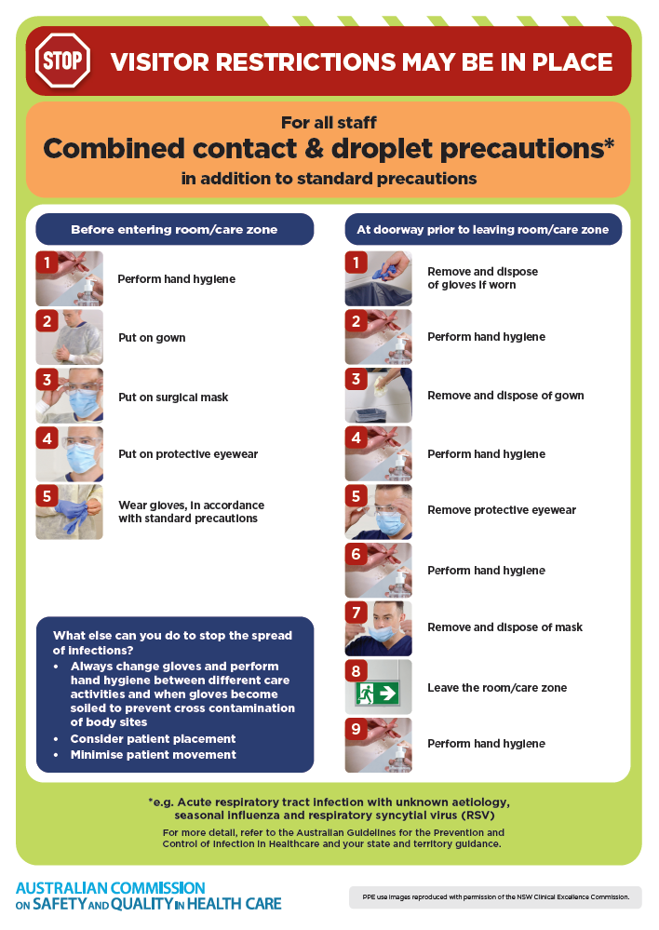
- Poster – Combined airborne and contact precautions
https://www.safetyandquality.gov.au/publications-and-resources/resource-library/infection-prevention-and-control-poster-combined-airborne-and-contact-precautions
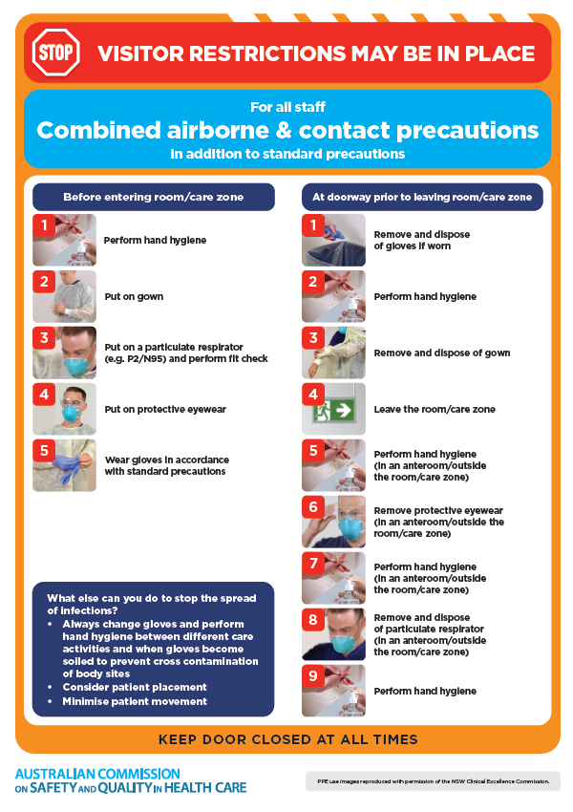
- Environmental Cleaning and Infection Prevention and Control www.safetyandquality.gov.au/environmental-cleaning
- Break the chain of infection poster
https://www.safetyandquality.gov.au/publications-and-resources/resource-library/break-chain-infection-poster
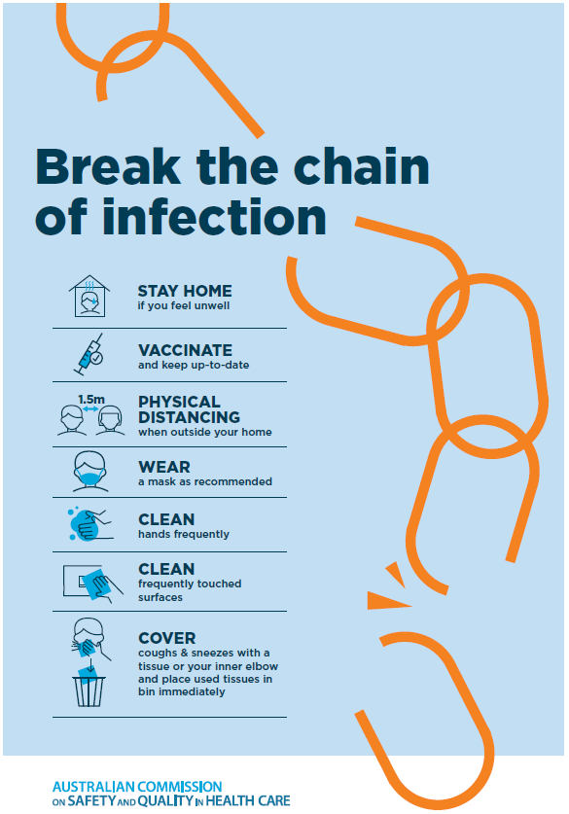
Disclaimer
On the Radar is an information resource of the Australian Commission on Safety and Quality in Health Care. The Commission is not responsible for the content of, nor does it endorse, any articles or sites listed. The Commission accepts no liability for the information or advice provided by these external links. Links are provided on the basis that users make their own decisions about the accuracy, currency and reliability of the information contained therein Any opinions expressed are not necessarily those of the Australian Commission on Safety and Quality in Health Care.

