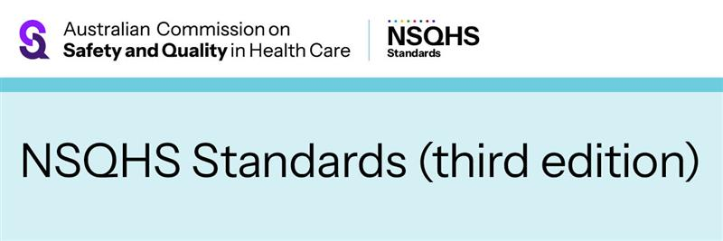
EMAIL MARKETING / DIRECT MAIL CONTENT – adapt to suit
July 2026
Have your say on the draft NSQHS Standards (third edition)
The Australian Commission on Safety and Quality in Health Care has released the initial draft of the National Safety and Quality Health Service (NSQHS) Standards (third edition) and is seeking feedback.
How to get involved
This is a significant opportunity to shape the future of high-quality healthcare in Australia to ensure it remains effective, safe and responsive to the evolving needs of patients and communities.
You can provide feedback via:
- survey
- written submission
- attending an online forum.
The consultation is open from 20 July until 25 September 2026.
Visit the Commission’s Engagement Hub to get involved: safetyandquality.gov.au/NSQHSS-thirdedition

