
On the Radar
Issue 755
10 August 2026

On the Radar is a summary of some of the recent publications in the areas of safety and quality in health care Inclusion in this document is not an endorsement or recommendation of any publication or provider Access to particular documents may depend on whether they are Open Access or not, and/or your individual or institutional access to subscription sites/services Material that may require subscription is included as it is considered relevant.

On the Radar is available online, via email or as a PDF or Word document from
https://www.safetyandquality.gov.au/news-and-media/newsletters/on-the-radar

If you would like to receive On the Radar via email, you can subscribe on our website https://www.safetyandquality.gov.au/news-and-media/newsletters/on-the-radar
or by emailing us at mail@safetyandquality.gov.au.
You can also send feedback and comments to mail@safetyandquality.gov.au.

For information about the Commission and its programs and publications, please visit https://www.safetyandquality.gov.au

On the Radar
Editor: Dr Niall Johnson
Contributors: Niall Johnson, Stephen Cull, Kylie Tran, Jing Song

Intravenous fluid therapy: Principles for safe, appropriate and sustainable use
Australian Commission on Safety and Quality in Health Care
Sydney: ACSQHC; 2026.
https://www.safetyandquality.gov.au/resources/intravenous-fluid-therapy-principles-safe-appropriate-and-sustainable-use

The Commission has released national guidance and resources to support the safe, appropriate and sustainable use of intravenous (IV) fluids in acute care settings. The guidance promotes the principles of Start, Stop, Switch: start IV fluids only when clinically indicated, stop them when no longer needed, and switch care based on patient response, including transitioning to oral fluids or medicines where appropriate.
Resources include:
- guidance on intravenous fluid therapy: principles for safe, appropriate and sustainable use
- guidance on safe administration of intravenous fluids: avoiding venous air embolism
- a fact sheet for prescribers
- a poster for clinicians.

Access the resources at www.safetyandquality.gov.au/ivfluids

Antibiogram resources
Australian Commission on Safety and Quality in Health Care
Sydney: ACSQHC; 2026
https://www.safetyandquality.gov.au/ams

The Australian Commission on Safety and Quality in Health Care has released new and updated resources to support the use of antibiograms within antimicrobial stewardship programs.

The resource suite includes a new fact sheet, How to use an antibiogram, together with updated versions of What is an antibiogram? and the Specification for a hospital cumulative antibiogram.

These resources provide practical and technical guidance on the interpretation, application and reporting of antimicrobial susceptibility data. They are intended to support clinicians and health services in using antibiograms to inform empiric prescribing, optimise antimicrobial use, guide stewardship activities and monitor local resistance patterns.

The updated Specification for a hospital cumulative antibiogram promotes a consistent and robust approach to developing hospital cumulative antibiograms, supporting their use in local prescribing guidelines, surveillance and quality improvement initiatives.

Collectively, these resources support health service organisations to make better use of local antimicrobial susceptibility data and strengthen efforts to reduce antimicrobial resistance.

The new and updated resources are available at https://www.safetyandquality.gov.au/ams

Prioritised Clinical Domains for Clinical Quality Registry (CQR) Development 2026
Australian Commission on Safety and Quality in Health Care
Sydney: ACSQHC; 2026
https://www.safetyandquality.gov.au/resources/clinical-quality-registry-cqr-prioritised-list-resources

Ten years after the first national prioritisation of clinical domains for Clinical Quality Registry (CQR) development, the Australian Commission on Safety and Quality in Health Care has released an updated evidence-based list of 75 priority diseases. This prioritised list identifies high cost, high burden conditions where CQRs have the greatest potential to improve patient outcomes and the health system, to help guide registry development, investment and participation. The full report, fact sheet and supporting resources can be accessed at https://www.safetyandquality.gov.au/resources/clinical-quality-registry-cqr-prioritised-list-resources.

Reports

Mental health: physical health deterioration while under the care of a low secure unit
Investigation report
Health Services Safety Investigation Body
Poole: HSSIB; 2026.
URL | https://www.hssib.org.uk/patient-safety-investigations/mental-health-investigating-under-the-patient-safety-incident-response-framework-psirf/second-investigation-report/
Notes | The latest investigation report from the Health Services Safety Investigations Body (HSSIB) in the UK examines ‘the care of a patient whose physical health deteriorated while being cared for on a low secure mental health unit and who later required admission to an acute hospital’. The report looks at ‘how physical deterioration was recognised and managed, how care was coordinated between mental health and acute services, and how specialist services supported the patient's care.’ The investigation highlighted wider system challenges, including pressure on specialist services and difficulties in helping patients in secure mental health settings engage with external healthcare services. The report includes findings, safety recommendations, observations and learnings that are applicable at various levels.

For information on the Commission’s work on recognising and responding to clinical deterioration, see the Recognising and Responding to Acute Deterioration standard, the National Consensus Statement: Essential elements for recognising and responding to acute physiological deterioration and the
National Consensus Statement: Essential elements for recognising and responding to deterioration in a person’s mental state.

Quality strategy for NHS-funded care in England
NHS England
London: NHS England; 2026
URL | https://www.england.nhs.uk/publication/quality-strategy-for-nhs-funded-care-in-england/
Notes | Published by NHS England on behalf of the National Quality Board, this strategy provides a structured approach to making quality the organising principle of NHS-funded care in England. It sets out a shared approach to quality across three interdependent domains: safety, effectiveness and experience.

Interoperability in healthcare: Towards an interconnected future
OECD
OECD Health Working Papers, No. 197. Paris: OECD Publishing; 2026.
DOI | https://doi.org/10.1787/eb71b7be-en
Notes | Interoperability has long been a goal for digital health with the goal of easy sharing of high quality data across and throughout health systems with a range of benefits. This report from the OECD suggests that this ‘remains a longstanding yet underachieved goal in the digitalisation of health systems’. The report examines ‘practices across OECD countries to support efficient, equitable, and impactful data use and sharing’ and ‘outlines opportunities … , focusing on stakeholder engagement, individual empowerment, global governance to guide interoperability efforts, collaboration, and the need for legislative foundations.’ The abstract also notes that ‘The full value of interoperability is estimated to be between 2.7% and 6.6% of health expenditure annually as per OECD country estimates. Realising it requires a shift from implementation of health information systems to meet the needs of individual facilities towards implementation within an integrated digital health ecosystem centred around the patient. This shift can enable data to follow patients across the care continuum and allow for timelier reuse of data for public benefit, with protections. While technical challenges have historically been prioritised, findings suggest that interoperability is inherently a people (e.g. governance, trust, adoption) and leadership challenge and highlights an opportunity to rethink interoperability as a driver of economic growth and healthier populations. Keys to success are the establishment of trusted health data networks and sustained investment in standards, governance, and data quality to enable scalable and meaningful health system transformation.’

Artificial intelligence-related health research: ethics review and oversight
World Health Organization
Geneva: WHO; 2026. p. 86.
URL | https://iris.who.int/items/21f44816-7ae8-4600-93ef-b4cc9a7c97f2  https://iris.who.int/handle/10665/386761
Notes | The potential applications of AI in health care are broad. This report examines some of the issues around the use of AI in ‘health-related research’, particularly ‘ethics review and oversight of three categories of AI-related health research: health-related data science using AI; research conducted with AI tools and technologies; and health-related research on AI tools and technologies’.

Journals

Australian Prescriber
Volume 49, Issue 4, August 2026
URL | https://australianprescriber.tg.org.au/volumes/49/issues/4.html
Notes | A new issue of Australian Prescriber has been published. Content in this issue of Australian Prescriber includes:  - Treatment of acute COVID-19 in the community (E Milliken)  - High prevalence of syphilis in Australia: test, treat and trace (M Gunathilake, D Martorana, V Perera)  - Rheumatic fever and rheumatic heart disease: updates for clinical practice (S Noonan, J Marangou, BJ Currie, V Wade, AP Ralph)  - Acne vulgaris: a clinical update (L Iyengar, B Welsh)  - Antibiotic prophylaxis for dental procedures: an update (T Divnic-Resnik, A Sadr, E Trinh, S Sukumar)  - Consumer Medicines Line closure  - New drugs:  – Donanemab for early Alzheimer disease  – Elafibranor for primary biliary cholangitis  – Odevixibat for progressive familial intrahepatic cholestasis and Alagille syndrome-associated cholestatic pruritus

Clinical and Public Health Guidelines
Volume 3, Issue 3, July 2026
URL | https://onlinelibrary.wiley.com/toc/28363973/2026/3/3
Notes | A new issue of Clinical and Public Health Guidelines has been published. Articles in this issue of Clinical and Public Health Guidelines include:  - The Values and Preferences of People Living With Motor Neurone Disease (MND): A Systematic Review and Meta-Analysis (Timothy Hugh Barker, Lemma N. Bulto, Grace Holland, Camille Schubert, Tracy Merlin, Samer G. Karam, Wojtek Wiercioch, Danielle Pollock, Cindy Stern, Jay Beasley-Hall, Nipun Shrestha, Steve Vucic, Lynne Giles, Zachary Munn)  - Integrating Artificial Intelligence and Automation Into Living Guideline Development: A Scoping Review of Existing Frameworks, Methods, and Applications (Nofisat Ismaila, Syed Arsalan Ahmed Naqvi, Lawrence Mbuagbaw, Jinhui Ma, Lehana Thabane)  - The European Multidisciplinary Evidence-Based Guideline on Pancreatic Cancer: Methodological Protocol (Laura C Leeuwenburgh, Magdalena Holze, Dena Akhoundzadeh, Adnan Alsourani, Ricardo Alvarez Jimenez, et al for the Multi-Societal European Evidence-Based Guideline on Pancreatic Cancer)  - Evidence-to-Decision Frameworks: Enhancing the Quality and Rigour of Guidelines and Recommendations (Jose F Meneses-Echavez, Pablo Alonso-Coello, Gunn Vist, Javier Bracchiglione, Y Song, S Flottorp, S E Rosenbaum)  - GIN-McMaster Guideline Development Checklist Extension for Integrating Artificial Intelligence in the Health Guideline Enterprise (Manuel Marques-Cruz, Bernardo Sousa-Pinto, Ignacio Neumann, Yuan Chi, Monika Nothacker, Artur Nowak, M Reinap, M Awad, P Alonso-Coello, A Qaseem, E A Akl, W Wiercioch, J Brozek, H J Schünemann, the GIN AI working group  - Development and Updating of Clinical Practice Guidelines—The Necessity of International Collaboration (Johanna H van der Lee, Irina M Mostovaya, J J Duvekot, R J Ensink, K Spijkers, M Pols, T A van Barneveld)  - Guidelines or Other Guidance Documents for Rare Diseases in the Netherlands: When and Where to Invest (Effort, Time and Money)?(Iméze J Hieltjes, Charlotte M W Gaasterland, Marieke Hermsen, Anne Marie van Wermeskerken, Ilse van Herk, Johanna H van der Lee)

Age and Ageing
Volume 55, Issue 7, July 2026
URL | https://academic.oup.com/ageing/issue/55/7
Notes | A new issue of Age and Ageing has been published. Articles in this issue of Age and Ageing include:  - Editor's View: Shifting horizons in dementia care—from prevention and screening to real-world clinical practice (Nicola Veronese)  - Editorial: What can we learn from a simulation of older adults’ movement through emergency care? (Hugh Logan Ellis)  - Multidisciplinary recommendations for palliative and supportive care in Creutzfeldt-Jakob disease and related disorders (Melissa Ng and others)  - Recent breakthroughs in blood-based biomarkers of Alzheimer disease: opportunities and challenges in older adults (Adam H Dyer and others)  - Hospital at Home—What does the evidence tell us? (Emma R L C Vardy and Jane A H Masoli)  - Beyond atypicality: reframing the clinical presentation of acute illness in older people (Sean Ninan and others)  - A meta-analytical umbrella review assessing urban environment exposures and cognitive health outcomes (Sophie Glover and others)  - Costs and cost-effectiveness of palliative care in residential aged care homes: a scoping review (Xueqing Yang and others)  - Cost-effectiveness of comprehensive geriatric assessment: systematic review of economic evaluations (Amanuel Lulu Yigezu and others)  - Deprescribing in older patients with hyperpolypharmacy: a cluster-randomised trial in primary care (Gert Baas and others)  - Overlapping premorbid frailty, multimorbidity and malnutrition and their associations with poor outcomes in patients with stroke (Masafumi Nozoe and others)  - Are there sex differences in the influence of insomnia symptoms and sleep duration on the trajectory of neuromuscular strength decline? (Letícia Coelho Silveira and others)  - How social, psychological, and spiritual needs are supported in the last months of life: evidence from the English Longitudinal Study of Ageing end-of-life interviews (Clément Meier and others)  - Frailty phenotype transitions and functional improvements during a supervised exercise trial in older people with HIV: results from the HEALTH Trial (Vitor H F Oliveira and others)  - Factors associated with mortality in older sepsis patients: a nationwide retrospective cohort study in Germany (Konstantin G Heimrich and others)  - Does immediate orthostatic hypotension in adults have clinical implications for syncope and falls? An analysis of the Irish longitudinal study of ageing (Catriona Reddin and others)  - Blood pressure polygenic score, cardiorespiratory fitness and odds of dementia: the HUNT Study (Maren Lerfald and others)  - Prevalence of sarcopenia and individual- and country-level risk factors in 36 countries: pooled analysis of nationally representative individual data (Simu Huang and others)  - Cognitive skills for daily decision making on admission is the most important factor associated with return to home or retirement home in a general-population low intensity rehab programme (T Mark Campbell and Nicole Dunlop)  - Effect of aspirin on healthspan in community-dwelling older adults: the ASPirin in reducing events in the elderly study (Haoxin Tina Zheng and others)  - Incidence and characteristics of poisonings in older adults with and without dementia: a matched cohort study using Swedish registry data (Ilsa R Wojt and others)  - Antidepressant use at the threshold: people prescribed antidepressants around the time of a dementia diagnosis (Mohamed Heybe and others)  - Vestibular perception, balance impairment, and fall risk in community-dwelling older adults (Yuxiao Li and others)  - Hospital-at-home and beyond: experiences of patients, caregivers and general practitioners with out-of-hospital care for moderate-to-severe lower respiratory tract infections in older adults—a qualitative study (Rianne M C Pepping and others)  - Barriers and facilitators for the implementation of a nationwide falls prevention pathway for older adults in the Netherlands (Ankie de Bekker and others)  - Development of a concern about falling scale for older adults living in long-term care settings (Mei Ling Lim and others)  - Sexuality behind clinic doors: experiences of healthcare professionals in primary care addressing sexuality with older people (Andrea Kocurkova and others)  - EnRICH: an integrated geriatrician-led Interface model associated with reduced emergency admissions among care home residents (Catriona Love and others)

Patient Experience Journal
Volume 13, Issue 2, 2026
URL | https://pxjournal.org/journal/vol13/iss2/
Notes | A new issue of the Patient Experience Journal (PXJ)has been published with a theme of ‘Rebuilding Trust in Healthcare’. Articles in this issue of the Patient Experience Journal include:  - Editorial: Trust: Why a Commitment to Human Experience Matters (Jason A Wolf)  - Healing the Social Covenant: Rebuilding Trust and Re-humanizing Healthcare (Cynda Hylton Rushton)  - A Modern Playbook for Trust Across the Health Ecosystem (E O'Malley)  - Co-Designing Trust: Patient Experience, Relationships, and the Design of Care (Toni Land)  - Building or Breaking Trust in Healthcare Through Patient and Family Engagement in Research and Service Design: The Need for Authentic Engagement Practices (Lisa D Hawke, Hajar Seiyad, Shoshana Hauer, Charlotte Munro, and Natasha Y Sheikhan)  - Racial Concordance and the Assumption of Trust: Why Engagement Is Often Mistaken for Partnership in the Care of Black Men (Samantha Faith Calhoun, Lacretia Carroll, Y'Esha Williams-Click, and Kola Brown)  - Supporting the Human Experience: Why Compassion Outperforms Empathy in Care Delivery (Katelyn Carey)  - Rebuilding Trust After Bondi Beach: Healing Patients, Protecting Caregivers, and the Sacred Work of Care (Anne Marie Hadley)  - Building Trust in the Absence of Certainty: Community as Trust in Action (Jennifer A Owens)  - AI as a Physician Companion in Enhancing Trust in Healthcare (S Gouher)  - When Hope Meets Harm: A Story of Trust, Pain, and Consent in Intimate Care (Sharon I Choe and Erin Foster)  - Secondary Infertility: A Personal Story of Loss and Grief (Ben Hughes)  - From Drifting to Anchored: How Online Health Communities Can Transform Care for Complex Chronic Illness (Mads Eggerding)  - Caring But Still Hurting: Uninsured Patients' Illness and Healthcare Experiences at a U.S. Free Clinic (Danaya Amornnimit, Eda G Christensen, Adelaida Salmeron, Kian Robison, Sofia Ampudia Arroyo, Jessica Benelli, Brenda Spearman, and Akiko Kamimura)  - Centering Community Voices to Address Healthcare Inequities in Underserved Utah Populations (Karishma Shah, Jazmine Abril, May Shaaban, Silvia Soule, Sonia Sehgal, Rawad Farhat, Jeannette Villalta, Oreta Tupola, Valentine Mukundente, Cathy Wolfsfeld, Ivana Holiday, Walter Watchman, Carrie Olvera, Lauren Gleave, Kamaile Tripp, A Sperber, and R Osborn)  - Pathways to Patient-Provider Conflict in Nigeria: A Structural Equation Model of Expectations, Communication, Trust, and Organizational Constraints (Akaninyene O Unaam, Christie D Akwaowo, and E A Unaam)  - Nurses' Perceptions of Medical Services in Acute Care Hospitals in the Post-COVID-19 Era (Yoko Nakano, T Yokotani, R Nakajima, and H Yoshii)  - From Hospital to Home After Lower-Extremity Open Reduction and Internal Fixation: Patients' Experiences of Pain Self-Management and Trust-Building Discharge and Follow-Up Support (Sahrudi Sahrudi, Achmad Fauzi Kamal, Masfuri Masfuri, and Kasiyah Junus)  - Navigating Uncertainty: Patient Experiences of BIRADS 0 Mammogram Results (Petranea Smith, Jasmine Warren, Marina Demas, Roberta Goldman, and Joanne E Wilkinson)  - Trust Earned Through Relational Care: How Adverse Childhood Experiences Shape Patient Trust in Their Inpatient Physicians—A Convergent Mixed-Methods Study (Marlise Jeanne Pierre-Wright, Ibrahim Badreldin Mokhtar, Uma Thachapuzha, Yashoswini Chakraborty, Revika Singh, Rachel O'Conor, Jing Song, Julia Lee, Maria E Theodorou, Christine Schaeffer, Kimberly Collins, and Muriel Jean-Jacques)  - Self-Medication Experience and Healthcare Trust Among Youth: A Regionally Concentrated Digital Survey in Indonesia (Wahyudi Wahyudi, Azra Muzaiyana Nasution, Arini Dwi Rahmadani, and Alysa Rahmadani Hasibuan)  - From Anticipation to Relief: Anxiety Reduction and Patient Experience as Indicators of Trust During Dental Extractions in Orthodontic Treatment (Kanza Tahir, Mubassar Fida, and Rashna Hoshang Sukhia)  - Patient-Centred Care: An Integrated Bibliometric and Structural Equation Modelling Approach (Japheth Nuhu Ahmed)  - Patient Psychological Safety: A Qualitative Study of Patient Experiences (Derick R Simmons, Cheryl Rathert, Ryan Valayil, Maria Joseph, and I Jawadi)  - Plan of Day | Plan of Stay: How Inter-Disciplinary Communication Improved Patient Experience and Hospital Throughput (Theresa Jean Dionne, Felicia Hurst, Danna Qunibi, Lauren Lazar, Sydney Mccurdy, Ashlyn Coenraad, Brittney Ward, Whitney Black, A Nelson, J Salem, and L Restrepo)  - Building a Culture of Trust: Engaging Teams with Targeted Tactics for Meaningful Improvement in Patient Experience (Anna Buckner and K Lewis)  - ``But What About Me?'': A Structural Redesign for Cascading Trust into an Integrated Culture of Care (Hazelin Hei Laam Ngan)

BMJ Quality &Safety online first articles
URL | https://qualitysafety.bmj.com/content/early/recent
Notes | BMJ Quality &Safety has published a number of ‘online first’ articles, including:  - Why a ‘human-in-the-loop’ is not an adequate safety strategy: the case for vendor accountability in clinical AI safety (Cassiopeia Frank)  - Real-time clinical decision support system for early identification of infection and sepsis in the intensive care unit: a retrospective development and prospective deployment study (Fang-Ju Sun, Yen-Yu Liu, Li-Kuo Kuo, Ting-Yu Hu, Kuang-Hua Cheng, Hung-Ting Chen, Po-Jen Chang, Min-Ching Wu, Hung-I Yeh, Kun-Pin Wu)  - Editorial: Testing the system without breaking it: the risks of in situ simulation (Victoria Brazil)  - Implementing evidence in residential aged care facilities: a longitudinal multi-method evaluation of knowledge broker evolution (Madeleine Tan, J Simon Bell, Shakti Shrestha, Adam La Caze, Terry P Haines, Annie ML Ea, Sarah Nicole Hilmer, Jacqueline Wesson, Michael Lawless, Brooke Blakeley, Sara Whittaker, Constance Dimity Pond, Angelita Martini, Nancy Ochieng, Francesca Glamorgan, Julie Normoyle, Dayna Cenin, Rebecca Walton, Alison Kitson, Alexandra Bennett, Amelia Stapley, Michelle Steeper, Monica Jung, Amanda J Cross)

International Journal for Quality in Health Care online first articles
URL | https://academic.oup.com/intqhc/advance-articles
Notes | International Journal for Quality in Health Care has published a number of ‘online first’ articles, including:  - Assessing the Real-World Value of Hemophilia Care: How Suitable Are Patient-Centered Outcomes for Hospital-Level Comparisons? (Diaz M Prameyllawati, Samantha C Gouw, Hester F Lingsma, Marjon H Cnossen, Floor C J I Heubel-Moenen, Frank W G Leebeek, Nick van Es, Johanna G van der Bom, Renske M T ten Ham, Martijn A H Oude Voshaar.  - Access and timeliness of acute stroke reperfusion after cluster-wide protocol standardisation: an interrupted time-series study in Hong Kong (Hoi-Lun Koo, Bun Sheng, Lilly D Engineer)  - Medical Waste Management within the Green Hospital Approach: A Systematic Review of Direct, Contextual, and Transferable Evidence (İbrahim H Kayral, Yankuba B Manga, Şeyma Boz, Peter Lachman, Usman Iqbal)

Online resources

Australian Living Evidence Collaboration
https://livingevidence.org.au/

[UK] NICE Guidelines and Quality Standards
https://www.nice.org.uk/guidance
The UK’s National Institute for Health and Care Excellence (NICE) has published new (or updated) guidelines and quality standards The latest reviews or updates include:
- NICE Guideline NG49 Metabolic dysfunction-associated steatotic liver disease (MASLD): assessment and management
https://www.nice.org.uk/guidance/ng49
- NICE Guideline NG198 Acne vulgaris: management
https://www.nice.org.uk/guidance/ng198
- NICE Guideline NG217 Epilepsies in children, young people and adults https://www.nice.org.uk/guidance/ng217
- NICE Review NR4 DMD Care UK's [Duchenne muscular dystrophy Care UK] guideline on orthopaedic care: NICE review https://www.nice.org.uk/guidance/nr4

Infection prevention and control resources
The Australian Commission on Safety and Quality in Health Care has developed a number of resources to assist healthcare organisations, facilities and clinicians These resources include:
- Poster – Combined contact and droplet precautions https://www.safetyandquality.gov.au/publications-and-resources/resource-library/infection-prevention-and-control-poster-combined-contact-and-droplet-precautions
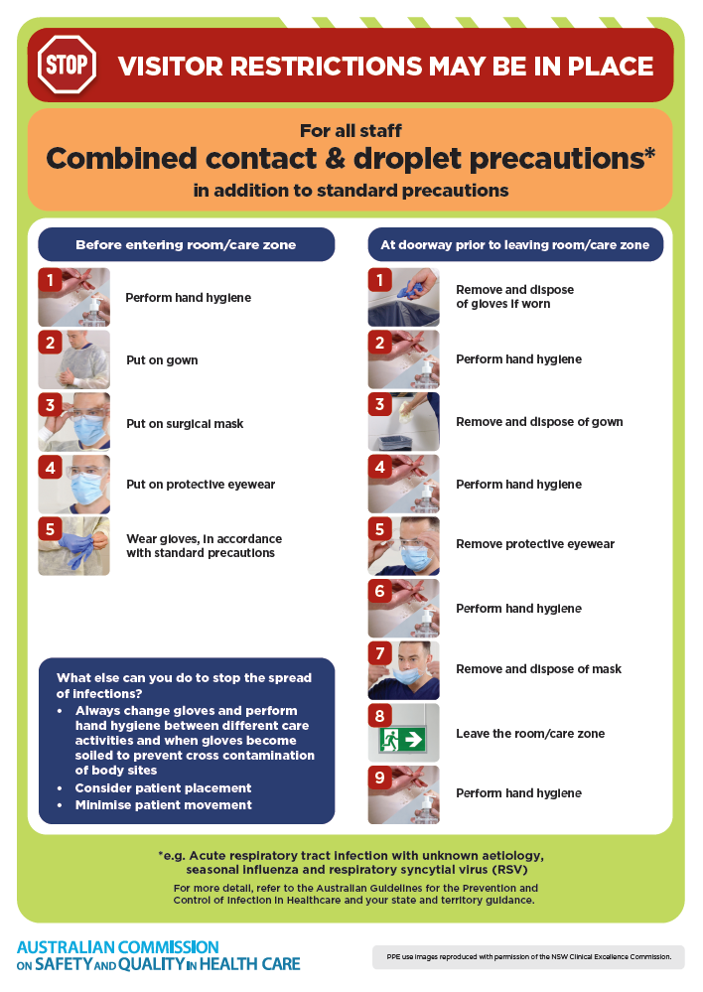
- Poster – Combined airborne and contact precautions
https://www.safetyandquality.gov.au/publications-and-resources/resource-library/infection-prevention-and-control-poster-combined-airborne-and-contact-precautions
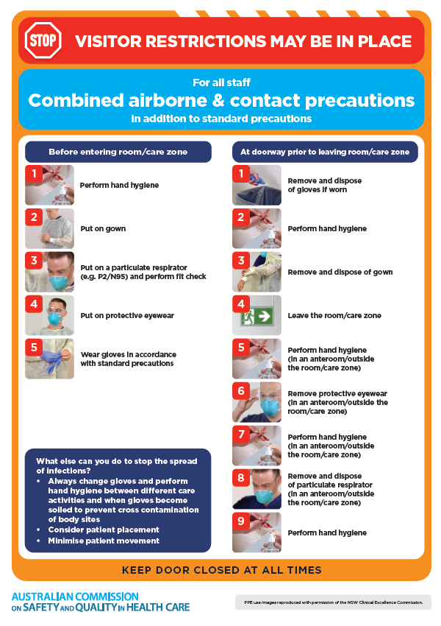
- Environmental Cleaning and Infection Prevention and Control www.safetyandquality.gov.au/environmental-cleaning
- Break the chain of infection poster
https://www.safetyandquality.gov.au/publications-and-resources/resource-library/break-chain-infection-poster
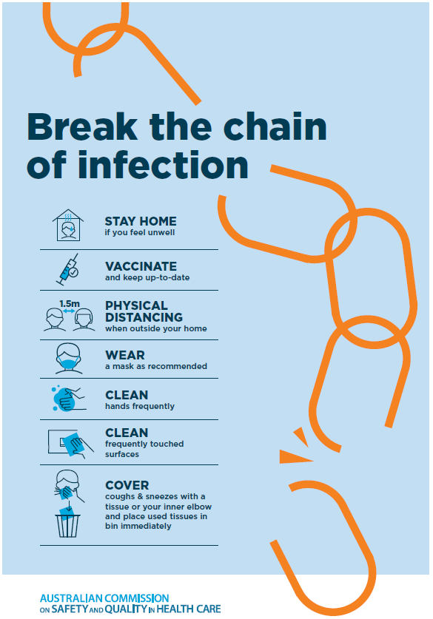
Disclaimer
On the Radar is an information resource of the Australian Commission on Safety and Quality in Health Care. The Commission is not responsible for the content of, nor does it endorse, any articles or sites listed. The Commission accepts no liability for the information or advice provided by these external links. Links are provided on the basis that users make their own decisions about the accuracy, currency and reliability of the information contained therein Any opinions expressed are not necessarily those of the Australian Commission on Safety and Quality in Health Care.

