
On the Radar
Issue 756
17 August 2026

On the Radar is a summary of some of the recent publications in the areas of safety and quality in health care Inclusion in this document is not an endorsement or recommendation of any publication or provider Access to particular documents may depend on whether they are Open Access or not, and/or your individual or institutional access to subscription sites/services Material that may require subscription is included as it is considered relevant.

On the Radar is available online, via email or as a PDF or Word document from
https://www.safetyandquality.gov.au/news-and-media/newsletters/on-the-radar

If you would like to receive On the Radar via email, you can subscribe on our website https://www.safetyandquality.gov.au/news-and-media/newsletters/on-the-radar
or by emailing us at mail@safetyandquality.gov.au.
You can also send feedback and comments to mail@safetyandquality.gov.au.

For information about the Commission and its programs and publications, please visit https://www.safetyandquality.gov.au

On the Radar
Editor: Dr Niall Johnson
Contributors: Niall Johnson

Reports

National Nursing Workforce Strategy
Department of Health, Disability and Ageing
Canberra; 2026. p.60.
URL | https://www.health.gov.au/our-work/national-nursing-workforce-strategy?language=en
Notes | The Department of Health, Disability and Ageing has released the National Nursing Workforce Strategy. The strategy ‘establishes priorities for strengthening the sustainability of the nursing workforce, aiming to bolster the delivery of health and aged care services to all Australian communities. It has been endorsed by all Health Ministers. It offers a comprehensive framework to foster collaboration and drive action among stakeholders in shaping the future of nursing workforce planning, investment and reform. The strategy highlights how investment in nursing can deliver considerable economic and societal benefits to all Australian communities and help to avoid the workforce supply and demand gap that will grow without reform.’

Results from the Adult Admitted Patient Survey 2025
Bureau of Health Information
St Leonards: BHI; 2026.
URL | https://www.bhi.nsw.gov.au/BHI_reports/patient_survey_results/adult-admitted-patient-survey-2025
Notes | The Bureau of Health Information (BHI) in New South Wales has released this report providing key findings in relation to 22,100 patients' experiences across a range of aspects of care in New South Wales public hospitals. The Adult Admitted Patient Survey asks people who have been admitted to a NSW public hospital to share their experiences of care. The report includes NSW trends, significant variation in hospital results and important measures of patient experience based on evidence and stakeholder input.

Measuring trust in health and medical science
Australian Academy of Health and Medical Science
Canberra: Australian Academy of Health and Medical Sciences; 2026. p. 18.
URL | https://aahms.org/media-release/trust-in-hms-under-pressure/
Notes | Evidence briefing from the Australian Academy of Health and Medical Sciences (AAHMS) that, according to their web page, examines ‘what Australians say about their trust in health and medical science. It looks at what their behaviours – including vaccination rates, participation in research, and engagement with the health system – reveal about the state of that trust.’ The report’s authors observe that ‘Trust in HMS is vital to the effectiveness of Australia’s research ecosystem and health system. While trust is generally high, it remains fragile, influenced by political, media, individual and system factors.’

Journal articles

Getting on the Same Page: Why Australia Needs a National Maternity Early Warning System (MEWS) Chart
Cutts BA, Bowyer L, Khot N, Lowe S, Kane SC
Medical Journal of Australia. 2026;224(8):e70256.
DOI | https://doi.org/10.5694/mja2.70256
Notes | Piece in the Medical Journal of Australia noting that ‘Observation charts are used to record and prompt responses for acutely deteriorating patients’ and advocating for the development and adoption of a standardised chart in maternity care. The authors ‘propose that the Australian Commission on Safety and Quality in Health Care, in the upcoming third edition of the National Safety and Quality Health Service Standards, review Standard 8 (recognising and responding to the acutely deteriorating patients) to generate a national Maternity Early Warning System (MEWS) Chart.’
The association between chain characteristics, complaints and hospitalisations in residential long-term care homes: Evidence from Australia
Yang JS, Sutton N, Ma N, Lin J
Health Policy. 2026:105718.
DOI | https://doi.org/10.1016/j.healthpol.2026.105718
Notes | Paper describing a study that sought to ‘examine the association between chain characteristics of for-profit and non-profit residential long-term care (LTC) homes, including chain affiliation, chain size and geographic clustering on the quality of care delivered in those homes’. The study used a sample that ‘comprised 2596 unique Australian residential LTC homes between 2015 and 2019.’ The authors report that ‘Multivariable analysis shows that homes operated by larger chains had higher rates of hospitalisations and complaints, controlling for other covariates influencing these outcomes. However, chain affiliated homes operating in a geographical clustering within Aged Care Planning Region had lower rates of preventable hospitalisations and complaints.’

Bearing a loss
Bambra H
The Monthly. 2026:46-52.
URL | https://www.themonthly.com.au/august-2026/essays/bearing-loss
Notes | Piece in The Monthly magazine examining some of the issues around miscarriage and abortion care in Australia.

At the end of a long day I made a mistake at work. No patient was harmed and yet it weighs on me
Srivastava R
The Guardian. 2026 10 August 2026.
URL | https://www.theguardian.com/commentisfree/2026/aug/11/at-the-end-of-a-long-day-i-made-a-mistake-at-work-no-patient-was-harmed-and-yet-it-weighs-on-me
Notes | Piece in The Guardian newspaper from an Australian oncologist and columnist reflecting on her experience of an error in her practice. This piece brought to mind the writing of the British neurosurgeon Henry Marsh who has written candidly on the experience of errors, including in his memoirs Do No Harm: Stories of Life, Death and Brain Surgery and Admissions: Life as a Brain Surgeon and in a talk titled On Making Mistakes.

JBI Evidence Synthesis
Volume 24, Issue 8, August 2026
URL | https://journals.lww.com/jbisrir/toc/2026/08000
Notes | A new issue of JBI Evidence Synthesis has been published. Articles in this issue of JBI Evidence Synthesis include:  - Editorial: The desk review: practical considerations for authors from the editors’ perspective (Hien Thi Ho, Tara Crandon)  - Facilitators and barriers to accessing mental health care services and social supports among perinatal refugee women: a qualitative systematic review (Shahin Kassam, Joyce O’Mahony, Lenora Marcellus)  - Models and frameworks of reflective clinical supervision for midwives: a scoping review (Annabel Tafe, Sue Kruske, Pamela (Res) McCalman, Sascha Kowalenko, Jyai Allen)  - Development, implementation, and evaluation of clinical practice guidelines, protocols, and pathways used in rural and remote Australia, Canada, and Aotearoa New Zealand: a scoping review (Luke Arkapaw, Sonia Hines, Mary Byrne, Stefano Zaccagnini, Nimali Mani, Gillian Harvey, Anthea Brand, Oliver Black, James A Smith)  - Psychometric properties of the Connor-Davidson Resilience Scale (CD-RISC) using COSMIN methodology: a systematic review protocol (Mariachiara Figura, Manuela Saurini, Davide Bartoli, Roberto Latina, Ercole Vellone, Maddalena De Maria)  - Delivery of mental health care for Black university students: a scoping review protocol (Eduardo Sodré Souza, Bruno Pereira Silva, Bruna de Candido, Emily Pereira de Moraes, Ana Paula Santos Dutra Silva, Nathalia Nakano Telles, Flavia de Oliveira Maia, Ana Paula de e Oliveira)  - Long-term effects of nasoalveolar molding in non-syndromic bilateral cleft lip and palate patients: a systematic review protocol (Mayank Khandelwal, Karthik Sennimalai, O P Kharbanda, Denny John)  - Predictive models for patients treated with or evaluated for peritoneal dialysis: a scoping review protocol (Jakub Ruszkowski, Sudha Ramakrishnan, Julia Strzelec, Weronika Roztkowska, Alicja M. Dębska-Ślizień, Monika Lichodziejewska-Niemierko)  - Prevalence of tuberculosis infection among pregnant women: a systematic review protocol (Prisana Mandeville, Jan M Nick, Fayette Truax, Safiye Sahin, Gurmeet Sehgal)  - Patient and family engagement in the analysis of adverse events in health care: a scoping review protocol (Pâmela Caroline Uemoto, Ana Maria Saut, Érica Brandão Moraes, Lucas Rodrigo Garcia Mello, Juliana Salomão Rocha Oliveira, Andresa Gomes Paula, Edmilson Lins Silva, M Santini Martins)  - Perspectives and experiences of South Asian youth seeking mental health services: a qualitative systematic review protocol (Bindia D Darshan, Tishani Thiviyakumar, Sandra Halliday, Kim Sears, Kednapa Thavorn, Kevin Woo)  - Underrepresentation in medical school admissions through a British colonialism lens: a scoping review protocol (Alexa Moschella, Claire Touchie, Evan Sterling, Scott Rauscher, Meron Samuel Demissie, Tiffany Ange Tchigio Djomou, Elaine Kilabuk, Geneviève Lemay, Thirusha Naidu, Michael Quon, Jerry M Maniate, Anna Romanova)  - Prevalence and incidence of pressure injury in adult patients receiving non-invasive ventilation for acute respiratory failure: a systematic review protocol (Francesca Moretto, Teresa Esposito, Eduardo Rocca, Lorenza Scotti, Erika Bassi, Paolo Gardois, Alberto Dal Molin, Francesco Musso, Luca Grillenzoni, Claudia Crimi, Cesare Gregoretti, Giulia Sartori, Ernesto Crisafulli, Paolo Navalesi, Gianmaria Cammarota, Andrea Cortegiani, Rosanna Vaschetto)  - Peer clinical supervision in nursing practice: a scoping review protocol (José Alves, Rita Arantes, Francisco Canhoto, Hugo Barreto, Rui Pereira, Ana Paula Macedo)

Health Policy
Volume 171, September 2026
URL | https://www.sciencedirect.com/journal/health-policy/vol/171/
Notes | A new issue of Health Policy has been published. Articles in this issue of Health Policy include:  - The efficiency trap: Wicked problems, complexity, and adaptive governance in health systems policy (Carrie Lethborg, Christine T Shiner, Melinda Collins, Lisa Braddy, ... Vijaya Sundararajan_  - Smartphones and social media are harming youth health: A comprehensive public health response is overdue (John Gannon, Silja Kosola, Karin Boode, Jean Calleja-Agius, ... Sonia Saxena)  - From institutions to homes: Achieving the triple aim requires reorienting health systems around home-based care (Marco Antonio Azevedo, Thiago José Dal Bosco, Sandro Boeck, Daniela da Rocha)  - Horizontal inequity in long-term care access under universal coverage in Japan (2001–2022) (Ruru Ping, Bo Hu, Takashi Oshio)  - Determinants of Emergency Department Choice and Switching: Evidence from Winnipeg, Manitoba (Enayon Sunday Taiwo, F Zaerpour, M Leeies)  - Understanding the relationship between frequent users of emergency departments and primary care quality: A retrospective observational study in England (Liwei Mou, Yiu-Shing Lau, William Whittaker)  - Partnerships in a heating climate: A qualitative analysis of multi-agency and intersectoral collaboration in heat-health action planning in Germany (Hannah Lintener, Lisa Kellermann, Alice Hoeppe, Marike Andreas, ... F F Sniehotta)  - Comparisons of patient complaint management systems in China, the United States, United Kingdom, Germany, and Japan: A ‘structure-process-outcome’ analytical framework (Lanting Lyu, Yanran Song, Ruike You, Xia Lin, Hu Chen)  - Coverage with evidence development programs: a scoping review on characteristics and patient access (Joost G E Verbeek, Rianne L Seefat, Erica A Wilthagen, Agnes Jager, ... Wim H van Harten)  - Canada’s oral health workforce: Using long-run trends to inform rising demand for dental services (Gabrielle Dark, Torin Pracek, C Papadopoulos, A Sweetman)  - Does point-of-care testing offer a positive economic impact on primary healthcare? A systematic review (Salih Adil Berktaş, Hakan Tüzün, Mehmet Ali Ergün, Mustafa Necmi İlhan)  - Impact of prospective payment models on cancer patient care: a systematic review (Juan José Pérez-Acevedo, Edgar Fabián Manrique-Hernández, Maricel Licht-Ardila, Alexandra Hurtado-Ortiz, ... Rafael Zuliban Pájaro-Martínez)  - The effect of music on financial anxiety: an experimental analysis among Italian young adults (Giacomo Degli Antoni, Gino Gandolfi, Maria G Soana)

Health Policy
Volume 172, October 2026
URL | https://www.sciencedirect.com/journal/health-policy/vol/172/
Notes | A new issue of Health Policy has been published. Articles in this issue of Health Policy include:  - Community-Centred Health Reform in Northern Canada: Workforce and Service Delivery Reforms in Nunavut between 2021 and 2028 (Jennifer Berry, Lisa Little, Jennifer Karach, Gail Tomblin Murphy, ... Tara Sampalli)  - Corruption and public healthcare quality in the European Union: Evidence from Europe’s regions (Andreas P Kyriacou, Oriol Roca-Sagalés)  - Towards a generic conceptual framework for the evaluation of task shifting in healthcare: a scoping review and consensus meetings (Daisy De Bruijn-Geraets, Monique Bessems-Beks, Bert Vrijhoef, Brigitte Essers, J Hendriks)  - Israel’s 2010 capitation reform and the widening of regional health disparities: A difference-in-differences analysis (Liran Maymoni, C Sharony)  - Advancing stakeholder analysis: Power and participation in health technology assessment policy development in the United Arab Emirates (Maiss Ahmad, Ruairi Brugha)  - Patient-reported outcome measures in palliative care: A systematic review to inform health policy and health system performance (Maria Katharaki, Christos Triantafyllou, Julie Ling, Joao Breda)  - Health care system distrust in Germany: Magnitude, inequalities, and associations with unmet need and non-adherence in a population-based survey (Jens Klein, Anna Christin Makowski, D Dingoyan, O von dem Knesebeck)  - A scoping review on community health care centers: Evidence in support of Italian policymakers to redesign the Italian primary care system (Ambrogio Cerri, Paola Arcaro, Alessio Perilli, Elena Veneziano, ... Gianfranco Damiani)  - The association between chain characteristics, complaints and hospitalisations in residential long-term care homes: Evidence from Australia (Jin Sug Yang, Nicole Sutton, Nelson Ma, Jiali Lin)  - A systematic review of economic evidence of artificial intelligence in healthcare (Jelena Schmidt, Alexander W. Carter, Alistair McGuire, Elias Mossialos, Robin van Kessel)  - Cultural sensitivity concerning the Gaeltacht people of Ireland – a concept analysis (Cassandra Uí Ghogáin)  - System failures in care continuity and coordination for people with multiple long-term conditions: an umbrella review of patient, carer, and professional perspectives (T C Richards, G J Melendez-Torres, H Dawes)  - Dementia care ethics, structural violence and unmet needs: A qualitative cross-country study (Daniel Sperling, Nadiye Barış Eren, Elona Gaxhja, Seda Guney, ... Sigurd Lauridsen)  - Demographic and economic drivers of healthcare system capacity in Italy: A local projection approach (Alessandro Bellocchi, Giuseppe Travaglini, Francesco Vidoli)  - Navigating licensure and practice in Canada: A qualitative study of barriers and supports among international medical graduates (Reem El Sherif, Samir Migally, Fernanda Claudio, Jacqueline Fortier, Gary Garber)  - The evolving landscape of doctor and nurse mobility in the OECD since 2000 with a focus on Canada (Ave Lauren, José Ramalho, Jean-Christophe Dumont, Gaetan Lafortune)  - Sustaining Canada’s cancer workforce: A pan-Canadian review of innovations in the rising needs for equitable care (G Tomblin Murphy, T Sampalli, D Domm, S Peacock, ... K MacKenzie)  - Workforce diversity and earnings differentials in Canadian nursing (Neeru Gupta, Pablo Miah, Sean Waite)  - Projected family physician workforce shortages in Canada through 2034: A scenario-based supply-demand modelling study (Olesya Levina, Marie-Chantal Benda, Vishva Danthurebandara, Thy Dinh, Chantal Couris)  - Does implementing strengths-based approaches improve adult social care outcomes in England? An econometric analysis of the Care Act 2014 (Paolo Candio, Francesco Salustri)  - Policy priorities in palliative and end-of-life care: An exploration of issues reflected in public strategy (Anna Collins, Rachel Coghlan, Meera R. Agar, Rohan Greenland, ... Jennifer Philip)  - A policy analysis of the three-month waiting period for new and returning residents to access provincial health insurance in Ontario, Canada (Dima Hadid, Giulia M. Muraca, Elizabeth K. Darling, Meredith Vanstone)  - Basic human values, responsiveness, and dignity in geriatric organizations in Israel: A qualitative study of state regulations (K Semyonov-Tal, E Davidov)  - Recommendations from health research for children and adolescents living in the Kimberley region of Western Australia: a scoping review (Lisa Cannon, Elizabeth J Elliott, Andrew Dossetor, Tracey W Tsang, ... L J Rice)  - Comparative analysis of in vitro diagnostic medical devices and laboratory-developed tests: Insights from global regulation (Jiwon Choi, Sohye Jeon, Jiyun Jung, Sooyeon Lim, ... KyeongTaek Oh)  - Improved accessibility and long-term effects of clinical networks: A mixed methods analysis of the implementation journey of a mature cancer network in Italy (Valeria D Tozzi, Paola Roberta Boscolo, Lucia Ferrara, Oscar Bertetto, ... Rosanna Tarricone)  - Vaccine hesitancy in conflict-affected Ukraine: An agent-based analysis of survey data (Amna Naeem, Iftikhar U Sikder, Marco Pangallo, Iuliia Pavlova, ... Ubydul Haque)  - Cross-country comparison of ex-ante sugar tax evaluations: Evidence from the biscuit, non-alcoholic beverage, and dairy dessert markets in France, Spain, and the United Kingdom (Céline Bonnet, Pauline Leveneur, Maxime Tranchard, Olivier Allais)  - The implementation of take-home naloxone in Germany. An interview study with professionals who offer overdose education and naloxone distribution (Simon Fleißner)  - Does practice make perfect? Panel evidence from hip fracture surgery in Italy (Sahar Paktinat, Cristina Ugolini, Rossella Verzulli)  - A process-oriented investigation of technology assessment in Italian hospitals: Insights and open challenges (Giulia Callista, Maria Pinelli, Emanuele Lettieri)  - Patient perspectives on hospital's environmental sustainability policy, a cross-sectional survey in the Netherlands (Jiske van der Giessen, Elisabeth Smale, Natalie Dangerman-Kasius, Elise Barendse, ... Nicole Hunfeld)  - Impact of Increased Capitation on Revenue Distribution Among General Practitioners: A Norwegian Case Study (Tor Iversen)  - Is higher-quality secondary mental healthcare more costly? A systematic review (Jinyang Chen, Adrián Villaseñor, M A Matias, A Barker, ... R Jacobs)  - Mapping European mental health policies: a scoping review and policy recommendations (Katerina Drakos, José Chen-Xu, Vasco Mendes, S Cerdas)  - Aligning with optimal care pathways for people with colon cancer: Clinical, survival and cost implications across socioeconomic and geographic populations in Australia (Lisa Guccione, Clement Wong, J M Yeung, A Lal)  - Reforming licensure pathways for internationally educated nurses in Canada: A comparative analysis of four provinces (Patrick Chiu, Natalie J Thiessen, Nasrin Alostaz, Rio Li, ... Kathleen Leslie)  - Crisis, competition and care: Market disruption in elective gynecology in the Netherlands due to COVID-19 (I Ismail, E L M Velthuijs, R A de Leeuw, W J K Hehenkamp, X Koolman)  - The role of personal experience, contemptuous beliefs and accountability after the COVID-19 pandemic in Germany: a mixed methods study (Paula Hanna Dau, Helge Giese, M Rumpel, R Hertwig, O Wegwarth)

BMJ Quality &Safety online first articles
URL | https://qualitysafety.bmj.com/content/early/recent
Notes | BMJ Quality &Safety has published a number of ‘online first’ articles, including:  - Integrating ‘what matters’ conversations into preoperative care: a qualitative evaluation of surgical team workflows and barriers (Kirstin Manges Piazza, Lindsay R Pelcher, Phoebe Whiteside, Morgan Cribbin, Amanda D Peeples, Caroline Pascal, Laura Ellen Ashcraft, Robert E Burke, Daniel Hall)  - Beyond ‘diagnostic error’: an ethnography of resilient behaviours and system adaptations in paediatric outpatient diagnosis (Christina L Cifra, Katherine Melton, Kathleen E Walsh, Ellen A Lipstein, Alisa Khan, Alyna T Chien, Irit R Rasooly, Trisha L Marshall, Patrick W Brady, Samira Ahmed, Kimberly Asitimbay, Alexander Fidel, Tamaki Hashiramoto, Ruby Hyland-Brown, Nolan Joyce, Brynn Telenko, Sara L Toomey, Christopher P Landrigan, Ken Catchpole on behalf of the Dialogue Study Group)

International Journal for Quality in Health Care online first articles
URL | https://academic.oup.com/intqhc/advance-articles
Notes | International Journal for Quality in Health Care has published a number of ‘online first’ articles, including:  - Continuity of care: listening to patients’ judgements on the quality of care (Richard Baker, Andrew W Murphy, Paul O’Connor)  - Illness Does Not Stop Childhood: Rethinking Play as a Dimension of Quality in Paediatric Healthcare (Katherine Andrea Dinamarca-Aravena and Ezequiel García-Elorrio)  - Glucometer Versus Standard Enzymatic Method for Gestational Diabetes Mellitus: A Systematic Review for Diagnostic Test Accuracy (Laarni Hannah Lacorte, Wilfredo Quijencio, Lucylynn Lizarondo)  - Advancing learning healthcare systems with best practice meetings: a mixed-methods study with insights from the Dutch Institute for Clinical Auditing (Felix Hers, Lisanne E van Rangelrooij, Janne van den Hurk, Lars van de Sanden, Willemien J van Driel, Grard A P Nieuwenhuijzen, Barend M E Mees, Mira S Staphorst, Mark M J Nielen, Michel W J M Wouters)

Online resources

Australian Living Evidence Collaboration
https://livingevidence.org.au/

Guidance
A number of guidelines or guidance have recently been published or updated These include:
- 2026 update of the core components of cardiovascular rehabilitation: a position statement from the Australian Cardiovascular Health and Rehabilitation Association (ACRA). Heart, Lung and Circulation, 35(8), 998-1017. Https://doi.org/10.1016/j.hlc.2026.05.008
- Safer Care Victoria, Victorian Guideline for the Prevention of Venous Thromboembolism in Adult Hospitalised Patients https://www.safercare.vic.gov.au/best-practice-improvement/clinical-guidance/venous-thromboembolism/victorian-guideline
- Safer Care Victoria, Acute Paediatric Asthma and Anaphylaxis – Practice point https://www.safercare.vic.gov.au/publications/acute-paediatric-asthma-and-anaphylaxis-practice-point
- Safer Care Victoria, Maternal and Child Health ehandbook https://www.safercare.vic.gov.au/best-practice-improvement/clinical-guidance/maternity
- New clinical practice points from the Victorian Perioperative Consultative Council
  - Supporting statewide introduction of NRFit® connectors
  - Urological Irrigation Fluid Management.
- New good practice points from the Consultative Council on Obstetric and Paediatric Mortality and Morbidity:
  - Transcutaneous Electrical Nerve Stimulation (TENS) machine interference with fetal scalp electrodes
  - Timing of birth in IVF pregnancy
  - Reviewing previous pregnancy placental histopathology at early pregnancy visits.
- New and updated clinical practice guidelines endorsed by the Australian Paediatric Clinical Practice Guidelines Collaborative, formerly the Paediatric Improvement Collaborative, are available at https://www.rch.org.au/clinicalguide/ Recent additions include
  - Acute meningococcal disease
  - Contact prophylaxis for invasive meningococcal or Hib disease
  - Burns - acute management
  - Burns - post acute care and dressings
  - Epistaxis
  - Molluscum contagiosum
  - Gastrooesophageal reflux disease (GORD) in infants
  - Von Willebrand disease.

Infection prevention and control resources
The Australian Commission on Safety and Quality in Health Care has developed a number of resources to assist healthcare organisations, facilities and clinicians These resources include:
- Poster – Combined contact and droplet precautions https://www.safetyandquality.gov.au/publications-and-resources/resource-library/infection-prevention-and-control-poster-combined-contact-and-droplet-precautions
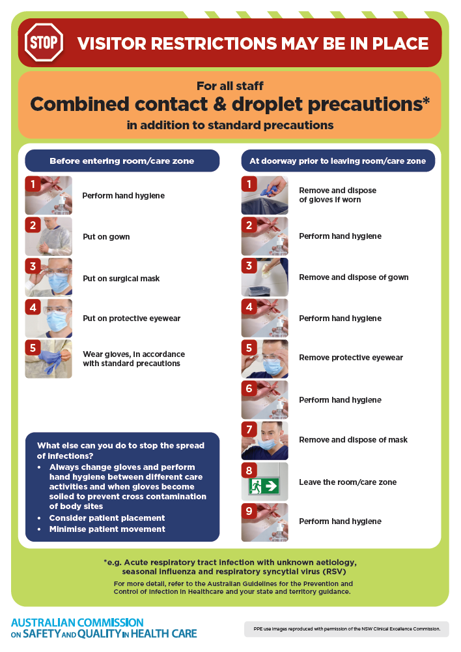
- Poster – Combined airborne and contact precautions
https://www.safetyandquality.gov.au/publications-and-resources/resource-library/infection-prevention-and-control-poster-combined-airborne-and-contact-precautions
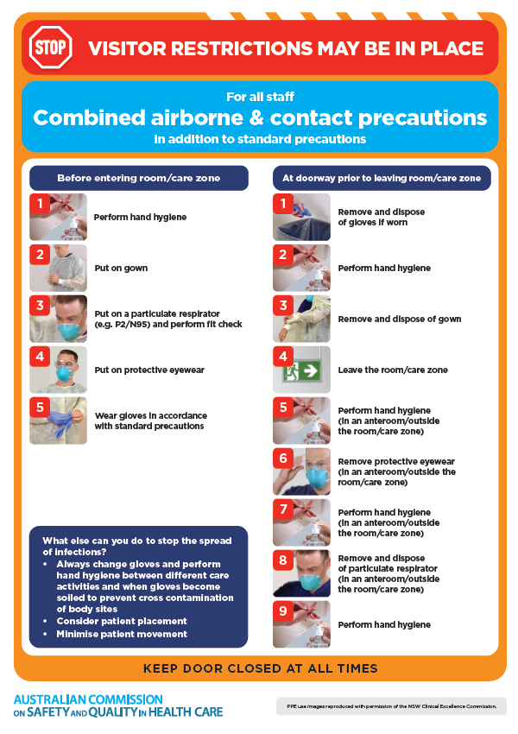
- Environmental Cleaning and Infection Prevention and Control www.safetyandquality.gov.au/environmental-cleaning
- Break the chain of infection poster
https://www.safetyandquality.gov.au/publications-and-resources/resource-library/break-chain-infection-poster
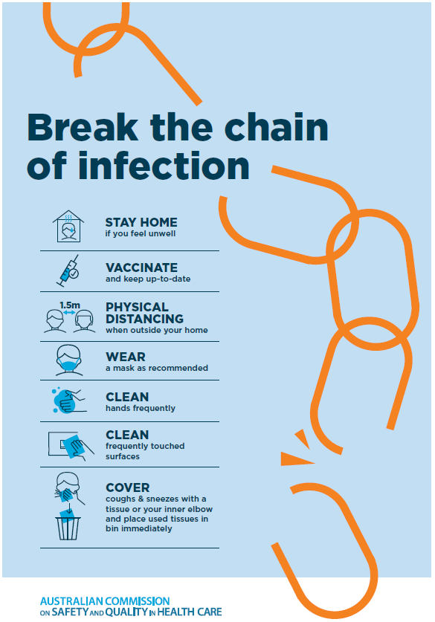
Disclaimer
On the Radar is an information resource of the Australian Commission on Safety and Quality in Health Care. The Commission is not responsible for the content of, nor does it endorse, any articles or sites listed. The Commission accepts no liability for the information or advice provided by these external links. Links are provided on the basis that users make their own decisions about the accuracy, currency and reliability of the information contained therein Any opinions expressed are not necessarily those of the Australian Commission on Safety and Quality in Health Care.

