
On the Radar
Issue 757
24 August 2026

On the Radar is a summary of some of the recent publications in the areas of safety and quality in health care Inclusion in this document is not an endorsement or recommendation of any publication or provider Access to particular documents may depend on whether they are Open Access or not, and/or your individual or institutional access to subscription sites/services Material that may require subscription is included as it is considered relevant.

On the Radar is available online, via email or as a PDF or Word document from
https://www.safetyandquality.gov.au/news-and-media/newsletters/on-the-radar

If you would like to receive On the Radar via email, you can subscribe on our website https://www.safetyandquality.gov.au/news-and-media/newsletters/on-the-radar
or by emailing us at mail@safetyandquality.gov.au.
You can also send feedback and comments to mail@safetyandquality.gov.au.

For information about the Commission and its programs and publications, please visit https://www.safetyandquality.gov.au

On the Radar
Editor: Dr Niall Johnson
Contributors: Niall Johnson

Reports

Insulin: supporting safe self-administration for patients in the community with a learning disability. Investigation report
Health Services Safety Investigation Body
Poole: HSSIB; 2026.

Electronic patient record systems – electronic referrals for ongoing care: advice and guidance. Interim report
Health Services Safety Investigation Body
Poole: HSSIB; 2026.
URL | https://www.hssib.org.uk/patient-safety-investigations/insulin-supporting-safe-self-administration-in-vulnerable-patient-groups-in-the-community/third-investigation-report/  https://www.hssib.org.uk/patient-safety-investigations/electronic-patient-record-systems-electronic-referrals-for-ongoing-care/interim-report/
Notes | These two reports are the latest from the Health Services Safety Investigation Body (HSSIB) in the UK.  Insulin: supporting safe self-administration for patients in the community with a learning disability. Investigation report is the HSSIB’s latest report on issues with the safe use of insulin in the community. Each report in the series has a focus on specific groups who may be at increased risk of harm because of the way they self-administer insulin. This report identified that people in England with a learning disability, who have diabetes and administer insulin, have come to harm because of gaps in healthcare services and inequitable access to support. The report’s findings include:  - People with a learning disability (who require insulin for diabetes) have been harmed when they have not been supported to self-administer insulin safely.  - People with a learning disability are not always empowered or enabled to self-manage their diabetes where they may be able to do so.  - Limitations in the availability of learning disability specialist services affect the ability of non-specialist staff to seek advice to support safe diabetes care.  - Diabetes technologies and insulin delivery devices are not always designed in ways that support people with a learning disability.  - Evidence gaps remain around how people with a learning disability manage diabetes with insulin and what support they need to do so safely.  The report includes findings, safety recommendations, observations and learnings that are applicable at various levels.  Electronic patient record systems – electronic referrals for ongoing care: advice and guidance. Interim report ‘is an interim publication as part of HSSIB’s focus on electronic patient record systems – electronic referrals for ongoing care. In light of concerns about patient safety heard by HSSIB, this report focuses on advice and guidance (A&G) services in the NHS in England.’ The report notes that A&G services enable clinicians in general practice to seek specialist advice about a patient's care, either before or instead of referring them to hospital for specialist assessment. A&G is often undertaken via the NHS electronic referral service (e-RS). This interim report identifies patient safety risks linked to how A&G services have been implemented across England. The report includes findings, recommendations, observations and learnings that are applicable at various levels.
Medicine safety: culturally and linguistically diverse community care
Pharmaceutical Society of Australia
Canberra: PSA; 2026.
URL | https://www.psa.org.au/advocacy/working-for-our-profession/medicine-safety/medicine-safety-culturally-and-linguistically-diverse-community-care/
Notes | The latest report from the Pharmaceutical Society of Australia (PSA) on medicines safety looks at medicine safety issues in Australia’s culturally and linguistically diverse communities. The report suggests that ‘Understanding patterns of medicine use, access, and safety among culturally and linguistically diverse populations is essential to ensuring equitable, culturally safe, and effective health care.’ The report includes a number of recommendations, including a number on the role and training of pharmacists.

How Care Coordination Varies Internationally: A Study of Primary Care Physicians in 10 Countries
Shah A, Maksut J, Gunja MZ
New York: The Commonwealth Fund; 2026.
DOI | https://doi.org/10.26099/fy59-w331
Notes | The latest from The Commonwealth Fund in the USA is a report drawing on a survey of primary care doctors in 10 high-income nations, including Australia, ‘to examine care coordination’. The authors observe that ‘Essential to any high-performing health system is coordination of primary care with other medical care and social services that patients receive. When primary care practices, specialists, hospitals, and social service providers work in harmony, patient outcomes are optimized.’ The authors identified the following highlights:  - ‘Frequent care coordination between primary care physicians (PCPs) and other types of providers was not universally reported in any of the 10 surveyed countries.  - Most PCPs across the surveyed countries do not receive a report from the specialists to whom they’ve referred patients within a week.  - The majority of physicians across all 10 countries reported they were able to electronically coordinate with providers outside of their practice.  - Around half of PCPs in Canada, New Zealand, and the U.K. said the amount of time they spend coordinating referrals with specialists was a major problem for their practice, while about one in four did so in the U.S.’  The authors observe that all the nations surveyed ‘has room to improve their care coordination between primary care physicians and other health providers.’ Further, they suggest two key lessons:  - Payment reform can incentivize care coordination  - Technology can enhance care coordination.

Strengthening health checks for the prevention and management of cardiovascular disease
OECD
Paris OECD Publishing
DOI | https://doi.org/10.1787/95c9ccdb-en
Notes | Report from the OECD that observes that ‘Cardiovascular diseases (CVDs) remain the leading cause of death and disability worldwide’. The report’s abstract continues ‘Health checks can strengthen the early detection and management of CVDs and their risk factors when appropriately targeted and linked to effective follow-up care. Yet access, uptake and implementation remain uneven across countries. Drawing on cross-country comparable data and examples of national policies and programmes from OECD countries, this brief identifies five policy considerations for strengthening cardiovascular health checks: improving access, increasing awareness and uptake among high-risk populations, strengthening health data and digital infrastructure, integrating health checks into coordinated care pathways, and ensuring cost-effective programme design. Together, these priorities can help policymakers strengthen cardiovascular prevention, reduce health inequalities and improve long-term population health.’

Journals

BMJ Quality & Safety
Volume 35, Issue 8, August 2026
URL | https://qualitysafety.bmj.com/content/35/8
Notes | A new issue of BMJ Quality & Safety has been published. Many of the papers in this issue have been referred to in previous editions of On the Radar (when they were released online). Articles in this issue of BMJ Quality & Safety include:  - Editorial: Widening of the ‘technical/practical’ divide: New advances in statistical process control bring new capabilities and new challenges. (Brant J Oliver)  - Editorial: Professional support is an important lifeboat, but let’s also stop people falling into the water (Alison Pearson, Kathryn Bamforth, Alice Miller)  - Editorial: Widening global gap in safe surgery: revisiting the surgical safety checklist at the 20th anniversary of the WHO Surgical Safety Checklist (Karolina Kogut, Nobhojit Roy, Mary E Brindle)  - Editorial: Tools to engage patients and family members in diagnostic safety: we see the trees, but what about the forest? (Aubrey Samost-Williams, Sigall K Bell, Eric J Thomas)  - Optimising professional support for doctors who experience work performance issues: a realist evaluation (Nicola Brennan, Ellie Reynolds, Tristan Price, Geoff Wong, Jennifer Cleland, Helen Lloyd, L Withers, T Gale)  - Surgical safety checklist awareness and safety attitudes in the Eastern Mediterranean region: a cross-sectional study (Assem Gebreal, Fatma Badr El Dine, Albaraa Abdulsalam, Doaa Hamdy Aly, Shaimaa Abdelaziz Abdelmoneim, Walid M Abd El Maksoud, Siwar Belhaj Salem, Alaa Nadir Mohamed Abdelrahim, Saja A Albanaa, Saja Alasaad, Rajiv Yussuf Ali, Ramez M Odat, Noha Taymour, Tabraiz Amin Malik, Abdelrahman Zaki Ali Mohammed, Notaila Mohammed Fayed, Khlood Saleh Mohammed Al-Ansi, Majda Attar, Ibrahim Mutwakil Gamal Ahmed, Ramy Mohamed Ghazy)  - Examining variations in the prevalence of hazardous opioid prescribing across general practices in England: a cross-sectional study (Teng-Chou Chen, Alex M Trafford, Matthew J Carr, Neetu Bansal, Evangelos Kontopantelis, Anthony Avery, Li-Chia Chen, Darren M Ashcroft)  - Scoping review of patient and family engagement interventions in diagnosis: a paradox of too much, yet so little (Mary A Hill, Helen Haskell, Katie N Dainty, Kerry Kuluski, Christine Shea, Layla Heimlich, Sharifa Kazi, Mark Sochaniwskyj, Alessia Priore, Taylor Leslie Marie Mason, Tess Coppinger, Simran Isani, Nicole Scala, Sara Shearkhani, Sadaf Kazi, Traber D Giardina, Kristen E Miller, Kelly M Smith)  - Welcome to the jungle: collection and evaluation of quality indicators with the QUALICATOR instrument (Jonas Backes, Justus Vogel, Alexander Geissler, Michael M Havranek, Sarah P Schladerer, David Ehlig)  - AI mirage: medical algorithms and the vanishing autopsy (Qi Wang)

Australian Journal of Primary Health
Volume 32, Issue 4, August 2026
URL | https://connectsci.au/py/issue/32/4
Notes | Recent articles in the Australian Journal of Primary Health include:  - Determinants of receipt of health education on non-communicable diseases through communities or workplaces among China’s rural-to-urban migrant population: a national repeated cross-sectional study (Di Wu, Yuru Niu)  - Australian GP experiences and perspectives of mental health care for adolescents: a qualitative study (Kisanet Tesfu, Amy Coe, Caroline Johnson, Catherine Kaylor-Hughes)  - Disability Liaison Officers and emergency department diversion: a retrospective analysis from an Australian health service (Andrea Simpson, Courtney P McFarlane, Patricia Barnes, Matthew P Yates, M A Templeton)  - Investigation and treatment rates following minimal trauma fracture: results of a primary care physician survey (M Wang, A Auwyang, A Das, M J Seibel)  - A cross-sectional survey of general practitioners’ perspectives on wait times for adolescent mental health specialists and services in Australia (Bridianne O’Dea, Mirjana Subotic-Kerry, Thomas Borchard, Belinda Parker, Bojana Vilus, Frank Iorfino, Alexis E Whitton, Ben Harris-Roxas, Tracey D Wade, M K de Valle, N Glozier, J Nicholas, M Torok, T A Braund, P J Batterham)  - Long-term experiences of patients prescribed medicinal cannabis in Australia: a qualitative interview study (Margaret-Ann Tait, Kate White, Claudia Rutherford, Daniel S J Costa, Rachel Campbell)  - Supporting access to primary care for people experiencing homelessness in Australia: a rapid review of the literature (Juliet Thottunkal, Nilakshi Gunatillaka, Elizabeth Forbes, Caroline Arthur, E Sturgiss, J Desborough)  - Towards vaccine equity for Aboriginal and Torres Strait Islander children aged 0–5 years: a rapid review of enablers, barriers and characteristics of successful programs (Connor Ryan, Cindy Tyson, Karina Baigrie, Clara Walker, Lisa M Seymour, R Kent, A Wighton, N Andersen, P A Gardiner)  - Optimising cancer support for rural residents from a refugee background: changing models of access and care (Abbie Lockwood, Iain Butterworth, April Gerolemou, Eh Ta Mue Lue, Boe Htoo, Zahir Azimi, Lisa Carson, Kaye Graves, Cheryl Martin, Simon Baker)  - A scoping review of opioid agonist treatment in Australian general practice (Warren Jennings, Idin Panahi, Tim Piatkowski, C Wirtz, D Ting, G Spurling)  - Triaging general practitioner referrals for specialist review to eConsultant – a pilot study (Jennifer Job, Caroline Nicholson, Ruby Strauss, Min-Chia Tsai, H David McIntyre, Reuben Beer, Andrew Swayne ,Joel Petre, Claire Jackson)  - Barriers to access reproductive and sexual health services among women with disabilities in Australia: a systematic review (Kousar Azhdari, Greer Lamaro Haintz)  - A cross-sectional survey confirming the barriers and facilitators to vaccine uptake and timeliness among Aboriginal children in Perth, Western Australia (Carla Puca, Samantha J Carlson, Leslie-Anne Conway, Anastasia Phillips, Naomi Nelson, Valerie Swift, Christopher C Blyth)  - Bridging the divide: GP narratives on lung cancer care in Tasmania (Sofoora Kawsar Usman, Pieter van Dam, Barbara de Graaff, A J Palmer, P Otahal, N Harkness, E Ball, R Grundy, M Hensher, A Black, E Witherden, I Cox)  - Stroke prevention using oral anticoagulants among patients with atrial fibrillation: a qualitative study of Australian general practitioners (S Wright, O Hamed, N Lowres, K Giskes, J Orchard, B Freedman, C Hespe)  - Understanding barriers and facilitators to breast cancer screening: insights from South Asian women and general practitioners in Victoria, Australia (Farwa Rizvi, Victoria White, Patricia M Livingston, Kylee Bellingham, Sue-Anne McLachlan, Debbie Passey, Jennifer Philip)  - The false promise of Primary Health Network generalist needs assessments (Stephen Duckett, Jane London)

The Lancet Primary Care
Volume 2, Number 7, July 2026
URL | https://www.thelancet.com/journals/lanprc/issue/vol2no7/PIIS3050-5143(26)X2007-6
Notes | The Lancet Primary Care is a relatively new open access journal. Articles in this issue of The Lancet Primary Care include:  - Editorial: 1 year of The Lancet Primary Care (The Lancet Primary Care)  - Home blood pressure monitoring for improving hypertension detection (Alejandro de la Sierra)  - Building resilient general practice beyond static emergency plans (Ulrik Bak Kirk, Ana Luisa Neves, Nanna Holt Jessen, Maria P Astier Peña, P Kallestrup)  - Community pharmacy and primary care access in central America: why governance matters (Esteban Zavaleta-Monestel, Beatriz Badilla-Baltodano, Fernando Martinez-Martinez)  - Reflecting on the ethical implications of audit and feedback to reduce overuse of pathology tests among high-requesting general practitioners (Louise Stone, Oliver Frank, Chun Wah Michael Tam)  - Reflecting on the ethical implications of audit and feedback to reduce overuse of pathology tests among high-requesting general practitioners (Denise A O’Connor, Paul Glasziou, Dina Schram, Alexandra Gorelik, Amelia Elwick, Kirsten McCaffery, Rae Thomas, Rachelle Buchbinder)  - Rethinking primary care redesign through community coordination hubs for interprofessional care (Emmanouil K Symvoulakis, Marios Spanakis, Katerina M Antoniou)  - Effectiveness of home-based self-monitoring of blood pressure for hypertension detection in India (EASE-BP): an open-label, randomised controlled trial (Rohit Bhatia, Partha Haldar, Imnameren Longkumer, Madakasira Vasantha Padma Srivastava, Puneet Misra, Gautam Sharma, Mamta Bhushan Singh, Rakesh Kumar, Harshal Ramesh Salve)  - Facilitated group-based peer support (Working Out Dads) versus brief phone intervention for mental health difficulties in early fatherhood in Victoria, Australia: a randomised controlled trial (Rebecca Giallo, Casey Hosking, Alannah Rudkin, Monique Seymour, Alison Fogarty, Le Ann Williams, Helen Findley, Amanda Cooklin, Jemimah Ride, Liana Leach, Brian Oldenburg, Catherine E Wood, Rohan Borschmann ,Kirsty Evans, Craig Garfield, Stephanie Brown, Karli Treyvaud, G McMahon, J Nicholson, A C Grobler)  - Integration of point-of-care testing for sickle cell disease into primary care in northern Ghana: a prospective feasibility study (Lucy Osei Ababio, Enyonam Duah, William Dormechele, Samuel Tamti Chatio, Judith Adagenera, Peter Mogere, Yewande Obioma, Patrick Ansah, Isaac Odame)  - Weight status and pathways to eating disorder referral from primary care in England and Northern Ireland: a cross-sectional analysis of routine care data (Chloe Gao, Jessica Wilkins, Alex Dregan, K L Allen, J Scuffell, U Schmidt)  - Implementation of digital health interventions in primary care in high-income countries: a systematic review (Judith Edwards, Megan Armstrong, Samina Begum, Emma Dunphy, Rosa Lau, M Naughton, S J Taylor, J Ross)  - Scaling up mental health services through the primary health care approach: implementation strategies from across the WHO European region (Anna Sagan, Rachel Greenley, Zulfiya Pirova, Ana Tijerino Inestroza, Cassie Redlich, Natasha Azzopardi-Muscat, Melitta Jakab, Ledia Lazëri)

International Journal for Quality in Health Care online first articles
URL | https://academic.oup.com/intqhc/advance-articles
Notes | International Journal for Quality in Health Care has published a number of ‘online first’ articles, including:  - Historically-Informed Quality Improvement: Applying historical insights from Black women’s maternity care to contemporary health service redesign (Jennifer Creese, Bharathy Kumaravel, Kellie Moss, Maxine Chapman, Natalie Darko, Floretta Cox, Ruw Abeyratne)  - Measuring Safer Opioid Use in Hospitals: Development of Consensus-Based Safety and Quality Indicators - a modified Delphi study (Abdullah Mutashar, Martin L Canning, J Hillen, M Fahim, N J Ailabouni, C R Freeman)  - Improving surgical patients’ safety in African hospitals: exploring healthcare professionals’ experiences of Phase 1 of the “5Rs to Rescue” programme (Charles Fadipe, Rowan Duys, Gillian J Bedwell, Pierre Barker, Godfrey Barabona, Bruce M Biccard, Ryan Ellis, Adam Hewit-Smith, Fitsum Kilfe, M E McPherson, B Mrara, E Ninise, R M Pearse, R Shayo, T J Stephens)

Online resources

Australian Living Evidence Collaboration
https://livingevidence.org.au/

Guidance
A number of guidelines or guidance have recently been published or updated These include:
- Prostate Cancer Foundation of Australia, 2026 Guidelines for the Early Detection of Prostate Cancer in Australia https://www.pcfa.org.au/media/dkljgdal/2026-guidelines-for-the-early-detection-of-prostate-cancer.pdf
- Royal College of Psychiatrists (UK), Wim’s Protocol: for the safe prescribing and monitoring of clozapine https://www.rcpsych.ac.uk/improving-care/wims-protocol

Infection prevention and control resources
The Australian Commission on Safety and Quality in Health Care has developed a number of resources to assist healthcare organisations, facilities and clinicians These resources include:
- Poster – Combined contact and droplet precautions https://www.safetyandquality.gov.au/publications-and-resources/resource-library/infection-prevention-and-control-poster-combined-contact-and-droplet-precautions
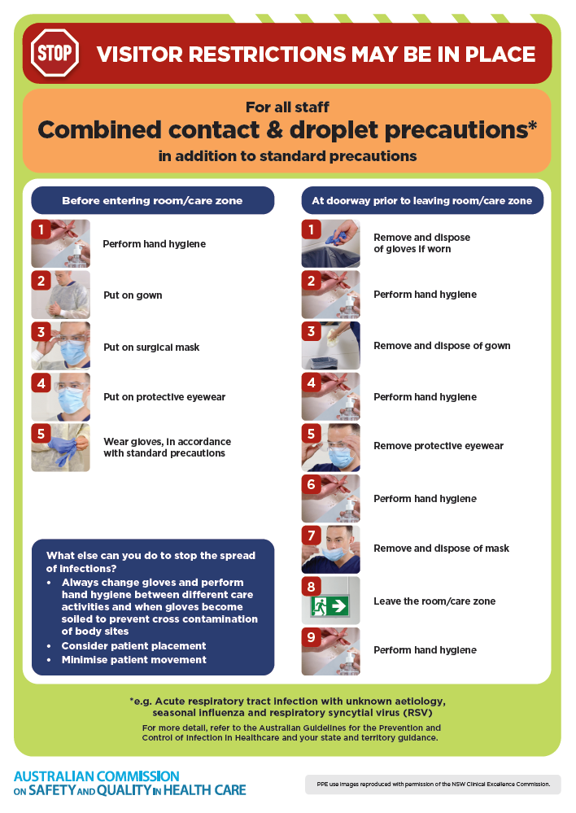
- Poster – Combined airborne and contact precautions
https://www.safetyandquality.gov.au/publications-and-resources/resource-library/infection-prevention-and-control-poster-combined-airborne-and-contact-precautions
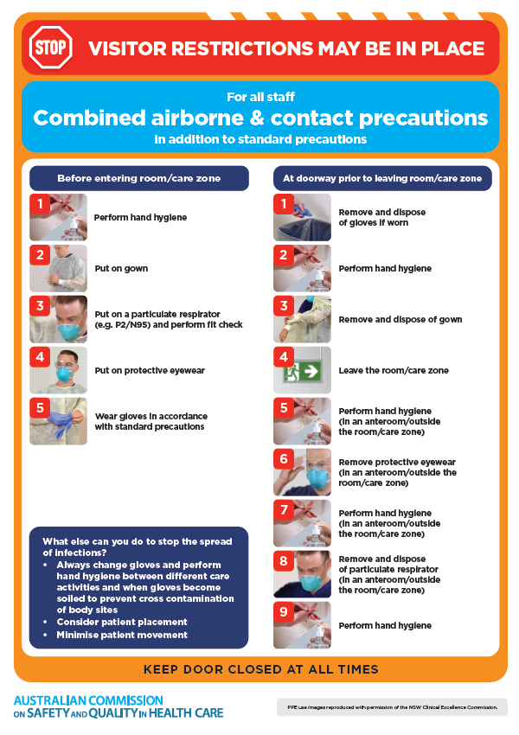
- Environmental Cleaning and Infection Prevention and Control www.safetyandquality.gov.au/environmental-cleaning
- Break the chain of infection poster
https://www.safetyandquality.gov.au/publications-and-resources/resource-library/break-chain-infection-poster
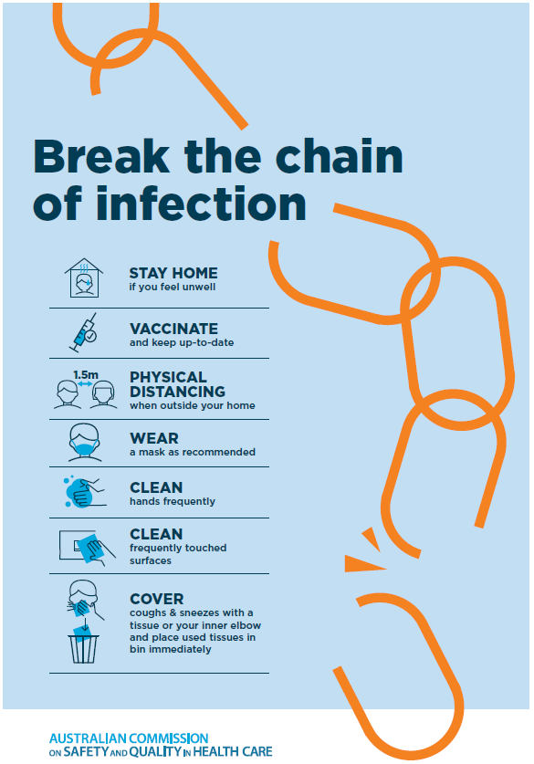
Disclaimer
On the Radar is an information resource of the Australian Commission on Safety and Quality in Health Care. The Commission is not responsible for the content of, nor does it endorse, any articles or sites listed. The Commission accepts no liability for the information or advice provided by these external links. Links are provided on the basis that users make their own decisions about the accuracy, currency and reliability of the information contained therein Any opinions expressed are not necessarily those of the Australian Commission on Safety and Quality in Health Care.

