
On the Radar
Issue 758
31 August 2026

On the Radar is a summary of some of the recent publications in the areas of safety and quality in health care Inclusion in this document is not an endorsement or recommendation of any publication or provider Access to particular documents may depend on whether they are Open Access or not, and/or your individual or institutional access to subscription sites/services Material that may require subscription is included as it is considered relevant.

On the Radar is available online, via email or as a PDF or Word document from
https://www.safetyandquality.gov.au/news-and-media/newsletters/on-the-radar

If you would like to receive On the Radar via email, you can subscribe on our website https://www.safetyandquality.gov.au/news-and-media/newsletters/on-the-radar
or by emailing us at mail@safetyandquality.gov.au.
You can also send feedback and comments to mail@safetyandquality.gov.au.

For information about the Commission and its programs and publications, please visit https://www.safetyandquality.gov.au

On the Radar
Editor: Dr Niall Johnson
Contributors: Niall Johnson

Updated High-Risk Medicines Education: Opioid Analgesics in Acute Settings module
https://hrmeducation.health.gov.au/

The Australian Commission on Safety and Quality in Health Care in collaboration with the Women’s and Children’s Health Network, South Australia have released the updated High-Risk Medicines Education: Opioid Analgesics in Acute Settings module.
The module follows scenario-based patient journeys, informed by real patient safety incidents and near misses to help learners apply key safety strategies with the use of opioids. Updates to the module include revised clinical content and enhanced interactive activities to improve user engagement.
The module is targeted to early career health professionals working in acute care, primary care and aged care.
Access the updated module at https://hrmeducation.health.gov.au/
Reports

National Report Card 2025
National Mental Health Commission
Canberra: NMHC; 2026. p. 93.
URL | https://www.mentalhealthcommission.gov.au/publications/national-report-card-2025  https://www.mentalhealthcommission.gov.au/news-media/news/release-national-report-card-2025-monitoring-and-reporting-australias-mental-health-system
Notes | The National Mental Health Commission has released its National Report Card 2025 reporting on the performance of Australia’s mental health system. The CEO’s Foreword to the report observes that ‘This year’s Report Card highlights both progress and opportunity. Promisingly, we are seeing more investment in the mental health system announced in 2025, and more people accessing support. However, the impact of this investment is unevenly distributed across society. There are signs that our service system isn’t facilitating access early enough for those experiencing mental health challenges and a workforce projected to continue to fall short of need. People experiencing mental health challenges continue to report lower life satisfaction and higher levels of loneliness, discrimination and financial stress than the broader population.’  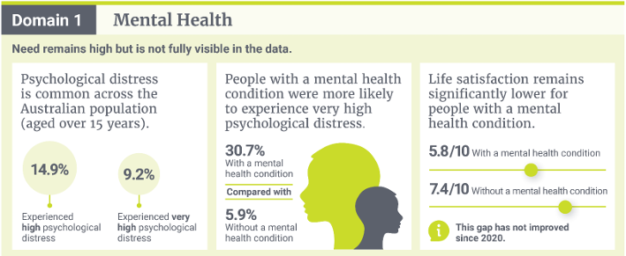

Use of emergency departments for lower urgency care 2017–18 to 2024–25
Australian Institute of Health and Welfare
Canberra: AIHW
URL | https://www.aihw.gov.au/reports/primary-health-care/eds-lower-urgency-care-2017-18-to-2024-25/contents/about
Notes | The Australian Institute of Health and Welfare (AIHW) has published this web report that ‘explores trends in emergency department (ED) presentations in the lower urgency categories of the Australasian College of Emergency Medicine’s Australasian Triage Scale’. It includes information by remoteness areas, socioeconomic areas, Primary Health Networks (PHNs) and Statistical Area Level 3 (SA3). Among the key findings:  - Percentage of ED presentations classified as lower urgency has decreased slightly, from 36% in 2021–22 to 30% in 2024–25  - People in remote and very remote areas consistently had higher rates of lower urgency care than those in major cities  - People living in the most disadvantaged areas continue to have much higher rates of lower urgency care  - Age-standardised rates of lower urgency care peaked at 130 per 1,000 in 2020–21 then fell to 105 per 1,000 in 2024–25  The report explicitly notes that ‘This report does not include data on Medicare Urgent Care Clinics and cannot be used to assess their impact.’

Journal articles

‘Routine’ medical treatments are not risk free. Patients should ask questions before consenting
Srivastava R
The Guardian. 2026 24 August 2026.
URL | https://www.theguardian.com/commentisfree/2026/aug/25/routine-medical-treatments-not-risk-free-healthcare-questions
Notes | In her most recent column this Australian oncologist and commentator touches on a number of topics, including variation, questions of what is ‘routine’ and ‘necessary’, consideration of risks, harms and benefits, and informed consent. It could be observed that much of this points to both value (possibly in the broader sense and not just cost) and patient-centred care.

The Joint Commission Journal on Quality and Patient Safety
Volume 52, Issues 9, September 2026
URL | https://www.sciencedirect.com/journal/the-joint-commission-journal-on-quality-and-patient-safety/vol/52/issue/9
Notes | A new issue of The Joint Commission Journal on Quality and Patient Safety has been published. Articles in this issue of The Joint Commission Journal on Quality and Patient Safety include:  - Editorial: The Quality Edit 2025: Practical Lessons for Improvement Leaders (Elizabeth Mort)  - Medicare and Medicaid Hospital Quality Ratings and Hospital Community Commitment: A Cross-Sectional Study (Matt Muellner, Megan L Rolfzen, Eric C Sun, Franklin Dexter, Karsten Bartels)  - Diagnostic Safety Policy and Practice: Advocacy Drivers and Challenges—Key Recommendations from a Qualitative Interview Study with US and Australian Experts (Maria R Dahm, Laura J Chien)  - Elimination of the Opioid Sliding Scale Is Associated with Improved Opioid Stewardship Metrics (Daniel A DeUgarte, Ross J Fleischman, Rebecca Trotsky, Ghassan Moubarak, ... Rodolfo Amaya)  - Development and Implementation of a Machine Learning Model for Prediction of Surgical Case Duration (Jeffrey H Siewerdsen, Niloufar Mirzavand Boroujeni, Aaron C Milhorn, Owais Sarwar, ... Mark W Clemens)  - Improving Hospital-to–Skilled Nursing Facility Transitions: Resident-Led Implementation and Evaluation of an EHR–Embedded Discharge Checklist (Priyanka A Dutta, Justin C Zhang, T Sanchez-Ortiz, L Peng, ... J D Harrison)  - Association of Timing of Psychiatry Consultation and Length of Stay and Length of Stay Index in Hospitalized Patients with Cancer: Risk-Adjusted Outcomes (Deepti Chopra, Noman Ali, Kodwo Dickson, S Belay, ... J Halm)  - Decreasing Herpes Simplex Virus (HSV) Testing Turnaround Time for Infants in a Hospital Setting: A Continuous Quality Improvement Project (Miranda J Reid, Peter S Chang, Stacey G Beal, K H Rand, M N Lossius)  - A Claims-Based Antimicrobial Stewardship Dashboard to Identify High-Priority Outpatient Antimicrobial Stewardship Targets and Future Quality Initiatives (M Taylor Danner, M Chow, B Rodriguez, G Stimes, D Palazzi)

Health Affairs Scholar
Volume 4, Issue 7, July 2026
URL | https://academic.oup.com/healthaffairsscholar/issue/4/7
Notes | A new issue of Health Affairs Scholar has been published. Articles in this issue of Health Affairs Scholar include:  - The effect of market size on pharmaceutical innovation: matching estimates to policy questions (Luca Maini et al)  - Collaborations between healthcare and public health in rural settings (Casey P Balio et al)  - Commercial prices relative to Medicare were lower under an employer-based reference pricing program (Roslyn C Murray and Christopher M Whaley)  - Over-the-counter emergency contraceptive sales before and after Dobbs: a difference-in-difference analysis of US retail data (Alice Abernathy et al)  - A cross-national review of novel oncology approvals in the United States and China (2020-2025) (Grace Collins et al)  - Socioeconomic value of adult respiratory vaccination in the United States: a benefit-cost analysis (Claud Theakston et al)  - Drug and country characteristics associated with global approval and launch of FDA-approved novel therapeutics (Mengyuan Fu et al)  - Advancing the measurement of favorable selection in Medicare Advantage: evidence from encounter data (Debra Bozzi et al)  - Conceptualizations of “public health” and government action among U.S. adults in 2025 (Lauren N Yan et al)  - Heterogeneous responses to risk-adjustment reform: evidence from dementia diagnosis in Medicare Advantage (Sidra Haye et al)  - Characteristics of urologists participating in Medicare Advantage networks and implications for prostate cancer care (Avinash Maganty et al)  - Rural–urban comparisons of area-based socioeconomic disadvantage and vulnerability indices (Hannah Lang and Kimberly A Rollings  - Who owns your doctor? A decade of trends in physician practice ownership in dermatology and gastroenterology (Becky Staiger et al)  - Pediatricians’ perceptions of children with disabilities and their health care (Carolyn C Foster et al)  - Healthcare access, utilization, and care experiences for American Indian and Alaska Native populations (Jessica N Monnet et al)  - Medical debt and subsequent use of alternative financial services among US adults (Hridika Shah et al)  - Separation from the CDC and its consequences for the public health workforce: findings from the CDC WISE Survey (Greta M Massetti et al)  - Minimizing H.R.1-related Medicaid coverage disruptions for high-risk patients (Rachel M Everhart et al)  - Spirit-based ready-to-drink cocktails and public health law: modernization without deregulation (Y Tony Yang)  - Trends in perception of generative AI in healthcare by US adult demographics and political identity (Benjamin Rader et al)  - Out-of-pocket insulin spending before and after the Inflation Reduction Act across demographic subgroups (Caroline G Borden et al)  - Associations between disability status, workplace accommodations, and well-being among practicing physicians and trainees (Lisa M Meeks et al)  - Taking stock of most-favored nation deals: how have markets reacted? (Noam Y Kirson et al)  - Ten high-priority areas for health policy research in 2026-2027 (Jose F Figueroa et al)  - Reforming Medicare payment for skin substitutes—ripping off the bandage (Jad F Zeitouni et al)  - Underinvesting in prevention: the costly blind spot in US diabetes care (Paul Y Han)  - Characterizing public participation in Prescription Drug User Fee Act reauthorization, 2010–2021 (Therese J Ziaks et al)  - Wage gaps between US nurses with and without disabilities (L Bixby et al)  - Changes in Medicare Part D coverage in competitive classes in the post–Inflation Reduction Act landscape: 2024–2026 (Hanke Zheng et al)  - Public support for regulating AI advice for mental health (Elizabeth M Stone and Rachel Topazian)  - Differences in the use of Medicare Advantage transportation benefits by primary care payment model and beneficiary needs (Melanie Canterberry et al)  - AI-assisted peer review: enhancing evaluation while increasing author workload (Himel Mondal)

International Journal for Quality in Health Care online first articles
URL | https://academic.oup.com/intqhc/advance-articles
Notes | International Journal for Quality in Health Care has published a number of ‘online first’ articles, including:  - Lessons learned from nationwide perinatal audit of severe postpartum haemorrhage in the Netherlands (Lisa Broeders, Steven V Koenen, Nicole de Vocht, Thomas van den Akker, Ageeth N Rosman)  - Learning from scale-up: a qualitative study of scaling-up interventions for people with multiple long-term conditions in primary care (S Chew, N Armstrong, G Maniatopoulos, N Perkins, K Khunti, R Baker, A Routen, J Willars, C Tarrant)  - Clinical Champions as an Implementation Strategy: Evidence and Practical Considerations (Ulfat Shaikh et al)  - Timeliness of discharge summary and post-discharge adverse events among patients hospitalised for community-acquired pneumonia (Anne Danjou, Magali Bouisse, Bastien Boussat, Sophie Blaise, , PhD , Xavier Courtois, Patricia Pavese, Mylène Maillet, Elodie Sellier, Jacques Gaillat, Bruno Degano, Sébastien Ducki, P François, A-C Toffart, C Schwebel, J Labarère)  - Assessing the Quality of Postnatal Care in India: Regional Disparities, Determinants, and Insights from NFHS-5 (Mahashweta Chakrabarty)

Online resources

Australian Living Evidence Collaboration
https://livingevidence.org.au/
- Drug treatments for people with influenza who are critically ill, interim Australian guideline https://livingevidence.org.au/influenza/

Guidance
A number of guidelines or guidance have recently been published or updated These include:
- The National Asthma Council Australia has published a series of short topic updates prepared with panels of asthma experts, to help primary care clinicians follow national guidelines in the Australian Asthma Handbook, updated late 2025. Each information sheet includes a Q&A, dosage guides, and key messages for patients. The topic updates include:
  - Asthma in adults: A quick reference guide
  - Overcoming Australia’s over-reliance on ‘blue puffers’ for asthma
  - Anti-inflammatory reliever is the recommended starting treatment for asthma
  - Maintenance-and-reliever therapy for asthma
  - Oral corticosteroid use in asthma: what’s safe and appropriate?
  - Triple therapy for asthma in primary care.

The Aboriginal Health and Medical Research Council of New South Wales (AH&MRC) resources
The Aboriginal Health and Medical Research Council of New South Wales (AH&MRC) has created webpages of resources, including
- Continuous quality improvement and risk resources https://www.ahmrc.org.au/resource-category/continuous-quality-improvement-risk/
- Governance, Policies & Procedures https://www.ahmrc.org.au/resource-category/governance-policies-procedures/
- Infection Prevention and Control Policy and Procedure Manual https://www.ahmrc.org.au/resource/infection-prevention-and-control-policy-and-procedure-manual/
- Accreditation & Compliance https://www.ahmrc.org.au/resource-category/accreditation-and-compliance/
- Bushfire Safety https://www.ahmrc.org.au/resource-category/bushfire-safety/

Health Innovation Series - e-Medication Safety
https://www.mq.edu.au/faculty-of-medicine-health-and-human-sciences/departments-and-schools/australian-institute-of-health-innovation/healthcare-tools-and-resources/health-innovation-series
The Health Innovation Series from the Australian Institute of Health Innovation at Macquarie University has had a number of recent issues added, including:
- When enough is enough: antibiotic duration in electronic medication systems
- Mind the denosumab gap: residents put at risk of fracture due to dose delays

[Canada] Sustainability-Embedded Quality Improvement (SE-QI) Toolkit
https://cascadescanada.ca/action-areas/quality-improvement-and-patient-safety/sustainability-embedded-quality-improvement/sustainability-embedded-quality-improvement-toolkit/
A Canadian-developed resource that helps healthcare teams identify, measure, and report the environmental impacts and co-benefits of quality improvement initiatives. According to The Collaborative Centre for Climate, Health & Sustainable Care at the University of Toronto, 'As environmental sustainability becomes increasingly recognized as an cross-cutting dimension of high-quality care, the SE-QI Toolkit and Spotlight provide a practical, evidence-informed, and Canadian-tested approach to embedding sustainability into everyday quality improvement practice.' https://climatehealth.utoronto.ca/2026/07/14/se-qi-toolkit-and-spotlight-national-launch/

[UK] Addressing health inequalities in infection and antimicrobial resistant infections: a UK-wide collaborative toolkit
UK Health Security Agency
London: UKHSA; 2026.
https://www.gov.uk/guidance/toolkit-for-addressing-health-inequalities-in-antimicrobial-resistance
The Health Security Agency in the UK has developed this toolkit for addressing AMR-related inequalities experienced by numerous groups of people, including inequalities based on disability, ethnicity, gender, geography, migrant status, drug dependence, pregnancy, religion, sexual orientation, and more.

[UK] Antimicrobial resistance (AMR) resources
https://www.england.nhs.uk/ourwork/prevention/antimicrobial-resistance-amr/
NHS England has released a number of AMR resources for healthcare systems in England, including roles and responsibilities in enacting the National Action Plan and strategies for meeting antibiotic prescribing targets. The resources include:
- Roles and responsibilities for delivery of the UK antimicrobial resistance national action plan
- Guidance on delivery of the antimicrobial prescribing targets of the UK AMR national action plan
- Planning the antimicrobial stewardship workforce
- Capability framework for antimicrobial stewardship specialists
- Reducing Watch and Reserve antibiotic consumption in hospitals – lessons learned from real-world practice.

[UK] NICE Guidelines and Quality Standards
https://www.nice.org.uk/guidance
The UK’s National Institute for Health and Care Excellence (NICE) has published new (or updated) guidelines and quality standards The latest reviews or updates include:
- NICE Guideline NG220 Multiple sclerosis in adults: management https://www.nice.org.uk/guidance/ng220

Infection prevention and control resources
The Australian Commission on Safety and Quality in Health Care has developed a number of resources to assist healthcare organisations, facilities and clinicians These resources include:
- Poster – Combined contact and droplet precautions https://www.safetyandquality.gov.au/publications-and-resources/resource-library/infection-prevention-and-control-poster-combined-contact-and-droplet-precautions
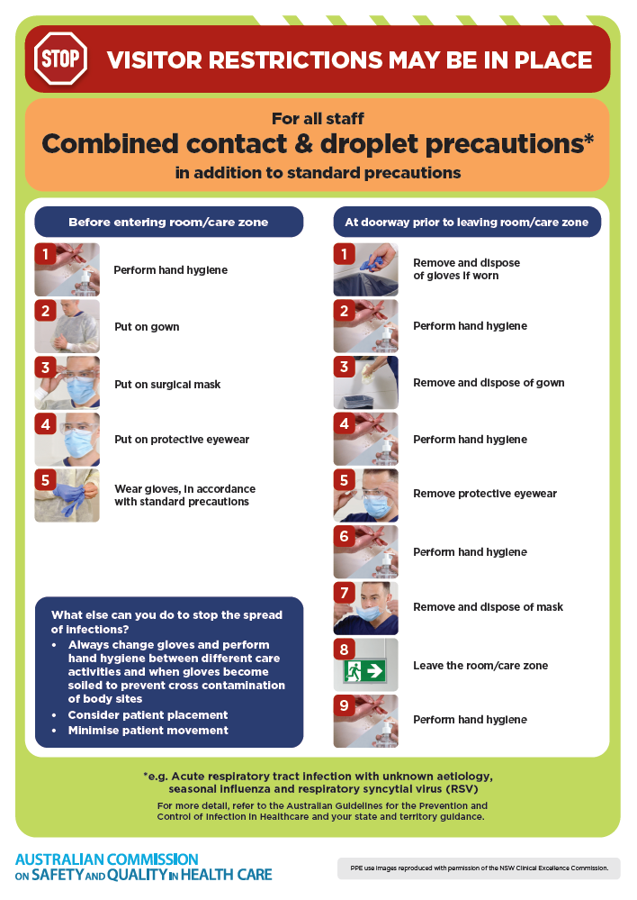
- Poster – Combined airborne and contact precautions
https://www.safetyandquality.gov.au/publications-and-resources/resource-library/infection-prevention-and-control-poster-combined-airborne-and-contact-precautions
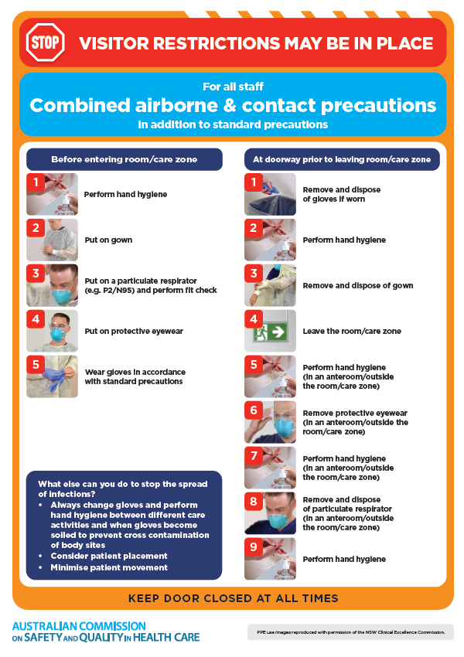
- Environmental Cleaning and Infection Prevention and Control www.safetyandquality.gov.au/environmental-cleaning
- Break the chain of infection poster
https://www.safetyandquality.gov.au/publications-and-resources/resource-library/break-chain-infection-poster
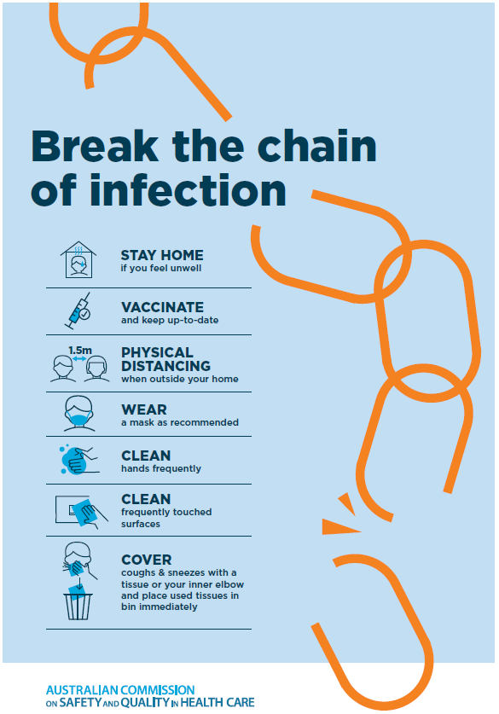
Disclaimer
On the Radar is an information resource of the Australian Commission on Safety and Quality in Health Care. The Commission is not responsible for the content of, nor does it endorse, any articles or sites listed. The Commission accepts no liability for the information or advice provided by these external links. Links are provided on the basis that users make their own decisions about the accuracy, currency and reliability of the information contained therein Any opinions expressed are not necessarily those of the Australian Commission on Safety and Quality in Health Care.

