
On the Radar
Issue 760
14 September 2026

On the Radar is a summary of some of the recent publications in the areas of safety and quality in health care Inclusion in this document is not an endorsement or recommendation of any publication or provider Access to particular documents may depend on whether they are Open Access or not, and/or your individual or institutional access to subscription sites/services Material that may require subscription is included as it is considered relevant.

On the Radar is available online, via email or as a PDF or Word document from
https://www.safetyandquality.gov.au/news-and-media/newsletters/on-the-radar

If you would like to receive On the Radar via email, you can subscribe on our website https://www.safetyandquality.gov.au/news-and-media/newsletters/on-the-radar
or by emailing us at mail@safetyandquality.gov.au.
You can also send feedback and comments to mail@safetyandquality.gov.au.

For information about the Commission and its programs and publications, please visit https://www.safetyandquality.gov.au

On the Radar
Editor: Dr Niall Johnson
Contributors: Niall Johnson, Kylie Tran

Updated High-Risk Medicines Education: Opioid Analgesics in Acute Settings module
https://hrmeducation.health.gov.au/

The Australian Commission on Safety and Quality in Health Care in collaboration with the Women’s and Children’s Health Network, South Australia have released the updated High-Risk Medicines Education: Opioid Analgesics in Acute Settings module.
The module follows scenario-based patient journeys, informed by real patient safety incidents and near misses to help learners apply key safety strategies with the use of opioids. Updates to the module include revised clinical content and enhanced interactive activities to improve user engagement.
The module is targeted to early career health professionals working in acute care, primary care and aged care.
Access the updated module at https://hrmeducation.health.gov.au/
Reports

First Nations Burden of Disease Study 2022
Australian Institute of Health and Welfare
Canberra: AIHW
URL | https://www.aihw.gov.au/reports/burden-of-disease/first-nations-burden-of-disease-study-2022/contents/about
Notes | The Australian Institute of Health and Welfare (AIHW) have released the second update to this report, the First Nations Burden of Disease Study 2022. This update provides ‘burden estimates for states and territories, and remoteness areas’.  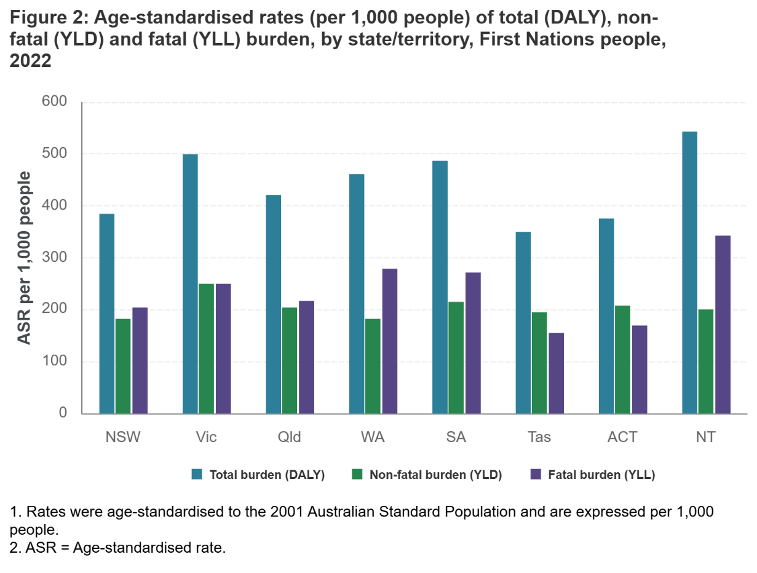

Emergency department use and experiences for children and young people: 2019–20 to 2024–25
Bureau of Health Information
St Leonards: BHI; 2026.

Healthcare Quarterly, April to June 2026
Bureau of Health Information
St Leonards: BHI; 2026.
URL | https://www.bhi.nsw.gov.au/BHI_reports/Insights_Series/children-young-people-use-experience-emergency-department  https://www.bhi.nsw.gov.au/BHI_reports/healthcare_quarterly/Apr-Jun2026
Notes | The Bureau of Health Information (BHI) in New South Wales has recently released a couple of reports. These have included:  - Emergency department use and experiences for children and young people: 2019–20 to 2024–25 examines the use and experiences of care for children and young people in NSW emergency departments (EDs).  - Healthcare Quarterly, April to June 2026 reports on activity and performance information for public hospital and ambulance services in NSW from April to June 2026.
Journal articles

Rebuilding Trust in the Patient-Physician Relationship
Rotenstein LS, Price G, Bates DW, Libby R
JAMA Internal Medicine. 2026

Rebuilding Trust in Medicine Requires Structural Change
Richman IB, Durant RW, Corbie G
JAMA Internal Medicine. 2026.
DOI | Rotenstein et al https://doi.org/10.1001/jamainternmed.2026.3819  Richman et al https://doi.org/10.1001/jamainternmed.2026.3822
Notes | Viewpoint piece and accompanying editorial in JAMA Internal Medicine reflecting on the ‘leap of faith’ that patients accept care as ‘they enter the physician-patient relationship from a position of vulnerability.’ These pieces examine how trust has been undermined and how to ‘redesign them so that trust becomes a deliberate outcome rather than a nostalgic aspiration.’ While some of these may have particular resonances in the USA context, many of them are universal.  Among the actions that could ‘help rebuild, enhance, and sustain patient-physician trust’, Rotenstein et al identify are:  - equip physicians with the training and tools that enable them to deliver experiences that foster trust  - design care models that prioritize continuity  - physician professional organizations should be more assertive in advocating for payment reforms that reward continuity and time spent with patients over volume. They should also advocate for care delivery models that integrate with public health and community resources, and for affordable and accessible health care  - countering misinformation and disinformation  - address these structural inequities while ensuring high-quality care and outcomes for all patients and communities.  Issues that may impact on trust in the relationship may include genuinely patient-centred care, shared decision-making, informed consent, including financial consent and, in the current environment, transparency around use of AI and patient data.

Age and Ageing
Volume 55, Issue 8, August 2026
URL | https://academic.oup.com/ageing/issue/55/8
Notes | A new issue of Age and Ageing has been published. Articles in this issue of Age and Ageing include:  - Editor's View: Editor's View - Blood-based markers for diagnosis of Alzheimer’s disease (Roy L Soiza)  - Editorial: Beyond single-drug indicators: the power of unsupervised phenotyping in mitigating medication-related harm (Richard Woodman)  - Editorial: Targeting deprescribing where it matters most (C McCarthy)  - Editorial: Hip fracture as a model for trends in geriatric medicine (Antony Johansen)  - Editorial: Deprescribing antihypertensive drugs in patients aged over 80 years: an evidence-based way forward (Denis O'Mahony)  - Editorial: Antidepressants at the threshold: what is really driving prescribing around dementia diagnosis? (Chengjun Liu and Katharine A Wallis)  - Editorial: Longitudinal ageing studies in sub-Saharan Africa—using observational data to support the shift towards integrated care for older people (Catherine Louise Dotchin et al)  - Emergency department-initiated interventions to reduce risk of recurrent falls in older adults: a systematic review and meta-analysis (Wilmar Charmant et al)  - Validation of the World Falls Guidelines risk stratification algorithm. A systematic review (Frederico Pieruccini-Faria et al)  - Determinants and mitigation strategies of vaccine hesitancy toward routine immunisations recommended for older adults: a systematic review (Siwen Huang et al)  - Effectiveness and safety of focused deprescribing interventions targeting specific drug classes in older adults across clinical settings: an umbrella systematic literature review (Ángel García Álvarez et al)  - Associations between neuropsychiatric symptoms and functional decline in dementia: a systematic review (Kevin O'Hara-Veintimilla et al)  - Antithrombotic strategy according to age in patients with atrial fibrillation and drug-eluting stents: a post hoc analysis of the ADAPT AF-DES randomised trial (Sang-Hyup Lee et al)  - A randomised, double-blind, placebo-controlled crossover trial on cannabinoid-based medication for behavioural disorders in old patients with severe dementia: the study results (Federica Bianchi et al)  - Ultra-processed foods and advanced stages of sarcopenia: multinomial evidence from the Birjand longitudinal ageing study (Akam Ramezani et al)  - Secondary prevention of myocardial infarction in people with dementia: a multi-jurisdictional retrospective cohort study in Asia, Europe and the USA (Jenni Ilomäki et al)  - How social isolation, loneliness and frailty play roles in all-cause death in later life? Global evidence from cohort studies across 31 countries (Yudong Miao et al)  - A decade of increasing complexity in patients sustaining a hip fracture in England, Wales and Northern Ireland: a national cohort study using the National Hip Fracture Database dataset (Richard James Holleyman et al)  - Health and health service use of Australian female live-in caregivers at multiple caregiver trajectory timepoints: a population-based dataset with time-matched controls (Leigh Tooth et al)  - Fragility fracture site is associated with frailty in older adults: a population-based cohort study in Japan (Ryutaro Shibata et al)  - Improvement of frailty and prefrailty in older cancer survivors: a 6-month home-based pilot study (Sabine Drevet et al)  - Real-world effectiveness of SGLT2 inhibitors in adults aged 75 years or older: a target trial emulation (Hisashi Noma et al)  - Comparing frailty index distribution, mortality and frailty dynamics across multiple countries: applying the ‘zero-state’ principle to harmonised ageing data (Saskia Drijver-Headley et al)  - Comparative effectiveness of high-dose versus standard-dose influenza vaccines in nursing home residents aged 65 and older in France: a nationwide cohort study on the French health data system from the 2022–2023 season (Helene Bricout et al)  - Intrinsic capacity trajectories and health outcomes in home care settings: a Canadian population-based cohort study (Bonaventure Amandi Egbujie et al)  - Community-based health and social care demand associated with frailty in people aged 50 and over in England 2025–40: routine data analyses and simulation modelling (Bronagh Walsh et al)  - Endovascular thrombectomy versus medical management in patients with dementia and acute ischaemic stroke (Huanwen Chen et al)  - Assessing incidence of clinically significantly prescribing cascades in older adults: a nationwide retrospective cohort study using the French National Health Data System (Frédéric Gervais et al)  - Does the use of benzodiazepine influence the effectiveness of lifestyle intervention? Secondary analysis from the Sarcopenia and Physical fRailty iN older people strategies (SPRINTT) trial (Elena Levati et al)  - ‘Doing it together?’ A dyadic qualitative study of perceptions, facilitators, barriers and expectations for physical activity in dementia (Shanshan Wang et al)  - Hospital at Home for older residents with physical deterioration: care home staff experiences (Chidiebere Nwolise et al)  - A policy scoping review of how ‘Hospitals at Home’ can and could support people with dementia (Anthony Zheng Wang et al)  - Primary care-based post diagnostic dementia care in England: modelling and scaling up evidence-based models for efficient future care (Magdalena Walbaum et al)  - Effects of a fall prevention program on falls among rural older adults with cardiovascular disease in China: a secondary analysis of the FAMILY cluster randomised trial (Ning Tang et al)

The Lancet Primary Care
Volume 2, Number 8, August 2026
URL | https://www.thelancet.com/journals/lanprc/issue/vol2no8/PIIS3050-5143(26)X2008-8
Notes | The Lancet Primary Care is a relatively new open access journal. Articles in this issue of The Lancet Primary Care include:  - Editorial: Primary and community care for a changing climate (The Lancet Primary Care)  - Brazil’s new autism care pathway and the limits of primary care expansion in middle-income health systems (Thiago Dias Sarti, Fernanda de Oliveira Ferreira Roza Victor, Vanessa Suzana Costa, F Poleze da Silva, B C de Santana Farias-Santos, A Calzi Roldi, A P Santana Coelho Almeida, Me Belotti))  - Patient vignettes: an underused yet powerful tool for assessing and improving quality of primary care (Anna Sagan, Dionne Kringos, Jan De Maeseneer, N Vackerberg, G Permanand, I Kowalska-Bobko, Ó Brito Fernandes, L Allen)  - Outcomes are the appropriate guide to general practice workforce needs, but better evidence is needed (Richard H Baker, Louis S Levene, Emilie M Couchman, George K Freeman, Tim Stokes)  - Interpretation of kidney outcomes during combined SGLT2 inhibitor and GLP-1 receptor agonist therapy (Dion Groothof, Mervin de Vries, Nicole S Erler, Reinold O B Gans, Stephan J L Bakker)  - Interpretation of kidney outcomes during combined SGLT2 inhibitor and GLP-1 receptor agonist therapy (Thijs T Jansz, Katherine G Young, Martha M Dinsdale, Pedro Cardoso, Richard A Oram, John M Dennis)  - A digital intervention to protect cognitive health in older adults with cognitive impairment: a three-arm, open-label, randomised controlled trial (Paul Little, Rosie Essery, Jane Somerville, Taeko Becque, Victoria Hayter, Beth Stuart, Katherine Bradbury, Gareth Griffiths, Simon Griffin, Tony Kendrick, Nanette Mutrie, Sian Robinson, Louise Robinson, Guiqing Yao, Shihua Zhu, Sebastien Pollet, James Denison-Day, Helen Brooker, Anne Corbett, Paul Lee, Shanaya Rathod, Bernard Gudgin, Rosemary Phillips, T Stokes, J Niven, A McCullagh, S McCloskey, M Rossor, J Gallacher, J O’Brien, C Ballard, L Yardley)  - Major adverse cardiovascular events and mortality associated with ADHD and its treatment in adults with hypertension: a retrospective, multinational cohort study (Yiling Zhou, Zihan Dong, Aske Astrup, Anders Engeland, Malcolm B Gillies, Astrid Lunde, Andrew S C Yuen, Yanli Zhang-James, Masako Araki, Isabell Brikell, Le Gao, Jan Haavik, Brian M D’Onofrio, Dina Sarsembayeva, Melissa Vos, Theresa Wimberley, Honghui Yao, Søren Dalsgaard, Stephen V Faraone, Kari Klungsøyr, Henrik Larsson, Kenneth K C Man, S-A Pearson, I C K Wong, H Zoega, Z Chang, E Du Rietz, H Snieder, C A Hartman)  - Weight-based levothyroxine dosing and long-term cardiovascular, bone, and mortality outcomes in older adults: an emulated target trial using UK primary care data (Mia Holley, Scott Wilkes, Ellen Dorothea Moss, Ian Maxwell, Rosie Dew, Salman Razvi)  - Unmet needs and primary care usage of unpaid carers in England: a repeated cross-sectional study (Sean Urwin, Rubab Ahmed, Matt Sutton)  - Overcoming technical barriers to enable real-time risk prediction in primary care: recommendations from expert workshops (Juliet A Usher-Smith, Lily C Taylor, Laura Blackburn, Chantal Babb de Villiers, Bhavya Krishnan, Evelyn Brunsdon, Georgios Lyratzopoulos, Ari Ercole, Niels Peek)  - Insulin initiation and titration for people with type 2 diabetes managed in primary care and guided by continuous glucose monitoring (Ramzi A Ajjan, Tadej Battelino, Xavier Cos, Stefano Del Prato, Chantal Mathieu, Mohammed Almehthel, Jochen Seufert, Bruno Guerci, Samuel Seidu)

JBI Evidence Synthesis
Volume 24, Issue 9, September 2026
URL | https://journals.lww.com/jbisrir/toc/2026/09000
Notes | A new issue of JBI Evidence Synthesis has been published. Articles in this issue of JBI Evidence Synthesis include:  - Editorial: The pre-post trap: meta-analysis of single-arm intervention studies with continuous outcomes (Isaac Saywell, Edoardo Aromataris)  - Effectiveness of foot temperature monitoring for preventing ulcers in individuals with diabetes: an umbrella review (Açucena Leal Araújo, Thiago Santos Garces, Francisca Diana da Negreiros, Raquel Sampaio Florêncio, Virna Ribeiro Cestari, Samuel Miranda Mattos, Wánderson Cássio Araújo, Kellen Alves Freire, Sarah Ellen da Fabricio, Lara Lídia Damasceno, Thiago Martins de Sousa, Vanessa de Poveda, Thereza Maria Moreira)  - Effectiveness of suture button fixation vs screw fixation for the management of acute distal tibiofibular syndesmotic injuries: a systematic review and meta-analysis (Matthew G Cehic, Ruurd Jaarsma, Ashley Whitehorn)  - Facilitator development for pre-registration health professions simulation: a scoping review (Renée Gordon, Jaime Riley, Diana Dupont, Beth Rogers, Kelly Day, Elizabeth Horsley, Amanda Ross-White, Laura A Killam)  - Caregivers’ experiences and perceptions of caring for children and adolescents with type 2 diabetes mellitus: a qualitative systematic review protocol (Ratchanok Phonyiam, Nareemarn Neelapaichit, T Srichalerm, C-H Teng)  - Diagnostic accuracy of tests for diabetic foot osteomyelitis: a Bayesian network meta-analysis protocol (Malavika Krishnakumar, Agnetha Folestad, Vivek Lakshmanan, Anandakrishnan Nandakumar, Dipu T Sathyapalan, Vineetha Karuveettil, Chandrashekar Janakiram, Georg Gutjahr)  - Development, implementation, and evaluation process of professional practice models for pediatric nursing: a scoping review protocol (Céline Lomme, Gwenaelle De Clifford-Faugère, Cécile Jaques, Anne-Sylvie Ramelet)  - Parents’ sleep experiences during pregnancy and the first 12 months after birth: a qualitative systematic review protocol (Hiroko Iwata, Eriko Terasawa, Kunie Maehara, Hisayo Okayama, Y Kozaki, I Hayford Budu, Mei-Feng Lin)  - Ethical aspects in scientific literature on participatory research approaches with older adults: a scoping review protocol (Rodrigo Serrat, Anna Urbaniak, Barbara Groot, Simay Ikier, T Yellon, N Yaylagul, O Gerdina, K Pihlainen, A Wanka, A Ozola, M Korkmaz, S Honorio, J Pons-Vila, D Lucantoni)  - Approaches used to teach sexual and gender diversity to undergraduate nursing students: a scoping review protocol (Lucas Cardoso dos Santos, Lucia Yasuko Nichiata, Dandara Guedes de Matos, Lucas Felipe de Moura, Vanessa Pagano, Thiago da Domingos, Narcisio Rios Oliveira, M Santini Martins  - Cost and cost-effectiveness of robotic-assisted pyeloplasty compared to laparoscopic pyeloplasty in patients with pelviureteric junction obstruction: a systematic review protocol (Nitinkumar Borkar, Madhusudan Prasad Singh, Ashwin Kumar C, Denny John)  - Exploring the definition and application of the concept of critical illness survivor: a scoping review protocol (Tiago André Peixoto, Cármen Queirós, Nuno Miguel Peixoto)  - Real-world implementation of clinical decision support systems in emergency departments: a scoping review protocol (Hwayeon Danielle Shin, K Payne, H Haskell, C G Wade, T Glatard, D Bates, P Dykes, A Syrowatka)  - Team adaptation in acute health care: a scoping review protocol (David Freer, Walter Eppich, Ellen Davies)

Health Policy
Volume 173, November 2026
URL | https://www.sciencedirect.com/journal/health-policy/vol/173/
Notes | A new issue of Health Policy has been published. Articles in this issue of Health Policy include:  - From clinic to classroom: Reframing health literacy as a foundational component of health systems (Yiqiu Wang, Mansour Amini, Shin Ling Wu)  - Defining unmet medical need: mapping stakeholder perspectives in a multi-level framework for Europe (Zilke Claessens, Anais Brouckaert, Isabelle Huys)  - Who uses and who needs informal care support? Quantitative evidence from the Dutch informal care monitor (Judith Bom, Mirjam de Klerk, Inger Plaisier, Leonoor Gräler, Job van Exel)  - Developing future leaders for healthcare systems: a Singapore case study (George Frederick Glass, Regina Ching Yin Tan, Valerie Mui Hang Yeo, Shermaine Tsin Tze Ong, Cher Heng Tan, David Dhevarajulu, Hon T Wong)  - A lesson, not an exception. Governing for greener healthcare systems: Exploring climate action in the National Health Service in the UK (Sophie Robinson, Michele L Barnes, Glenn Hoetker, Kathryn J Bowen)  - Fifty years of empirical research on medical assistance in dying: A mapping review (Sean Riley, Gianna R Strand, Iris Parra Jounou, Marta Perin, Chiara Crico, Fenne Bosma, Janet Delgado)  - What retains experienced NHS nurses: Results from a discrete choice experiment in England (Ourega-Zoé Ejebu, Shabbar Jaffry, Joanne Turnbull, Clare Huxley, Emma Pollard)  - Integrating internationally educated health professionals into Canada's health workforce: A synthesis of policy reforms and implementation experiences (Tara Sampalli, Gail Tomblin Murphy, Arezoo Mojbafan, Damilola Iduye, Annette J Elliott Rose, Ruth Martin-Misener, Caroline Chamberland-Rowe, Janet Rigby)  - Investing in Canada’s nursing workforce: a comprehensive review to inform policy innovations and directions (Gail Tomblin Murphy, Tara Sampalli, Arezoo Mojbafan, Annette J Elliott Rose, Ruth Martin-Misener, Caroline Chamberland-Rowe, Janet Rigby)  - Heat-health action plans overlook Europe's most important health system resource: the health and care workforce (Michelle Falkenbach, Ellen Kuhlmann, Ber Oomen, Marius-Ionuț Ungureanu, Tomas Zapata, M Wismar)  - What mechanisms enable whole-of-government action on suicide prevention in Australia? A policy review (Jaelea Skehan, Max Tran, L Reifels, J Cuenca)  - From incident response to system design: Japan’s 2025 PMD Act drug-shortage reform (Hiroaki Mamiya, Eri Oya, Daichi Mitani)  - Effects of hospital planning reforms on access, costs, efficiency, and quality of care in OECD countries: Systematic review and meta-analysis (Lang Charlotte, Bukanova-Berend Daria, Litvinova Karina, Yon Aliénor, Blum Marcel, Vogel Justus, Geissler Alexander, Ehlig David)  - Helping children grow more: Learning from the successes and challenges of Chile Crece Más (2007–2026) (Patrick Walker, Sofia Solano, Giselle Medel, Evelyn Gomez, Katherine Farnam, Jaime Sapag, Thomas Bossert)  - Parenthood and gender differences in French GPs’ labour supply responses to declining physician density: panel fixed-effects evidence (Alain Paraponaris, Julien Silhol, Bruno Ventelou)

International Journal for Quality in Health Care online first articles
URL | https://academic.oup.com/intqhc/advance-articles
Notes | International Journal for Quality in Health Care has published a number of ‘online first’ articles, including:  - Using an evidence-informed co-design approach to develop a mechanism to measure experiences of the open disclosure process: An Irish case study (Aoife De Brún, Eilish McAuliffe, Maria Boylan, Helen Thompson, Catherine Hand, Alexandria Collins, Geraldine Kilkelly, Noreen Kennedy, Clara Meehan, Lorraine Schwanberg, Éidín Ní Shé, the members of the Co-Design team)  - Frailty, depression, and quality of life in acute care for elderly: a serial mediation and moderated mediation study in Taiwan (Chau-Nee Chen, Tzu-Jung Fang, Cheng-Fang Hsieh, Chun-Chang Chen, Yu-Fu Chen, Hong-Yaw Chen, Pin-Yu Lai, Yu-Han Lu, Hon-Yi Shi)  - Bringing AI to the Front Lines: PMcardio for Detecting Occlusive Myocardial Infarction in STEMI and STEMI-Equivalent Activations (Mohamad Bahrou, Karthik Missula, Ted Amadi, Asad Cheema, M Siddique)  - What Supports Sustainable Pace in the Operating Room? A Sequential Explanatory Mixed-Methods Study Using Self-Determination Theory (Johan Eriksson, Kristina Lämås, Lena Lindholm, Micael Appelblad, Malin Sund)

Online resources

Guidance
A number of guidelines or guidance have recently been published or updated These include:

[UK] NICE Guidelines and Quality Standards
https://www.nice.org.uk/guidance
The UK’s National Institute for Health and Care Excellence (NICE) has published new (or updated) guidelines and quality standards The latest reviews or updates include:
- Clinical Guideline CG178 Psychosis and schizophrenia in adults: prevention and management https://www.nice.org.uk/guidance/cg178

Infection prevention and control resources
The Australian Commission on Safety and Quality in Health Care has developed a number of resources to assist healthcare organisations, facilities and clinicians These resources include:
- Poster – Combined contact and droplet precautions https://www.safetyandquality.gov.au/publications-and-resources/resource-library/infection-prevention-and-control-poster-combined-contact-and-droplet-precautions
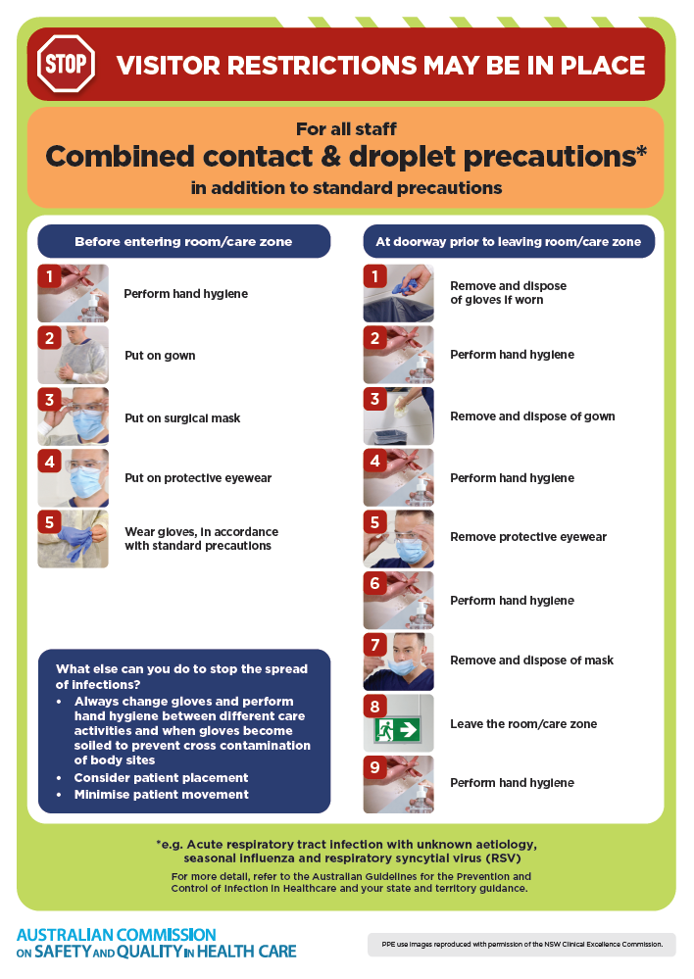
- Poster – Combined airborne and contact precautions
https://www.safetyandquality.gov.au/publications-and-resources/resource-library/infection-prevention-and-control-poster-combined-airborne-and-contact-precautions
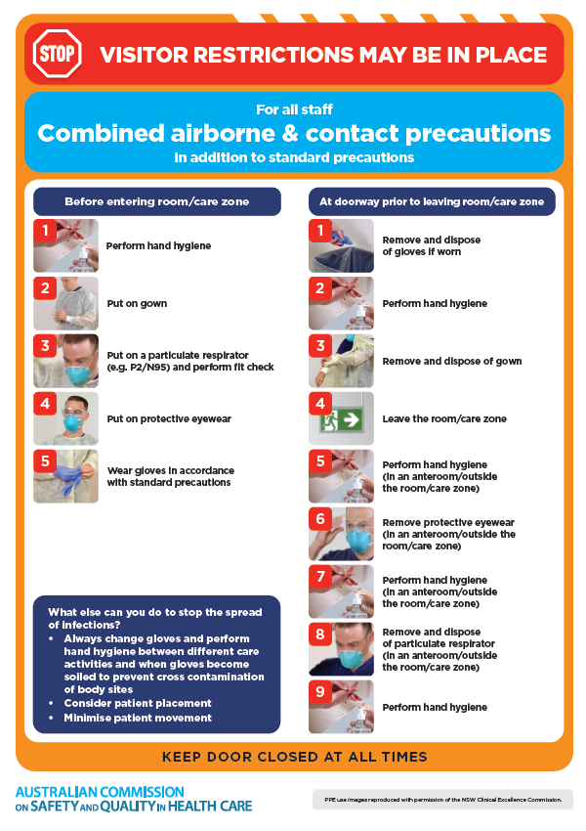
- Environmental Cleaning and Infection Prevention and Control www.safetyandquality.gov.au/environmental-cleaning
- Break the chain of infection poster
https://www.safetyandquality.gov.au/publications-and-resources/resource-library/break-chain-infection-poster
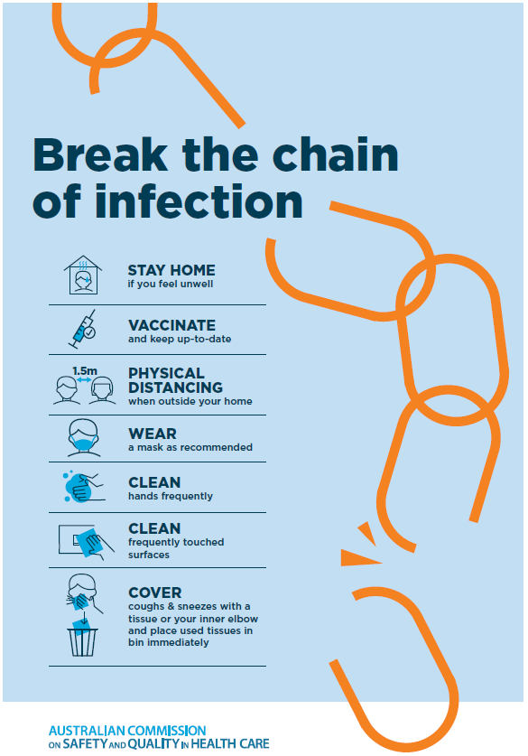
Disclaimer
On the Radar is an information resource of the Australian Commission on Safety and Quality in Health Care. The Commission is not responsible for the content of, nor does it endorse, any articles or sites listed. The Commission accepts no liability for the information or advice provided by these external links. Links are provided on the basis that users make their own decisions about the accuracy, currency and reliability of the information contained therein Any opinions expressed are not necessarily those of the Australian Commission on Safety and Quality in Health Care.

