
On the Radar
Issue 761
21 September 2026

On the Radar is a summary of some of the recent publications in the areas of safety and quality in health care Inclusion in this document is not an endorsement or recommendation of any publication or provider Access to particular documents may depend on whether they are Open Access or not, and/or your individual or institutional access to subscription sites/services Material that may require subscription is included as it is considered relevant.

On the Radar is available online, via email or as a PDF or Word document from
https://www.safetyandquality.gov.au/news-and-media/newsletters/on-the-radar

If you would like to receive On the Radar via email, you can subscribe on our website https://www.safetyandquality.gov.au/news-and-media/newsletters/on-the-radar
or by emailing us at mail@safetyandquality.gov.au.
You can also send feedback and comments to mail@safetyandquality.gov.au.

For information about the Commission and its programs and publications, please visit https://www.safetyandquality.gov.au

On the Radar
Editor: Dr Niall Johnson
Contributors: Niall Johnson, Courtney Webb, Kylie Tran, Hayley Warren, Brighid Carey

Evidence to inform options for standards for cultural safety: rapid literature review and environmental scan
Fuller J
Sydney: ACSQHC; 2026.
https://www.safetyandquality.gov.au/clinical-topics/first-nations-health#independent-rapid-literature-review-and-environmental-scan
The Australian Commission on Safety and Quality in Health Care commissioned an independent rapid literature review and environmental scan to inform options for strengthening cultural safety in Australian hospitals and support the Commission's broader standards for First Nations Cultural Safety Review. This work was undertaken by Jayde Fuller, Director of Indigenous Regulatory Practice.
This report is being shared as an independent resource to support consultation, engagement and co-design with Aboriginal and Torres Strait Islander peoples, organisations and other stakeholders. The findings provide an important evidence base to inform discussion and consideration of policy and reform options for strengthening First Nations cultural safety in hospitals and support ongoing discussions with First Nations peoples, communities, organisations, health services, professional bodies and governments. The report does not represent final Commission policy or decisions.

Raising consumer awareness of ultrasound in pregnancy
https://www.safetyandquality.gov.au/clinical-topics/womens-health#ultrasound-during-pregnancy

The Australian Commission on Safety and Quality in Health Care has developed new educational resources to help consumers better understand diagnostic and non-diagnostic ultrasounds during pregnancy. The new resources include:
- A fact sheet for consumers explaining the different types of pregnancy ultrasounds.
- A poster for display in healthcare practices, which includes a QR code linking to the fact sheet.

The fact sheet was co-designed with medical practitioners and consumers to ensure it is evidence-based, relevant, and responsive to the needs and preferences of patients. It explains the differences between diagnostic and non-diagnostic ultrasound scans and supports consumers to make informed decisions about their care.

The fact sheet is intended to complement discussions with healthcare providers and can be used as a take-home reference or incorporated into routine patient education.

Antimicrobial Resistance Data Explorer Dashboards
Australian Passive AMR Surveillance (APAS) and the National Alert System for Critical Antimicrobial Resistances (CARAlert) were established by the Australian Commission on Safety and Quality in Health Care to collect data on antimicrobial resistance (AMR) across Australia. Data analyses inform strategies for antimicrobial stewardship and infection prevention and control programs.

The Commission has recently published enhancements to the Data Explorer dashboards for both surveillance systems.

The APAS Data Explorer maps important AMR data by local area. It has been updated to include data from 2020 to 2025 for the existing multidrug-resistant organisms displayed on the dashboard, as well as new combinations:
- Staphylococcus aureus: resistance to clindamycin, erythromycin, and trimethoprim–sulfamethoxazole, respectively.
- Streptococcus pneumoniae: resistance to erythromycin or azithromycin, penicillin, and tetracycline or doxycycline, respectively.

The CARAlert Data Explorer has been updated to include data from January 2017 to June 2026 on critical antimicrobial resistances (CARs), which are priority organisms with critical resistance to last-line antimicrobials. The CARAlert Data Explorer enable trend tracking by year, state and territory, specimen type and resistance.

These data analyses inform strategies and priorities for antimicrobial stewardship and infection prevention and control programs, as well as prescribing guidelines and information for clinicians and consumers about safe and appropriate use of antimicrobials.
For more information and the latest data analysis reports, visit the Commission’s Antimicrobial Use and Resistance in Australia (AURA) webpage.
Updated High-Risk Medicines Education: Opioid Analgesics in Acute Settings module
https://hrmeducation.health.gov.au/

The Australian Commission on Safety and Quality in Health Care in collaboration with the Women’s and Children’s Health Network, South Australia have released the updated High-Risk Medicines Education: Opioid Analgesics in Acute Settings module.
The module follows scenario-based patient journeys, informed by real patient safety incidents and near misses to help learners apply key safety strategies with the use of opioids. Updates to the module include revised clinical content and enhanced interactive activities to improve user engagement.
The module is targeted to early career health professionals working in acute care, primary care and aged care.
Access the updated module at https://hrmeducation.health.gov.au/

Books

Human Experience in Action: Insights and Opportunities for Transforming Healthcare
Wolf JA, editor
Nashville: The Beryl Institute; 2026.
URL | https://theberylinstitute.org/human-experience-in-action/
Notes | The latest release from The Beryl Institute (who describe themselves as ‘global community of practice committed to transforming the human experience in healthcare’) is this book drawing on contributions from more 40 people working in the consumer and patient experience domain in many counties, including Australia.

Reports

Progress Report on the Joint Statement on the Inappropriate Use of Psychotropic Medicines to Manage the Behaviours of People with Disability and Older People
Aged Care Quality and Safety Commission, Australian Commission on Safety and Quality in Health Care, and the NDIS Quality and Safeguards Commission
ACSQHC, ACQSC and NDIS Commission; 2026.
URL | https://www.agedcarequality.gov.au/news-publications/news/release-progress-report-joint-statement-inappropriate-use-psychotropic-medicines-manage-behaviours-people-disability-and-older-people  https://www.safetyandquality.gov.au/clinical-topics/cognitive-impairment/reducing-inappropriate-use-psychotropic-medicines  https://www.ndiscommission.gov.au/psychotropicmedication
Notes | The foreword to this progress reports notes: ‘The importance of ensuring the safe and appropriate use of psychotropic medicines for people with disability and older people was highlighted by findings of the Royal Commission into Aged Care Quality and Safety and the Royal Commission into Violence, Abuse, Neglect and Exploitation of People with Disability.  In March 2022 the NDIS Quality and Safeguards Commission (NDIS Commission), the Australian Commission on Safety and Quality in Health Care (ACSQHC) and the Aged Care Quality and Safety Commission (ACQSC), signed a Joint Statement on the Inappropriate Use of Psychotropic Medicines to Manage the Behaviours of People with Disability and Older People (Joint Statement). The Joint Statement outlines a shared commitment to work together to reduce the inappropriate use of psychotropic medicines.  Since the Joint Statement was signed, the three Commissions have progressed a number of projects addressing the measures outlined.  This [progress] report brings together work that has been occurring to reduce the inappropriate use of psychotropic medicines for people with disability and older people, wherever they receive care and support.’

Learning from investigations where intrapartum care has been given at home. National learning report:
Daniels R, Bartlett E, Carritt J, Davison E, Anna Madeley, Manning L, et al.
Maternity and Newborn Safety Investigations (MNSI) programme 2026. p. 54.
URL | https://www.mnsi.org.uk/news/improving-patient-safety-for-intrapartum-care-at-home/
Notes | The latest from the Maternity & Newborn Safety Investigations (MNSI)programme in the UK is this report identifying a number of areas in which care could be improved for women receiving intrapartum care at home in the UK. The report includes a series of safety observations and prompts on topics such as staffing availability, training and guidance, and communications between different care professionals.

Vaccines, thiomersal and autism spectrum disorder. Evidence review 2010–2025
World Health Organization
Geneva: WHO; 2026.
URL | https://www.who.int/publications/i/item/9789240123533
Notes | For some decades there has been some debate, and misinformation and disinformation, about the safety of some vaccines and components of vaccines. This report from the World Health Organization (WHO) is a ‘systematic review [that] provides a current assessment of peer-reviewed studies published between 2010 and August 2025 investigating potential associations between vaccines and autism spectrum disorder (ASD), with particular focus on the organomercury vaccine component thiomersal, and also considers studies reporting other neurodevelopmental disorders (NDD). It updates previous WHO reviews by assessing the methodological quality, strength of evidence and risk of bias of the available literature. The review finds that the most methodologically rigorous primary studies do not support a causal association between vaccines, including thiomersal-containing vaccines, and ASD.’

Report of the Knowledge Community on responsible artificial intelligence in health. From promise to practice
World Health Organization
Copenhagen: WHO Regional Office for Europe; 2026. p. 34.
URL | https://www.who.int/europe/publications/i/item/WHO-EURO-2026-13381-53155-83077
Notes | According to the abstract from this resource: ‘This report presents the proceedings of the Knowledge Community on artificial intelligence (AI) in health, a 5-week structured online dialogue held between October and December 2025 by the WHO Regional Office for Europe. Bringing together clinicians, researchers, policy-makers and digital health experts from across the Region and globally, the Community explored what responsible AI in health means in practice. Discussions moved progressively from defining ethical and economically sustainable AI, through real-world examples of both promise and harm, to the barriers and enablers shaping deployment. Key barriers identified included fragmented and biased datasets, governance gaps, unclear accountability and AI literacy deficits. Enablers centred on strong governance frameworks, codesign with patients and clinicians, transparency and equitable access.’

National Commission into the Regulation of AI in Healthcare: Recommendations for a future regulatory framework
London: Medicines and Healthcare products Regulatory Agency; 2026; 2026. p. 119.
URL | https://www.gov.uk/government/publications/national-commission-into-the-regulation-of-ai-in-healthcare-recommendations-for-a-future-regulatory-framework
Notes | Report from the UK’s National Commission into the Regulation of AI in Healthcare. The National Commission was established to advise government on a future regulatory framework for AI in healthcare with a view to ensuring that patients can benefit from safe and effective AI technologies. The report considers the regulation of safe and effective software and AI-enabled medical devices but also broader issues such as accountability, transparency, clinical practice, organisational governance and system-wide level assurance.  The Commission's recommendations are organised around three connected areas of change.  - Proportionate lifecycle regulation  - System-wide responsibility and safe management  - Trust, transparency and predictability.  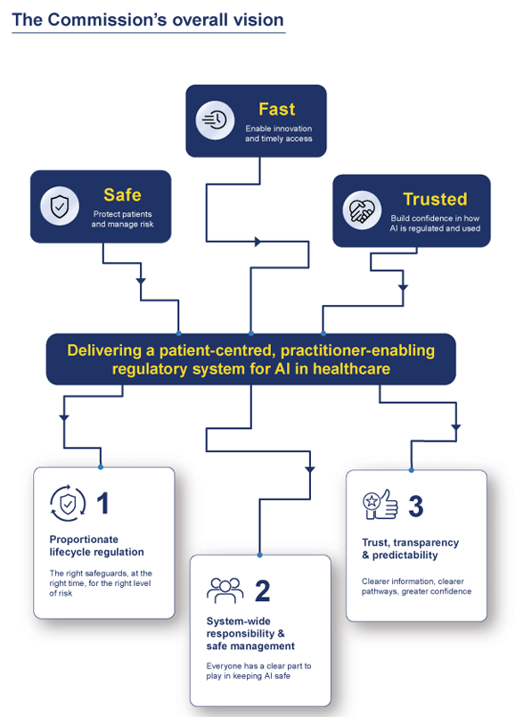
The public’s views on the regulation of AI in health care: findings from deliberative research and public polling and implications for policy
Thornton N, Gardner T, Binesmael A, Horton T, Burkitt R, Duxbury K, et al
London: Health Foundation; 2026. P. 54.

Care and consideration. Lessons for AI adoption in the public sector from a research collaboration with NICE
Machirori M, Rincon C, Studman A
London: Ada Lovelace Institute; 2026. P. 43.
URL | Health Foundation https://www.health.org.uk/reports-and-analysis/reports/the-publics-views-on-the-regulation-of-ai-in-health-care  Ada Lovelace Institute https://www.adalovelaceinstitute.org/report/care-and-consideration/
Notes | In addition to the WHO and UK National Commission reports on AI, a number of other reports have been released in the UK on the topic. These include reports from the Health Foundation and the Ada Lovelace Institute.  The Health Foundation’s report was commissioned by the Medicines and Healthcare products Regulatory Agency (MHRA) as part of the independent National Commission into the Regulation of AI in Healthcare (above). The report brought together polling and research exploring what the public thinks regulators should prioritise and what is needed to build and maintain public trust in AI regulation in the UK.  The report from the Ada Lovelace Institute stems from the Institute partnering with the UK’s National Institute for Health and Care Excellence (NICE) to explore the conditions that would enable the public body’s ethical adoption, evaluation and governance of AI, with a focus on tools for internal processes.

Journal articles

Regulating artificial intelligence in health care: a tech-enabled, people-centred future
Denniston AK, Hughes H
The Lancet Digital Health. 2026.
DOI | https://doi.org/10.1016/j.landig.2026.101113
Notes | Paper in The Lancet Digital Health co-authored by the chair of the UK’s National Commission into the Regulation of AI in Healthcare and the UK’s Patient Safety Commissioner that describes the National Commission and its final report. The authors note  ‘The recommendations include specific changes that aim to increase risk proportionality and balance risk versus benefit, providing flexibility to add safeguards where needed, and reduce regulatory burden where appropriate. We propose to rethink how we approach evidence (what we need when), with the requirements for evidence distributed more appropriately across the total product lifecycle of the device. We indicate that this approach will not only enhance safety during this post-market phase but will also provide an opportunity to accelerate some devices to market under conditional authorisations, supported by additional safeguards. The “in pathway” evidence can then be collected safely to support full authorisation in the UK and potentially internationally.  The report also advises that we need to be more system-wide in our approach to assuring safety, thinking less about regulation as simply an interaction between the manufacturer and product regulator but rather a fundamental duty with the manufacturer, health-care provider, and health-care professional having distinct responsibilities. We call for interventions that support those individuals in having greater clarity regarding their responsibilities (including on issues such as liability) and to ensure that health-care professionals can become competent and confident regarding AI technologies that become relevant to their role. We call for greater transparency regarding when AI is being used in health care, its provenance, and its ongoing performance and safety. We also call for greater predictability and clarity in the regulatory system, thus helping everyone to be confident that high-quality, safe technologies will get appropriate authorisation quickly and that low-quality, unsafe technologies will be rejected, backed up by enforcement powers to rapidly remove products from the market.’

Healthcare Policy
Volume 21, Number 4, August 2026
URL | https://www.longwoods.com/publications/healthcare-policy/27771/
Notes | A new issue of Healthcare Policy has been published. Articles in this issue of Healthcare Policy include:  - Editorial: Long-Stay Patients and The Curious Case of Disappearing Hospital Beds in Canada and Australia (Michael Pervan and J M Sutherland)  - Lack of Transparency in Pharmaceutical Industry Payments to Canadian Physicians and Patient Groups (Joel Lexchin)  - Commentary: Healthcare Partnerships, Medical Scandals and Canada’s Lack of Transparency in Pharmaceutical Donations (Sharon Batt)  - Wildfire Evacuation Lessons from La Ronge, a Northern Saskatchewan Site: Physician Debriefings (M Karnitsky, J D C Irvine, D Irvine and V McKinney)  - Commentary: Beyond Preparedness: What Rural Wildfire Evacuations Reveal about Health System Interfaces (Ellen Schenk)  - Who’s Coming Through the Door? Quantifying Care Continuity of Personal Support Services in Home Care (Sandra M McKay, Travis A Van Belle, David Fry, Kathryn A Nichol, Trevor Heer, W Lomas and E C King  - Should Health Canada Use Reports from Foreign Regulators to Approve New Drugs? (Joel Lexchin)  - Advancing Community Engagement in Healthcare in Rural British Columbia: A Gap Analysis to Improve Community Involvement in Healthcare Planning (Jude Kornelsen, Paul Adams and Kate Wills)  - Reporting and Accountability: An Assessment of the 2017 Bilateral Agreements in Canada (Whitney Loerzel, Leyna Lowe and Haizhen Mou)

Health Affairs
Volume 45, Number 9, September 2026
URL | https://www.healthaffairs.org/toc/hlthaff/45/9
Notes | A new issue of Health Affairs has been published with themes of ‘Health Care Finance, Costs, Spending & more’. Articles in this issue of Health Affairs include:  - Colorado Braces For Impact As It Prepares To Meet H.R. 1’s New Rules (Jessica Bylander)  - US Health Care Financing: Tax, Premium, And Out-Of-Pocket Contributions Among Tax Filers, 2023 (Irene Papanicolas, Maecey Niksch, Jonathan Cylus, and Bianca K Frogner)  - Medicare Advantage Rebates Are Too Large To Be Financed By Reductions In Plans’ Medical Spending Alone (Michael E Chernew, Jingwei Sun, and J Michael McWilliams)  - New Medicaid State-Directed Payment Limits Are Likely To Decrease Medicaid Spending By 10–25 Percent In 17 States (Debra J Lipson)  - Insurers’ Acquisition Of Ambulatory Surgery Centers Was Not Associated With Changes In Performance, 2013–21 (Xiaoxi Zhao, Nandita adhakrishnan, Cheryl L Damberg, Michael R Richards, and Christopher M Whaley)  - New MA Risk-Adjustment Model Had Limited Effects On Premiums And Cost Sharing, Small Effects On Benefit Generosity (Niru Ghoshal-Datta, Michael E Chernew, K Miller, A Chopra, E Everhart, and J M McWilliams)  - Same-Insurer Coverage Associated With Fewer Hospitalizations, More Outpatient Visits Among Dual-Eligible Enrollees (Hyunjee Kim, Angela Senders, Maanyatha Cheekati, S Edelstein, S Lindner, S M Retchin, and J Jung)  - Medicaid/CHIP Income Thresholds And Health Services Use Among Children In Low-Income Households, 2016–23 (Cristian R Ramos, Xu Ji, Hefei Wen, and Janet R Cummings)  - Growth In Participation Of Mental Health Counselors, Marriage And Family Therapists After Medicare Coverage Expansion (Yanlei Ma, Hefei Wen, Jiebing Wen, E John Orav, Ezra Golberstein, and José F Figueroa)  - WIC Benefits Issued Remotely Increased Participation, Especially In States With Online Benefit Distribution, 2017–21 (Emily C Dore, Matthew M Lee, Margaret McConnell, and Rita Hamad)  - Housing Instability And Acute Care Use Among Veterans Approved For A VA Home Loan And Those Who Were Denied (J Tsai, and H A Beydoun)  - Health Services Professionals Endorse Omitting Some Research Information Under Limited Circumstances: Survey (Alan S Gerber, Mackenzie Lockhart, Eric M Patashnik, and Harold A Pollack)  - To Omit Or Not To Omit? Why Transparency And Humility Are Compatible With Health Services And Public Health Leadership (Brian G Southwell)  - What Can You Say When You Can’t Say Everything? (Lori Dorfman, Liana B Winett, Katherine Schaff, and Pamela Mejia)  - Broken Teeth And The Quiet Cost Of Caregiving (Wang Xing)

BMJ Quality &Safety online first articles
URL | https://qualitysafety.bmj.com/content/early/recent
Notes | BMJ Quality &Safety has published a number of ‘online first’ articles, including:  - Establishing quality prescribing indicators for Australian primary care: a Delphi study (James Nind, Anna Mackintosh, Amanda J Cross, Gregory M Peterson, Constance Dimity Pond, Elizabeth Manias, Bandana Saini, Jan Radford, Johnson George)  - Standard Elements in Studies of Adverse Events and Medical Error (SESAME): explanation and elaboration (Richard T Griffey, Lee M Adler, David C Stockwell, Peter D Hibbert, Dorthe O Klein, Rene Schwendimann, Andrew D Auerbach, Rachel Ancona, Ryan M Schneider, David Classen, Christopher R Carpenter, Anne W S Rutjes, Maria Unbeck The SESAME Development Team)  - Equity-focused patient safety: reframing cultural competence, cultural humility and structural competence as determinants of patient safety (Anna Robinson-Barella, Hiranmayi Madabhushi Hari, Kayleigh Davison, Matthew Cooper, Evgenia Stepanova, Andrew Kenneth Husband, Hamde Nazar)

International Journal for Quality in Health Care online first articles
URL | https://academic.oup.com/intqhc/advance-articles
Notes | International Journal for Quality in Health Care has published a number of ‘online first’ articles, including:  - Comprehension of an AI-generated discharge letter versus a traditional discharge letter: two controlled quasi-experimental parallel-group studies (Fabrizio Bert, Lorenzo Rosset, Francesco Conrado, Daniele Consoli, Giacomo Scaioli, Giuseppina Lo Moro, Roberta Siliquini)  - Peer accountability in patient safety: an under-examined determinant of team performance (Marcos Martínez)  - Implementing clinician-led sustainability interventions in a tertiary intensive care unit: a quality improvement evaluation (Wei Jun Dan Ong, Faheem A Khan, Woon Hean Keenan Chong, Lawrence Ace Azul, A Kansal)  - Transitional care services are cost-effective for older patients with chronic obstructive pulmonary disease in Korea (Yu Seong Hwang, Deog Kyeom Kim, Jung-Kyu Lee, Eun Young Heo, Hyun Woo Lee, Su Kyoung Kim, Yukyung Park, Woo Jin Kim, Seon Sook Han, Yeon Jeong Heo, Da Hye Moon, Oh Beom Kwon, Myung Goo Lee, Ji Young Hong, Chang Youl Lee, Heui Sug Jo)  - Implementing System Improvement Actions After Peer Review of Emergency Department Incident Reports: A Before-and-After Quality Improvement Evaluation (Natsumi Hata and Tatsuya Nishiuchi)  - Physician Maldistribution Persisted Despite Health System Capacity Expansion in Türkiye, 2002–2023 (Ahmet Aykut and Leyla Merda Ekmen Aykut)  - Readability and Clinical Accuracy of AI-Generated Hospital Discharge Instructions: An Audit of Three Large Language Models (Rajat Goel)  - Decarbonising health systems while protecting quality and safety: everyone has a role (Jeffrey Braithwaite, Samantha Spanos, Carolynn L Smith, Yvonne Zurynski, Georgia Fisher, Lisa Pagano, Louise A Ellis, Kate Churruca, Ellen Joan van Vliet, Ezequiel Garcia-Elorrio)

Infection prevention and control resources
The Australian Commission on Safety and Quality in Health Care has developed a number of resources to assist healthcare organisations, facilities and clinicians These resources include:
- Poster – Combined contact and droplet precautions https://www.safetyandquality.gov.au/publications-and-resources/resource-library/infection-prevention-and-control-poster-combined-contact-and-droplet-precautions
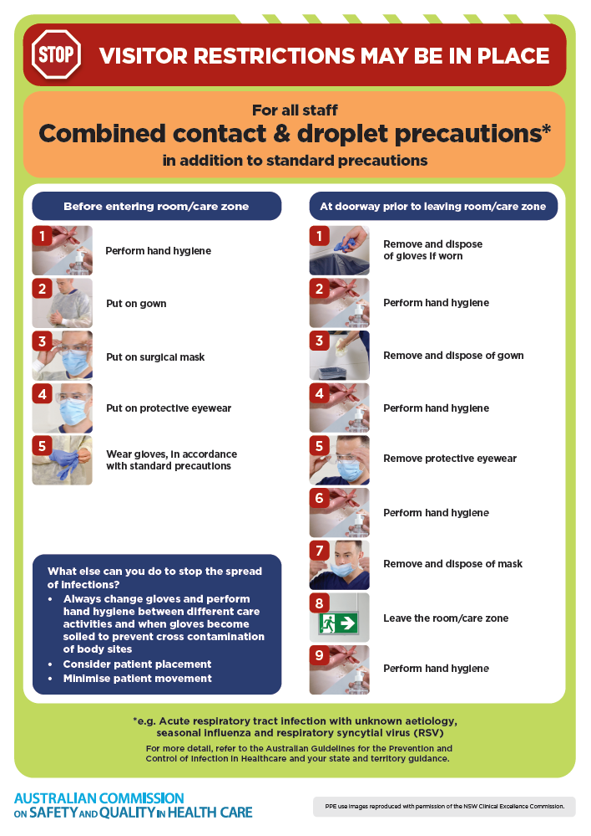
- Poster – Combined airborne and contact precautions
https://www.safetyandquality.gov.au/publications-and-resources/resource-library/infection-prevention-and-control-poster-combined-airborne-and-contact-precautions
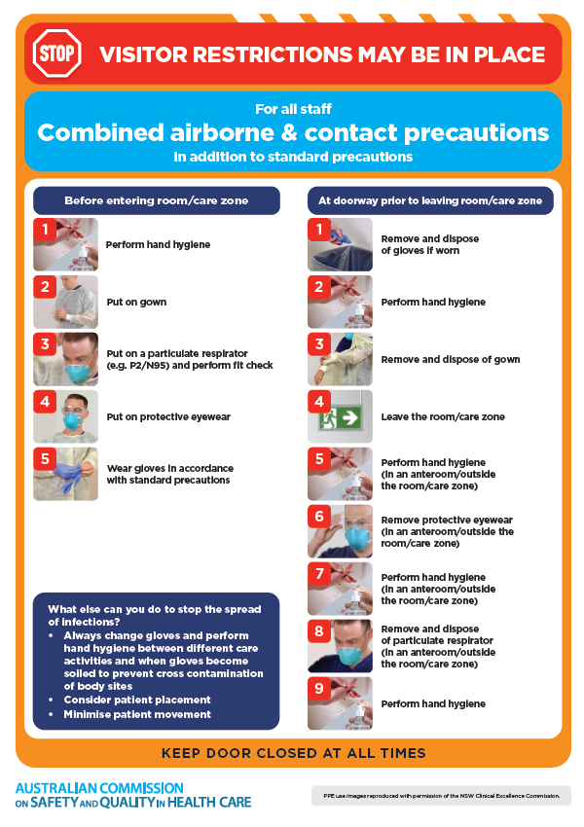
- Environmental Cleaning and Infection Prevention and Control www.safetyandquality.gov.au/environmental-cleaning
- Break the chain of infection poster
https://www.safetyandquality.gov.au/publications-and-resources/resource-library/break-chain-infection-poster
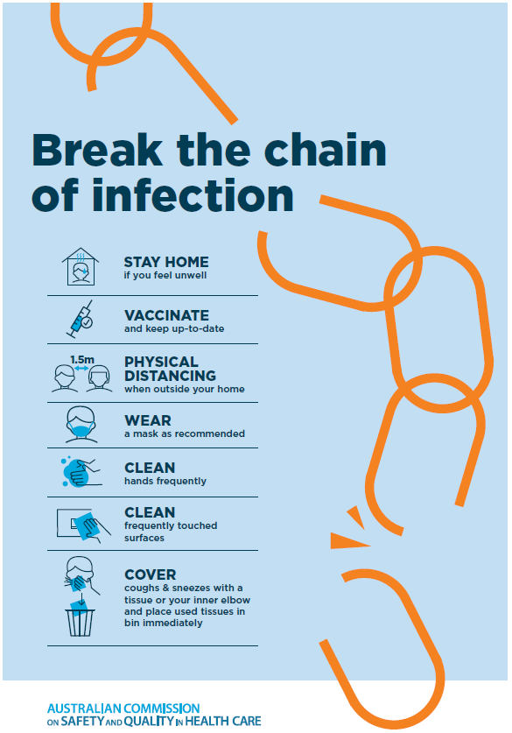
Disclaimer
On the Radar is an information resource of the Australian Commission on Safety and Quality in Health Care. The Commission is not responsible for the content of, nor does it endorse, any articles or sites listed. The Commission accepts no liability for the information or advice provided by these external links. Links are provided on the basis that users make their own decisions about the accuracy, currency and reliability of the information contained therein Any opinions expressed are not necessarily those of the Australian Commission on Safety and Quality in Health Care.

