
On the Radar
Issue 762
28 September 2026

On the Radar is a summary of some of the recent publications in the areas of safety and quality in health care Inclusion in this document is not an endorsement or recommendation of any publication or provider Access to particular documents may depend on whether they are Open Access or not, and/or your individual or institutional access to subscription sites/services Material that may require subscription is included as it is considered relevant.

On the Radar is available online, via email or as a PDF or Word document from
https://www.safetyandquality.gov.au/news-and-media/newsletters/on-the-radar

If you would like to receive On the Radar via email, you can subscribe on our website https://www.safetyandquality.gov.au/news-and-media/newsletters/on-the-radar
or by emailing us at mail@safetyandquality.gov.au.
You can also send feedback and comments to mail@safetyandquality.gov.au.

For information about the Commission and its programs and publications, please visit https://www.safetyandquality.gov.au

On the Radar
Editor: Dr Niall Johnson
Contributors: Niall Johnson

Reports

Mental health crisis care: care of patients in emergency departments
Health Services Safety Investigation Body
Investigation report
Poole: HSSIB; 2026.
URL | https://www.hssib.org.uk/patient-safety-investigations/safety-issues-for-people-experiencing-a-mental-health-crisis-who-come-into-contact-with-urgent-and-emergency-care-services/investigation-1-report-2-of-2/
Notes | The latest investigation report from the Health Services Safety Investigations Body (HSSIB) in the UK is the second of two investigation reports into crisis care in emergency departments (EDs), with the focus here on patients in ED in mental health crisis.  The report observes that ‘Around 3% of ED attendances are mental health-related. However, people experiencing mental health problems are twice as likely as other patients to remain in the ED for more than 12 hours.’  Furthermore, ‘The ED environment itself was a safety risk for people in mental health crisis. Busy, noisy, crowded and overstimulating spaces, together with limited privacy, poor observation, unsuitable rooms and long waits, could increase distress, deterioration, violence and aggression, and the likelihood of people leaving before care was complete. These risks were heightened where environments did not meet sensory, communication, neurodevelopmental, trauma-related or equality needs, and where dedicated mental health spaces were unavailable, unsuitable or inconsistently designed.’  The report includes findings, safety recommendations, observations and learnings that are applicable at various levels.

Journal articles

Centring Aboriginal and Torres Strait Islander Voices: A Framework for Culturally Safe and Racism-Free Healthcare
Elvidge E, West R, Nicholls K, Harvey K, Thompson Y, Rogers GB, et al
Medical Journal of Australia. 2026;224(9):e70295
DOI | https://doi.org/10.5694/mja2.70295
Notes | Piece in the Medical Journal of Australia whose authors ‘propose a framework to strengthen cultural safety through Aboriginal and Torres Strait Islander community-governed assessment, greater accountability, data sovereignty and mandated cultural safety and anti-racism standards.’ The authors assert that ‘Positive models already exist, particularly within ACCHOs [Aboriginal Community Controlled Health Organisations], demonstrating that culturally safe care is both attainable and sustainable when communities are empowered through self-determination’  The Commission recently commissioned an independent rapid literature review and environmental scanhttps://www.safetyandquality.gov.au/clinical-topics/first-nations-health#independent-rapid-literature-review-and-environmental-scan to inform options for strengthening cultural safety in Australian hospitals and support the Commission's broader standards for First Nations Cultural Safety Review.

Time for an Update: The Currency of Clinical Guidelines in Australia—A Cross-Sectional Analysis
White H, Fernandes E, Peduru-Arachchige K, Turner T, McGloughlin S, McDonald S.
Medical Journal of Australia. 2026;224(9):e70288
DOI | https://doi.org/10.5694/mja2.70288
Notes | Recent piece in the Medical Journal of Australia suggesting that ‘For most high-priority clinical conditions in Australia, there are no up-to-date evidence-based guidelines available to support clinical decision-making.’ The authors suggested that ‘Guideline developers and funders should invest more energy and resources into planning for updates and ensuring that methods and processes are optimised to facilitate this, such as considering a living approach.’

The AUstralian-CLimate and Health Attitudes, RIsk and Trust in the sYstem (AU-CLARITY) Study: A National, Representative Survey
Braithwaite J, Smith CL, Zurynski YA, Ellis LA, Fisher G, Churruca K, et al.
Medical Journal of Australia. 2026;224(9):e70293
DOI | https://doi.org/10.5694/mja2.70293
Notes | Piece in the Medical Journal of Australia reporting on an online survey that sought the views of 6030 adults in Australia on ‘experiences of climate-related events, and views on climate change and health system preparedness.’ While the majority of respondents ‘(65%, 3910/6030) were concerned about climate change, yet only 45% (2735/6030) perceived it as a serious risk to their own health.’  The authors conclude: ‘Many Australians recognise climate change as a health challenge; personal risk perception and confidence in system preparedness vary. Targeted health policies are needed to effectively communicate health risks and support healthcare's climate change resilience.’  Disclosure: The lead author is also an Australian Commission on Safety and Quality in Health Care Board member.

Complaining about healthcare can feel like an act of betrayal. But there is a real cost to silence
Srivastava R
The Guardian. 2026 21 September 2026.
URL | https://www.theguardian.com/commentisfree/2026/sep/22/healthcare-system-failure-patient-complaints-cost-to-silence
Notes | In her most recent column this Australian oncologist and commentator reflects on the many challenges that complaints can pose for patients and clinicians.  Complaints are also considered important information for patient satisfaction, quality and governance measures. Some recent examples of literature include:  - Lyu L, Song Y, You R, Lin X, Chen H. Comparisons of patient complaint management systems in China, the United States, United Kingdom, Germany, and Japan: A ‘structure-process-outcome’ analytical framework. Health Policy. 2026;171:105655.  - Pripkó J, Pusztafalvi H. Reframing patient complaints as a quality and governance function in healthcare. International Journal for Quality in Health Care. 2026:mzag073.  - Reader TW. Learning from healthcare complaints: challenges and opportunities. BMJ Quality & Safety. 2026;35(2):78-82.  - Reader TW, Gillespie A, Roberts J. Patient complaints in healthcare systems: a systematic review and coding taxonomy. BMJ Quality & Safety. 2014;23(8):678-689.  - Wang Y, Ram S, Scahill S. Risk identification and prediction of complaints and misconduct against health practitioners: a scoping review. International Journal for Quality in Health Care. 2024;36(1):mzad114.

BMJ Quality & Safety
Volume 35, Issue 9, September 2026
URL | https://qualitysafety.bmj.com/content/35/9
Notes | A new issue of BMJ Quality & Safety has been published. Many of the papers in this issue have been referred to in previous editions of On the Radar (when they were released online). Articles in this issue of BMJ Quality & Safety include:  - Editorial: Operationalising ‘what matters’—will we ever find a way to patient-centred care? (Margaret Schwarze, Kate Telma, Lauren J Taylor)  - Editorial: Healthcare provision in prisons: an ongoing challenge (Emma Plugge, Caroline Watson)  - Editorial: Please document the nature of the medical emergency (J A Gold)  - Integrating ‘what matters’ conversations into preoperative care: a qualitative evaluation of surgical team workflows and barriers (Kirstin Manges Piazza, Lindsay R Pelcher, Phoebe Whiteside, Morgan Cribbin, Amanda D Peeples, Caroline Pascal, Laura Ellen Ashcraft, Robert E Burke, Daniel Hall)  - The incidence of avoidable healthcare-associated harm in prisons in England: a retrospective case note review (Isobel Joy McFadzean, Saied Ibrahim, Verity Wainwright, Maria Panagioti, M Jordan, S Flynn, R N Keers, T Millar, D M Ashcroft, A Edwards, A J Avery, J Shaw, A Carson-Stevens)  - Equity in action: a scoping review and meta-framework for embedding equity in quality improvement (Tara A Burra, Bourne Auguste, Lisha Lo, Toluwanimi Durowaye, Haben Dawit, Susanna Fung, Christine Shea, Terri Rodak, Noor Ramji, Sanjeev Sockalingam, Brian M Wong)  - Effectiveness of clinician-directed default nudges on reducing overuse of tests and treatments in healthcare: a systematic review of randomised controlled trials (Gemma Altinger, Caitlin M P Jones, Giovanni E Ferreira, Jason Soon, Tammy C Hoffmann, C Maher, R Chang, J A Linder, A Traeger)  - When documentation changes but behaviour persists: de-implementation in a neonatal intensive care unit (Mohammad Adawi, Matthew Garber, Padma Nandula, Vasantha H.S Kumar, Ida Alami, Sanket D. Shah)  - Radiology reporting in the age of artificial intelligence: implications for patient safety (Igor Toker, Sven Jansen, Julius Knoche, Daniel Lorenz)

BMJ Quality & Safety
Volume 35, Issue 10, October 2026
URL | https://qualitysafety.bmj.com/content/35/10
Notes | A new issue of BMJ Quality & Safety has been published. Many of the papers in this issue have been referred to in previous editions of On the Radar (when they were released online). Articles in this issue of BMJ Quality & Safety include:  - Editorial: Audit and feedback in primary care: if you build it, will they come? Understanding which clinicians engage with an audit and feedback intervention (Steve Van den Bulck, Bert Vaes)  - Editorial: Interprofessional learning as a mechanism for quality improvement and patient safety (Andreas Xyrichis, Merrick Zwarenstein)  - Who chooses to engage? Understanding the characteristics of physicians who voluntarily engage with an audit and feedback intervention: a retrospective cohort study (Cherry Chu, Noah Ivers, Braeden Terpou, Mina Tadrous, Canyucel Gungor, Geneviève Rouleau, Laura Desveaux)  - Implementation of a patient-centred complex intervention to improve Initial Medication Adherence to cardiovascular disease and diabetes treatments in primary care (the IMA-cRCT study): a mixed-methods process evaluation (Carmen Corral-Partearroyo, Alba Sánchez-Viñas, María Teresa Peñarrubia-María, Montserrat Gil-Girbau, Ignacio Aznar-Lou, Claudia Palma-Vasquez, C Gallardo-González, M del Carmen Olmos-Palenzuela, M Rubio-Valera)  - International survey of people living with chronic conditions: development and evaluation of the PaRIS Patient Questionnaire (PaRIS-PQ) in 18 countries (Jose M Valderas, Ian Porter, Jonathan P Evans, Monique Heijmans, Mieke Rijken, Oliver Groene, Janika Bloemeke-Cammin, R Sunol, R Williams, M Ballester, K de Bienassis, C Kendir, F Guanais, D de Boer, M van den Berg)  - Cocreation and codesign in maternal health: processes, outcomes and implementation challenges (Mohamed Rishard, Kavinda Rajaratne, Kavinda Jayasingha, Hemantha Senanayake, Millawage Supun Dilara Wijesinghe)  - Development and pilot evaluation of the implementation of a whole-team training pack to improve the effectiveness, efficiency, safety and equity of remote general practice (Joseph Clift, Francesca Helen Dakin, Anwar Khan, Nicholas Woodier, Trisha Greenhalgh, Rebecca Payne)  - How can we prevent clinical deskilling when using AI? (Ian Scott, Anton van der Vegt, Peter Douglas)

The Joint Commission Journal on Quality and Patient Safety
Volume 52, Issues 10, October 2026
URL | https://www.sciencedirect.com/journal/the-joint-commission-journal-on-quality-and-patient-safety/vol/52/issue/10
Notes | A new issue of The Joint Commission Journal on Quality and Patient Safety has been published. Articles in this issue of The Joint Commission Journal on Quality and Patient Safety include:  - Is AI Patient Safety 4.0? From Find-and-Fix to Continuous Intelligence: Toward Care That Needs No Advocate (Jonathan B Perlin)  - CommonSpirit Health’s Innovative Approach to Achieving and Sustaining Clinical Excellence (Stephanie Rogers, Tracy Sklar, John Morelli, L Jenson)  - Improving Health Equity in Hypertension Control for Black Patients (Catherine T Harper, Stacey K Hammer, Olugbemiga E Jegede, Stefannie Cairrikier Davidson, Leslie Kern, Tiffany Randolph, Kardie Tobb)  - How Collaboration Between Surgeons and Medical Oncologists Affects Outcomes for Patients with Pancreatic Cancer (Anays Murillo, Sing Chau Ng, Sarah M Schroter, Sara Myers, Joseph Tobias, Kelly Kenzik, Teviah E Sachs)  - A Framework to Characterize the Costs of Delayed Diagnoses (Carl T Berdahl, Joachim M Hero, Sara G McCleskey, Dave Baiocchi, Elizabeth Marsolais, Daniel A Yang, G D Schiff, A Kern-Goldberger, S C Ahluwalia)  - Informing the Measurement of Timely Follow-Up on Inconclusive or Abnormal Screening Mammograms: An Environmental Scan (Marlika Marceau, Omar Nafaa, C Mita, L Samal, D W Bates, P C Dykes, A Syrowatka)  - Symptom Tracking in Primary Care: Designing and Testing an EHR–Embedded Safety-Net System (Talya Salant, James Benneyan, Anthony Zhong, Jasper Su, Molly Hodsden, Seth J. Berkowitz, R Phillips, G D Schiff)  - Developing and Validating a Trigger Tool to Improve Detection of Anticoagulation-Associated Bleeding in Hospitalized Adult Patients (Uyen Thi Nguyen, Nguyen Tran Nam Tien, Khai Xuan Bui, Phung Gia Nghiem, Minh Huy Nguyen, La Vinh Truc Tran, Huyen Thi Thu Cao, Hoa Dinh Vu, Quynh Thi Huong Bui, Hoang Anh Nguyen)  - Empowering Sustainability During Kidney Transplants Using a Patient Safety Framework (Maria Lee, Arielle Ilano, Gerry Gamino, Eugene Gil, Ifechukwu Okeke, Lora Randa, Akash Shanmugam, Seema Gandhi, G R Roll)  - Redesigning a Culture of Safety and High Reliability—Advancing our Patient Safety Organizational Learning System Through the Kirkpatrick Framework (Sandip A Godambe, Frank Federico, Emily Tooley, Jared Capouya, Brittany Pfeifer, Kristen Frost, Timothy McDonald)  - Survey Response Rate as an Operational Lever in Hospital Patient Experience Measurement: Evidence from National HCAHPS, OAS CAHPS, and CMS Overall Hospital Star Ratings Data (Samuel J Flanders)  - Uneven Compassion and the Emotional Safety of the Healthcare Workforce (Sheila K Stevens, Richard M Elias)

Journal of Primary Health Care
Volume 18, Issue 3, September 2026
URL | https://connectsci.au/hc/issue/18/3
Notes | A new issue of the Journal of Primary Health Care has been published. Articles in this issue of the Journal of Primary Health Care include:  - Editorial: It’s more than just a good consultation: defining high quality primary (health) care(Felicity Goodyear-Smith, Tim Stokes)  - Cefalexin prescribing appropriateness in general practice: an evaluation study (Ibrahim S Al-Busaidi, Sarmad Qamar, Yao-Min Lin, Dee Mangin, B Hudson)  - Paracetamol-associated knowledge, attitudes and practices of the New Zealand public: an online survey (Samantha Marsh, Eeva-Katri Kumpula, Sarah Hetrick, Sarah Fortune)  - Comparing physical examination in face-to-face and remote External Clinical Teaching Visits in general practice vocational training (Benjamin Mundy, Alison Fielding, Amanda Tapley, Sarah Gani, Rula Ali, M Bentley, R Boland, L Zbaidi, E Holliday, J Ball, M van Driel ,L Klein, P Magin)  - Evaluating dispensing patterns of Parkinson’s medications from 2012 to 2024 in Australia: insights from the Pharmaceutical Benefits Scheme concessional database (Saisha Shetty, A Park, E Kruger, M Siervo, M Tennant)  - Assessing the applicability of the Model for Understanding Success in Quality (MUSIQ) for primary care: a multi-case mixed methods analysis (Jane Cullen, Nihal Jayamaha, Paul Childerhouse, Lynn McBain)  - Primary care clinicians’ perspectives on migraine management in Aotearoa New Zealand: a qualitative study (Julia Randerson, Fiona Imlach, Jonathan Kennedy, Susan Garrett)  - Strategies for research capacity building by family physicians in primary care: a scoping review (Margarida Gil Conde, Carolina Penedo, Francisco Freitas Barcelos, Raquel Carmona Ramos, Sofia Silvério Serra, Cristina Ribeiro, Paulo Jorge Nicola)  - Methods for measuring comprehensiveness in primary care: a narrative review (Derek Baughman, Rafay Nasir, Andrew Bazemore)  - A wholistic approach to patient-empowered care: a quality improvement report (Andrew Corin)  - Carbon emissions of urban general practice and waste to landfill audit: a quantitative case-study in New Zealand (Darla Stroud-Bennett, Lachlan White, Kiyomi Kitagawa)  - From continuity to emergence: a new conceptual framework for primary care (Jonathan Edward Simon)  - What does the evidence tell us: are hearing aids worth recommending for mild to moderate hearing loss? (Vanessa Jordan)  - Rokoā (Rongoā) Māori in primary care: supporting safe use alongside prescribed medicines (Brendon McIntosh, Jo Barnes)

Public Health Research & Practice
Volume 36, Issue 3, September 2026
URL | https://connectsci.au/pu/issue/36/3
Notes | A new issue of Public Health Research & Practice has been published. Articles in this issue of Public Health Research & Practice include:  - How can we meaningfully involve older adults in aged care research? Insights from establishing a consumer research advisory group (Janani Thillainadesan, Danielle Hutchinson, Carrie Hayter, Matthew Halpin, Joanne Coombes, Diane McPhail, Alan McPhail)  - ‘Join Us’: the vanguard phase of a disease-agnostic Australian research register(Bruce Neal, Jessica Smith, Clare Arnott, Louisa Ruth Jorm, Rachel Neale, Anthony Brown, Greg Stewart, Lauren Houston, Helen Monaghan)  - Using administrative health data to ascertain ovarian cancer treatment information in Australia: a validation against medical records (Kate Gersekowski, Jim Codde, Paul A Cohen, Peter Grant, S J Jordan, P M Webb)  - Evaluation capacity building in community health using a learning-by-doing approach: project overview and study protocol (Stephanie M Fletcher-Lartey, Ben J Smith)  - Unpacking stigma, health and wellbeing needs of women partners of men who have sex with men (Kyla Lawson, Bernard Saliba, Ses Salmond, S Sawleshwarkar, C MacPhail, J Costello, D McCreadie, C Gierck, A Dawson)  - Improving allied health service use for type 2 diabetes management in Australia: a scoping review of barriers, enablers and policy opportunities (Emma Cox, Tiffany Tsoukalas, Sophia Parada, Sarah Dennis, Pippy Walker, Gideon Meyerowitz-Katz, Victoria Silvestro, Stephen Colagiuri, A A Gibson)

Journal of Health Services Research & Policy
Volume: 31, Number: 4, October 2026
URL | https://journals.sagepub.com/toc/hsrb/31/4
Notes | A new issue of the Journal of Health Services Research & Policy has been published. Articles in this issue of the Journal of Health Services Research & Policy include:  - Editorial: Beyond preparedness: Building resilient health systems through capabilities (Giovanni Fattore)  - Assessing the resilience of a key health service: The response of acute surgical provision in England to the disruption of the COVID-19 pandemic (Andrew Hutchings, Orlagh Carroll, Geoff Bellingan, David Cromwell, S Ramani Moonesinghe, S J Moug, N Smart, R Vohra, R J Hinchliffe, R Grieve)  - Improving the quality of residential care for people with disabilities — What is the experience of inspectors when implementing care quality regulations in Ireland? (Paul Dunbar, Laura Keyes, John P Browne)  - Shared clinical governance arrangements between NHS and independent acute hospitals in England: Findings from a national survey of senior leaders (Gemma Stringer, Jane Ferguson, Kieran Walshe, Christos Grigoroglou, Thomas Allen, Michael Anderson, Karen Bloor, Eleanor Gee, Nils Gutacker)  - A qualitative study on addressing COVID-19 vaccine hesitancy in marginalised communities in the UK - Professional and public perspectives (Basharat Hussain, Helen Marson-Smith, Benjamin Duke, Mimi Gbadesire, Sadaf Khurshid and Stephen Timmons)  - Help and support for gambling harm among United Kingdom Armed Forces personnel: A mixed-methods study (Blair Biggar, Hannah Champion, Matthew Jones, Glen Dighton, Justyn Larcombe, Matt Fossey and Simon Dymond)  - Rapid adaptation of first contact physiotherapy services for musculoskeletal patients in the UK and Australia during the COVID-19 pandemic: A multiple case study (Oluwatoyin Adenike Adeniji, Theopisti Chrysanthaki, Evangelos Pappas, Magdalena Zasada, Karen Stenner and Nicola Carey)  - Addressing health worker migration in Africa (Sunny C. Okoroafor, James Avoka Asamani, San Boris Bediakon, Adam Ahmat, Egide Rwamatwara, Ogochukwu Chukwujekwu and Kasonde Mwinga)  - Protected appointment-based waiting list strategies are associated with waiting time reductions in outpatient and community health services: A systematic review and meta-analysis (Kate E Noeske, Nicholas F Taylor, Annie K Lewis and Katherine E Harding)

BMJ Quality &Safety online first articles
URL | https://qualitysafety.bmj.com/content/early/recent
Notes | BMJ Quality &Safety has published a number of ‘online first’ articles, including:  - Documentation-related diagnostic safety concerns in primary care: a structured medical record review of 1116 patient records (Rita Fernholm, Caroline Kappelin, Elinor Nemlander)

International Journal for Quality in Health Care online first articles
URL | https://academic.oup.com/intqhc/advance-articles
Notes | International Journal for Quality in Health Care has published a number of ‘online first’ articles, including:  - Comparing methodological approaches for outlier detection: a cross-sectional study of older persons in 2,744 Australian long-term care facilities (Dylan Harries, Johannes Schwabe, Robert N Jorissen, Brian W Pulling, Gillian E Caughey, Tracy Comans, Maria C Inacio, the ACAC QMET Collaborators)  - ISO 9001 and JCI Preparedness as Drivers of Quality Improvement at a Tertiary Cardiac Care Center: A Five-Year Analysis from Pakistan (Huma Shakoor, Waqas Naseem, S S Ahmad Shah, N Shah, A Karim, T Rasool)  - The intent is good but… Exploring barriers and enablers to clinical pathway use in regional Australian Emergency Departments (Innocent Tawanda Mudzingwa, Phoebe Griffin, E Tavender, G Barrington, V Tran, S J Prior)  - Effect of an ERAS Nursing Protocol on Recovery After Minimally Invasive Lumbar Fusion: A Randomsized Trial (Yun Gao, Na Wang, Ling Zhang)  - Patient perspectives on transdisciplinary models of care in allied health: a qualitative study (Casey Peiris, Aruska D’Souza, Jacqueline Van Groningen, J Seymour, K Donohoe, A da Silva, C Marston, J Lewis, J Langford, L Rees)  - Data, Digital Health and AI: Building the Foundations of Modern Quality Management in Healthcare (Amar Shah and Usman Iqbal)  - In Response to Baker et al.: Reconsidering the Balance Between Access and Continuity in Primary Care (Andi Ratu Boelqiah Assaad et al)  - We Are Confused—Are You? Towards Terminology Clarity in Care Delivery: Pathway, Journey, Process, or Chain? (Diaz M Prameyllawati and Evelien S van Hoorn)  - Sustainable quality improvement interventions to ensure adequate documentation of chaperone presence in breast clinic: A multi-cycle clinical audit (Cian M Hehir, Gavin G Calpin, Nadia Walsh, Gordon R Daly, Gavin P Dowling, S Hembrecht, K Kearns, M Allen, A Butt, C Power, A D K Hill)  - Factors Associated with the Presence of Non-Conformities in the Certification of Hospital Clinical Management Units in Andalusia (Patricia Bonachela-Solás, Luis López-Rodríguez, Antonio Cervera-Barajas, Elena Varela-Rubio, Rubén Morilla-Romero de la Osa)  - Targeting what matters: A quasi-experimental controlled before-and-after study on targeted double checks in parenteral medication administration (Afke van de Plas, Fatma Karapinar-Çarkit, J Jacobs, R Rennenberg, D Klein)  - From Safety Science to Operational Reality: Competing Institutional Logics in the Translation of National Patient Safety Recommendations (Mohammad Farhad Peerally, Elizabeth Sutton, Jane Ferguson, Kieran Walshe, Natalie Armstrong, Expert Advisory Group to REACTION)  - Expectation–perception gaps in healthcare service quality: A systematic review and meta-analysis toward service design–oriented healthcare evaluation (Li-Yu Tseng and Kevin C Tseng)

Online resources

[UK] NICE Guidelines and Quality Standards
https://www.nice.org.uk/guidance
The UK’s National Institute for Health and Care Excellence (NICE) has published new (or updated) guidelines and quality standards The latest reviews or updates include:
- NICE Guideline NG253 Suspected sepsis in people aged 16 or over: recognition, assessment and early management https://www.nice.org.uk/guidance/ng253
- Clinical Guideline CG143 Sickle cell disease: managing acute painful episodes in hospital https://www.nice.org.uk/guidance/cg143

[USA] Effective Health Care Program reports
https://effectivehealthcare.ahrq.gov/
The US Agency for Healthcare Research and Quality (AHRQ) has an Effective Health Care (EHC) Program. The EHC has released the following final reports and updates:
- Predictors, Consequences, and Organizational Interventions for Burnout Among Healthcare Workers: A Systematic Review of Longitudinal Studies https://effectivehealthcare.ahrq.gov/products/worker-safety-wellness/research

Infection prevention and control resources
The Australian Commission on Safety and Quality in Health Care has developed a number of resources to assist healthcare organisations, facilities and clinicians These resources include:
- Poster – Combined contact and droplet precautions https://www.safetyandquality.gov.au/publications-and-resources/resource-library/infection-prevention-and-control-poster-combined-contact-and-droplet-precautions
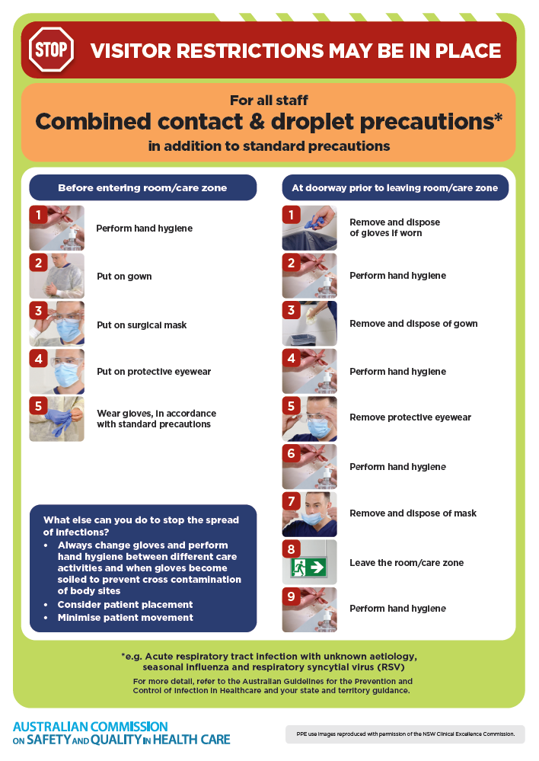
- Poster – Combined airborne and contact precautions
https://www.safetyandquality.gov.au/publications-and-resources/resource-library/infection-prevention-and-control-poster-combined-airborne-and-contact-precautions
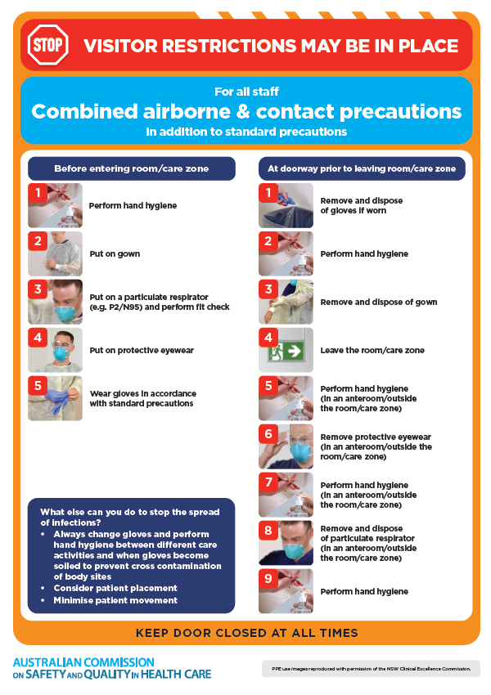
- Environmental Cleaning and Infection Prevention and Control www.safetyandquality.gov.au/environmental-cleaning
- Break the chain of infection poster
https://www.safetyandquality.gov.au/publications-and-resources/resource-library/break-chain-infection-poster
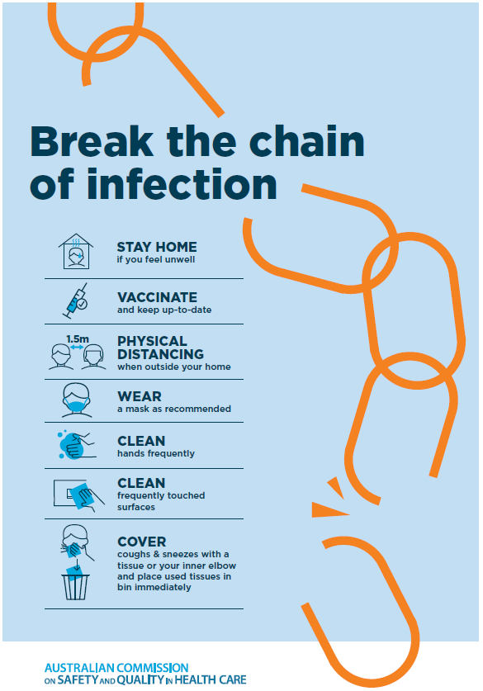
Disclaimer
On the Radar is an information resource of the Australian Commission on Safety and Quality in Health Care. The Commission is not responsible for the content of, nor does it endorse, any articles or sites listed. The Commission accepts no liability for the information or advice provided by these external links. Links are provided on the basis that users make their own decisions about the accuracy, currency and reliability of the information contained therein Any opinions expressed are not necessarily those of the Australian Commission on Safety and Quality in Health Care.

