World AMR Awareness Week

Ideas for activities and events in 2026

This guide provides ideas from the Commission and other groups for running activities and events to promote the key messages of World Antimicrobial Resistance Awareness Week (WAAW).

Run games and competitions for consumers
- Run an ‘Antibiotic or not?’ challenge and present participants with common infections. Ask them to decide whether antibiotics are likely to help.
- Get participants to complete a checklist of actions that help prevent antimicrobial resistance (AMR). For example: washing their hands regularly, ensuring their vaccinations are up to date and learning one fact about AMR. The participant with the most completed actions wins.
- Display posters with a QR code that links to the WAAW Consumer Quiz. Examples of posters can be found on the World Health Organization (WHO) website – Campaign materials.
- Hold a WAAW poster competition and display entries throughout the organisation.
- Set up a guessing game where participants estimate how many vials of ceftriaxone, or another broad-spectrum antimicrobial, were used during the year.

Conduct consumer information sessions
Inform consumers (including patients and their carers) about why antimicrobials need to be used carefully, and how they can help. You can use the Commission’s consumer PowerPoint presentation, and distribute written information to consumers about the Antimicrobial Stewardship Clinical Care Standard, and what it means for patients and consumers. You could also hand out the Commission’s Do I really need antibiotics? fact sheet and information on making decisions about antimicrobials use for middle ear infection in children, bronchitis, sore throat, chronic obstructive pulmonary disease (COPD) exacerbation and sinusitis. The Commission has a new For Consumers section on its website which includes information about antibiotics and AMR.

Download the Commission’s World AMR Awareness Week resources
The Commission updates the suite of WAAW resources annually which can be used by health service organisations to conduct local activities. The suite of resources includes a clinician and consumer quiz, clinician and consumer PowerPoint presentation, a World AMR Awareness Week 2026 and a Think before using antibiotic poster, web banner and email banner. Get creative about how and where you use the resources.

Audit the volume and appropriateness of local antimicrobial prescribing
Health service organisations can review the volume and appropriateness of antimicrobial use and prescribing by using audit tools. The National Antimicrobial Utilisation Surveillance Program (NAUSP) can be used to review usage rates while tools such as the National Antimicrobial Prescribing Survey (NAPS), can be used to assess appropriateness. Some health service organisations may have their own local tools which they can use. The local audit data for volume and appropriateness can be used to provide local feedback and encourage discussion during WAAW. Consider incorporating slides on local health service results in the Commission’s PowerPoint presentation.

Target healthcare professionals
Run information sessions for specific groups of healthcare professionals and discuss their role in the appropriate use of antimicrobials and antimicrobial stewardship. For example, organise ward-based education sessions with nurses, information sessions with pharmacists, or run a feedback session for prescribers. Consider which group would be most appropriate to target in your organisation e.g. junior doctors or consultants or visiting medical officers. Use these sessions to share the results of antimicrobial prescribing audits and highlight performance against the Antimicrobial Stewardship Clinical Care Standard indicators.

Create an information display
Choose a prominent area of the health service organisation to display the Commission’s resources as well as local resources from your health service. You could also:
- Hand out written material with information on where to find local policies, procedures, and local processes for seeking specialist advice or referral, as well as contact details of antimicrobial stewardship team members.
- Have a range of healthcare workers rostered to staff the display including doctors, nurses, pharmacists and managers, to reflect the multidisciplinary nature of good antimicrobial management.
- Create a display featuring local information relevant to antimicrobial use. For example, antimicrobial usage audit results or local resistance and susceptibility data. The Commission has a poster that can be printed and displayed.
- Be innovative. A mobile WAAW trolley with an entry box for the WAAW quiz; creative catering such as bacteria cake pops, WAAW fortune cookies or jelly agar treats with WAAW messages printed.
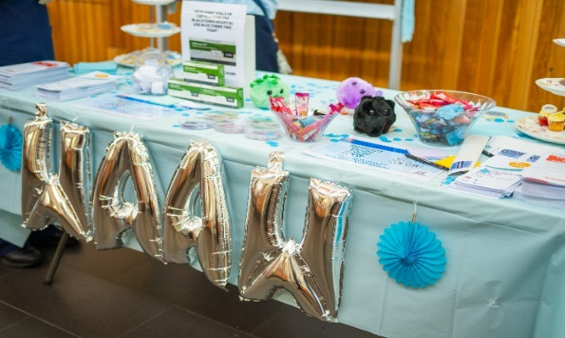
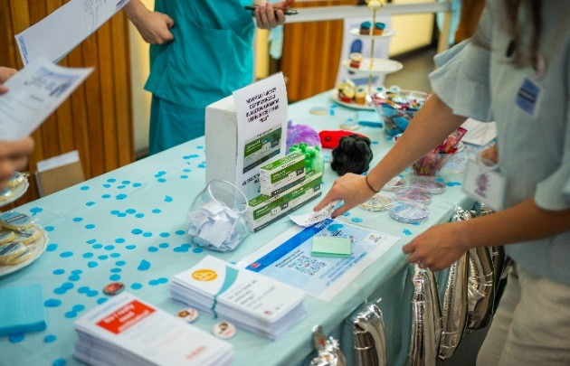
Figure 1. Example of a WAAW stall

Use social media and join the discussion
If your health service organisation has a social media account, use these to promote and distribute messages about antimicrobial resistance and events and activities happening during the week. A range of social media resources are available on the WHO's campaign material library, including story-format graphics for digital engagement activities and tiles that can be used for social media posts.
Consider wearing light blue. Encourage your health service organisation’s executive and communications team to promote staff wearing light blue during the week. Organise photos of colleagues wearing light blue and post it in hospital newsletters or the health service organisation’s social media account with a message on why your organisation is ‘Going Blue for AMR.’
Check your organisation’s social media policy before you begin.

For more information
Please visit: www.safetyandquality.gov.au/waaw

© Australian Commission on Safety and Quality in Health Care 2026

