
On the Radar
Issue 763
5 October 2026

On the Radar is a summary of some of the recent publications in the areas of safety and quality in health care Inclusion in this document is not an endorsement or recommendation of any publication or provider Access to particular documents may depend on whether they are Open Access or not, and/or your individual or institutional access to subscription sites/services Material that may require subscription is included as it is considered relevant.

On the Radar is available online, via email or as a PDF or Word document from
https://www.safetyandquality.gov.au/news-and-media/newsletters/on-the-radar

If you would like to receive On the Radar via email, you can subscribe on our website https://www.safetyandquality.gov.au/news-and-media/newsletters/on-the-radar
or by emailing us at mail@safetyandquality.gov.au.
You can also send feedback and comments to mail@safetyandquality.gov.au.

For information about the Commission and its programs and publications, please visit https://www.safetyandquality.gov.au

On the Radar
Editor: Dr Niall Johnson
Contributors: Niall Johnson, Bianca van Vlimmeren

Aged Care Infection Prevention and Control poster suite
https://www.safetyandquality.gov.au/clinical-topics/aged-care-and-older-people#standard-and-transmission-based-precautions-in-aged-care

Posters are an effective infection prevention and control (IPC) education tool, particularly in resource- limited healthcare settings without dedicated IPC teams, such as aged care settings.

Al-Raimi (2026) found that posters can act as quick reference guides, reducing reliance on memory and supporting greater adherence to IPC practices.

Eryilmaz Eren et al (2026) found that posters are more than just visual reminders, they improve IPC practices and reinforce appropriate behaviours through continuously conveying key messages.

The Australian Commission on Safety and Quality in Health Care has released new standard and transmission-based precautions posters to support infection prevention and control (IPC) within aged care.

Designed for use in residential and community-based aged care settings, these practical visual resources provide clear, easy-to-follow guidance that supports staff to implement IPC measures and reduce the risk of infection transmission. The poster suite includes:
- 3 Easy Steps to Using Alcohol-Based Hand Rub
- Standard Precautions
- Contact Precautions
- Respiratory Precautions
- Respiratory Precautions with a Particular Filter Respirator
- Combined Contact and Respiratory Precautions
- Combined Contact and Respiratory Precautions with a Particular Filter Respirator.

Whether displayed in staff areas, clinical workspaces or points of care, these resources support ongoing IPC education and reinforce best practice at the moment they are needed.

Reports

Planning ahead for the next pandemic: Acting early saves lives and protects economies
Policy brief
OECD
Paris: OECD Publishing; 2026.

The Economic Case for Pandemic Preparedness and Response: Beyond Lockdowns
OECD Health Policy Studies
OECD
Paris: OECD Publishing; 2026. p. 363.
URL | https://doi.org/10.1787/c5602a1c-en  https://doi.org/10.1787/b7b3852e-en
Notes | Planning ahead for the next pandemic is a policy brief from the OECD that notes that ‘Pandemics are rare, but can have substantial consequences for population health, health system resilience and economies.’  The UN General Assembly the other week coincided with a High-Level Meeting on Pandemic Prevention, Preparedness and Response (PPPR).  The COVID-19 pandemic is estimated to have led to ‘more than 7 million reported deaths, an estimated 28 million excess deaths’, a widely cited examination of the mortality caused by the 1918 influenza pandemic estimated that mortality to be in the range of 50 to 100 million (and examined why the figures were so uncertain).  The key messages in the policy brief include:  - Pandemics occur rarely but disrupt every facet of society when they strike.  - Left unchecked, an outbreak could overwhelm health systems within months and threaten economies.  - Early and effective implementation of non-pharmaceutical interventions (NPIs) can reduce the need for more disruptive measures later.  - Stockpiling personal protective equipment (PPE) and hygiene supplies, alongside stronger disease surveillance, is critical for early and effective pandemic response.  - Investing in pandemic preparedness and response (PPR) is affordable.  The OECD has also published The Economic Case for Pandemic Preparedness and Response: Beyond Lockdowns The abstract for this much longer report (363 pages) notes ‘This report examines the potential consequences of future pandemics on population health, health system resilience and the economy across 51 … countries, using advanced epidemiological and economic modelling techniques and scenario-based analyses. It assesses the extent to which eight non-pharmaceutical interventions (NPIs) for community infection prevention and control can mitigate health and economic consequences in the early phases of five types of outbreak scenarios before pharmaceutical interventions or vaccines are available at scale.  The central message is clear: in the OECD, investing, on average, almost 6 USD PPP per capita per year in pandemic preparedness and response is a smart investment for both public health and economic resilience. Early implementation of NPIs such as hand hygiene, mask use and physical distancing can save more lives and limit economic disruption than delayed action, which may necessitate the introduction of lockdowns to regain control of transmission. Robust disease surveillance and stockpiling systems are essential for enabling timely and effective response.’

Journal articles

From principles to practice: an actionable framework for AI governance in healthcare organisations
Freeman S, Wang A, Saraf S, Potts E, McKimm A, Coiera E, et al.
BMJ Digital Health & AI. 2026;2(1):e000018.
DOI | https://doi.org/10.1136/bmjdh-2026-000018
Notes | The authors of this piece observe that ‘Artificial intelligence (AI) technologies are being rapidly adopted in healthcare, yet organisational governance often lacks the processes needed to oversee their safe and responsible use. Previous AI governance frameworks largely focus on high-level AI ethics principles, leaving healthcare organisations struggling to translate these principles into practice, assess risk and embed AI oversight into existing processes.’ The paper describes the development of a framework that ‘provides healthcare organisations with a structured approach to assessing, governing and monitoring AI systems throughout their life cycle and may support the safe and responsible adoption of AI in practice’. The authors are seeking to fill the gap between “principles-based” and use of AI in healthcare.

Association of long-term care facility ownership and location on residents’ mortality and hospitalisations: A population-based retrospective cohort study in Australia
Rahja M, Davies LW, Jorissen RN, Crotty M, Whitehead C, Evans K, et al
BMJ Open. 2026;16(9):e117917.
DOI | https://doi.org/10.1136/bmjopen-2026-117917
Notes | Australian study examining ‘whether LTCF [Long-term care facility] ownership was associated with risks of mortality, emergency department (ED) presentations, unplanned hospitalisations and hospital days during the first 12 months after LTCF entry, and whether these associations varied by geographical region in Australia.’ This was a retrospective propensity score-matched cohort study using data on more than 200,000 individuals in the Registry of Senior Australians National Historical Cohort (2013–2018). Of the 205 079 residents included, 4.4% lived in government-run, 51.3% in not-for-profit and 44.4% in for-profit LTCFs. The authors report that  ‘Compared with residents in not-for-profit LTCFs, mortality risk was higher in for-profit (HR=1.17, 95% CI 1.09 to 1.26) and government facilities (HR=1.20, 95% CI 1.08 to 1.35) located in inner regional areas (24.1% of residents).  Residents in government LTCFs had lower ED presentation risk than residents in not-for-profit (sHR=0.68, 95% CI 0.57 to 0.82) and for-profit (sHR=0.61, 95% CI 0.52 to 0.72) LTCFs.  Similar observations were made for unplanned hospitalisations and hospital days, and across regions.’

Prenatal exposure to paracetamol and the risk of autism and attention-deficit/hyperactivity disorder: An umbrella review and meta-meta-analysis
Tayebi-Hillali H, Blanco-Suárez M, Rivas-Mundiña B, Limeres-Posse J, Diniz-Freitas M, Diz-Dios P.
Developmental Medicine & Child Neurology. 2026
DOI | https://doi.org/10.1111/dmcn.70512
Notes | There has been some conjecture about possible causes of autism and attention-deficit/hyperactivity disorder in past years. According to the article’s abstract: ‘This meta-meta-analysis synthesizes evidence on prenatal paracetamol exposure and neurodevelopmental outcomes. … Overall, the findings indicate a lack of robust epidemiological evidence supporting a causal association.’  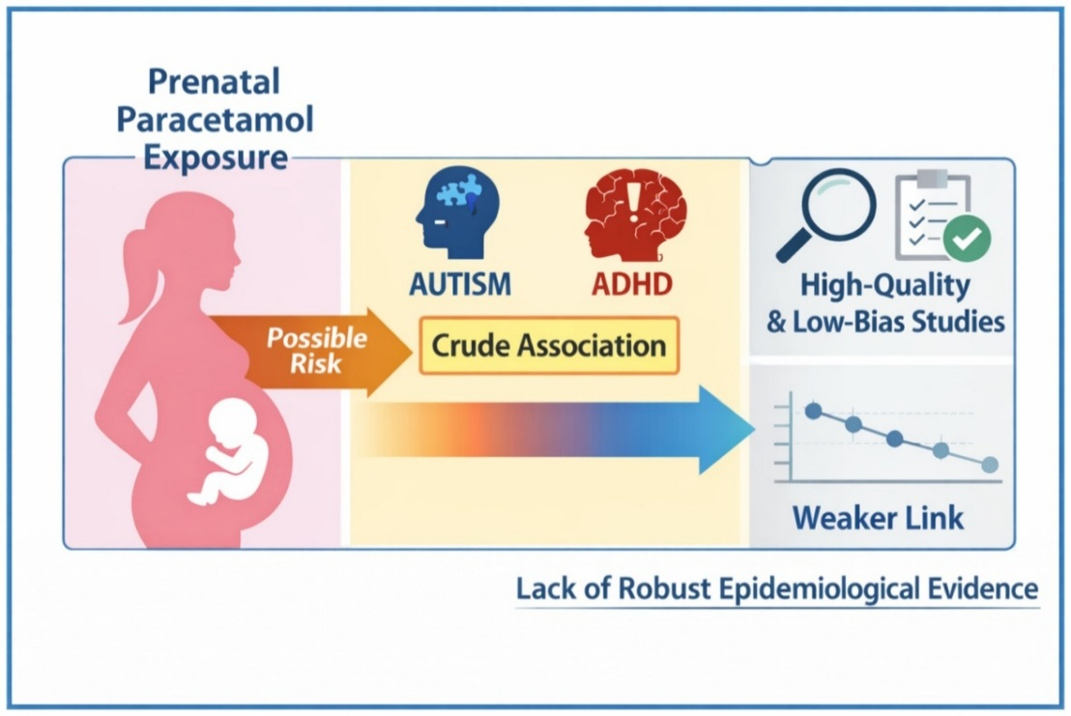
Australian Health Review
Volume 50, Issue 4, October 2026
URL | https://connectsci.au/ah/issue/50/4
Notes | The Australian Health Review has moved to a continuous publication model. In the continuous publication model, once an article is ready for publication, it is immediately published online with final citation details. These are compiled into issues over time. Recent articles in the Australian Health Review include:  - Evaluating discharge opioid prescribing practices in elective surgical patients: a retrospective audit from a tertiary surgical and rehabilitation centre (Karen Lee, Champika Pattullo, Elizabeth Vujcich)  - Linking emergency department opioid prescribing with ongoing opioid use: a statewide data linkage study (Champika Pattullo, William Dace, Anita Pelecanos, Gerben Keijzers, Peter Donovan)  - Transforming evidence into support: investing in a carer wellbeing research agenda (Bróna Nic Giolla Easpaig, Bronwyn Newman, Lukas Hofstaetter, Lucy Jones, Rhiannon Edge, Reema Harrison)

International Journal for Quality in Health Care
Volume 38, Issue 3, July 2026
URL | https://academic.oup.com/intqhc/issue/38/3
Notes | A new issue of the International Journal for Quality in Health Care has been published. Many of the papers in this issue have been referred to in previous editions of On the Radar (when they were released online). Articles in this issue of the International Journal for Quality in Health Care include:  - Patients and staff perspectives on hospital ward strain and its impacts on patient care and the workforce: a mixed-methods systematic review (Ga Bercades et al)  - Editorial: A perspective on value-based healthcare implementation: successes and challenges (Azhar Ali et al)  - Editorial: Independent pharmacist prescribing: how it can work and how to support its implementation (Deonne Dersch-Mills and E Garcia Elorrio)  - Editorial: Evaluating the effectiveness of the ‘patient transport’ app in improving healthcare quality, patient safety, and workflow efficiency (Roisin O’Malley et al)  - Editorial: Continuity of care: listening to patients’ judgements on the quality of care (Richard Baker et al)  - Editorial: Illness does not stop childhood: rethinking play as a dimension of quality in paediatric healthcare (Katherine Andrea Dinamarca-Aravena and Ezequiel García-Elorrio)  - Assessing the quality of patient safety incident investigation reports (Lorelle Bowditch et al)  - Operational inefficiency and perceived quality in a paediatric day hospital: a lean-informed study of patient flow, caregiver and staff perceptions (Mario Casolino et al)  - The outcomes of Lean management in a large academic hospital in Finland in 2018–2023: a qualitative study (Irmeli Hirvelä et al)  - What is a Mortality Committee for? Autopsy as a quality indicator (Francisco Ortuño-Andériz et al)  - Improving stroke care and outcomes through AHA/ASA primary stroke certification: a pre-post study in Jordan (Mohammad R Alosta et al)  - Navigating regulatory pathways for access to innovative medicines in Tunisia (Sarah Zerei et al)  - The right to play in paediatric healthcare: policy and practice in Chile (Aleksandra Glos et al)  - Factors influencing perceived risk of lonely death among older adults living alone: analysis of the 2024 Seoul Senior Citizen Survey (Hye Jin Nam et al)  - Diabetes care guided by quality indicators: a cost-effectiveness analysis in the Brazilian public health system (Yasmin Vitória Andrade de Castro Alves et al)  - Patient engagement and feasibility of a QR code–based digital information tool in the emergency department (Akash Manes et al)  - Assessing the real-world value of hemophilia care: how suitable are patient-centered outcomes for hospital-level comparisons? (D M Prameyllawati et al)  - Hospital at Home vs conventional hospitalization: good clinical outcomes with lower cost and nosocomial complications (Eulalia Balbina Villegas Bruguera et al)  - Improving surgical patients’ safety in African hospitals: exploring healthcare professionals’ experiences of Phase 1 of the ‘5Rs to Rescue’ programme (Charles Fadipe et al)  - Access and timeliness of acute stroke reperfusion after cluster-wide protocol standardization: an interrupted time-series study in Hong Kong (Hoi-Lun Koo et al)  - Advancing learning health care systems with best practice meetings: a mixed-methods study with insights from the Dutch Institute for Clinical Auditing (Felix Hers et al)  - Measuring safer opioid use in hospitals: development of consensus-based safety and quality indicators—a modified Delphi study (A Mutashar et al)  - Assessing the quality of postnatal care in India: regional disparities, determinants, and insights from NFHS-5 (Mahashweta Chakrabarty)  - Assessment of knowledge, attitudes, and practices around cervical cancer screening in the Gulu district of Northern Uganda: a cross-sectional study (Tana Chongsuwat et al)  - Learning from scale-up: a qualitative study of scaling-up interventions for people with multiple long-term conditions in primary care (Sarah Chew et al)  - Historically informed quality improvement: applying historical insights from Black women’s maternity care to contemporary health service redesign (Jennifer Creese et al)  - Medication reconciliation documentation and documented discrepancies in a tertiary Saudi hospital: a retrospective observational study (AH Alharthi et al)  - Cultural determinants and strategic priorities for medication safety in acute care: a multidisciplinary Delphi study (Neville Schembri et al)  - Observed quality of intrapartum care in Dire Dawa Administration, Eastern Ethiopia (Moti Tolera Jalu et al)  - Frailty, depression, and quality of life in acute care for elderly: a serial mediation and moderated mediation study in Taiwan (Chau-Nee Chen et al)  - Development and validation of a machine learning-based model for predicting fall-related injury risk in hospitalized patients (Shiyu Wang et al)  - Timeliness of discharge summary and postdischarge adverse events among patients hospitalized for community-acquired pneumonia (Anne Danjou et al)  - Lessons learned from nationwide perinatal audit of severe postpartum haemorrhage in the Netherlands (Lisa Broeders et al)  - What supports sustainable pace in the operating room? A sequential explanatory mixed-methods study using self-determination theory (Johan Eriksson et al)  - Using an evidence-informed co-design approach to develop a mechanism to measure experiences of the open disclosure process: an Irish case study (Aoife De Brún et al)  - Physician maldistribution persisted despite health system capacity expansion in Türkiye, 2002–23 (Ahmet Aykut and Leyla Merda Ekmen Aykut)  - Satisfaction with clinical practice environments among early-career health professionals in South Africa: findings from the WiSDOM cohort study (Laetitia C Rispel et al)  - Implementing clinician-led sustainability interventions in a tertiary intensive care unit: a quality improvement evaluation (Wei Jun Dan Ong et al)  - The four main domains of the concept of return-on-investment from healthcare quality improvement programmes (S’thembile Thusini et al)  - Peer accountability in patient safety: an under-examined determinant of team performance (Marcos Martínez)  - Also a feeling—how frontline health care professionals construct patient safety (Axel Ros et al)  - From compliance to prediction: Clinical laboratories as digital infrastructure for health-system quality and safety (Shruti Gupta and Prasenjit Mitra)  - The circular supply chain: a strategic framework for hospital operations in the era of value-based care (Soo Hoon Lee et al)  - Clinical champions as an implementation strategy: evidence and practical considerations (Ulfat Shaikh et al)  - From reactive compliance to systemic value: a paradigm shift in global patient safety (Tong Liu et al)  - The power of collaboration: the untold story of World Blood Donor Day and World Patient Safety Day (Neelam Dhingra)  - Decarbonizing health systems while protecting quality and safety: everyone has a role (Jeffrey Braithwaite et al)  - Readability and clinical accuracy of AI-generated hospital discharge instructions: an audit of three large language models (Rajat Goel)  - Bringing artificial intelligence to the front lines: PMcardio for detecting occlusive myocardial infarction in STEMI and STEMI-equivalent activations (Mohamad Bahrou et al)  - Interventions to improve Cultural Safety in healthcare in CANZUS countries: a systematic mixed studies review of First Nations Peoples’ experiences (Anne van der Breggen et al)  - Patient and family activated escalation systems: a systematic review (Noémie Déom et al)  - Medical waste management within the Green Hospital approach: a systematic review of direct, contextual, and transferable evidence (İbrahim H Kayral et al)  - Glucometer versus standard enzymatic method for gestational diabetes mellitus: a systematic review for diagnostic test accuracy (Laarni Hannah Lacorte et al)
BMJ Leader
Volume 10, Issue 3, September 2026
URL | https://bmjleader.bmj.com/content/10/3
Notes | A new issue of BMJ Leader has been published. Articles in this issue of BMJ Leader include:  - Editorial: Developing the Learning Zone (Iain Smith)  - What is the evidence base for leadership coaching for postgraduate medical doctors? A scoping review (Fiona Jane Day, Alexios-Fotis Mentis, Cuncun Lu, Anna Mae Scott, Oscar Lyons)  - Nursing followership: a concept analysis (Wafaa ALQadrie, Ali Saleh)  - Leveraging local knowledge for crisis management: a practice-based approach to managing uncertainty in healthcare during COVID-19 (Karl-Emanuel Dionne, Kathy Malas, Margaux Manent, Simon Reeves)  - A survey of attitudes, behaviours and barriers to environmental sustainability among healthcare staff at an NHS trust (B Elson, B Murphy)  - Promoting kindness through media increases patient satisfaction in an emergency department: a simple intervention to uplift patients and lower stress (David A Fryburg, Stacey Mueller, A Pilarski, J L Rabaglia, J D Truwit)  - Potential carbon savings in the management of shoulder dislocations through allied health professional-led patient pathways: an observational study using audit data (Gemma Shearer, Simon Nicole, Ben Bowling, J Saleem, N Zreik, C Hubbard, D Tennent, L Hindle, M Phull, T W R Briggs, W K Gray)  - Diversity in US medical school department chairs: 45-year retrospective analysis (Milin Patel, Nachiket Patel, Jeffrey Ding, Shaheer Mujahid, Nancy D Spector, Sophia Kamran, Javed Siddiqi, Faisal Khosa)  - How a National Health Service (NHS) hospital successfully designed a leadership programme for disabled staff (Rasleen Kahai, L Blair, R Craig)  - Impact of promoting ‘Only order what you need’ and ceasing pharmacy-initiated managed repeats in a large general practice (Laura Smith, Helen Kingston, Richard Podmore, Chloe Jenvey, Daniel Tucker)  - Impacts of a relational leadership development programme on psychological sense of community (Naseeha Islam, S G Wiederholt, B Park, A Tuepker, E Waller Uchison, L Gordon, M Lewis, A Mansour, N A Steckler, S T Edwards)  - Systems thinking in global health: are we targeting the right people? Insights from the launch of the SYSTAC Europe Forum (Claudia Truppa, Abeer S Ahmad, Katrine J Chamorro De Angeles, Amanda Quintana, Rachel Cassidy, Anna Duchenko, Carmen Sant Fruchtman, Daniel Cobos Muñoz, Karl Blanchet, Dell Saulnier, Sabine Margarete Damerow)  - Four pillars of sustainable food services in healthcare: a practical approach for healthcare leadership (Fiona Parascandalo, Iliya Khakban, Casey Qian, Elizaveta Zvereva, Amy Ford, Russell de Souza, Myles Sergeant)  - When a panel discussion on women’s leadership became a case study in its challenges (Ashifa Trivedi, Renée McCulloch, Heather Caudle, Nuthana Prathivadi Bhayankaram, Nisha Thakrar, Cicely Marston)  - Embracing artificial intelligence in surgical training: a clinical leadership perspective (Patrick Cook, Atef Hassan, Ryan Kerstein, Mohamed A Imam)  - Primary care has a voice: let’s use it (Ashifa Trivedi, Martha Martin, Zahra Yasen, Tanvir Alam, Claire Fuller, Nick Harding, Nikita Kanani, Mayur Lakhani, Anthony McKeever, Rich Withnall)  - Leadership styles in psychiatry: applying servant, ethical and authentic leadership in clinical practice (Pat Fitzpatrick)  - Supporting international medical graduates in the National Health Service: what is the way forward? (Aderemi Alalade, Hemant Maraj)  - Leadership in the mirror: Discovering dyslexic leadership as a strategic asset in healthcare integration (Joel Simon Phillips)  - From clinical expertise to leadership capability: a challenge to generic and multidisciplinary leadership programmes in support of tailored leadership development (Amanda H Goodall, Natasha Maw)  - Reflections on grassroots leadership in planetary health (Jennifer McNesfield)  - Understanding the Imposter Phenomenon in Order to Build a Stronger Surgical Workforce (MT Monaghan, R Ford, K Dalrymple)  - P1 Connect NENC: a single digital ‘front door’ for inter-hospital referrals across the North East and North Cumbria Integrated Care System (Thomas Salisbury, Edwin Wong, Chris Plummer, Nikhil Premchand)

BMJ Quality &Safety online first articles
URL | https://qualitysafety.bmj.com/content/early/recent
Notes | BMJ Quality &Safety has published a number of ‘online first’ articles, including:  - Editorial: Uncovering the missing links: from peripheral intravenous catheter policy and care to measurable outcomes (Josephine Lovegrove, Claire Rickard)  - Impact of non-technical skills training on patient outcomes in surgery: a systematic review and meta-analysis (Ibrahim M Muhammad, Maha F Valiyakathu, Gianluigi Zanovello, Stefan Haensel, Bhaskar Somani, Nicholas Raison)

International Journal for Quality in Health Care online first articles
URL | https://academic.oup.com/intqhc/advance-articles
Notes | International Journal for Quality in Health Care has published a number of ‘online first’ articles, including:  - Editorial: Postnatal contact is not enough: measuring and improving care for women and newborns (Reece Hinchcliff)  - Case-mix adjustment of HCAHPS scores based on national benchmarks in Japan: a multicenter cross-sectional study (Takuya Aoki and Masato Matsushima)  - The I’-chart: a preliminary investigation of an improved individuals chart for quality improvement and control (Jacob Anhøj, Wayne A Taylor , Mohammed A Mohammed,  - Patient Safety Culture in Low- and Lower-Middle-Income Countries: A Systematic Review of Evidence Involving Hospital Pharmacists (Ezinwanne Jane Ugochukwu, Olanrewaju Faith Omotayo, Onyinye Blessing Ukoha-Kalu, Isaac Ibezim, Abdulmuminu Isah, Nneka Uchenna Igboeli, Chukwuemeka Michael Ubaka)  - Report Quality Is Not Investigation Quality: Strengthening Patient Safety Learning (Lis Parida, Sudarwan Danim, Rendy Wikrama Wardana, Fitri April Yanti, Rikas Saputra)

Online resources

Australian Living Evidence Collaboration
https://livingevidence.org.au/

No Harm Done podcast
https://noharmdonepodcast.com/podcast/nhd-s3-ep4-a-cg-supermodel/
The latest iteration of the Australian podcast, No Harm Done, includes a discussion of the new National Model for Clinical Governance.

Past Present Future podcast
https://www.ppfideas.com/
This British podcast currently has a series titled An Ageing World and the first episodes include Lifespan vs Healthspan and The Meaning of Death. The latter issue features Dr Richard Coker, the author of Timor Mortis: How We Live With Death.

Infection prevention and control resources
The Australian Commission on Safety and Quality in Health Care has developed a number of resources to assist healthcare organisations, facilities and clinicians These resources include:
- Standard and transmission-based precautions https://www.safetyandquality.gov.au/clinical-topics/infection-prevention-and-control/standard-and-transmission-based-precautions
- Poster – Combined contact and droplet precautions https://www.safetyandquality.gov.au/publications-and-resources/resource-library/infection-prevention-and-control-poster-combined-contact-and-droplet-precautions
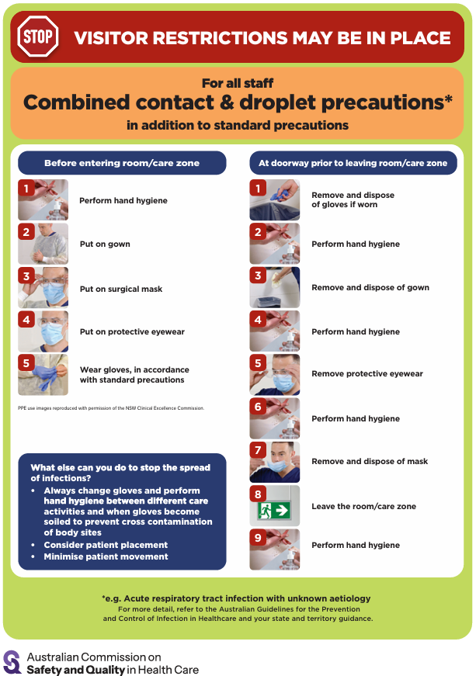
- Poster – Combined airborne and contact precautions https://www.safetyandquality.gov.au/publications-and-resources/resource-library/infection-prevention-and-control-poster-combined-airborne-and-contact-precautions
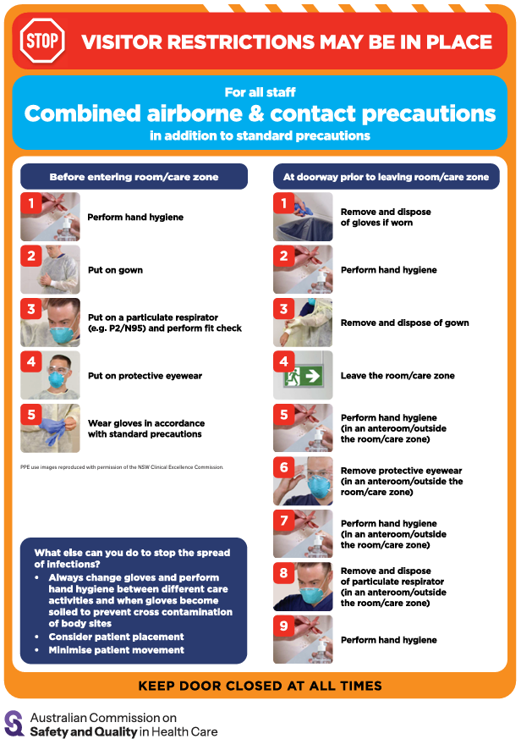
- Aged Care standard and transmission-based precautions posters – https://www.safetyandquality.gov.au/clinical-topics/aged-care-and-older-people#standard-and-transmission-based-precautions-in-aged-care-
- Break the chain of infection poster
https://www.safetyandquality.gov.au/publications-and-resources/resource-library/break-chain-infection-poster
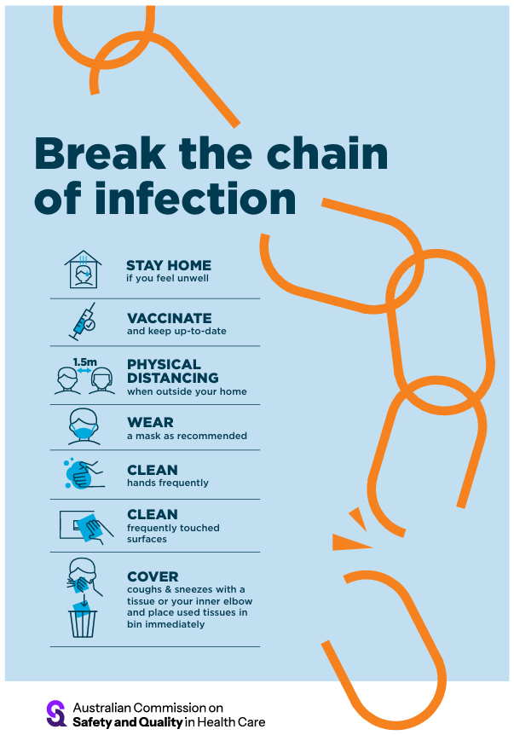

Disclaimer
On the Radar is an information resource of the Australian Commission on Safety and Quality in Health Care. The Commission is not responsible for the content of, nor does it endorse, any articles or sites listed. The Commission accepts no liability for the information or advice provided by these external links. Links are provided on the basis that users make their own decisions about the accuracy, currency and reliability of the information contained therein Any opinions expressed are not necessarily those of the Australian Commission on Safety and Quality in Health Care.

