
On the Radar
Issue 764
12 October 2026

On the Radar is a summary of some of the recent publications in the areas of safety and quality in health care Inclusion in this document is not an endorsement or recommendation of any publication or provider Access to particular documents may depend on whether they are Open Access or not, and/or your individual or institutional access to subscription sites/services Material that may require subscription is included as it is considered relevant.

On the Radar is available online, via email or as a PDF or Word document from
https://www.safetyandquality.gov.au/news-and-media/newsletters/on-the-radar

If you would like to receive On the Radar via email, you can subscribe on our website https://www.safetyandquality.gov.au/news-and-media/newsletters/on-the-radar
or by emailing us at mail@safetyandquality.gov.au.
You can also send feedback and comments to mail@safetyandquality.gov.au.

For information about the Commission and its programs and publications, please visit https://www.safetyandquality.gov.au

On the Radar
Editor: Dr Niall Johnson
Contributors: Niall Johnson, Elyse Powell

Better Care Everywhere: Medico-legal risks module
https://learn.safetyandquality.gov.au/mod/page/view.php?id=16767

The Australian Commission on Safety and Quality in Health Care has released the Better Care Everywhere: Medico-legal risks module. This resource is part of the Better Care Everywhere suite aimed at supporting the delivery of high-quality care.
This free, self-directed online learning module examines how clinical uncertainty leads to low-value care, explains key legal medico legal concepts and highlights the critical role effective communication plays in avoiding defensive practice. Reducing low-value care improves patient outcomes, reduces harm and supports system sustainability. By strengthening understanding of medico legal risks, this module helps health professionals navigate clinical uncertainty and support safe and appropriate care.

Reports

Polypharmacy in Australia in 2025
Australian Institute of Health and Welfare
Canberra: AIHW
URL | https://www.aihw.gov.au/reports/medicines/polypharmacy-in-australia-in-2025/contents/about
Notes | The Australian Institute of Health and Welfare (AIHW) have released this web report as the first in a series on polypharmacy. The AIHW web page notes ‘Polypharmacy is defined as the same person being on five or more medicines over a year to manage one or more health conditions. This report will explore how polypharmacy is distributed across age and sex, and what medicines were commonly dispensed in 2025.’ The report uses data from the Pharmaceutical Benefits Scheme (PBS) and Repatriation Pharmaceutical Benefits Scheme (RPBS). Medicines supplied through private prescriptions are not included, so the results may underestimate the true extent of polypharmacy in Australia.

For information on the Commission’s work on medicines safety and quality, see https://www.safetyandquality.gov.au/clinical-topics/medicines-safety-and-quality

Digital Technology Experiences of Children and Young People: Project Report
McLean S, Fuller-Tyszkiewicz M, Fardouly J, Khalil H, Hudry K, Bourne d, et al
Sydney: National Mental Health Commission; 2026.
URL | https://www.mentalhealthcommission.gov.au/news-media/news/release-digital-technology-experiences-children-and-young-people-report
Notes | The National Mental Health Commission (NMHC) has released the Digital Technology Experiences of Children and Young People report. This Australian study looks at how children and young people use digital technology, and what this may mean for their mental health and wellbeing. The report examines Australian evidence on social media, handheld and portable devices, streaming platforms, gaming, messaging apps, artificial intelligence, and online forums. It was led by researchers from La Trobe University, Deakin University and the University of Sydney.  Along with the project report, the NMHC has also released an accompanying technical report and the previously released consultation summary and discussion paper, available from https://www.mentalhealthcommission.gov.au/projects/understanding-how-digital-technology-is-impacting.  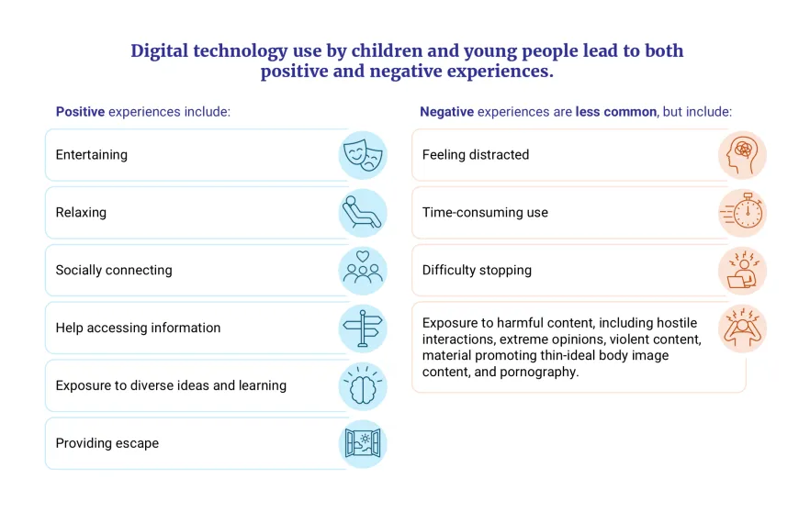
Achieving excellent patient experience
NHS England
London: NHS England; 2026
URL | https://www.england.nhs.uk/long-read/achieving-excellent-patient-experience/
Notes | Document from NHS England that describes excellent patient experience looks and feels like across NHS-funded care, through the NHS experience excellence framework. This framework identifies 5 experience pillars and clarifies the importance of being clear about the behaviours, systems and culture that help people feel listened to, respected, involved and supported throughout their care.  The 5 Experience of care pillars:  Pillar 1: Making it easy and accessible  Pillar 2: Building confidence and trust and agreeing expectations  Pillar 3: Valuing and understanding what matters  Pillar 4: Addressing needs and concerns  Pillar 5: Supporting people to look after themselves safely and confidently.

Prevention: The general practice role in evidence-based and equitable prevention
Ellenby R, Mandla A, Stewart M, Tzortziou Brown V
London: Royal College of General Practitioners; 2026. p. 22.
URL | https://www.rcgp.org.uk/News/Not-enough-time-to-offer-preventative-care
Notes | Report from the Royal College of General Practitioners (RCGP) in the UK that found that while prevention is recognised as important, patients trust their GP’s advice, many GP say that they lack and funding to provide preventive care. The report notes that ‘General practice already delivers substantial preventive care, but its impact is constrained by workforce pressures, lack of infrastructure, system design and the wider determinants of health.’ The authors note ‘A system-wide approach to prevention offers tremendous opportunities for improving health and wellbeing, getting people into education and work and boosting the economy. This report focuses on the important role general practice can play as part of this wider response, and the support needed to create the capacity for this work.’

Digital Done Right: Moving towards a future where everyone is included
Age UK
London: Age UK; 2026. p. 34.
URL | https://www.ageuk.org.uk/siteassets/documents/reports-and-publications/reports-and-briefings/active-communities/digital-done-right-report/
Notes | Report from a UK charity, Age UK, that highlights that older people have different levels of access, skills and confidence and many face barriers when using essential services. Age UK is calling for a more inclusive approach to digital transformation, including designing services around older people’s needs; making digital services easier to navigate; maintaining accessible non-digital alternatives; and providing support to develop digital skills and confidence. While not purely focussed on health and health care, the report does discuss the important of digital inclusion and digital health literacy as a key dimension to modern life.

Breaking the cycle: How to build a more productive NHS
Allas T, Charlesworth A, Chhoa-Howard H, Fozzard K, Moulds A, Rocks S
London: The Health Foundation; 2026.
URL | https://www.health.org.uk/reports-and-analysis/reports/breaking-the-cycle
Notes | Report from the Health Foundation in the UK that examines the importance of improving health productivity. It is argued that improving productivity will be critical if health services are to deliver better outcomes for patients and to reduce future spending pressures. The authors suggest that ‘Building an NHS that serves patients, the public and staff well – now and in the future – will depend on sustained productivity growth. At its heart, improving productivity means achieving better health outcomes within the available resources.’

Implementing integrated health campaigns: Decision-making and planning guide
World Health Organization
Geneva: WHO; 2026. p. 88.
URL | https://iris.who.int/handle/10665/387697
Notes | This recent publication from the World Health Organization (WHO) ‘provides a framework for countries considering the integration of health campaigns across multiple health programmes.’ The guide ‘responds to the need for more coordinated, people-centred approaches to campaign planning and delivery. It outlines the rationale for integrating interventions such as immunization, malaria prevention, neglected tropical disease control and nutrition services, highlighting potential benefits including improved coverage, operational efficiency, cost-effectiveness, equity and strengthened health systems, while also addressing associated challenges related to governance, financing, logistics, workforce capacity and safety.’  The publication ‘presents a five-step process for decision-making and planning: establishing a multisectoral coordination mechanism, mapping planned campaigns, assessing opportunities for integration, developing a multi-year integrated workplan and budget, and regularly reviewing implementation plans.’

Conducting information environment assessments for health emergencies: An implementation toolkit
World Health Organization
Geneva: WHO; 2026. p. 40.
URL | https://iris.who.int/handle/10665/387691
Notes | Also recently published by the World Health Organization (WHO) is this toolkit that ‘describes the processes involved in conducting an information environment assessment (IEA) as part of health emergency preparedness and response. It provides resources, templates and tools to guide teams from planning an assessment—including selecting the assessment team, defining goals and objectives and determining the scope of the data—through the preparation of an IEA report, its regular updating and the implementation of recommended actions. It also includes a rapid IEA approach for use during health emergency response, either as a standalone assessment, as part of an established risk assessment activity or to build on a previously completed IEA.’

Reducing alcohol-related harm: SAFER implementation handbook
World Health Organization
Geneva: WHO; 2026. p. 170.
URL | https://iris.who.int/handle/10665/387714
Notes | This implementation handbook from the WHO ‘provides practical guidance for countries, communities and institutions seeking to implement the World Health Organization’s SAFER initiative and accelerate progress under the Global alcohol action plan 2022–2030. The handbook translates evidence and global policy commitments into concrete implementation pathways.’  The SAFER initiative was launched in 2018 and promotes five high-impact, cost effective alcohol policy interventions  Strengthen restrictions on availability;  Advance and enforce drink driving countermeasures;  Facilitate access to screening, brief interventions and treatment;  Enforce advertising restrictions;  Raise alcohol prices.

Implementation guidance on policies and programmes for improving complementary feeding
United Nations Children’s Fund (UNICEF), World Health Organization (WH(O)
New York: United Nations Children’s Fund; 2026. p. 298.
URL | https://iris.who.int/handle/10665/387673
Notes | From the United Nations Children’s Fund (UNICEF) and the World Health Organization( WHO) is this implementation guidance that ‘provides evidence-based guidance on translating WHO recommendations on complementary feeding into practice. It aims to support the delivery of effective interventions that enable infants and young children aged 6–23 months to consume adequate and healthy diets. The recommended approach fosters a shared vision and joint planning through interventions embedded within multiple systems, while promoting equity and inclusion, particularly for vulnerable and marginalized populations.’  This guidance is ‘intended primarily for government staff across health, agriculture, social development and welfare, food safety, finance and education involved in policy development, programme design and implementation, as well as other organizations supporting complementary feeding interventions.’

Journal articles

Australian Prescriber
Volume 49, Issue 5, October 2026
URL | https://australianprescriber.tg.org.au/volumes/49/issues/5.html
Notes | A new issue of Australian Prescriber has been published. Content in this issue of Australian Prescriber includes:  - Hepatitis B update: enabling progress towards elimination (J Davies, M Capati, N Allard)  - Endometriosis and adenomyosis: diagnosis and management (SB Crawford, A Hui, D Mazza)  - Cardiac amyloidosis: recognition, diagnosis and management (N Gorrie, E Montgomery, G McCaughan, AS Carroll, NK Bart)  - Glaucoma management in adults: an update (PW Loh, M Walland, A Atik)  - Multiple myeloma: an overview of drug therapies and supportive care (J Hocking)  - Management of acute hyperkalaemia: evidence, practice and pitfalls (S Ford,  - COVID-19 vaccines move to the National Immunisation Program with revised eligibility  - TGA Medicines Safety Update summary  – Withania somnifera (Ashwagandha) and very rare risk of liver injury  – GLP-1 RAs and rare vision disorder  - New drugs:  – Delgocitinib for chronic hand eczema  – Vanzacaftor, tezacaftor and deutivacaftor fixed-dose combination for cystic fibrosis

Healthcare Papers
Volume 23, Number 4, August 2026
URL | https://www.longwoods.com/publications/healthcarepapers/27925/
Notes | A new issue of Healthcare Papers has been published with a theme of ‘Social Prescribing as Strategic Infrastructure’. Articles in this issue of Healthcare Paper include:  - Social Prescribing as a Catalyst for System Transformation (Sara Allin and Audrey Laporte)  - Social Prescribing as Strategic Infrastructure: Unlocking Community Capacity for Sustainable Healthcare When Institutions Reach Their Limits (Kate Mulligan)  - Equity-Driven and Community Empowerment-Focused Social Prescribing: Lessons from the Front Lines (Gary C. Bloch and Nassim Vahidi-Williams)  - From Innovation to Infrastructure: Embedding Social Prescribing in Canada's Care System (Sandi Pelly and Liv Mendelsohn)  - Social Prescribing and the Welfare State (Seth A Berkowitz)  - Social Prescribing as Strategic Infrastructure: An English Perspective (Kerryn Husk and Chris Dayson)  - Bridging the Gap In Social Prescribing: “Lived Territories” As Community Pivots for Proximity-Based Health Systems (Lara Gautier and Géraldine Layani)  - Toward Community Health 2067: Social Prescribing, Learning Systems and the Making of an Enabling State (Kate Mulligan)

The Lancet Primary Care
Volume 2, Number 9, September 2026
URL | https://www.thelancet.com/journals/lanprc/issue/vol2no9/PIIS3050-5143(26)X2009-X
Notes | The Lancet Primary Care is a relatively new open access journal. Articles in this issue of The Lancet Primary Care include:  - Editorial: Rural health care: from policy ambition to local reality (The Lancet Primary Care)  - Enabling person-centred care among adults living with chronic conditions (Elizabeth Manias)  - Check my Beat—a lifesaving campaign in South Africa for cardiovascular health (David Jankelow, Ruchika Meel, Georgia Torres, Mandi Fine, Elizabeth Schaafsma, Thobile Ziqubu, Erika Dau, Eric Klug, Ruan Kruger)  - The weight of words: embracing effective health promotion in primary care (Tim Thorne, Paul Welfordsson)  - Effectiveness of the Responses to Illness Severity Quantification (RISQ) system versus standardised malnutrition treatment on mortality in acutely malnourished children treated in a community-based nutrition programme in Ngouri, Chad (CRIMSON): a multicentre, cluster-randomised trial (Nancy M Dale, Youssouf Djidita Hagre, Djamnoné L Debtanné,Difo Saha Mermoz, Boubacar Harouna, Innocent Golnodji, Didier Zidouemba, Mahmat Bechir, M Madjissem, C Tehoua, G Tomlinson, S Shepherd, S Zlotkin, C S Parshuram)  - Prescribing cascades, associated patient characteristics, and health-care utilisation in older community-dwelling adults in Ireland: a retrospective, observational cohort study (Steven Gilmore, Ann Sinéad Doherty, Frank Moriarty, F Boland, R Muddiman, T Fahey, B Clyne, D O’Mahony, E Wallace)  - SMS text message reminders versus usual care for cervical screening attendance in London, UK: a retrospective secondary analysis of routinely collected data (Beth Nichol, Josephine Ruwende, Jeff Powell Davies, Kaloyan Haralampiev, Christian Von Wagner, Aikaterini Grimani, Luke Vale, I Vlaev)  - Relational continuity, care coordination, and experience of person-centred care in primary care of people living with chronic conditions: a secondary, cross-sectional analysis of OECD PaRIS data (Ángel González de la Fuente, Oscar Brito-Fernandes, Luke N Allen, Nicolás Larraín, Candan Kendir, Frederico Guanais, Dionne Kringos, Michael van den Berg)  - Refinement of a scoping tool to tackle antimicrobial resistance via a primary health care approach: insights from Kazakhstan, Sweden, and Thailand (Serena W Y Chong, Sarah Paulin, Faraz Khalid, Stephan Stenmark, Danilo Lo Fo Wong, Deborah Tong, Ketevan Kandelaki, Viroj Tangcharoensathien, Bassem Zayed, Abzal Zhumagaliuly, Erica Barbazza, S B Syed, N Bruinsma)  - Metabolic dysfunction-associated steatotic liver disease in primary care: an international Delphi consensus (Gong Feng, Shouping Gong, Frank Tacke, Luca Valenti, Mark Muthiah, Koki Kato, Zhaoxiang Yu, Giovanni Targher, Christopher D Byrne, Mohamed Farouk Allam, Wah Kheong Chan, Yusuf Yilmaz, Jingjing Ren, Juan Pablo Arab, Giada Sebastiani, Jacob George, Seung Up Kim, Yang Zhao, Aung Hlaing Bwa, Khalid A Alswat, Weiru Zhang, Helen M Parretti, Laura Elizabeth Moreno, Sombat Treeprasertsuk, Ajay Duseja, Martin Bach Jensen, Mei Feng, Catherine Wendy Spearman, Bernardo Meza-Torres, Syifa Mustika, Nahum Méndez-Sánchez, Boon How Chew, Marlen Ivón Castellanos Fernández, Man Mi, Nicholas Kyalo Muendo, Thomas Yuen Tung Lam, Aimei Dong, Jay H Shubrook, Xiaotong Gao, Marium Ahmed, Qiang Gao, Won Kim, Helena Cortez-Pinto, Yuen Ching Chan, Katarzyna Nessler, Ponsiano Ocama, M A B Khan, M Pericleous, D A Koutoukidis, J Chai, S Vinker, M-H Zheng for the GPS-MASLD Alliance)

Age and Ageing
Volume 55, Issue 9, October 2026
URL | https://academic.oup.com/ageing/issue/55/9
Notes | A new issue of Age and Ageing has been published. Articles in this issue of Age and Ageing include:  - Editor’s view: Falls management and prevention (Roy L Soiza)  - Editorial: What can we learn from cannabinoid trials? (Kaisu H Pitkälä and Hanna- Maria Roitto)  - ‘Inverting the logic’—the value of a ‘no-problem’ list in frailty care (John Cooke and Paul Finucane)  - Aggression and violence towards informal dementia caregivers: a call for recognition and action (Jia Yin Ruan et al)  - Culturally adapted post-diagnostic dementia support for South Asian people living with dementia and caregivers: a rapid review (A Akhtar et al)  - Emergency department revisits and hospital readmissions following a fall-related emergency department presentation in older adults: a systematic review and meta-analysis (Chris Larue et al)  - Prevalence and associated factors of hospitalisation-associated disability in older adults: a systematic review and meta-analysis (Li Zeng et al)  - Existing validated tools for assessing intrinsic capacity and its components within a positive ageing framework: a scoping review and structured appraisal by the Multidisciplinary International Positive Ageing Group (Yves Henrotin et al)  - Prevalence, characteristics and risk factors for chronic lower-limb oedema in the older population living in the community or in an aged-care home: a systematic review (Maree O’connor et al)  - Advancing dementia-friendly hospital care: a systematic review of healthcare professionals’ reported barriers and facilitators using the theoretical domains framework (Michael Shimelash et al)  - Gut microbiome modulation can improve cognitive function in older adults: a systematic review and meta-analysis (Benjamin Birns et al)  - Effects of the ‘ReacStep’ training program on balance recovery and fall risk factors in older people: an assessor-blinded randomised controlled trial (Shivam Sharma et al)  - Staying active with multimorbidity in acute hospital settings trial: a feasibility randomised controlled trial of allied health assistant mobility rehabilitation for patients with multimorbidity (David A Snowdon et al)  - Cost-effectiveness of an integrated falls prevention programme in primary healthcare for older people in rural China: an economic evaluation alongside the FAMILY trial (Ting Wei et al)  - Effectiveness and cost-effectiveness of the Keep-On-Keep-Up digital falls prevention programme in community-dwelling older adults: results of a randomised controlled trial (Chloe French et al)  - Frailty index deficit interchangeability: an empirical test using random survival forests in adults with cardiovascular disease (Jack Quach et al)  - Standing strong and tall—improving mobility and balance in older Aboriginal people through the Ironbark program (Rebecca Ivers et al)  - Assisted dying practices for individuals living with frailty: prevalence and eligibility (Tommaso Squeri et al)  - Slowing disease accumulation but persistent complexity: population-level multimorbidity dynamics in old age (Yuge Zhang et al)  - Association between loneliness and incident use of benzodiazepines and opioids: analyses of the Canadian Longitudinal Study on Aging (J A Watt et al)  - Prioritising modifiable risk factors for self-management of urinary incontinence in older men: integrating expert consensus with patient readiness (Olawunmi Olagundoye et al)  - Cardiometabolic medication exposures and cognitive outcomes in Alzheimer’s disease (Yihan Wang et al)  - Outcome-specific thresholds and clinically relevant changes in frailty: evidence from a population-based longitudinal cohort (A Álvarez-Bustos et al)  - Pharmacological stratification of fall-risk-increasing drugs for prevention of fall-related injuries in older adults: a population-based cohort study (Miriam Schechner et al)  - GLP-1-based treatments and long-term clinical outcomes in MASLD amongst older adults: a retrospective cohort study (T Koutouratsas et al)  - Physiotherapy implementation and hospitalisation-associated disability according to prehospital functional status in older patients with heart failure: a secondary analysis of a prospective nationwide multicentre registry (Nobuaki Hamazaki et al)  - Exploring clinical reasoning in physical and occupational therapists treating frail older adults in skilled nursing facilities: a Delphi study (Thomas Bloch et al)  - Peripheral immune signatures predict cognitive decline in older adults: a population-based cohort study (Heya Luan et al)  - Consumer and health professional reflections and feedback on the Help After Leaving hospiTal delirium rehabilitation programme (Yonas Tesfaye et al)  - Understanding the dynamics of crisis situations in care for community-dwelling older individuals—a qualitative study (Dolly R E Haselager et al)  - Measuring what matters: evaluating the psychometric properties of goal attainment scaling in a psychosocial dementia trial (Jessica Budgett et al)  - CCL2 and CXCL2 are markers of delirium vulnerability in community dwelling older people (Hannah Moorey et al)

JBI Evidence Synthesis
Volume 24, Issue 10, October 2026
URL | https://journals.lww.com/jbisrir/toc/2026/10000
Notes | A new issue of JBI Evidence Synthesis has been published. Articles in this issue of JBI Evidence Synthesis include:  - Editorial: In safe hands: human-led publishing and where AI can help (Melanie Dankel, Mara Lambert, Tara Crandon, Hien Ho)  - Experiences of having a sibling with autism spectrum disorder: a qualitative systematic review (Alžběta Smrčková, Jiří Kantor, Dagmar Sedláčková, Neda Kabiri, Zuzana Svobodová, Blanche Kiszio, Tereza Vrbová, Véronique de Goumoëns, Lua Perimal-Lewis, Zachary Munn, Miloslav Klugar)  - Gender-affirming and age-appropriate online resources for gender-independent, intersex, nonbinary, transgender, genderqueer, and gender-diverse (GIaNT+) youth: a scoping review (Roya Haghiri-Vijeh, Kat Newman-Seymour, Terri Beley, Mari Newman, Daniel Huizenga, C Huel, F Sobhan)  - Children’s and parents’ use of diabetes technologies in the primary school environment: a scoping review (Tracey O’Neill, Karen McTague, Thelma Begley, Sonam Banka-Cullen, Eleanor Hollywood)  - Methodological quality of systematic reviews on neck pain treatments: a cross-sectional appraisal using AMSTAR 2 (Leonard Ho, Ka Wai Yuen, Cyrus Chung Choi, Yolenda Man Cheung, Irene XY Wu, Vincent Chi Chung)  - Mapping the evidence on artificial intelligence–based clinical decision support systems for undergraduate nursing students: a scoping review protocol (Francesco Scerbo, Gabriele Caggianelli, Simone Ciucciarelli, Giovanni Cangelosi, Valentina Vanzi, Rocco Mazzotta)  - Cost-effectiveness of artemisinin-based combination therapies for first-line treatment of malaria among pediatric and adult populations: a systematic review protocol (Bindu MA, Spoorthi KR, Akhil Jith, Saraswathy GR, Chandrasekhar Janakiram, Denny John)  - Interventions to address social and structural conditions for individuals with select complex, chronic, disabling conditions: a scoping review protocol (Marcia Finlayson, Nadine Akbar, Erna Snelgrove-Clarke, Amanda Ross-White, Afolasade Fakolade, Ruth Ann Marrie)  - Effectiveness of organizational interventions vs usual care for reducing incidence and mitigating impact of workplace violence on registered nurses: a systematic review protocol (Domenico Cannizzaro, Ilaria Saguatti, Dalia Caleffi, Sergio Rovesti, Paola Ferri)  - Suffering at the end of life in the intensive care unit: a scoping review protocol (Yodang Yodang, Rongyu Hua, Decha Tamdee, Jittawadee Rhiantong, Patraporn Bhatarasakoon)  - Estimating the burden of hypertension prevalence in Filipino Americans: a systematic review protocol (Persephone Vargas, Irina Benenson, Cheryl Holly)  - Concept analyses on care and caring in nursing and midwifery: a scoping review protocol (Janet Bell)  - Oral health interventions for UK-based Bengali children and their families: a scoping review protocol (K Julia Hurry, Janet Davies, Tim Newton, Amanda Moore, Vanessa Muirhead)  - Reliability of lung ultrasound in adult patients in emergency and intensive care settings: a systematic review protocol (Yusuf S Nawawi, Cindy Stern, Paramita Khairan, Ashley Whitehorn)  - Integrated service strategies for women experiencing intimate partner violence and substance use problems: a scoping review protocol (Saijun Zhang, Robin Christian, Xiaoshan Z Gordy, Lei Zhang, Okechukwu Erinne)

Health Affairs
Volume 45, Number 10, October 2026
URL | https://www.healthaffairs.org/toc/hlthaff/45/10
Notes | A new issue of Health Affairs has been published with themes of ‘Price Negotiations, Health Care Spending & more’. Articles in this issue of Health Affairs include:  - Real-World Brinkmanship In Hospital-Insurer Negotiations (Jason D Buxbaum, Neil Mehta, and Andrew M Ryan)  - Provider-Sponsored Health Plans Negotiated Lower Prices For Health Services Compared With Traditional Insurers, 2024 (Mitchell Mead, Cody Lendon Mullens, Adrian Diaz, and Andrew M Ibrahim)  - Slower Price Growth, Modest Utilization Increases Drove Slowdown In US Health Care Spending Growth, 2014–19 (Nikhil R Sahni, Vishnu Murale, Heather Bello Thornhill, and David M Cutler)  - Spending Growth In A Large Massachusetts Insurer Driven By Volume And Intensity (Michael E Chernew, Matthew P Day, D M Cutler, and M Guerriere)  - Net Prescription Drug Prices And Spending In Medicare Part D Before And After Generic Entry (Scott Laughery, Colin Baker, and Rachel Fehr)  - Supplemental Rebates From Drug Makers To State Medicaid Programs Grew Fivefold From 2017 To 2024 (Max C Yates, Jason B Gibbons, Aaron S Kesselheim, and Benjamin N Rome)  - Charting A Path Forward For Medicare Advantage: Expert Consensus On Policy Priorities And Trade-Offs (Dmitry Khodyakov, Erin A Taylor, Christine Buttorff, Hannah James, M E Sorbero, R O Reid, and M Dworsky)  - American Indian And Alaska Native Underrepresentation In US Health Professions (Nicole Stern, Maria Portela Martinez, F Dobkin, and E Salsberg)  - Health Care Use Among Children With Hispanic Parents Declined After Shifts In US Immigration Policy In 2018 (Jordan Herring, Indira Ghandi Islas, and Maria Portela Martinez)  - Childhood Housing Assistance Associated With Lower Rates Of Adult Diabetes And Hypertension, 1970–2021 (Jeffrey D Colvin, Isabella Zaniletti, Kirk McClure, Matt Hall, D Ginther, J A Carlson, N Sastry, and P J Chung)  - Criminal Legal Referrals Were Associated With Delayed Substance Use Treatment, Disparity By Housing Status (Anna C Holdiman, Dale S Mantey, Tim Mercer, A Testa, S Jain, J Embers-Weems, K Claborn, and J Benzer)  - Systematic Review Of US Health Care Safety-Net Definitions (Danielle S Browne, Jennifer R Cardin, Y Tang, P Chatterjee, A S Navathe, and JM Liao)  - Dementia Care Patterns In The US Vary By Clinician Type: Evidence From A National Workforce Study, 2024–25 (Sumedha Gupta, Rushil Zutshi, Kosali Simon, and John R Bowblis)  - Accessing Cancer Screening As A Person With Quadriplegia (Sharifa Abu-Hamda)

Health Affairs Scholar
Volume 4, Issue 9, September 2026
URL | https://academic.oup.com/healthaffairsscholar/issue/4/9
Notes | A new issue of Health Affairs Scholar has been published. Articles in this issue of Health Affairs Scholar include:  - Characterizing the credentialed bachelor's-level behavioral health support workforce: a national descriptive study (Brianna M Lombardi et al)  - Effects of the enhanced nurse licensure compact on interstate mobility and nursing employment (Hong-Lun Tiunn et al)  - Sociodemographic characteristics of nurses entering and leaving the US nursing workforce in 2018 and 2022 (Kyla F Woodward et al)  - Building on the 2025 National Academies Pharmacy Workshop: health systems financially supported pharmacist roles (Vinita B Pai et al)  - Podcast advertising by online sports betting platforms and alcohol brands, 2024-2025 (Mark K Meiselbach et al)  - Changes in documentation of social risk factor diagnosis codes: comparison of Medicaid Accountable Care Organization model types (Kevin H Nguyen et al)  - Streamlining oversight in Medicare advantage: measuring coding intensity via contract rankings (Trenton Chang et al)  - Over 3 in 4 adults potentially subject to Medicaid work requirements may already have a route to exclusion or compliance (Joshua Varcie et al)  - Primary care physician characteristics and potentially inappropriate medications in older adults (Yuki Tatsuno et al)  - Numerous overlapping programs add complexity, unpredictability to rural hospital finances (Carolyn San Soucie et al)  - FDA drug quality assurance inspections: frequency, outcomes, and time to reinspection, 2008-2025 (Yunxiang Sun et al)  - Cross-country differences in household healthcare spending (Irene Papanicolas et al)  - Beyond binary measures: introducing a safety net hospital index (Fredric Blavin et al)  - Does Medicare Advantage funding disparity affect managed care insurers' profitability? Evidence from Puerto Rico (Sergio A Rivera-Rodríguez et al)  - Medicaid waiver-based housing supports in a safety-net setting: utilization and spending outcomes (Nicole C McCann et al)  - The integrated vulnerability measure a novel financial distress index for US hospitals (Julianna Bernardi et al)  - State-level paid sick leave: impacts of policy design on access by immigrant workers (Zhenyi Luo et al)  - Marketplace coverage during pregnancy: what can we learn from state-level variation? (Julia C P Eddelbuettel et al)  - Cost and utilization outcomes of pharmacist-led medication therapy optimization in a Medicare ACO population (Hazem F Elewa et al)  - Party identification and public attitudes toward raw milk, water fluoridation, and acetaminophen use (Filip Viskupič et al)  - Mental health care access in rural communities amid the expansion of telehealth (Anja Gruber et al)  - Three facts about private equity in the US hospital sector (M Naslund et al)  - ‘So easy to destroy, so hard to build’: understanding impacts of federal rule changes on the Title X program, 2018-2024 (Rebecca G Simmons et al)  - Long-term growth in child mental health expenditures, 2004-2023 (Joshua Breslau et al)  - Financing and health system capacity for precision medicine in Asia: a six country landscape analysis (Adena Li Tyin Peh et al)  - History of drug pricing reform in the United States: from policy foundations to latest reforms (Sujith Ramachandran et al)  - Telehealth use among US adults with type 2 diabetes: differences in medication fill patterns and care processes (Terrence T Liu et al)  - Primary care, weather, and the missed opportunity for savings (Maranna Yoder et al)  - Boarded patients, blurred benchmarks: an opportunity for CMS (Elyssa F L Grogan et al)  - What's old is new: how anti-trans policy mimics the anti-abortion strategy that culminated in Dobbs (Fiona R Miller et al)  - When nurses are held accountable for AI-driven clinical decisions, they must be engaged early and meaningfully (Meghan Reading Turchioe et al)  - Implementing a nicotine cap to make America Healthy Again (Dana Mowls Carroll et al)  - The vendorification of Medicare Advantage (David J Meyers and J Marr)  - Rebuilding health and human services: a call to strategic planning and action (Sean Bruna and Adam Sarvana)  - Precision nutrition testing is the future of personalized care: evidence and coverage policies for equitable access (Danea M Horn et al)  - Medicaid payment rates for substance use disorder treatment—design, data, and lack of transparency (Kayla N Tormohlen et al)

International Journal for Quality in Health Care online first articles
URL | https://academic.oup.com/intqhc/advance-articles
Notes | International Journal for Quality in Health Care has published a number of ‘online first’ articles, including:  - Quality Frameworks in Intensive Care Units: A Scoping Review of Accreditation, Certification, and Standards-Based Pathways to Safer Care (Javier Muñoz, José Antonio Peral-Gutiérrez de Ceballos, Raquel Ribón-Liberal, Elena Moreno-Ortega , Lourdes Carmen Visedo)  - Preparing HSCT and CAR‑T Therapy Programmes for JACIE Inspection: A Structured Methodological Approach to Implementing a Quality Management System (Dimitrios Bourantas and Carlos Panizo)

Online resources

Australian Living Evidence Collaboration
https://livingevidence.org.au/

Guidance
A number of guidelines or guidance have recently been published or updated These include:
- Evaluation and Management of Anaemia in Chronic Kidney Disease: Synopsis of the Kidney Disease: Improving Global Outcomes 2026 Clinical Practice Guideline, Annals of Internal Medicine, https://doi.org/10.7326/ANNALS-26-023
- Living Evidence for Australian Pregnancy and Postnatal Care (LEAPP): Transforming the Australian Pregnancy and Postnatal Care Guidelines
Cumpston MS, Arno A, Baptista SN, Barnes S, Bradfield Z, Chakraborty SP, et al
Medical Journal of Australia. 2026 2026/09/01;224(9):e70301. https://doi.org/10.5694/mja2.70301

[UK] Explain THIS: Engaging clinicians in adopting new technologies and innovations
https://www.thisinstitute.cam.ac.uk/explain-this/explain-this-engaging-clinicians-in-adopting-new-technologies-and-innovations/
The latest addition to the Explain THIS learning resources from The Healthcare Improvement Studies (THIS) Institute ‘summarises how current evidence might be used to inform practical, achievable strategies for clinician engagement in the adoption of new technologies and innovations.’

Infection prevention and control resources
The Australian Commission on Safety and Quality in Health Care has developed a number of resources to assist healthcare organisations, facilities and clinicians These resources include:
- Standard and transmission-based precautions https://www.safetyandquality.gov.au/clinical-topics/infection-prevention-and-control/standard-and-transmission-based-precautions
- Poster – Combined contact and droplet precautions https://www.safetyandquality.gov.au/publications-and-resources/resource-library/infection-prevention-and-control-poster-combined-contact-and-droplet-precautions
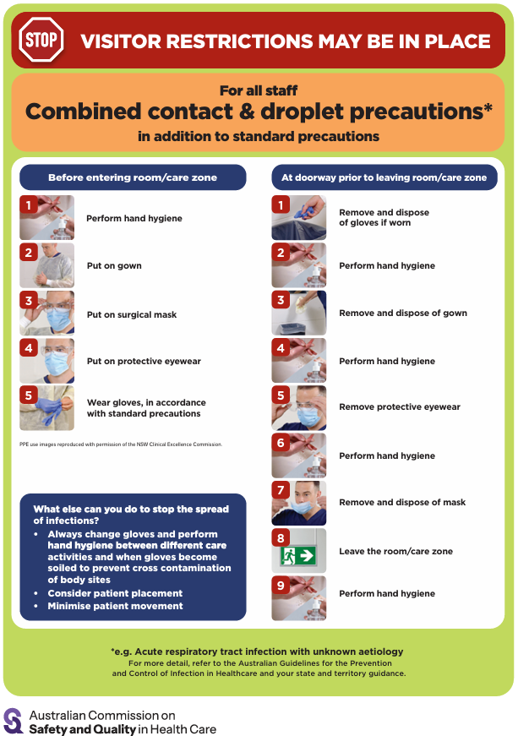
- Poster – Combined airborne and contact precautions https://www.safetyandquality.gov.au/publications-and-resources/resource-library/infection-prevention-and-control-poster-combined-airborne-and-contact-precautions
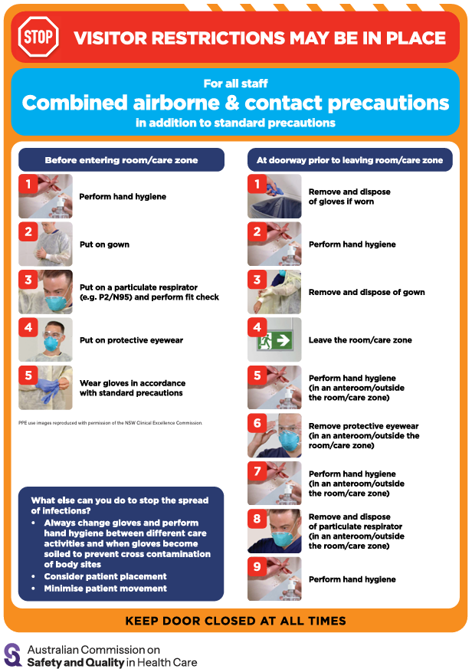
- Aged Care standard and transmission-based precautions posters – https://www.safetyandquality.gov.au/clinical-topics/aged-care-and-older-people#standard-and-transmission-based-precautions-in-aged-care-
- Break the chain of infection poster
https://www.safetyandquality.gov.au/publications-and-resources/resource-library/break-chain-infection-poster
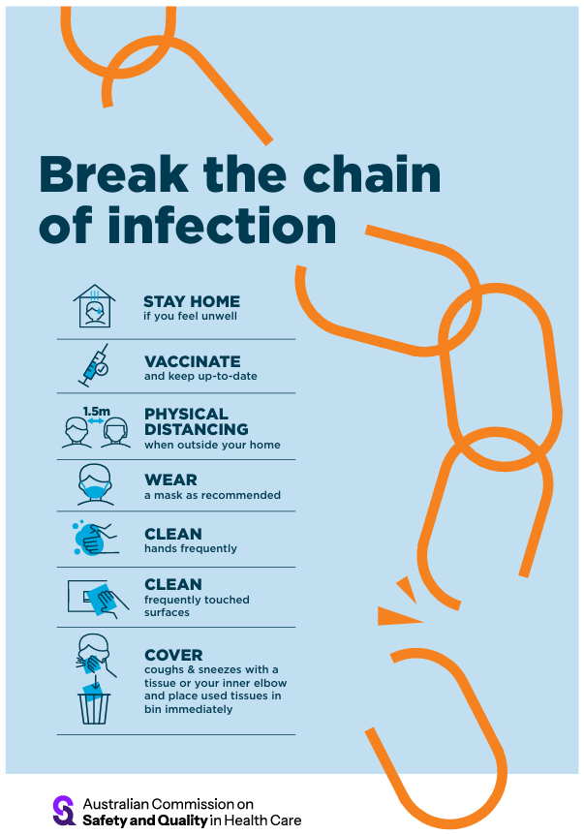

Disclaimer
On the Radar is an information resource of the Australian Commission on Safety and Quality in Health Care. The Commission is not responsible for the content of, nor does it endorse, any articles or sites listed. The Commission accepts no liability for the information or advice provided by these external links. Links are provided on the basis that users make their own decisions about the accuracy, currency and reliability of the information contained therein Any opinions expressed are not necessarily those of the Australian Commission on Safety and Quality in Health Care.

