
On the Radar
Issue 765
19 October 2026

On the Radar is a summary of some of the recent publications in the areas of safety and quality in health care Inclusion in this document is not an endorsement or recommendation of any publication or provider Access to particular documents may depend on whether they are Open Access or not, and/or your individual or institutional access to subscription sites/services Material that may require subscription is included as it is considered relevant.

On the Radar is available online, via email or as a PDF or Word document from
https://www.safetyandquality.gov.au/news-and-media/newsletters/on-the-radar

If you would like to receive On the Radar via email, you can subscribe on our website https://www.safetyandquality.gov.au/news-and-media/newsletters/on-the-radar
or by emailing us at mail@safetyandquality.gov.au.
You can also send feedback and comments to mail@safetyandquality.gov.au.

For information about the Commission and its programs and publications, please visit https://www.safetyandquality.gov.au

On the Radar
Editor: Dr Niall Johnson
Contributors: Niall Johnson, Bianca van Vlimmeren

Infection Prevention and Control Week 2026: Past, present, prepared for the future
https://www.safetyandquality.gov.au/news-and-media/events-and-awareness-days/infection-prevention-and-control-week
Infection prevention and control (IPC) week is celebrated globally from the 18–24 October 2026 to promote effective IPC practices which protect patients, carers and healthcare workers.

The Commission’s theme for IPC week 2026 is Past, present, prepared for the future. It recognises the progress made in infection prevention and control, reinforces the importance of consistent IPC practices today, and highlights the actions needed to ensure patients, communities and healthcare workers remain protected into the future. Contemporaneous literature continues to support the importance of IPC going forward, and the role of all healthcare professionals in preventing the spread of infections.
Past:
Evaluation of preventive interventions addressing healthcare-associated infections and antimicrobial resistance: a systematic review
Campisi E, Di Liberto E, Barchitta M, Maugeri A, Favara G, Magnano San Lio R, et al
Journal of Hospital Infection. 2026 2026/05/01/;171:120-136.
A systematic review evaluated the effectiveness of IPC interventions in reducing healthcare-associated infections (HAIs). Different elements of standard precautions were identified as key interventions in reducing the risk of HAIs. Hand hygiene was associated with reduced HAI especially for urinary tract infections and surgical site infections. Use of environmental cleaning measures were associated with reduced HAI’s and antimicrobial resistance (AMR), while antimicrobial stewardship programs reduce inappropriate antibiotic usage, with subsequent reductions in HAIs and AMR.

Present:
Sports fever! Getting the ball rolling to prevent infections at the World Cup™ and beyond
Mehrotra P, Mathew T, Trulik KG, Kaye KS, Nori P, Bearman G, et al
Antimicrobial Stewardship & Healthcare Epidemiology. 2026;6(1):e61.
This 2026 paper considers the increased likelihood of transmission of infections at sporting events particularly the 2026 FIFA World Cup. Authors emphasise the importance of preparedness of healthcare workers and public health officials both in and out of sporting events to mitigate infectious diseases outbreaks. Suggested intervention included outbreak management plans, prevention of transmission of infections through food and water contamination, education to prevent transmission of infections through airborne or contact routes during sport events, and access to vaccinations.

Prepared for the future:
Global randomised controlled trials in infection prevention and control: a bibliographic review from the past two decades
Mitchell BG, Matterson G, Carroll MR, Donnelly H, Marimuthu K, Tehan PE
Journal of Hospital Infection. 2026 2026/08/01/;174:459-465.
This paper reviewed the long-term trends in IPC research, recognising that IPC recommendations and guidelines are underpinned by low-quality evidence. There is an increasing volume of IPC research emerging and Australia was noted to produce a significant volume of IPC research and to work collaboratively across the globe when undertaking randomised control trials. This paper highlights the importance of IPC guidelines (such as the Commission’s Australian Guidelines for the Prevention and Control of Infection in Healthcare, and the Aged Care IPC guide) rapidly incorporating emerging evidence as it arises.

Reports

National Cardiac Registry 2026 Annual Status Report
Lefkovits J, Poulter R, Pyyvaara J, Dinh D, Sivakumaran T, Lucas M, and Wijaya, J. on behalf of the Registry Steering Committee
Wayville SA: National Cardiac Registry Limited; 2026. p. 96.
URL | https://nationalcardiacregistry.org.au/2026-annual-status-report/
Notes | The National Cardiac Registry 2026 Annual Status Report was recently launched.  As is stated in the report’s executive summary, ‘The National Cardiac Registry (NCR) strengthens Australia’s capacity to measure, benchmark, and improve cardiovascular care by capturing real-world data from over 146,000 percutaneous coronary intervention (PCI) procedures. With 68 public and private hospitals across all eight jurisdictions contributing to a consistent national minimum data set, the NCR provides a comprehensive view of national PCI care.  By monitoring eleven key quality indicators, including timely reperfusion, complications, and 30 day outcomes, the registry identifies local, jurisdictional, and national opportunities for clinical improvement.’  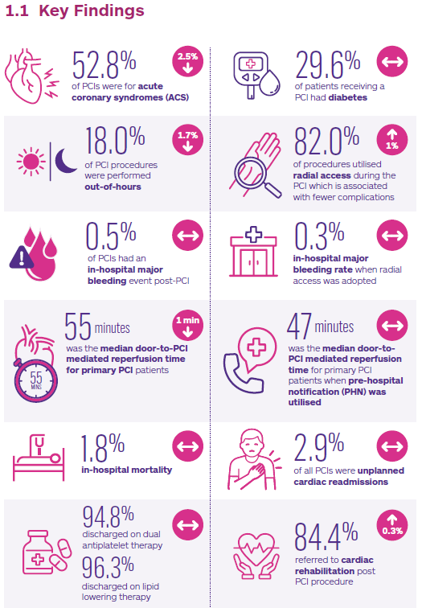

For information on the Commission’s work on clinical quality registries, including the Australian Framework for National Clinical Quality Registries and the Australian Register of Clinical Registries, see https://www.safetyandquality.gov.au/data-and-measurement/clinical-quality-registries

Journal articles

Leadership Paradoxes in Healthcare Organizations
Bhardwaj A
Journal of Healthcare Leadership. 2026;18:650595.
DOI | https://doi.org/10.2147/JHL.S650595
Notes | This perspectives piece in the Journal of Healthcare Leadership reflects on various aspects of leadership in these settings, including the challenges and paradoxes. The author of this piece observes that ‘Effective leaders in Healthcare Organizations (HCOs) are usually characterized by their core and aspirational attributes such as integrity, transparency, collaboration, compassion, emotional intelligence, and servant leadership.' However, it is also noted that these are complex organisations that provide leadership challenges and complexities that are not readily resolved. Some of these can lead towards a ‘dark side of leadership’ that can be damaging for individuals and organisations. It is recognised that the many ‘competing demands generate enduring paradoxes that cannot be resolved but instead require ongoing recalibration and adaptation’ and that ‘paradox as inherent to HCO’s leadership’. The author suggests ‘adaptive decision-making, contextual judgment, integrative thinking, and dynamic balancing of competing priorities to strengthen leadership, governance, and organizational performance.’  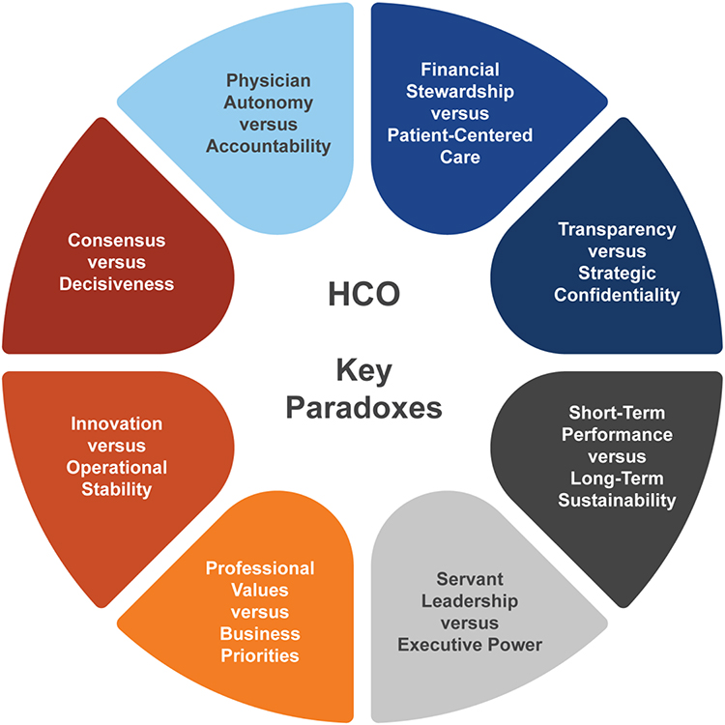
Pediatric Quality & Safety
Volume 11, Issue 5, September/October 2026
URL | https://journals.lww.com/pqs/toc/2026/09000
Notes | A new issue of Pediatric Quality & Safety has been published. Articles in this issue of Pediatric Quality & Safety include:  - Improving Referral Adherence in a Developmental/Behavioral Clinic: A Quality Improvement Initiative (Sarah E Rysdyk, Jamie L Roberts)  - Achieving Faster Bleeding Disorder Treatment in the Emergency Department: A Quality Improvement Initiative (K Adams, M Caskey, L Neill, D Moczygemba, Y Yuan, S Yanger, E Munns, J Heineman, A Gurunathan)  - Improving Guideline-concordant Antibiotic Use for Acute Otitis Media in a Pediatric Primary Care Network (Sarah Sweeney, Anna Simon, Laura Morano, Jason Chang, Kari Goebel, Kenisha Campbell, S A Morelli, M P Kronman)  - Impact of a Quality Improvement Initiative to Reduce Medication-induced Kidney Injury (William Stoudemire, Nour Akil, Adam Bernstein, Erica Bjornstad, Meredith Cuthriell, Nicole D Damari, Darren Dewalt, Carmen Echols, C Falato, Y Liao, C Loughlin, C McKinzie, M Steiner, K Westreich)  - Report Cards as a Sustainability Tool for Guideline Adherence in Pediatric Traumatic Brain Injury (Kaitlyn T Marks, Carlie Myers, N Gregor, S Wang, B Zhang, D K Maue, J Skoch, E Rheaume, M Kotagal, J Kaplan, M Dewan  - Reducing Inpatient Pediatric Central Line–associated Bloodstream Infections by Proactive Risk Assessment and Escalation (Chris I Wong, Claudia Hoyen, Joyce Deptola, Theresa Smith, Josephine Rey, C G Macias)  - Quality Improvement Partnership to Improve Human Papillomavirus Vaccine Rates: Start at Age 9 Campaign (Lauren E Ng, Jessica P Fenton, Linda Mermelstein, Lori Ellis, Randi Trope)  - Nasal Intermittent Positive Pressure Ventilation: Guideline Implementation Guided by Practice Preference Measurement (Sofia Gnecco-González, Emily Whitesel, John Zupancic, M Gupta, D M Pursley, H Healy)  - A Quality Improvement Project to Increase Discharges before Noon at a Pediatric Hospital (Karen C Willis, Samantha M Gunkelman, Brittany K Potts, Kerwyn C Jones, Angela M Contant, Karan R Johnson, Prabi Rajbhandari)  - Impact on Health Disparities: Secondary Analysis of an Unplanned Extubation Quality Improvement Study (Gayathri Sreenivasan, Parvathy Krishnan, Lance A Parton, Meenakshi Singh)  - Decreasing Prescriber Errors in a Tertiary Care Pediatric Intensive Care Unit via QI Methodology (Timothy Brandt, Dhara D Shah, G Cassel-Choudhury)  - Quality Improvement Initiative: Implementation of a Unified Pediatric Asthma Pathway Reduces Critical Care Requirements (Jocelyn A Livezey, Jessica Witkowski, Kendra Grether-Jones, Moonjoo Han, Michelle Linenberger, Stephanie Mateev, Kirsten McCullough, Heather McKnight, JoAnne Natale, K Reneau, B J Smith, L Tsang, L Tzimenatos, M Y Hamline)  - Optimizing Nutrition in Pediatric Burn Patients: A Quality Improvement Initiative (Tamara O Sharf, Mary S Kim, Dylan W Arkowitz, Elizabeth M Waibel, Jonathan M Teets, S Schug, E C Elliott, M P Sharron, R S Burd)  - Enhancing Patient Throughput Through Front-end Redesign and Alternate Care Space Implementation in a Pediatric Emergency Department: A Quality Improvement Initiative (Cortney C Braund, B K Johnson, S Moen, S Spencer, T Justilian, S Sternberg, K Vickrey, M Cerchie, C Dunham, N Navanandan)  - Synthesizing Interest-holder Perspectives and Evidence-based Potentially Better Practices to Improve High-risk Infant Follow-through Care Quality (Lindsay Rosenfeld, Nisha Dalvie, Cindy Chwa, Jonathan S Litt)  - Increasing Interpreter Use for Pediatric Cardiology Units: A Quality Improvement Initiative (Dulce Maria Ovalle Sanchez, Jennifer Gauntt, Ronna Porterfield, Robert J Gajarski)  - Standard Elements in Studies of Adverse Events and Medical Error (SESAME): explanation and elaboration (Richard T Griffey, Lee M Adler, D C Stockwell, P D Hibbert, D O Klein, R Schwendimann, A D Auerbach, R Ancona, R M Schneider, D Classen, C R Carpenter, A W S Rutjes, M Unbeck  - Standard Elements in Studies of Adverse Events and Medical Error: the SESAME statement (Richard T Griffey, David C Stockwell, Lee M Adler, R Ancona, D Classen, R M Schneider, A W S Rutjes, C R Carpenter, M Unbeck)  - Sustaining Quality Improvement to Increase Adverse Childhood Experience Questionnaire Response Rates and Proposal of Plan-do-study-act-assess Cycle (Sarah A Commaroto, Kelly Campbell, Madison Tyle, Melissa Chow, Shainal Gandhi, Monica Khadka, Marilyn Torres, Emily Coughlin, V Kiluk)  - Increasing Rates of Health-related Social Needs Screening in a Pediatric Critical Care Setting Through Quality Improvement (Hemen Muleta, Camilo Pardo, Amanda Klafter, Susan Velasco, Renee Whiskey-LaLanne, Henry M Ushay, Patricia Hametz, Kevin P Fiori, Gina Cassel-Choudhury)

Health Policy
Volume 174, December 2026
URL | https://www.sciencedirect.com/journal/health-policy/vol/174/
Notes | A new issue of Health Policy has been published. Articles in this issue of Health Policy include:  - Training by geography, not merit: the Medical Training (Prioritisation) Act 2026 and the NHS workforce (Chianu Dibia)  - Rare disease definitions across regulatory and reimbursement systems: policy objectives and implications for patient access (Constanza Vargas, Stephen Goodall, Manuel Espinoza, Richard De Abreu Lourenco)  - Leadership for implementation is essential to turn health workforce ambition into reform (Michelle Falkenbach, Maria Joachim, Matthias Wismar, Gemma A Williams, ... Ellen Kuhlmann)  - The 2025 European health data space regulation: implementation challenges in harmonising opt-out rules for reusing health data (Andrea Martani, Lea Skovgaard, Jonas J Neubert, Gesine Richter, Luca Marelli)  - Measuring and governing potentially low-value invasive coronary angiography in Europe: a systematic review, construct-specific meta-analysis, and policy framework (Priyanka Boettger, Kerstin Piayda, Heinz Frederik Noll, Ole Stegemann, ... Eva-Maria Wild)  - “Nothing for Us Without Us”: Normalising patient and public involvement and engagement in national clinical audits and health system improvement (Seif El Hadidi, Maureen Flynn, C Tully, M Cronin, ... L Brent)  - Singapore’s Centre for Healthcare Innovation (CHI) Innovation Cycle (Casper Chong Kee Ng, Eugene Soh)  - Women’s health workforce and outpatient care delivery in Alberta: Evidence from 26 years of population-based data (Amity E Quinn, Natalie V Scime, Tim Zhang, Flora Au, ... Erin A Brennand)  - Participation in out-of-home activities and health-related quality of life among Australian children with disabilities: Evidence from the longitudinal study of Australian children (Benojir Ahammed, Khorshed Alam, Zahirul Hoque, Syed Afroz Keramat)  - Health professionals’ language capacity in Canada: a mixed qualitative analysis of regulatory data and implications for workforce planning (Nimrit Kenth, Lise Richard, Ivy Bourgeault)  - Towards distinctions-based Indigenous health workforce reform in Canada: A comparative policy analysis (Mona Lisa Bourque Bearskin, Liquaa Wazni, Nikki Rose Hunter–Porter (St’uxwtsews), Leanne Kelly, ... Arezoo Mojbafan)  - Building Indigenous primary health care infrastructure in Canada: A retrospective comparative policy analysis of Alberta and Ontario (Erynne Sjoblom, Stephanie Montesanti, Emily Fleming, L Crowshoe, ... K Williams)  - Mapping the process of implementing Health System Performance Assessment into political decision-making: expert survey among 22 European countries (Miriam Blümel, Katharina Achstetter, Philipp Hengel, R Busse)  - Assessing and strengthening health promotion in local governments: Development and structure of the PROMOACTIVA-GL tool (A Mujika, M J Pumar-Méndez, I Anton-Solanas, O Lopez-Dicastillo, ... N Hernantes)  - Understanding consumer preferences for allied health telehealth services in Australia: a discrete choice experiment (Feby Savira, Alice Petcopoulos, Madison Frith, Deniz Senyel, ... Richard Norman)  - Ethical and legal challenges of cross-border health data sharing in Europe: A normative policy analysis of ICUData4EU (Jinshuo Liu, M Eijkholt, Y Ma)  - Retirements and organizational performance: Mixed methods evidence from Portuguese public hospitals (Eduardo Costa, J Gonçalves, P Martins)  - Public–private and dual-practice workforce dynamics in small countries: findings from a Small Countries Initiative consultation across the WHO European Region (Teodor Cristian Blidaru, Tomas Zapata, Nicolae Dragos Garofil, Yanina Andersen, ... Natasha Azzopardi-Muscat)  - Who stays, who leaves? Transitions from part-time to full-time private-sector employment among physicians in Portugal (Eduardo Costa, Joana Ferreira Cima, Joana Gomes-da-Costa)  - Beyond physician headcounts: a population-based analysis of regional physician practice patterns in northern Ontario, Canada (Emilie Labranche, Sarah Newbery, Joshua O Cerasuolo, Robert Ohle, David W Savage)  - Setting the wages of physicians and nurses working in hospitals across ten central and Eastern European countries – A comparative analysis (Katarzyna Dubas-Jakóbczyk, A Dimova, T Habicht, M Poldrugovac, ... A Domagała)  - Prices and prescribing of competing cancer medicines in Dutch hospitals after imatinib loss of exclusivity: a retrospective claims analysis (Tessa Marsman, Wouter van Straaten, Xander Koolman)  - Delays in access to generic semaglutide point to key missing pieces in Canada's drug approval system (Daniel Eisenkraft Klein, Aaron S Kesselheim)  - Identifying safety concerns in geriatric health settings: insights from Israel geriatric home inspection reports (Keren Semyonov-Tal)  - Emergency department utilization following the introduction of a new primary health care center in Wiener Neustadt, Austria: an interrupted time series analysis (Alexander Braun, Daniel Dick, Claus P Nowak, D Mikšová)
BMJ Quality &Safety online first articles
URL | https://qualitysafety.bmj.com/content/early/recent
Notes | BMJ Quality &Safety has published a number of ‘online first’ articles, including:  - Effectiveness of patient engagement in patient safety on reducing adverse events: a systematic review and meta-analysis (Sixue Cai, Liqin Wei, Yunting Luo, Yan Cai, Yan Jiang)  - Orthopaedic surgical implementation gap: an exploratory descriptive analysis tracking the use of common elective orthopaedic surgeries in England across two decades (Laura Kudrna, Kelly Ann Schmidtke, Hannah Crothers, Katharine Reeves, Mary Kariuki, Chetan Khatri, Imran A Ahmed, Gevdeep Bhabra, Stephen Metcalfe, Samuel I Watson, Richard Lilford)

International Journal for Quality in Health Care online first articles
URL | https://academic.oup.com/intqhc/advance-articles
Notes | International Journal for Quality in Health Care has published a number of ‘online first’ articles, including:  - Understanding Workplace Violence in Healthcare: Insights from an Eight-Year Case Study in a Swiss Hospital Network (Angela Greco)  - When Teamwork Is Not Enough: How Organizational Learning and Continuous Improvement Strengthen the Teamwork–Handoff Relationship in Hospitals (Seung-Hwan Kim)  - Healthcare Workflow Interventions to Reduce Delays in Urological Care: A Systematic Review (Rafaela Rosalba de Mendonça, Marcello Perez Marques de Azevedo, Maria Claudia Bicudo, João Paulo Zambon)  - Waiting for elective orthopaedic surgery: A qualitative scoping review of the patient experience (Elizabeth Walkley, Katheryn Hall, Dannielle Hopkinson, Mina Nichols-Boyd, Elise Williams, Nicole Pope)

Online resources

Australian Living Evidence Collaboration
https://livingevidence.org.au/

Guidance
A number of guidelines or guidance have recently been published or updated These include:
- A Summary for Non-Psychiatrists of the Australian and New Zealand Journal of Psychiatry Grading of Recommendations, Assessment, Development and Evaluations (GRADE) Guidelines for the Management of Schizophrenia, Medical Journal of Australia https://doi.org/10.5694/mja2.70287

Infection prevention and control resources
The Australian Commission on Safety and Quality in Health Care has developed a number of resources to assist healthcare organisations, facilities and clinicians These resources include:
- Standard and transmission-based precautions https://www.safetyandquality.gov.au/clinical-topics/infection-prevention-and-control/standard-and-transmission-based-precautions
- Poster – Combined contact and droplet precautions https://www.safetyandquality.gov.au/publications-and-resources/resource-library/infection-prevention-and-control-poster-combined-contact-and-droplet-precautions
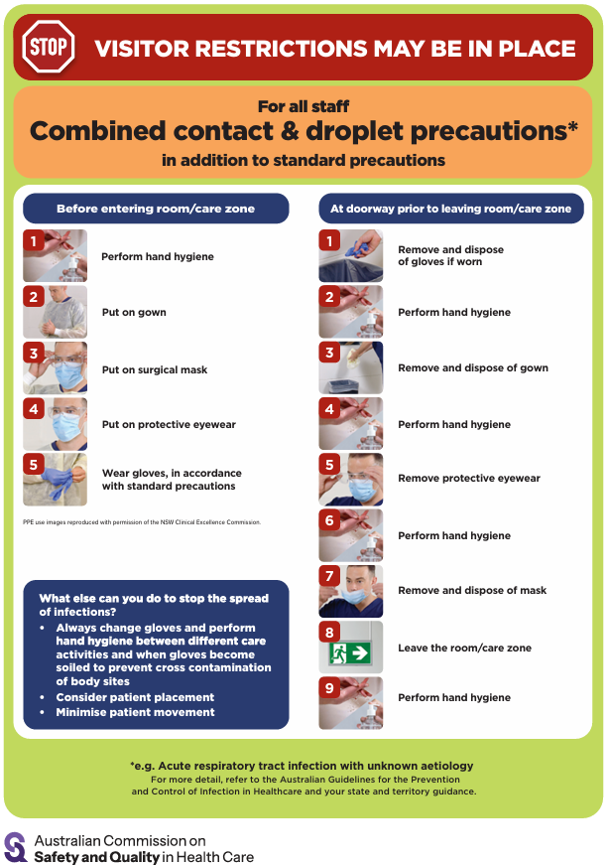
- Poster – Combined airborne and contact precautions https://www.safetyandquality.gov.au/publications-and-resources/resource-library/infection-prevention-and-control-poster-combined-airborne-and-contact-precautions
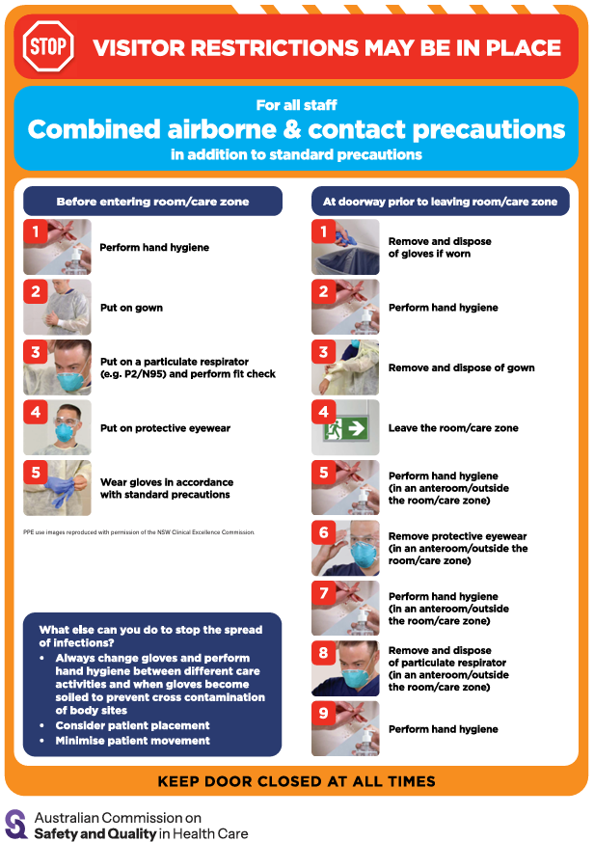
- Aged Care standard and transmission-based precautions posters – https://www.safetyandquality.gov.au/clinical-topics/aged-care-and-older-people#standard-and-transmission-based-precautions-in-aged-care-
- Break the chain of infection poster
https://www.safetyandquality.gov.au/publications-and-resources/resource-library/break-chain-infection-poster
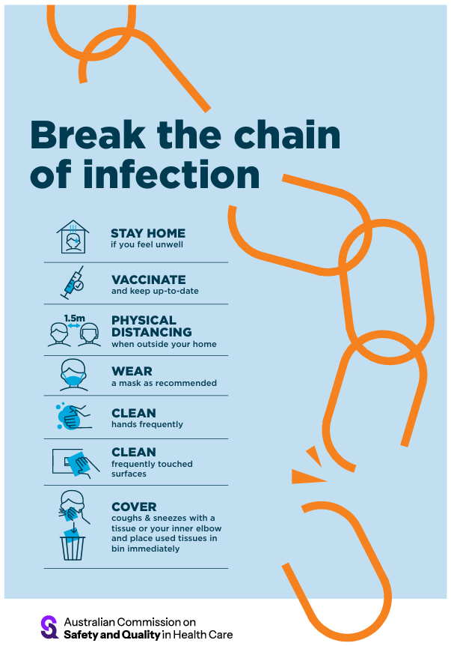

Disclaimer
On the Radar is an information resource of the Australian Commission on Safety and Quality in Health Care. The Commission is not responsible for the content of, nor does it endorse, any articles or sites listed. The Commission accepts no liability for the information or advice provided by these external links. Links are provided on the basis that users make their own decisions about the accuracy, currency and reliability of the information contained therein Any opinions expressed are not necessarily those of the Australian Commission on Safety and Quality in Health Care.

