
On the Radar
Issue 766
26 October 2026

On the Radar is a summary of some of the recent publications in the areas of safety and quality in health care Inclusion in this document is not an endorsement or recommendation of any publication or provider Access to particular documents may depend on whether they are Open Access or not, and/or your individual or institutional access to subscription sites/services Material that may require subscription is included as it is considered relevant.

On the Radar is available online, via email or as a PDF or Word document from
https://www.safetyandquality.gov.au/news-and-media/newsletters/on-the-radar

If you would like to receive On the Radar via email, you can subscribe on our website https://www.safetyandquality.gov.au/news-and-media/newsletters/on-the-radar
or by emailing us at mail@safetyandquality.gov.au.
You can also send feedback and comments to mail@safetyandquality.gov.au.

For information about the Commission and its programs and publications, please visit https://www.safetyandquality.gov.au

On the Radar
Editor: Dr Niall Johnson
Contributors: Niall Johnson, Elyse Powell

Reports

WHO guideline on the integrated management of obesity in children
World Health Organization
Geneva: WHO; 2026. p. 148.

WHO guideline on the integrated management of obesity in adolescents
World Health Organization
Geneva: WHO; 2026. p. 164.
URL | Children: https://www.who.int/publications/i/item/9789240123397  Adolescents https://www.who.int/publications/i/item/9789240123878
Notes | The World Health Organization (WHO) recently published this pair of guidelines on obesity focussing on children and adolescents respectively.  - The purpose of the WHO guideline on the integrated management of obesity in children ‘is to provide …adoptable and adaptable, clear, practice- and science-informed global clinical and public health recommendations on the integrated management and care of children in all their diversity, aged 29 days to under 10 years living with obesity, for improved health, functioning and reduced obesity-associated disability, using a primary health care approach.’  - The companion WHO guideline on the integrated management of obesity in adolescents ‘provides practice- and science-informed global clinical and public health recommendations for the integrated management of obesity in adolescents aged 10–19 years, responding to the growing global burden of obesity and supporting improved case management and care pathways through a primary health care approach.’  The two guidelines present evidence-informed recommendations on dietary interventions, physical activity, sedentary behaviour and sleep, behaviour changing interventions, digital health interventions, pharmacotherapy, bariatric surgery and weight-management devices, and multimodal interventions.

Global roadmap for hypertensive disorders of pregnancy from 2026 to 2035 and beyond
World Health Organization
Geneva: WHO; 2026. p. 94.
URL | https://www.who.int/publications/i/item/9789240125483
Notes | Also recently released by the World Health Organization (WHO) is this ‘global roadmap’ for addressing ‘hypertensive disorders of pregnancy’. The document’s executive summary observes that ‘Hypertensive disorders of pregnancy, notably pre-eclampsia and eclampsia, constitute a major and persistent global public health challenge. They are among the leading causes of maternal death and severe morbidity, have lasting consequences for women’s cardiovascular health and contribute substantially to stillbirth, preterm birth, newborn mortality and morbidity and health-system costs.’ It also notes that ‘The Roadmap articulates a shared vision, strategic priorities and coordinated actions across five interconnected areas – research and innovation; norms and standards; access to health products; implementation; and advocacy and accountability – to accelerate progress towards ending preventable stillbirth, maternal and newborn mortality and morbidity associated with hypertensive disorders of pregnancy’.
Ageing is living: Implementation approaches for healthy ageing and care in the WHO European Region
World Health Organization
Copenhagen: WHO Regional Office for Europe; 2026. p. 13.
URL | https://www.who.int/europe/publications/i/item/WHO-EURO-2026-13777-53551-84141
Notes | Short report from the World Health Organization’s Regional Office for Europe that outlines ‘a regional framework for enabling people to live longer lives in good health, with dignity and social connection’. According to the report, the approach ‘combines four strategic policy actions – promoting health and preventing disease; transforming health and care systems; creating age-friendly environments; and challenging ageism – with four foundational actions on leadership, investment, innovation, and data and evidence. Its twin-track approach addresses the needs of older persons today while investing across the life course so that future generations can age in better health.’  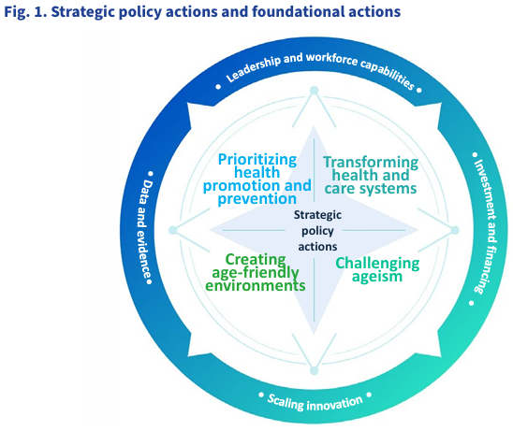

Forward Together: 2025–26 Impact Report
Healthcare Excellence Canada
Ottawa: Healthcare Excellence Canada; 2026. p. 51
URL | https://www.healthcareexcellence.ca/
Notes | This report from Healthcare Excellence Canada is their annual impact report. In which they share the progress they and partners have been making toward safe, high-quality care, and the people and collective efforts driving it across Canada. Among the areas covered in this report are:  - Care closer to home and community  - Care of older adults  - Health workforce retention and support  - Embedding the foundations of quality, safety and equity.
Journal articles

Time to Measure the Outcomes of What Nurses Really Do
Kennedy LS, Kalvas LB, Curley MAQ
JAMA Internal Medicine. 2026.
DOI | https://doi.org/10.1001/jamainternmed.2026.5066
Notes | This Viewpoint piece in JAMA Internal Medicine highlights the importance of reframing nursing care outcomes to better reflect the value of nursing care and its impact on safety and quality. The authors examine how nursing quality is often assessed through harms prevented, such as falls and pressure injuries rather than the broader impact nurses have on patient care. The authors emphasise the critical role nurses play in assessment, surveillance, care coordination and supporting patients and families, demonstrating the need for measures that better capture the broader outcomes nursing care helps achieve. The authors ‘propose nurse-sensitive outcome measures that reflect the full scope of nursing practice, together with a framework to guide the development of these measures’ and identify nine domains of acute and critical care nursing practice and possible outcome measures for each.

Guidelines for the management of adult penicillin allergy in community and specialist settings in Australia and New Zealand: An AGREE II and Delphi-based approach
National Allergy Council Drug Allergy consortium, Lucas M, Kehoe J, Stiles S, Salter SM, Loprete J, et al.
Journal of Allergy and Clinical Immunology: Global. 2026;5(6).
DOI | https://doi.org/10.1016/j.jacig.2026.100784
Notes | Article reporting on the development of a guideline that ‘aims to provide recommendations for the assessment and management of adults with a penicillin allergy label, for Australian health professionals working in both community and specialist settings.’ The guideline was developed in collaboration with the Australasian Society of Clinical Immunology and Allergy (ASCIA), the National Allergy Council and the National Allergy Centre of Excellence (NACE).  It is noted in this piece that ‘Penicillin allergy is commonly reported with an estimated global prevalence of approximately 9% among adults. A penicillin allergy label (PAL) is a note in a person’s medical record indicating that they have reported an allergic reaction to penicillin. However, studies show that <10% of people formally tested are truly penicillin allergic’. Furthermore, ‘There are significant negative impacts associated with PALs for both individuals and health care systems, including higher rates of morbidity and mortality, greater antimicrobial resistance, prolonged hospital stays and readmissions, and increased health care costs.’  It is suggested that ‘These adult guidelines will support the implementation of penicillin allergy delabeling programs in community and specialist centers in Australia.’

Australian Journal of Primary Health
Volume 32, Issue 5, October 2026
URL | https://connectsci.au/py/issue/32/5
Notes | Recent articles in the Australian Journal of Primary Health include:  - ‘It’s about demonstrating the impact and effectiveness of the work we do.’ Results of a survey to measure the research capacity of a community-based health and social service (Debra Mitchell, Lauren Barker, Camilla Radia-George, Natasha K Brusco)  - Association between experience quality in a short-term, voluntary, rural, funded, immersion placement program on future rural engagement decisions (Brenden James, Robyn Ramsden, Louise Geddes, S Pit, Y Guisard)  - Perspectives on primary care management of chronic hepatitis B in refugees: findings from qualitative interviews with healthcare providers in Melbourne, Victoria (Amireh Fakhouri, Sara L Newton, L Mascarenhas, M Temple-Smith)  - A tale of two realities: how do policymakers and general practitioners perceive the performance of primary health networks in Australia (Yabo Yan, Andrew Podger)  - Health system responsiveness in cervical screening: experiences of Muslim immigrant women in Australia (Shazra Abbas, Kirsty Teague, Julia Brotherton, Wanda Stelmach, Sumit Kane)

BMJ Quality & Safety
Volume 35, Issue 11, November 2026
URL | https://qualitysafety.bmj.com/content/35/11
Notes | A new issue of BMJ Quality & Safety has been published. Many of the papers in this issue have been referred to in previous editions of On the Radar (when they were released online). Articles in this issue of BMJ Quality & Safety include:  - Editorial: Testing the system without breaking it: the risks of in situ simulation (Victoria Brazil)  - Editorial: Beyond the competent champion: reconsidering how champions’ success is defined, measured and supported (Emily R George, Kendra Bird, Rosemary Raymundo)  - Association between mass casualty in-situ simulation format with ongoing operational and patient care metrics in an adult emergency department: a retrospective cohort study (Nitay Raisch, Gal Pachys, Baruch Berzon, Dina Cashdan, Aya Cohen, Evan Avraham Alpert, Nadya Kagansky, Tzachi Slutsky, Ari M Lipsky, Yehoshua Pinchuk, Ahmad Naama, Osnat Levtzion Korach, Joseph Offenbacher, Danie)l Trotzky  - Service users’ experiences of maternity care in England informed by the Saving Babies’ Lives Care Bundle Version 2: A reflexive thematic analysis (Holly E Reid, Debbie M Smith, Kate Widdows, Alexander EP Heazell)  - Retrospective analysis of preventable procedural adverse events (ICD-10 Y62–Y69) in the TriNetX network: a multiregional study before, during and after the COVID-19 pandemic (Rosario Caruso, Marco Di Muzio, Emanuele Di Simone, Sara Dionisi, Arianna Magon, Gianluca Conte, Alessandro Stievano, Emanuele Girani, Sara Boveri, Pier Mario Perrone, Silvana Castaldi, Lorenzo Menicanti, Mary Dolansky)  - Building capacity for change: developing an evidence-based competencies framework to power champions (Harveer Punia, Giulia Zucal, Patricia Julian, Katherine Wallace, Susan McNeill, Doris Grinspun)  - ‘They don’t know my body’: health consumer recognition and escalation of acute deterioration – a systematic review (James Bonnamy, Janeane Dart, Claire Palermo, Renee Molloy, Kirsten Small, Clifford Connell)  - Carrying the torch: Dr Lucian Leape’s enduring legacy in patient safety – lessons from dentistry (Elsbeth Kalenderian, Rachel Ramoni, Joel White, Muhammad Walji)
BMJ Quality &Safety online first articles
URL | https://qualitysafety.bmj.com/content/early/recent
Notes | BMJ Quality &Safety has published a number of ‘online first’ articles, including:  - Early achieved ambulation is associated with reduced venous thromboembolism among hospitalised medicine patients (Erik H Hoyer, Daniel J Brotman, Daniel Young, Brandyn D Lau, Elizabeth Colantuoni, Karli Funk, Elliott R Haut, Ximin Li, Michael B Streiff)

International Journal for Quality in Health Care online first articles
URL | https://academic.oup.com/intqhc/advance-articles
Notes | International Journal for Quality in Health Care has published a number of ‘online first’ articles, including:  - Hospital crowding as a quality problem: redesigning reliability in early acute care (John Tshon Yit Soong, Nick Murch, Nikolaus Sevdalis, , Derek Bell, Marcus Eng Hock Ong)  - Evolution and national benchmarking of patient safety culture in a newly established hospital: a two-year repeated cross-sectional study (ShouYung Huang and Jim C Huang)  - Challenges and opportunities with adapting international health care quality indicators to local contexts: A descriptive case study (Isabelle Vedel , Deniz Cetin-Sahin, Geneviève Arsenault-Lapierre, Clara Bolster-Foucault, Marwa Ilali, Amélie Quesnel-Vallée)  - Pharmaceutical company payments to medical school deans and university hospital directors in Japan: a nationwide cross-sectional study (Keita Shimizu, Akemi Hara, Piotr Ozieranski, Ivan D Florez, Yangqin Xun, Janne Estill, Yaolong Chen, Yudai Kaneda, Tetsuya Tanimoto, Akihiko Ozaki)  - Rethinking Surgical Governance Through Structured Prospective Challenge (Mohamed Alkashty)  - Feeling safe is not the same as being safe: a question of construct validity (Andi Ratu Boelqiah Assaad, Wahyu Nisawati Mafrukha, Silmi Fadhila Ihsani, Raisa Zuhra Salsabila Awaluddin, Raup Padillah)

Online resources

Guidance
A number of guidelines or guidance have recently been published or updated These include:
- Royal Australian and New Zealand College of Obstetricians and Gynaecologists (RANZCOG), Management of Vasomotor and Genitourinary Symptoms of Menopause (C-Gyn 9) guideline https://ranzcog.edu.au/news/menopause-guideline-vasomotor-genitourinary-symptoms/
RANZCOG has also released three accompanying resources:
  - A quick reference guide for clinicians, including prescribing tables
  - A patient information pamphlet, to assist consumers with understanding their available treatment options and informed decision-making
  - A podcast episode which distils key takeaways from the guideline in an accessible format
- Guidelines for the management of adult penicillin allergy in community and specialist settings in Australia and New Zealand
National Allergy Council Drug Allergy consortium, Lucas M, Kehoe J, Stiles S, Salter SM, Loprete J, et al.
Journal of Allergy and Clinical Immunology: Global. 2026;5(6). https://doi.org/10.1016/j.jacig.2026.100784

Infection prevention and control resources
The Australian Commission on Safety and Quality in Health Care has developed a number of resources to assist healthcare organisations, facilities and clinicians These resources include:
- Standard and transmission-based precautions https://www.safetyandquality.gov.au/clinical-topics/infection-prevention-and-control/standard-and-transmission-based-precautions
- Poster – Combined contact and droplet precautions https://www.safetyandquality.gov.au/publications-and-resources/resource-library/infection-prevention-and-control-poster-combined-contact-and-droplet-precautions
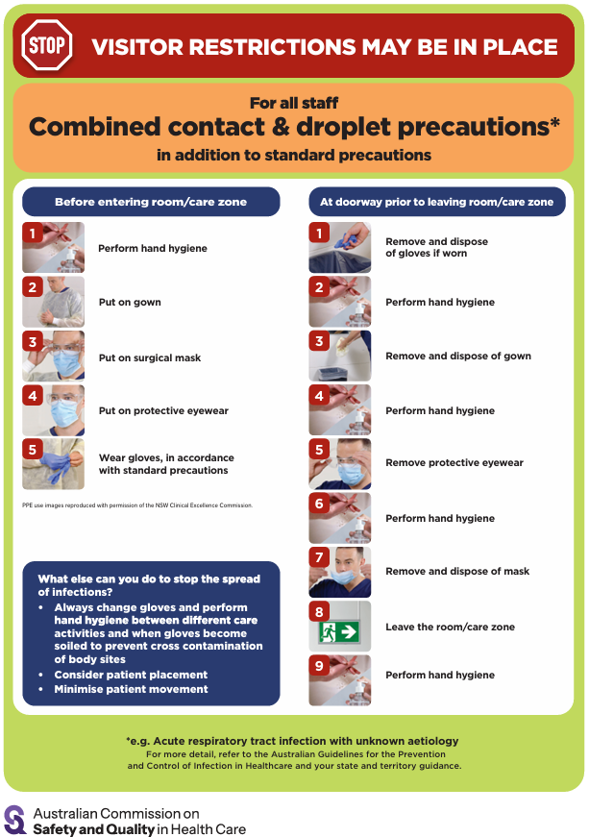
- Poster – Combined airborne and contact precautions https://www.safetyandquality.gov.au/publications-and-resources/resource-library/infection-prevention-and-control-poster-combined-airborne-and-contact-precautions
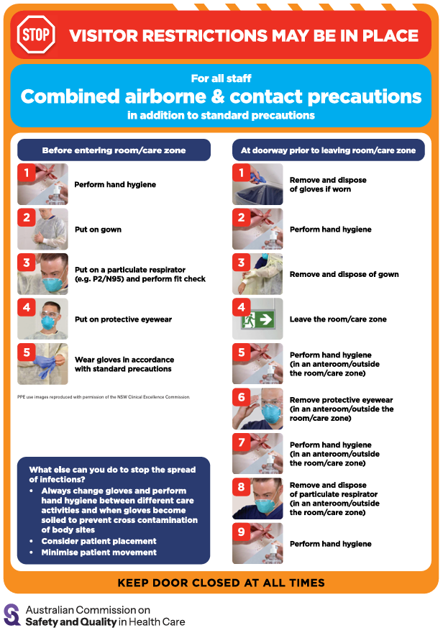
- Aged Care standard and transmission-based precautions posters – https://www.safetyandquality.gov.au/clinical-topics/aged-care-and-older-people#standard-and-transmission-based-precautions-in-aged-care-
- Break the chain of infection poster
https://www.safetyandquality.gov.au/publications-and-resources/resource-library/break-chain-infection-poster
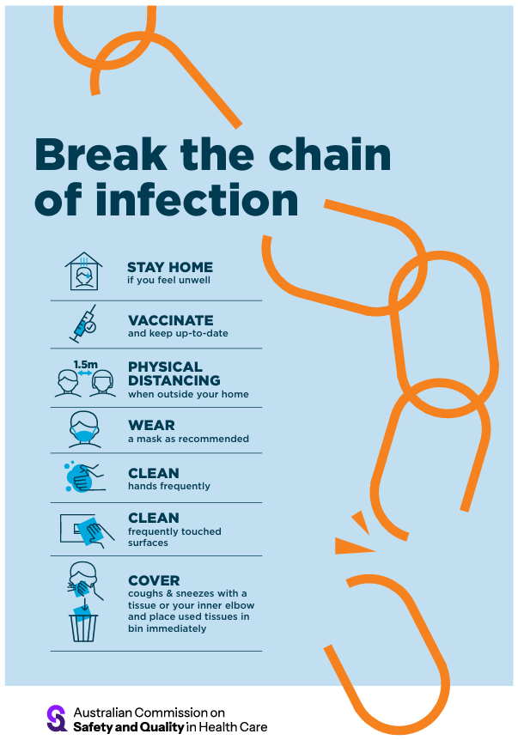

Disclaimer
On the Radar is an information resource of the Australian Commission on Safety and Quality in Health Care. The Commission is not responsible for the content of, nor does it endorse, any articles or sites listed. The Commission accepts no liability for the information or advice provided by these external links. Links are provided on the basis that users make their own decisions about the accuracy, currency and reliability of the information contained therein Any opinions expressed are not necessarily those of the Australian Commission on Safety and Quality in Health Care.

