
On the Radar
Issue 767
2 November 2026

On the Radar is a summary of some of the recent publications in the areas of safety and quality in health care Inclusion in this document is not an endorsement or recommendation of any publication or provider Access to particular documents may depend on whether they are Open Access or not, and/or your individual or institutional access to subscription sites/services Material that may require subscription is included as it is considered relevant.

On the Radar is available online, via email or as a PDF or Word document from
https://www.safetyandquality.gov.au/news-and-media/newsletters/on-the-radar

If you would like to receive On the Radar via email, you can subscribe on our website https://www.safetyandquality.gov.au/news-and-media/newsletters/on-the-radar
or by emailing us at mail@safetyandquality.gov.au.
You can also send feedback and comments to mail@safetyandquality.gov.au.

For information about the Commission and its programs and publications, please visit https://www.safetyandquality.gov.au

On the Radar
Editor: Dr Niall Johnson
Contributors: Niall Johnson, Bianca van Vlimmeren

Aged Care Infection Prevention and Control Guide
Second ed.
Australian Commission on Safety and Quality in Health Care
Sydney: ACSQHC; 2026.
https://www.safetyandquality.gov.au/resources/aged-care-infection-prevention-and-control-guide

The Australian Commission on Safety and Quality in Healthcare has released the 2nd edition of the Aged Care Infection Prevention and Control Guide. The guide provides national practical, evidence-based infection prevention and control guidance tailored to the aged care sector and providing care to the older person. It focuses on supporting IPC education, monitoring and surveillance to ensure Australian aged care services have effective and evidence-based IPC programs. The guide includes a dedicated chapter for implementing IPC leads within aged care services, within considerations for residential, home and community-based services.
Access the updated guide at: https://www.safetyandquality.gov.au/resources/aged-care-infection-prevention-and-control-guide

Access resources to support IPC in aged care at: https://www.safetyandquality.gov.au/clinical-topics/aged-care-and-older-people#infection-prevention-and-control-in-aged-care

Reports

Electronic referrals for ongoing care: risk of losing patient referrals
Interim report
Health Services Safety Investigation Body
Poole: HSSIB; 2026.
URL | https://www.hssib.org.uk/patient-safety-investigations/electronic-patient-record-systems-electronic-referrals-for-ongoing-care/second-interim-report/
Notes | The latest report from the Health Services Safety Investigations Body (HSSIB) in the UK is the second of two interim reports from an investigation into electronic patient record systems – electronic referrals for ongoing care in the UK’s National Health Service (NHS). The report identifies that patient referrals can disappear from worklists in the NHS electronic referral service without staff knowing, putting patients at risk of missed or delayed care. The report includes findings, actions and learnings that are applicable at various levels.

For information on the Commission’s work on medicines safety and quality, see https://www.safetyandquality.gov.au/clinical-topics/medicines-safety-and-quality

Journal articles

Elements and governance of infection prevention and control programs in residential aged care homes: A scoping review
Shaban RZ, Curtis K, Fry M, McCormack B, Parker D, Macbeth D, et al
American Journal of Infection Control. 2026;54(9):1023-1032.
DOI | https://doi.org/10.1016/j.ajic.2026.05.006
Notes | Shaban et al. (2026) examined the key elements of infection prevention and control (IPC) programs in residential aged care facilities. Whilst IPC programs in residential aged care facilities across the world varied widely in scope, common elements included the use of standard precautions, consideration of the older person and employee’s health, and the importance of ongoing infection surveillance.  The governance requirements of an IPC were also reviewed. Whilst the competencies, roles and responsibilities for a person in charge of IPC (IPC lead) varied, the importance of an IPC lead was emphasised across the literature.

Multisociety guidance for infection prevention and control in nursing homes
Mody L, Advani SD, Ashraf MS, Bartlett AH, Bradley SF, Burdsall DP, et al.
Infection Control & Hospital Epidemiology. 2025;46(11):1069-1096.
DOI | https://doi.org/10.1017/ice.2025.10252
Notes | The Society for Healthcare Epidemiology of America (2025) published guidance for providing IPC within nursing homes. The guidance considers the nuances of upholding IPC practices whilst providing care in a home-like environment. A key recommendation was having an IPC lead for each nursing home. The guidance included detail on the training, resources and governance structures needed to support the IPC Lead within nursing home to enable effective IPC.
Empathic Leadership in Healthcare Drives Experience and Workforce Stability: Insights From a Leading Healthcare Organization
Riess H, Dodd PA, Arata M
Journal of Patient Experience. 2026;13:23743735261499609.
DOI | https://doi.org/10.1177/23743735261499609
Notes | Following a previous item on ‘leadership paradoxes’ is this piece on the value of ‘empathic leadership’ from a group at a US medical system. The authors note that ‘Healthcare faces a profound workforce crisis driven by burnout, administrative burden, moral distress, and rapid system-wide change. These forces negatively affect both patient experience and workforce morale.’ They report on a ‘large-scale empathy implementation’ and suggest that ‘empathic practices appear to strengthen empathic communication between care professionals and with their patients’ and ‘also improve psychological safety, and retention’. The authors content that ‘Empathic leadership should be recognized as foundational to resilient healthcare systems, supporting professional fulfillment, mitigating burnout, sustaining high-quality patient care and financial sustainability.’

Peer accountability: lessons for how teams transmit, enforce and reproduce norms for safe care
Churruca K, Ellis LA, Braithwate J
International Journal for Quality in Health Care. 2026:mzag176.
DOI | https://doi.org/10.1093/intqhc/mzag176
Notes | Editorial in the International Journal for Quality in Health Care reflecting on an article that examined peer accountability as a determinant of team performance. The authors of this editorial observe that ‘Organisational culture is among the most frequently cited explanations for variation in the quality and safety of care, and reviews report reasonably consistent associations between cultures characterised by effective leadership, teamwork and trust, and better patient outcomes’. However, they also note that ‘It is harder to specify just how culture does its work. What is it, for example, that enables a good culture to contribute to better patient outcomes?’ They state the review suggests ‘Peer accountability is defined as the reciprocal responsibility, situated horizontally among coworkers, to uphold shared standards and to address departures from them.’ But they expand on this, arguing  ‘Peer accountability is more than a correlate of good team functioning. It is one of the means by which norms for the safety of care are communicated, enforced and reproduced locally, producing safety “sub-cultures”. For example, a clinician who queries a missed patient identification check is in essence both correcting the immediate omission and restating the team’s standard. Yet whether this is experienced as constructive accountability or as blame or policing will depend on trust, psychological safety, just culture and professional power, including whether junior staff can question more senior colleagues. Where such questions are absent, a norm is also communicated by omission. The normalisation of deviance, and the cultures of entrapment described in analyses of hospital disasters, can thus be understood not simply as failures of stated values, but of their transmission and reinforcement through both leaders and peers.’  The review and the editorial both discuss how peer accountability can influence care and how it could be used and how it may manifest in teams. The authors of this editorial argue that ‘For those running services, it means treating the stability of teams as a matter of patient safety and not of workforce planning alone’ as ‘the relationships through which standards are upheld are an asset that accrues slowly, depletes quickly, but often lacks clear or explicit ownership. That is a lesson everyone in healthcare must take to heart.’
The Joint Commission Journal on Quality and Patient Safety
Volume 52, Issues 11, November 2026
URL | https://www.sciencedirect.com/journal/the-joint-commission-journal-on-quality-and-patient-safety/vol/52/issue/11
Notes | A new issue of The Joint Commission Journal on Quality and Patient Safety has been published. Articles in this issue of The Joint Commission Journal on Quality and Patient Safety include:  - Generational Change in the Healthcare Workforce: Perspectives from Health System Leaders (Andrew A White, Thomas H Gallagher, Keegan D Warren, Jasmine Kaur, William M Sage)  - The Next Generation of Quality Measurement: Development and Evaluation of an Electronic Diagnostic Quality Measure in Pneumonia (Lindsay D Visnovsky, Brittany Kent, Elizabeth D Rutter, Jorie M Butler, ... B E Jones)  - Healthcare Staff Experience During JCI Accreditation Preparation and Survey: Evidence From Dubai, United Arab Emirates (Sravan Kumar, Johan Snygg, Pavan Kumar)  - What Weighs into a Clinician’s Decision to Request an Interpreter? A Discrete Choice Experiment (Rose L Molina, Nayantara Biswas, Elysia Larson, Leonor Fernández)  - Implementation of Virtual Clinical Emergency Response Team Model: Impact on Response Timeliness and Reliability (Carl Daniel, Aline Kalaydjian, Jannika V Machnik, Farhan Ishaq, ... Ngoc-Anh Anh Nguyen)  - A Clinical Decision Support (CDS) Tool for Management of Pro Re Nata (PRN) Range Orders in Phase I Postanesthesia Care Unit (PACU): One Organization’s Experience Standardizing Registered Nurse Use (Jennifer M Paquette, Philip J Trapskin, Rhonda RGessler, K J Van Dyke, A R Keenan)  - Enhancing Patient Access Through Scheduling Innovation, Patient Facing Tools, and Workforce Redesign at a Comprehensive Cancer Center (Mahir Raza Sayeed, Alexandra Blake Martinez, P Amado, L Burke, ... V J Hassid)  - Utilizing Quality Improvement Methodology to Implement a Perioperative Intravenous Acetaminophen Protocol in Neonatal Gastrointestinal Surgery (Gemma Barber, Abbey Arnott, Jacob Davidson, Claire Parent, ... J Y Lam)  - Automating Aspiration Precautions to Reduce Latent Safety Risk in the Emergency Department (Rohit B Sangal, Suresh K Pavuluri, John Sather, Jeanie Haggan, ... Arjun K Venkatesh)  - Using Visual Management to Improve Compliance with Chlorhexidine Gluconate Bathing and Nasal Decolonization (Abigail Ruby, Eman Chami, Hannah Musgrove, Xuan Ma, ... Gwen Gnam)  - Calibrated Consent: The Next Step for Personalized Video Surgical Education (Henry Bair)

BMJ Quality &Safety online first articles
URL | https://qualitysafety.bmj.com/content/early/recent
Notes | BMJ Quality &Safety has published a number of ‘online first’ articles, including:  - Early achieved ambulation is associated with reduced venous thromboembolism among hospitalised medicine patients (Erik H Hoyer, Daniel J Brotman, Daniel Young, Brandyn D Lau, Elizabeth Colantuoni, Karli Funk, Elliott R Haut, Ximin Li, Michael B Streiff)

International Journal for Quality in Health Care online first articles
URL | https://academic.oup.com/intqhc/advance-articles
Notes | International Journal for Quality in Health Care has published a number of ‘online first’ articles, including:  - Implementing a Multidisciplinary Fall Prevention Model in Primary Care: Outcomes from a Geriatric Fall Clinic (Chitima Boongird, Thanit Veerapong, Wannisa Wongpipathpong, Konlawat Sabsuantang, Pritsana Punyawai, Sarayut Nijvipakul, Kamonporn Suwanthaweemeesuk, P Wongsawan, S Yodbute)  - Editorial: When Home Becomes the Best Hospital (Joseph J Y Sung and David Greenfield)  - Failure Mode and Effects Analysis of the In-Hospital Medication Process: Identification of Systemic Risks and development of Improvement strategies (Christian Hermann, Ute Amann, Tobias Rüther, Stefan Kääb, Catherine Glocker, Vera Smolka, Isabel Brinkmann, Caroline Rösch, Josef Hollmann, Julian Steinbrech, Martin Göring, Angela Herold, D Strobach, M Günther)  - Beyond morbidity and mortality: integrating measurement into surgical quality systems (António Gomes and Vitor Nunes)  - Editorial: Peer accountability: lessons for how teams transmit, enforce and reproduce norms for safe care (Kate Churruca, Louise A Ellis, J Braithwate)  - Abdominal wall stewardship after colorectal surgery is a neglected quality-improvement opportunity (Matthew P Irwin, J D Harding, M von Papen)  - A Quality Improvement Initiative in Hospital-Based Speech-Language Pathology: Development and Evaluation of a Lean–Agile Management Model (Carina Escudero, Cirley Novais Valente Junior, Gisele Chagas de Medeiros, Fernanda Chiarion Sassi, Ana Paula Ritto, Claudia R Furquim de Andrade)

Online resources

Australian Living Evidence Collaboration
https://livingevidence.org.au/

Guidance
A number of guidelines or guidance have recently been published or updated These include:
- American Society of Hematology 2026 guidelines for diagnosis of iron deficiency.
Powers JM, Lim MY, Achebe MO, Akpan IJ, Auerbach M, Brown MC, et al.
Blood Advances. 2026: https://doi.org/10.1182/bloodadvances.2025015950

Infection prevention and control resources
The Australian Commission on Safety and Quality in Health Care has developed a number of resources to assist healthcare organisations, facilities and clinicians These resources include:
- Standard and transmission-based precautions https://www.safetyandquality.gov.au/clinical-topics/infection-prevention-and-control/standard-and-transmission-based-precautions
- Poster – Combined contact and droplet precautions https://www.safetyandquality.gov.au/publications-and-resources/resource-library/infection-prevention-and-control-poster-combined-contact-and-droplet-precautions
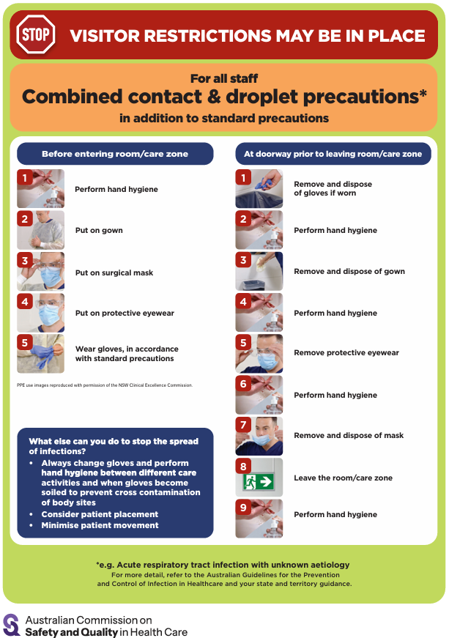
- Poster – Combined airborne and contact precautions https://www.safetyandquality.gov.au/publications-and-resources/resource-library/infection-prevention-and-control-poster-combined-airborne-and-contact-precautions
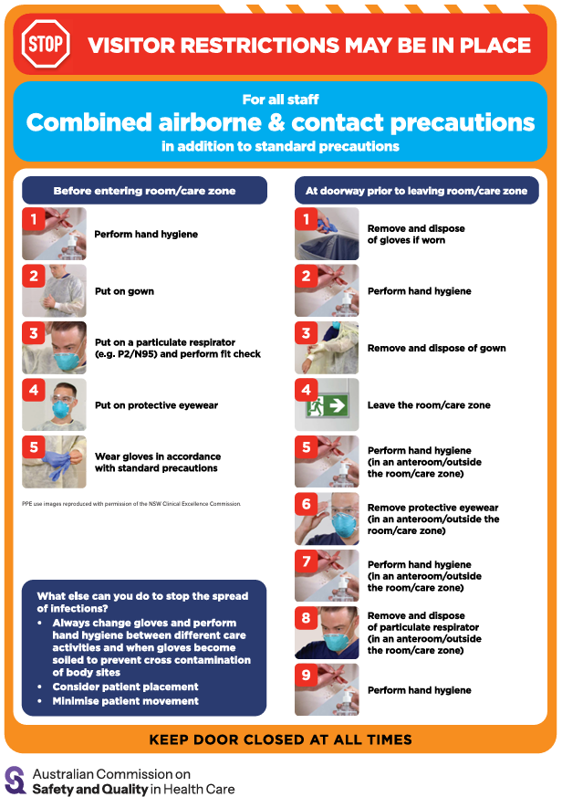
- Aged Care standard and transmission-based precautions posters – https://www.safetyandquality.gov.au/clinical-topics/aged-care-and-older-people#standard-and-transmission-based-precautions-in-aged-care-
- Break the chain of infection poster
https://www.safetyandquality.gov.au/publications-and-resources/resource-library/break-chain-infection-poster
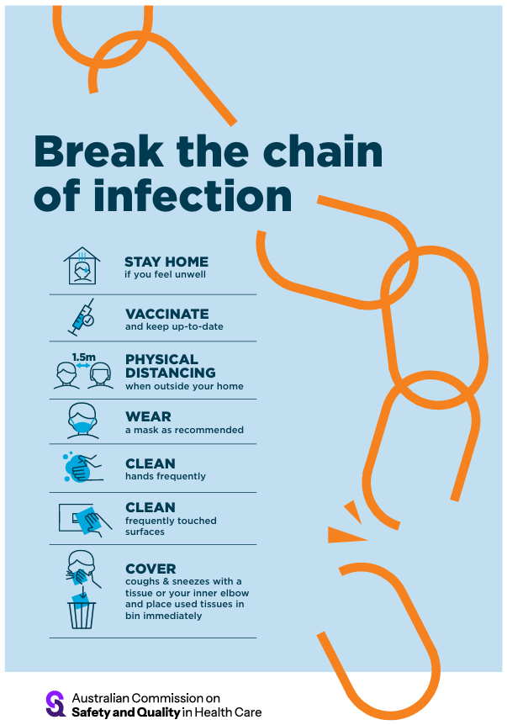

Disclaimer
On the Radar is an information resource of the Australian Commission on Safety and Quality in Health Care. The Commission is not responsible for the content of, nor does it endorse, any articles or sites listed. The Commission accepts no liability for the information or advice provided by these external links. Links are provided on the basis that users make their own decisions about the accuracy, currency and reliability of the information contained therein Any opinions expressed are not necessarily those of the Australian Commission on Safety and Quality in Health Care.

