Annual Report 2025–26

Published by the Australian Commission on Safety and Quality in Health Care
Level 5, 255 Elizabeth Street, Sydney NSW 2000
Phone: (02) 9126 3600
Email: mail@safetyandquality.gov.au Website: www.safetyandquality.gov.au
ISBN (print): 978-1-923353-60-2
ISBN (online): 978-1-923353-61-9
© Australian Commission on Safety and Quality in Health Care 2026
All material and work produced by the Australian Commission on Safety and Quality in Health Care is protected by copyright. The Commission reserves the right to set out the terms and conditions for the use of such material.
As far as practicable, material for which the copyright is owned by a third party will be clearly labelled. The Commission has made all reasonable efforts to ensure that this material has been reproduced in this publication with the full consent of the copyright owners.
With the exception of any material protected by a trademark, any content provided by third parties, and where otherwise noted, all material presented in this publication is licensed under a Creative Commons Attribution-NonCommercial – NoDerivatives 4.0 International licence.


Enquiries about the licence and any use of this publication are welcome and can be sent to communications@safetyandquality.gov.au.
The Commission’s preference is that you attribute this publication (and any material sourced from it) using the following citation:
Australian Commission on Safety and Quality in Health Care Annual Report 2025–26. Sydney; ACSQHC, 2026.
Disclaimer
The content of this document is published in good faith by the Australian Commission on Safety and Quality in Health Care for information purposes.
The Commission does not accept any legal liability for any injury, loss or damage incurred by the use of, or reliance on, this document.

Acknowledgement of Country
We, the Australian Commission on Safety and Quality in Health Care, acknowledge the Traditional Owners and Custodians of Country throughout Australia and pay respect to those who have preserved and cared for the lands on which we live and work, and from which we benefit each day.
We recognise the strength and resilience of First Nations people and acknowledge and respect their continuing connections and relationships with country, rivers, land and sea.
We acknowledge the ongoing contribution First Nations people make across the health system and wider community. We also pay our respects to Elders past and present, and extend that respect to all Traditional Custodians of this land.
We acknowledge and respect the Gadigal people, Traditional Custodians of the ancestral lands where our office is located.

Letter of transmittal
The Honourable Mark Butler MP Minister for Health and Ageing
Minister for Disability and the National Disability Insurance Scheme Parliament House
CANBERRA ACT 2600

Dear Minister Butler
On behalf of the Board of the Australian Commission on Safety and Quality in Health Care (the Commission), I am pleased to submit our annual report for the financial year ending 30 June 2026.
This report was prepared in accordance with the requirements of the National Health Reform Act 2011 and section 46 of the Public Governance, Performance and Accountability Act 2013.
The report includes the Commission’s audited financial statements, as required by section 42 of the Public Governance, Performance and Accountability Act 2013.
The Commission’s annual performance statements were prepared in accordance with the requirements of section 39 of the Public Governance, Performance Accountability Act 2013 and accurately present the Commission’s performance from 1 July 2025 to 30 June 2026.
As required by section 10 of the Public Governance, Performance and Accountability Rule 2014, I certify on behalf of the Board that:
- the Commission has prepared fraud risk assessments and fraud control plans
- the Commission has in place appropriate fraud control mechanisms that meet its specific needs
- all reasonable measures have been taken to appropriately deal with fraud relating to the Commission.
This report was approved for presentation to you in accordance with a resolution of the Board on 9 September 2026.

I commend this report to you as a record of our achievements and compliance. Yours sincerely

Professor Christine Kilpatrick AO Chair
Australian Commission on Safety and Quality in Health Care
9 September 2026

Contents
Acknowledgement of Country 3
Letter of transmittal 4
Highlights 7
- Overview
About the Commission 9
New Strategic Plan 2025–2030 10
Report from the Chair 12
Report from the Chief Executive Officer 13
First Nations people’s health and reconciliation 14
Working across health care 15
International engagement 17
National Health Reform Agreement 17
Journal articles 17
- Report on Performance
Strategic Priority 1: High-quality care in an evolving environment 19
Strategic Priority 2: Strong outcome-focused clinical governance 24
Strategic Priority 3: Empowered patients, carers and communities 36
Strategic Priority 4: An improvement-driven workforce culture 40
Annual performance statements 47
- Corporate governance and accountability
Legislation and requirements 55
The Commission’s Board 56
Committees 63
Internal governance arrangements 66
External scrutiny 67
- Our organisation
Organisational structure 72
People management 72
Staff profile 73
Work health and safety 75
Capability 75
Workplace diversity 76
First Nations employment 77
- Financial statements
Independent auditor's report 79
Financial statements 81
- Appendices
Appendix A: Related-entity transactions 105
Appendix B: Freedom of information summary 105
Appendix C: Compliance with ecologically sustainable development 106
- Indexes and references
Acronyms 108
Glossary 110
Index of figures 114
Index of tables 114
Compliance index 115
Index 117

Highlights
Accreditation
Australian Health Service Safety and Quality Accreditation

487
hospital and day procedure services assessed

National General Practice Accreditation

2,435
general practices assessed

Safety and Quality Advice Centre

2,970
email enquiries addressed

Diagnostic Imaging Accreditation Scheme

5,073
imaging practices accredited

940
phone calls taken
National Pathology Accreditation Scheme

593
pathology practices accredited

Website and resources
Website page views

11.2 million
Resource downloads

1.3 million
National Hand Hygiene Initiative
Organisations

1,062
‘Moments’ of hand hygiene

770,404
Compliance

86.9%
national benchmark 80%

NHHI Learning Management System

4,857
organisations using the system

New releases and events
National Medicines Symposium 2025 National Model for Clinical Governance
Medication Management at Transitions of Care Stewardship Framework Colonoscopy Clinical Care Standard (Revision)
Emergency Laparotomy Clinical Care Standard
Usability Guidance for Optimising My Health Record Viewing Platforms in Acute Care Atlas Focus Report: Colonoscopy
Stroke Clinical Care Standard (Revision) Healthcare Sustainability and Resilience Module
Electronic Medication Management Self-Assessment Tool Integrated Health and Aged Care Services Module and User Guide

- Overview

This section provides an overview of the Australian Commission on Safety and Quality in Health Care (the Commission), including its mission, role, functions and accountability, and reports from the Commission’s Chair and Chief Executive Officer.
About the Commission
New Strategic Plan 2025–2030
Report from the Chair
Report from the Chief Executive Officer
First Nations people’s health and reconciliation
Working across health care
International engagement
National Health Reform Agreement
Journal articles

About the Commission
In 2006, the Council of Australian Governments established the Commission to lead and coordinate national improvements in the safety and quality of health care. The Commission’s permanent status was confirmed with the passage of the National Health and Hospitals Network Act 2011 and its role codified in the National Health Reform Act 2011.

The Commission began as an independent statutory authority on 1 July 2011. It is funded by the Australian Government and state and territory governments.

Our purpose
Our purpose is to lead improvements in the safety and quality of health care, so all Australians receive better care, everywhere.
The Commission contributes to better health outcomes and experiences for Australians and improves clinical appropriateness and sustainability in the health system by leading and coordinating healthcare quality improvement nationally.
The functions of the Commission are specified in section 9 of the National Health Reform Act 2011. These functions include:
- formulating standards, guidelines and indicators relating to healthcare safety and quality matters
- advising health ministers on national clinical standards
- promoting, supporting and encouraging the implementation of these standards and related guidelines and indicators
- monitoring the implementation and impact of the standards
- promoting, supporting and encouraging the implementation of programs and initiatives relating to healthcare safety and quality
- formulating model national schemes that support healthcare safety and quality and enable the accreditation of organisations that provide safe and high-quality healthcare services
- publishing reports and papers relating to healthcare safety and quality.

Our accountability
The Commission is a corporate Commonwealth entity and part of the Health portfolio of the Australian Government. As such, it is accountable to the Australian Parliament and the Minister for Health and Ageing and the Minister for Disability and the National Disability Insurance Scheme the Hon Mark Butler, MP.

New Strategic Plan 2025–2030

In July 2025, the Board released the Commission’s new Strategic Plan 2025–2030. The new plan recognises that the next 5 years will be dynamic, and will bring changes to workforce, models of care, patient and carer needs, technology, community trust, and in socioeconomic and environmental impacts on health.

Our strategic plan responds to these changes, and leverages our unique role, connections, capability and evidence-led culture to lead safety and quality improvement nationally.
Outcome: Consistently excellent care, responsive to patient needs and preferences, is delivered. The health system responds to the evolving environment including to the impact of artificial intelligence, new models of care and climate change.
High-quality care in an evolving environment
Focus: High-quality health care is delivered consistently, reliably and equitably for all Australians.
Outcome: The health system is connected, with strong leadership and governance, and is increasingly shaped by data and evidence about outcomes.
Strong, outcome-focused clinical governance
Focus: Clinical governance, integrated standards and accreditation drive better patient outcomes.
Outcome: Patients are informed and empowered to shape their care. All organisations have the systems and governance in place to integrate the patient, carer, consumer and community voice, at every level of healthcare design and delivery.
Empowered patients, carers and communities
Focus: Health care is designed and delivered with patients and communities.
Outcome: Improvement is embedded in organisational workforce culture and healthcare delivery. This includes fostering accountability, continuous learning, cultural safety, and a readiness to speak up, act and improve.
An improvement-driven workforce culture
Focus: Better health care is everyone’s responsibility, every day.

The Commission is a trusted national steward of quality improvement for better health outcomes.
We collaborate with our key partners to drive the delivery of excellent health care across the health system and patient journey.
We harness evidence and the patient voice to inform the delivery of high-quality, equitable and sustainable person-centred health care.
We prioritise leadership by Aboriginal and Torres Strait Islander peoples and communities to support culturally safe care.

Report from the Chair

Professor Christine Kilpatrick AO

The Commission continued to provide trusted national leadership in supporting safe, high-quality and evidence-based health care across Australia.

Over the past year, the Board and I have been pleased to contribute to the Commission’s strategic direction during an important period of change for the health system. This year the Commission released its new Strategic Plan 2025–2030, setting a clear direction for our work in high-quality care in an evolving environment, strong outcome-focused clinical governance, empowered patients, carers and communities, and an improvement-driven workforce.
The Strategic Plan recognises that the health system is changing rapidly. New models of care, digitally enabled services, artificial intelligence (AI), workforce pressures, climate-related risks and changing community expectations all require a coordinated national approach to safety and quality. The Commission’s role is to support the health system to respond to these changes while keeping patients, carers and communities at the centre of care.
With a renewed focus on high-quality health care that is delivered consistently, reliably and equitably for all Australians, the Commission strives for strong clinical governance, and greater connection across the health system.
The Commission’s work will be shaped by data and evidence and focus on measuring outcomes.
A major achievement this year was the release of the National Model for Clinical Governance. I was pleased to contribute to this work through the Clinical Governance Advisory Committee. The model represents an important shift in how clinical governance is understood, led and embedded across the health system.
It reinforces that clinical governance is not only a responsibility of boards and executives, but a shared responsibility at every level of a health service.
The National Model for Clinical Governance supports a stronger and more consistent approach to accountability, leadership, risk management and continuous improvement. Its foundations align with the National Safety and Quality Health Service (NSQHS) Standards, including the Clinical Governance Standard, to help health services strengthen the systems that support safe, reliable and high-quality care.
The Commission continued to provide national leadership to support digitally enabled care and responsible use of AI. Digitally enabled care has enormous potential to improve access, coordination of care and health outcomes, but it must be designed and implemented safely.
During 2025–26, the Commission progressed work on the safe use of digital tools, including guidance for clinicians on AI, and national guidance for the onscreen presentation of electronic discharge summaries, supporting safer transfer of information between care settings.
The Commission worked with the Australian Digital Health Agency on Usability Guidance for Optimising My Health Record Viewing Platforms in Acute Care, offering practical guidance to improve access to patient information. The Commission also released the Medication Management at Transitions of Care Stewardship Framework to improve communication between hospitals and primary and aged care to reduce the risk of medication-related harm during transitions of care and improve outcomes for patients.
AI is already influencing healthcare delivery, and the Commission’s work in this area helps clinicians and health services understand both the opportunities and the risks.
The Commission’s pragmatic AI guidance for clinicians supports practical, safe and responsible use of AI in day-to-day care, while maintaining a focus on evidence, safety, transparency and patient outcomes.

I would like to acknowledge the Commission’s partners across the Australian Government, state and territory governments, private health services, primary care, aged care, medical colleges, accreditation agencies, consumer groups and professional organisations. Their expertise and collaboration are essential to improving safety and quality across the health system.
I thank my fellow Board members for their guidance and contribution over the past year. I also thank the Commission’s Chief Executive Officer, Conjoint Professor Anne Duggan, the executive team and all Commission staff for their continued commitment and leadership.
The Commission’s work remains central to supporting a health system that is safe, effective, person-centred, equitable and responsive to change. I look forward to continuing to work with our partners to improve outcomes for all people receiving health care in Australia.

Report from the Chief Executive Officer
Conjoint Professor Anne Duggan

The Commission delivered a broad program of work this year, aligned with our new Strategic Plan 2025–2030, to support safer, higher-quality, person-centred health care for all Australians.
In 2025–26 the Commission commenced consultation on and development of the third edition of the National Safety and Quality Health Service (NSQHS) Standards for public, private and day hospitals. This is a major national program that will ensure the standards remain contemporary and responsive to current and emerging models of care. Public consultation to inform the third edition of the NSQHS Standards was undertaken
with health services, clinicians, consumers, jurisdictions and priority population groups. This engagement is essential to ensuring that the standards remain practical, flexible and relevant across diverse healthcare settings.
The extensive feedback we received from across the system informed the development of the initial draft of the third edition of the NSQHS Standards, which will aim to strengthen the link between clinical governance, workforce culture, data driven decision-making and patient outcomes. The third edition is designed to focus on integrated system-level safety and the delivery of high-quality care, every day.
During the year, the Commission continued to support implementation of national standards across a range of settings and programs. This included work on the National General Practice Accreditation Scheme, the National Safety and Quality Primary and Community Healthcare Standards, the National Safety and Quality Mental Health Standards for Community Managed Organisations, the National Clinical Trials Governance Framework, and the Integrated Health and Aged Care Services Module.
Clinical Care Standards continue to be one of the Commission’s most valuable contributions to improving care across Australia. These standards translate evidence into practical guidance for clinicians, services and patients on priority areas where there is variation in care and opportunity for improvement. In 2025–26, the Commission released a new Emergency Laparotomy Clinical Care Standard, updated Clinical Care Standards for stroke and colonoscopy and commenced review of the Venous Thromboembolism Prevention Clinical Care Standard and Acute Coronary Syndromes Clinical Care Standard.
The Commission also released the Atlas Focus Report: Colonoscopy. The Atlas highlighted variation in access, follow-up and outcomes for colonoscopy, and identified opportunities to improve care, including for people in rural and disadvantaged areas.
Person-centred care remained central to the Commission’s work. We released resources to support informed consent and shared decision making. The revised Australian Open Disclosure Framework sets out a nationally consistent approach and practical guidance to support healthcare professionals across all settings to provide clear, timely and compassionate communication with patients.

Improving cultural safety and outcomes for Aboriginal and Torres Strait Islander peoples remained a major priority. The Commission continued work to review standards for cultural safety for health services and to support alignment across national standards. This work contributes to the broader goal of ensuring that health care is culturally safe, respectful and responsive for Aboriginal and Torres Strait Islander peoples.
The Commission progressed work on environmental sustainability in health care, including the release of the Healthcare Sustainability and Resilience Module. This work provides a framework of actions to support health service organisations address healthcare impacts on the environment and the climate risks affecting human health and equitable access to high-quality care.

As the health system continues to evolve, the Commission’s role remains clear: to provide national leadership, trusted standards, practical guidance and evidence-based resources that support safe and high-quality care for all people in Australia.
I thank the Board for their ongoing advice and guidance as the Commission continues to adapt to the challenges and opportunities in our rapidly changing healthcare environment. I also feel immense gratitude and thank our exceptional Commission staff for their dedication, skill and commitment in supporting quality improvement in health care.
I extend my sincere appreciation to all the clinicians, health professionals, patients, organisations and individuals who have contributed to the wide range of resources, events and standards delivered over the past 12 months. I look forward to collaborating with the Australian Government and state and territory health departments, as well as the many stakeholders and organisations that work with us to achieve our shared goal of supporting the delivery of safe and high-quality health care for all Australians.

First Nations people’s health and reconciliation

The Commission recognises that racism and culturally unsafe care pose a known and continuing risk of harm to First Nations people.
Recent reports have demonstrated that systemic and institutional racism remains embedded across Australian healthcare structures, policies and practices, and contributes directly to inequitable access and outcomes for First Nations people.
The Commission recognises that reconciliation is a significant journey that will be a part of Australia’s history for many years to come. The Commission works in partnership with First Nations individuals, organisations and communities, and with other health organisations, as an ally and change-maker in improving First Nations people’s health outcomes and experiences of health care.
The Commission has committed to leading the health system to reorient the delivery of health care and build the capability and capacity of its staff to act in culturally safe and responsive ways. The Commission aims to ensure that it integrates cultural safety into all its work and recognises that cultural safety is required for care to be clinically safe.
For the healthcare system to be effective and deliver better outcomes for First Nations people it must be culturally safe and free from racism and discrimination.
The Commission is working with First Nations organisations, stakeholders, communities and experts to improve the cultural safety of health care through work such as the review of cultural safety standards for hospitals, the National Model for Clinical Governance and the development of the third edition of the National Safety and Quality Health Service (NSQHS) Standards.

Reconciliation Action Plan
The Commission’s Reconciliation Action Plan (RAP) is an important part of its commitment to reconciliation and to improving the safety and quality of health care for First Nations people in Australia.
The Commission finalised and released Innovate RAP in 2024–25. Innovate RAP focuses on strengthening relationships with Aboriginal and Torres Strait Islander peoples and piloting strategies for more reconciliation commitments to empower Aboriginal and Torres Strait Islander peoples. Innovate RAP is being implemented over two years. To support the implementation of actions within the RAP, the Commission also established the Aboriginal and Torres Strait Islander Health Advisory Group and several internal working groups and processes to review implementation and progress against RAP objectives.

Working across health care

The Commission works in collaboration with a range of stakeholders to address key cross-sectoral issues in healthcare safety and quality.

Australian Digital Health Agency
The Commission works in partnership with the Australian Digital Health Agency (ADHA) under a memorandum of understanding (MoU) that establishes a shared commitment to strengthening clinical governance, safety and quality across the national digital health work program.
The MoU provides a principles-based framework for collaboration, including:
- a shared vision to embed safety and quality in digitally enabled care and national digital health infrastructure, such as My Health Record
- complementary roles, with the Commission leading clinical governance, safety and quality, and ADHA delivering national digital health infrastructure
- joint identification and management of emerging clinical safety and quality risks within the digital health environment.
The partnership is supported by formal governance arrangements, including joint working and steering groups and regular engagement between senior executives, to provide strategic oversight and alignment on national priorities.
The Commission contributes to national digital health leadership through participation in ADHA governance and advisory committees relating to connected care, clinical governance, virtual care, and the ‘share by default’ national health reforms.

Australian Institute of Health and Welfare
A highlight of 2025–26 was cross-agency collaboration between the Commission and the Australian Institute of Health and Welfare (AIHW) to develop the Australian Health System Performance Assessment Framework (SPA Framework). While negotiations were underway on the 2026–2031 National Health Reform Agreement addendum, AIHW was tasked with updating the Australian Health Performance Framework in a project funded by the Department of Health, Disability and Ageing.
Recognising the relevance of the work to both parties and the potential to share expertise, a partnership was formed between AIHW and the Commission. A set of comprehensive definitions of the domains of quality care was identified as a useful resource to support development of the SPA Framework.
The Commission and the AIHW , which included an embedded Commission officer, conducted a concurrent process to identify the key domains of quality and develop definitions of high-quality care that reflect the Australian context (see Defining Quality in health care). To support alignment, this definitional work was incorporated into the SPA Framework. The SPA Framework is scheduled for submission to the Department of Health, Disability and Ageing in the second half of 2026.

Healthdirect
Healthdirect, Australia’s virtual public health information service, is a key partner in the Commission’s work to support safe, high-quality virtual care. The partnership is underpinned by strong executive engagement, with regular meetings between senior leaders to progress shared priorities in clinical governance, virtual care, and artificial intelligence.
Healthdirect contributes senior clinical expertise through representation on the Commission’s Digitally Enabled Care Advisory Committee and the Artificial Intelligence Program Advisory Group. Clinical governance is central to the partnership, with Healthdirect’s Clinical Governance and Quality Framework aligned to the Commission’s National Model for Clinical Governance.
In 2025–26, Healthdirect supported the Commission’s virtual care priorities by exploring how the new National Model for Clinical Governance and the draft third edition of the NSQHS Standards could apply to virtual care services.

Australian Health Practitioner Regulation Agency
In May 2026, the Commission worked in partnership with the Australian Health Practitioner Regulation Agency (Ahpra) to publish updated guidance to strengthen the processes for credentialing, re-credentialing and defining facility-specific scope of clinical practice for public and private health services and clinicians. The guidance was developed in consultation with states, territories, the private health sector, colleges and specialty societies.
The updated guidance reflects improved requirements and processes developed by Ahpra and the national boards regarding accreditation programs for health practitioner training, supervised practice for medical practitioners, continuing professional development and performance, and standards for scope of practice.

Digitally Enabled Care Advisory Committee
The Digitally Enabled Care Advisory Committee (DECAC) provides strategic advice to support the Commission’s work on digitally enabled care. The committee plays a key role in strengthening the safety, quality and equity of digitally enabled care across Australia’s health system, in alignment with Commonwealth, state and territory digital health strategies.
In 2025–26, DECAC members were instrumental in shaping the Commission’s digitally enabled care agenda. This included guiding the approach to embedding digitally enabled care in the third edition of the NSQHS Standards, contributing to workplan priorities, and supporting the development of key resources.
DECAC membership includes senior clinical, consumer and digital health leaders from state and territory health departments, professional colleges, the private hospital sector, the Department of Health, Disability and Ageing, and ADHA.

National Aboriginal Community Controlled Health Organisation
In 2025–26, the Commission continued working closely with the National Aboriginal Community Controlled Health Organisation (NACCHO), sharing information, collaborating on guidance, and connecting policies and systems with the aim of improving health outcomes for First Nations people.
The Commission and NACCHO worked together under an MoU on projects to improve quality use of medicines, collaborated at the NACCHO conference and the National Medicines Symposium, and provided advice and guidance to shared committees.
NACCHO also provided support to the Commission’s First Nations staff in 2025–26.

International engagement

In 2025–26 the Commission continued to represent Australia on the global stage, strengthening our leadership in healthcare safety and quality.
The Commission participated in several international forums, including the:
- Organisation for Economic Co-operation and Development (OECD) Working Party on Health Care Quality Outcomes
- World Health Organisation (WHO) Global Ministerial Summit on Patient Safety
- World Sepsis Congress.
The Commission also coordinates Australia’s contribution of qualitative and technical information to OECD to inform its work on health indicators. In 2025–26 this included information about women’s health, integrated care, strengthening emergency care, chronic disease and long-term care for older people. Additionally, the Commission contributed to global discussions about health systems performance.
Each year, the Commission also receives international requests from governments, research institutes and health services seeking to learn about its work on quality and safety in health care. For example, the
Commission provided information on its Open Disclosure Policy to the East Java University Consortium. The Commission’s resources are freely available from the website and are downloaded by health services and clinicians across the world.
Active international engagement enables the Commission to align national priorities with global standards, contribute to shaping the international health agenda and gather insights into innovative practices that have potential to support better health outcomes in Australia.

National Health Reform Agreement

The National Health Reform Agreement 2011 (NHRA) is a national agreement between the Australian Government and all state and territory governments that sets out the priorities, funding and roles for public hospitals and health services. On 27 February 2026 the latest addendum to the agreement, covering 2026–2031, was signed.
The Commission is referenced in the addendum as a national body responsible for a range of important activities that will drive and contribute to safety and quality improvements within the Australian healthcare system.
The Commission’s strategic priorities (2025–2030)– high-quality care in an evolving environment; strong outcome-focused clinical governance; empowered patients, carers and communities; and an improvement-driven workforce culture – are closely aligned and will help the Commission contribute to the NHRA’s vision that the Australian healthcare system should be person-centred, equitable, responsible and sustainable.

Journal articles

Below is a list of journal articles authored by Commission staff.
Alsaba N, Hullick C, Heath R, et al. Words and language matter: improving older person’s healthcare outcomes through use of age-positive language. Emergency Medicine Australasia 2026; 38(3):e70295, https:// doi.org/10.1111/1742-6723.70295.
Bhasale AL, Hullick C, Sukkar MB, et al. A salute to ten years of Australian Clinical Care Standards: celebrations and challenges. Medical Journal of Australia 2025; 223(4):177–179, https://doi.org/10.5694/ mja2.52697.
Egerton-Warburton D, Kuhn L, Enticott J, et al. Implementing best practice for peripheral intravenous cannula use in Australian emergency departments: a stepped-wedge cluster-controlled trial and health economic analysis protocol. BMJ Open 2025; 15(6):e096962, https://doi.org/10.1136/bmjopen-2024-096962.
Fong L, Sukkar MB, Ahmed R, et al. Establishing a national standard to achieve better outcomes for people living with chronic obstructive pulmonary disease. Australian Prescriber 2024; 47(6):168–170, https://doi. org/10.18773/austprescr.2024.053.
Lovegrove J, Havers S, Schults J, et al. Does policy and practice for peripheral intravenous catheters match clinical standards? A point prevalence study. Infection, Disease & Health, 2025; 31(2), https://doi. org/10.1016/j.idh.2025.09.004.
Lovegrove J, Havers S, Smith A, et al. Peripheral intravenous catheter policies and procedures across Queensland: a document review and analysis of underpinning evidence and alignment with clinical standards. Australian Health Review 2025; 49(6): AH25234, https://doi.org/10.1071/AH25234.
Macfarlane S, Trollor JN, Koncz R, et al. Supporting the appropriate use of psychotropic medicines in aged and disability care. Australian Prescriber 2026; 49(1):4–9, https://doi.org/10.18773/austprescr.2026.006.
Southerland LT, van Oppen JD, Chartier LB, et al. A comparative analysis of hospital-acquired complications and sentinel event reporting across Australia, Canada, New Zealand, England, and the United States. The Joint Commission Journal on Quality and Patient Safety 2026 ; 52(8): 374–91, https://doi.org/10.1016/j. jcjq.2026.04.011.

- Report on Performance

This section details the Commission’s achievements against its four priority areas under the Strategic Plan 2025-2030.
Strategic Priority 1: High-quality care in an evolving environment
Strategic Priority 2: Strong outcome-focused clinical governance
Strategic Priority 3: Empowered patients, carers and communities
Strategic Priority 4: An improvement-driven workforce culture
Annual performance statements

Strategic Priority 1:
High-quality care in an evolving environment

This priority focuses on providing consistently excellent care and being responsive to patient needs and preferences. The health system responds to the evolving environment including to the impacts of artificial intelligence, new models of care and climate change.

Digitally enabled care
As digitally enabled care continues to expand at pace, there is an increasing risk of variability in practice, fragmented care and patient harm.
In response, in 2025–26 the Commission released its Priorities for high-quality digitally enabled care, articulating the Commission’s unique national leadership role in ensuring digitally enabled care is safe, integrated and trusted.
These priorities provide a future-oriented roadmap to guide the Commission’s work and engagement with key partners as the digital health environment evolves. They focus on four areas to strengthen high-quality digitally enabled care:
- embedding digitally enabled care within clinical governance
- strengthening virtual care quality
- advancing connected care through standardised data
- leading system-wide quality improvement in digitally enabled care.
The priorities are underpinned by foundational principles
- build capability across care settings
- support equitable and culturally safe access
- strengthen clinician and consumer trust.
They set a clear and coordinated approach to ensuring best practice in high-quality digitally enabled care, underpinned by rigorous clinical governance.

Medication Management at Transitions of Care Stewardship Framework
The Commission leads and coordinates national initiatives to reduce harm associated with transitions of care. In September 2025, the Commission released the Medication Management at Transitions of Care Stewardship Framework (the Framework). The Framework describes a stewardship approach to support safe and high-quality medication management when patients transition from acute care to primary and aged
care. It aims to improve communication between clinicians across settings and reduce the risk of medication-related harm during transitions of care. The Framework is designed to be incorporated into existing organisational systems, processes and clinical practices.

The Framework is composed of four core elements and is underpinned by effective communication between clinicians, person-centred care and digital enablers. The Framework is supported by an explainer video series and evidence briefings outlining strategies and digital approaches to facilitate safe medication management at transitions of care. Since publication, the Framework has been adopted by several jurisdictions.

Guidance for Optimising My Health Record Viewing Platforms in Acute Care
The Commission collaborated with the Australian Digital Health Agency to improve the user experience in
My Health Record viewing platforms in acute care settings. The Usability Guidance for Optimising My Health Record Viewing Platforms in Acute Care (the Guide) offers practical recommendations for health services and software vendors to improve interface design and navigation.
User-friendly viewing platforms encourage greater clinician use and enhance patient care. This helps clinicians working in time-critical environments to:
- find key patient information quickly
- support safer, more informed decisions
- improve workflow efficiency.
Clinicians are encouraged to use the new Guide to advocate for improvements in the design and usability of the viewing platform in their workplaces.

Pragmatic artificial intelligence guidance for clinicians
In August 2025, the Commission published three documents to support clinicians in the use of artificial intelligence (AI) tools: an overarching AI clinical use guide, an AI scribe safety scenario and an AI interpretation of medical images safety scenario.
As of May 2026, the documents have been downloaded approximately 10,000 times and referenced in jurisdictional and peak body AI guidance.
The guides were designed to support clinicians before, during and after their day-to-day use of AI tools.
Focus areas included obtaining consent to use the tool, privacy considerations for AI and health information, understanding and managing AI bias, and the importance of ongoing monitoring of the performance of the tools over time.
The project was funded by the Department of Health, Disability and Ageing to support a whole-of-economy AI budget measure.

Electronic Medication Management Self-Assessment Tool
In February 2026, the Commission delivered the Electronic Medication Management Self-Assessment Tool (EMMSAT), an online resource designed to assist hospitals in assessing and optimising their electronic medication management systems through incremental improvements.
The EMMSAT is structured around a series of domains and indicators, enabling hospital teams to tailor the assessment to their local context – ranging from a comprehensive review across all domains to a focused assessment of selected indicators. The tool also supports the generation of assessment reports, action plans and longitudinal indicator comparisons to track progress over time.

National Guidelines for Presentation of Electronic Discharge Summaries
In December 2025, the Commission published the National Guidelines for Presentation of Electronic Discharge Summaries (the Guidelines), an update of its 2017 guidelines.
The Guidelines provide evidence-based recommendations on the structure, format and content of electronic discharge summaries, supported by clinical governance, training and evaluation processes. They are designed to improve the quality and usability of discharge information, assist clinicians in primary care to identify follow-up actions and risks at transitions of care, and support improved patient outcomes.
The updated Guidelines reflect consultation with clinicians, peak bodies and jurisdictions, and respond to increasing digital capability across the health system. They emphasise the importance of a coordinated, system-wide approach to achieving national consistency in discharge information.
The Guidelines also support implementation of recommendations from the Royal Commission into Aged Care Quality and Safety, including Recommendation (66a), and inform future reform activity under the National Health Reform Agreement (2026–2031 addendum).

Virtual care
Virtual care has become an essential part of how Australians access health services, and spans primary, secondary and tertiary care including emergency services. More than 11 million Australians had a telehealth consultation in 2025, highlighting the scale and reach of care delivered outside traditional in-person settings.
To support high-quality virtual care, regardless of setting, the Commission began development of standards for high-quality virtual care in May 2026. These standards will establish clear, consistent expectations for high-quality virtual care.
The standards form part of a broader national approach to strengthening virtual care quality. They align with the National Model for Clinical Governance and complement the draft third edition of the National Safety and Quality Health Service (NSQHS) Standards, ensuring a coherent framework to support quality and safety across both in-person and virtual care.

Framework for Collaborative Action on Climate and Health
Climate change is a defining health challenge. It affects population health and puts increasing pressure on Australia’s health system. The National Health and Climate Strategy sets the national direction, with a focus on mobilising the health workforce and ensuring action is equitable, particularly for Aboriginal and Torres Strait Islander peoples and for rural and regional communities, who are at a disproportionately increased risk of adverse health impacts from climate change due to existing inequities.
Following on from the release of the Joint Statement: Working together to achieve sustainable high-quality health care in a changing climate by the Commission, the Interim Australian Centre for Disease Control and the Council of Presidents of Medical Colleges, a health college working group was established to co-design a Framework for Collaborative Action on Climate and Health. The framework is a voluntary national mechanism to align activity across health colleges, share learning and strengthen collective leadership.
The working group brought together representatives from medical, nursing and midwifery, and allied health professional colleges, alongside representatives from the Australian Indigenous Doctors’ Association (AIDA).
The framework includes three domains: partnerships and position statements; education and training; and research and quality improvement.
The framework has been endorsed by 25 participating health colleges and AIDA, establishing a platform that can be extended to other domains.

Clinical Care Standards
Clinical Care Standards support the delivery of evidence-based clinical care by describing the care patients should be offered by clinicians and health services. They play an important role in the delivery of high-quality care and are based on general principles for providing care that is person-centred, culturally safe, equitable and appropriate.
Clinical Care Standards can help address unwarranted clinical variation, including aspects of clinical management that may be considered low-value care, such as interventions with minimal benefit relative to their costs or potential harms.

Emergency Laparotomy Clinical Care Standard
Emergency laparotomy for time-critical abdominal conditions, such as bowel obstruction, perforation, ischaemia or sepsis, is among the highest-risk emergency surgical procedures, especially for older or frail adults and those with significant comorbidities. In Australia, mortality is approximately 7%, and the average hospital stay exceeds 12 days. Postoperative complications are common, and many patients experience poor functional outcomes.
The Emergency Laparotomy Clinical Care Standards to improve processes of care and optimise outcomes including survival, quality of life and functional independence for patients undergoing this high-risk surgery.
The standard builds on a substantial and growing evidence base demonstrating the benefits of standardised approaches to emergency laparotomy care including insights from the Australian and New Zealand Emergency Laparotomy Audit – Quality Improvement and the UK’s National Emergency Laparotomy Audit.
The standard was endorsed by 20 key professional organisations and was launched in May 2026.

Reviews of Clinical Care Standards
The Commission has published 20 Clinical Care Standards since 2014. The standards are reviewed periodically to ensure they continue to reflect clinical practice guidelines, are relevant to clinical practice and address priorities for quality improvement.
During 2025–26, the following work was undertaken on published Clinical Care Standards.

Stroke Clinical Care Standard
The second update of the Stroke Clinical Care Standard was published in June 2026. The Stroke Clinical Care Standard aims to improve the assessment, management and transitions of care for patients with stroke to increase their likelihood of survival and recovery and reduce their risk of another stroke. Survival rates from stroke are improving, with the percentage of all deaths in which stroke was the underlying cause falling from 6.8% to 4.4% from 2015 to 2022. Key updates in the standard address the important rehabilitation and follow-up care needs for stroke survivors, as well as their acute inpatient needs.

Colonoscopy Clinical Care Standard
The updated Colonoscopy Clinical Care Standard was launched in September 2025 in conjunction with the Atlas Focus Report: Colonoscopy. The Standard continues to support high-quality colonoscopy in line with the Safety and Quality Model for Colonoscopy, with updates including cultural safety and equity considerations and strengthened communication at referral and follow-up.

Infection control

National infection control guidance
Healthcare-associated infections are infections acquired through the delivery of care and can affect patients and healthcare workers. Infection prevention and control strategies eliminate and reduce the risk of infections and minimise the development of multidrug-resistant organisms in healthcare settings.
In 2025–26, the Commission:
- reviewed and updated The Aged Care Infection Prevention and Control Guide to align with the Aged Care Quality Standards, including adding a new chapter on the Infection Prevention and Control Lead framework
- progressed updates to the Australian Guidelines for the Prevention and Control of Infection in Healthcare, including commissioning systematic reviews on transmission-based precautions and waterless care models, and developing new content on outbreak management, environmental cleaning, reprocessing, sterile stock storage, and ‘bare below the elbows’
- developed a new resource to support safe spirometry in general practice
- reviewed and updated national guidance on non-tuberculous Mycobacterium infections associated with cardiac surgery
- updated a fact sheet to promote meaningful healthcare-associated infection surveillance.

National Hand Hygiene Initiative
The National Hand Hygiene Initiative was established in 2008 as a multimodal approach to improving hand hygiene compliance in health services. Hand hygiene compliance in Australian healthcare organisations consistently exceeds the national hand hygiene benchmark of 80%. We are reviewing the hand hygiene requirements to align with the development of the third edition of the NSQHS Standards, including:
- a comprehensive review of current auditing requirements, to reduce audit burden and better align with local reporting and quality improvement activities
- an update of the hand hygiene auditor training pathways to simplify auditor training and increase accessibility of this across the health system
- the publication of new promotional posters on the 5 Easy Steps of Glove Use and the 5 Easy Steps of Handwashing
- the migration of all auditing and hand hygiene eLearning support material to the National Hand Hygiene Knowledge base.

Antimicrobial Use and Resistance in Australia (AURA) Project
Antimicrobial resistance (AMR) continues to be a significant issue in the safety and quality of health care. AMR contributes to a reduction in the range of antimicrobials available to treat infections, and increases the morbidity and mortality associated with infections caused by multidrug-resistant organisms.
The Commission’s AURA Project supports the response to AMR in Australia with funding provided by the Australian Centre for Disease Control for:
- coordinating and reporting on data from the National Alert System for Critical Antimicrobial Resistances (CARAlert) and Australian Passive AMR Surveillance (APAS)
- reporting on community antimicrobial use based on analyses of data from the Pharmaceutical Benefits Scheme (PBS) and MedicineInsight program
- reporting AMR data from APAS to the WHO Global Antimicrobial Resistance and Use Surveillance System.

Medicine shortages
Medicine shortages and discontinuations can compromise patient safety. The Commission has developed guidance on the conservation of medicines during shortages and on safety considerations for mitigating risks associated with medicine discontinuations.
In 2025–26, the Commission updated resources for acute and primary care clinicians and consumers in response to shortages of intravenous fluids and benzathine benzylpenicillin injection. The Commission also developed a protocol to support the response to medicines shortages when there is potential to impair the safe and quality use of medicines; and to describe the collaboration and communication between the Commission, the Therapeutic Goods Administration (TGA), and states and territories.

Adverse event reporting of medical devices
Medical devices are one of several areas in which the Commission works closely with the TGA, reflecting a longstanding partnership focused on patient safety. The Commission has contributed to this work through participation in the TGA’s Mandatory Reporting Steering Committee, which informed legislative changes to strengthen post-market surveillance.
From 21 March 2026, reporting of medical device adverse events became mandatory for all Australian healthcare facilities, including public hospitals, private hospitals and day hospital facilities. Implementation is being phased in across the many device categories.
The legislative changes also enable health service organisations to submit adverse event reports directly to the Commission. In response, the Commission has established processes to receive and acknowledge reports and to share them with the TGA, supporting national surveillance and safety monitoring. The
Commission also published a National Standards Advisory to support alignment with reporting requirements under the NSQHS Standards.

Strategic Priority 2:
Strong outcome-focused clinical governance

This priority focuses on clinical governance, integrated standards and accreditation to drive better patient outcomes.

National Model for Clinical Governance
In June 2026, the Commission released a new National Model for Clinical Governance (national model) aimed at significantly improving the quality of care and outcomes for patients in Australian public and private hospitals.
The national model is part of a broader program of work to develop strong, outcome-focused clinical governance.
Clinical governance is the combination of organisational culture, systems and structures that enables everyone in a health service to deliver care that is consistently high quality and improving.
The national model signals a strategic shift in how clinical governance is understood, led and embedded in every health service by:
- elevating clinical governance to board and executive level, emphasising that it is a core board responsibility
- building the culture of the organisation to support the delivery of high-quality care every day rather than by complying with accreditation requirements.
Although implementation of the national model is not mandatory, the Commission encouraged all health services to use it when they next reviewed their clinical governance arrangements. The six foundations of clinical governance in the model will form the structure of the Clinical Governance Standard in the third edition of the NSQHS Standards (in development).
The Commission published a new clinical governance web hub that includes implementation resources and stories of success.

National coordination of guidance
Clinical guidance is an umbrella term for evidence-based documents that support clinical decision-making, with the aim of promoting safe, consistent and appropriate patient care. In 2024, the Commission’s Inter-Jurisdictional Committee identified the need for a national approach to coordinating clinical guidance to reduce duplication of effort and create greater efficiency and consistency across the Australian healthcare system.
Between June 2024 and June 2025, an environmental scan and consultations with jurisdictional representatives, clinical experts and guidance developers across the country helped to frame the scope of this work. Key findings revealed several layers of complexity, including siloed development of guidance with unclear prioritisation rationales to support the case for new guidance; variations in implementation; ongoing costs to maintain the currency of guidance; and variations in governance and oversight processes. Examples of good practice were also discovered. For example, the Paediatric Improvement Collaborative (PIC) involves all jurisdictions working together to develop nationally coordinated, high-quality guidance for a shared topic area of paediatric care (see case study below).
The final project report recommended that the Commission explore opportunities to scale effective elements of the PIC model across the health system. The report also recommended that the Commission consider emerging digital health innovations, including the Department of Health, Disability and Ageing’s feasibility assessment of an electronic clinical decision support system that would enable a more connected digital health system and support tailored clinical decisions using a clinically trusted knowledge base. The Commission has an advisory role in supporting this work.

Case study: Paediatric Improvement Collaborative
The Paediatric Improvement Collaborative (PIC) was formed in 2018 as a tri-state initiative between New South Wales, Queensland and Victoria, under the auspices of the Royal Children’s Hospital Melbourne. It identified opportunities to develop and maintain shared clinical guidelines on selected paediatric topics when a national approach can contribute to better practice, reducing variation.
Now a national initiative, the PIC has evolved its governance arrangements to strengthen inter-jurisdictional relationships and collaboration and expand the range of national guidelines available to support the delivery of safe, consistent care.

National Safety and Quality Health Service Standards
The National Safety and Quality Health Service (NSQHS) Standards specify the safety and quality systems and processes a health service must establish and use to support the delivery of high-quality care.
The second edition of the NSQHS Standards was implemented in 2017 and assessment of health services commenced in January 2019. These standards apply in public, private and day hospitals. When fully implemented, they can improve the safety and quality of care provided and protect patients from harm.
All hospitals in Australia are required to implement the NSQHS Standards. A key requirement of the NSQHS Standards is that health services implement a comprehensive and robust clinical governance framework that provides a foundation for all other clinical safety and quality processes.
With the NSQHS Standards and clinical governance framework in place, health service organisations can improve their comprehensive care, management of acute deterioration and reduce the risk of harm to patients from common risks such as hospital-acquired infections, medication errors and lapses in communication.

Assessment to the NSQHS Standards
At 30 June 2026, 1,313 hospitals had been assessed to the NSQHS Standards. Health services must demonstrate they meet all the actions in the NSQHS Standards to achieve accreditation. Of the 487 organisations assessed in the 2025–26 financial year, 163 organisations (33%) met all actions at the initial assessment.
Figure 1 summarises the outcomes for assessment of health service organisations in 2025–26 and provides initial trend data.

Figure 1 Health service organisation accreditation, 2025–26
Announced – 20
Mandatory short notice – 458
Assessments conducted
Areas of improvement identi ed,
reassessment required
All actions met at initial assessment
2 (22%)
7 (78%)
7 (35%)
13 (65%)
315 (69%)
143 (31%)
Accreditation outcome
Not accredited – 0
Accredited – 487 (100%)
Interim – 9

Ongoing assessment as part of the accreditation cycle

Note: The term ‘health service’ includes only hospitals and day procedure services, for which accreditation to the NSQHS Standards (second edition) is mandatory. Other services assessed to the NSQHS Standards are not included. This figure shows assessments that were finalised between 1 July 2025 and 30 June 2026.

Providing guidance on implementation
The Commission monitors and responds to emerging issues, developing resources that support implementation of and assessment to the standards.
In 2025–26, the Commission updated and released:
- Advisory AS18/01: Advice on not applicable actions
- Advisory AS18/05: Transferring between accrediting agencies
- Advisory AS18/12: Implementing the Colonoscopy Clinical Care Standard
- Addendum to the NSQHS Standards Accreditation Workbook (2025).
Throughout the year, the Commission also published additional resources that support the implementation and assessment of the NSQHS Standards, including:
- Advisory AS25/01: Mandatory reporting of medical device adverse events.
This advisory describes the legislated requirements for health service organisations to report medical device-related adverse events.

Safety and Quality Advice Centre
The Commission’s Safety and Quality Advice Centre plays a key role in ensuring that accrediting agencies, assessors and health services have a shared understanding of NSQHS Standards and assessment requirements under the Australian Health Service Safety and Quality Accreditation (AHSSQA) Scheme.
The data derived from the Advice Centre are one source of information used to monitor and evaluate the functions of the AHSSQA Scheme. This includes identifying trends relating to individual safety and quality standards, emerging issues, information gaps, and opportunities to improve resources for the health system.
Between 1 July 2025 and 30 June 2026, the Advice Centre received 2970 email enquiries and 940 phone calls.

Improving reliability of assessment for accreditation

Short notice assessments
The Commission introduced short notice assessments in 2023–24 to improve the reliability and accuracy of assessment processes. Short notice assessments help to ensure that assessment outcomes reflect day-to-day practice, and that assessment processes support continuous implementation of the NSQHS Standards and reduce the administrative burden of preparing for an accreditation assessment.
In 2025–26, 458 of the 487 Australian hospitals assessed to the NSQHS Standards completed mandatory short notice assessments. Feedback from hospitals, accrediting agencies and other stakeholders is that the transition to short notice assessment has been smooth and that this assessment method is preferred by clinicians and health services.

Public reporting of accreditation outcomes
An NSQHS Standards dashboard was first published in 2021 to provide an overview of accreditation assessments, outcomes and overall performance by sector and by standard. This dashboard complements the public reporting tool on the performance of individual hospital assessments and provides details on accreditation expiry dates and areas in which improvements are required to achieve accreditation. In 2025–26, the dashboard had 9,948 users and 12,829 page views.

A dashboard for the National Safety and Quality Digital Mental Health (NSQDMH) Standards was first published in May 2025. In 2025–26, this site had 3,692 users and 5,180 page views.

Oversight and feedback on accrediting agency performance
The Commission manages and oversees accrediting agency approval and performance as part of the requirements of the AHSSQA Scheme. The Commission conducts observation visits and prepares an annual performance review report for discussion with each approved accrediting agency. This report gathers insights and feedback from:
- observers on accreditation assessment visits
- health services
- assessment outcome data
- Safety and Quality Advice Centre data.
Four observation visits were conducted in 2025–26. These visits reviewed assessments of the NSQHS Standards and the NSQDMH Standards.

Review of accreditation outcomes data
Accrediting agencies continue to submit data on assessment outcomes monthly through the Commission’s data collection portal. The portal validates the data submitted to ensure accuracy, consistency and completeness. The data are analysed in a variety of ways to report to state and territory regulators, the Department of Health, Disability and Ageing, program areas and program administrators.
In 2025–26, an annual report was prepared for the Productivity Commission on accredited hospitals.
An extensive analysis of assessment data formed part of the review of the second edition of the NSQHS Standards and development of the third edition.

Assessor training
It is mandatory for assessors to complete foundational training before they participate in assessments. An updated NSQHS Standards orientation course was released in February 2026. A total of 825 people enrolled in the updated course by the end of 2025–26. Of these, 290 people have completed all modules and 64 people have completed the course in order to become an assessor.

Post-assessment survey
Each health service assessed to any set of standards developed by the Commission is invited to provide feedback on the assessment process and their accrediting agency. This online post-assessment survey is emailed directly to the health service once accreditation is determined.
For the NSQHS Standards, the 2025–26 response rate was 33% (94 of 283). Notable findings included:
- assessors are professional and knowledgeable, demonstrating clear and open communication throughout the assessment to ensure there were ‘no surprises’ at the closing meeting
- assessors understood the context of the organisation, demonstrating strong knowledge of what safe, high-quality care looks like
- assessors asked relevant, targeted questions, actively engaged staff during the assessment process, and spent over 60% of their time assessing the delivery of clinical care
- assessments were delivered in a highly constructive manner, providing a clear, actionable road map for continuous improvement, rather than a list of deficiencies
- the introduction of short notice assessment has been well received; however, some services reported issues with information technology systems and requirements to upload evidence that assessor teams can access and navigate independently and after hours.

Case study: Updated National Safety and Quality Health Service (NSQHS) Standards Assessor Orientation course
The Commission provides foundational training relating to National Safety and Quality Health Service Standards. The primary audience for the National Safety and Quality Health Service (NSQHS) Standards Assessor Orientation Course are recruits planning to join an approved accrediting agency to undertake assessment using the NSQHS Standards. Other users include health service organisations’ safety and quality workforce and managers responsible for implementing the NSQHS Standards, including local coordination of accreditation.
The NSQHS Standards Assessor Orientation Course released in 2018, included 32 learning modules, 25 quizzes, multiple evaluations, and 5 discussion boards, taking up to 40 hours to complete. The 2018 course no longer aligned with the sector’s maturity regarding implementation of the NSQHS Standards, or the Australian Health Service Safety and Quality Accreditation (AHSSQA) Scheme rules and resources. Accrediting agencies identified the course’s length and outdated content as barriers to completion and assessor recruitment.
The Commission undertook a review of the course content and developed a refreshed, shorter, contemporary course which was designed to include a range of tools shown to engage and improve user experience, such as videos, pictograms and interactive elements.
The updated course consists of three modules that provide information on the requirements of the AHSSQA Scheme and demonstrate the assessor responsibilities and functions as they conduct an accreditation assessment. The revised program is freely available and takes less than six hours to complete.

Development of the National Safety and Quality Health Service (NSQHS) Standards (third edition)
The NSQHS Standards set the national benchmarks for safe, high-quality care across Australia’s hospitals and health services. The Commission’s vision for the third edition is to provide high-quality care for all Australians, supported by nationally consistent and effective systems operating across the continuum of care.
Development of the third edition began in 2025-26 and is scheduled for completion in 2028, with assessment starting in 2030.
During 2025–26, the Commission:
- identified new evidence-based quality practices, emerging evidence and contemporary clinical governance approaches
- conducted its first public consultation to understand the needs across the health system.
The first public consultation identified that the NSQHS Standards provide a solid and credible foundation for safety and quality in Australian health care. There was broad support for retaining their core intent and role within the safety and quality framework.
Stakeholders identified several areas for consideration in the next edition. Based on the feedback we received, the third edition NSQHS Standards strengthen the link between clinical governance, workforce culture, data-driven decision-making and patient outcomes. They are designed to focus on integrated, system-level safety and quality.
The new National Model for Clinical Governance will form the basis of the Clinical Governance Standard in the third edition. The model emphasises the crucial role of boards and executives in establishing the right culture, systems and structures to support the workforce to deliver the best care possible. It shifts the focus from complying with accreditation requirements as a means of building the culture of the organisation to one in which delivery of high-quality care is the core focus of everyone in a health service, every day. The model emphasises the importance of workforce wellbeing, clinician engagement, and the health of Aboriginal and Torres Strait Islander peoples.
The Commission has worked with experts to refine the initial draft and plans to conduct public consultation in 2026–27.

Case study: Engaging the system – public consultation on the NSQHS Standards (third edition)
The first public consultation on the third edition demonstrated how a well-planned, multichannel approach can deliver both strong reach and rich, actionable feedback. Between late April and November 2025, the Commission delivered a comprehensive consultation program to identify the health system’s needs for the third edition of the NSQHS Standards. The consultation had a clear focus on priority groups, whose voices have historically been under-represented in standards development.
Peak consumer organisations were contracted to coordinate consumer focus groups and to support participation from First Nations people, people with disability, and people from culturally and linguistically diverse communities. Aboriginal and Torres Strait Islander stakeholders were engaged through dedicated forums and the Aboriginal and Torres Strait Islander Health Advisory Group.
The engagement activities included:
- facilitation of 87 forums (attended by more than 1,400 participants)
- analysis of 1,046 surveys responses (with 47% received from the community)
- review of 7,500 pieces of coded feedback (including from 193 detailed written submissions).

This wealth of feedback provided a strong, inclusive evidence base that underpinned the initial drafting of the third edition. The initial draft was released to the Commission’s Board and standing committees in June 2026 for refinement, ahead of the second public consultation phase.

Digital Mental Health Standards
In 2022, the Commission began implementation of the National Safety and Quality Digital Mental Health Standards (Digital Mental Health Standards), which operate under the AHSSQA Scheme. The Digital Mental Health Standards apply to mental health, suicide prevention and alcohol and other related drug services delivered via a digital platform.
In 2025–26, the Commission published Digital Mental Health Modules to support streamlined assessment processes for community-managed organisations and primary and community healthcare organisations that deliver digital mental health services. The Commission also worked with accrediting agencies to streamline the assessment framework that describes how organisations can achieve accreditation to the Digital Mental Health Standards.
At 30 June 2026, 80 assessments have been undertaken to the Digital Mental Health Standards. Early adopters of the standards in 2023 are now undergoing their first re-accreditation, which happens on a three-yearly basis to ensure quality improvement processes remain effective for the service users.

Mental Health Standards for Community Managed Organisations
The Commission began implementing the National Safety and Quality Mental Health Standards for Community Managed Organisations (Mental Health Standards) in 2024. Operating under the AHSSQA Scheme, the Mental Health Standards are designed for the community-managed organisation sector, and deliver services to people, families and carers who are experiencing or at risk of mental ill health.
In 2025–26, the Commission worked with the Department of Health, Disability and Ageing to transition mental health service providers to the Commission’s Mental Health Standards. This followed an announcement by health ministers to decommission the Department’s National Standards for Mental Health Services (2010).
At 30 June 2026, 176 assessments have been undertaken to the Mental Health Standards.

Primary and Community Healthcare Standards
In 2023, the Commission began implementation of the National Safety and Quality Primary and Community Healthcare Standards (Primary and Community Healthcare Standards), which operate under the AHSSQA Scheme. These standards apply to a wide range of primary and community healthcare settings, including single-discipline and multidisciplinary services with a focus on oral health, mental health and health promotion.
Depending on the service context and previous accreditation, assessments can be conducted as desktop, virtual or onsite assessments to the Primary and Community Healthcare Standards.
In 2025–26, the Commission worked with accrediting agencies to streamline the assessment models that describe how organisations can achieve accreditation to the Primary and Community Healthcare Standards.
At 30 June 2026, 1,640 assessments have been undertaken to the Primary and Community Healthcare Standards.
Private dental practices have now transitioned their accreditation from the first edition of the NSQHS Standards to the Primary and Community Healthcare Standards. The Commission has worked closely with accrediting agencies and the sector to support this transition and build understanding of the value of accreditation.

Cosmetic Surgery Standards
In 2024, the Commission began implementation of the National Safety and Quality Cosmetic Surgery Standards (Cosmetic Surgery Standards), which operate under the AHSSQA Scheme. These Standards are part of a suite of reforms to the Australian cosmetic surgery sector that began in September 2022. The
Cosmetic Surgery Standards address specific safety and quality risks that are unique to the cosmetic surgery sector, and ensure people undergoing cosmetic surgery receive safe, person-centred care.
The Cosmetic Surgery Module was developed to provide a limited set of actions that services are required to implement in addition to the NSQHS Standards, allowing them to comply with both the NSQHS Standards and the Cosmetic Surgery Standards.
In 2025–26, the Commission developed user guides for the Cosmetic Surgery Standards and Cosmetic Surgery Module. The user guides support cosmetic surgery providers to implement the requirements and ensure consistency through the accreditation process.
At 30 June 2026, 15 assessments have been undertaken to the Cosmetic Surgery Standards.

Environmental Sustainability Standards
In 2025, the Commission published the Healthcare Sustainability and Resilience Module to support the integration of environmental sustainability and climate resilience strategies into quality improvement frameworks. The module is made up of five additional actions that represent environmental sustainability standards for organisations and service providers who are currently accredited against the Commission’s National Safety and Quality Standards.
In 2025–26, the Commission wrote to health ministers to seek endorsement of the module, with most state and territories endorsing. The Commission published a monitoring tool to support those wishing to prepare for an assessment against the module.
The Commission anticipates assessments to the module to begin in late 2026.

Integrated Health and Aged Care Services Module
As part of the Commission’s work in aged care reforms, after the Royal Commission into Aged Care Quality and Safety, the Commission published the Integrated Health and Aged Care Services Module and User Guide.
The Commission continues to work with the Department of Health, Disability and Ageing to look at a potential expansion of the use of the module outside of those providing the Commonwealth-funded Multi-Purpose Service Program.
At 30 June 2026, 21 assessments have been undertaken to the Integrated Health and Aged Care Services Module.

Diagnostic Imaging Accreditation Scheme
The Commission is responsible for reviewing and managing the Diagnostic Imaging Accreditation Scheme (DIAS) and its standards. This is an off-work program, funded by the Department of Health, Disability and Ageing.
At 30 June 2026, there were 5,205 imaging practices in the Commission’s database. Almost all (97% or 5,073) were accredited or accredited with conditions. The vast majority (85% or 4,287) of accredited imaging practices held full accreditation. The remaining 14% were accredited to subset or entry-level standards.
In 2025–26, the Commission progressed its review of DIAS, including by running two public consultations on accreditation methodology. Consultation on the proposed changes to DIAS included a transition from a
four-year desktop assessment to a three-year risk-based assessment process, involving virtual, onsite and/or short notice assessments.
The revised scheme is expected to be renamed the Medical Imaging Accreditation Scheme (MIAS), to reflect the broader role of medical imaging.
In 2025, the Commission released the draft Medical Imaging Standards, which will be assessed under MIAS. The Medical Imaging Standards support a safety and quality framework and promote continuous quality improvement for imaging practices. The Commission worked with health economists to assess the costs and benefits of implementation. This analysis will be incorporated into a regulatory impact analysis.
The Medical Imaging Standards are scheduled for release in late 2026, with accreditation under MIAS due to begin in 2028.

National Pathology Accreditation Scheme
The Commission is responsible for managing and maintaining the National Pathology Accreditation Scheme (NPAS) and its standards.
At January 2026, a total of 593 laboratories were accredited against all NPAS standards, a small decrease from 624 at January 2025. Approximately 71% of accredited laboratories were in Category B (Branch; 53%) or Category B Point of Care (Point of Care; 18%).
In 2025–26, the Commission, in collaboration with the National Pathology Accreditation Advisory Council, reviewed 10 national pathology standards.
Achievements in 2025–2026 for NPAS include:
- update and release of the
- Requirements for laboratory testing of human immunodeficiency virus (HIV) and hepatitis C virus (HCV)
- Requirements for medical testing for human genetic variation
- Requirements for the development and use of in-house in vitro diagnostic medical devices
- consolidation of eight standards into the draft National Pathology Standards
- review and public consultation on the
- draft National Pathology Standards
- Point of Care Testing Standard for aged care and health services
- Requirements for procedures related to the collection, processing, storage and issue of human haemopoietic progenitor cells.

National General Practice Accreditation Scheme
The Department of Health, Disability and Ageing funds the Commission to coordinate the National General Practice Accreditation (NGPA) Scheme, which supports national consistency in accreditation to the Royal Australian College of General Practitioners (RACGP) Standards for general practices.
Under the NGPA Scheme, the Commission approves and monitors the performance of accrediting agencies and develops a variety of resources and information tools, including advisories and resources for the NGPA Scheme, assessment outcomes data and lessons learned.

In 2025–26, 2,435 general practices were assessed to the RACGP Standards fifth edition. Of assessed practices, 99% met the requirements of the standards and were awarded accreditation. Only 16 general practices were not accredited.
In 2025–26, the Commission published the public consultation results of a review looking into changes to the accreditation cycle under the NGPA Scheme. Feedback highlighted issues within the current system and issues with its openness to reform. A decision was made to work on improvements to ensure the stability of the Scheme while the sector prepares to transition to the sixth edition of the RACGP Standards for general
practices. Feedback from the consultation will be embedded in the development of more resources to support general practices.

National Clinical Trials Governance Framework
In 2025–26, the Commission continued to strengthen the implementation and oversight of the National Clinical Trials Governance Framework (NCTGF), building on the momentum established in previous years. The Framework has now become a critical enabler of safer, higher-quality clinical trials across Australia, with increasing recognition that clinical trials are core business for health services rather than supplementary activities.
Throughout the year, health services demonstrated stronger leadership accountability and governance of clinical trials than in previous years, with clearer executive oversight and improved integration into existing risk management, quality assurance and safety systems. These advances have contributed to more consistent, transparent and reliable clinical trial governance nationwide, supporting better outcomes for patients and communities.
The Commission continued its leadership role in the sector, engaging widely with stakeholders and shaping national discussions through key forums and partnerships. This included active participation in the Inter-Governmental Policy Reform Group and presentations at major sector events such as the Australian Clinical Trials Education Centre Conference, Australian Clinical Trials Alliance, Association of Regulatory and Clinical Scientists, Society of Clinical Research Sites, and the Queensland Health NCTGF Community of Practice. These engagements have strengthened collaboration and shared learning across the clinical trials ecosystem.
A significant milestone in 2025–26 was the evolution of the NCTGF assessment approach. The maturity scale rating system was extended through to 2030, aligning with the upcoming third edition of the NSQHS Standards. This change provides greater certainty and supports a more realistic, continuous improvement pathway for health services, ensuring they are encouraged as they build capability over time.
To further support implementation, the Commission conducted 20 site visits across Australia, providing valuable insights into real-world application of the NCTGF. Lessons learned have directly informed improvements to guidance materials, including updates to the ‘Not Applicable’ advisory, ensuring greater clarity and usability for services undergoing assessment.
Overall, 2025–26 marked a year of consolidation and advancement, with the NCTGF now firmly embedded as a cornerstone of clinical trial governance in Australia. The progress made positions the sector to continue improving the safety, quality and impact of clinical trials, ultimately benefiting patients, clinicians and the broader health system.

Credentialing and defining scope of clinical practice
In May 2026, the Commission published updated guidance for public and private health services and clinicians to strengthen the processes for credentialing, re-credentialing and defining facility-specific scope of clinical practice. The guidance was developed in consultation with states, territories, the private health sector, colleges and specialty societies and the Australian Health Practitioner Regulation Agency (Ahpra).

Strategic Priority 3:
Empowered patients, carers and communities

This priority focuses on ensuring patients are informed and empowered to shape their care. It ensures that all organisations have the systems and governance in place to integrate the patient, carer, consumer and community voice, at every level of healthcare design and delivery.

National priority: Driving better care everywhere
In 2025–26, the Commission progressed the Better Care Everywhere initiative as a practical approach to reducing the incidence of low-value care and unwarranted clinical variation across Australia. The initiative brought together guidance, tools and resources developed by the Commission to provide clearer, evidence-based direction on what appropriate care looks like and to support health services and clinicians to take action to improve outcomes for patients and strengthen equity and sustainability in the health system.
The initiative highlighted the impacts of low-value care, including inequity of patient outcomes through potentially harmful care, misuse of limited resources, unnecessary environmental impacts, and increased burden and stress for patients and clinicians.
A central feature of this work was the Better Care Everywhere Toolkit, which provided six evidence-based strategies, practical tools and resources to help teams identify and reduce unwarranted clinical variation. The Toolkit supported services to strengthen clinical systems, use data to understand where care varied, embed best practice, support shared decision making, measure what mattered and connect with peers to share what worked.
In addition to the Toolkit, Better Care Everywhere website hubs were launched on the Commission’s website in April 2026 for chronic obstructive pulmonary disease (COPD), heavy menstrual bleeding, colonoscopy and sepsis.
A Better Care Everywhere Advisory Group was established to support the Commission in the strategic planning of initiatives and resources to prevent low-value care and unwarranted healthcare variation. The Advisory Group will provide advice on the activities outlined in the Commission’s three-year Work Plan and the Addendum to the National Health Reform Agreement 2026–2031.

First Nations priorities: Reviewing standards for cultural safety in hospitals
In 2025–26, the Commission was engaged by the Department of Health, Disability and Ageing to undertake an initial 12-month project to review standards for cultural safety in hospitals and develop options to strengthen cultural safety.

In 2025–26, a team of First Nations staff were engaged to support this work. The Commission’s Aboriginal and Torres Strait Islander Advisory Group met three times to provide advice and First Nations leadership to the project. A literature review and environmental scan were undertaken by a First Nations researcher and stakeholder engagement and consultation processes started.
In 2026–27, this work will provide an important foundation to inform the Commission’s responsibilities under Schedule B: ‘Better health outcomes for Aboriginal and Torres Strait Islander people’ under the Addendum to the National Health Reform Agreement 2026–2031.

Australian Open Disclosure Framework
During 2025–26, the Commission led national work to revise the Australian Open Disclosure Framework (the Framework), strengthening contemporary guidance on open, honest and compassionate communication following actual or potential harm in health care.
The revision of the Framework was undertaken during 2025–26 and was published in June 2026 and replaces the 2014 edition. The project aimed to provide contemporary, principles-based guidance that supports healthcare professionals and organisations to communicate effectively after events causing actual or potential harm.
Key activities during the year included a review of existing evidence, policy and practice, alongside extensive internal and external stakeholder consultation with a specialist advisory group convened to assist in the development of the revision. Consumers, clinicians, jurisdictional representatives, professional groups and legal experts provided input to ensure the Framework reflected real-world practice and patient expectations. Emphasis was placed on person-centred communication, cultural safety, apology and restorative approaches.
The revised Framework is supported by practical implementation resources including an accompanying fact sheet for health service organisations and two short videos featuring a clinician and consumer. Together, these resources aimed to improve accessibility, usability and understanding of open disclosure, supporting health services to embed the principles into everyday practice and organisational systems.

National Consensus Statement: Essential elements for safe and high-quality paediatric end-of-life care (second edition)
In 2025–26, the Commission continued to strengthen national guidance for safe, high-quality paediatric end-of-life care. This supports children, young people and families to receive compassionate, child and family-centred care that respects dignity, values and cultural needs. Key priorities included shared decision making, coordinated multidisciplinary care and strong organisational systems to support care delivery at the end of life.
The revised National Consensus Statement: Essential elements for safe and high-quality paediatric
end-of-life care (the Statement) was released in June 2026 and builds on the original 2016 publication. The revision incorporates current evidence and contemporary models of paediatric palliative care that recognise the diverse settings in which children receive end-of-life care across Australia.
Development of the Statement involved extensive consultation with clinicians, paediatric palliative care services, consumers, carers, professional colleges and jurisdictional stakeholders. This engagement ensured the Statement was practical, flexible and applicable across a variety of healthcare settings, including hospitals, community services and home-based care. The work strengthens national consistency and quality of paediatric end-of-life care.

Risk screening and assessment
The Commission developed a fact sheet, ‘Risk screening and assessment’, to promote consistent and shared understanding and application of risk screening and assessment processes across healthcare settings.
Aligned with the NSQHS Standards, especially the Comprehensive Care Standard, the fact sheet reinforces that screening without action represents low-value care. It provides practical guidance for health services, clinicians and accrediting agencies on what constitutes good practice, including the use of validated tools, timely escalation, assessment, and integration of findings into individualised care planning.
Designed for use by health services, clinicians and accrediting agencies, the fact sheet includes clear definitions, key principles and applied examples to support consistent implementation across diverse settings, including acute, community and residential care.
The resource was informed by internal collaboration and external consultation, ensuring it is practical, accessible and relevant across the health system. The fact sheet was released in June 2026.

Co-design resource hub
In 2025–26, the Commission launched a co-design resource hub and an accompanying fact sheet to support health service organisations to strengthen consumer partnerships in the design and delivery of care. The resources were developed after a review of existing co-design guidance to identify high-quality, contemporary resources that would be relevant for Australian healthcare services.
The co-design resource hub offers practical tools, templates and case studies to assist health services in embedding co-design into their practice. The fact sheet outlines the principles, benefits and conditions
needed for effective co-design. Together, these resources support health services to work in partnership with patients, families and carers to shape models of care and design systems that improve health outcomes and experiences.

Shared decision making
Shared decision making and informed consent work best when patients, clinicians, and health services engage in open, timely and effective communication.
In 2025–26, the Commission adopted the Ask Share Know decision-making model as a practical approach to improving conversations between patients and clinicians. The model is designed to support structured, meaningful dialogue between clinicians and patients that enables shared decision making and strengthens
the process of informed consent. The model is closely aligned with the Commission’s Better Care Everywhere initiative, which aims to support better-informed choices to reduce the likelihood of low-value care.
At its core, the framework is structured around three guiding questions designed to support critical dialogue between patients and clinicians.
- What are my options? (Including wait and watch.)
- What are the possible benefits and harms of those options?
- How likely are each of those benefits and harms to happen to me?
The Commission has incorporated the Ask, Share, Know model and its associated resources into its website to support use across the sector.

Informed consent
The Commission has updated and aligned its guidance on informed consent to ensure a shared understanding among clinicians and patients about what consent processes and key conversations should involve. Informed consent is both a process of engagement and an outcome that recognises and respects patients’ autonomy and healthcare rights. When done well, it contributes to high-quality care and works best when there is good communication between the patient and their healthcare professional.
The updated guidance supports clinicians in reducing the incidence of low-value care by ensuring the provision of accessible, accurate and relevant information about the healthcare intervention, and the expected outcomes, benefits, risks and alternative options, relevant to that person, including doing nothing, watching and waiting, and/or lifestyle intervention.
Patients, their families and carers are also supported to better understand healthcare consent, build their confidence to make decisions about their own health care, and effectively engage in informed consent processes.
Three new fact sheets for clinicians, patients and substitute decision makers describe the key elements of informed consent, what supports should be provided and what to expect as part of the process.

Person-centred care
Person-centred care is health care that respects the patient, their family and carers and responds to the person’s preferences, needs and values. It involves seeking out and understanding what is important to the patient, their family, carers and support people, fostering trust and establishing mutual respect. It also means working together to make decisions and determine goals of care.
A webinar was held on International Day for People with Disability 2025, titled ‘Inclusive health care for people with intellectual disability’ as part of the person-centred care in practice series. The webinar explored how personalised adjustments can support safe, high-quality, person-centred care for people with intellectual disability. It included presentations from the Queensland Centre of Excellence in Intellectual Disability and Autism Health and the Southern Adelaide Local Health Network.
In addition, two issues of the Person-centred care insights newsletter were released in 2025–26. These newsletters highlight resources, events, training opportunities and new initiatives in person-centred care and are shared to a network of more than 6,000 members. The newsletters support healthcare professionals to build person-centred cultures within their organisations and enable cross-collaboration, including sharing innovative approaches to care.

Easy Read fact sheets
Easy Read is an accessible way of providing information using a simple layout with text and images. Easy Read can assist in providing information to people with intellectual disability and is also useful for people with English as a second language, older Australians, people with low literacy, and people with learning disabilities.
In 2025–26, three new Easy Read documents were developed to be used in conjunction with the User Guide for the Health Care of People with Intellectual Disability, to explain the topics of polypharmacy, transitions of care and good communication and positive behaviour support.
An Easy Read resource – Could it be sepsis? – was also developed to help people understand the signs and symptoms of sepsis and what to do if they are worried about sepsis.

Patient-reported experience and outcome measures
In 2025–26 the Commission has continued to support the development and use of patient-reported experience and outcome measures (PREMs and PROMs). These tools integrate the patient voice into quality assessment and capture information on outcomes that only patients can report.
In 2025–26, the Commission supported the development of new Australia-specific tools through partnerships with research institutions, including work to develop:
- a combined PROM and PREM in maternity care
- a PREM for use in Indigenous primary healthcare services
- a PREM for use in young children receiving care in hospital.
The Commission published the outcome of a research collaboration with the Western Australian Child and Adolescent Health Service – an adaptation of the Australian Hospital Patient Experience Question Set for adolescents.

Strategic Priority 4:
An improvement-driven workforce culture

This priority focuses on embedding improvement into organisational workforce culture and healthcare delivery. This includes fostering accountability, continuous learning and cultural safety, and encouraging a readiness to speak up, act and improve.

Defining Quality in health care
This year, the Commission developed an explicit definition of Quality to guide the assessment of health care across Australia. This definition establishes a clear, shared understanding of what quality means in the Australian health care context, and will underpin the Commission’s new quality assessment framework,
including the future development of associated measures and indicators. It also provides a concise definition to support the National Model for Clinical Governance, released in June 2026.
In parallel, the Commission worked closely with the Australian Institute of Health and Welfare to embed this definition of Quality into the new Australian Health System Performance Assessment Framework (SPA), ensuring consistency in how Quality is understood and assessed nationally.
The Commission will use the definition to develop measures and indicators to collect information to help answer questions about the quality and safety of the health care system. The measures and indicators will include those that the Commission has already developed (hospital-acquired complications, avoidable hospital readmissions and sentinel events) as well as indicators such as patient reported measures (which ensure the voices of patients are heard), and measures that capture the perspectives of hospital staff on patient safety culture.

Investigating healthcare variation
The Commission’s Atlas Focus Reports show how healthcare use differs across the country and raise important questions about why this variation might be occurring. The next step – investigating the reasons for variation – is vital for understanding whether it is warranted and whether action is required.

Warranted healthcare variation is due to differences in patients’ needs or preferences. When a difference in use of health care does not reflect these factors, it is unwarranted healthcare variation. Understanding the reasons for unwarranted healthcare variation helps guide actions such as increasing access to treatment options that produce better outcomes for patients and avoiding treatment that has little benefit.

Atlas Focus Report: Colonoscopy
The Commission launched the Atlas Focus Report: Colonoscopy with the revised Colonoscopy Clinical Care Standard at the World Congress of Gastroenterology in September 2025. The Atlas Focus Report: Colonoscopy examines trends in the rates of Medicare Benefits Schedule–subsidised colonoscopies and repeat colonoscopies (within 2 years and 10 months) between 2013–14 and 2023–24.
Only a small proportion of people (those at higher risk) need a repeat colonoscopy within three years. Variation in rates of repeat colonoscopy within three years can indicate a need to improve care, because:
- high rates may reflect repeats that are not clinically necessary
- low rates may reflect a lack of access, which may lead to under-diagnosis and under-treatment of bowel cancer.
Over the past decade, national rates of repeat colonoscopy performed within 2 years and 10 months decreased by 8%. This may reflect greater adherence to recommended surveillance intervals in some local areas. At the same time, there was growing disparity between regions – the falls in repeat colonoscopy were much greater in remote areas and socioeconomically disadvantaged areas. Lack of access to colonoscopy services may be contributing to the low rates in these areas. The report highlighted potential strategies for improving equity of access, including:
- consumer education programs on bowel cancer screening in underserved areas
- increased access to Aboriginal Community Controlled Health Services
- financial incentives for endoscopists to work in underserved areas
- expanded outreach programs for underserved areas.

Indicators, measures and dataset specifications
While most health care in Australia is associated with good clinical outcomes, preventable adverse events and complications continue to occur across the healthcare system. To assist in identifying instances of harm, the Commission has developed indicators for local monitoring of safety and quality. These indicators are used to monitor events such as hospital-acquired complications (HACs), avoidable hospital readmissions, severe acute maternal morbidity and sentinel events. These indicators are intended to be used alongside patient-reported experience measures (PREMs) and patient-reported outcome measures (PROMs), which ensure the voices of patients are heard. They are typically used in conjunction with measures that capture the perspectives of hospital staff on patient safety culture.

Hospital-acquired complications list
In 2025–26, the Commission continued to enhance national efforts to monitor and improve patient safety through the hospital-acquired complications list. Updated visual summaries of HAC goal rates over time were published on the HACs Frequently Asked Questions and Resources page for the three largest hospital peer groups. These visualisations enabled health services to better benchmark performance and track progress, reinforcing the use of top-quartile peer rates as an aspirational standard, as outlined in the State of Patient Safety and Quality in Australian Hospitals report.

Responding to strong demand from health services, the Commission expanded the HAC visualisations to include national time series data. This enhancement provided a clearer view of system-wide trends over time, enabling services to contextualise their performance within broader national patterns. Together, these improvements strengthened the usability of HAC data, supported informed decision-making and targeted quality improvement initiatives at the local level.

Avoidable hospital readmissions list
In 2025–26, the Commission continued its role under the extended 2020–2025 Addendum to the National Health Reform Agreement to review and maintain the list of conditions considered to be avoidable hospital readmissions.
The Commission supported health services and jurisdictions in understanding this list and interpreting it as an indicator set. This included providing advice and responding to questions about specific incidences of avoidable hospital readmissions.

Sentinel events
Sentinel events are serious adverse events that result in death or significant patient harm and signal critical failures in the safety of care.
In 2025–26, the Commission’s Sentinel Event Internal Steering Committee (SEISC), comprising senior clinical and executive leaders, played a key role in supporting consistent national interpretation by reviewing queries and providing expert advice on potential sentinel events.
Queries and SEISC determinations were systematically analysed to identify emerging trends, common areas of uncertainty, and potential gaps in guidance. This ongoing review process helped ensure the sentinel event list and associated specifications remained clinically relevant, current, and aligned with evolving practice.
In 2025–26, the SEISC considered a variety of complex cases and provided timely, authoritative advice to state and territory health departments. This work strengthened national consistency in the identification and reporting of sentinel events, supported more accurate classification, and contributed to improved system-wide learning from the most serious patient safety incidents.

Clinical Care Standard indicators
The Commission has continued its work to develop and specify indicators to support the implementation of its Clinical Care Standards. These indicators provide services with a tool to monitor the care they provide against that described in the standards. This supports local quality improvement activities. In 2025–26, the Commission:
- developed new indicators for the Emergency Laparotomy Clinical Care Standard (see page 30)
- reviewed and updated existing indicators in the Stroke Clinical Care Standard (see page 31)
- began the review of existing indicators in the Acute Coronary Syndromes Clinical Care Standard and Venous Thromboembolism Prevention Clinical Care Standard
- began the development of new indicators for the Osteoporosis Clinical Care Standard.

Patient safety culture measurement
Measuring patient safety culture from the perspective of staff can provide insights that lead to improvements in the safety of care.

In 2025–26, the Commission undertook the following activities to support the measurement and improvement of patient safety culture:
- completed a rapid literature review and environmental scan to identify needs for, and interests in, more support in patient safety culture measurement
- began the pilot to validate a short question set based on the Australian Hospital Survey on Patient Safety Culture (A-HSOPS 2.0) within existing organisational staff surveys
- continued refining the patient safety measurement toolkit and supporting services that are implementing the surveys of patient safety culture.

Practice Reflections
As part of the Commission’s role under the Quality Use of Diagnostics, Therapeutics and Pathology Program, funded by the Department of Health, Disability and Ageing, the Commission developed Practice Reflections, a new general practitioner–focused quality improvement initiative designed to support data-driven clinical reflection and improved care.
In November 2025, the Commission distributed the first Practice Reflections reports to more than 35,000 general practitioners. These reports focused on office-based spirometry testing and its use in
diagnosing chronic obstructive pulmonary disease (COPD), aligning with the COPD Clinical Care Standard released by the Commission the previous year. By providing clinicians with tailored insights linked to national standards, the reports aim to strengthen awareness of best practice in diagnosis of COPD.
The reports provided general practitioners with comparative data on their spirometry claims relative to peers in similar practice settings, supported by evidence-based resources and structured points for reflection. This approach enabled clinicians to identify variation in practice, support continuing professional development, and drive targeted improvements in patient care.
Building on strong engagement with the initial release, the Commission commenced development of the next Practice Reflections report, scheduled for mid-2026, focusing on COPD medications. This ongoing work is supporting a scalable approach to continuous quality improvement in primary care.

Core Hospital-Based Outcome Indicators
The Commission’s Core Hospital-Based Outcome Indicators (CHBOI) Toolkit provides health services with a structured approach to monitoring hospital mortality and identifying potential areas for safety and quality improvement. The toolkit supports more consistent, data-driven analysis at the local level, enabling services to detect variation and prioritise targeted interventions.
In 2025–26, the Commission progressed a comprehensive update of the CHBOI Toolkit. This update used the latest risk and funding calculations, updated national payment rates, and incorporated important system changes, including the latest disease coding standards (ICD-10-AM 12th Edition) and hospital classification system updates (AR-DRG Version 11). These enhancements improved the accuracy, relevance and comparability of the indicators.
Together, these improvements strengthened the CHBOIs as a national resource, supporting more robust mortality monitoring, enhancing benchmarking capability, and enabling health services to better identify and respond to areas of unwarranted variation in patient outcomes.

Classification of Hospital Acquired Diagnoses
The Classification of Hospital Acquired Diagnoses (CHADx) enables hospitals to systematically identify, count and monitor a wide range of adverse events occurring during inpatient care, supporting more comprehensive safety and quality improvement efforts. Used alongside broader measures such as HACs, CHADx provides extra detail and clinical specificity, allowing health services to better understand patterns of harm and target areas for improvement.
In 2025–26, the Commission updated CHADx to match new national disease coding standards that came into effect on 1 July 2025. The update included a review of more than 4,500 diagnosis codes. This update ensures that the classification remains current and reflective of contemporary clinical practice, improving the accuracy and consistency of adverse event reporting.
Together, these enhancements strengthen CHADx as a critical national safety tool, supporting more granular analysis of patient harm, enhancing comparability across jurisdictions, and enabling health services to identify trends and implement more targeted, evidence-based improvement strategies.

Clinical Quality Registries
The Commission partnered with the Department of Health, Disability and Ageing to support implementation of the National Clinical Quality Registries and Virtual Registries Strategy through the Department’s National Clinical Quality Registry Program. This work continued to strengthen the national infrastructure underpinning Clinical Quality Registries and enhance their role in driving improvements in patient care.
In 2025–26, the Commission progressed two key projects funded by the Department – updating the prioritised list of clinical domains for Clinical Quality Registry development and modernising the Australian Register of Clinical Registries (ARCR). The 2026 update to the 2016 prioritised domain list ensured it remains contemporary, fit for purpose, and aligned with emerging healthcare priorities. By identifying areas of greatest need and impact, this work supports strategic investment in registries and strengthens their contribution to national safety and quality improvement. Publication of the final report is planned for late 2026.
The ARCR continues to play a critical role in improving visibility, coordination and collaboration across registry activity in Australia. From the second half of 2025, the Commission undertook targeted stakeholder consultation to assess the ARCR’s functionality and future needs. This informed the development of a business and functional requirements report provided to the Department, laying the foundation for a more modern, user-focused platform capable of supporting increased interoperability and data use. Further technical development will occur in partnership with the Department.
Following the release of the Australian Framework for National Clinical Quality Registries 2024 (CQR Framework), the Commission also worked with stakeholders to develop a CQR Framework Self-Assessment Tool. This resource is designed to support registry operators to systematically assess and strengthen
their alignment with national quality standards, driving greater consistency, transparency and continuous improvement across the sector. The tool is being finalised, and release is planned for the fourth quarter of 2026.

Safe and quality use of medicines
The Commission has continued to implement a variety of quality use of medicine (QUM) initiatives funded under the Department of Health, Disability and Ageing’s Quality Use of Diagnostics, Therapeutics and Pathology program. These activities are integrated with activities that support the safe, appropriate and sustainable use of medicines in the Australian health system.

National Medicines Symposium
The Commission hosted the National Medicines Symposium on 22 October 2025. The Symposium had the theme ‘Quality use of medicines in people with diabetes’ and explored priorities, challenges and future directions for medicines safety in people with diabetes.
There were more than 3,400 registrations and nearly 3,500 live views during the broadcast. Topics discussed included strategies to improve diabetes management in primary care, optimising diabetes care during key transition periods, the importance of person-centred care and non-pharmacological approaches. The recorded symposium sessions are available online as a valuable resource for clinicians and consumers.

Quality use of medicines stewardship
The Commission has continued to implement and integrate a variety of QUM activities that support safe and quality use of medicines in the Australian health system. During 2025–26, the following activities were undertaken:
- The content of the National Prescribing Service MedicineWise website was revised and archived. Select QUM resources were identified for transition to the Commission’s new website as part of the digital transformation project.
- Access to QUM eLearning modules was maintained, and their content revised.
- A literature review and environmental scan on a defined set of indications for the use of medicinal cannabis was commissioned. This is to inform the development of a draft report and clinician fact sheets to support safe and quality use.

Online learning modules for high-risk medicines
High-risk medicines eLearning modules have been developed to support clinicians to safely use these medicines. Currently, there are seven eLearning modules. They cover introduction to high-risk medicines, insulin, anticoagulants, clozapine, psychotropic medicines, opioid analgesics in acute settings, and anticancer medicines.
In 2025–26, the Commission coordinated revisions of the Opioid Analgesics in Acute Settings Module.

Case study: Supporting safe and sustainable use of intravenous fluids
In 2025–26, the Commission led initiatives to support the safe and appropriate use of intravenous (IV) fluids in hospital settings. This work formed part of the Australian Government’s broader response to global IV fluid shortages, with a focus on strengthening supply chain resilience.
Development of national clinical guidance on safe and appropriate use of IV fluids began in early 2026, supported by an expert advisory group. It included the release of national guidance and implementation support materials on the ‘Sip Til Send’ initiative to support safe pre-procedural fluid management. More guidance, including on reducing the risk of venous air embolism and promoting principles for safe and appropriate use of IV fluids, is planned for release in 2026.
These initiatives aim to reduce preventable harm associated with IV fluid therapy, avoid unnecessary or prolonged use, and support earlier returns to oral hydration and medicines, thus improving patient comfort and safety.

MedicineInsight program
In 2025–26, the Commission strengthened MedicineInsight as Australia’s largest longitudinal primary care data collection. It gives participating practices practical insights into prescribing and patient-care patterns and enables them to compare results with other practices and track change over time.
MedicineInsight continued to support practice-led quality improvement through tailored practice reports and optional individual general practitioner (GP) reports. It brings together local, regional and national benchmarks with evidence-based recommendations that could be used for continuing professional development.
In 2025–26, the MedicineInsight General Practice Advisory Group met three times and helped ensure outputs remained relevant to general practice by advising on report design and priority topics and noting third-party data access applications that progressed through internal assessment to the Commission’s Data Governance Committee for decision-making.
MedicineInsight reports continued to reinforce the Commission’s primary care priorities and were supported by continuing professional development (CPD) guides, which include activities, accredited by the RACGP and the Australian College of Rural and Remote Medicine, to help practices turn data into measurable improvements.
In November 2025, the MedicineInsight GP Snapshot: Chronic obstructive pulmonary disease (COPD) – pharmacological management was released. It summarises national aggregate data on antibiotic prescribing and stepwise inhaler therapy and provides clear practice points to support COPD care. It was followed by practice-level and GP reports with actionable insights, alongside an accompanying CPD guide.

Annual performance statements
As the accountable authority of the Commission, the Board presents the 2025–26 annual performance statements of the Commission, as required under subsection 39(1) of the Public Governance, Performance and Accountability Act 2013. In the opinion of the Board, based on advice from Commission management and the Audit and Risk Committee, these annual performance statements accurately reflect the performance of the Commission and comply with subsection 39(2) of the Public Governance, Performance and Accountability Act 2013.



Professor Christine Kilpatrick AO
Board Chair

Our purpose
Our purpose is to lead improvements in the safety and quality of health care, so all Australians receive better care, everywhere.
The Commission contributes to better health outcomes and experiences for Australians and improves clinical appropriateness and sustainability in the health system by leading and coordinating healthcare quality improvement nationally.
The functions of the Commission are specified in section 9 of the National Health Reform Act 2011. They include:
- formulating standards, guidelines and indicators relating to healthcare safety and quality matters
- advising health ministers on national clinical standards
- promoting, supporting and encouraging the implementation of these standards and related guidelines and indicators
- monitoring the implementation and impact of the standards
- promoting, supporting and encouraging the implementation of programs and initiatives relating to healthcare safety and quality matters
- formulating model national schemes that enable the accreditation of organisations that provide healthcare services and relate to healthcare safety and quality matters
- publishing reports and papers relating to healthcare safety and quality matters.

Analysis of performance against purpose
In 2025–26, the Commission achieved its deliverables in line with the Commission’s section of the Health Portfolio Budget Statements and Corporate Plan 2025–26. The Commission continued to deliver consistently high-quality and valuable work to the health system, to drive quality improvement and support better health outcomes.
The Commission’s Strategic Plan 2025–2030 guided the Commission in undertaking its work. The Strategy includes four strategic priorities that aim to ensure that high-quality care is delivered consistently, reliably and equitably for all Australians.
Key to the Commission’s strategic priorities are partnerships led at a national level, supported by local activities and implementation to improve quality, value and outcomes. To facilitate these national partnerships, the Commission works closely with patients, carers, clinicians, the Australian and state and territory health systems, the private sector, managers and healthcare organisations to achieve a safe, high-quality and sustainable health system.
The Commission drives the delivery of excellent health care across the health system and patient journey, in collaboration with our key partners. The Commission works with its partners to support the implementation of safety and quality initiatives by developing guidance, resources, tools and educational materials.
The Commission also supports an improvement-driven workforce culture, and the Commission supports the evaluation of its activities and the measurement of the impact on the health system of its initiatives to improve safety and quality. The Commission continually looks to identify new and emerging safety and quality issues while being responsive to the evolving needs of its partners and the healthcare system.
The Commission has taken a risk management approach to balancing work plan activities, including considering the impact of its work on the health system as it manages ongoing pressures and workforce challenges. The Commission continually monitors the progress of projects and deliverables and has consequently been able to progress its strategic priorities as planned, and deliver the work plan.

In 2025–26, some of the Commission’s key achievements included:
- release of the priorities for high-quality digitally enabled care, articulating the Commission’s unique national leadership role in ensuring digitally enabled care is safe, integrated and trusted
- release of the Medication Management at Transitions of Care Stewardship Framework to support safe and high-quality medication management when patients transition from acute care to primary and aged care
- launch of the Emergency Laparotomy Clinical Care Standard to optimise outcomes including survival, quality of life and functional independence for patients undergoing this high-risk surgery
- release of the updated Stroke Clinical Care Standard to improve the assessment, management and transitions of care for patients with stroke to increase likelihood of survival and recovery while reducing risk of another stroke
- launch of the Atlas Focus Report: Colonoscopy with the revised Colonoscopy Clinical Care Standard at the World Congress of Gastroenterology
- release of the updated Assessor orientation training modules, to align with the current stage of implementation of the National Safety and Quality Health Service (NSQHS) Standards
- broad public consultation on the development of the NSQHS Standards (third edition) to understand the needs across the health system
- publication of the updated Aged Care Infection Prevention and Control Guide to align with the Aged Care Quality Standards, including a new chapter on the Infection Prevention and Control (IPC) Lead framework
- publication of guidance and resources to support clinicians in the use of Artificial Intelligence (AI) tools
- release of the National Consensus Statement: Essential elements for safe and high-quality paediatric end-of-life care which incorporates current evidence, contemporary models of paediatric palliative care and the diverse settings in which children receive end-of-life care across Australia
- developing three new Easy Read documents to support the User Guide for the Health Care of People with Intellectual Disability to explain the topics of polypharmacy, transitions of care and good communication and positive behaviour support
- hosting the National Medicines Symposium 2025 on the theme ‘Quality use of medicines in people with diabetes’ which explored priorities, challenges and future direction for medicines safety in people with diabetes release of MedicineInsight GP Snapshot: Chronic obstructive pulmonary disease (COPD) – pharmacological management, summarising national aggregate data on antibiotic prescribing and stepwise inhaler therapy to support guideline-aligned COPD care, plus a new resource to support safe spirometry in general practice.

Performance against the Corporate Plan 2025–26 and Health Portfolio Budget Statements
The Commission’s Corporate Plan 2025–26 was prepared under subsection 35(1)(a) of the Public Governance, Performance and Accountability Act 2013, and published in accordance with section 16E(3) of the Public Governance, Performance and Accountability Rule 2014.
The Corporate Plan 2025–26 identifies the strategic priorities that drive the Commission’s direction and work for the next four years to 2028–29 and specifies how the Commission will measure its performance during that period. The Corporate Plan is informed by the Commission’s work plan, which is required by the National Health Reform Act 2011. The Corporate Plan can be accessed on the Commission’s website at the following link: Corporate Plan 2025–26 | Australian Commission on Safety and Quality in Health Care.
The Commission’s performance criteria for 2025–26 were published in the Corporate Plan and formed the basis of the Commission’s entry in the 2025–26 Health Portfolio Budget Statements. Table 1 provides a report against the performance measures set out in the Corporate Plan 2025–26 and Health Portfolio Budget Statements.
Table 1 Report against performance criteria and targets in the 2025–26 Corporate Plan and Health Portfolio Budget Statements
Performance criteria | Target 2025–26 | Result against performance criteria
Implement National Safety and Quality Health Service (NSQHS) Standards and coordinate the Australian Health Service Safety  and Quality Accreditation Scheme, while supporting health services, health professionals, patients and consumers to form effective partnerships. | Hospitals and day procedure services are assessed against the NSQHS Standards. | Achieved  Hospitals and day procedure services are being assessed against the NSQHS Standards at short notice. Over a 3-year assessment cycle, 1,313 hospitals and day procedure services are required to be assessed against the NSQHS Standards, with 487 assessed in 2025-26. Of these 487 hospitals and day procedure services, 163 (33%) met all actions at the initial assessment, and the remaining 324 (67%) met all actions at the final assessment.  There is ongoing monitoring of the assessment outcomes data by states, territories, the Department of Health, Disability and Ageing and program areas.  Formal meetings with approved accrediting agencies are held three times per year to address issues identified with the standards and the scheme as well as to discuss reforms.  Performance reports for, and annual performance meetings with, the seven approved accrediting agencies were conducted in first quarter of 2026. Issues identified during performance assessments will be addressed and form part of the conditions of approval.
 | Develop 5 publications or other resources to provide guidance to  support implementation of the second edition of the NSQHS Standards. | Achieved  The Commission has developed and maintained more than 10 publications and other resources to support the implementation of the standards including:  - updated Advisories on – not applicable actions
- requirements for health services following significant safety and quality review
- transferring between accrediting agencies
- implementing the Colonoscopy Clinical Care Standard
- mandatory reporting of medical device adverse events
- updated fact sheets and Advisories for the National Clinical Trials Governance Framework including
  - maturity rating scale extensions
  - not applicable actions
  - incident management
- release of assessment outcome data dashboard for clinical trials
- updated fact sheets and advisories to support assessment of the Integrated Health and Aged Care Service Module.
The Commission is also in the process of developing fact sheets on:
- requests for accreditation extensions
- requests for hybrid and virtual assessment to the NSQHS Standards
- assessor skills, recency of assessment practice and continuing professional development
models of care and governance arrangements that meet the criteria to become accredited.
 | Accrediting agencies are approved to assess health services to the NSQHS Standards. | Achieved  Approval of the accrediting agencies assessing national safety and quality standards reviewed to ensure compliance with the requirements outlined in the Australian Health Service Safety and Quality  (AHSSQA) Scheme Policy. In conducting assessments using the Scheme (including the relevant standards), an accrediting agency must properly and effectively  implement all provisions and components of the Scheme including:  - any orientation or training programs assessors are required by the Commission to undertake  - the data specifications and processes for the Scheme  - the Commission’s rating scale for accreditation assessments  - the Commission’s requirements for the conduct of short notice assessment  - membership and terms of reference of the Accrediting Agencies Working Group.  - All agencies with approval dates expiring have been reviewed and extended.
Agencies seeking to expand their approvals to include aged care have been reviewed and notified of the outcomes.
- National Safety and Quality Health Service (NSQHS) Standards
- National Clinical Trials Governance Framework (NCTGF)
- National Safety and Quality Primary and Community Healthcare (NSQPCH) Standards
- National Safety and Quality Mental Health Standards for Community Managed Organisations (NSQMHCMO)
- Integrated Health and Aged Care Module (IHAC Module)
National Safety and Quality Cosmetic Surgery (NSQCS) Standards
 | Develop 5 publications or other resources to provide guidance to health services, health professionals and consumers about forming effective partnerships. | Achieved  Several publications have been developed including:  - three Easy Read fact sheets to support the NSQHS Standards User Guide for the Health Care of People with Intellectual Disability  - one Easy Read fact sheet to support people with or caring for someone with sepsis  - publication of co-design fact sheet and resources on website  - publication of three fact sheets on informed consent (for clinicians, consumers and substitute decision makers)  - progress report – Joint Statement on the inappropriate use of psychotropic medicines.  In addition, the following resources have been made available:  - three person-centred care webinars including one scheduled to coincide with International Day of People with Disability  two person-centred care in practice newsletters distributed to a network of over 6,000 subscribers.
Examine healthcare variation and work to reduce unwarranted variation to improve quality and appropriateness of care for all Australians. | Produce a rolling program of reports and guidance with time series data on healthcare variation in Australia. | Achieved  Atlas Focus Report: Colonoscopy was produced alongside the updated Colonoscopy Clinical Care Standard in September 2025.  The Atlas Focus Report: Osteoarthritis of the knee will be released in November 2026.
 | Produce clinical care standards and other resources focusing on high-impact, high-burden and high-variation areas of clinical care. | Achieved  The Emergency Laparotomy Clinical Care Standard was completed and launched in May 2026 at the Royal Australasian College of Surgeons Annual Scientific Congress in May 2026.  Development of the Osteoporosis Clinical Care Standard began, and a topic working group was established and met to discuss the scope and focus of the Standard.
 | Review and revise previously released Clinical Care Standards. | Achieved  The review of the Stroke Clinical Care Standard (formerly the Acute Stroke Clinical Care Standard) was completed, and the updated Standard was launched in June 2026.  The updated Colonoscopy Clinical Care Standard was launched in September 2025 at the World Congress of Gastroenterology during Australian Gastroenterology Week.  The review of the Acute Coronary Syndromes Clinical Care Standard began.  The review of the Venous Thromboembolism Prevention Clinical Care Standard began.
Evaluate to improve stakeholders’ experience of working with the Commission. | Use/maintain systems and processes to evaluate and improve stakeholder consultation and advisory mechanisms. | Achieved  The Commission has been consulting stakeholders and committee members and gaining feedback to improve their experience.  An annual all-staff stakeholder engagement workshop was held in May 2026, and information on key issues was shared with the leadership team in June 2026.
Identify, specify and refine clinical and patient reported measures and safety and quality indicators to enable health services to monitor and improve the safety and quality of care. | Provide and maintain nationally agreed health information standards, measures and indicators for safety and quality, including:  - support and measure performance towards new Clinical Care Standards  support and measure performance towards an enhanced patient safety culture. | Achieved  There has been continued activity to support measurement of the Clinical Care Standards and safety culture including:  - indicators for the Acute Stroke Clinical Care Standard have been updated and published  - indicators for the Emergency Laparotomy Clinical Care Standard were developed and published  - the review of indicators for the Venous Thromboembolism Prevention Clinical Care Standard has begun  - the review of indicators for the Acute Coronary Syndromes Clinical Care Standard has begun  - initial scoping has begun on the development of indicators for the Osteoporosis Clinical Care Standard  continued to provide advice to services, states and territories on implementation of projects to measure patient safety culture
- a literature review and environmental scan to inform future Commission work, and implementation resources to support measurement of patient safety culture, are complete
development of short patient safety culture survey is complete. A pilot of the survey with the first tranche of sites is underway.
 | Provide further guidance and tools for health services to support the local use of data for safety and quality improvement. | Achieved  A comprehensive definition of high-quality care and the domains that constitute high-quality care has been published as part of the National Model for Clinical Governance.  Continued support of local use of patient reported outcome and experience measures (PROMs and PREMs):  - Work is progressing to develop the domains of high-quality health care into a measurement framework.  - Completion of the first cycle of the OECD Patient-Reported Indicator Surveys, which collects information about patient-reported measures for people living  with chronic conditions in primary care; including engagement with general practices.  A fact sheet was released in June 2026 to support health service organisations in analysing and using healthcare-associated infection surveillance data to inform infection prevention and control strategies and quality improvement activities, and improve patient safety outcomes.
 | Maintain guidance and tools for adverse patient safety events and hospital-acquired complications. | Achieved  The Commission continues to maintain the hospital-acquired complications (HACs) and avoidable hospital readmissions (AHRs) lists and consider queries and suggested revisions with the Independent Health and Aged Care Pricing Authority on pricing models.  The Commission continues to maintain the Australian Sentinel Events List and respond to queries received from states and territories.  To support health services in local safety and quality monitoring, the Commission has completed the work to update the:  - HAC goal rates with the updated results and visualisation published in April 2026; this update also includes refinements based on stakeholder feedback  - CHBOI toolkit (a set of mortality indicators) based on national hospital data to 2023–24  Classification of Hospital Acquired Diagnosis (CHADx) specification to 13th edition ICD10AM.
Note: Wording for the performance criteria and targets reflect the Commission’s Corporate Plan 2025–26. The Commission’s performance criteria are on pages 17-19 of the Corporate Plan 2025–26 and pages 155-160 of the 2025–26 Portfolio Budget Statements

- Corporate governance and accountability

This section outlines the Commission’s legislative requirements, corporate governance and accountability processes, including internal and external scrutiny arrangements and procedures for risk management and fraud control. It also includes profiles of the Commission’s Board and committee members.
Legislation and requirements
The Commission’s Board
Committees
Internal governance arrangements
External scrutiny

Legislation and requirements

The Commission is a corporate Commonwealth entity of the Australian Government. It is accountable to the Australian Parliament and the Australian Government Minister for Health and Ageing.

The Commission’s principal legislative basis is the National Health Reform Act 2011, which sets out the Commission’s purpose, powers, functions, and administrative and operational arrangements. The National Health Reform Act 2011 also sets out the Commission’s Constitution and the processes for appointing members of the Board, appointing the Chief Executive Officer (CEO), and operating Board meetings.
The Commission must fulfil the requirements of the Public Governance, Performance and Accountability Act 2013, which regulates certain aspects of the financial affairs of Commonwealth entities, including their obligations relating to financial and performance reporting, accountability, banking and investment and the conduct of their accountable authorities and officials.

Compliance with legislation
The Commission has complied with the provisions and requirements of the:
- Public Governance, Performance and Accountability Act 2013
- Public Governance, Performance and Accountability Rule 2014
- Appropriation Acts
- other instruments defined as ‘finance law’, including relevant ministerial directions.

Strategic planning
The Commission’s Strategic Plan 2025–2030 outlines four priority areas of focus.
- Strategic Priority 1: High-quality care in an evolving environment – High-quality health care is delivered consistently, reliably and equitably for all Australians.
- Strategic Priority 2: Strong outcome-focused clinical governance – Clinical governance, integrated standards and accreditation drive better patient outcomes.
- Strategic Priority 3: Empowered patients, carers and communities – Health care is designed and delivered with patients and communities.
- Strategic Priority 4: An improvement-driven workforce culture – Better health care is everyone’s responsibility, every day.

Ministerial directions
Section 16 of the National Health Reform Act 2011 empowers the Australian Government Minister for Health, Disability and Ageing to make directions with which the Commission must comply. The Minister for Health and Ageing made no such directions during the 2025–26 reporting period.

The Commission’s Board

The Commission’s Board governs the organisation and is responsible for the proper and efficient performance of its functions. The Board establishes the Commission’s strategic direction, including directing and approving its strategic plan and monitoring its implementation.

The Board also oversees the Commission’s operations. It ensures that appropriate systems and processes are in place to ensure the Commission operates in a safe, responsible and ethical manner, consistent with its regulatory requirements.
The Board is established and governed by the provisions of the National Health Reform Act 2011 and the
Public Governance, Performance and Accountability Act 2013.

Related-entity transactions
In accordance with the requirements prescribed by section 17BE of the Public Governance, Performance and Accountability Rule 2014 and the Australian Government Department of Finance Resource Management Guide 136: Annual reports for corporate Commonwealth entities, related-entity transactions for 2025–26 are disclosed in Appendix A.

Indemnity and insurance
The Commission holds directors’ and officers’ liability insurance cover through Comcover, the Australian Government’s self-managed fund. As part of its annual insurance renewal process, the Commission reviewed its insurance coverage in 2025–26 to ensure that the coverage was still appropriate for its operations. During the year, no indemnity-related claims were made, and the Commission knows of no circumstances likely
to lead to such claims. Many of the liability limits under the Commission’s schedule of cover are standard Australian Government limits, such as $100 million in cover for general liability and professional indemnity and the directors’ and officers’ liability. The Commission’s business interruption indemnity cover is for a period of up to 24 months. Motor vehicle, third-party property damage and expatriate cover have not been taken out because they do not apply to the Commission.

Board membership 2025–26
The Australian Government Minister for Health and Ageing appoints the Commission’s Board in consultation with all state and territory health ministers. The Board includes members who have extensive experience and knowledge in the fields of healthcare administration, provision of health services, law, management, primary health care, corporate governance, and safety and quality improvement.

Professor Christine Kilpatrick AO (Chair)
Professor Kilpatrick has been a member of the Commission’s Board since 17 July 2023 and was appointed Chair on 1 April 2024. Professor Kilpatrick brings to the Board extensive clinical experience as a neurologist, as well as academic and hospital administration experience gained working in both the public and private sectors. She is an experienced leader noted for building strong clinical governance and a safety culture.
Her previous roles include Chief Medical Officer Royal Melbourne Hospital, Chief Executive Officer Royal Children’s Hospital, and Chief Executive Officer Royal Melbourne Hospital.
Professor Kilpatrick holds other Board appointments, including Chair Royal Children’s Hospital, Chair Healthdirect Australia, Board Director Central Adelaide Local Health Network, and Board Director Victorian Managed Insurance Authority.
Qualifications: MBBS, MBA, MD, FRACP, FRACMA, FAICD, FAHMS, Hon FCHSM, DMedSci (Hons)
Board membership: (as member) 17 July 2023 – 31 March 2024, (as Chair) 1 April 2024 – 31 March 2029.

Professor Jeffrey Braithwaite
Professor Braithwaite is a leading health services and systems researcher. His work on systems reform involves 152 countries and has been used by many international bodies including the World Health Organization, the United Nations, the International Society for Quality in Health Care, the World Bank and the Organisation for Economic Co-operation and Development. He is Founding Director of the Australian Institute of Health Innovation, and Director of the Centre for Healthcare Resilience and Implementation Science at Macquarie University. He has five professorial appointments including in the United Kingdom, Denmark and Norway and teaches in two programs for Harvard Medical School: leadership, management and quality improvement; and systems reform. Professor Braithwaite shares his cutting-edge knowledge on safer, high-quality care, especially in creating an innovative, improvement-led culture.
Qualifications: BA, DipLR, MBA, MIR (Hons), PhD, FIML, FCHSM, FFPHRCP (UK), FAcSS (UK), Hon FRACMA, FAAHMS
Board membership: 1 April 2024 – 31 March 2027.

Ms Christine Gee AM
Ms Gee brings to the Board extensive experience in private hospital administration, having held executive management positions for more than 30 years. She is Chair of the Commission’s Private Hospital Sector Committee.
Ms Gee was appointed Director of Ramsay Mental Health Australia in March 2025. Before this, she held the position of CEO of the Toowong Private Hospital. She is involved in several state and national boards and committees, including as the National President of the Australian Private Hospitals Association. Ms Gee is a member of the Medical Board of Australia and is the Chair of the Board’s National Special Issues Committee (Sexual boundaries and family violence). Up until December 2025, she was also a community member of the Queensland Board of the Medical Board of Australia.
Ms Gee was the 2021 recipient of the Gold Medal of the Australian Council on Healthcare Standards. She was appointed a Member (AM) of the Order of Australia (General Division) on 12 June 2023.
Qualifications: MBA
Board membership: Appointed as a Commission Board member in March 2006; appointed to the Board on 1 July 2011; reappointed 1 July 2018 – 31 March 2022; reappointed 1 April 2022 – 31 March 2027.

Dr Hung The Nguyen
Dr Hung Nguyen is a general practitioner, medical and cultural educator with a longstanding dedication to Aboriginal and Torres Strait Islander health and multicultural health. He has extensive experience working across urban, rural and remote Aboriginal community health services in the Northern Territory and Victoria. Currently, he serves as the Medical Director of the Central Australian Aboriginal Congress.
Dr Nguyen was the inaugural Censor for the RACGP Aboriginal and Torres Strait Islander Health faculty, and previously Director of Medical and Cultural Education for Northern Territory General Practice Education. For over 20 years, he has delivered cultural competency and cultural safety training for a variety of organisations including the Medical Board of Victoria, Palliative Care Victoria, and the Postgraduate Medical Council of Victoria.
Dr Nguyen currently holds several governance and leadership positions: President of the Australasian Society of Lifestyle Medicine; Board Director of Therapeutic Guidelines Limited, Health Education Australia Limited and Australasian Institute of Clinical Governance. His work focuses on improving patient journeys, cultural safety, and engagement in healthcare quality improvement.
Qualifications: BMedSci (Hons), MBBS (Hons), MPH, FRACGP, FASLM, GAICD, AICGG
Board membership: 1 April 2026 – 31 March 2030.

The Hon Peter McClellan AM KC
Mr McClellan was admitted to the New South Wales Bar (NSW) in 1975 and appointed Queen’s Counsel in 1985. He practised in many areas of the law, especially environmental law. He was Counsel Assisting the Royal Commission into British Nuclear Tests in Australia (‘Maralinga’) and was an Assistant Commissioner of the New South Wales Independent Commission Against Corruption. He also appeared in and conducted several other government inquiries, including the Sydney Water Inquiry, which examined the safety of Sydney’s water supply.
Mr McClellan was appointed a judge of the NSW Supreme Court in 2001. In 2003 he was appointed Chief Judge of the NSW Land and Environment Court. In 2005 he was appointed Chief Judge of the Common Law Division of the NSW Supreme Court. In that role he was responsible for the management of major criminal trials and appeals. He also had oversight of major civil cases including medical negligence.
In 2013, he was appointed a judge of appeal.
In his various judicial roles, Mr McClellan has been responsible for bringing many changes to court procedures. He was responsible for the introduction of the process that allows experts to give evidence concurrently.
Mr McClellan was the Chair of the Royal Commission into Institutional Responses To Child Sexual Abuse, which completed its work in December 2017.
He is presently Chair of the NSW Sentencing Council.
Qualifications: BA, LLB
Board membership: Began as Acting Director on 1 April 2023; appointment from 17 July 2023 – 30 June 2026.

Dr Hannah Seymour
Dr Seymour is a practising clinician in geriatrics at Fiona Stanley Hospital in Western Australia, where she looks after older people in partnership with orthopaedic surgeons. Dr Seymour has experience in using data to improve care and has been involved in various capacities with the Australian and New Zealand Hip Fracture Registry since its formation. Dr Seymour is a past president of the Fragility Fracture Network, an international organisation whose goal is to improve care of older people with fragility fractures across the world. Her passion is improving outcomes and experience for frail older people in hospitals.
Dr Seymour has extensive clinical leadership experience. She has held positions in the Western Australian Department of Health in falls prevention and aged care. She gained experience in transformation through the Four-Hour Rule Program at Royal Perth Hospital and led the clinical commissioning of Fiona Stanley Hospital, where she was a medical director. Dr Seymour was the clinical nominee on the Sustainable Health Review and the Clinical Director of the Western Australian Electronic Medical Records program for five years.
Qualifications: BSc, MBBS (Hons), FRACP, GAICD
Board membership: Appointed 1 April 2022 – 31 March 2025; reappointed 1 April 2025 – 31 March 2029.

Mr David Swan
Mr Swan has more than 25 years of experience as a chief executive, leading major public and private sector hospitals. He most recently served as CEO of St Vincent’s Private Hospitals. From 2010 to 2016, Mr Swan was the Chief Executive of SA Health, where he was responsible for South Australia’s health system, including hospitals, community health, mental health, the ambulance service and research facilities.
Mr Swan was Chair of the Australian Health Ministers’ Advisory Council and has served as chair and director on numerous private and public boards. Mr Swan is currently a Chair of Talent Quarter, Director of the Board of the Northern Adelaide Local Health Network, Director of Westfund Health Insurance and a member of Cancer Council South Australia.
Qualifications: BHSmgt, PGDipMExec, GAICD
Board membership: 1 April 2025 – 31 March 2030.

Dr Alicia Veasey
Dr Veasey is a Torres Strait Islander woman, a rural–regional public obstetrician and gynaecologist, and health system reform leader working across clinical care, governance, policy, workforce, safety and quality, and Indigenous health sovereignty.
Grounded in both clinical and cultural lived experience, Dr Veasey brings together frontline healthcare knowledge, Indigenous leadership, and state and national health system reform expertise to advance cultural safety, anti-racism, Indigenous governance, clinical governance, Indigenous data sovereignty, and health system accountability. She is Managing Director and co-founder of Gullidala, an Indigenous-led social enterprise specialising in Indigenous Knowledge Translation, policy translation, strategic facilitation and implementation science. She is also a Board Director of the Australian Indigenous Doctors’ Association, a Global Atlantic Fellow, and a 2025 Churchill Fellow.
As a Board Director of the Australian Commission on Safety and Quality in Health Care since April 2024, Dr Veasey brings a commitment to embedding Aboriginal and Torres Strait Islander leadership, governance, cultural safety and accountability as essential to safe, high-quality health care.
Qualifications: BNurs, MBBS, MPH, MHM, MSocChgLead, IFEPAG, FRANZCOG
Board membership: 1 April 2024 – 31 March 2029.

Ms Kylie Ward
Ms Ward is a multi-award-winning executive leader, former CEO, board chair and experienced non-executive director with extensive experience across governance, leadership, organisational performance and systems change.
Ms Ward works with leaders and organisations through her independent advisory practice, supporting them to navigate complexity, strengthen capability and improve performance. She has led complex organisations through periods of significant change, reform and growth, and has held senior executive and governance roles including ministerially appointed positions on national boards and committees.
She brings a unique combination of clinical insight, strategic thinking and governance expertise, with a strong understanding of the relationship between leadership, culture, quality, safety and sustainable performance.
Her career includes contributions to national policy discussions, parliamentary inquiries and health and social reform initiatives, working at the intersection of leadership, systems and community outcomes.
Ms Ward is recognised for combining strong strategic and operational capability with a deeply human approach to leadership – balancing accountability, performance, collaboration and the needs of people and communities. She brings courage, discretion and presence to her governance work, with a focus on integrity, meaningful outcomes and long-term impact.
Her contribution to leadership and professional practice has been recognised through multiple awards and seven honorary university appointments.
Qualifications: RN, MMgt, FAICD, Hon FCHSM, Wharton Fellow.
Board membership: 31 March 2022 – 30 June 2026.

Ms Leanne Wells
Ms Wells is a health advocate and is the former longstanding Chief Executive Officer of the Consumers Health Forum of Australia. Her appointment brings a health consumer advocacy perspective to the Board, as well as extensive governance experience. Ms Wells is also a member and Chair of the Primary Care Committee.
Ms Wells has been a member of various advisory groups, including the Strengthening Medicare Taskforce, the Primary Health Care 10 Year Plan and the National Preventive Health Strategy 2021–30, and has served on several not-for-profit boards in the health sector.
Qualifications: BA (Comms), Adv DipBus, MAICD, MAIML
Board membership: 1 April 2024 – 31 March 2028.

Dr Helena Williams
Dr Williams brings to the Board expertise as a registered specialist general practitioner, with 35 years of experience in family practice and, more recently, refugee health, aged care and clinical trials. She was Medical Director for the SilverChain Group, working in both health and aged care spaces for almost 7 years, and is now working as Head of Medical Services for Amplar Health Home Hospital.
Dr Williams’s governance experience includes 6 years as the Presiding Member (Chair) of the Southern Adelaide Local Health Network Governing Council, and she is currently a director on both the Barossa Hills Fleurieu Local Health Network Board and the ECH Board.
Past directorships include the Southern Adelaide Health Service, Cancer Council South Australia, Noarlunga Health Services, the South Australian Divisions of General Practice, and the Australian General Practice Network.
Qualifications: MBBS, FRACGP, AFRACMA
Board membership: Appointed as a Commission member in April 2008; appointed to the Board on 1 July 2011 (term concluded 30 June 2018); reappointed 1 April 2019 – 31 March 2024; reappointed 1 April 2024 –
31 March 2026.

Board meetings and attendance
Table 2 shows attendance at Board meetings and the beginning and ending of Board member terms.

Table 2 Attendance at Board meetings, 2025–26

Name | Meeting date
Name | 21 Jul  2025 | 2 Sep  2025 | 23 Oct  2025 | 24 Feb  2026 | 17 Apr  2026 | 30 Jun  2026
Prof Christine Kilpatrick AO | p | p | p | p | p | p
Mr David Swan | p | p | p | p | p | p
Ms Christine Gee AM | p | a | p | p | p | p
The Hon Peter McClellan AM KC | a | p | p | p | p | p
Dr Hannah Seymour | p | a | p | p | p | p
Adjunct Professor Kylie Ward | l | l | l | l | l | l
Dr Helena Williams | a | p | p | p | n/a | n/a
Prof Jeffrey Braithwaite | p | p | p | p | p | p
Ms Leanne Wells | a | p | p | p | p | p
Dr Alicia Veasey | p | a | p | p | p | p
Dr Hung The Nguyen | n/a | n/a | n/a | n/a | p | p
a = absent; l = leave of absence; n/a = not applicable; p = present

Board development
New Board members undertake formal induction, including a meeting with the Chair and the CEO. They receive an induction manual containing the Board operating guidelines, which inform the conduct of the Board members and describe their responsibilities and duties under legislation.
Board members are encouraged to undertake ongoing professional development relevant to, and appropriate for, the Commission’s needs. The Commission supports Board members to pursue these activities.

Ethical standards
The operating guidelines for the Commission’s Board provide a Board Charter that outlines the functions, duties, and responsibilities of the Board, as well as a code of conduct that defines the standard of conduct required of Board members and the ethics and values they are bound to uphold. The Duty to Disclose Interests Policy for Board Members requires them to recognise, declare and take reasonable steps to avoid or appropriately manage any conflicts of interest. This includes the duty to disclose material personal interests as required under section 29 of the Public Governance, Performance and Accountability Act 2013.

Committees

In 2006, the Council of Australian Governments established the Commission to lead and coordinate national improvements in the safety and quality of health care.

The Commission began as an independent statutory authority on 1 July 2011, funded jointly by the Australian Government and state and territory governments. The Commission’s role, functions and responsibilities are governed by the National Health Reform Act 2011. The Commission is a corporate Commonwealth entity under the Public Governance, Performance and Accountability Act 2013.
The Commission’s purpose is to lead improvements in the safety and quality of health care, so all Australians receive better care, everywhere.
The Commission Board, appointed by the Minister for Health and Ageing is responsible for governing the Commission and meeting its functions and responsibilities under legislation. The Commission’s CEO is responsible for the day-to-day administration of the Commission, and reports to the Board. The CEO is supported by the Executive.
In undertaking its work, the Commission is supported by the Inter-Jurisdictional Committee, which is made up of senior official representatives with appropriate skills and experience from the Australian Government Department of Health, Disability and Ageing, and each state and territory.
In addition, the Board has established two sector-specific subcommittees – the Private Hospital Sector Committee and Primary Care Committee – and an Audit and Risk Committee.
Expert advisory committees, working groups and consultants are also engaged to assist with the Commission’s functions as required.
The Audit and Risk Committee helps the Board discharge its responsibilities under the National Health Reform Act 2011 and the Public Governance, Performance and Accountability Act 2013 with respect to financial reporting, performance reporting, risk oversight and management, and internal control.
The Inter-Jurisdictional Committee, Private Hospital Sector Committee and Primary Care Committee meet regularly to provide advice to the Commission and the Board on the Commission’s work, and safety and quality matters in the states and territories.
Additional sector, expert and topic-specific committees and reference groups provide specialised advice on the Commission’s programs and projects.

Audit and Risk Committee
The Board established the Audit and Risk Committee in compliance with section 45 of the Public Governance, Performance and Accountability Act 2013 and section 17 of the Public Governance, Performance and Accountability Rule 2014. The primary role of the committee is to help the Board discharge its responsibilities with respect to financial reporting, performance reporting, system of risk oversight and management, and system of internal control.
The committee’s responsibilities include:
- reviewing the appropriateness of risk management frameworks, including identification and management of the Commission’s business and financial risks (including fraud and corruption)
- reviewing the system for monitoring the Commission’s compliance with legislation, including the Public Governance, Performance and Accountability Act 2013 and Public Governance, Performance and Accountability Rule 2014
- monitoring preparation of the Commission’s annual financial statements and recommending their acceptance by the Board
- reviewing the appropriateness of the Commission’s performance measures, and how these are assessed and reported
- assessing whether relevant policies are in place to maintain an effective internal control framework, including for security arrangements and business continuity
- reviewing the work undertaken by the Commission’s outsourced internal auditors, including approving the internal audit plan, and reviewing all audit reports and issues identified in them.
The Audit and Risk Committee Charter is available online.
The Audit and Risk Committee met five times during 2025–26. Table 3 summarises members’ attendance at committee meetings.
In accordance with the Public Governance, Performance and Accountability Rule 2014, although members of the Commission’s senior management attended meetings as advisers, they were not members of the Audit and Risk Committee and most members are not officials of any Commonwealth entity.
Table 3 Audit and Risk Committee attendance and remuneration, 2025–26

 | Meeting date
Committee member | 18 Aug  2025 | 25 Aug  2025 | 1 Dec  2025 | 27 Feb  2026 | 25 May  2026 | Remuneration
Ms Jennifer Clark (Chair) | p | p | p | p | p | $51,160.15
Mr Peter Achterstraat | p | p | p | p | p | $18,150.00
Ms Lily Viertmann* | p | p | p | p | p | $12,000.00
Mr David Swan | p | p | p | a | p | Remunerated for Board position, not Audit and Risk Committee
* eligible for payment from 1 December 2026; a= absent p = present

Ms Jennifer Clark (Chair)
Ms Clark is the Chair of the Audit and Risk Committee. Ms Clark has an extensive background in business, finance and governance through a career as an investment banker and as a non-executive director.
She has been the chair or member of over 20 audit, risk and finance committees in the Commonwealth and private sectors over the past 30 years. Ms Clark is a Fellow of the Australian Institute of Company Directors and has substantial experience in financial and performance reporting, audit and risk management.

Mr Peter Achterstraat AM, BCom, LLB, BEc (Hons)
Mr Achterstraat is currently Commissioner of the NSW Productivity and Equality Commission and was Auditor-General of NSW (2006–2013) and NSW Chief Commissioner of State Revenue (1999–2006). He was President of the Australian Institute of Company Directors (NSW Division) from 2014 to 2020.
Mr Achterstraat is a fellow of Chartered Accountants Australia and New Zealand, as well as CPA Australia and the Governance Institute of Australia. He has more than 30 years of experience in finance and governance.

Ms Lily Viertmann
Ms Viertmann has extensive experience in governance, financial audit and risk management. She has been a chief financial officer, chief risk officer and chief audit executive in the Australian Government. She has held senior roles in both the Commonwealth and Queensland public sectors, including membership of audit committees and executive boards.
Ms Viertmann is a Fellow of CPA Australia, a graduate of the Australian Institute of Company Directors, a finalist in the 2012 ACT Telstra Business Women’s Awards and a recipient of Chartered Accountants Australia and New Zealand Leadership in Government Awards Outstanding Contribution in Public Administration Award 2018. She has over 20 years of experience in financial management, 13 of these as a chief financial officer.

Mr David Swan
Mr Swan is a member of the Audit and Risk Committee representing the Board. Mr Swan was appointed to the committee in May 2025. Mr Swan’s skills, qualifications and experiences are included under ‘The Commission’s Board’.

Inter-Jurisdictional Committee
The Inter-Jurisdictional Committee is made up of senior safety and quality managers from the Australian Government and state and territory governments. It is responsible for advising the Commission on policy development and facilitating engagement with state, territory and Australian Government health departments. The role of the committee members is to:
- advise the Commission on the adequacy of the policy development process, particularly policy implementation
- ensure that health departments and ministries are aware of new policy directions and can review local systems accordingly
- monitor national actions to improve patient safety, as approved by health ministers
- help collect national data on safety and quality
- build effective mechanisms in all jurisdictions to enable national public reporting.

Other committees and consultations
The Board has established two standing committees that provide specific advice and support across all relevant areas of its work and are chaired by members of the Board. These are the:
- Private Hospital Sector Committee
- Primary Care Committee.
The Private Hospital Sector Committee is chaired by Ms Christine Gee, and the Primary Care Committee is chaired by Ms Leanne Wells.
The Commission works closely with several other expert committees, working parties and reference groups, established for limited periods, to inform and support its work. These groups allow the Commission to draw on expert knowledge, consult with relevant key individuals and organisations, and develop appropriate implementation strategies.
The Commission consults widely with subject matter experts, peak bodies, states and territories, consumers, and other relevant organisations and individuals. This includes ongoing discussions with key national and other organisations, and with an extensive network of formal reference and advisory groups. The Commission also undertakes formal consultation on specific issues.

Internal governance arrangements

The CEO manages the Commission’s day-to-day administration and is supported by an executive management team and internal management committees. The Commission’s internal governance arrangements include internal management, risk management, fraud control and internal audit.

Internal management
The Commission has two internal management groups and four committees.
The Executive Team and Leadership Team meet regularly to facilitate information sharing and support decision-making.
The Workplace Consultative Committee facilitates regular consultation and employee participation in the development and review of human resources and operational policies and procedures. The Information and Records Management Steering Committee assesses the Commission’s record keeping, promotes good record management practices across the Commission and develops strategies to ensure that all records are digitised. The Reconciliation Working Group meets quarterly to support the implementation of the Commission’s Reconciliation Action Plan. The Culture Working Group supports implementation of the Commission’s Employee Census Action Plan by identifying and recommending practical initiatives to strengthen a positive, inclusive and engaging workplace culture.

Risk management
Risk management is part of the Commission’s strategy to promote accountability through good governance and robust business practices. The Commission is committed to embedding risk management principles and practices consistent with the Australian Standard, Risk management – Guidelines, (AS ISO 31000:2018) and the Commonwealth Risk Management Policy into its:
- organisational culture
- governance and accountability arrangements
- reporting, performance review, business transformation and improvement processes.
Through the risk management framework and supporting processes, the Commission formally establishes and communicates its approach to ongoing risk management. This framework also guides employees in their actions and their decisions in relation to accepting and managing risks.

Fraud and corruption control
The Commission recognises the responsibility of all Australian Government entities to develop and implement sound financial, legal and ethical decision-making. The Commission’s Fraud and Corruption Control Plan complies with the Attorney-General’s Commonwealth Fraud and Corruption Control Framework. The
plan minimises the potential for instances of fraud and corruption within the Commission’s programs and activities by employees or people external to the Commission. Fraud and corruption risk assessments help the Commission understand fraud and corruption risks, identify internal control gaps and weaknesses, and develop strategies to mitigate the risks. These assessments are conducted regularly across the organisation, and consider the Commission’s business activities, processes and accounts. The Commission also delivers regular fraud and corruption awareness training to staff.

Internal audit
Internal audit is a key component of the Commission’s governance framework. It provides an independent, ongoing appraisal of the organisation’s internal control systems. The internal audit process provides assurance that the Commission’s financial and operational controls can manage the organisation’s risks and are operating in an efficient, effective and ethical manner.
The Commission has appointed Crowe Australasia as its internal auditor. The firm provides assurance of the overall state of the Commission’s internal controls and advises on any systemic issues that require management’s attention.

External scrutiny

Freedom of information
Agencies subject to the Freedom of Information Act 1982 are required to publish information for the public as part of the Information Publication Scheme. In accordance with Part II of the Act, each agency must display a plan on its website showing the information it publishes in accordance with the requirements of the scheme. The Commission’s plan and freedom of information disclosure log are available on its website.
See Table 12 in Appendix B for a summary of freedom of information activities for 2025–26.

Judicial decisions and reviews by external bodies
No judicial decisions or external reviews significantly affected the Commission in 2025–26.

Parliamentary and ministerial oversight
The Commission is a corporate Commonwealth entity of the Australian Government and part of the Health portfolio. As such, it is accountable to the Australian Parliament and the Australian Government Minister for Health and Ageing.

Executive remuneration
Remuneration and other benefits for the CEO and Board members are set by the Remuneration Tribunal. Employees are covered by either the Commission’s Enterprise Agreement 2024–2027 or other employment legislation (determinations). Any employee covered by the Enterprise Agreement may also have an individual flexibility agreement in operation.
See Table 4 for remuneration paid to key management personnel, Table 5 for remuneration paid to executives and Table 6 for remuneration paid to other highly paid staff for 2025–26.

Table 4 Remuneration paid to Key Management Personnel, 2025-26

Name | Position title | Short-term benefits ($) |  |  | Post-employment benefits  ($) | Long-term benefits ($) |  | Termination benefits  ($) | Total remuneration  ($)
Name | Position title | Base salary | Bonuses | Other benefits and allowances | Super-annuation contributions | Long service leave | Other long-term benefits | Termination benefits  ($) | Total remuneration  ($)
Anne Duggan | Chief Executive Officer | 495,408 | – | 17,774 | 30,169 | 15,243 | – | – | 558,594
Christopher Leahy | Chief Operating Officer | 326,234 | – | 57,888 | 54,114 | 11,333 | – | – | 449,569
Suchit Handa | Acting Chief Operating Officer | 19,129 | – | – | 2,682 | 587 | – | – | 22,397
Christine Kilpatrick | Board Chair | 87,596 | – | – | 10,511 | – | – | – | 98,107
Christine Gee | Board Member | 28,916 | – | – | 3,470 | – | – | – | 32,386
Peter McClellan | Board Member | 28,916 | – | – | 3,470 | – | – | – | 32,386
Leanne Wells | Board Member | 28,916 | – | – | 3,470 | – | – | – | 32,386
Alicia Veasey | Board Member | 28,916 | – | – | 3,470 | – | – | – | 32,386
Jeffrey Braithwaite | Board Member | 28,916 | – | – | 3,470 | – | – | – | 32,386
David Swan | Board Member | 28,916 | – | – | 3,470 | – | – | – | 32,386
Hannah Seymour | Board Member | 28,916 | – | – | 3,470 | – | – | – | 32,386
Helena Williams | Board Member | 22,683 | – | – | 2,775 | – | – | – | 25,459
Kylie Ward | Board Member | 8,549 | – | – | 1,026 | – | – | – | 9,575
Hung Nguyen | Board Member | 6,233 | – | – | 748 | – | – | – | 6,981
Total |  | 1,168,243 | – | 75,662 | 126,316 | 27,163 | – | – | 1,397,383

Table 5 Remuneration paid to executive staff (Senior Executive Service equivalent), 2025–26

Total remunera-tion bands  ($) | Number of SES staff 1 | Short-term benefits ($) |  |  | Post-employment benefits  ($) | Long- term benefits ($) |  | Termina- tion benefits  ($) | Total remunera- tion  ($)
Total remunera-tion bands  ($) | Number of SES staff 1 | Average base salary | Average bonuses | Average other benefits and allowances | Average super-annuation contribu- tions | Average long service leave 2 | Average other long-term benefits | Average termina-tion benefits 3 | Average total remuneration
0-220,000 | – | – | – | – | – | – | – | – | –
220,001-245,000 | 1 | 188,022 | – | 12,818 | 30,171 | 10,597 | – | – | 241,608
245,001-270,000 | – | – | – | – | – | – | – | – | –
370,001-395,000 | – | – | – | – | – | – | – | – | –
395,001-420,000 | 1 | 338,784 | – | 17,774 | 51,120 | 11,077 | – | – | 418,756
Notes:
- Any employee who held a substantive senior executive or equivalent position during 2025-26 is represented as one. This excludes those executives who have been disclosed in Table 3.
- Excludes bond rate impact on long service leave.
- No termination payments were made to senior executive service or equivalent employees during 2025–26.

Table 6 Remuneration paid to other highly paid staff, 2025–26

Total remunera- tion bands  ($) | Number of other highly paid staff 1 | Short-term benefits ($) |  |  | Post-employment benefits  ($) | Long-term benefits ($) |  | Termination benefits  ($) | Total remuneration  ($)
Total remunera- tion bands  ($) | Number of other highly paid staff 1 | Average base salary | Average bonuses | Average other benefits and allowances | Average super-annuation contribu- tions | Average long service leave 2 | Average other long-term benefits | Average termination benefits | Average total remuneration
265,000-270,000 | – | – | – | – | – | – | – | – | –
270,001-295,000 | – | – | – | – | – | – | – | – | –
295,001-320,000 | 1 | 244,072 | – | 17,774 | 36,879 | 8,578 | – | – | 307,304
320,001-345,000 | 1 | 282,814 | – | – | 43,594 | 10,283 | – | – | 336,690
345,001-370,000 | 1 | 284,877 | – | – | 56,618 | 9,772 | – | – | 351,266
370,001-395,000 | – | – | – | – | – | – | – | – | –
395,001-420,000 | – | – | – | – | – | – | – | – | –
Notes:
- Excludes bond rate impact on long service leave.
- No termination payments were paid to employees who terminated during 2025–26.

Developments and significant events
The Commission is required under section 19(1) of the Public Governance, Performance and Accountability Act 2013 to keep the Minister for Health and Ageing and the Minister for Finance informed of any significant decisions or issues that have affected, or may affect, its operations. In 2025–26, there were no such decisions or issues.

Environmental performance and ecologically sustainable development
Section 516A of the Environment Protection and Biodiversity Conservation Act 1999 requires Australian Government organisations and authorities to include information in their annual reports about their environmental performance and their contribution to ecologically sustainable development. The Commission is committed to making a positive contribution to ecological sustainability. The Commission’s compliance with ecologically sustainable development is detailed in Appendix C.

Advertising and market research
Section 311A of the Commonwealth Electoral Act 1918 requires Australian Government departments and agencies to include particulars in their annual reports of amounts over $13,200 that were paid to advertising agencies, market research organisations, polling organisations, direct mail organisations or media advertising organisations. In 2025–26, the Commission did not make any payments over $13,200 to these types of organisations.

National Health Reform Act 2011 amendments
No amendments to the National Health Reform Act 2011 were made during 2025–26.

Government policy orders
No new government policy orders applicable to the Commission were issued in 2025–26.

- Our organisation

The Commission employs a diverse range of highly skilled professionals with experience across the healthcare industry. Because of the nature of its work, the Commission has a strong national presence in safety and quality in both the public and private sectors.

The Commission is committed to managing and developing its staff members to achieve the objectives and outcomes in its work plan.
Organisational structure
People management
Staff profile
Work health and safety
Capability
Workplace diversity
First Nations employment

Organisational structure
Figure 2 Organisational structure

 |  |  |  |  |  |  |  | Chief Executive Officer
 |  | Chief Operating Officer |  |  |  |  |  | Chief Medical Officer |  |  |  |  |  | Chief Nursing Officer
Executive Director, Clinical Governance |  |  |  |  | Executive Director, Strategy and Innovation |  |  |  |  |  | Executive Director, Intergovernment Relations |  |  |  |  |  | Senior Medical Adviser

People management

The continuing commitment, adaptability and professionalism of Commission staff has enabled the Commission to continue leading national efforts to improve the quality and safety of health care for Australians.

The Commission continues to support a high-performing workforce through its performance management framework and fostering a clear sense of purpose and direction across the organisation.
The Commission’s performance development scheme encourages regular and constructive discussions between employees and managers. All employees are supported by an individual performance and development plan, with managers and employees sharing responsibility for capability development and career growth.
The Commission participates in the Australian Public Service Commission’s APS Induction Pathway program, which helps new employees build an understanding of the Australian Public Service, its operating environment and standards of conduct expected of all staff.
In May 2026, the Commission encouraged all staff members to participate in the Australian Public Service Commission’s employee census survey, helping the Commission better understand staff experiences and identify opportunities to further strengthen its workplace culture.

The Culture Working Group
The Culture Working Group supports implementation of the Commission’s Employee Census Action Plan by identifying and recommending practical initiatives to strengthen a positive, inclusive and engaging workplace culture. It provides staff-informed insights to promote wellbeing, inclusion and respectful behaviours, and contributes to monitoring progress and outcomes of culture initiatives.

Staff profile
As of 30 June 2026, the Commission’s headcount was 156 employees. Most employees are located in Sydney. Tables 7, 8, 9 and 10 provide a breakdown of the Commission’s employee profile by classification, gender, state or territory of residence, full-time or part-time status, and ongoing or non-ongoing status.
Table 7 Total employee headcount profile, as at 30 June 2026

 | Female |  |  |  | Male |  |  |  | Non-binary
 | Non-ongoing |  | Ongoing |  | Non-ongoing |  | Ongoing |  | Non-ongoing |  | Ongoing
Classification | Full time | Part time | Full time | Part time | Full time | Part time | Full time | Part time | Full time | Part time | Full time | Part time | Total
CEO | 1 | 0 | 0 | 0 | 0 | 0 | 0 | 0 | 0 | 0 | 0 | 0 | 1
MO6 | 0 | 0 | 1 | 1 | 0 | 0 | 0 | 0 | 0 | 0 | 0 | 0 | 2
EL2 | 5 | 0 | 15 | 6 | 1 | 0 | 9 | 0 | 0 | 0 | 0 | 0 | 36
EL1 | 13 | 1 | 34 | 6 | 3 | 0 | 16 | 0 | 0 | 0 | 0 | 0 | 73
APS6 | 9 | 2 | 19 | 1 | 2 | 0 | 6 | 0 | 0 | 0 | 0 | 0 | 39
APS5 | 1 | 0 | 1 | 0 | 0 | 0 | 2 | 0 | 0 | 0 | 0 | 0 | 4
APS4 | 0 | 0 | 0 | 1 | 0 | 0 | 0 | 0 | 0 | 0 | 0 | 0 | 1
Total | 29 | 3 | 70 | 15 | 6 | 0 | 33 | 0 | 0 | 0 | 0 | 0 | 156

Table 8 Female employee headcount profile by state and territory, as at 30 June 2026

Jurisdiction | Non-ongoing |  |  | Ongoing |  |  | Total
Jurisdiction | Full time | Part time | Total | Full time | Part time | Total | Total
NSW | 28 | 3 | 31 | 70 | 14 | 84 | 115
Qld | 0 | 0 | 0 | 0 | 0 | 0 | 0
SA | 1 | 0 | 0 | 0 | 0 | 0 | 1
Tas | 0 | 0 | 0 | 0 | 0 | 0 | 0
Vic | 0 | 0 | 0 | 0 | 1 | 0 | 1
WA | 0 | 0 | 0 | 0 | 0 | 0 | 0
ACT | 0 | 0 | 0 | 0 | 0 | 0 | 0
External territories | 0 | 0 | 0 | 0 | 0 | 0 | 0
Overseas | 0 | 0 | 0 | 0 | 0 | 0 | 0
Total | 29 | 3 | 31 | 70 | 15 | 84 | 117

Table 9 Male employee headcount profile by state and territory, as at 30 June 2026

Jurisdiction | Non-ongoing |  |  | Ongoing |  |  | Total
Jurisdiction | Full time | Part time | Total | Full time | Part time | Total | Total
NSW | 6 | 0 | 6 | 33 | 0 | 33 | 39
Qld | 0 | 0 | 0 | 0 | 0 | 0 | 0
SA | 0 | 0 | 0 | 0 | 0 | 0 | 0
Tas | 0 | 0 | 0 | 0 | 0 | 0 | 0
Vic | 0 | 0 | 0 | 0 | 0 | 0 | 0
WA | 0 | 0 | 0 | 0 | 0 | 0 | 0
ACT | 0 | 0 | 0 | 0 | 0 | 0 | 0
External territories | 0 | 0 | 0 | 0 | 0 | 0 | 0
Overseas | 0 | 0 | 0 | 0 | 0 | 0 | 0
Total | 6 | 0 | 6 | 33 | 0 | 33 | 39

Table 10 Non-binary employee headcount profile by state and territory, as at 30 June 2026

Jurisdiction | Non-ongoing |  |  | Ongoing |  |  | Total
Jurisdiction | Full time | Part time | Total | Full time | Part time | Total | Total
NSW | 0 | 0 | 0 | 0 | 0 | 0 | 0
Qld | 0 | 0 | 0 | 0 | 0 | 0 | 0
SA | 0 | 0 | 0 | 0 | 0 | 0 | 0
Tas | 0 | 0 | 0 | 0 | 0 | 0 | 0
Vic | 0 | 0 | 0 | 0 | 0 | 0 | 0
WA | 0 | 0 | 0 | 0 | 0 | 0 | 0
ACT | 0 | 0 | 0 | 0 | 0 | 0 | 0
External territories | 0 | 0 | 0 | 0 | 0 | 0 | 0
Overseas | 0 | 0 | 0 | 0 | 0 | 0 | 0
Total | 0 | 0 | 0 | 0 | 0 | 0 | 0

Work health and safety
The Commission promotes a healthy and safe workplace and is committed to meeting its obligations under the Work Health and Safety Act 2011 and the Safety, Rehabilitation and Compensation Act 1988. All new staff are required to complete online work health and safety training as part of their induction, as well as regular refresher training.

The Commission undertook various activities during 2025–26 to encourage employees to adopt healthy work practices (see ‘Highlights’).

Highlights
- Ergonomic workstation assessments were conducted for all new staff and existing staff as required
- Access was provided to standing desks and ergonomic equipment where required
- Biannual workplace inspections were conducted
- All staff members were encouraged to report incidents and hazards in the workplace
- Access to an Employee Assistance Program (EAP) was made available to all staff
- Regular online webinar sessions on wellbeing were conducted by the Commission’s EAP provider for all staff, including for R U OK? Day
- Access to the Fitness Passport program was made available to all staff
- Influenza vaccinations were made available to all staff
- Staff were able to take reasonable time away from duty during ordinary work hours to donate blood
- Access was provided to reimbursement of eyewear costs for use with screen-based equipment
Five work health and safety incidents were reported in 2025–26. There were no notifiable incidents in 2025–
26. No notices were issued to the Commission, and no investigations were initiated under the Work Health and Safety Act 2011.

Capability

The Commission values the skills, expertise and contributions of its staff and recognises the importance of continuously building capability across the organisation.

In 2026, the Commission undertook a capability review to assess leadership capability and identify gaps to support delivery of the Strategic Plan 2025–2030. The review informed the commencement of a Leadership Development and Alignment program focused on systems thinking, adaptive leadership, and leading change.
The next phase of work will focus on identifying organisational and leadership capability priorities to inform future capacity development.

Strategic Commissioning Framework
The Commission operates in line with the APS Strategic Commissioning Framework and took steps during 2025–26 to bring core work in-house. The Commission’s target for 2025–26 was to bring $920,538 (GST exclusive) of core work in house in the Portfolio, Program and Project Management Job Family. This target was partially achieved, with an actual reduction of $761,593 (GST exclusive) in relevant supplier expenditure.

Learning and development
Learning and development opportunities are primarily identified through the performance development scheme. The Commission supports ongoing learning and professional growth through regular continuing professional development sessions and by providing all staff members with access to online learning platforms.
During 2025–26, the Commission’s study support and training arrangements continued to support the development of staff skills and capabilities. Five staff accessed study support assistance to study a range of tertiary courses. These included Master of Public Health, Master of Health Administration, Master of Business Administration and Master of Global Health. Sixty-three staff completed external training courses. In addition to mandatory training such as privacy, security and fraud awareness, internal training was provided to staff on appropriate workplace behaviour and leadership development.

Workplace diversity

The Commission is committed to fostering a diverse and inclusive workplace that values the skills, expertise and perspectives of all staff. Through a range of initiatives, the Commission supports greater representation of under-represented groups, develops emerging talent and builds staff awareness and capability to contribute to an inclusive workplace culture.

The Commission renewed its membership with ACON Pride in Health + Wellbeing and the Diversity Council Australia. Staff also participated in a range of awareness-building activities including learning opportunities focused on LGBTQIA+ inclusion and cultural safety. In addition, all Commission staff complete the Australian Institute of Aboriginal and Torres Strait Islander Studies online Core Cultural Learning: Aboriginal and Torres Strait Islander Australia (CORE) Foundation Course.
The Commission marked NAIDOC Week 2025 by hosting internal presentations on First Nations Cultural Safety Standards, a CPD session featuring Purple House’s work in remote health care, and a staff afternoon tea with a fundraising initiative supporting emerging First Nations leaders, alongside encouraging participation in community events.
During National Reconciliation Week 2026, the Commission advanced its commitment to reconciliation through staff engagement in learning events, webinars and discussions that increased awareness and understanding of First Nations histories, cultures, truth-telling and cultural knowledge.
Commission staff have access to the Department’s staff diversity networks, which provide networking opportunities, information, and valuable workplace and peer support. These networks include:
- Culturally and Linguistically Diverse Network
- Disability and Carers Network
- Gender Equality Network
- Health Pride (LGBTQIA+) Network
- Neurodiversity Network
- National Aboriginal and Torres Strait Islander Network, including Friends of the National Aboriginal and Torres Strait Islander Network.

First Nations employment

The average proportion of the Commission’s workforce who identified as being of First Nation origin during 2025–26 was 2.72% full time equivalent employees.

The Commission is committed to improving the recruitment, retention and career development of First Nations employees. The Commission undertook a number of recruitment processes to fill Affirmative Measure – Indigenous positions during 2025–26 and was successful in filling 3 of these positions.
During 2025–26, the Commission established a dedicated First Nations Health team to lead the Cultural Safety Standards Review Project, a First Nations-led initiative to analyse evidence on standards and inform recommendations for national standards for cultural safety in hospitals.

- Financial statements
Independent auditor’s report
Financial statements
Overview and notes to the financial statements
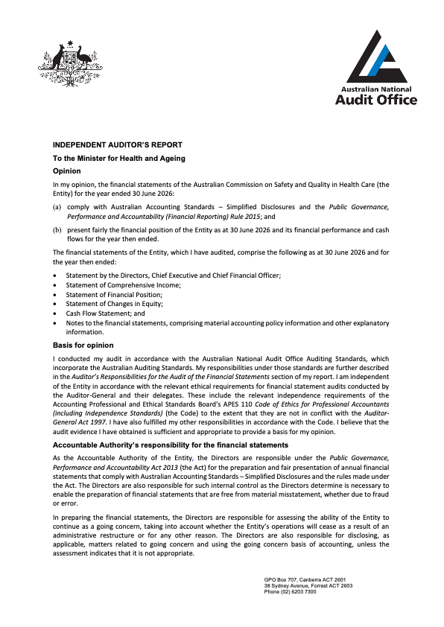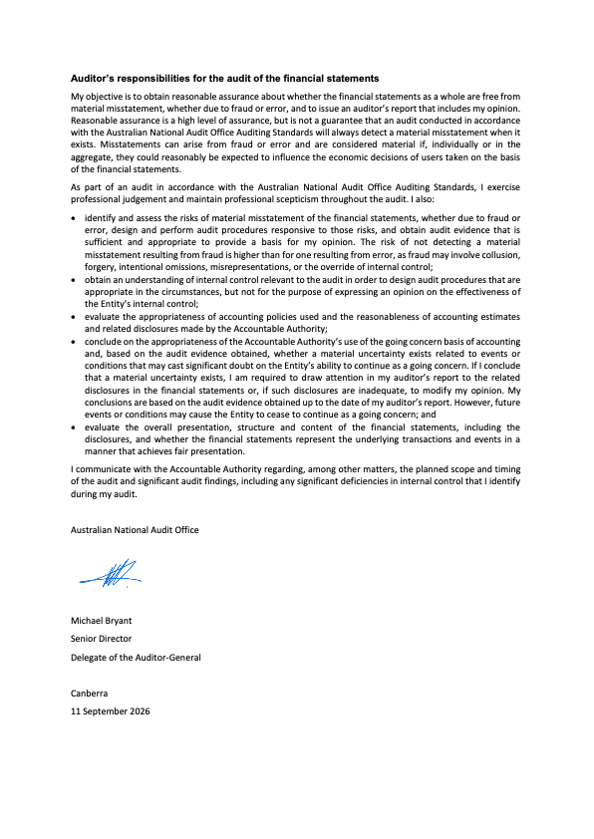
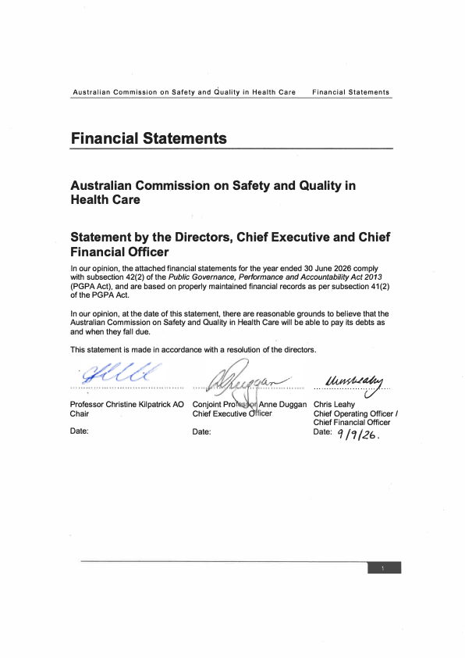
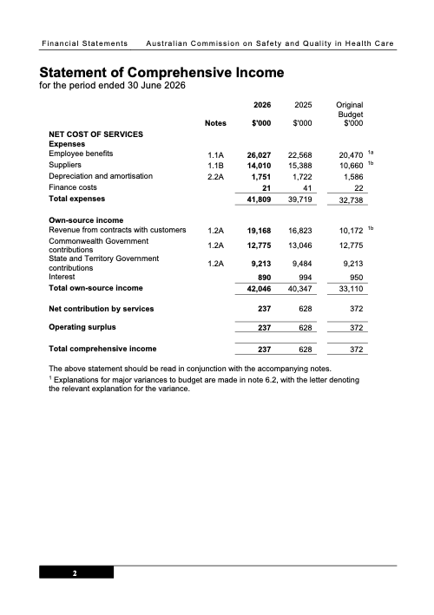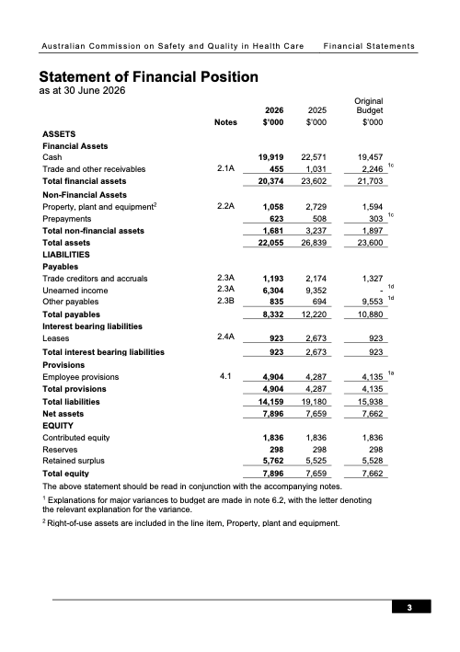
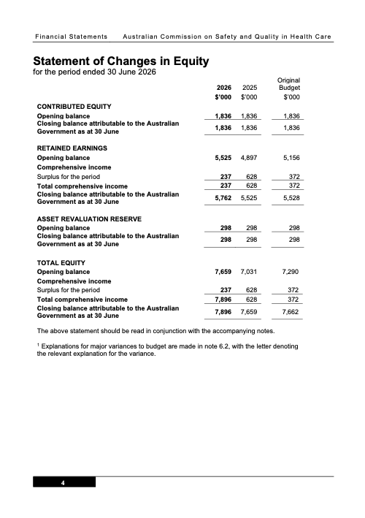
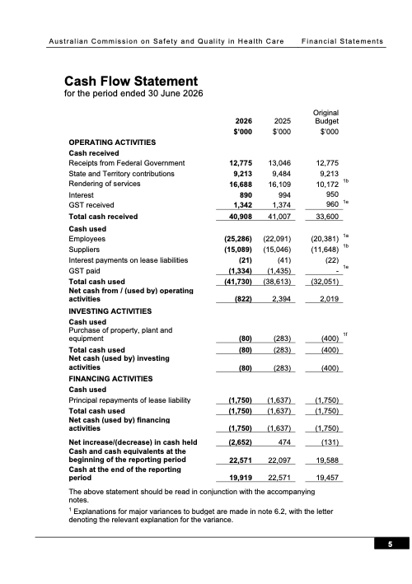
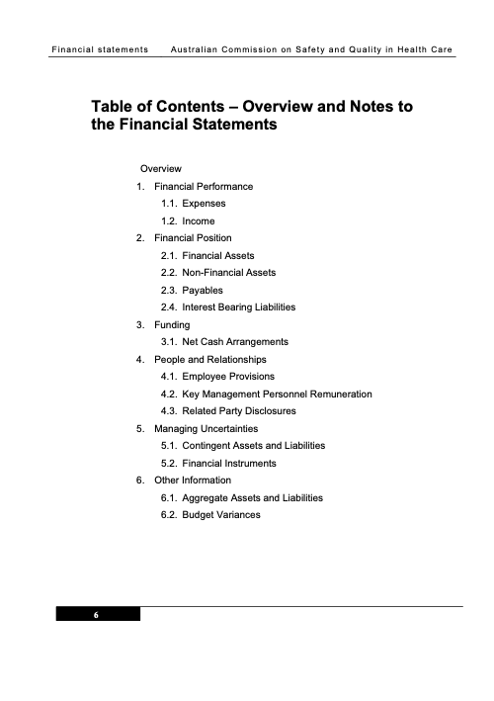
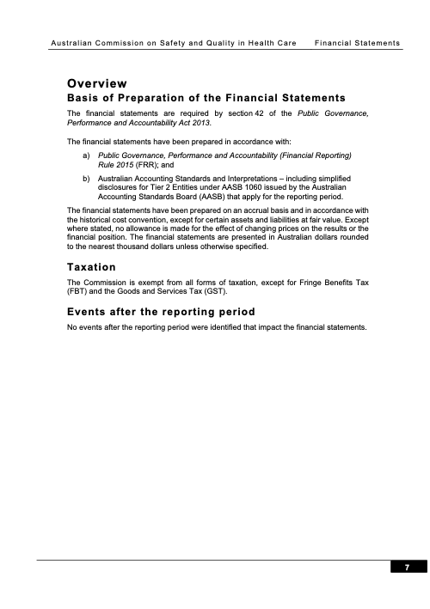
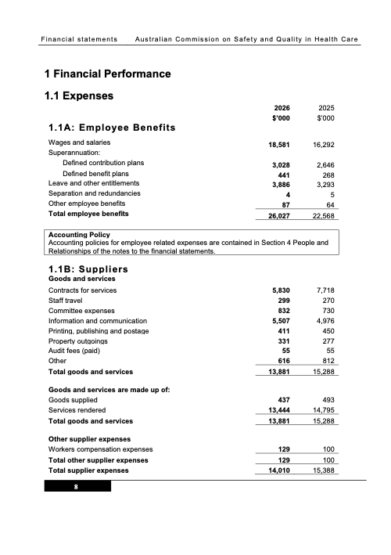
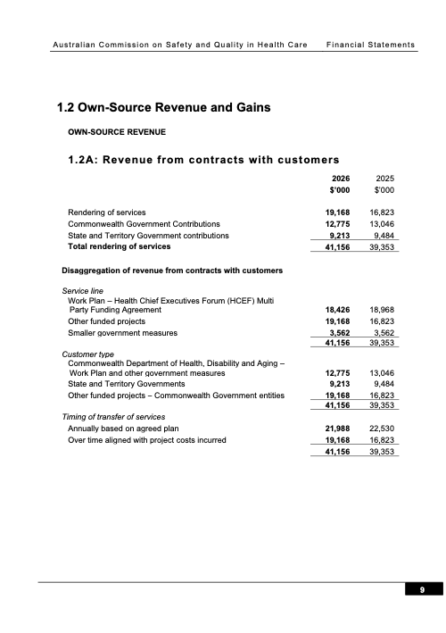
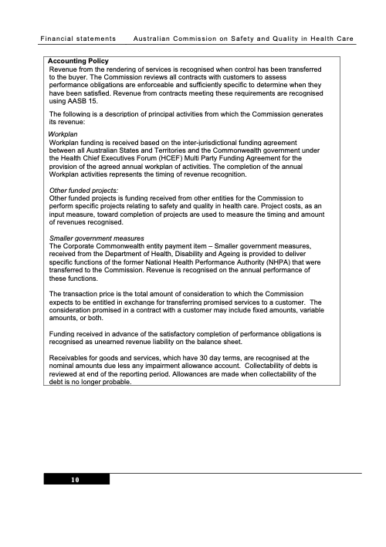
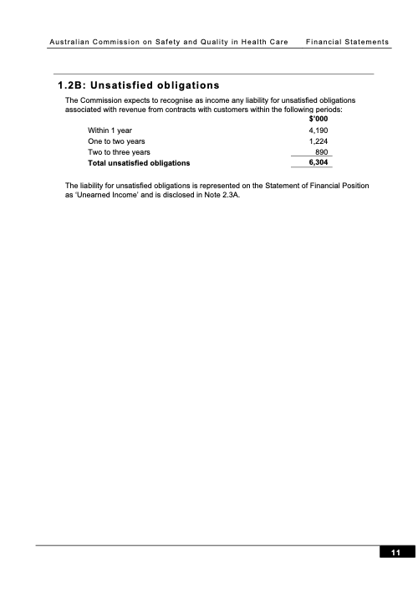
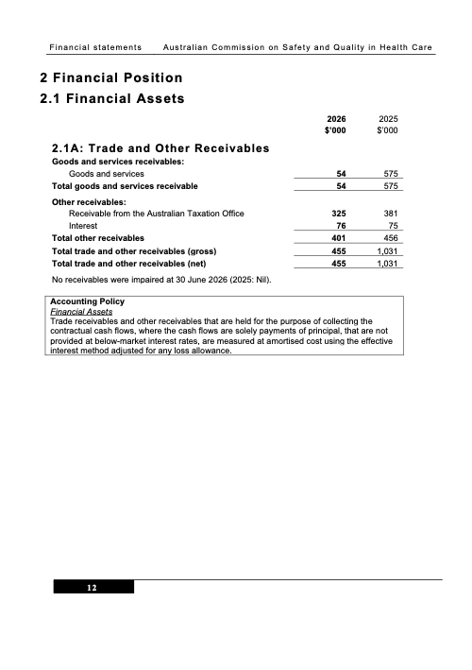
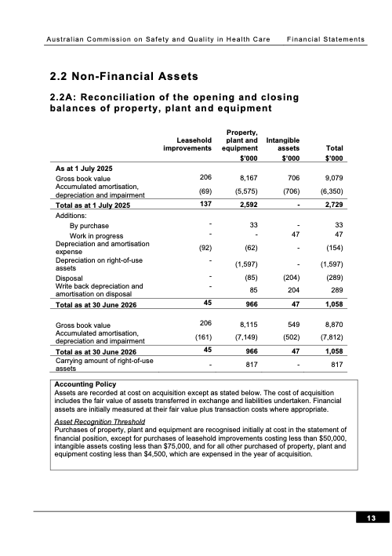
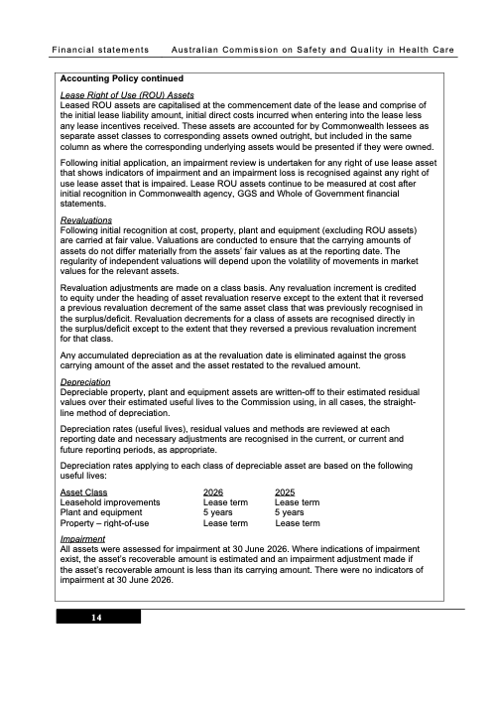
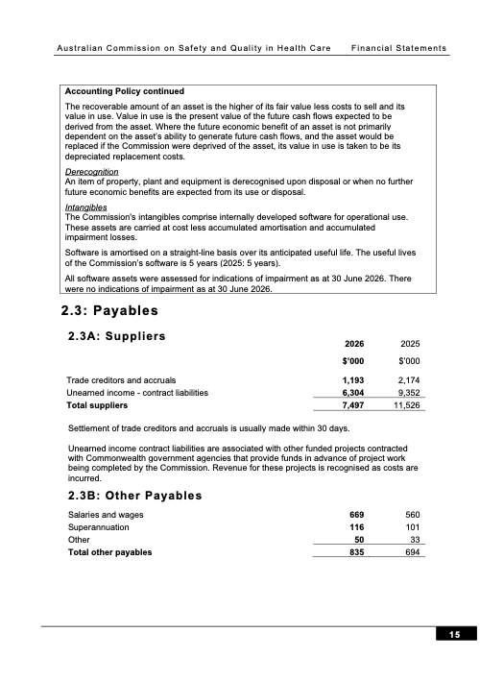
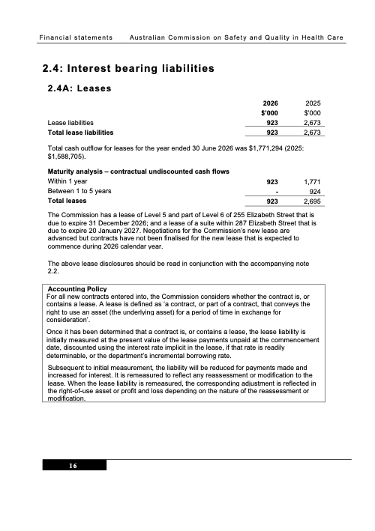
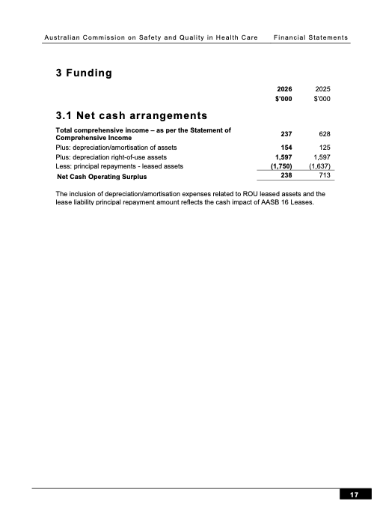
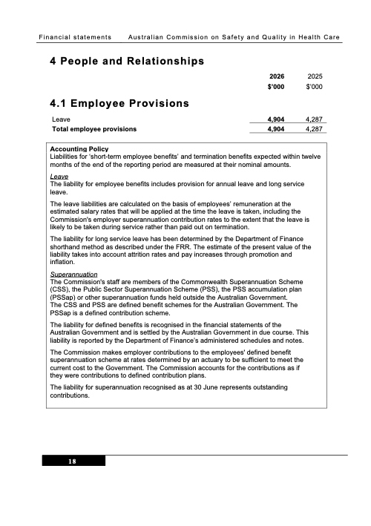
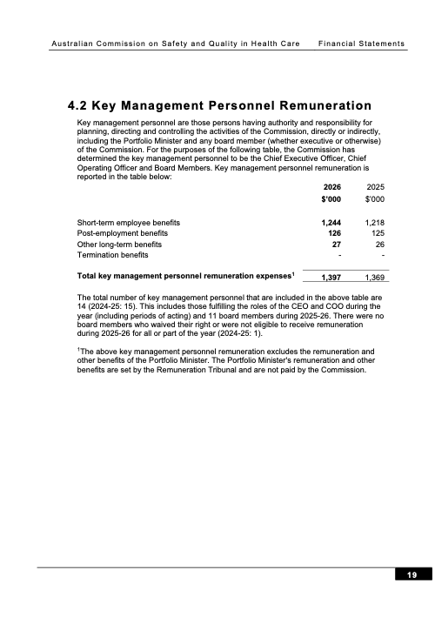
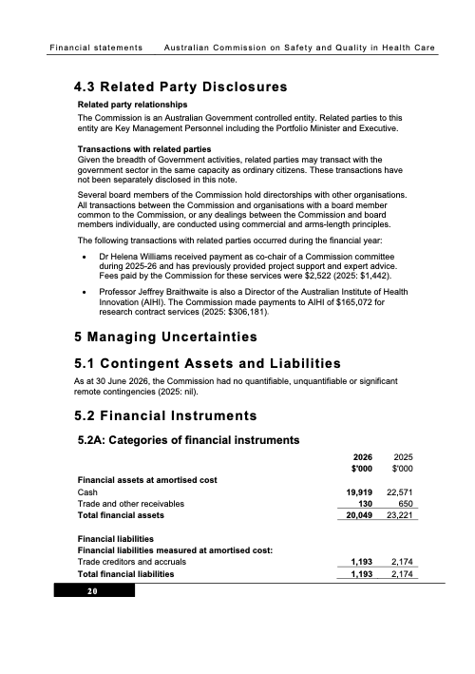
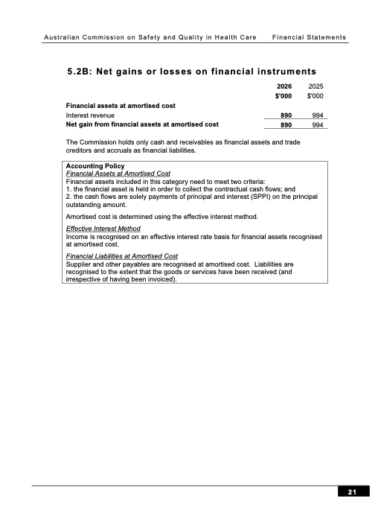
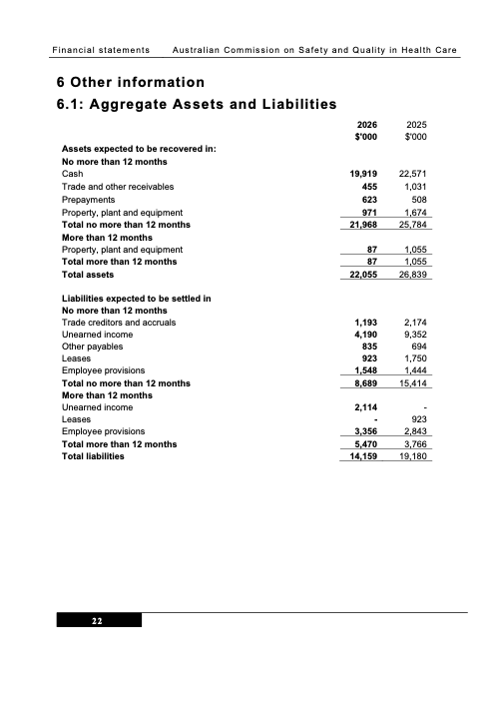
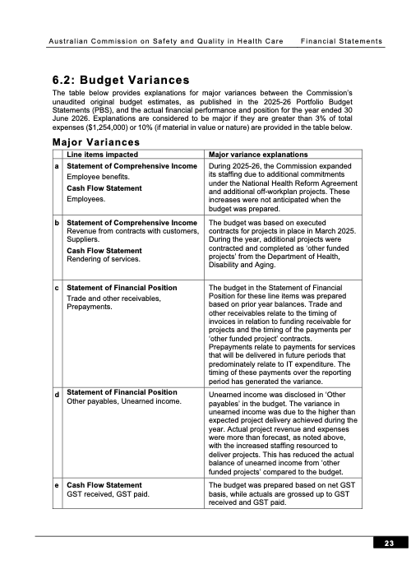
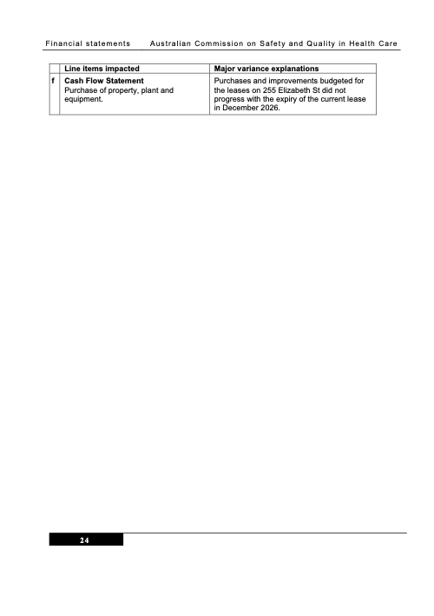
- Appendices
Appendix A: Related-entity transactions
Appendix B: Freedom of information summary
Appendix C: Compliance with ecologically sustainable development

Appendix A: Related-entity transactions
Table 11 Related-entity transactions, 2025–26

Vendor no | Commonwealth entity | Number of transactions | Transaction value | Description
100362 | Department of Health, Disability and Ageing | 11 | $1,436,783 | Payments processed in 2025–26 for corporate services received from the Department of Health, Disability and Ageing under the shared services agreement.

Appendix B: Freedom of information summary
Table 12 summarises freedom of information requests and their outcomes for 2025–26, as discussed on page 93.
Table 12 Freedom of information summary, 2025–26

Activity | Number
Requests
On hand at 1 July 2025 | 0
New requests received during 2025–26 FY period | 3
Total requests handled during 2025–26 FY period | 3
Total requests completed as at 30 June 2026 | 3
Total requests on hand as at 30 June 2026 | 0
Action of request
Access granted in full | 0
Access granted in part | 3
Access refused | 0
Access transferred in full | 0
Request withdrawn | 0
No records | 0
Response time
0–30 days | 2
30–60 days | 1

Appendix C: Compliance with ecologically sustainable development
The Commission is committed to making a positive contribution to ecological sustainability. Table 13 details the Commission’s activities in accordance with section 516A(6) of the Environment Protection and Biodiversity Conservation Act 1999.
Table 13 Summary of the Commission’s compliance with ecologically sustainable development

Environment Protection and Biodiversity Conservation Act 1999 requirement | Commission response
Activities of the Commission during 2025-26 accord with the principles of ecologically sustainable development | The Commission ensures that its decision-making and operational activities mitigate environmental impact. The principles of ecologically sustainable development are embedded in the Commission’s approach to its work plan and in corporate, purchasing and operational guidelines.
Outcomes specified for the Commission in an Appropriation Act for 2025-26 contribute to ecologically sustainable development | The Commission’s single appropriations outcome focuses on improving safety and quality in health care across the Australian health system. As such, the Commission does not directly contribute to ecologically sustainable development.
Effects of the Commission’s activities on the environment | The Commission’s offices are located in a 5-star1 building, and the Commission works proactively with building management to achieve energy savings where possible. The Commission continues to improve the  dissemination of publications, reports and written materials through electronic media to minimise printing.
Measures the Commission is taking to minimise its impact on the environment | To reduce its environmental impact, the Commission is improving its website functionality and increasing the use of multichannel strategies to distribute information electronically.  To reduce travel, the Commission uses remote meeting attendance options wherever feasible.  The Commission advocates responsible use of materials, electricity and water and disposal of waste. This behaviour is expected of all staff and visitors.
Mechanisms for reviewing and increasing the effectiveness of these measures | The Commission has established mechanisms to review current practices and policies. Staff are encouraged to identify initiatives to adopt behaviours, procedures and policies that can minimise their environmental impact, the impact of their team and the impact of the Commission more broadly.
Note:
- According to the National Australian Built Environment Rating System
The Commission is committed to making a positive contribution to ecological sustainability. Table 14 details the Commission’s activities in accordance with section 516A(6) of the Environment Protection and Biodiversity Conservation Act 1999 and the Australian Government’s APS Net Zero 2030 target. Greenhouse gas emissions reporting uses a methodology consistent with the whole-of-Australian Government approach as part of the APS Net Zero 2030 target.

Table 14 Greenhouse gas emissions inventory, 2025–26

Emission source | Scope 1 (t CO₂-e) | Scope 2 (t CO₂-e) | Scope 3 (t CO₂-e) | Total (t CO₂-e)
Electricity  (location-based approach) | N/A | 124.81 | 5.86 | 130.67
Natural gas | – | N/A | – | –
Solid waste | – | N/A | – | –
Refrigerants | – | N/A | N/A | –
Fleet and other vehicles | – | N/A | – | –
Domestic commercial flights | N/A | N/A | 58.80 | 58.80
Domestic hire car | N/A | N/A | – | –
Domestic travel accommodation | N/A | N/A | 9.52 | 9.52
Other energy | – | N/A | – | –
Total t CO₂-e | – | 124.81 | 74.18 | 198.99
Note: The table above presents emissions related to electricity usage using the location-based accounting method. CO₂-e = carbon dioxide equivalent: N/A = not applicable.
Solid waste data was unable to be separated from landlord data and has not been included.
Efforts were made to separate the data; however, a small portion of the Commission’s domestic travel emissions may be included in the Department of Health, Disability and Ageing’s annual report due to shared services agreements.
Table 15 Electricity greenhouse gas emissions, 2025–26

Emission source | Scope 2 (t CO₂-e) | Scope 3 (t CO₂-e) | Total (t CO₂-e) | Electricity (kWh)
Electricity (location-based approach) | 124.80 | 5.85 | 130.65 | 195,000.27
Market-based electricity emissions | 130.65 | 17.75 | 148.39 | 161,284.72
Total renewable electricity consumed | N/A | N/A | N/A | 33,715.55
Renewable power percentage1 | N/A | N/A | N/A | 33,715.55
Jurisdictional renewable power percentage | N/A | N/A | N/A | –
Greenpower | N/A | N/A | N/A | –
Large-scale generation certificates | N/A | N/A | N/A | –
Behind-the-meter solar2 | N/A | N/A | N/A | –
Total renewable electricity produced | N/A | N/A | N/A | –
Note: The table above presents emissions related to electricity usage using both the location-based and the market-based accounting methods. CO₂-e = carbon dioxide equivalent. Electricity usage is measured in kilowatt hours (kWh).
- The renewable power percentage (RPP) accounts for the portion of electricity used from the grid that falls within the Renewable Energy Target (RET).
- Reporting behind-the-meter solar consumption and/or production is optional. The quality of data is expected to improve over time as emissions reporting matures.

7. Indexes and references
Acronyms
Glossary
Index of figures
Index of tables
Compliance index
Index

Acronyms

Acronym | Description
ADHA | Australian Digital Health Agency
Ahpra | Australian Health Practitioner Regulation Agency
AHSSQA Scheme | Australian Health Service Safety and Quality Accreditation Scheme
AI | artificial intelligence
AIHW | Australian Institute of Health and Welfare
AM | Member of the Order of Australia
AMR | antimicrobial resistance
AO | Officer of the Order of Australia
APAS | Australian Passive AMR Surveillance
ARCR | Australian Register of Clinical Registries
AURA | Antimicrobial Use and Resistance in Australia
CARAlert | National Alert System for Critical Antimicrobial Resistances
CEO | Chief Executive Officer
CHADx | Classification of Hospital Acquired Diagnoses
CHBOI | Core Hospital-Based Outcome Indicators
COPD | chronic obstructive pulmonary disease
CQR | Clinical Quality Registries
DECAC | Digitally Enabled Care Advisory Committee
DIAS | Diagnostic Imaging Accreditation Scheme
EMMSAT | Electronic Medication Management Self-Assessment Tool

Acronym | Description
FRACGP | Fellow of the Royal Australian College of General Practitioners
HACs | Hospital-acquired complications
HCV | hepatitis C virus
HIV | human immunodeficiency virus
MD | Doctor of Medicine
MIAS | Medical Imaging Accreditation Scheme
MoU | memorandum of understanding
NACCHO | National Aboriginal Community Controlled Health Organisation
NCTGF | National Clinical Trials Governance Framework
NGPA | National General Practice Accreditation
NSQDMH Standards | National Safety and Quality Digital Mental Health Standards
NSQHS Standards | National Safety and Quality Health Service Standards
PBS | Pharmaceutical Benefits Scheme
PIC | Paediatric Improvement Collaborative
PREM | patient-reported experience measures
PROM | patient-reported outcome measures
QUM | quality use of medicines
RACGP | Royal Australian College of General Practitioners
RAP | Reconciliation Action Plan
SEISC | Sentinel Event Internal Steering Committee
TGA | Therapeutic Goods Administration

Glossary

Word | Description
Accreditation | A formal program where trained independent reviewers assess evidence of implementation for specified standards. In this document, the relevant standards are the National Safety and Quality Health Service (NSQHS) Standards.
Adverse event | An incident that results in harm to a patient or consumer.
Antimicrobial | A chemical substance that inhibits or destroys bacteria, viruses or fungi, including yeasts and moulds.
Antimicrobial resistance | A property of organisms – including bacteria, viruses, fungi and parasites – that allows them to survive and/or grow in the presence of antimicrobial levels that would normally suppress growth of or kill susceptible organisms.
Antimicrobial stewardship | A program implemented in a health service organisation to reduce the risks associated with increasing antimicrobial resistance and extend the effectiveness of antimicrobial treatments. Antimicrobial stewardship may incorporate a broad range of strategies, including monitoring and reviewing antimicrobial use.
Appropriate care | Appropriate care should see that patients receive the right type and amount of care, in the right place, at the right time. The care offered should also be based on the best available evidence.
Artificial intelligence | Computer systems able to perform tasks that normally require human intelligence, such as visual perception, speech recognition, decision-making and translation between languages.
Carer | A person who provides personal care, support and assistance to another individual who needs it because they have a disability, medical condition (including a terminal or chronic illness) or mental illness, or they are frail or aged. An individual is not  a carer merely because they are a spouse, de facto partner, parent, child, other relative or guardian of an individual, or live with an individual who requires care. A person is not considered a carer if they are paid, a volunteer for an organisation, or caring as part of a training or education program. For Aboriginal and Torres Strait Islander people, there may be a collective approach to carer responsibilities.
Clinical Care Standards | Standards developed by the Commission and endorsed by health ministers that identify and define the care people should expect to be offered or receive for specific clinical conditions or procedures. The Clinical Care Standards highlight best-practice care and priority areas for quality improvement, and include indicators to support quality improvement.
Clinical governance | Clinical governance is central to providing the best possible outcomes for patients. It is the combination of organisational culture, systems and structures that enables everyone in a health service to deliver care that is consistently high quality and improving. Effective clinical governance means that boards, executives, clinical  leaders and the workforce are clearly accountable to patients and the community for providing high-quality care – care that is person-centred, safe, effective, accessible and integrated, in a health system that is equitable, efficient and sustainable.
Clinician | A trained health professional who provides direct clinical care to patients. Includes registered and non-registered practitioners, nurses, midwives, medical practitioners, allied health professionals, paramedics and other professionals who provide health care, and students who provide health care under supervision.
Consumer (healthcare) | A person who has used, or may potentially use, health services, or is a carer for a patient using health services. A healthcare consumer may also act as a consumer advocate or representative to provide a consumer perspective, contribute consumer experiences, advocate for the interests of current and potential health service users, and take part in decision-making processes.
Credentialing | A process that verifies the qualifications and experience of a clinician to determine their ability to provide safe, high-quality healthcare services within a specific healthcare setting and role.
Cultural safety | Cultural safety is determined by Aboriginal and Torres Strait Islander individuals, families and communities. Culturally safe practice is the ongoing critical reflection of health practitioner knowledge, skills, attitudes, practising behaviours and power differentials in delivering safe, accessible and responsive health care free from racism.
Digital health | The use of technology to help Australians live healthier lives with greater control and better access to their information. It includes My Health Record, electronic prescriptions and telehealth.
Digitally enabled care | The appropriate application and integration of digital health tools and technologies in clinical settings to deliver, coordinate or enhance patient care.
End of life | The period when a patient is living with, and impaired by, a fatal condition, even if the trajectory is ambiguous or unknown. This period may be years, in the case of patients with chronic or malignant disease, or very brief, in the case of patients who suffer acute and unexpected illnesses or events such as sepsis, stroke or trauma.
Environmentally sustainable health care | Health care that minimises environmental impact and reduces emissions while providing high-quality care.
Equity | The absence of unfair, avoidable or remediable differences among groups of people, whether those groups are defined socially, economically, demographically or geographically or by other dimensions of inequality (e.g. sex, gender, ethnicity, disability or sexual orientation).
Evidence-based practice | Health care that integrates the best available research evidence with clinical expertise and the patient’s unique values and circumstances.
Hand hygiene | A general term referring to any hand-cleansing action.
Healthcare variation | A situation in which patients with the same condition receive different types of care. For example, in a group of patients with the same condition, some may have no active treatment, some may be treated in the community and others in hospital, and some may have surgery while others receive medication. Some variation in how health care is provided is desirable because of differences in patients’ needs, wants and preferences (see ‘unwarranted healthcare variation’).
Healthcare-associated infections | Infections that are acquired in healthcare facilities (nosocomial infections) or that occur because of healthcare interventions (iatrogenic infections). Healthcare-associated infections may manifest after people leave healthcare facilities.
High-quality care | Health care that is person-centred, safe, effective, accessible and integrated, provided in a way that is equitable, efficient and sustainable.
Hospital-acquired complication | A complication for which clinical risk mitigation strategies may reduce (but not necessarily eliminate) the risk of that complication occurring.
Integrated care | Where all parts of the health system work together to deliver person-centred care that is seamless, comprehensive, coordinated and efficient across the continuum of care.
Lived experience | Someone with personal experience of ill-health, including mental, chronic or acute illness.
Low-value care | Care that provides little or no benefit, may cause patient harm, or yields marginal benefits at a disproportionately high cost.
Medication management | Practices used to manage the provision of medicines. Medication management has also been described as a cycle, pathway or system, which is complex and  involves a number of different clinicians. The patient is the central focus. The system includes manufacturing, compounding, procuring, dispensing, prescribing, storing, administering, supplying and monitoring the effects of medicines. It also includes decision-making, and rules, guidelines, support tools, policies and procedures that are in place to direct the use of medicines.
My Health Record | A secure online summary of a consumer’s health information that is managed by the System Operator of the national e-health record system (the Secretary of the Department of Health, Disability and Ageing). Healthcare providers can share health records to a consumer’s My Health Record in accordance with the consumer’s access controls. This may include information such as medical history, treatments, diagnoses, medications and allergies.
National Safety and Quality Health Service (NSQHS) Standards | Standards developed by the Commission in consultation and collaboration with states and territories, technical experts, health service organisations and patients that aim to protect the public from harm and improve the quality of health services. The NSQHS Standards provide a quality assurance mechanism that tests whether relevant systems are in place to ensure that minimum safety and quality standards are met, and a quality improvement mechanism that allows health service organisations to realise aspirational or developmental goals.
Open disclosure | An open discussion between a healthcare provider and a patient when things go wrong that have harmed or had the potential to cause harm to the patient. The discussion may include an expression of regret by the provider, an explanation of what happened and its consequences, and steps to prevent it happening again.
Organisational culture | A set of values, expectations, formal and informal practices, and behaviours that define the unique organisational environment. ‘The way things are done around here’.
Partnering with consumers | A type of relationship with consumers that involves treating consumers and carers with dignity and respect; communicating and sharing information between consumers, carers (when relevant) and health service organisations; encouraging and supporting consumers’ participation in decision-making; and fostering collaboration between consumers, carers and health service organisations in planning, designing, delivering and evaluating health care. Other terms used  internationally to describe a similar concept include ‘patient-based care’, ‘consumer-centred care’, ‘person-centred care’, ‘relationship-based care’, ‘patient-centred care’ and ‘patient- and family-centred care’.
Patient | A person receiving health care. Synonyms for ‘patient’ include ‘consumer’ and ‘client’.
Patient outcome | The status of a patient that is wholly or partially attributable to an action, agent or circumstance.
Patient safety | Minimising the risk of unnecessary harm associated with health care.
Patient safety incident | An event or circumstance that could have resulted, or did result, in unnecessary harm to a patient.
Patient-reported experience and outcome measures | Information collected directly from patients about their experience of health services, and the outcomes of health services. Patient-reported experience measures (PREMs) include patients’ views and observations on matters such as the accessibility and physical environment of services and aspects of the patient–clinician interaction. Patient-reported outcome measures (PROMs) are used to obtain information from patients on their health status such as overall health and wellbeing, the severity of symptoms such as pain, measures of daily functioning and psychological symptoms.
Person-centred care | Health care that respects the patient, their family and carers, and responds to the person’s preferences, needs and values. Person-centred care is equitable, culturally safe and free from racism and all other forms of discrimination.
Priority group | Specific population group at elevated risk of poorer health outcomes, including Aboriginal and Torres Strait Islander people, people with mental health conditions, those living in rural/remote or lower socioeconomic areas, and people identifying as gay, lesbian, bisexual, transgender or intersex.
Quality improvement | The efforts of the individuals, the workforce and others – including consumers, patients and their families, researchers, planners and educators – to make changes that will lead to better patient outcomes (health), better system performance (care) and better professional development. Quality improvement activities may be undertaken in sequence, intermittently or continually.
Quality use of medicines (QUM) | Quality use of medicines refers to selecting medicine management options wisely. It includes choosing suitable medicines and using only if a medicine is considered necessary with the aim of using medicines safely and effectively to get the best possible outcome.
Safety culture | A culture in which everyone enables and cares for each other to adopt patient safety as part of routine business, with the wellbeing of the workforce and consumers at the centre.
Shared decision making | Discussion and collaboration between a patient or consumer and their healthcare provider. The process aims to bring together the patient/consumer’s values, goals and preferences with the best available evidence about benefits, risks and uncertainties of treatment, in order to reach the most appropriate healthcare decisions for that person.
Standard | Agreed attributes and processes designed to ensure that a product, service or method will perform consistently at a designated level.
Transitions of care | When all or part of a person’s health care is transferred between care providers. Transitions of care may occur within and between healthcare locations, settings, care delivery types, levels of care and involve a range of healthcare providers.
Unwarranted healthcare variation | Differences in clinical practices, treatments, or outcomes that cannot be explained by differences in patient needs, preferences or evidence-based guidelines.
Virtual care | Any interaction between a patient and a clinician(s), occurring remotely with the use of information technologies.

Index of figures

Figure | Title | Page
Figure 1 | Health service organisation accreditation, 2025–26 | 38
Figure 2 | Organisational structure | 98

Index of tables
Table | Title | Page
Table 1 | Report against performance criteria and targets in the 2025 -26 Corporate Plan and Health Portfolio Budget Statements | 69
Table 2 | Attendance at Board meetings, 2025–26 | 85
Table 3 | Audit and Risk Committee attendance and remuneration, 2025–26 | 88
Table 4 | Remuneration paid to Key Management Personnel, 2025–26 | 94
Table 5 | Remuneration paid to executive staff (Senior Executive Service equivalent), 2025–26 | 95
Table 6 | Remuneration paid to other highly paid staff, 2025–26 | 95
Table 7 | Total employee headcount profile, as at 30 June 2026 | 100
Table 8 | Female employee headcount profile by state and territory, as at 30 June 2026 | 101
Table 9 | Male employee headcount profile by state and territory, as at 30 June 2026 | 102
Table 10 | Non-binary employee headcount profile by state and territory, as at 30 June 2026 | 103
Table 11 | Related-entity transactions, 2025–26 | 136
Table 12 | Freedom of information summary, 2025–26 | 136
Table 13 | Summary of the Commission’s compliance with ecologically sustainable development | 137
Table 14 | Greenhouse gas emissions inventory, 2025–26 | 138
Table 15 | Electricity greenhouse gas emissions, 2025–26 | 139
Table 16 | Mandatory reporting orders as required under legislation | 149

Compliance index
The Commission is bound by legislative requirements to disclose certain information in this annual report.
The operative provisions of the Public Governance, Performance and Accountability Act 2013 came into effect on 1 July 2014. The Public Governance, Performance and Accountability Amendment (Corporate Commonwealth Entity Annual Reporting) Rule 2016 prescribes the reporting requirements for the Commission (Table 16).
Table 16 Mandatory reporting orders as required under legislation

Requirement | Reference | Page listing of compliant information
Accountable authority | Public Governance, Performance and Accountability Amendment (Corporate Commonwealth Entity Annual Reporting) Rule 2016, subsection 17BE(j) | 66
Amendments to the Commission’s enabling legislation and to any other legislation directly relevant to its operation | Public Governance, Performance and Accountability Amendment (Corporate Commonwealth Entity Annual Reporting) Rule 2016, subsection 17BE(a) | 96
Approval by the accountable authority | Public Governance, Performance and Accountability Amendment (Corporate Commonwealth Entity Annual Reporting) Rule 2016, section 17BB | 66
Assessment of the impact of the performance of each of the Commission’s functions | National Health Reform Act 2011, subsection 53(a) | 27–73
Assessment of the quality of healthcare services provided | National Health Reform Act 2011, subsection 53(b)(ii) | 57–65
Assessment of the safety of healthcare services provided | National Health Reform Act 2011, subsection 53(b)(i) | 27–50
Audit Committee | Public Governance, Performance and Accountability Amendment (Corporate Commonwealth Entity Annual Report) Rule 2016, subsection 17BA(taa) | 88–9
Board committees | Public Governance, Performance and Accountability Amendment (Corporate Commonwealth Entity Annual Reporting) Rule 2016, subsection 17BE(j) | 87–90
Ecologically sustainable development and environmental performance | Environment Protection and Biodiversity Conservation Act 1999, section 516A | 96, 137–9
Enabling legislation, functions and objectives | Public Governance, Performance and Accountability Amendment (Corporate Commonwealth Entity Annual Reporting) Rule 2016, subsection 17BE(a) | 11, 75, 87
Financial statements | Public Governance, Performance and Accountability Act 2013, subsection 43(4) | 108–33
Financial statements certification: a statement, signed by the accountable authority | Public Governance, Performance and Accountability Act 2013, subsection 43(4) | 111
Financial statements certification: Auditor-General’s Report | Public Governance, Performance and Accountability Act 2013, subsection 43(4) | 109–10
Government policy orders | Public Governance, Performance and Accountability Amendment (Corporate Commonwealth Entity Annual Reporting) Rule 2016, subsection 17BE(e) | 96
Indemnities and insurance premiums for officers | Public Governance, Performance and Accountability Amendment (Corporate Commonwealth Entity Annual Reporting) Rule 2016, subsection 17BE(t) | 77
Information about remuneration for key management personnel | Public Governance, Performance and Accountability Amendment (Corporate Commonwealth Entity Annual Report) Rule 2016, subsection 17CA | 94
Information about remuneration for other highly paid staff | Public Governance, Performance and Accountability Amendment (Corporate Commonwealth Entity Annual Report) Rule 2016, subsection 17CC | 93–5
Information about remuneration for senior executives | Public Governance, Performance and Accountability Amendment (Corporate Commonwealth Entity Annual Report) Rule 2016, subsection 17CB | 95
Judicial decisions and decisions by administrative tribunals | Public Governance, Performance and Accountability Amendment (Corporate Commonwealth Entity Annual Reporting) Rule 2016, subsection 17BE(q) | 93
Key activities and changes that have affected the Commission | Public Governance, Performance and Accountability Amendment (Corporate Commonwealth Entity Annual Reporting) Rule 2016, subsection 17BE(p) | 14–17, 67–9
Location of major activities and facilities | Public Governance, Performance and Accountability Amendment (Corporate Commonwealth Entity Annual Reporting) Rule 2016, subsection 17BE(l) | inside front cover, 100
Ministerial directions | Public Governance, Performance and Accountability Amendment (Corporate Commonwealth Entity Annual Reporting) Rule 2016, subsection 17BE(d) | 76
Organisational structure | Public Governance, Performance and Accountability Amendment (Corporate Commonwealth Entity Annual Reporting) Rule 2016, subsection 17BE(k) | 98
Related-entity transactions | Public Governance, Performance and Accountability Amendment (Corporate Commonwealth Entity Annual Reporting) Rule 2016, subsections 17BE(n) and (o) | 77, 135
Reporting of significant decisions or issues | Public Governance, Performance and Accountability Amendment (Corporate Commonwealth Entity Annual Reporting) Rule 2016, subsection 17BE(f) | 96
Reports about the Commission by the Auditor-General, a parliamentary committee, the Commonwealth Ombudsman or the Office of the Australian  Information Commissioner | Public Governance, Performance and Accountability Amendment (Corporate Commonwealth Entity Annual Reporting) Rule 2016, subsection 17BE(r) | 93
Responsible minister | Public Governance, Performance and Accountability Amendment (Corporate Commonwealth Entity Annual Reporting) Rule 2016, subsection 17BE(c) | 11
Review of performance | Public Governance, Performance and Accountability Amendment (Corporate Commonwealth Entity Annual Reporting) Rule 2016, subsection 17BE(g) | 66–73
Statement on governance | Public Governance, Performance and Accountability Amendment (Corporate Commonwealth Entity Annual Reporting) Rule 2016, subsection 17BE(m) | 75–96

Index

A
abbreviations,
Aboriginal and Torres Strait Islander Health Advisory Group, see also First Nations people
accountability
accountable authority, see also Board of
Commission,
accreditation assessment,
accrediting agency performance,
assessors,
of health practitioners,
of health service organisations,
improving reliability of processes,
of mental health service providers, outcomes data, review of,
outcomes public reporting,
post-assessment surveys,
of primary and community healthcare, short notice assessments,
statistics,
accreditation schemes
Australian Health Service Safety and Quality Accreditation (AHSSQA) Scheme,
Diagnostic Imaging Accreditation Scheme,
National General Practice Accreditation Scheme,
National Pathology Accreditation Scheme,
Achterstraat, Peter
Acknowledgement of Country,
ACON Pride in Health + Wellbeing, acronyms,
acute care
Usability Guidance for Optimising My Health Record Viewing Platforms in Acute Care,
acute coronary syndromes,
address and contact details,
adverse events,
indicators and dataset specifications,
medical devices adverse event reporting,
sentinel events,
advertising and market research,
Advice Centre see Safety and Quality Advice Centre
advisory groups see stakeholder consultation and advisory mechanisms aged care
infection prevention and control guide,
Integrated Health and Aged Care Service Module and User Guide,
Royal Commission,
Aged Care Quality Standards,
AI (artificial intelligence) see artificial intelligence (AI) annual performance statements see performance anticancer medicines,
anticoagulants,
antimicrobial resistance (AMR),
Antimicrobial Use and Resistance in Australia (AURA) project,
APAS (Australian Passive AMR Surveillance),
APS see Australian Public Service (APS) artificial intelligence (AI),
guidance for clinicians,
Artificial Intelligence Program Advisory Group,
Ask, Share, Know decision-making model,
Assessor Orientation training modules,
assessors,
Atlas Focus Report: Colonoscopy,
Atlas Focus Report: Osteoarthritis,
Audit and Risk Committee,
audits
independent auditor’s report on financial statements,
internal,
AURA (Antimicrobial Use and Resistance in Australia) project,
Australian and New Zealand Emergency Laparotomy Audit – Quality Improvement,
Australian Centre for Disease Control,
Australian College of Rural and Remote Medicine,
Australian Commission on Safety and Quality in Health Care
accountability,
accountable authority, see also Board address and contact details,
Board members see Board establishment,
funding,
legislative framework,
organisational structure, performance results see performance purpose and functions,
role,
Safety and Quality Advice Centre,
strategic priorities see Strategic Plan 2025–2030 Australian Digital Health Agency (ADHA),
Australian Framework for National Clinical Quality Registries,
Australian Guidelines for the Prevention and Control of Infection, Australian Health Performance Framework,
Australian Health Practitioner Regulation Agency, 22, 50
Australian Health Service Safety and Quality Accreditation (AHSSQA) Scheme, see also
accreditation assessment
Australian Health System Performance Assessment Framework (SPA Framework), Australian Hospital Patient Experience Question Set,
Australian Hospital Survey on Patient Safety Culture, Australian Indigenous Doctors’ Association,
Australian Institute of Aboriginal and Torres Strait Islander Studies, Core Cultural Learning course, Australian Institute of Health and Welfare,
Australian Open Disclosure Framework, Australian Passive AMR Surveillance (APAS),
Australian Public Service (APS) Strategic Commissioning Framework,
Australian Public Service Commission,
Australian Register of Clinical Registries,
avoidable hospital readmissions list,

B
benzathine benzylpenicillin injection, shortages of,
Better Care Everywhere initiative,
Board,
accountable authority statement, appointment,
Chair,
Chair’s report,
committees,
establishment,
ethical standards,
induction,
meetings,
membership,
operating guidelines,
professional development,
remuneration,
role and responsibilities,
Braithwaite, Professor Jeffrey,
Butler, Hon. Mark, see also Minister for Health, Disability and Ageing

C
cannabis, medicinal,
capability review,
CARAlert (National Alert System for Critical Antimicrobial Resistances), cardiac surgery,
case studies
National Safety and Quality Standards Assessor Orientation Course,
Paediatric Improvement Collaborative (PIC), 36
public consultation on the NSQHS Standards (third edition), supporting safe and sustainable use of intravenous fluids,
Chair of the Board,
attendance at Board meetings,
remuneration,
report,
statement on annual performance statements, statement on financial statements,
Chief Executive Officer,
appointment,
remuneration,
report,
role and responsibilities,
statement on financial statements,
Chief Medical Officer,
Chief Nursing Officer,
Chief Operating Officer,
remuneration,
statement on financial statements,
children see paediatric care
chronic obstructive pulmonary disease (COPD) Clinical Care Standard,
GP prescribing and patient care patterns,
reports for GPs,
Clark, Jennifer,
Classification of Hospital Acquired Diagnoses (CHADx),
climate change, see also environmental sustainability
Clinical Care Standards,
acute coronary syndrome,
colonoscopy,
COPD,
emergency laparotomy,
indicators,
osteoporosis,
reviews of,
safety and quality indicators,
stroke,
venous thromboembolism,
clinical governance,
of clinical trials,
national model,
Clinical Governance Advisory Committee,
clinical guidance, improving national coordination of,
clinical handovers see transitions of care
clinical practice, credentialing and defining scope of,
clinical quality registries,
clinical trials,
clozapine,
co-design resource hub, collaboration see partnerships
Collaborative Action on Climate and Health, colonoscopy
Atlas Focus Report: Colonoscopy,
Colonoscopy Clinical Care Standard,
Safety and Quality Model for Colonoscopy,
Comcover,
Commission see Australian Commission on Safety and Quality in Health Care committees
Board,
internal,
see also stakeholder consultation and advisory mechanisms
Commonwealth Electoral Act 1918,
Commonwealth Fraud and Corruption Control Framework, Commonwealth Risk Management Policy,
community healthcare standards, Comprehensive Care Standard, conflicts of interest disclosure, consultative processes
Board,
staff,
see also committees; stakeholder consultation and advisory mechanisms
consumers, see also patient safety; patient-reported experience measures (PREM)
contact details,
COPD see chronic obstructive pulmonary disease (COPD)
Core Cultural Learning: Aboriginal and Torres Strait Islander Australia (CORE) Foundation Course,
Core Hospital-Based Outcome Indicators (CHBOI) Toolkit,
core work brought in-house, coronary care,
corporate governance and accountability,
Corporate Plan 2025–26
Commission performance against criteria,
corporate services,
corruption control,
Cosmetic Surgery Standards and Module,
credentialing, see also accreditation assessment Crowe Australasia,
cultural safety,
staff awareness building,
standards for health services and hospitals,
Cultural Safety Standards Review Project,
Culturally and Linguistically Diverse Network, Culture Working Group,

D
data collection,
day procedure services assessment to NSQHS Standards, decision-making,
electronic clinical decision support system, shared,
definitions (glossary),
dental practices,
Department of Finance, see also Minister for Finance
Department of Health, Disability and Ageing,
feasibility assessment of electronic clinical decision support system,
mental health standards and,

program funding,
shared services agreement,
see also Minister for Health, Disability and Ageing developments and significant events,
diabetes,
Diagnostic Imaging Accreditation Scheme,
digital health,
electronic clinical decision support system,
see also artificial intelligence (AI); digitally enabled care; My Health Record system; virtual care Digital Mental Health Modules,
digital mental health standards,
digitally enabled care,
see also virtual care
Digitally Enabled Care Advisory Committee,
Disability and Carers Network,
disability services for people with intellectual disability,
discharge summaries,
Diversity Council Australia,
Duggan, Professor Anne,
CEO’s report,
statement on financial statements,
see also Chief Executive Officer

E
East Java University Consortium, Easy Read fact sheets,
ecologically sustainable development,
electricity usage and greenhouse gas emissions, electronic discharge summaries,
electronic health records see My Health Record system Electronic Medication Management Self-Assessment Tool,
Emergency Laparotomy Clinical Care Standard,
employees see staff
enabling legislation see legislative framework end-of-life,
end-of-life care,
enquiries to Advice Centre,
Enterprise Agreement 2024–2027,
Environment Protection and Biodiversity Conservation Act 1999,
environmental performance,
environmental sustainability,
ethical standards,
evidence-based practice,
Executive Directors,
executive remuneration,
Executive Team,
external scrutiny,

F
fact sheets,
finance law compliance, financial statements,
Chair, CEO and CFO statement on, independent auditor’s report, preparation of,
First Nations Health team,
First Nations people
Acknowledgement of Country, Commission employees,
cultural safety,
health advisory groups, Reconciliation Action Plan,
fraud control,
freedom of information,
Friends of the National Aboriginal and Torres Strait Islander Network,

G
Gee, Christine,
Gender Equality Network, general practices
assessment to RACGP standards, Practice Reflections,
primary care data collection, glossary,
governance
of clinical trials see clinical governance Commission internal governance, Commission’s Board see Board
government policy orders, greenhouse gas emissions,

H
hand hygiene,
Handa, Suchit,
health and safety at work see work health and safety health care,
assessment to NSQPCH Standards,
data collection,
informed consent,
low-value,
performance assessment of health system,
person-centred,

priorities see Strategic Plan 2025–2030
risk screening and assessment,
variations in see healthcare variation
see also adverse events; hospitals; National Safety and Quality Health Service (NSQHS) Standards; patient safety; patient-reported experience measures (PREM)
Health Portfolio Budget Statements
Commission performance against criteria,
Health Pride (LGBTQIA+) Network,
health records (My Health Record system),
health service organisations
assessment to NSQHS Standards,
cultural safety standards,
risk screening and assessment,
see also accreditation assessment; hospitals
Healthcare Sustainability and Resilience Module,
healthcare variation,
Atlas Focus Report: Colonoscopy,
unwarranted,
healthcare-associated infections,
Healthdirect,
highlights (summary),
high-risk medicines learning modules,
hospital-acquired complications (HACs),
hospitals
adverse events indicators and measures, assessment to NSQHS Standards,
avoidable readmissions list,
Core Hospital-Based Outcome Indicators (CHBOIs) Toolkit,
cultural safety standards,
medical device adverse event reporting,
medication management systems,
short notice assessments,

I
imaging practices,
indemnity and insurance,
indicators, measures and dataset specifications,
individual flexibility agreements,
infection prevention and control , see also antimicrobial resistance (AMR); sepsis
Information and Records Management Steering Committee,
Information Publication Scheme,
information services
Healthdirect,
public reporting of accreditation outcomes,
informed consent,
insulin products,
insurance,
Integrated Health and Aged Care Service Module and User Guide,

intellectual disability
services for people with intellectual disability,
Inter-Governmental Policy Reform Group,
Inter-Jurisdictional Committee,
internal audit,
internal management and governance,
international engagement,
intravenous fluids
safe and sustainable use of, shortages of,
investigations (WHS),

J
journal articles,
judicial decisions,

K
key achievements see performance
key management personnel remuneration, Kilpatrick, Professor Christine,
accountable authority statement,
Chair’s report,
statement on financial statements,
see also Chair of the Board

L
laboratories,
laparotomy,
Leadership Development and Alignment program, Leadership Team,
Leahy, Christopher,
statement on financial statements,
see also Chief Operating Officer
learning, development and training,
legislative framework, see also names of specific acts, for example National Health Reform Act 2011;
Public Governance, Performance and Accountability Act 2013
letter of transmittal,
liability insurance,
lived experience,
low-value care,

M
market research,
McClellan, Hon Peter,
measures and safety quality indicators,
medical device adverse event reporting,
medical imaging standards and accreditation,
medical records (My Health Record system),

medication management,
electronic systems in hospitals,
at transitions of care (stewardship framework),
medication safety
high-risk medicines learning modules,
National Medicines Symposium,
quality use of medicines initiatives,
medicinal cannabis,
medicine shortages and discontinuations,
IV fluid shortages,
MedicineInsight General Practice Advisory Group,
MedicineInsight program,
MedicineWise website,
mental health standards,
Minister for Finance,
Minister for Health, Disability and Ageing,
ministerial directions,
Multi-Purpose Service Aged Care Module,
My Health Record system,
Mycobacterium infections,

N
NAIDOC Week 2025, 106
National Aboriginal and Torres Strait Islander Network,
National Aboriginal Community Controlled Health Organisation,
National Alert System for Critical Antimicrobial Resistances (CARAlert), National Clinical Quality Registry,
National Clinical Trials Governance Framework
National Consensus Statement: Essential elements for safe and high-quality paediatric end-of-life care,
National Emergency Laparotomy Audit (UK),
National General Practice Accreditation Scheme,
National Guidelines for Presentation of Electronic Discharge Summaries,
National Hand Hygiene Initiative,
National Health and Climate Strategy (2024–28),
National Health and Hospitals Network Act 2011,
National Health Reform Act 2011,
amendments,
codifies Commission’s role,
establishment of Board,
functions of Commission,
Ministerial directions,
National Health Reform Agreement (NHRA) 2011,
2026–31 Addendum,
National Medicines Symposium 2025
National Model for Clinical Governance,
National Pathology Accreditation Advisory Council,
National Pathology Accreditation Scheme,

National Pathology Standards,
National Prescribing Service (NPS) MedicineWise website, National Reconciliation Week 2026,
National Safety and Quality Cosmetic Surgery Standards,
National Safety and Quality Digital Mental Health (NSQDMH) Standards,
National Safety and Quality Health Service (NSQHS) Standards,
assessment to,
assessors and assessor training,
clinical governance standard,
comprehensive care,
cosmetic surgery,
guidance on implementation, see also fact sheets implementation (performance report),
medical device adverse event reporting advisory,
mental health standards,
primary and community healthcare, public consultation,
short notice assessments,
third edition, development of,
see also accreditation assessment
National Safety and Quality Mental Health Standards for Community Managed Organisations,
National Safety and Quality Primary and Community Healthcare Standards,
National Sepsis Program Extension see sepsis Neurodiversity Network,
Nguyen, Dr Hung,
notifiable incidents,

O
open disclosure,
opioid analgesics,
Organisation for Economic Cooperation and Development Australia’s contribution of information,
Patient-Reported Indicator Surveys,
Working Party on Health Care Quality Outcomes, organisational culture,
organisational structure,
osteoarthritis,
Osteoporosis Clinical Care Standard,

P
paediatric care,
Paediatric Improvement Collaborative (PIC), parliamentary and ministerial oversight, partnerships,
co-design resource hub,
see also stakeholder consultation and advisory mechanisms pathology laboratories,
patient empowerment,
patient safety,
adverse patient safety events, antimicrobial resistance (AMR), 33
infection prevention and control,
see also sepsis
at transitions of care,
see also Clinical Care Standards; health care; medication safety; National Safety and Quality Health Service (NSQHS) Standards
patient safety culture measurement,
patient-reported experience measures (PREM),
patient-reported outcome measures (PROM),
patients (consumers),
people management, see also staff
people with intellectual disability, support of,
performance
accountable authority statement, highlights of year (statistics),
key achievements,
performance against Corporate Plan 2025–26 and Health Portfolio Budget Statements criteria, Strategic Priority 1: High-quality care in an evolving environment,
Strategic Priority 2: Strong, outcome-focused clinical governance,
Strategic Priority 3: Empowered patients, carers and communities,
Strategic Priority 4: An improvement-driven workforce culture,
performance and development plan (employees), performance assessment (health system),
person-centred care,
Pharmaceutical Benefits Scheme (PBS) data, plans and planning
corporate see Corporate Plan 2025–26 Employee Census Action Plan,
employee performance and development plans,
fraud and corruption control plan,
information publication plan, Reconciliation Action Plan,
strategic see Strategic Plan 2025–2030 work plan,
portfolio membership, see also Health Portfolio Budget Statements
Practice Reflections,
Primary Care Committee,
primary health care
data collection,
standards,
priorities (Commission) see Strategic Plan 2025–2030
Priorities for high-quality digitally enabled care,
priority groups,
Private Hospital Sector Committee,
professional development
Board,
staff,
psychotropic medicines,
public consultation see stakeholder consultation and advisory mechanisms
Public Governance, Performance and Accountability Act 2013,
Public Governance, Performance and Accountability Rule (PGPA Rule),
public reporting of accreditation outcomes, publications,
fact sheets,
journal articles,
new releases,
see also Clinical Care Standards Purple House,
purpose and functions of Commission,
analysis of performance against purpose, see also performance

Q
quality assessment framework, quality improvement, defined, ‘quality’ in health care, defining,
quality standards see National Safety and Quality Health Service (NSQHS) Standards Quality Use of Diagnostics, Therapeutics and Pathology Program,
quality use of medicines,
National Medicines Symposium,
see also medication safety

R
reconciliation,
National Reconciliation Week 2026,
Reconciliation Action Plan, Reconciliation Working Group,
records management,
recruitment,
related-entity transactions,
remuneration
Audit and Risk Committee members, Board members,
employees,
executives,

key management personnel, other highly paid staff,
Requirements for laboratory testing of human immunodeficiency virus (HIV) and hepatitis C virus (HCV),
Requirements for medical testing for human genetic variation,
Requirements for procedures related to the collection, processing, storage and issue of human haemopoietic progenitor cells,
Requirements for the development and use of in-house in vitro diagnostic medical devices, responsible minister, see also Minister for Health, Disability and Ageing
reviews by external bodies,
risk management (Commission),
risk screening and assessment in healthcare settings, Royal Australian College of General Practitioners,
Standards for general practices, Royal Children’s Hospital Melbourne,
Royal Commission into Aged Care Quality and Safety,

S
safety see medication safety; National Safety and Quality Health Service (NSQHS) Standards; patient safety; work health and safety
Safety, Rehabilitation and Compensation Act 1988, Safety and Quality Advice Centre,
safety and quality data,
Safety and Quality Model for Colonoscopy,
safety culture, defined, see also patient safety culture measurement
senior executives,
remuneration,
see also Chief Executive Officer Senior Medical Advisor,
Sentinel Event Internal Steering Committee,
sentinel events,
sepsis,
Seymour, Dr Hannah,
short notice assessments, significant decisions or issues, spirometry,
staff
APSC employee census,
consultative processes,
Enterprise Agreement 2024–2027,
First Nations employees,
learning, development and training,
location,
people management,
profile and statistics,

recruitment,
remuneration,
work health and safety, workplace diversity,
stakeholder consultation and advisory mechanisms,
standards
clinical care see Clinical Care Standards cosmetic surgery,
general practices,
medical imaging,
mental health,
new releases,
NSQHS see National Safety and Quality Health Service (NSQHS) Standards virtual care,
see also accreditation assessment
state and territory governments,
state and territory health departments,
state and territory health ministers,
Strategic Commissioning Framework,
Strategic Plan 2025–2030,
priorities,
Strategic Priority 1: High-quality care in an evolving environment,
Strategic Priority 2: Strong, outcome-focused clinical governance,
Strategic Priority 3: Empowered patients, carers and communities,
Strategic Priority 4: An improvement-driven workforce culture,
Stroke Clinical Care Standard,
study support,
supplier expenditure reduction,
Swan, David,

T
terminology (glossary),
Therapeutic Goods Administration (TGA), Mandatory Reporting Steering Committee,
thromboembolism,
training (assessors),
training (staff),
transitions of care,
medication management at,

U
Usability Guidance for Optimising My Health Record Viewing Platforms in Acute Care,
User Guide for the Health Care of People with Intellectual Disability,

V
variation in health care see healthcare variation Veasey, Dr Alicia,
venous thromboembolism prevention standard,
Viertmann, Lily,
virtual care, see also digitally enabled care Virtual Registry Strategy,

W
Ward, Adjunct Professor Kylie,
webinars,
websites
MedicineWise,
page views and resource downloads, Wells, Leanne,
Williams, Dr Helena,
work brought in-house,
work health and safety,
Work Health and Safety Act 2011,
work plan,
workforce (Commission) see staff
workforce culture, improvement-driven,
workplace (Commission)
culture,
diversity,
Workplace Consultative Committee, World Health Organization (WHO)
Global Antimicrobial Resistance and Use Surveillance System,
Global Ministerial Summit on Patient Safety, World Sepsis Day,

