Australian Commission on Safety and Quality in Health Care logo 


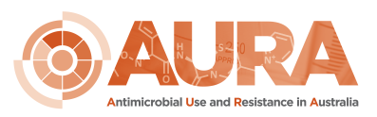

****July 2018

2017 Aged Care National Antimicrobial Prescribing Survey Report



Published by the Australian Commission on Safety and Quality in Health Care  
Level 5, 255 Elizabeth Street, Sydney NSW 2000

Phone: (02) 9126 3600  
Fax: (02) 9126 3613

Email: mail@safetyandquality.gov.au   
Website: www.safetyandquality.gov.au

ISBN: 978-1-925665-46-8   
© Australian Commission on Safety and Quality in Health Care 2018

All material and work produced by the Australian Commission on Safety and Quality in Health Care is protected by copyright. The Commission reserves the right to set out the terms and conditions for the use of such material.

As far as practicable, material for which the copyright is owned by a third party will be clearly labelled. The Australian Commission on Safety and Quality in Health Care has made all reasonable efforts to ensure that this material has been reproduced in this publication with the full consent of the copyright owners.

With the exception of any material protected by a trademark, any content provided by third parties, and where otherwise noted, all material presented in this publication is licensed under a [Creative Commons Attribution-NonCommercial-NoDerivatives 4.0 International licence](http://creativecommons.org/licenses/by-nc-nd/4.0/).

Creative Commons Licence

Enquiries about the licence and any use of this publication are welcome and can be sent to [communications@safetyandquality.gov.au](mailto:communications@safetyandquality.gov.au).

The Commission’s preference is that you attribute this publication (and any material sourced from it) using the following citation:

National Centre for Antimicrobial Stewardship and Australian Commission on Safety and Quality in Health Care. Antimicrobial Prescribing and Infections in Australian Aged Care Homes: Results of the 2017 Aged Care National Antimicrobial Prescribing Survey. Sydney: ACSQHC; 2018

**Disclaimer**

The content of this document is published in good faith by the Australian Commission on Safety and Quality in Health Care for information purposes. The document is not intended to provide guidance on particular healthcare choices. You should contact your healthcare provider on particular healthcare choices.

The Commission does not accept any legal liability for any injury, loss or damage incurred by the use of, or reliance on, this document.

# Contents

Contents 3

Summary 4

Introduction 5

Methods 6

Survey results 10

Discussion 21

References 26

# Summary

The 2017 Aged Care National Antimicrobial Prescribing Survey (acNAPS) identified continuing high rates of inappropriate antimicrobial use, and ongoing risks to the safety of care provided to residents in aged care homes. There were small improvements in documentation, and a lower reported prevalence of infections and antimicrobial use in 2017, compared with the 2016 acNAPS.

In 2017, 292 aged care homes collected and submitted acNAPS data to the National Centre for Antimicrobial Stewardship (NCAS), compared with 287 in 2016. Across both years all states, remoteness areas and organisation types were represented. There were no participants from either the Australian Capital Territory or the Northern Territory. Most of the 2017 participating homes were located in Victoria (67.8%), classified as inner regional (43.8%) and state government operated (68.2%). Of the 12,307 residents included, most resided in not-for-profit and government operated homes (46.6% and 45.5% respectively).

The prevalence of residents with infection signs and/or symptoms on the survey day was 2.8% in 2017, compared with 3.1% in 2016 (p = 0.08). The prevalence of residents prescribed at least one antimicrobial on the survey day was 8.8% in 2017, compared with 9.9% in 2016 (p<0.01). If all topical antimicrobials were excluded, the prevalence was 6.7% in 2017 compared with 7.6% in 2016. A total of 1,231 antimicrobial prescriptions were analysed for the 2017 acNAPS.

In 2017, the three most common indications for prescribing antimicrobials were cystitis (17.1%), pneumonia (10.9%) and non-surgical wound infections (5.1%). The three most commonly prescribed antimicrobials were clotrimazole (20.8%), cefalexin (19.4%) and amoxicillin (6.1%).

Aspects of inappropriate antimicrobial use in aged care homes in 2017 which continue to be cause for concern include:

* More than half (55.2%) of the antimicrobial prescriptions were for residents with no signs and/or symptoms of infection in the week prior to the start date, compared with 45.4% in 2016
* Of all antimicrobial prescriptions dispensed for residents with signs and/or symptoms of infection, only 18.4% met the internationally recognised McGeer *et al* infection definitions, compared with 36.5% in 2016
* The start date was greater than six months prior to the survey day for 26.9% of antimicrobial prescriptions, compared with 30.1% in 2016
* The indication for commencing an antimicrobial was not documented for 23.7% of prescriptions, compared with 25.6% in 2016
* The antimicrobial review or stop date was not documented for 55.6% of prescriptions, compared with 59.2% in 2016
* One-third (33.1%) of antimicrobial prescriptions were for topical use, compared to 32.4% in 2016. Most minor skin infections are self-limiting and resolve without the use of an antibiotic with standard skin hygiene care, and if an antibiotic is required, topical antibiotics are only appropriate for patients with minor, localised areas of impetigo.

Participating aged care homes are able to generate reports that compare their performance against national aggregate data. These reports provide immediate feedback on opportunities to improve antimicrobial prescribing practice.

The analyses presented in this report and data on the prevalence of antimicrobial resistance in Australian aged care home residents reinforce the potentially significant role of aged care homes in enhanced amplification of antimicrobial resistance in Australia.

The Australian Commission on Safety and Quality in Health Care (the Commission) and NCAS will continue to promote the appropriate use of antimicrobials in aged care homes, and the use of tools such as acNAPS to monitor antimicrobial use and inform strategies to improve care for residents.

The 2017 acNAPS results also highlight the need for evidence-based infection prevention and control and antimicrobial stewardship programs to be implemented in Australian aged care homes.

The Commission has worked with the Australian Government Department of Health on the inclusion of infection prevention and control and antimicrobial stewardship requirements in the new Aged Care Quality Standards, and will continue to support this work through collaboration on targeted strategies to promote effective infection control and antimicrobial stewardship programs in aged care homes.

# Introduction

In Australia, aged care services are managed by not-for-profit organisations, government organisations, and private companies. In 2017, 902 organisations operated 2,672 services in residential aged care, and there were almost 201,000 residential aged care places with an average occupancy rate of 92%. The three largest states: New South Wales, Victoria and Queensland, collectively accounted for about 80% of these places. There were also 3,636 aged care places in multi-purpose services, which integrate both health and aged care services in rural and regional areas.[1]

The Aged Care National Antimicrobial Prescribing Survey (acNAPS) is a collaborative project between the National Centre for Antimicrobial Stewardship (NCAS), the Guidance Group and Victorian Healthcare Associated Infection Surveillance System (VICNISS) Co-ordinating Centre. The Australian Commission on Safety and Quality in Health Care (the Commission) provides funding for acNAPS for incorporation of data in the Antimicrobial Use and Resistance in Australia (AURA) Surveillance System.

All Australian aged care homes and multi-purpose services are eligible to participate in the acNAPS, and participation is mostly voluntary. As of 2017, Victorian State Government operated aged care homes are required to participate in acNAPS as part of the VICNISS Infection Control Indicator Program.[2]

The acNAPS is a standardised surveillance tool that can be used to monitor the prevalence of infections and antimicrobial use. The survey was piloted in 2015, and was originally modelled upon the European Centre for Disease Prevention and Control Healthcare-Associated Infection in Long Term Care Facilities (HALT) study.[3],[4] Follow-up evaluation demonstrated that most aged care homes that participated in the acNAPS pilot study (90.6%) would be willing to participate again. The acNAPS has subsequently been conducted in 2016 and 2017.

Aged care home residents are susceptible to infections for a variety of reasons including advanced age, multiple co-morbidities, poor functional status, compromised immune status and the use of invasive devices such as urinary tract catheters.[5] In addition, residents reside in a close living environment and have frequent contact with potentially colonised or infected staff or other residents. Some aged care home residents also have multiple and/or prolonged hospitalisations.[6],[7] There is also a growing body of evidence on the prevalence of infections caused by antimicrobial resistant organisms in residents of aged care homes both in Australia and internationally. [8],[9]

Infection prevention and control programs are an integral part of care in aged care homes to protect vulnerable residents from acquiring preventable infections. An effective infection prevention and control program describes and implements evidence-based strategies that are necessary to eliminate or substantially reduce infections.

An antimicrobial stewardship (AMS) program is complementary to an infection prevention and control program. The aim of AMS programs is to decrease inappropriate antimicrobial usage and avoid adverse consequences of antimicrobial use, including antimicrobial resistance, toxicity and unnecessary costs. Since 2013 the National Safety and Quality Health Service Standards have required Australian hospitals to have an AMS program in place.[10],[11]

The current draft Aged Care Quality Standards propose that aged care homes will be required to demonstrate AMS practices that ‘promote appropriate antibiotic prescribing and use to support optimal care and reduce the risk of increasing resistance to antibiotics’.[12] Transition to the new Aged Care Quality Standards is expected to commence from 1 July 2018, with assessment against the Standards from 1 July 2019.

To be successful, infection prevention and control and AMS programs need to be evidence-based and informed by comprehensive surveillance data. Surveillance of antimicrobial resistance and antimicrobial use is a priority area for national action in Australia.[13] The AURA Surveillance System enables improved coordination and integration of data on antimicrobial resistance, antimicrobial use and appropriateness of prescribing in Australia, and has, since it was established in 2014, increased the comprehensiveness of that data.

This report presents analyses of acNAPS data collected and submitted in 2017 and includes comparisons with 2016 acNAPS data.

# Methods

## Time frame

The official data collection and submission period for 2016 acNAPS was between 27 June and 9 September, and for 2017 acNAPS the data collection period was between 19 June and 1 September.

## Recruitment

Numerous strategies were used to notify aged care homes about the acNAPS. These included newsletters issued by the Australian Government Department of Health, NCAS, VICNISS Coordinating Centre, the Commission, the Australian Aged Care Quality Agency, NPS MedicineWise, the Australasian College for Infection Prevention and Control, AusPharm, and the Pharmaceutical Society of Australia. The objectives of the communication strategy were to sustain participation by aged care homes and multi-purpose services and to recruit new participants in all states and territories.

## Survey method

Aged care homes could choose to use one of two survey methods to collect data. Method 2 was recommended for smaller aged care homes that wished to expand their sample size to better assess their performance.

**Method 1: A single-day point prevalence survey**

On the survey day, all residents are screened to determine if they:

* Have an antimicrobial prescription and/or
* Have signs and symptoms of a suspected or confirmed infection.

**Method 2: A single-day point prevalence survey plus an additional one month retrospective survey**

On the survey day, all residents are screened to determine if they:

* Have an antimicrobial prescription and/or
* Have signs and symptoms of a suspected or confirmed infection.

In addition, all residents present on the survey day are screened to determine if they had an antimicrobial prescription on any day during the previous month (that was ceased prior to the survey day).

## Data collection forms

### Aged Care Home form

Each participating aged care home completed the Aged Care Home form (Appendix 1). Both facility and resident-level data were captured.

Facility-level demographic and denominator data fields included:

* State or territory
* Remoteness classification (major city, inner/outer regional, remote or very remote)[14]
* Organisation type (not-for-profit, government or private)
* Use of the National Residential Medication Chart[15]
* Access to the *Therapeutic Guidelines: Antibiotic*[16]
* Endorsed guidelines routinely used for the management of suspected urinary tract infections.

Aged care homes are not required to use the National Residential Medication Chart, however there are potential benefits of using it. The *Therapeutic Guidelines: Antibiotic* aims to assist clinicians prescribing of therapeutic and prophylactic antimicrobials. In the latest version of these guidelines, optimal management of aged care home residents with suspected urinary tract infections is outlined by a clinical algorithm.

Resident survey day denominator data fields included:

* Number of residents present
* Number of residents aged 85 years and over
* Number of male residents.

All residents of the participating aged care home or multipurpose service who were present on the survey day were eligible for inclusion.

### Antimicrobials form

The Antimicrobials form (Appendix 2) was completed for residents who were receiving an antimicrobial on the survey day (Methods 1 and 2), and within the previous month (Method 2 only). Antimicrobial prescriptions included all antibiotics, antiviral agents, antifungal agents, and anti-parasitic agents. Data were collected about prescribing elements including the start date, choice, dose, frequency and route of the agent, initial mode of prescription (for example, written directly by prescriber), indication, and documentation of a review or stop date. The indication for prescribing an antimicrobial was reported according to a standardised list.

If the antimicrobial start date was known, and the therapy had commenced less than six months before the survey day, data were collected about the resident’s microbiology results, urinary investigations and catheter devices and signs and/or symptoms of a suspected infection. The timeframe for these data was the antimicrobial start date and the six days prior to the survey.

Microbiology data were collected from final microbiology reports only. If more than one specimen was collected within the specified timeframe, only the most recent result was reported.

The list of reportable infection signs and/or symptoms was divided into seven body systems: urinary tract, respiratory tract, skin or soft tissue, gastrointestinal tract, oral, eye, and other. Signs and symptoms common to many different infection types were also included, such as fever, leucocytosis, acute change in mental status and acute functional decline in activities of daily living. The signs and symptoms were required to be recorded in official documents such as resident histories or hospital discharge summaries*.*

### Infections form

An Infections form (Appendix 3) was completed for residents who had signs and/or symptoms of a suspected infection on the survey day. Data were collected about signs and/or symptoms present on the survey date and the two days prior to the survey.

In contrast to the Antimicrobials form, and as previously detailed in the 2016 acNAPS report1, the gastrointestinal tract infection signs and/or symptoms were excluded from the Infections form for the following reasons:

* Gastrointestinal tract infections have been infrequently reported as part of point prevalence studies over six years (VICNISS/ Rural Infection Control Practice Group and acNAPS data combined)
* Gastrointestinal outbreaks in aged care homes are notifiable in all states and territories
* The focus of acNAPS is on appropriate surveillance for the more common infections: urinary tract infections (UTIs), respiratory infections, and skin or mucosal infections
* There are limited resources in aged care homes to collect and submit data.

Each suspected infection was classified by the surveyor as ‘aged care home’ or ‘non-aged care home’ associated. Aged care home associated infections were those for which the resident’s signs and/or symptoms commenced at least two calendar days after (re)admission into the home. Conversely, the non-aged care home associated infections were those for which the resident’s signs and symptoms commenced within two calendar days of being admitted into the home.

When collecting data for the Infections form, it was acceptable to use official and non-official data sources. For example, staff handover notes, incident reports, wound-care folders or verbal information from a senior aged care home clinician.

## Electronic acNAPS

The NAPS coordinating team developed detailed information technology specifications that included the data fields required for an e-version of the three data collection forms. On the survey day, data collection forms were manually completed by the surveyors and then used to assist with electronic data entry. Registered surveyors could access the e-versions via the NAPS web portal.

Each suspected infection was classified as meeting or not meeting McGeer *et al* infection surveillance definitions by applying an electronic decision algorithm. The widely referenced McGeer *et al* definitions were specifically developed for use in long-term care facilities. The definitions were revised in 2012, taking into account the most recent evidence and the availability of improved diagnostics for surveillance.

## Once the data was entered, reports could be generated and downloaded immediately via the NAPS web portal. These reports enabled participants to compare their performance against national aggregate data. Surveyors were encouraged to forward the reports to those who are able to impact on resident care. This included administrators and clinicians such as general practitioners, pharmacists and nurses.

## Support

Surveyors could choose to participate in optional online training sessions. One-hour beginner sessions for new surveyors provided detailed information about the acNAPS methodology. Brief refresher sessions were also held for more experienced surveyors. The NAPS coordinating team also provided email and telephone assistance throughout 2016 and 2017.

## Limitations

The acNAPS results should be interpreted in the context of the limitations detailed below.

**Sampling and selection bias**

The results may not be generalisable to all Australian aged care homes. Most of the participating aged care homes that contributed to acNAPS in 2016 and 2017 were:

* Located in Victoria
* Classified as inner regional
* State government operated.

The 2016 data analysed as part of this report may differ from previous reports because some data were:

* Entered retrospectively
* Omitted due to anomalies
* Included that had previously been omitted.

**Infection definitions**

Signs and symptoms of infection in older residents may be atypical, so failure to meet the McGeer *et al* definitions may not fully exclude the presence of a true infection. In addition, the McGeer *et al* definitions require microbiological confirmation for some infections (for example, UTI). This means that these infections will not be confirmed unless specimens are taken.

**Seasonal variation**

The survey was conducted during winter. The results may have been different in another season. Certain respiratory infections for example are usually less frequent in spring, summer and autumn.

**Validation**

The analysis relied on the validity of local assessments. There was no additional external validation undertaken.

# Survey results

## A: Participation

In 2017, 292 aged care homes collected and submitted acNAPS data to NCAS; 287 participated in 2016. In both years all states, remoteness areas and organisation types were represented; there were no participants from either the Australian Capital Territory or the Northern Territory.

Most participating aged care homes were located in Victoria (67.8%). More than 40% were classified as inner regional, and 68.2% were state government operated (Table 1). Of the 12,319 residents audited, most resided in not-for-profit (46.6%) and government (45.5%) operated aged care homes.

Table : Participating aged care homes by state, remoteness area classification and provider type (2016 and 2017)

|  |  |  |  |  |  |  |
| --- | --- | --- | --- | --- | --- | --- |
|  | | **2016** | | **2017** | | **2017 residents audited** |
| **No.** | **%** | **No.** | **%** | **No.** |
| **State** | **NSW** | 36 | 12.5 | 38 | 13.0 | 1,378 |
| **Vic** | 190 | 66.2 | 198 | 67.8 | 6,762 |
| **QLD** | 28 | 9.8 | 19 | 6.5 | 1,366 |
| **SA** | 7 | 2.4 | 8 | 2.7 | 788 |
| **WA** | 15 | 5.2 | 21 | 7.2 | 1,632 |
| **Tas** | 11 | 3.8 | 8 | 2.7 | 381 |
| **Remoteness** | **Major Cities** | 82 | 28.6 | 87 | 29.8 | 5,817 |
| **Inner regional** | 120 | 41.8 | 128 | 43.8 | 4,949 |
| **Outer regional** | 73 | 25.4 | 68 | 23.3 | 1,414 |
| **Remote** | 9 | 3.1 | 8 | 2.7 | 113 |
| **Very remote** | 3 | 1.0 | 1 | 0.3 | 14 |
| **Provider type** | **Not for profit** | 83 | 28.9 | 81 | 27.7 | **5,737** |
| Charitable | 27 | 9.4 | 11 | 3.8 | 672 |
| Religious | 33 | 11.5 | 36 | 12.3 | 2,567 |
| Community-based | 23 | 8.0 | 34 | 11.6 | 2,498 |
| **Government** | 183 | 63.8 | 201 | 68.9 | **5,593** |
| State government | 182 | 63.4 | 199 | 68.2 | 5,395 |
| Local government | 1 | 0.3 | 2 | 0.7 | 198 |
| **Private** | 21 | 7.3 | 10 | 3.4 | **977** |
| **Total** | | **287** | **-** | **292** | **-** | **12,307** |

## B: Resident characteristics

For both 2016 and 2017, a little over one half (57.5%) of the residents were aged greater than 85 years and one-third (33.9%) were male. In 2017, 4.1% (*n*=507) of residents had been admitted to a hospital in the previous 30 days, and 3.5% (*n*=432) had an indwelling urinary catheter on the survey day (Table 2).

Table 2: Number and characteristics of all residents on the survey day (2016 and 2017)

|  |  |  |  |  |  |
| --- | --- | --- | --- | --- | --- |
| **Characteristic** | **2016** | | **2017** | | |
| **No.** | **%** | | **No.** | **%** |
| **Present on survey day** | 13,398 | - | | 12,307 | - |
| **Aged >85 years** | 7,355 | 54.9 | | 7,072 | 57.5 |
| **Male** | 4,448 | 33.2 | | 4,167 | 33.9 |
| **Admitted to hospital in previous 30 days** | 630 | 4.7 | | 507 | 4.1 |
| **Indwelling urinary catheter present** | 513 | 3.8 | | 432 | 3.5 |

## C: Prevalence of infections and antimicrobial use

The prevalence of infection was calculated as the proportion of residents present on the survey day who had signs and/or symptoms of a suspected infection. The prevalence of antimicrobial use was calculated as the proportion of residents present on the survey day who were prescribed at least one antimicrobial.

The prevalence of residents who had signs and/or symptoms of a suspected infection was 2.8% in 2017, compared with 3.1% in 2016. The prevalence of residents prescribed at least one antimicrobial was 8.8% in 2017, compared with 9.9% in 2016 (Table 3). If all topical antimicrobials were excluded, the prevalence was 6.7% in 2017 compared with 7.6% in 2016.

Table 3: Prevalence of infections and antimicrobial use (2016 and 2017)

|  |  |  |  |  |  |  |  |
| --- | --- | --- | --- | --- | --- | --- | --- |
| **On survey day** | **2016** | | | **2017** | | | **p-value** |
| **No.** | **%** | **95% CI** | **No.** | **%** | **95% CI** |
| **Residents with signs and/or symptoms of a suspected infection** | 417 | 3.1 | 2.8-3.4 | 349 | 2.8 | 2.5-3.1 | 0.08 |
| **Residents prescribed at least one antimicrobial** | 1,321 | 9.9 | 9.4-10.4 | 1,087 | 8.8 | 8.3-9.3 | <0.01 |
| **Number of residents present** | 13,398 | - | - | 12,307 | - | - | - |

In 2017, Queensland had the lowest prevalence of residents with signs and/or symptoms of a suspected infection (*n*=23; 1.7%). Of the three organisation types, not-for-profit aged care homes had the lowest prevalence of suspected infections in both 2016 and 2017: 2.7% (*n*=166) and 2.3% (*n*=131) respectively (Table 4).

In 2017, South Australia had the highest prevalence of residents with signs and/or symptoms of a suspected infection (*n*= 50, 6.3%). Of the five remoteness classifications, for both 2016 and 2017 aged care homes in remote areas had the highest prevalence of suspected infections: 12.4% (*n*=17) and 7.1% (*n*=8) respectively. Similarly, of the three organisation types, government operated aged care homes had the highest prevalence of suspected infections: 3.7% (*n*=203) and 3.5% (*n*=196) in 2016 and 2017 respectively (Table 4).

Table 4: Prevalence of residents with signs and/or symptoms of a suspected infection on the survey day, by state, remoteness and provider type (2016 and 2017)

|  |  |  |  |  |  |
| --- | --- | --- | --- | --- | --- |
| **Category** | | **Residents with infection signs and/or symptoms** | | | |
| **2016** | | **2017** | |
| **No.** | **Prevalence (%)** | **No.** | **Prevalence (%)** |
| **State** | **NSW** | 59 | 4.0 | 71 | 5.2 |
| **Vic** | 226 | 3.0 | 162 | 2.4 |
| **QLD** | 48 | 2.4 | 23 | 1.7 |
| **SA** | 21 | 3.6 | 50 | 6.3 |
| **WA** | 55 | 4.5 | 35 | 2.1 |
| **Tas** | 8 | 1.2 | 8 | 2.1 |
| **Remoteness** | **Major Cities** | 184 | 3.1 | 135 | 2.3 |
| **Inner regional** | 148 | 2.8 | 156 | 3.2 |
| **Outer regional** | 65 | 3.2 | 50 | 3.5 |
| **Remote** | 17 | 12.4 | 8 | 7.1 |
| **Very remote** | 3 | 4.4 | 0 | 0.0 |
| **Organisation type** | **Not for profit** | 166 | 2.7 | 131 | 2.3 |
| **Government** | 203 | 3.7 | 196 | 3.5 |
| **Private** | 48 | 2.8 | 22 | 2.3 |
| **Total** | | **417** | **3.1** | **349** | **2.8** |

In 2017, Tasmania reported the lowest prevalence of residents prescribed at least one antimicrobial (*n*=15, 3.9%). Of the three organisation types, private aged care homes for both 2016 and 2017 had the lowest prevalence: 6.4% (*n*=109) and 5.0% (*n*=49) respectively (Table 5).

In both 2016 and 2017, South Australia had the highest prevalence of residents prescribed at least one antimicrobial: 13.8% (*n*=81) and 17.3% (*n*=136) respectively. Aged care homes in areas classified as remote had the highest prevalence of residents prescribed at least one antimicrobial: 19.0% (*n*=26) and 24.8% (*n*=28) in 2016 and 2017 respectively (Table 5).

Table 5: Prevalence of antimicrobial use on the survey day, by state, remoteness and provider type (2016 and 2017)

|  |  |  |  |  |  |
| --- | --- | --- | --- | --- | --- |
| **Category** | | **Residents prescribed at least one antimicrobial** | | | |
| **2016** | | **2017** | |
| **No.** | **Prevalence (%)** | **No.** | **Prevalence (%)** |
| **State** | **NSW** | 196 | 13.2 | 121 | 8.8 |
| **Vic** | 616 | 8.2 | 560 | 8.3 |
| **QLD** | 235 | 11.9 | 130 | 9.5 |
| **SA** | 81 | 13.8 | 136 | 17.3 |
| **WA** | 146 | 12.1 | 125 | 7.7 |
| **Tas** | 47 | 7.1 | 15 | 3.9 |
| **Remoteness** | **Major Cities** | 661 | 11.1 | 474 | 8.1 |
| **Inner regional** | 439 | 8.4 | 431 | 8.7 |
| **Outer regional** | 189 | 9.2 | 154 | 10.9 |
| **Remote** | 26 | 19.0 | 28 | 24.8 |
| **Very remote** | 6 | 8.8 | 0 | 0.0 |
| **Organisation type** | **Not-for-profit** | 698 | 11.3 | 486 | 8.5 |
| **Government** | 514 | 9.3 | 552 | 9.9 |
| **Private** | 109 | 6.4 | 49 | 5.0 |
| **Total** | | **1,321** | **9.9** | **1,087** | **8.8** |

## D: Suspected infections (on the survey day)

In 2017, 2.8% (*n*=349) of residents were reported to have a total of 360 suspected infections on the survey day. Overall, 39.4% (*n*=142) of suspected infections met the McGeer *et al* infection definitions (Table 6). In the 48 hours prior to the survey day, a microbiological specimen was taken for 6.6% (*n*=23) of these residents. Almost one-half of the specimens (*n*=11, 47.8%) were urine samples.

Table 6: Number and percentage of residents with signs and/or symptoms of a suspected infection by body system (2017)

|  |  |  |  |  |  |
| --- | --- | --- | --- | --- | --- |
| **Body system** | **No. of suspected infections** | **ACH-associated suspected infections§** | | **Suspected infections that met McGeer *et al* definition** | |
| **No.** | **%** | **No.** | **%** |
| **Respiratory tract** | 132 | 92 | 69.7 | 69 | 52.3 |
| **Skin, soft tissue** | 117 | 90 | 76.3 | 50 | 42.4 |
| **Urinary tract** | 74 | 56 | 73.7 | 1 | 1.3 |
| **Eye** | 19 | 16 | 84.2 | 16 | 84.2 |
| **Oral** | 9 | 6 | 66.7 | 6 | 66.7 |
| **Gastrointestinal** | 1 | 0 | 0.0 | 0 | 0.0 |
| **Total** | **360** | **265** | **73.6** | **142** | **39.4** |

§ACH=aged care home

## E: Antimicrobial use

Antimicrobial data collected as part of Method 1 and Method 2 were combined for the analyses presented in this section. The unit of analysis is antimicrobial prescriptions.

In 2017, 1,087 residents were prescribed a total of 1,231 antimicrobials (Table 7). The start date was unknown for 4.3% (*n*= 53) of antimicrobial prescriptions, compared with 3.8% (*n*=57) in 2016. About one quarter (*n*=332, 26.9%) of antimicrobial prescriptions were commenced more than six months prior to the survey day, compared with 30.1% in 2016.

### Quality indicators

In 2017, the two key quality indicators – ‘indication documented’ and ‘review or stop date documented’ – were reported for 76.3% (*n*=939) and 44.4% (*n*=547) of antimicrobial prescriptions respectively. In 2016, the same indicators were reported for 74.4% (*n*=1,111) and 40.8% (*n*=609) of antimicrobial prescriptions (Table 7).

Table 7: Key quality indicators (2016 and 2017)

|  |  |  |  |  |
| --- | --- | --- | --- | --- |
| **Quality Indicator** | **% of total antimicrobial prescriptions** | | | |
| **2016** | | **2017** | |
| **No.** | **%** | **No.** | **%** |
| **Indication** | | | | |
| Documented | 1,111 | 74.4 | 939 | 76.3 |
| Not documented | 382 | 25.6 | 292 | 23.7 |
| **Review or stop date** | | | | |
| Documented | 609 | 40.8 | 547 | 44.4 |
| Not documented | 884 | 59.2 | 784 | 55.6 |
| **Total** | **1,493** | - | **1,231** | - |

In 2017, the indication for an antimicrobial prescription was documented for all Tasmanian residents (100%).

Of the three organisation types, indication documentation was highest in the private aged care homes for both 2016 and 2017: 91.2% (*n*=104) and 85.2% (*n*=46) respectively. Over the same time period, private aged care homes were also most likely to document the review or stop date: 50.0% (*n*=57) in 2016 and 53.7% (*n*=29) in 2017 (Table 8).

Table 8: Key quality indicators, by state, remoteness and provider type (2016 and 2017)

|  |  |  |  |  |  |  |  |
| --- | --- | --- | --- | --- | --- | --- | --- |
|  | | **No. of prescriptions** | | **Indication documented (%)** | | **Review or stop date documented (%)** | |
| **2016** | **2017** | **2016** | **2017** | **2016** | **2017** |
| **State** | **NSW** | 237 | 136 | 77.6 | 67.6 | 46.0 | 41.9 |
| **QLD** | 276 | 147 | 77.9 | 87.8 | 35.1 | 44.9 |
| **SA** | 92 | 155 | 70.7 | 79.4 | 50.0 | 61.3 |
| **Tas** | 48 | 15 | 68.8 | 100.0 | 45.8 | 73.3 |
| **Vic** | 656 | 639 | 73.3 | 71.5 | 37.8 | 40.4 |
| **WA** | 184 | 139 | 72.3 | 88.5 | 47.3 | 43.2 |
| **Remoteness** | **Major Cities** | 777 | 543 | 75.4 | 81.2 | 42.2 | 51.0 |
| **Inner regional** | 475 | 482 | 70.5 | 77.2 | 39.6 | 43.8 |
| **Outer regional** | 208 | 171 | 76.9 | 63.7 | 37.5 | 29.8 |
| **Remote** | 27 | 35 | 92.6 | 48.6 | 33.3 | 22.9 |
| **Very remote** | 6 | 0 | 83.3 | 0 | 100.0 | 0 |
| **Organisation type** | **Not for profit** | 816 | 548 | 74.4 | 82.5 | 40.4 | 49.5 |
| **Government** | 563 | 629 | 71.0 | 70.1 | 39.4 | 39.3 |
| **Private** | 114 | 54 | 91.2 | 85.2 | 50.0 | 53.7 |
| **Total** | | **1,493** | **1,231** | **74.4** | **76.3** | **40.8** | **44.4** |

The majority (*n*= 739, 86.9%) of antimicrobial prescriptions in 2017, similarly to 2016, were written by a prescriber (Table 9). Seventy-one (8.4%) prescriptions were given via a telephone or fax order. Of those telephone/fax prescriptions, 60.6% (*n*=43) were for residents who were examined by a prescriber within three days of the antimicrobial start date, and 31.0% (*n*=22) were for residents who were not examined by a prescriber during this time period.

Table 9: Prescription mode (2016 and 2017)*

|  |  |  |  |  |
| --- | --- | --- | --- | --- |
| **Mode of prescription** | **2016** | | **2017** | |
| **No.** | **%** | **No.** | **%** |
| **Written by prescriber** | 893 | 90.5 | 739 | 86.9 |
| **Phone or fax order** | 73 | 7.4 | 71 | 8.4 |
| **Unknown** | 21 | 2.1 | 40 | 4.7 |
| **Total** | **987** | **100** | **850** | **100** |

*Only prescriptions with a known start date less than six months prior to the survey day were included.

### Most commonly prescribed antimicrobials

In 2017, the most commonly prescribed antimicrobials were clotrimazole (*n*=256, 20.8%), cefalexin (*n*=239, 19.4%), amoxicillin (*n*=75, 6.1%), trimethoprim (*n*=71, 5.8%), amoxicillin–clavulanic acid (*n*=71, 5.8%) and doxycycline (*n*=70, 5.7%).

By comparison, in 2016, the top five antimicrobials were cefalexin (*n*=319, 21.4%), clotrimazole (*n*=262, 17.5%), amoxicillin–clavulanic acid (*n*=92, 6.3%), trimethoprim (*n*=94, 6.2%), and chloramphenicol (*n*=83, 5.6%) (Figure 1).

In 2017, most antimicrobial prescriptions were for either oral (*n*=794, 64.5%) or topical (*n*=407, 33.1%) administration. The five most commonly prescribed topical antimicrobials in 2017 were clotrimazole (*n*=248, 60.9%), chloramphenicol (*n*=66, 16.2%), gramicidin–neomycin–nystatin (Kenacomb®) (*n*=26, 6.4%), miconazole (*n*=25, 6.1%) and mupirocin (*n*=10, 2.5%).

Figure : Most commonly prescribed antimicrobials (2016 and 2017)

### Common indications for prescribing antimicrobials

In 2017, the top five known indications for prescribing antimicrobials were cystitis (*n*=211, 17.1%), chest and lower respiratory tract infection (*n*=134, 10.9%), non-surgical wound infection (*n*=63, 5.1%), tinea (*n*=58, 4.7%) and cellulitis (*n*=51, 4.1%). In 2016, the top five known indications were cystitis (*n*=263, 17.6%), chest and lower respiratory tract infection (*n*=164, 11.0%), non-surgical wound infection (*n*=85, 5.7%), cellulitis (*n*=71, 4.8%), and asymptomatic bacteriuria (*n*=58, 3.9%) (Figure 2).

Figure : Most common indications (treatment and prophylaxis) for antimicrobial prescriptions (2016 and 2017)*

*Indications categorised by surveyors as ‘Other’ are not included (2017, *n*=304 and 2016, *n*= 372)

Note: LRTI = lower respiratory tract infection; COPD = chronic obstructive pulmonary disease; Ulcers include pressure, venous and arterial ulcers; UTI = urinary tract infection

Of all known indications for prescribing antimicrobials, almost three-quarters (*n*=875, 71.1%) in 2017 were for treatment, compared with 74.8% (*n*=1,117) in 2016. Of these treatment indications, chest and lower respiratory tract infections were most commonly reported: 14.1% (*n*=158) and 14.1% (*n*=123), in 2016 and 2017 respectively (Figure 3).

Figure 3: Most common treatment indications for antimicrobial prescriptions (2016 and 2017)*

*Indications categorised by surveyors as ‘Other’ are not included (2017, *n*=205 and 2016, *n*= 271)

Note: LRTI = lower respiratory tract infection; COPD = chronic obstructive pulmonary disease; Ulcers include pressure, venous and arterial ulcers; UTI = urinary tract infection

In 2017, cystitis was the most common reason for prescribing antimicrobials for prophylactic use (*n*=104, 29.2%) (Figure 4).

Figure 4: Most common prophylactic indications for antimicrobial prescriptions, 2016 and 2017*

*Indications categorised by surveyors as ‘Other’ are not included (2017, *n*=99 and 2016, *n*= 101)

Note: LRTI = lower respiratory tract infection; COPD = chronic obstructive pulmonary disease

### Microbiology, urinary investigations and infection signs and/or symptoms

Additional information was collected about microbiology results, urinary investigations and catheter devices, and the presence of signs and/or symptoms of a suspected infection for all residents who were prescribed an antimicrobial. Of the total 1,231 antimicrobial prescriptions in 2017, 850 (69.0%) had a start date documented that was less than six months prior to the survey day.

A microbiological sample was collected for 15.6% (*n*=133) of the 850 prescriptions within the week prior to the antimicrobial start date. Specimens were most frequently collected for systemic (*n*=2, 40.0%) and urinary tract infections (*n*=80, 39.9%) (Figure 5).

Figure 5: Percentage of antimicrobial prescriptions that had microbiological samples taken, by body system, acNAPS contributors, 2017*†

*The number of prescriptions is displayed next to the name of each body system

†Body system as per the indication specified for commencing the antimicrobial

In 2017, just under one-half (*n*=513, 44.8%) of antimicrobial prescriptions were for residents who had signs and/or symptoms of a suspected infection in the week prior to the antimicrobial start date. Forty percent of these infections were classified as aged care home-associated, and only 18.4% (*n*=211) met the McGeer *et al* infection criteria. This is a reduction of approximately 50% compared with 2016, when 36.5% of antimicrobial prescriptions were for residents who had signs and/or symptoms of a suspected infection in the week prior to the antimicrobial start date that met the McGeer *et al* infection criteria. It is not known why there was such a large decrease between 2016 and 2017 in classification of infections; there was no change in the criteria.

In 2017, compliance with the McGeer *et al* infection criteria was highest for eye (*n*=34, 46.6%) and respiratory infections (*n*=62, 29.1%) (Table 10).

Table 10: Number and percentage of antimicrobial prescriptions where infection signs and/or symptoms were recorded and McGeer et al criteria were met, by body system (2017)*†

|  |  |  |  |  |  |  |  |
| --- | --- | --- | --- | --- | --- | --- | --- |
| **Body system** | **No. of prescriptions** | **With signs and symptoms of infection** | | **ACH-associated suspected infections§** | | **Infections that met McGeer *et al* criteria** | |
| **No.** | **%** | **No.** | **%** | **No.** | **%** |
| **Skin, soft tissue** | 424 | 170 | 40.1 | 155 | 36.6 | 82 | 19.3 |
| **Urinary tract** | 323 | 114 | 35.3 | 99 | 30.7 | 17 | 5.3 |
| **Respiratory tract** | 213 | 150 | 70.4 | 129 | 60.6 | 62 | 29.1 |
| **Other body system** | 86 | 29 | 33.7 | 27 | 31.4 | 11 | 12.8 |
| **Eye** | 73 | 38 | 52.1 | 36 | 49.3 | 34 | 46.6 |
| **Oral** | 17 | 9 | 52.9 | 10 | 58.8 | 3 | 17.6 |
| **Gastrointestinal tract** | 10 | 3 | 30.0 | 2 | 20.0 | 2 | 20.0 |
| **Total** | **1146\*** | **513** | **44.8** | **458** | **40.0** | **211** | **18.4** |

*Prescriptions for medical prophylaxis and unknown indications were excluded from this table

†Some prescriptions may have had infection signs and/or symptoms from more than one body system

§ACH=aged care home

# Discussion

In 2017, the prevalence of both infections and antimicrobial use reported to the acNAPS decreased, compared with 2016. [17]

Ongoing inappropriate antimicrobial use in aged care homes in 2017, which potentially places the safety of residents at risk, included the prescription of antimicrobials for unconfirmed infections, prolonged duration of antimicrobial prescriptions and the widespread use of topical antimicrobials. The following results were of particular concern:

* Over one-half of the antimicrobial prescriptions (55.2%) were for residents with no signs and/or symptoms of a suspected infection in the week prior to the start date
* Only 18.4% of prescriptions were for residents with infection signs and/or symptoms that met internationally accepted surveillance criteria, which is half the number that met the criteria in 2016
* The start date was greater than six months prior to the survey day for 26.9% of antimicrobial prescriptions
* The indication for commencing an antimicrobial was not documented for 23.7% of prescriptions
* The antimicrobial review or stop date was not documented for 55.6% of prescriptions
* One-third (33.1%) of antimicrobial prescriptions were for topical use.

Data on the prevalence of antimicrobial resistance in Australian aged care home residents, in combination with the inappropriate antimicrobial use identified by successive acNAPS, suggest that aged care homes have the potential to enhance amplification of antimicrobial resistance in Australia.

The 2017 acNAPS results reinforce the need for effective infection prevention and control programs and the development and implementation of AMS programs in Australian aged care homes. These programs are important if infections and inappropriate antimicrobial use are to be significantly reduced.

The Commission and NCAS will widely disseminate the results of the 2017 acNAPS and examine strategies to enhance the number and representativeness of the aged care homes that participate in acNAPS in 2018.

Appendix 1: Aged Care Home (ACH) form

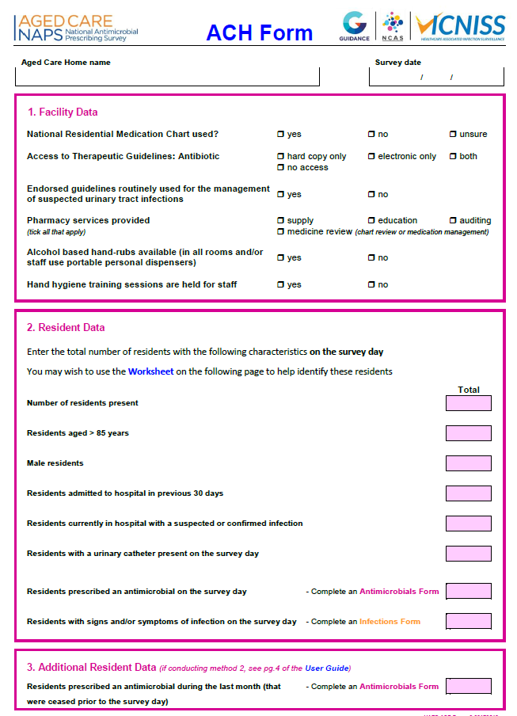

Appendix 2: Antimicrobials form

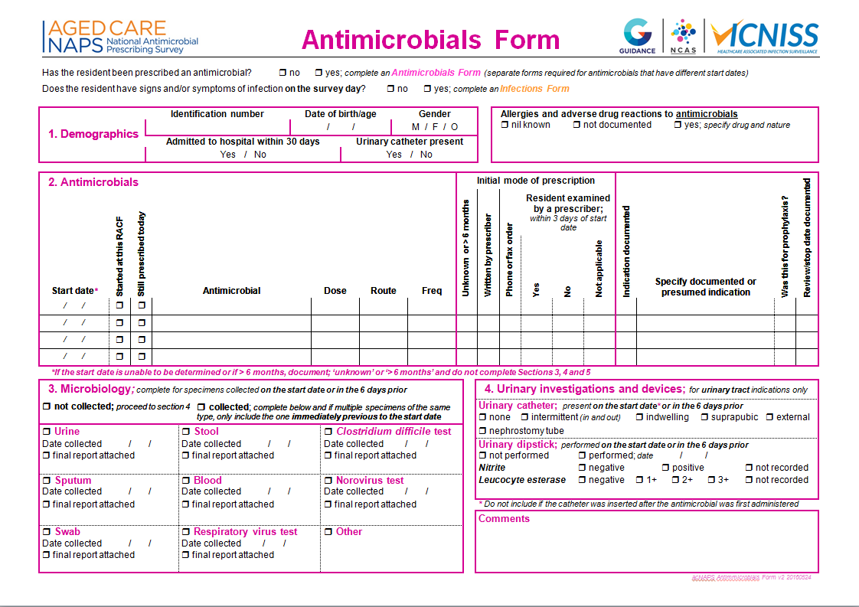

Appendix 3: Infections form

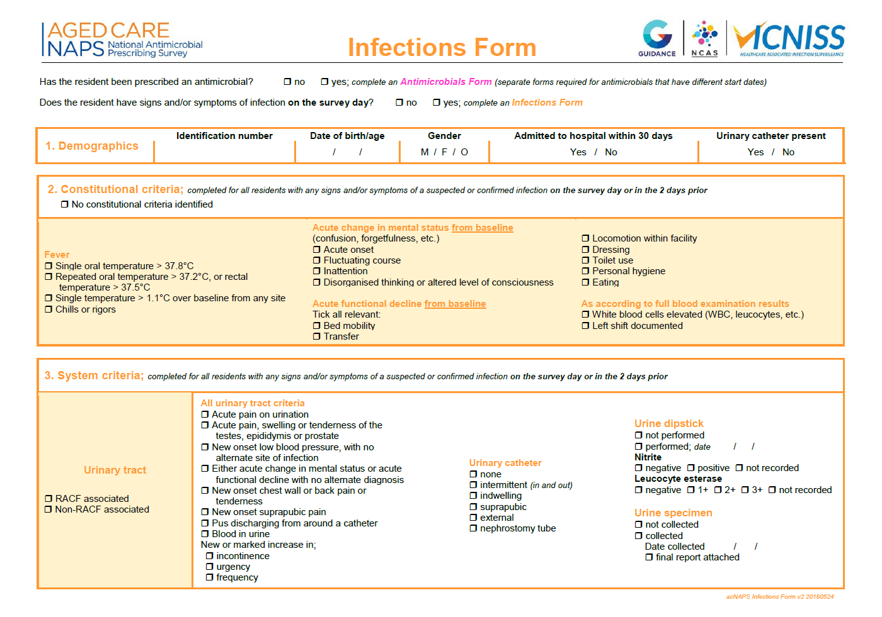

# References

1. Commonwealth of Australia. 2016-17 Report on the Operation of the Aged Care Act 1997. Department of Health. Canberra Commonwealth of Australia 2017.
2. Victorian Healthcare Associated Infection Surveillance Coordinating Centre. E bulletin June 2017. Available from: [www.vicniss.org.au/publications/e-bulletin/](http://www.vicniss.org.au/publications/e-bulletin/)
3. European Centre for Disease Prevention and Control. Healthcare associated infections in long term care facilities in Europe: The HALT project. <https://ecdc.europa.eu/en/healthcare-associated-infections-long-term-care-facilities> (accessed May 2018).
4. Smith M, Atkins S, Worth L, Richards M, Bennett N. Infections and antimicrobial use in Australian residential aged care facilities: a comparison between local and international prevalence and practices. Aust Health Rev. 2013; 37(4):529-34.
5. Garibaldi RA. Residential care and the elderly: the burden of infection. J Hosp Infect. 1999;43 Suppl:S9-18.
6. Ingarfield SL FJ, Jacobs IG, Gibson NP, Holman CDJ, Jelinek GA. Use of emergency departments by older people from residential care: a population based study. Age Ageing. 2009;38:314-18.
7. Richards CL, Jr. Infection control in long-term care facilities. J Am Med Dir Assoc. 2007;8(3 Suppl):S18-25.
8. Coombs G, Bell JM, Daley D, Collignon P, Cooley L, Gottlieb T, Iredell J, Kotsanas D, Nimmo G and Robson J on behalf of the Australian Group on Antimicrobial Resistance, Turnidge JD. Australian Group on Antimicrobial Resistance. Sepsis Outcome Programs 2016 Report. Sydney: ACSQHC; 2018
9. Australian Commission on Safety and Quality in Health Care (ACSQHC). AURA 2017: second Australian report on antimicrobial use and resistance in human health. Sydney: ACSQHC; 2017.
10. Australian Commission on Safety and Quality in Healthcare (ACSQHC). National Safety and Quality Health Service Standards. ACSQHC Sydney 2011
11. Australian Commission on Safety and Quality in Health Care. National Safety and Quality Health Service Standards. 2nd ed. Sydney: ACSQHC; 2017
12. Aged Care Standards and Accreditation Agency. Guidance on the draft Aged Care Quality Standards 2017. <https://agedcare.health.gov.au/quality/single-set-of-aged-care-quality-standards/draft-aged-care-quality-standards-and-draft-application-of-draft-aged-care-quality-standards-by-service-type> (accessed May 2018).
13. Australian Government Department of Health, Australian Government Department of Agriculture. Responding to the threat of antimicrobial resistance: Australia’s first antimicrobial resistance strategy 2015–2019. Canberra: Australian Government; 2015
14. Australian Bureau of Statistics. 1270.0.55.005 Australian Statistical Geography Standard (ASGS): Volume 5 - Remoteness Structure, July 2016. Canberra: ABS; July 2016
15. Australian Commission on Safety and Quality in Healthcare. National Residential Medication Chart 2014. <https://www.safetyandquality.gov.au/our-work/medication-safety/nrmc/> (accessed May 2018).
16. Antibiotic Expert Groups. Therapeutic Guidelines: Antibiotic. Version 15. Melbourne Therapeutic Guidelines Limited 2014.
17. National Centre for Antimicrobial Stewardship and Australian Commission on Safety and Quality in Health Care. Aged Care National Antimicrobial Prescribing Survey 2016. Sydney: ACSQHC; 2017