

March 2017

A guide to the potentially avoidable deaths indicator in Australia

Commission on Safety and Quality in Health Care

Level 5, 255 Elizabeth Street, Sydney NSW 2001

Phone: (02) 9126 3600

Fax: (02) 9126 3613

Email: mail@safetyandquality.gov.au

Website: [www.safetyandquality.gov.au](http://www.safetyandquality.gov.au)

ISBN: 978-1-925224-77-1

© Commonwealth of Australia 2017

All material and work produced by the Australian Commission on Safety and Quality in Health Care is protected by Commonwealth copyright. It may be reproduced in whole or in part for study or training purposes, subject to the inclusion of an acknowledgement of the source.

The Commission’s preference is that you attribute this publication (and any material sourced from it) using the following citation:

Falster, M and Jorm, L. *A guide to the potentially avoidable deaths indicator in Australia.* Centre for Big Data Research in Health, University of New South Wales in consultation with Australian Commission on Safety and Quality in Health Care and Australian Institute of Health and Welfare: Sydney 2017

Enquiries regarding the use of this publication are welcome and can be sent to [communications@safetyandquality.gov.au](mailto:communications@safetyandquality.gov.au).

Preface

This preface has been written by the Australian Commission on Safety and Quality in Health Care. It is a separate piece of work from “*A guide to the potentially avoidable deaths indicator in Australia*” which was prepared by subject experts from the Centre for Big Data Research in Health, University of New South Wales.

The guide was developed in consultation with the Australian Commission on Safety and Quality in Health Care and the Australian Institute of Health and Welfare on behalf of the National Health Information Standards and Statistics Committee (NHISSC).

This guide is intended to help professionals within the health system to understand and interpret one of the indicators in the National Health Performance Framework (NHPF), which focuses on potentially avoidable deaths. The NHPF was first developed in 2001 and revised in 2009, with the main purpose of providing a structure for reporting on the performance of the Australian health system at the national level. The framework can also be used as a guiding structure when developing sets of performance indicators for more discrete components of the health system, such as a particular program, or a specific target group.

Within certain sectors of the health system, there is a lack of clarity regarding how to accurately interpret the National Health Performance Framework indicator 1,2 ‘*Potentially Avoidable Deaths*’ and an interpretive guide could potentially resolve this issue. NHISSC actioned the Australian Institute for Health Welfare and the Australian Commission on Safety and Quality in Health Care (the Commission) to discuss options on the best way to develop an appropriate user guide. Subject matter epidemiological experts from the Centre for Big Data Research in Health, University of New South Wales were contracted to write the guide.

The guide provides an overview of the potentially avoidable deaths indicator, including common ways that this indicator is reported in Australia, interpretation, and a brief history of how the indicator was developed. This guide is intended as background and a resource for understanding and interpreting this indicator.

While the guide has been written for a wide audience it is primarily for professionals in the health system, and should also have utility for service level staff in states and territories, Primary Health Networks (PHNs), and Local Health Network Boards and CEOs.



March 2017

**A guide to the potentially avoidable deaths indicator in Australia**

Prepared by:

Centre for Big Data Research in Health, University of New South Wales

for

The National Health Information Standards and Statistics Committee

In consultation with:

Australian Commission on Safety and Quality in Health Care

and Australian Institute of Health and Welfare





Contents

1. Background 3

2. Overview of potentially avoidable deaths 4

2.1 Evolution of potentially avoidable deaths as a health performance indicator 5

2.2 Strengths and limitations as a health performance indicator 7

3. Using the potentially avoidable deaths indicator 9

3.1 Comparisons between geographic regions 10

Other factors to consider 11

3.2 Breakdowns by cause of death and population subgroups 12

3.3 Trends in potentially avoidable deaths 14

Limitations 14

4. Further resources 16

5. References 17

Appendices 19

Appendix 1: Conditions in the potentially avoidable deaths indicator 19

Appendix 2: Example of comparisons between geographic regions using peer grouping to make fairer comparisons 20

Appendix 3: Examples of breakdown of potentially avoidable deaths by conditions - sex, age and Indigenous status 21

Appendix 4: Examples of time trends 24

# 1. Background

This guide provides an overview of the potentially avoidable deaths health performance indicator, including a guide to interpreting common forms of statistics reported in Australia, and a brief history of how the indicator was developed.

A potentially avoidable death, as used in performance measures, is a death from a condition that could have been prevented through provision of individualised care and/or treatment through existing primary or hospital care.1

Potentially avoidable deaths are used in Australia as a performance indicator for the effectiveness of the health system, including hospital, primary and community care. The indicator is currently in the Australian National Healthcare Agreement (NHA)1, 2, and a part of the Performance and Accountability Framework.3

Comparisons of population-based mortality rates or person-years of life lost between geographic regions are used to identify areas with relatively high mortality due to potentially avoidable deaths. Breakdowns of potentially avoidable deaths by cause of death or population subgroups can help to identify priorities for targeted policy interventions. Trends over time can be used to monitor for improvements or identify emerging problem areas.

While the indicator is easy to calculate using routinely collected mortality data, different definitions for the indicator have been used over the years and by different agencies, which can make comparisons over time or between jurisdictions difficult.

The indicator is also influenced by a variety of factors, such as changes in disease incidence and the use of different disease coding systems, making direct attribution to specific health policies and/or programs difficult.

The Australian Commission on Safety and Quality in Health Care (the Commission) and the Australian Institute of Health and Welfare (AIHW) were jointly commissioned by the National Health Information Standards and Statistics Committee (NHISSC) to develop this guide on the potentially avoidable deaths indicator. The guide has been written by academics from the University of New South Wales who have extensive experience in this area.

The Commission sponsored this project as part of the development and explanation of safety and quality indicators in health care delivery, in both the primary care and hospital sector.

# 2. Overview of potentially avoidable deaths

A potentially avoidable death is one that could be potentially prevented with individualised care or through existing primary care or hospitalisation. Potentially avoidable deaths, also referred to as avoidable mortality, are a subset of all premature mortality (deaths under 75 years), and include deaths considered to be potentially preventable (those amenable to screening and primary prevention) and potentially treatable (those amenable to therapeutic interventions). Measures of potentially avoidable deaths are commonly used in Australia and internationally as a high-level health system performance indicator.

Potentially avoidable deaths are identified from cause of death codes recorded in routinely collected mortality data. The indicator comprises a broad range of causes of death, including infections, cancer, diabetes, maternal and infant causes, external causes (such as transport injury), and diseases of the circulatory, genitourinary, respiratory and digestive systems. The current Australian health performance indicator includes 11 major categories of potentially avoidable deaths (Appendix 1). Past and current specifications for the potentially avoidable deaths indicator as used in the Australian National Healthcare Agreement, including additional identifying criteria such as relevant age thresholds, are detailed in the AIHW Metadata Online Registry (METeOR).1

Potentially avoidable deaths are usually presented as age-standardised rates (e.g. the numbers of deaths per 100 000 people per year, which has been adjusted to take into account different age structures of population groups), or as potential years of life lost (PYLL) per 100 000 people – an estimate of the additional years of life which would have been lived if people had not died prematurely. Ideally, 95% upper and lower confidence intervals should be reported, but this is not always the case. An example of standardised rates of potentially avoidable deaths is presented in Table 1 below.

Table 1: Example, Avoidable deaths by region of usual residence and sex, 2014. *Source: Adapted from Australian Bureau of Statistics 2016, 3303.0 – Causes of Death, Australia, 2014, Potentially avoidable deaths (table 5.1).*

|  |  |  |  |  |  |  |
| --- | --- | --- | --- | --- | --- | --- |
| Region of usual residence | Males | | Females | | Persons | |
| Number | Ratea | Number | Ratea | Number | Ratea |
| New South Wales | 5,366 | 136.8 | 3,097 | 76.9 | 8,463 | 106.6 |
| Victoria | 3,879 | 131.5 | 2,243 | 73.2 | 6,122 | 101.8 |
| Queensland | 3,403 | 140.9 | 1,976 | 81.2 | 5,379 | 110.9 |
| South Australia | 1,285 | 142.2 | 737 | 78.4 | 2,022 | 109.9 |
| Western Australia | 1,779 | 139.8 | 914 | 72.7 | 2,693 | 106.5 |
| Tasmania | 465 | 159.1 | 324 | 105.0 | 789 | 132.0 |
| Northern Territory | 302 | 269.7 | 201 | 198.0 | 503 | 236.6 |
| Australian Capital Territory | 185 | 101.1 | 121 | 65.4 | 306 | 82.8 |
| Australia (total) | 16,668 | 138.4 | 9,615 | 78.2 | 26,283 | 108.0 |

a Standardised death rate, deaths per 100 000 of estimated mid-year population.

## 2.1 Evolution of potentially avoidable deaths as a health performance indicator

The concept of potentially avoidable deaths was first introduced by Rutstein and colleagues in the US in the 1970s, as a set of ‘unnecessary untimely deaths’ which should not occur in the presence of timely and effective medical care.4 The conditions included in this set were decided through group consensus by a team of medical specialists using a broad definition of ‘medical care’, resulting in a list of more than 90 conditions that were either preventable or treatable through the role of a physician.

This concept was further developed as a health performance indicator by Charlton and colleagues in the UK,5 who selected a subset of 14 conditions from the Rutstein study that were considered amenable to medical intervention, and applied this at the population level to examine regional variations in mortality. Use of similar indicators expanded across countries over the next few decades, leading to the development of a number of different indicator sets, some specific to a health system or country,6-10 and others to facilitate international comparisons,11-13 such as in the European Community atlas of avoidable death.14 The history and development of these indicators have been well documented.15, 16

Currently, potentially avoidable deaths are used as a tool for monitoring the performance of the health care system in many countries, including Australia,1, 17 New Zealand,18 Canada,19 the UK,20, 21 the USA and the European Union12. However, the definition of the indicator varies across countries for a number of reasons.

The primary reason is that the indicator is designed to reflect deaths that are avoidable given the current state of the healthcare system. As there are differences in healthcare systems between countries, as well as in the point in time when indicators were developed, it is understandable that the indicators differ accordingly. Some indicator sets may also have a selected scope for conditions of interest, such as only those amenable to therapeutic treatment,5 or conditions which allow reliable comparison between countries.12 There are also differences in the way countries report on the indicator, using either an aggregated indicator or a stratified set of conditions, and reporting deaths as either mortality rates or as PYLL.

There are also similarities in the use of the indicator between countries. Given that a death is an objective (or ‘hard’) outcome, there are few technical variations in the way the indicator is defined other than the causes of death that are included. While there have been differences in the exact definition of the indicator, such as whether older people are included or not, what age cut-off is used (most indicators now exclude people aged over 75 years),16 and whether this cut-off varies between conditions (e.g. in Australia acute lymphoid leukaemia is considered for people under 45 years only), most versions of potentially avoidable deaths have a broadly similar scope - containing a mix of deaths considered ‘treatable’ or ‘amenable’ through efforts of healthcare services, and deaths ‘preventable’ through primary prevention and broader public health interventions.

In Australia, the first use of potentially avoidable deaths as a health performance indicator was in the NSW Chief Health Officer’s reports, commencing in 2002, using methodology developed for New Zealand.7 As the indicator has continued to be used for national performance monitoring, its specifications have been revised and reviewed over time, including updates to account for changes in disease classification and coding, and occasional major reviews which take into account the current state of clinical care in the Australian health care system and the quality of data available. These revisions, undertaken by a panel of clinicians, policymakers and data experts, ensure that the measure remains relevant to Australian policy priorities, reliable in its measurement, and comparable between regions and over time. In 2015 the indicator was revised, taking into consideration the findings of a large evidence-based reviews of the indicator specification completed by the European Union12 and New Zealand.18 Conditions were reviewed according to both the relative volume of deaths and the presence of contemporary interventions shown to be capable of reducing mortality within 5 years, and the indicator no longer categorises deaths as either ‘preventable’ or ‘treatable’, as preventive and therapeutic health interventions both play a role in preventing deaths for many of the conditions within the indicator.

|  |
| --- |
| **Box 1: Evolution of potentially avoidable deaths** |
| * Initially developed in the US in the 1970s, a number of versions of the indicator have since been developed to allow monitoring at the level of a country, or comparison between countries. * The indicator is comprised of a number of causes of death, including those potentially treatable through therapeutic interventions, as well as those potentially preventable through broader public health interventions. * On several occasions, the conditions included in the Australian indicator have been reviewed and revised by an expert committee to ensure they remain reliable and relevant for monitoring performance of the Australian health care system. |

## 2.2 Strengths and limitations as a health performance indicator

A key strength of the potentially avoidable deaths indicator is the ease with which it can be calculated using routinely collected mortality data, which is widely available in many countries to both policymakers and researchers at a variety of jurisdictional levels. Given death is an objective outcome, the data in scope of the potentially avoidable death indicator is also less variable than data used to calculate some other health performance indicators, such as potentially preventable hospitalisations, where records in scope may vary across jurisdictions because of variations in hospital coding and admission practices.

As the potentially avoidable deaths indicator contains a range of causes of death, such as those due to cancers, infections, chronic diseases, injuries and poisonings, it also allows multiple facets of the health care system to be investigated, such as the delivery of care in different settings.16

A key limitation of the indicator is that the scope of causes of death included is not always consistent over time and between countries. Most versions of the indicator can be traced back to a set of common sources.15 However, the indicator is defined to reflect deaths that are avoidable given the current state of a healthcare system, and by necessity requires review and modification in the context of the healthcare system at the time in which it is being measured. For example, the development of new treatments and interventions mean that an avoidable cause of death today, such as HIV/AIDS or colorectal cancer, may not have been avoidable ten or twenty years earlier, making comparisons over time difficult.

Comparisons between countries or long-term trends over time within countries may be further influenced by the use of different disease coding systems (e.g. International Classification of Diseases versions 9 and 10) which code conditions in different ways, and changes in disease coding technology, such as the introduction of automated coding.22 Furthermore, some cause of death data in Australia are retrospectively updated to reflect the findings of subsequent coronial investigations, and could affect the total number of potentially avoidable deaths in a year and/or the number of deaths in some conditions. These changes are most likely to affect data on potentially avoidable deaths related to external causes of morbidity and mortality, such as suicide.23

A further limitation is that potentially avoidable deaths may be influenced by many factors, making direct attribution of the indicator to specific health policies and/or programs difficult. For example, an increase in potentially avoidable mortality rates for a specific condition may reflect an increase in the disease incidence over time, rather than lack of appropriate health care. Similarly, a decrease in mortality rates for a specific condition may reflect a decrease in disease incidence, rather than an increase in people surviving with the condition because of appropriate care. The indicator may also be influenced by broader public health policies currently outside the scope of the Australian indicator. Further difficulties attributing performance of the indicator to specific policies arise from the long time lag between when preventive action could have occurred and the time of death for many of the conditions.

Finally, the causes of death included in the indicator may not be definitive. While the indicator is based on current evidence, not every death from the select causes may necessarily have been avoidable, and there may be other causes of death which arguably were avoidable but are not captured by the indicator. The purpose of the indicator, however, is to be an indicative tool for measuring the performance of the health care system and highlighting where potential problems may exist, and it should be interpreted accordingly.

|  |
| --- |
| **Box 2: Strengths and limitations as a health performance indicator** |
| **Key strengths:**   * Easy to calculate using routinely collected mortality data. * Can be disaggregated at various levels, including geographic and population groups, and by cause of death, to highlight priority areas for further investigation. * Potentially allows investigation of various components of the health care system   **Key limitations:**   * Different definitions have been used over the years and by different agencies, which can make comparisons over time or between jurisdictions difficult. * Influenced by a variety of factors, such as changes in disease incidence or the use of different disease coding systems, making direct attribution to specific health policies and/or programs difficult. |

# 3. Using the potentially avoidable deaths indicator

Three different types of information are commonly reported for potentially avoidable deaths:

1. **Comparisons between geographic regions:** identifies how rates of potentially avoidable deaths differ across geographic regions.
2. **Breakdowns by condition and population subgroups:** provides supplementary information on potentially avoidable deaths for a region, which allows for priority areas to be identified, such as certain conditions or population subgroups with very high rates of mortality.
3. **Trends in rates of potentially avoidable deaths:** displays changes in rates of mortality over time, to monitor improvements or identify emerging problem areas.

This information is designed to help identify priority areas for policy and evaluation. It is the responsibility of health care professionals to respond to the information presented, in conjunction with their experience and local knowledge, to address any issues identified.

## 3.1 Comparisons between geographic regions

The most common form of reporting involves comparing potentially avoidable mortality between geographic regions, typically as age-standardised population-based rates or PYLL. These comparisons take into account the different age structures of the population of different geographic regions. They are used as a screening tool to identify areas with relative high mortality for more in-depth analysis and potential policy intervention.

This comparison is typically presented on a map, with coloured shading representing areas with a lower- or higher- than average mortality rate. This comparison can also be presented as a table or figure, listing or visually representing each geographic region and their corresponding values. The regions used for comparison often reflect those relevant to health policymakers, such as Primary Health Networks (PHNs).

An example map published by the National Health Performance Authority is provided below, showing variation in rates of potentially avoidable deaths across Medicare Locals (now superseded by PHNs) in Australia.17 In this map, areas coloured in light yellow have the lowest age-standardised rates of mortality (between 96-130 deaths per 100 000 population), and the areas coloured in dark red have the highest rates of mortality (between 182-316 deaths per 100 000 population). The colour gradient in between represents the gradient from areas with the lowest- to the highest- rates of mortality. This map shows large variation in patterns of mortality, with areas near major cities and in the south-eastern parts of Australia tending to have the lowest rates of potentially avoidable deaths, and areas in central, northern and western Australia tending to have the highest rates of mortality.

Figure 1: Example figure, number of potentially avoidable deaths per 100,000 people, age-standardised, 2009-2011. (Source: National Health Performance Authority).

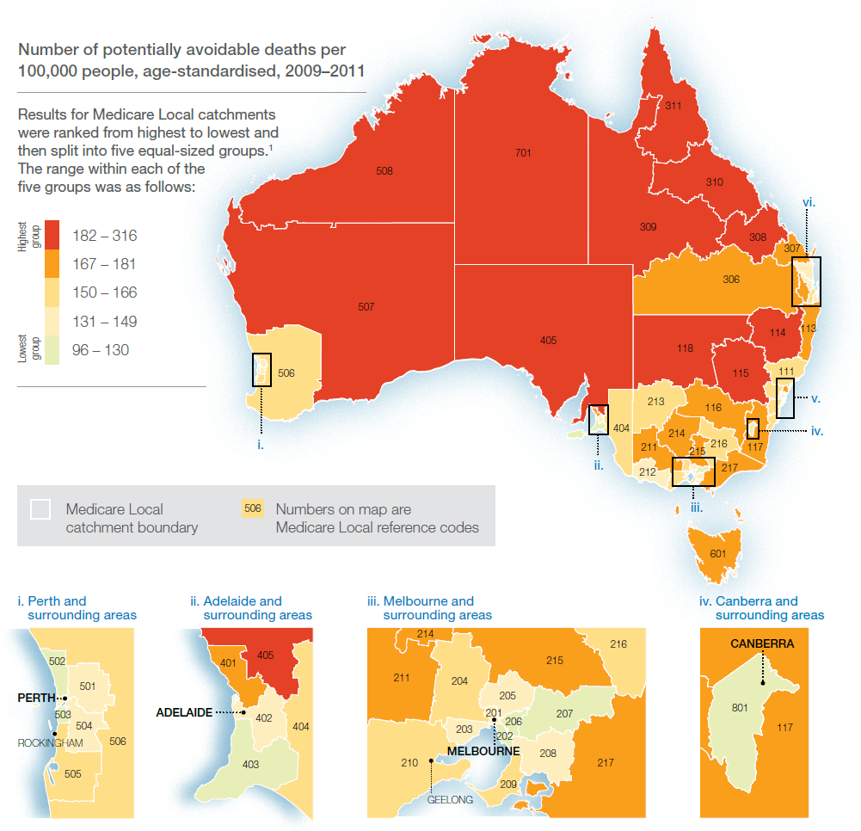

### Other factors to consider

Many factors influence peoples’ risk of mortality, including age, socioeconomic status, lifestyle risk factors, chronic conditions, ability to afford care and remoteness from services. Some of the geographic variation in potentially avoidable deaths may reflect differences in these factors between populations. Although some of these factors reflect relevant aspects of the healthcare system, their influence makes it difficult to identify the contributions of specific changes in practice (such as new effective treatments) or policy (such as introduction of new models of care).

Almost all reporting of potentially avoidable deaths presents age-standardised rates or PYLL, which takes into account the fact that some areas have an older population with a greater risk of mortality. However, the impacts of other population characteristics, such as variations in socioeconomic status, are usually not accounted for.

Some reports partially account for this issue by presenting potentially avoidable deaths by geographic areas classified into ‘peer groups‘, stratified to allow fairer comparisons between similar areas, such as those of equivalent socioeconomic status or remoteness from services centres. An example of such reporting is provided in Appendix 2.

A review is warranted if the potentially avoidable deaths mortality rate in an area is found to be high. This may be in comparison to all other areas being reported, a benchmark or expected value, or other comparable areas with similar characteristics. Review of areas with low rates of potentially avoidable deaths may help to identify successful intervention strategies, or possibly unexpected data issues.

|  |
| --- |
| **Box 3: Comparison between geographic regions** |
| * Comparisons of population-based mortality rates or person years of life lost between geographic regions are used to identify areas with relative high mortality due to potentially avoidable deaths. * Some of the geographic variation in mortality is likely to reflect differences in the characteristics of the population, such as socioeconomic status. * Where available, comparison between regions with similar socioeconomic and remoteness characteristics can help to identify if mortality from potentially avoidable deaths is higher than would be expected. * Areas with a high rate of potentially avoidable deaths warrant further review. |

## 3.2 Breakdowns by cause of death and population subgroups

To help inform interventions to reduce potentially avoidable deaths, more detailed information by cause of death and/or population subgroups is often provided. This may be for the country or state or territory as a whole, or separately for each geographic region. Some reports group several years of data together to increase the stability of rates when reporting for small geographic regions or population subgroups.

It is common for rates of potentially avoidable deaths to be presented by the causes of death, either by groups of conditions (e.g. treatable, preventable) or by specific types of conditions (e.g. diabetes, cancer, transport accidents). An example of such reporting is presented in Appendix 3. However, the large number of causes of deaths included in the indicator, and the small number of deaths which occur for some of these causes, may limit the extent of this reporting.

Deaths may also be broken down according to age groups and Indigenous status. Indigenous people in Australia have historically poorer health than other Australians, including higher rates of potentially avoidable deaths. The National Healthcare Agreement recommends that rates of potentially avoidable deaths in Australia should be reported by Indigenous status,1 and disparities between Indigenous and non-Indigenous Australians are reported as part of the Aboriginal and Torres Strait Islander Health Performance Framework.24 However, variation in the quality of data on Indigenous identification restricts reporting across states. The small number of deaths which occur within smaller geographic areas, as well as some demographic groups (such as Indigenous people), often mean several years of data (e.g. five years) are combined so the rates are more statistically reliable. An example of reporting by Indigenous status is presented in Appendix 3.

Breakdowns of potentially avoidable deaths can convey different types of information. Looking at how the deaths are distributed can help identify where the greatest burden of preventable mortality lies in a population, and what targeted priority areas should be.

Comparing the profile of potentially avoidable deaths in one region to other similar regions, or to a state or national average, can help identify if the profile is different to what might be expected. For example, if a region has a particularly high mortality rate for one cause when compared to the Australian total, this may indicate a potential problem area which needs to be addressed even if it comprises a relatively small proportion of the total number of deaths. Conversely, if a region has a particularly low relative mortality rate for one cause, this might reflect the implementation of a successful policy within the region.

Population subgroups or causes of death that have the highest rates of potentially avoidable deaths should be the focus for targeted policies. A review may be warranted if a cause of death or population subgroup has a relatively higher rate than expected.

|  |
| --- |
| **Box 4: Breakdown by cause of death and population subgroups** |
| * Breakdowns of potentially avoidable deaths by cause of death or population subgroup can help to identify priorities for targeted policy interventions. * Potentially avoidable deaths are sometimes presented by cause of death, as well as by age and Indigenous status. * Causes of death with the highest mortality indicate priority areas to target improvement. * Causes of death with a higher than expected mortality rate may indicate potential areas for review. |

## 3.3 Trends in potentially avoidable deaths

Trends in potentially avoidable deaths, usually presented as age-standardised population-based mortality rates by year, can be used to monitor changes to evaluate the impact of policies or identify emerging problems. Trends can be presented as an overall figure over time, or broken down by area, type of condition or Indigenous status of the population. An example of reporting of time trends is presented in Appendix 4.

An increasing trend in potentially avoidable deaths may indicate that mortality rates are increasing and is an issue requiring further investigation. A decreasing trend may indicate that mortality is decreasing, which may be the result of changes in the effective management of health conditions, changes in the way services have been provided or a decrease in disease incidence.

When looking at trends, care should be taken not to over-interpret small changes. Fluctuations can emerge as a result of even a small number of events, particularly in small populations where even a single death can heavily influence the population-based rate. These fluctuations mean that changes in rates will not always move in a direct manner, such as in a straight line, and more attention should be paid to longer-term trends over several years than small differences between two years. Some reports group several years of data together to increase the stability of rates when reporting for small geographic regions or population subgroups.

### Limitations

Changes in potentially avoidable deaths over time may reflect factors other than changes in the provision of health care. These factors may include technical issues, such as changes in data quality of Indigenous identification, which can influence trends and disparities in causes of death between Indigenous and non-Indigenous Australians.25 These factors may also include changes in disease incidence - which would lead to a change in corresponding deaths for that condition without any potential change in the quality of treatment or care provided for those with disease.

The strongest limitation when interpreting time trends in potentially avoidable deaths is changes in the causes of death included in the indicator. While the indicator is reviewed and updated by health policymakers to help minimise potential data quality issues and keep it relevant to the current health care system, the development of new treatments, intervention and screening could mean that an avoidable cause of death today may not have been avoidable in the recent past. Therefore, comparing trends over time using a current definition may be incorrectly counting some deaths in the past as ‘avoidable’. Conversely, comparing trends using changing definitions over time can be misleading if there are considerable changes to the number and scope of causes of death which are included in the indicator.

These issues are monitored by health policymakers, and the indicator is reviewed and revised to help minimise their impact. However, some changes may not be able to be fully accounted for. Care should always be taken when viewing trends to look for these data limitations, interpret the data with caution, and utilise local knowledge of what is happening within a particular local area to inform interpretation of the trends. In some cases the changes in data quality may be too great to allow for meaningful comparisons over time, and time trends may not be reported.

A review is warranted if there is an increasing trend in potentially avoidable deaths over time. Examination of decreasing trends may help identify where successful intervention strategies have been introduced.

|  |
| --- |
| **Box 5: Trends over time** |
| * Trends can be used to monitor changes in mortality from potentially avoidable deaths over time. * Interpretation of trends may be limited if there have been improvements in treatment over time, and thus the deaths that would be considered truly ‘avoidable’. * Trends may not be reported if there are concerns about poor data quality limiting comparability over time. * A review may be warranted if trends reveal an increase in rates of potentially preventable deaths over time. |

# 4. Further resources

The potentially avoidable deaths indicator comprises a range of conditions that may be preventable or treatable through different means within the health care system. As there is no single principle that characterises the mechanisms by which mortality for these causes can be avoided, policymakers need to utilise their experience and knowledge at the local level to better understand the priority areas and issues faced within their region.

Some international organisations are supplementing broad indicators of avoidable mortality with more detailed profiles of individual causes of death.20 Similar information is being reported in Australia for leading causes of premature mortality,26 as well as reports on disease prevalence and cancer survival, which, where available, can help to inform on trends, disparities, and possible interventions for these leading causes of death.

Further information on potentially avoidable deaths in Australia is available in the following reports.

* Australian Bureau of Statistics, 2016. Causes of Death. ABS Cat. No. 3303.0. Canberra, ABS. Available at <http://www.abs.gov.au/ausstats/abs@.nsf/Lookup/by%20Subject/3303.0~2014~Main%20Features~Potentially%20Avoidable%20Mortality%20~10043>
* Australian Institute of Health and Welfare, 2016. *PI 18-Selected potentially avoidable deaths*. Available at <http://meteor.aihw.gov.au/content/index.phtml/itemId/598750>
* Australian Institute of Health and Welfare, 2015. *Aboriginal and Torres Strait Islander Health Performance Framework 2014 report: detailed analyses*. Cat. no. 167. Canberra, AIHW.
* Australian Institute of Health and Welfare, 2015. *Premature mortality in Australia 1997–2012*. Available at: <http://www.aihw.gov.au/deaths/premature-mortality/>
* HealthStats NSW, 2016. *Potentially avoidable deaths*. Available at <http://www.healthstats.nsw.gov.au/Indicatorgroup/indicatorViewList?code=avo&topic=topic_avodth&name=Potentially%20avoidable%20deathsTopic>
* National Health Performance Authority, 2013, *Healthy Communities: Avoidable deaths and life expectancies in 2009-2011.*
* Public Health Information Development Unit, 2006. *Australian and New Zealand atlas of avoidable mortality*. The University of Adelaide
* SCRGSP (Steering Committee for the Review of Government Service Provision) 2016, *Report on Government Services 2016*, Productivity Commission, Canberra.

# 5. References

1. Australian Institute of Health and Welfare. National Healthcare Agreement: PI 16 – Potentially avoidable deaths, 2016. 2016. Available at: <http://meteor.aihw.gov.au/content/index.phtml/itemId/598750>. Accessed May 2016,
2. Council of Australian Governments (COAG). Intergovernmental Agreement (IGA) on Federal Financial Relations: Schedule F National Healthcare Agreement. 2008. Available at: <http://www.federalfinancialrelations.gov.au/content/national_agreements.aspx>. Accessed March 2013,
3. National Health Performance Authority. National health reform performance and accountability framework. 2015. Available at: <http://www.nhpa.gov.au/internet/nhpa/publishing.nsf/content/paf>. Accessed May 2016
4. Rutstein DD, Berenberg W, Chalmers TC, et al. Measuring the quality of medical care. A clinical method. N Engl J Med 1976;294:582-588
5. Charlton JRH, Silver R, Hartley RM, et al. Geographical Variation in Mortality from Conditions Amenable to Medical Intervention in England and Wales. The Lancet 1983;321:691-696
6. Mackenbach JP. The contribution of medical care to mortality decline: McKeown revisited. Journal of Clinical Epidemiology 1996;49:1207-1213
7. Tobias M, Jackson G. Avoidable mortality in New Zealand, 1981-97. Aust N Z J Public Health 2001;25:12-20
8. Poikolainen K. The Effect of Health Services on Mortality: Decline in Death Rates from Amenable and Non-Amenable Causes in Finland, 1969-81. The Lancet 1986;327:199-202
9. Westerling R. Indicators of "avoidable" mortality in health administrative areas in Sweden 1974-1985. Scandinavian Journal of Social Medicine 1993;21:176-187
10. Nolte E, Scholz R, Shkolnikov V, et al. The contribution of medical care to changing life expectancy in Germany and Poland. Soc Sci Med 2002;55:1905-1921
11. Simonato L, Ballard T, Bellini P, et al. Avoidable mortality in Europe 1955-1994: a plea for prevention. J Epidemiol Community Health 1998;52:624-630
12. AMIEHS. Avoidable mortality in the European Union: Towards better indicators for the effectiveness of health systems. Volume 1: Final report. 2011. Available at http://amiehs.lshtm.ac.uk. Accessed May 2016
13. Gay JJ, Paris V, Devaux M, et al. Mortality Amenable to Health Care in 31 OECD Countries: Estimates and Methodological Issues. OECD Health Working Papers, No 55, 2011
14. Holland WW. European Community atlas of 'avoidable death'. Oxford: Oxford University Press; 1988
15. Nolte E, McKee M. Does health care save lives? Avoidable mortality revisited. London: The Nuffield Trust; 2004
16. Page A, Tobias M, Glover J, et al. Australian and New Zealand atlas of avoidable mortality. Adelaide: PHIDU, University of Adelaide.; 2006
17. National Health Performance Authority. Healthy Communities: Avoidable deaths and life expectancies in 2009–2011. National Health Performance Authority; 2013
18. New Zealand Ministry of Health. Saving Lives: Amenable Mortality in New Zealand, 1996–2006. Wellington: New Zealand Ministry of Health; 2010
19. Canadian Instiutute for Health Information. Avoidable deaths. 2016. Available at: <http://indicatorlibrary.cihi.ca/pages/viewpage.action?pageId=1114195> Accessed May 2016
20. NHS England. CCG Outcomes Indicator Set 2015/16: Technical Guidance 2015
21. Office for National Statistics. Avoidable mortality in England and Wales, 2013. Office for National Statistics; 2015
22. Australian Bureau of Statistics. 3303.0 - Causes of death, Australia, 2013, Technical Note 1. 2015. Available at: <http://www.abs.gov.au/ausstats/abs@.nsf/Lookup/3303.0Technical+Note12013>. Accessed May 2016.
23. Australian Bureau of Statistics. 3303.0 - Causes of death, Australia, 2013, Suicides. 2015. Available at: <http://www.abs.gov.au/ausstats/abs@.nsf/Lookup/by%20Subject/3303.0~2013~Main%20Features~Suicides~10004> Accesses May 2016.
24. Australian Institute of Health and Welfare. Aboriginal and Torres Strait Islander health performance framework 2014 report: detailed analyses. Australian Institute of Health and Welfare; 2015
25. Australian Bureau of Statistics. 3303.0 - Causes of death, Australia, 2013, Deaths of Aboriginal and Torres Strait Islander persons. 2015. Available at: [http://www.abs.gov.au/ausstats/abs@.nsf/Lookup/by%20Subject/3303.0~2013~Main%20Features~Deaths%20of%20Aboriginal%20and%20Torres%20Strait%20Islander%20Persons~10005#](http://www.abs.gov.au/ausstats/abs@.nsf/Lookup/by%20Subject/3303.0~2013~Main%20Features~Deaths%20of%20Aboriginal%20and%20Torres%20Strait%20Islander%20Persons~10005) Accessed May 2016.
26. Australian Institute of Health and Welfare. Premature mortality in Australia 1997–2012. 2015. Available at: <http://www.aihw.gov.au/deaths/premature-mortality/>. Accessed May 2016.

# Appendices

## Appendix 1: Conditions in the potentially avoidable deaths indicator

Causes of death included in the potentially avoidable deaths health performance indicator, as per the specifications for the National Healthcare Agreement in 2016,1 are listed below.

|  |  |
| --- | --- |
| **Infections**   * Selected invasive infections * Viral pneumonia and influenza * HIV/AIDS   **Cancer**   * Colorectal * Skin * Breast * Acute lymphoid leukaemia/Acute lymphoblastic leukaemia (limit to 0-44 years) * Prostrate * Kidney * Thyroid * Hodgkin's disease * Cervix   **Diabetes**  **Diseases of the circulatory system**   * Rheumatic and other valvular heart disease * Hypertensive heart and renal disease * Pulmonary embolism * Ischaemic heart disease * Cerebrovascular diseases * Heart failure   **Diseases of the genitourinary system**   * Renal failure   **Diseases of the respiratory system**   * COPD * Asthma   **Diseases of the digestive system:**   * Peptic ulcer disease   **Maternal & infant causes**   * Complications of the perinatal period   **Other conditions**   * Complications of pregnancy, labour or the puerperium | **Selected external causes of morbidity and mortality**   * Falls * Fires and burns * Suicide and self-inflicted injuries * Misadventures to patients during surgical and medical care * Medical devices associated with adverse incidents in diagnostic and therapeutic use * Surgical and other medical procedures as the cause of abnormal reaction of the patient, or of later complication, without mention of misadventure at the time of the procedure   **Other external causes of morbidity and mortality**   * Transport accidents * Exposure to inanimate mechanical forces * Exposure to animate mechanical forces * Accidental drowning and submersion * Other accidental threats to breathing * Exposure to electric current, radiation and extreme ambient air temperature and pressure * Contact with heat and hot substances * Contact with venomous animals and plants * Exposure to forces of nature * Accidental poisoning by and exposure to noxious substance * Overexertion, travel and privation * Accidental exposure to other and unspecified factors * Assault * Event of undetermined intent * Legal interventions and operations of war * Drugs, medicaments and biological substances causing adverse effects in therapeutic use * Sequelae of external causes of morbidity and mortality |

## Appendix 2: Example of comparisons between geographic regions using peer grouping to make fairer comparisons

Figure A2.1: Potentially avoidable deaths, treatable and preventable, age-standardised, by Medicare Local catchment, 2009-2011. *Source: National Health Performance Authority 2013, Healthy Communities: Avoidable deaths and life expectancies in 2009-2011, page 7*

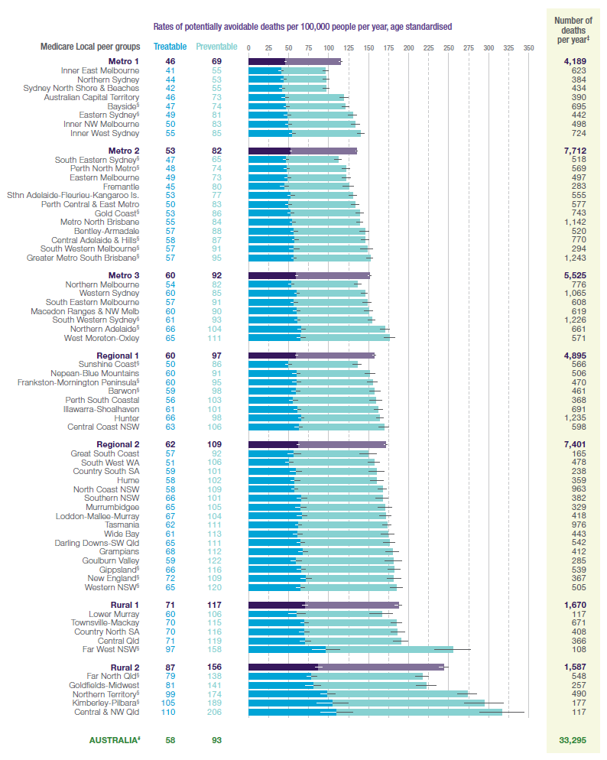

## Appendix 3: Examples of breakdown of potentially avoidable deaths by conditions - sex, age and Indigenous status

Figure A3.1: Average number of potentially treatable and preventable deaths per year by cause and sex in Australia, 2009-2011. *Source: National Health Performance Authority 2013, Healthy Communities: Avoidable deaths and life expectancies in 2009-2011, page 4*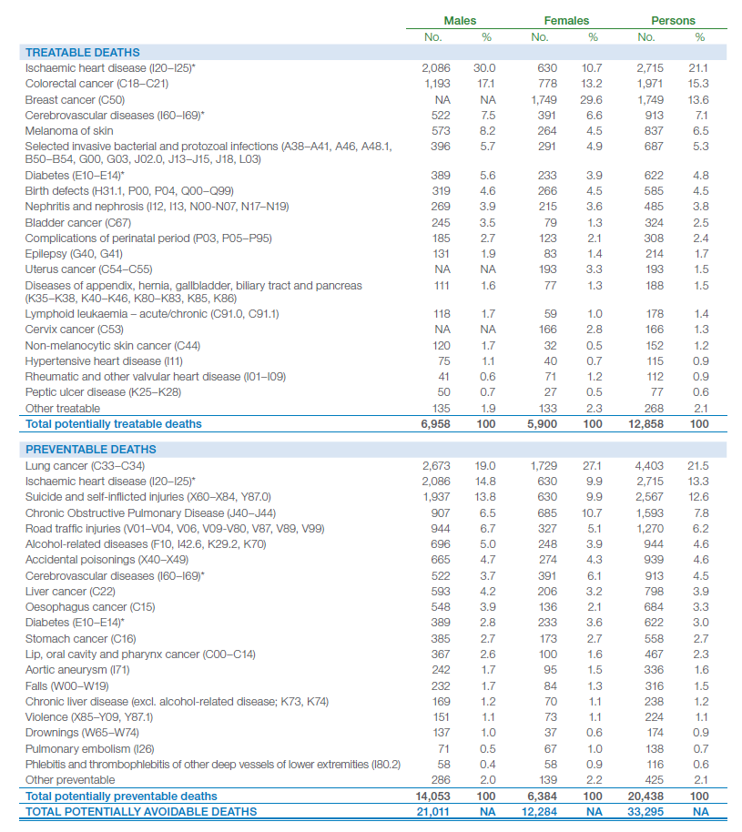

Figure A3.2: Potentially avoidable deaths, persons aged under 75 years: 2012-2013, NSW. *Source: Centre for Epidemiology and Evidence. HealthStats NSW. Sydney: NSW Ministry of Health. Available at: www.healthstats.nsw.gov.au. Accessed 24/05/2016*Chart showing rates of PADs by age group up to 75 years.LL/UL 95%CI = lower and upper limits of the 95% confidence interval for the point estimates are displayed

Figure A3.3: Age-standardised mortality rates, rate ratios and rate differences for avoidable causes of death, Indigenous and non-Indigenous Australians aged 0-74, NSW, Qld, WA, SA and NT, 1998-2012. *Source: Australian Institute of Health and Welfare 2015. Aboriginal and Torres Strait Islander Health Performance Framework 2014 report: detailed analyses. Cat. No. IHW 167. Page 966*

Charts showing PAD by indigenous status.


## Appendix 4: Examples of time trends

A4.1: Potentially avoidable deaths, persons aged under 75 years: Comparison by LHD, NSW 2001-2002 to 2012-2013. *Source: Centre for Epidemiology and Evidence. HealthStats NSW. Sydney: NSW Ministry of Health. Available at: www.healthstats.nsw.gov.au. Accessed 24/05/2016*

**Chart of PADs - time trend by Local Health District.**

**Australian Commission on Safety and Quality in Health Care**

Level 5, 255 Elizabeth Street, Sydney NSW 2001

GPO Box 5480, Sydney NSW 2001

Phone: (02) 9126 3600

Fax: (02) 9126 3613

Email: mail@safetyandquality.gov.au

Website: www.safetyandquality.gov.au

