Australian Commission on Safety and Quality in Health Care logo 




**November 2018**

**Australian Passive Antimicrobial Resistance Surveillance**

**First report: multi-resistant organisms**

Published by the Australian Commission on Safety and Quality in Health Care

Level 5, 255 Elizabeth Street

Sydney NSW 2000

Phone: (02) 9126 3600

Fax: (02) 9126 3613

Email: [aura@safetyandquality.gov.au](mailto:aura@safetyandquality.gov.au)

Website: [www.safetyandquality.gov.au](http://www.safetyandquality.gov.au)

ISBN: 978-1-925665-47-5

© Australian Commission on Safety and Quality in Health Care 2018

All material and work produced by the Australian Commission on Safety and Quality in Health Care (the Commission) is protected by copyright. The Commission reserves the right to set out the terms and conditions for the use of such material.

As far as practicable, material for which the copyright is owned by a third party will be clearly labelled. The Commission has made all reasonable efforts to ensure that this material has been reproduced in this publication with the full consent of the copyright owners.

With the exception of any material protected by a trademark, any content provided by third parties and where otherwise noted, all material presented in this publication is licensed under a [Creative Commons Attribution–NonCommercial–NoDerivatives 4.0 International licence](http://creativecommons.org/licenses/by-nc-nd/4.0/).

Creative Commons Licence

Enquiries about the licence and any use of this publication are welcome and can be sent to [communications@safetyandquality.gov.au](mailto:communications@safetyandquality.gov.au).

The Commission’s preference is that you attribute this publication (and any material sourced from it) using the following citation:

Australian Commission on Safety and Quality in Health Care. Australian Passive Antimicrobial Resistance Surveillance. First report: multi-resistant organisms. Sydney: ACSQHC; 2018

**Disclaimer**

The content of this document is published in good faith by the Commission for information purposes. The document is not intended to provide guidance on particular healthcare choices. You should contact your health care provider for information or advice on particular healthcare choices.

The Commission does not accept any legal liability for any injury, loss or damage incurred by the use of, or reliance on, this document.

Contents

Summary 1

Key findings of APAS data from 2006 to 2017: 1

Implications 2

1 Introduction 4

2 Methods and considerations for interpreting the data 5

2.1 Data Extraction 5

2.2 Pathology services 5

2.3 Representativeness 5

2.4 Isolates and specimen types 6

2.5 Setting 6

2.6 Remoteness 6

2.7 Antimicrobials 6

2.8 The OrgTRx system and the development of APAS 6

2.9 Data characteristics 7

3 Methicillin resistance in *Staphylococcus aureus* 8

3.1 Methicillin resistance in *Staphylococcus aureus* by specimen type 8

3.2 Methicillin resistance in *Staphylococcus aureus* by Remoteness Area 9

3.3 Methicillin resistance in *Staphylococcus aureus* by setting 11

4 Fluoroquinolone non-susceptibility in *Escherichia coli* 13

4.1 Fluoroquinolone non-susceptibility in *Escherichia coli* by specimen type 13

4.2 Fluoroquinolone non-susceptibility in *Escherichia coli* by Remoteness Area 15

4.3 Fluoroquinolone non-susceptibility in *Escherichia coli* by setting 17

5 Vancomycin non-susceptibility in *Enterococcus faecium* 19

5.1 Vancomycin non-susceptibility in *Enterococcus faecium* by specimen type 19

5.2 Vancomycin non-susceptibility in *Enterococcus faecium* by Remoteness Area 21

5.3 Vancomycin non-susceptibility in *Enterococcus faecium* by setting 23

6 Discussion 25

Appendices 28

A1. Pathology services that contribute to APAS 28

A2. Representativeness 29

A3. Isolates and specimen types 30

A4. Setting 31

A5. Remoteness 32

7 References 34

## Summary

The Antimicrobial Use and Resistance in Australia (AURA) Surveillance System, coordinated by the Australian Commission on Safety and Quality in Health Care (the Commission), provides essential information to develop and implement strategies to prevent and contain antimicrobial resistance (AMR) in human health and improve antimicrobial use across the acute and community healthcare settings. AURA also supports the National Safety and Quality Health Service (NSQHS) Standard Preventing and Controlling Healthcare-Associated Infection[1] and Australia’s National Antimicrobial Resistance Strategy (2015–2019).[2] Funding for AURA is provided by the Australian Government Department of Health and state and territory health departments.

Australian Passive AMR Surveillance (APAS) is a key component of the AURA Surveillance System. APAS is providing an increasingly comprehensive picture of AMR in Australia. APAS was established by the Commission in 2015 with the support of Queensland Health, which enabled access to the OrgTRx system, as the information technology infrastructure. APAS collects, analyses and reports on de-identified patient level AMR data contributed by public and private pathology services across Australia. These laboratories report AMR detected in isolates referred from public and private hospitals, aged care homes and community settings. At present, there is variable geographic representation in APAS, as not all states and territories have laboratories that contribute data. The Commission continues to work with public and private laboratories to increase participation in APAS.

Initially, data were captured from January 2015 from all contributing laboratories; historical data have now been incorporated from four of those laboratories. The APAS system includes over 50 million AMR records from 2006 to 2018 enabling trend analysis and examination of patterns of AMR across Australia.

This report includes analyses of APAS data for three types of important resistances in Australia:

* Methicillin resistance in *Staphylococcus aureus* (MRSA)
* Fluoroquinolone non-susceptibility[3] in *Escherichia coli*
* Vancomycin non-susceptibility in *Enterococcus faecium*.

These resistances were selected because trend analyses showed that rates are increasing in health and aged care settings, and there are opportunities for intervention.

### Key findings of APAS data from 2006 to 2017:

* Methicillin-resistance in *S. aureus* was stable at around 20% in New South Wales, Queensland and South Australia for a decade (2006 to 2015); there is evidence that rates are slowly increasing nationally over the last three years (from 21.6% in 2015 to 22.5% in 2017)
* Methicillin-resistance in *S. aureus* is higher and worsening in remote and very remote areas of Australia (40.6% and 40.2%, respectively, in 2017), reflecting the growing problem of MRSA in some communities
* Methicillin-resistance in *S. aureus* is also higher and worsening in aged care homes (increasing from 25.1% in 2006 to 36.2% in 2014 from long term APAS contributor data; and was 32.1% in 2017 for all contributing laboratories)
* The proportion of MRSA has been stable at around 22% in hospitals for both cohorts of contributors
* Methicillin-resistance in *S. aureus* in the community has risen from 8.5% in 2006 to 14.6% in 2014, and 19.1% in 2017
* Despite significant restriction of fluoroquinolones in hospitals and the community, the proportion of non-susceptibility to fluoroquinolones in *E. coli* has risen from 2% in 2006 to 11.8% in 2017; the trend is most apparent in major cities and the proportion has risen in all regions of Australia
* In 2017 the proportion of fluoroquinolone non-susceptibility in *E. coli* were highest in aged care homes (18.1%), followed by hospitals (12.1%), and the community (10.2%)
* Vancomycin non-susceptible *E. faecium* strains are now very common across Australia, exceeding 40% of all *E. faecium* for all specimen types since 2010
* Vancomycin non-susceptible *E. faecium* are principally seen in hospitals in urban settings; there is evidence that rates are decreasing nationally over the last three years, from 51% in 2015 to 42% in 2017.

### Implications

##### Aged care homes

The findings are consistent with international and national studies that have shown a significant burden of infection and colonisation with resistant organisms among people living in residential aged care and high levels of unnecessary antimicrobial prescribing and inappropriate antimicrobial use. It is clear from these data that residential aged care homes are an important community setting for monitoring AMR because of their potential for enhancing amplification of AMR in Australia, as a result of the high frequency movement of residents between them and acute hospitals.

The Commission will work with the Australian Government Department of Health to continue to promote implementation of effective antimicrobial stewardship and infection prevention and control programs in aged care homes.

##### MRSA in rural and remote areas

MRSA is disproportionate to the population in rural and remote areas of Australia. The current healthcare impact in these populations and the possibility of expansion of this resistance in other Australian settings is a focus area for containment programs and surveillance. The interpretation of the data from this report, and locally available data, will be undertaken in conjunction with state and territory health departments.

##### Increasing non-susceptibility to fluoroquinolones in *E. coli,* vancomycin non-susceptibility in *E. faecium* and community-onset MRSA infections

##### The findings regarding increasing non-susceptibility to fluoroquinolones in *E. coli*, vancomycin non-susceptibility in *E. faecium* and community-onset MRSA infections require the revision of treatment guidelines, such as empirical treatment decisions for severe infections. The Commission has provided advice to Therapeutic Guidelines and the expert groups that develop guidelines for treatment of bacterial infections to ensure inclusion of these data in the development of guidelines, where relevant.

##### The use of APAS data for quality improvement

The clear epidemiological differences between organisms shown in this report highlight the importance of a cross-sectoral approach to address factors that affect the containment of resistance. The use of APAS data supports clinical decisions about antimicrobial therapy and antimicrobial stewardship programs, improvements to infection prevention and control, and in the care of patients infected with, or colonised by, resistant organisms.

The AURA National Coordination Unit will continue to identify strategic priorities for surveillance of antimicrobial resistance and analyses of these data through its collaboration with state and territory health departments and private pathology services from across Australia to enhance APAS, and to disseminate reports to inform strategies to prevent and contain AMR. Increasing the population coverage of APAS will provide data for the AURA Surveillance System on the emergence of, and trends in, antimicrobial resistance in the human health setting.

##### Data considerations

Work to increase participation and enhance geographic representativeness and population coverage of the APAS data will actively continue. Although APAS is not completely geographically representative, the analyses presented in this report provide important insights into trends in AMR in Australia that have not previously been possible.

## 1 Introduction

The Antimicrobial Use and Resistance in Australia (AURA) Surveillance System, which is coordinated by the Australian Commission on Safety and Quality in Health Care (the Commission), provides a national platform to inform the development of strategies to prevent and contain antimicrobial resistance (AMR) in human health and improve antimicrobial use across the acute and community healthcare settings. AURA also supports the National Safety and Quality Health Service (NSQHS) Standard Preventing and Controlling Healthcare-Associated Infection1 and Australia’s first National Antimicrobial Resistance Strategy (2015–2019).2 Funding for AURA is provided by the Australian Government Department of Health and state and territory health departments.

AMR data included in the AURA Surveillance System are collected by passive and targeted programs, including Australian Passive AMR Surveillance (APAS), the Australian Group on Antimicrobial Resistance (AGAR), the National Neisseria Network (*Neisseria gonorrhoeae* and *N. meningitides*), the National Notifiable Diseases Surveillance System (*Mycobacterium tuberculosis*), Sullivan Nicolaides Pathology, and the National Alert System for Critical Antimicrobial Resistances (CARAlert).

APAS was established by the Commission in 2015 with the support of Queensland Health, which enabled access to the OrgTRx system as the information technology infrastructure. APAS collects, analyses and reports on de-identified patient level AMR data contributed by 10 public and private pathology services across Australia. These laboratories detect AMR in isolates referred from public and private hospitals, aged care homes and community settings. Initially, data were captured from January 2015 from all contributing laboratories; historical data have now been incorporated from four of those laboratories. The APAS system includes over 50 million AMR records from 2006 to 2018.

The data captured by APAS enable reporting on AMR in the form of:

* Longitudinal datasets for specified organism-antimicrobial combinations
* Cumulative antibiograms showing rates of resistance for a range of organisms from a specified specimen type within a time period
* Tabulations showing the resistance profiles of organism strains isolated during a time period
* Reporting for individual units within hospitals or health services, or at a statewide level.

Comprehensive antibiogram and resistant organism reporting from the current APAS contributors has been implemented at the local level, as has national reporting by the Commission through AURA 2016[4] and AURA 2017[5].

For this first report on APAS data, the Commission has selected three types of highly important resistances to analyse and report:

1. Methicillin resistance in *Staphylococcus aureus*
2. Fluoroquinolone non-susceptibility in *Escherichia coli*
3. Vancomycin non-susceptibility in *Enterococcus faecium*.

These resistances were selected for this initial APAS report because trend analyses showed that rates are increasing in health and aged care settings, and there are opportunities for intervention, either through antimicrobial stewardship programs, antimicrobial prescribing guidelines or infection prevention and control programs to improve the safety of care provided to patients.

Future reports will include analyses of trends for other resistances captured through APAS.

## 2 Methods and considerations for interpreting the data

### 2.1 Data Extraction

Data were extracted from APAS on 14 February 2018; detailed information on the attributes of the data extracted is available in the appendices.

### 2.2 Pathology services

At the time of data extraction for this report, 10 large pathology services were contributing data to APAS:

* ACT Pathology (all public and some private Australian Capital Territory health services)
* Pathology Queensland (all Queensland Health public services)
* Mater Pathology Brisbane (Queensland public and private patients)
* SA Pathology (public health catchments for South Australia)
* NSW Health Pathology laboratories that provide services to Sydney, South Western Sydney, South Eastern Sydney, Illawarra Shoalhaven, Hunter New England, Mid North Coast and Northern NSW Local Health Districts (LHDs) and the Sydney Children’s Hospital Network (Randwick).
* The Royal Hobart Hospital (Tasmania)
* Monash Health Service (Victoria)
* PathWest Laboratory Medicine (Western Australia).

Historical data from 2006 were available from four of these pathology services: the former Sydney South West Pathology Service that provides services to Sydney and the South Western Sydney LHDs; Mater Pathology Brisbane; Pathology Queensland and SA Pathology (Table A1).

It is important to note that, for historical data in particular, there may have been changes since 2006 in the number of facilities from which the pathology services have received isolates, and numbers are likely to have varied from year to year. In addition, a number of public laboratories have been reconfigured or renamed during the period to which the analyses relate; these changes are not addressed in detail in this report.

Sullivan Nicolaides Pathology has been an important early contributor to national passive surveillance through the provision of reports on resistance in isolates referred by hospitals, aged care homes, community and general practices in Queensland and Northern NSW specifically for AURA 20163 and AURA 2017.4 Sullivan Nicolaides Pathology data are not incorporated in the analyses for this report, as it is specific to data submitted directly to APAS.

### 2.3 Representativeness

The distribution of the number of isolates for which data were available for all contributors (2015–2017) by state and territory was compared with the distribution of the Australian population using Australian Bureau of Statistics (ABS) Australian Demographic Statistics.[6]

Jurisdictions with state-wide public pathology services (Queensland, South Australia, Western Australia and the Australian Capital Territory) are most representative. Queensland, in particular, is comprehensively covered due to the involvement of Mater Pathology Brisbane. Data from Victoria are limited as there is only one contributing site, and data are not available from the Northern Territory (Figure A1). NSW has, since APAS commenced, brought together all public laboratories as the statewide service NSW Health Pathology; the laboratory names used in this report reflect naming conventions during the period 2015–2017.

### 2.4 Isolates and specimen types

Data were only included where there were at least 30 isolates for each analyses. Analyses were conducted only when the proportion of isolates that were tested against a single antimicrobial was at least 75%. To minimise the impact of duplicate testing, and to avoid distortions created by testing of only selected, usually more resistant, isolates in some laboratories, only data from the first isolate, per specimen type, per patient, per year were used. Results from isolates detected in infection control and environmental sampling were excluded because they are not representative of isolates from clinical infections. Nine specimen types were defined for the purposes of analyses of APAS data (Table A2).

### 2.5 Setting

Where available, the settings from which the isolates were obtained were included in the analyses (Table A3). Currently, these include aged care, community, multi-purpose service, public hospital, and private hospital as assigned by the pathology service that contributed the data for the specimen. It is important to note that, for historical data in particular, there may have been changes since 2006 in the range and acuity of services offered in some settings, particularly those currently categorised as multi-purpose services. Information about each of these changes is not routinely available.

### 2.6 Remoteness

The healthcare facilities (including general practices) from where the isolates were detected were stratified in terms of remoteness using the ABS Australian Statistical Geography Standard (ASGS).[7]

The Remoteness Areas Structure within the ASGS divides Australia into five categories of remoteness on the basis of a measure of relative access to services.

The five Remoteness Areas for Australia are major cities, inner regional, outer regional, remote and very remote. Table A4 shows the number of facilities served by each contributor to APAS by Remoteness Area. Table A5 shows the number of facilities in each setting from which isolates were obtained by Remoteness Area.

### 2.7 Antimicrobials

Some antimicrobials are subject to different reporting practices across contributing laboratories. For example, some laboratories use cefoxitin or oxacillin to test for methicillin resistance. These differences have been dealt with at the time of data extraction. For others, the agent reported in some laboratories may differ slightly from that tested (for example, ampicillin tested, but the result is reported against amoxicillin); data on both types of reporting practices have been merged for the analyses.

### 2.8 The OrgTRx system and the development of APAS

OrgTRx is a comprehensive pathology system that has been effectively operated by Queensland Health since 2006. OrgTRx conforms to guidelines promulgated in other countries, particularly those of the Clinical and Laboratory Standards Institute in the United States, for recording and analyses of antimicrobial susceptibility test data, including cumulative and ongoing summaries of susceptibility patterns of clinically significant microorganisms.

The OrgTRx system enables collection of susceptibility data directly from laboratory information systems and uses data cube functionality for the preparation of a range of standard regular reports and cumulative antibiograms at the local level. The data and antibiograms support antimicrobial stewardship (AMS) teams, in those hospitals that the laboratory serves, to perform ad-hoc queries and investigate resistance trends. All participating APAS laboratories have access to the data cube and the capacity to generate routine reports at a local level to inform local AMR strategies.

There have been two phases of the development of APAS. The first phase in 2015 was a successful pilot to test the feasibility of the use of OrgTRx outside Queensland. Subsequently, pathology services have been progressively incorporated into APAS between 2015 and early 2017; data from all 10 contributing services have been captured since January 2015. The Commission’s strategy was to work with all states and territories to promote national coverage. This included discussions with the private pathology sector, and the successful inclusion in APAS of Mater Pathology Brisbane.

For the second phase, which commenced in May 2017, the Commission increased the breadth and depth of the APAS data by integrating historical data from 1 January 2006 to 31 December 2014 from four of the participating pathology services. The Commission will continue to work with public and private laboratories to increase participation and enhance state, territory and geographic representation.

### 2.9 Data characteristics

Passive AMR surveillance involves the extraction of routine susceptibility testing results from laboratory information systems. Passive AMR surveillance differs in a number of ways from the targeted AMR surveillance conducted by AGAR for the AURA Surveillance System. These differences include:

* The range of agents tested against any given isolate tends to be smaller than with targeted AGAR surveillance
* Although there is some commonality between services, each contributor tests and reports different antimicrobials according to their local practice
* Three different susceptibility testing systems are used in clinical microbiology across Australia, and test results (categorical interpretations) are not always comparable between systems. The AURA Surveillance System acknowledges the differences that occur in the interpretation of results obtained by each method, and is working with stakeholders to promote alignment with a single method in Australia.
* The results of duplicate testing are included in the data collected. Duplicate testing means that the same bacterial strain is tested and reported from repeated specimens and similar specimens from a single infection episode. This is appropriate clinical laboratory practice from a patient management perspective. The impact of these duplicates is minimised for analyses of APAS data by using algorithms based on resistance patterns and selected time periods for which duplicates are not counted. Only the first isolate for the first specimen per specimen type per year is included in the dataset for analyses. A repeat isolate from the same specimen type is not included.
* Only categorical data are available through APAS, namely the reporting categories of ‘susceptible’, ‘intermediate’ and ‘resistant’; these categories are defined by interpretive criteria for resistance testing that are commonly called breakpoints.

## 3 Methicillin resistance in *Staphylococcus aureus*

*S. aureus* is a common human pathogen that causes a wide range of infections, including minor infections such as boils, impetigo and wound infections; moderate infections such as cellulitis; and serious infections such as bone and joint infections, pneumonia, endocarditis and septicaemia. Resistance to methicillin confers resistance to all β-lactam antimicrobials in community practice and almost all in hospital practice.

There was an increasing number of *S. aureus* isolates reported by the four long-term APAS contributors from 2006 to 2011. The number of isolates reported has since declined slightly. In addition to a growing incidence of methicillin-resistant *S. aureus* (MRSA) infections, the rising numbers of *S. aureus* isolates reported to 2011 could either reflect extensions of the patient bases served by the contributors, changes in infection sampling practices, or both.

### 3.1 Methicillin resistance in *Staphylococcus aureus* by specimen type

Figure 1 shows the trends in methicillin resistance by specimen type reported by the four long-term APAS contributors. Between 2006 and 2014, 447,819 specimens reported by these services contained *S. aureus*; 3.4% were blood cultures, 3.0% were urine specimens, and 93.6% were from other specimen types such as pus, respiratory, genital and enteric.

Whilst the overall prevalence of MRSA has not changed substantially since 2006, there are upward trends in prevalence in outer regional, remote and very remote areas.

Figure 1: Percentage of methicillin-resistant *Staphylococcus aureus* by specimen type and total number of *S. aureus*, long-term APAS contributors, 2006–2014*

* The four pathology services are: Mater Pathology Brisbane, Pathology Queensland, SA Pathology, former Sydney South West Pathology Service

Data were available from all APAS contributors for the period 2015–2017, where 314,026 specimens were examined (Figure 2). A small but significant increase in the proportions that were methicillin-resistant was observed, from 21.6% in 2015 to 22.5% in 2017 across all specimen types (χ2 for trend = 19.72, *P* < 0.0001).

Figure 2: Percentage of methicillin-resistant *Staphylococcus aureus* by specimen type, APAS contributors, 2015–2017*

* All 10 pathology service contributors to APAS (see Table A1)

### 3.2 Methicillin resistance in *Staphylococcus aureus* by Remoteness Area

For the four long-term APAS contributors, the bulk of isolates of *S. aureus* came from major cities (67.2%). Similar trends were observed in the complete data set from 2015–2017 (Figure 3), among the isolates for which Remoteness Area was known (93.4% of isolates).

Figure 3: Proportion of *Staphylococcus aureus* by Remoteness Area, APAS contributors, 2006-2014 (A)*, 2015-2017(B)†

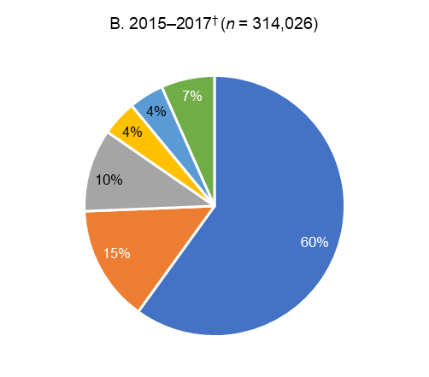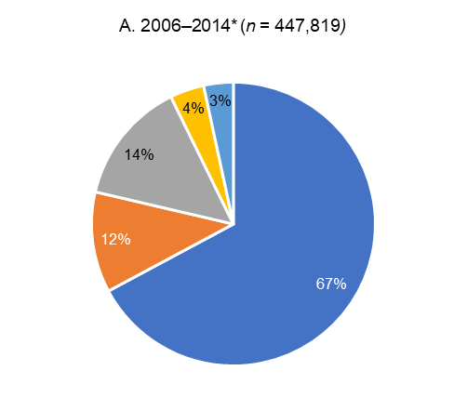

* The four pathology services were: Mater Pathology Brisbane, Pathology Queensland, SA Pathology, former Sydney South West Pathology Service

† All 10 pathology services contributors to APAS (see Table A1)

There was a major upward trend in the proportion of methicillin resistance in *S. aureus* in isolates from remote and very remote areas of Australia between 2006 and 2014 (Figure 4). Analyses of APAS data indicate that methicillin resistance is currently more prevalent in isolates from outer regional, remote and very remote areas of Australia than in the major cities and inner regions (Figure 5).

Figure 4: Percentage of methicillin-resistant *Staphylococcus aureus* by Remoteness Area and state, long-term APAS contributors, 2006–2014*

* The four pathology services were: Mater Pathology Brisbane, Pathology Queensland, SA Pathology, former Sydney South West Pathology Service

Figure 5: Percentage of methicillin-resistant *Staphylococcus aureus* by Remoteness Area, APAS contributors 2015–2017*

* All 10 pathology service contributors to APAS (see Table A1)

### 3.3 Methicillin resistance in *Staphylococcus aureus* by setting

Settings were categorised into aged care home, community, multi-purpose service, and hospitals (public and private). Other was used to categorise facilities such as correctional services. However, this was not consistently defined across states and territories. Of 447,819 *S. aureus* isolates from the four long-term APAS contributors, 99.5% were able to be classified by setting. Of these isolates, 77.6% were from hospitals (public and private). Similarly, 94.8% of 314,026 *S. aureus* isolates reported by all APAS contributors from 2015–2017 were able to be classified by setting; 80.2% were from hospitals (public and private) (Figure 6).

There were distinct upward trends in the proportion of methicillin-resistance in *S. aureus* isolates from the community and from aged care homes from 2006 to 2014 (Figure 7). Since 2015, the proportion of methicillin-resistance in *S. aureus* isolates in hospitals and aged care homes has remained steady, while the upward trend in methicillin-resistance in community isolates has continued (Figure 8).

Figure 6: Proportion of *Staphylococcus aureus* isolates by setting, APAS contributors 2006-2014 (A)*, 2015-2017(B)†

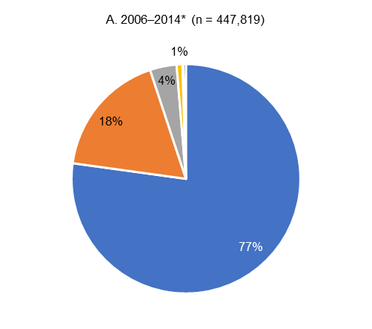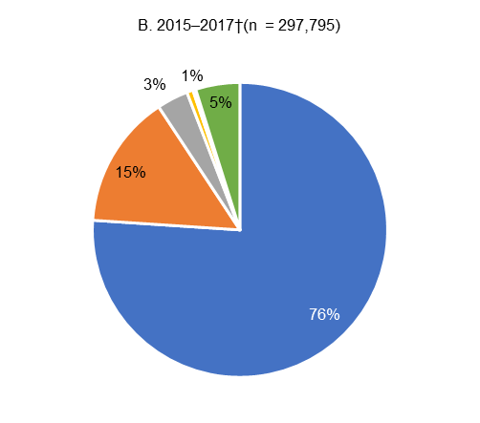

* The four pathology services were: Mater Pathology Brisbane, Pathology Queensland, SA Pathology, former Sydney South West Pathology Service

† All 10 pathology service contributors to APAS (see Table A1)

§ Other includes facilities that APAS contributors have categorised as correction services; the approach to use of this categorisation is not consistent across states and territories

**Figure 7: Percentage of methicillin resistant *Staphylococcus aureus* by setting and number of isolates, long-term APAS contributors, 2006–2014\***

* The four pathology services were: Mater Pathology Brisbane, Pathology Queensland, SA Pathology, former Sydney South West Pathology Service

Figure 8: Percentage of methicillin-resistant *Staphylococcus aureus* by setting, APAS contributors, 2015–2017*

* All 10 pathology service contributors to APAS (see Table A1)

† Other includes facilities that APAS contributors have categorised as correction services; the approach to use of this categorisation is not consistent across states and territories

## 4 Fluoroquinolone non-susceptibility in *Escherichia coli*

*Escherichia coli* is a member of the Enterobacterales (previously Enterobacteriaceae) family. It is one of the most common and important species of Enterobacterales and it causes both community- and hospital-associated infections.

*E. coli* is associated with a range of infections, including urinary tract infections, biliary infections, other intra-abdominal infections (including those following surgery, and often mixed with other pathogens) and septicaemia. In particular, *E. coli* is the most common cause of urinary tract infection and septicaemia in the community and in otherwise healthy people. Less frequently, *E. coli* is a cause of bacteraemia from intravascular lines and meningitis. Until now, fluoroquinolones have been one of the mainstays of treatment for infections caused by strains resistant to other antimicrobial classes, especially because they can be administered orally.

There was an increasing number of *E. coli* isolates in the four long-term APAS contributors from 2006 to 2017. Since 2012, total numbers have been relatively consistent. The numbers could reflect extensions of the patient bases served by the contributors, changes in infection sampling practices, or both.

### 4.1 Fluoroquinolone non-susceptibility in *Escherichia coli* by specimen type

Prevalence of fluoroquinolone non-susceptibility was examined using available antimicrobial susceptibility test data for ciprofloxacin (non-urine specimens) and norfloxacin (urine specimens). Non-susceptibility includes the reported categories of ‘intermediate’ and ‘resistant’.

Figure 9 shows the trends in fluoroquinolone non-susceptibility by specimen type in the four long-term APAS contributors. Between 2006 and 2014, 501,607 specimens from those services contained *E. coli*; 89.9% of which were from urine specimens, 4.6% from blood cultures and 5.5% were from other specimen types. The prevalence of fluoroquinolone non-susceptibility has increased across all specimen types since 2006.

Similar trends over the shorter period of 2015–2017 were observed when the data from all APAS contributors were examined (Figure 10). Data were available for 276,302 specimens for this period.

Figure 9: Percentage of fluoroquinolone non-susceptibility *Escherichia coli* by specimen type and total number of *E. coli,* long-term APAS contributors, 2006–2014*

* The four pathology services were: Mater Pathology Brisbane, Pathology Queensland, SA Pathology, former Sydney South West Pathology Service

Figure10*:* Trends in fluoroquinolone non-susceptibility in *Escherichia coli* by specimen type, APAS contributors, 2015–2017*

* All 10 pathology service contributors to APAS (see Table A1)

### 4.2 Fluoroquinolone non-susceptibility in *Escherichia coli* by Remoteness Area

For the four long-term APAS contributors, 90% of the isolates of *E. coli* came from major cities (Figure 11). In the complete data set from 2015–2017, 71.2% were from major cities among the isolates for which Remoteness Area was known (93.1% of isolates).

Figure 11: Proportion of *Escherichia coli* by Remoteness Area, APAS contributors, 2006-2014 (A)*, 2015-2017(B)†

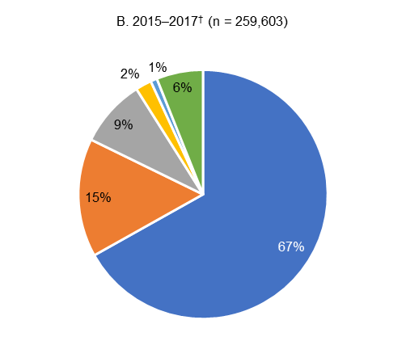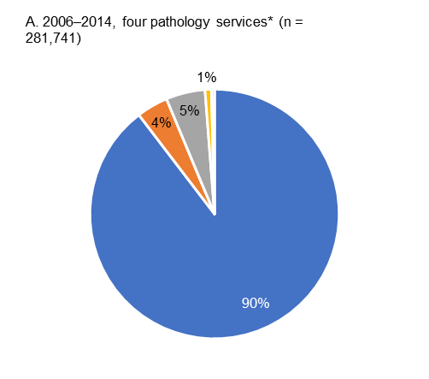

* The four pathology services were: Mater Pathology Brisbane, Pathology Queensland, SA Pathology, and former Sydney South West Pathology Service

† All 10 pathology service contributors to APAS (see Table A1)

There were upward trends in fluoroquinolone non-susceptible *E. coli* in isolates from the major cities of Australia (Figure 12 and Figure 13). When data from all APAS contributors were examined, substantial increases in fluoroquinolone non-susceptibility were observed in all Remoteness Areas for 2015–2017 (Figure 13). The proportion of non-susceptibility aligned reasonably well with the population distribution, although they were somewhat lower in outer regional, remote and very remote areas.

Figure 12: Percentage of fluoroquinolone non-susceptible *Escherichia coli* by Remoteness Area, long-term APAS contributors, 2006–2014*†

* The four pathology services were: Mater Pathology Brisbane, Pathology Queensland, SA Pathology, former Sydney South West Pathology Service

† There were insufficient data from very remote Australia

Figure 13: Percentage of fluoroquinolone non-susceptible *Escherichia coli* by Remoteness Area, APAS contributors, 2015–2017*

* All 10 pathology service contributors to APAS (see Table A1)

### 4.3 Fluoroquinolone non-susceptibility in *Escherichia coli* by setting

Settings were categorised into aged care home, community, multi-purpose service, and hospital (public and private). Of 501,607 *E. coli* isolates from the four long-term APAS contributors, 99.6% were able to be classified by setting. Of these isolates, 69.8% were from hospitals (public and private). Similarly, 95.3% of 276,302 *E. coli* reported byall APAS contributors for 2015–2017 were able to be classified by setting; 89.3% were from hospitals (public and private) (Figure 14).

Figure 14: Proportion of *Escherichia coli* isolates by setting, APAS contributors, 2006-2014 (A)*, 2015-2017(B)†

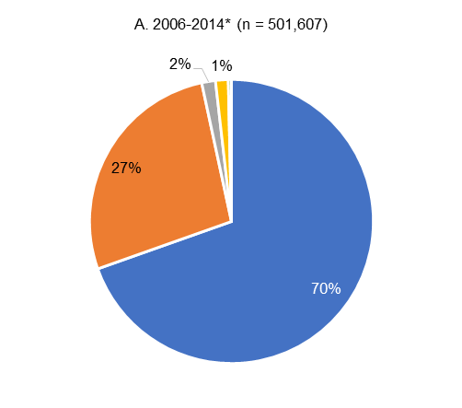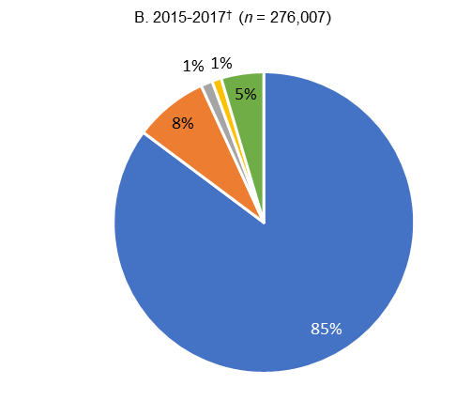

* The four pathology services were: Mater Pathology Brisbane, Queensland Health, SA Pathology, former Sydney South West Pathology Service

† All 10 pathology service contributors to APAS (see Table A1)

Distinct upward trends in the percentages of *E. coli* isolates that were fluoroquinolone non-susceptible were observed in all settings, for both long-term APAS contributors (2005–2014) and for all APAS contributors for which data are currently available for 2015–2017) (Figures 15 and 16).

Figure 15: Percentage of fluoroquinolone-non-susceptible *Escherichia coli* by setting, long-term APAS contributors, 2006–2014*

* The four pathology services were: Mater Pathology Brisbane, Pathology Queensland, SA Pathology, former Sydney South West Pathology Service

Figure 16: Percentage of fluoroquinolone non-susceptible *Escherichia coli* reported by setting, APAS contributors, 2015–2017*

* All 10 pathology service contributors to APAS (see Table A1)

## 5 Vancomycin non-susceptibility in *Enterococcus faecium*

*Enterococcus* species are opportunistic pathogens that cause a range of infections in patients whose physical barriers are compromised through surgery or invasive devices. They rarely cause disease in healthy people, but may cause infections in vulnerable patients, such as people who are very elderly or immunosuppressed.

They are a cause of urinary tract infection in patients with catheters or structural abnormalities and are associated with other intestinal organisms in many intra-abdominal infections, especially those of the biliary tract. These infections can be complicated by septicaemia. Enterococci are also a less common, but important, cause of endocarditis. Relatively few classes of antimicrobials are effective for the treatment of infections caused by enterococci. Resistance to vancomycin in *E. faecium*, almost always associated with resistance to ampicillin, severely reduces the number of effective agents for this pathogen.

There was an increasing number of *E. faecium* isolates in the long-term APAS contributors from 2006 to 2011. In addition to a growing incidence of *E. faecium* infections, the rising numbers could reflect extensions of the patient bases served by the contributors, changes in infection sampling practices, or both.

### 5.1 Vancomycin non-susceptibility in *Enterococcus faecium* by specimen type

Figure 17 shows the trends in vancomycin non-susceptibility by specimen type in the four long-term APAS contributors. Between 2006 and 2014, 9,032 specimens from those services contained *E. faecium*; 54.2% were from urine, 12.6% from blood cultures, and 33.2% were from other specimen types.

The overall prevalence of vancomycin non-susceptibility increased rapidly from 2006 to 2010. However, it remained relatively constant from 2011 to 2014.

Over the shorter period of 2015–2017, examination of data from all APAS contributors (Figure 18) showed the overall prevalence of vancomycin non-susceptible *E. faecium* declined, with the exception of isolates from blood cultures. Data were available for 9,453 specimens for this period.

Figure 17: Percentage of vancomycin non-susceptible *Enterococcus faecium* by specimen type and total number of *E. faecium*, long-term APAS contributors, 2006–2014*

* The four pathology services were: Mater Pathology Brisbane, Pathology Queensland, SA Pathology, former Sydney South West Pathology Service

Figure 18: Percentage of vancomycin non-susceptible *Enterococcus faecium* by specimen type, APAS contributors, 2015–2017*

* All 10 pathology service contributors to APAS (see Table A1)

### 5.2 Vancomycin non-susceptibility in *Enterococcus faecium* by Remoteness Area

For the four pathology services with long-term data, the bulk of isolates of *E. faecium* came from major cities (94.4%). Similar trends were observed in the complete data set from 2015–2017 (Figure 19), where 88.9% of *E. faecium* isolates were from major cities.

Figure 19: Proportion of *Enterococcus faecium* reported by Remoteness Area, APAS contributors, 2006-2014 (A)* and 2015-2017 (B)†

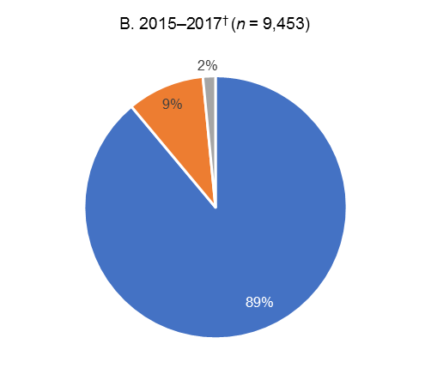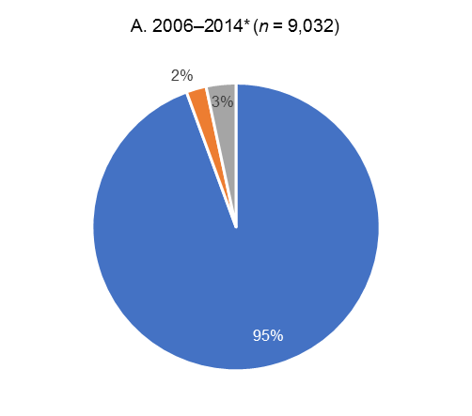

* The four pathology services were: Mater Pathology Brisbane, Pathology Queensland, SA Pathology, and former Sydney South West Pathology Service

† All 10 pathology service contributors to APAS (see Table A1)

The initial upward trend in vancomycin non-susceptible *E. faecium* seen in long-term data (2006–2014) was evident in the major cities of Australia (Figure 20). However, data from all APAS contributors, where available, reveals a downward trend in all Remoteness Areas (Figure 21).

Figure 20: Percentage of vancomycin non-susceptible *Enterococcus faecium* by Remoteness Area, long-term APAS contributors 2006–2017*†

* The four pathology services were: Mater Pathology Brisbane, Pathology Queensland Health, SA Pathology, former Sydney South West Pathology Service

† Insufficient data were available for inner and outer regional Australia 2006–2009

Figure 21: Percentage of vancomycin-non-susceptible *Enterococcus faecium* by Remoteness Area, APAS contributors 2015–2017*

* All 10 pathology service contributors to APAS (see Table A1)

### 5.3 Vancomycin non-susceptibility in *Enterococcus faecium* by setting

Settings were categorised into aged care home, community, multi-purpose service, and hospital (public and private). Of 9,032 *E. faecium* isolates from the four long-term APAS contributors, all were from hospitals (public and private). Similarly, 98.9% of 9,453 *E. faecium* from the 10 services that commenced contributing to APAS in 2015 were from hospitals (public and private).

There was a significant increase in the proportion of vancomycin non-susceptible *E. faecium* among isolates from hospitals from 2006 to 2011, χ2 for trend = 323.1, *P* < 0.0001 (Figure 24). Evidence from the large collection of laboratories suggests that rates are now in decline (Figure 25).

Figure 22: Percentage of vancomycin non-susceptible *Enterococcus faecium* in hospitals and total number of *E. faecium*, long-term APAS contributors 2006–2014*

* The four pathology services were: Mater Pathology Brisbane, Queensland Health, SA Pathology, former Sydney South West Pathology Service

Figure 23: Percentage of vancomycin non-susceptible *Enterococcus faecium* by setting, APAS contributors, 2015–2017*

* All 10 pathology service contributors to APAS (see Table A1)

## 6 Discussion

APAS is a key component of the AURA Surveillance System. APAS collects AMR data passively from public and private laboratories. The analysis of these data enables reporting on antimicrobial resistance rates, and allows healthcare professionals to develop cumulative antibiograms to inform clinical decisions and improve patient care in their health service organisations. APAS data complement AMR data incorporated in the AURA Surveillance System from other programs, including: AGAR, CARAlert, the National Neisseria Network, the National Notifiable Diseases Surveillance, and Sullivan Nicolaides Pathology.

This report is focussed on analyses of APAS data for three types of highly important resistances where trend analyses showed increasing rates in health and aged care settings, and there are opportunities for intervention:

* Methicillin resistance in *S. aureus*
* Fluoroquinolone non-susceptibility in *E. coli*
* Vancomycin non-susceptibility in *E. faecium*.

Analyses were performed for data from four original APAS contributors for the period 2006–2014 and for data from all 10 APAS contributors for the period 2015–2017. These contributors provided services to 1,250 facilities from 2006–2017.

Between 2006 and 2014, 447,819 *S. aureus* isolates were reported by the four long-term APAS contributors, 93.6% were from specimen types other than blood culture and urine. For the period 2015–2017, analyses of results for 314,026 *S. aureus* isolates, for which susceptibility was reported by all 10 APAS contributors, showed a small but significant increase in the proportions that were methicillin-resistant (χ2 for trend = 19.72, *P* < 0.0001). For both long-term and all APAS contributors, the majority of isolates that contained *S. aureus* were from public and private hospitals and were referred from services located in major cities.

Methicillin resistance in *S. aureus* have been stable at around 20% in New South Wales, Queensland and South Australia for a decade; however, there is evidence that rates are increasing nationally in the three years to 2017. Rates of methicillin resistance in *S. aureus* are higher and increasing in remote and very remote areas of Australia, reflecting the growing problem of MRSA in some communities. The impact of this distribution of resistance over time for regional and metropolitan health care settings is not yet clear.

There is a changing underlying picture in relation to the clones of MRSA that is not readily apparent from the overall prevalence data. However, data from the AGAR program shows that the relatively stable overall prevalence of MRSA is due in part to a decline in prevalence of a healthcare-associated clone of MRSA (ST239), combined with a rise in both community-associated clones and a different healthcare-associated clone (ST22) that has become prominent in aged care facilities.[8], [9] The gradual decrease in MRSA from blood cultures and urine specimens probably reflects the declining prevalence of ST239.

Community-associated MRSA are the now dominant type of MRSA in many parts of Australia, in part driven by high rates of antimicrobial use and skin disease in some community settings.

The proportion of methicillin resistance in *S. aureus* is increasing in isolates from aged care homes, where it is considerably higher than in hospitals. The proportion of methicillin resistance in community isolates of *S. aureus* has risen from 8.5% in 2006 to 14.6% in 2014, and 19.1% in 2017.

Between 2006 and 2014, 501,607 specimens reported by the four long-term APAS contributors contained *E. coli*, the majority of which (89.9%) were from urine specimens. The prevalence of fluoroquinolone non-susceptibility increased across all specimen types from 2006 to 2014. Similar trends were observed for the 276,302 specimens reported by all APAS contributors from 2015 to 2017.

Despite significant restriction of fluoroquinolones in hospitals and the community, the proportion of non-susceptibility to fluoroquinolones in *E. coli* has risen from 2% in 2006 to 11.8% in 2017. The trend is most apparent in major cities and the proportion has risen in all regions of Australia. In 2017, fluoroquinolone non-susceptibility in *E. coli* were highest in isolates from aged care homes (18.1%), followed by those from hospitals (12.1%), and the community (10.2%).

Between 2006 and 2014, 9,032 specimens from the four long-term APAS contributors contained *E. faecium*; over half of these (54.2%) were from urine, 12.6% from blood culture, and 33.2% were from other specimen types. The overall prevalence of vancomycin non-susceptibility increased rapidly from 2006 to 2010, and was relatively constant from 2011 to 2014. Data available for 9,453 specimens for the period 2015–2017 for all APAS contributors showed a decline in the overall prevalence of vancomycin non-susceptible *E. faecium*, with the exception of isolates from blood cultures.

Vancomycin-resistant *E. faecium* strains are now very common across Australia, exceeding 40% of all *E. faecium* since 2010. Vancomycin-resistant *E. faecium* are principally seen in hospitals in urban settings, and there is evidence that the proportions have decreased nationally over the last three years, from 51% in 2015 to 42% in 2017.

This report clearly shows the different epidemiology for each of the organisms included in the analyses. MRSA is disproportionately higher in rural and remote areas. Vancomycin-resistant *E. faecium* is currently found only in hospital isolates. Fluoroquinolone resistance in *E. coli* is more evenly distributed across all remoteness areas and settings however, it may be increasing more rapidly in the hospital setting.

The findings are consistent with international and national studies that have shown a significant burden of infection and colonisation with resistant organisms among people living in residential aged care, and high levels of unnecessary antimicrobial prescribing and inappropriate antimicrobial use.[10],[11] It is clear from these data that residential aged care homes are an important community setting for monitoring AMR because of their potential for enhancing amplification of AMR in Australia, including as a result of the high frequency movement of residents between them and acute hospitals.

These findings highlight the importance of effective prevention strategies for the interface between aged care homes and hospitals, and implementation of evidence-based infection control strategies in aged care settings. The Commission will work with the Australian Government Department of Health to continue to promote implementation of effective antimicrobial stewardship and infection prevention and control programs in aged care homes.

Additionally, antimicrobial guidelines, unique to different geographical and service delivery settings, may become important, given the varying resistance patterns represented in these longitudinal analyses. The Commission has provided advice to Therapeutic Guidelines, and expert groups that develop antimicrobial treatment guidelines, to ensure inclusion of this data in the development of guidelines.

The findings highlight the strategic importance of AMR surveillance, and the role that APAS and the AURA Surveillance System play in monitoring the emergence of, and trends in, AMR, and informing the response to AMR in the human health setting.

The Commission will ensure that its ongoing collaboration with state and territory health departments, and private pathology services from across Australia, promotes enhancement of AMR surveillance and increasing utility of resistance data to inform strategies for AMR prevention and containment.

## Appendices

### A1. Pathology services that contribute to APAS

Table A1: APAS contributors by state/territory and year for which data have been submitted

|  |  |  |  |  |  |  |  |  |  |  |  |  |  |
| --- | --- | --- | --- | --- | --- | --- | --- | --- | --- | --- | --- | --- | --- |
| State | Contributor | Year | | | | | | | | | | | |
| **2006** | **2007** | **2008** | **2009** | **2010** | **2011** | **2012** | **2013** | **2014** | **2015** | **2016** | **2017** |
| ACT | ACT Pathology | No | No | No | No | No | No | No | No | No | Yes | Yes | Yes |
| NSW | Pathology North* | No | No | No | No | No | No | No | No | No | Yes | Yes | Yes |
| NSW | South Eastern Area Laboratory Service† | No | No | No | No | No | No | No | No | No | Yes§ | Yes | Yes |
| NSW | Sydney South West Pathology Service** | Yes | Yes | Yes | Yes | Yes | Yes | Yes | Yes | Yes | Yes | Yes | Yes |
| Qld | Mater Pathology Brisbane | Yes | Yes | Yes | Yes | Yes | Yes | Yes | Yes | Yes | Yes | Yes | Yes |
| Qld | Pathology Queensland | Yes | Yes | Yes | Yes | Yes | Yes | Yes | Yes | Yes | Yes | Yes | Yes |
| SA | SA Pathology Service | Yes | Yes | Yes | Yes | Yes | Yes | Yes | Yes | Yes | Yes | Yes | Yes |
| Tas | Royal Hobart Hospital Pathology Service | No | No | No | No | No | No | No | No | No | Yes | Yes | Yes |
| Vic | Monash Health Pathology Service | No | No | No | No | No | No | No | No | No | Yes | Yes | Yes |
| WA | PathWest Pathology Service | No | No | No | No | No | No | No | No | No | Yes | Yes | Yes |

No = data not available; Yes = data available.

Note: NSW has, since APAS commenced, brought together all public laboratories as the statewide service NSW Health Pathology. The laboratory names used in this report reflect naming conventions during the period 2015–2017.

* The former Pathology North provides services to Hunter New England, Mid North Coast and Northern NSW LHDs

† The former South Eastern Area Laboratory Service provides services to Illawarra Shoalhaven and South Eastern Sydney LHDs and Sydney Children’s Hospital.

§ Data for the former South Eastern Sydney LHD was contributed from 2 April 2016 only

** The former Sydney South West Pathology Service provides services to South West Sydney LHD and Sydney LHD.

### A2. Representativeness

Figure A1: Estimated Australian population share by state and territory6, compared with the number of isolates for which susceptibility data was available from APAS contributors, 2015–2017

### A3. Isolates and specimen types

For the purpose of analysis, nine specimen category types, as defined in OrgTRx, were combined as indicated in Table A2.

Table A2: Classification of specimen category types for which susceptibility testing was performed

|  |  |
| --- | --- |
| OrgTRx specimen category | APAS specimen type |
| Acid fast bacilli | | Other* |
| Blood culture | | Blood |
| Cerebrospinal fluid | | Other |
| Ear, nose, and throat† | | Other |
| Enteric | | Other |
| Genital | | Other |
| Respiratory | | Other |
| Tissue/Fluid/Pus/Prosthesis | | Other |
| Urine | | Urine |

AFB = Acid fast bacilli; CSF = cerebrospinal fluid; ENT = ear, nose, and throat

* Other = Other specimen types (excluding blood or urine)

† May occasionally include eyes

### A4. Setting

Table A3: Number of facilities that are associated with each APAS contributor by setting*

|  |  |  |  |  |  |  |  |  |
| --- | --- | --- | --- | --- | --- | --- | --- | --- |
| Contributor | Aged Care Home | Comm-unity | Multi-purpose service | Other† | Private hospital | Public hospital | Unknown | Total |
| ACT Pathology | 0 | 19 | 0 | 2 | 4 | 3 | 10 | 38 |
| Mater Pathology Brisbane | 128 | 12 | 0 | 0 | 28 | 4 | 4 | 176 |
| Monash Health Pathology Service | 0 | 1 | 0 | 0 | 0 | 7 | 1 | 9 |
| Pathology North Pathology Service§ | 29 | 17 | 15 | 6 | 14 | 44 | 11 | 136 |
| PathWest Pathology Service | 0 | 13 | 36 | 18 | 9 | 46 | 21 | 143 |
| Pathology Queensland | 4 | 13 | 80 | 1 | 2 | 89 | 53 | 242 |
| Royal Hobart Hospital Pathology Service | 0 | 6 | 0 | 1 | 2 | 1 | 8 | 18 |
| SA Pathology Service | 156 | 135 | 19 | 2 | 18 | 48 | 48 | 425 |
| South Eastern Area Laboratory Service§ | 0 | 0 | 0 | 0 | 3 | 17 | 3 | 23 |
| Sydney South West Pathology Service§ | 4 | 16 | 0 | 2 | 1 | 11 | 6 | 40 |
| **Total** | **320** | **232** | **150** | **32** | **81** | **270** | **165** | **1,250** |

* Facilities from which isolates were sourced were allocated to a setting using postcode data from myagedcare.gov.au, myhospitals.gov.au, and the Australian Institute of Health and Welfare listing of public and private hospitals [12]

† Other includes facilities that APAS contributors have categorised as correction services; the approach to use of this categorisation is not consistent across states and territories

§ NSW has, since APAS commenced, brought together all public laboratories as the statewide service NSW Health Pathology. The laboratory names used in this report reflect naming conventions during the period 2015–2017.

### A5. Remoteness

The Australian remoteness structure for 2016 as classified by the Australian Statistical Geography Standard6 is shown in Figure A2.

Figure A2: Map of the 2016 Remoteness Areas for Australia

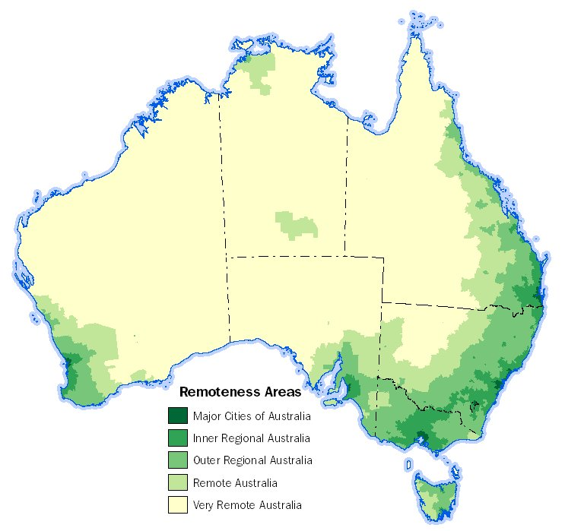

Currently there are 1,250 facilities that are associated with the 10 pathology services that contribute to APAS. The Remoteness Area for facilities associated with each APAS contributor is shown in Table A4. There were 42 that could not be classified for the analyses presented in this report.

Table A4: Number of facilities associated with each APAS contributor by Remoteness Area, 2006–2017

|  |  |  |  |  |  |  |  |
| --- | --- | --- | --- | --- | --- | --- | --- |
| Contributor | Major Cities of Australia | Inner Regional Australia | Outer Regional Australia | Remote Australia | Very Remote Australia | Unknown* | Total |
| ACT Pathology | 38 | 0 | 0 | 0 | 0 | 0 | 38 |
| Mater Pathology Brisbane | 164 | 3 | 1 | 0 | 0 | 8 | 176 |
| Monash Health Pathology Service | 8 | 0 | 0 | 0 | 0 | 1 | 9 |
| Pathology North Pathology Service† | 23 | 57 | 36 | 0 | 0 | 20 | 136 |
| PathWest Pathology Service | 37 | 16 | 33 | 27 | 21 | 9 | 143 |
| Queensland Health | 33 | 38 | 67 | 27 | 77 | 0 | 242 |
| Royal Hobart Hospital Pathology Service | 0 | 17 | 1 | 0 | 0 | 0 | 18 |
| SA Pathology Service | 228 | 59 | 90 | 31 | 16 | 1 | 425 |
| South Eastern Area Laboratory Service† | 16 | 4 | 0 | 0 | 0 | 3 | 23 |
| Sydney South West Pathology Service† | 37 | 3 | 0 | 0 | 0 | 0 | 40 |
| Total | **584** | **197** | **228** | **85** | **114** | **42** | **1,250** |

* unable to be classified

† NSW has, since APAS commenced, brought together all public laboratories as the statewide service NSW Health Pathology. The laboratory names used in this report reflect naming conventions during the period 2015–2017.

The distribution of settings by Remoteness Area is summarised in Table A5.

Table A5: Number of facilities associated with APAS contributors by setting and Remoteness Area, 2006–2017

|  |  |  |  |  |  |  |  |
| --- | --- | --- | --- | --- | --- | --- | --- |
| Setting | Major Cities of Australia | Inner Regional Australia | Outer Regional Australia | Remote Australia | Very Remote Australia | Unknown | Total |
| Aged Care Home | 223 | 40 | 47 | 2 | 0 | 8 | 320 |
| Community | 136 | 30 | 34 | 13 | 7 | 12 | 232 |
| Multi-purpose service | 0 | 9 | 50 | 32 | 59 | 0 | 150 |
| Public/Private Hospitals | 152 | 88 | 74 | 15 | 19 | 3 | 351 |
| Private Hospital | 67 | 11 | 2 | 0 | 0 | 1 | 81 |
| Public Hospital | 85 | 77 | 72 | 15 | 19 | 2 | 270 |
| Other* | 13 | 10 | 4 | 2 | 1 | 2 | 32 |
| Unknown | 60 | 20 | 19 | 21 | 28 | 17 | 165 |
| **Total** | **584** | **197** | **228** | **85** | **114** | **42** | **1,250** |

* Other includes facilities that APAS contributors have categorised as correction services; the approach to use of this categorisation is not consistent across states and territories

## 7 References

1. Australian Commission on Safety and Quality in Health Care. National Safety and Quality Health Service Standards. 2nd ed. Sydney: ACSQHC; 2017.
2. Australian Government Department of Health, Australian Government Department of Agriculture. Responding to the threat of antimicrobial resistance: Australia’s First National Antimicrobial Resistance Strategy 2015–2019. Canberra; 2015.
3. *Non-susceptibility includes both the intermediate and resistant category
4. Australian Commission on Safety and Quality in Health Care (ACSQHC). AURA 2016: first Australian report on antimicrobial use and resistance in human health. Sydney: ACSQHC, 2016.
5. Australian Commission on Safety and Quality in Health Care (ACSQHC). AURA 2017: second Australian report on antimicrobial use and resistance in human health. Sydney: ACSQHC, 2017.
6. Australian Bureau of Statistics. Australian Demographic Statistics, Sep 2017. Canberra: ABS; 2017. (ABS Cat. No. 3101.0.) [www.abs.gov.au/ausstats/abs@.nsf/mf/3101.0](http://www.abs.gov.au/ausstats/abs@.nsf/mf/3101.0) (accessed Mar 2018).
7. Australian Bureau of Statistics. Australian Statistical Geography Standard (ASGS): Volume 5 - Remoteness Structure, July 2016. Canberra: ABS; July 2016 (ABS Cat. No.1270.0.55.005) [www.abs.gov.au/websitedbs/D3310114.nsf/home/remoteness+structure/](http://www.abs.gov.au/websitedbs/D3310114.nsf/home/remoteness+structure/) (accessed Mar 2018).
8. Turnidge, J., Coombs, G., Daley, D., Nimmo, G., Australian Group on Antimicrobial Resistance (AGAR) participants, 2000–14. MRSA: A Tale of Three Types 15 years of survey data from AGAR. Sydney: ACSQHC; 2016
9. Coombs G, Bell JM, Daley D, Collignon P, Cooley L, Gottlieb T, Iredell J, Kotsanas D, Nimmo G and Robson J on behalf of the Australian Group on Antimicrobial Resistance, Turnidge JD. Australian Group on Antimicrobial Resistance. Sepsis Outcome Programs 2016 Report. Sydney: ACSQHC; 2018
10. Centers for Disease Control and Prevention. The core elements of antibiotic stewardship for nursing homes. Atlanta (GA): US Department of Health and Human Services, CDC; 2015.
11. National Centre for Antimicrobial Stewardship and Australian Commission on Safety and Quality in Health Care. Aged Care National Antimicrobial Prescribing Survey 2016. Sydney: ACSQHC; 2017
12. Australian Institute of Health and Welfare 2015. Australian hospital peer groups. Health services series no. 66. Cat. no. HSE 170. Canberra: AIHW.