AURA 2016

First Australian report on antimicrobial use and resistance in human health

Summary report

© Commonwealth of Australia 2016

This work is copyright. It may be reproduced in whole or in part for study or training purposes, subject to the inclusion of an acknowledgement of the source.

Address requests and inquiries concerning reproduction and rights for purposes other than those indicated above in writing to:

AURA – Commonwealth Programs, Australian Commission on Safety and Quality in Health Care, GPO Box 5480, Sydney NSW 2001

Or email AURA@safetyandquality.gov.au

Suggested citation: Australian Commission on Safety and Quality in Health Care (ACSQHC). AURA 2016: first Australian report on antimicrobial use and resistance in human health – summary report. Sydney: ACSQHC, 2016.

An online version of this report can be accessed at www.safetyandquality.gov.au.

ISBN: 978-1-925224-47-4 (print) 978-1-925224-48-1 (online)

**Acknowledgements**

Many individuals and organisations gave their time and expertise over an extended period to this report and the Antimicrobial Use and Resistance in Australia (AURA) project, which were conducted by the Commission. In particular, the Commission wishes to thank the Australian Government Department of Health, the states and territories and their public hospitals, contributing private hospitals, the Australian Group on Antimicrobial Resistance, the National Centre for Antimicrobial Stewardship, SA Health, Queensland Health, Pathology Queensland, Sullivan Nicolaides Pathology, NPS MedicineWise, the National Neisseria Network, the Australian Mycobacterium Reference Laboratory Network and other key experts who have provided their time and considered advice. The involvement and willingness of all concerned to share their experience and expertise are greatly appreciated.

Members of the AURA Project Reference Group are Professor John Turnidge, Dr Phillipa Binns, Professor Marilyn Cruickshank, Dr Jenny Firman, Ms Aine Heaney, Mr Duncan McKenzie, Adjunct Professor Kathy Meleady, Dr Brett Mitchell, Professor Graeme Nimmo, Dr Alicia Segrave, Professor Karin Thursky, Dr Morgyn Warner, Professor Roger Wilson and Associate Professor Leon Worth.

The members of the Commission’s AURA team are also acknowledged for their significant contribution to the development of the AURA Surveillance System and this report.

**Disclaimer**

This report is based on the best data and evidence available at the time of development.

Edited and designed by Biotext Pty Ltd

# Contents

Contents iii

Overview 1

What is antimicrobial resistance? 1

Antimicrobial use and appropriateness of prescribing 1

Antimicrobial resistance 2

International comparisons 2

Using information for action 2

Antimicrobial use and appropriateness 3

Key messages 3

Antimicrobial use in hospitals 3

Antimicrobial use in the community – primary care 5

Antimicrobial use in the community – residential aged care facilities 8

Antimicrobial resistance 10

Key messages 10

Resistance trends of concern 13

International comparisons 15

Key messages 15

Antimicrobial use in hospitals 15

Antimicrobial use in the community 16

Antimicrobial resistance 17

Using information for action 20

Key messages 20

References 23

# Overview

*AURA 2016: first Australian report on antimicrobial use and resistance in human health* provides the most comprehensive picture of antimicrobial resistance (AMR), antimicrobial use (AU) and appropriateness of prescribing in Australia to date. It sets a baseline that will allow trends to be monitored over time. AURA 2016 also highlights areas where future work will inform action to prevent the spread of AMR.

Comprehensive, coordinated and effective surveillance of AMR and AU is a national priority. Surveillance is essential to understand the magnitude, distribution and impact of AMR and AU, as well as to identify emerging issues and trends. It allows the early detection of critical antimicrobial resistances to ensure that effective action can be taken, and provides information on the effectiveness of measures designed to promote appropriate AU and contain AMR. Surveillance is a critical component of Australia’s National Antimicrobial Resistance Strategy.

The Antimicrobial Use and Resistance in Australia (AURA) Surveillance System is the new system to coordinate data from a range of sources, and allow integrated analysis and reporting at a national level. The AURA Surveillance System brings together partner programs such as the Australian Group on Antimicrobial Resistance, the National Antimicrobial Prescribing Survey (NAPS), the National Antimicrobial Utilisation Surveillance Program (NAUSP) and Queensland Health’s OrgTRx system. Data is also sourced from the Pharmaceutical Benefits Scheme and the Repatriation Pharmaceutical Benefits Scheme (PBS/RPBS), NPS MedicineWise, the National Neisseria Network, the National Notifiable Diseases Surveillance System, the Report on government services 2015, and Sullivan Nicolaides Pathology.

The AURA Surveillance System will provide critical information needed by clinicians, policy makers, researchers and health system managers to target efforts to inform antimicrobial stewardship, and AMR policy and program development.

This summary report of AURA 2016 presents the key messages and data from that report.

## What is antimicrobial resistance?

AMR is an issue of great importance for health care in Australia. AMR occurs when bacteria change to protect themselves from the effects of antimicrobials. This means that the antimicrobial can no longer eradicate or stop the growth of the bacteria. Antimicrobials can be life-saving agents in the fight against infection, but their effectiveness is diminished by AMR.

AMR has a direct impact on patient care and patient outcomes; it is a critical and immediate challenge to health systems around the world. It increases the complexity of treatment and the duration of hospital stay, and places an additional burden on patients, healthcare providers and the healthcare system.

## Antimicrobial use and appropriateness of prescribing

AU is a key driver of AMR – the more we use antimicrobials, the more likely it is that resistance will develop. Appropriate use of antimicrobials can be life-saving, but inappropriate use needs to be monitored and minimised to prevent and contain AMR. Inappropriate use might include prescribing antimicrobials when they are not necessary, prescribing the wrong type of antimicrobial or prescribing for the incorrect duration.

On any given day in 2014, around 38% of patients in Australian hospitals were receiving antimicrobial therapy. Around 23% of these prescriptions were considered inappropriate, and around 24% were noncompliant with guidelines. Prescriptions for surgical prophylaxis are a significant concern – this indication is the most common reason for prescribing antimicrobials in hospitals (13.1% of all prescriptions), but also has the highest proportion of inappropriate use (40.2% of prescriptions were deemed to be inappropriate).

Antimicrobial prescribing is high in the community, with 46% of Australians being dispensed at least one antimicrobial in 2014. High volumes of antimicrobials are prescribed unnecessarily for upper respiratory tract infections.

In residential aged care facilities, 11.3% of the residents were on antimicrobials, but only 4.5% had a suspected or confirmed infection. Antimicrobials are sometimes used unnecessarily in residential aged care facilities for urinary tract infections, and unspecified skin and soft tissue infections.

## Antimicrobial resistance

Data from hospitals, residential aged care facilities and the community was reported for priority organisms. Resistances and trends of concern include resistance to third-generation cephalosporins and carbapenems in *Enterobacteriaceae*, decreased susceptibility to ceftriaxone in *Neisseria gonorrhoeae*, resistance to ciprofloxacin in *Shigella* species, and resistance to erythromycin in *Streptococcus agalactiae*.

## International comparisons

AU in the Australian community is higher than in many other countries. Rates of AMR in gram-negative organisms (*Escherichia coli* and *Klebsiella* *pneumoniae*) are lower than in other countries, but high to very high for gram-positive organisms (*Staphylococcus aureus* and *Enterococcus faecium*). Australia has low rates of resistance to fluoroquinolones compared with other countries, reflecting the restricted use of this antimicrobial class in Australia.

## Using information for action

The information generated through surveillance of AU and AMR more accurately informs and supports strategies to prevent and contain AMR. A national, comprehensive and coordinated surveillance system, such as the AURA Surveillance System, provides data that can be used at many levels – by individuals, healthcare services, jurisdictional health authorities, national bodies and global AMR organisations – to ensure appropriate and effective use of antimicrobials, timely response to emerging resistance and coordinated efforts.

AURA 2016 provides valuable data and comprehensive analyses of AMR, AU and appropriateness of prescribing in Australia, and sets a baseline that will allow AMR and AU trends to be monitored over time. It also highlights areas where additional work would improve understanding and inform further action.

AURA 2016 and a detailed data supplement are available on the [AURA website](http://www.safetyandquality.gov.au/antimicrobial-use-and-resistance-in-australia/).

# Antimicrobial use and appropriateness

Key messages

Hospitals

* AU in hospitals was highest in 2010, and has gradually declined since then. However, on any given day in 2014, 38.4% of hospital patients were being treated with an antimicrobial.
* There is large variation in the rates of AU between states and territories, but the factors driving this variation are unclear.
* Data shows that 23.0% of prescriptions were considered inappropriate and 24.3% were noncompliant with guidelines. Inappropriate use was highest for respiratory tract infections and surgical prophylaxis.

Community

* AU in the community is high, with 46% of the population being dispensed at least one systemic antimicrobial prescription in 2014–15. AU is highest in children (0–9 years old) and older people (aged 65 and over).
* Prescribing varies across states and territories, and across local areas.
* High volumes of antimicrobials are prescribed unnecessarily for respiratory tract infections – more than 50% of people with colds and other upper respiratory tract infections were prescribed an antimicrobial when it was not recommended by guidelines.
* Some antimicrobials are prescribed more in winter, which suggests that they are potentially misused to treat viral illnesses such as colds and influenza.

Residential aged care facilities

* In residential aged care facilities, 11.3% of the residents were on antimicrobials, but only 4.5% had a suspected or confirmed infection.
* One in five antimicrobial prescriptions was written for residents who had no signs or symptoms of infection in the week before starting the antimicrobial. Of patients who did have signs of infection and were prescribed antimicrobials, only one-third of these prescriptions were appropriate.
* Antimicrobials are sometimes used unnecessarily in residential aged care facilities for urinary tract infections, and unspecified skin and soft tissue infections.

Inappropriate use of antimicrobials – such as prescribing antimicrobials when they are not necessary, or prescribing the wrong type of antimicrobial – is a key driver of AMR. To prevent and contain AMR, it is important that AU is monitored, and that inappropriate use is minimised.

## Antimicrobial use in hospitals

Data on AU in hospitals is sourced from the 2014 NAUSP report.1

Use of antimicrobials in Australian hospitals peaked in 2010, and has declined since then. The rates of use have decreased for some classes of antimicrobials, but have increased for other classes.

There are more than 100 different antimicrobial agents, but 20 of these account for 92% of all antibacterials used in hospitals. Data from NAUSP shows that by far the most commonly prescribed antimicrobial in hospitals is amoxicillin–clavulanate, followed by flucloxacillin, cefazolin and amoxicillin.

### Differences in prescribing rates

Antimicrobial usage rates are measured as defined daily doses (DDDs) per 1000 occupied-bed days (OBDs), which allows data to be compared across hospitals, jurisdictions or countries. There is large variation in AU among states and territories – Tasmania has the highest rate of AU, and Queensland has the lowest (Figure 1).

Figure 1 Overall antimicrobial usage rates by jurisdiction, 2014

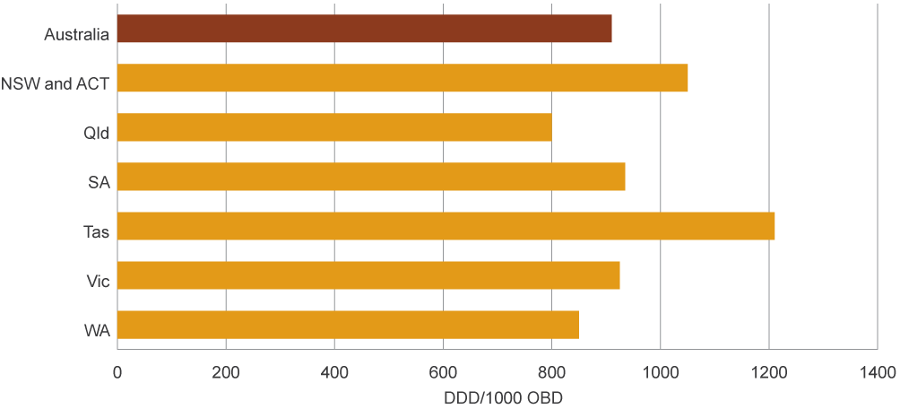

ACT = Australian Capital Territory; DDD/1000 OBD = defined daily doses per 1000 occupied-bed days; NSW = New South Wales; Qld = Queensland; SA = South Australia; Tas = Tasmania; Vic = Victoria; WA = Western Australia

Data source: National Antimicrobial Utilisation Surveillance Program report, 2014

Aminoglycosides, cephalosporins, fluoroquinolones and macrolides represent the classes of antimicrobials most likely to drive AMR. Overall, the usage rates of these four antimicrobial classes have declined in the large and medium public hospitals, and principal referral hospitals, that participate in NAUSP. Specifically, over the past five years:

rates of gentamicin use (the most commonly used aminoglycoside) have decreased steadily across Australia

use of ceftriaxone (the most commonly prescribed third-generation cephalosporin) and some macrolides appears to be seasonal, reflecting their role in the treatment of lower respiratory tract infections

rates of fluoroquinolone use have remained relatively constant.

Understanding variation in prescribing rates is critical to improving the quality, value and appropriateness of AU. However, there is currently insufficient evidence to identify which factors are driving variation in volumes and patterns of AU in Australian hospitals.

### Appropriateness of prescribing

Data on appropriateness of prescribing in hospitals is sourced from the 2014 NAPS report.2

On any given day in an Australian hospital in 2014, 38.4% of patients were being administered an antimicrobial. Of these prescriptions, 24.3% were noncompliant with guidelines and 23.0% were considered to be inappropriate prescriptions. The main reasons why prescriptions were deemed to be inappropriate were that an antimicrobial was not needed, the antimicrobial chosen was incorrect (spectrum too broad), or the duration, dose or frequency of treatment was incorrect.

In 2014, the most common indications (reasons) for antimicrobial prescriptions in hospitals were:

surgical prophylaxis (13.1%)

community-acquired pneumonia (11.3%)

medical prophylaxis (8.3%)

cellulitis or erysipelas (skin infections) (4.4%).

Antimicrobials are often prescribed to patients undergoing surgery to prevent infection during and after the procedure – this is known as surgical prophylaxis. Inappropriate surgical prophylaxis is a major concern – it is the most common reason for antimicrobial prescriptions in hospitals, but also has the highest proportion of inappropriate use. Of all surgical prophylaxis prescriptions, 40.2% were deemed to be inappropriate. Reasons for inappropriateness included incorrect duration, dose or frequency, and there were instances where an antimicrobial was not needed at all.

## Antimicrobial use in the community – primary care

Data on AU in primary care is sourced from the Australian Government Department of Health Drug Utilisation Sub Committee database and the Australian Government Department of Human Services pharmacy claim database.

In the Australian community, AU is high. In 2014, 46% of Australians had at least one antimicrobial dispensed to them under the PBS or the RPBS. The overall rate was 23.8 DDD/1000 inhabitants/day, which is an increase compared with 2013, but a decrease compared with the peak in 2008 (Figure 2).

Figure 2 Volume of antimicrobials dispensed under the PBS/RPBS per year, 1994–2014

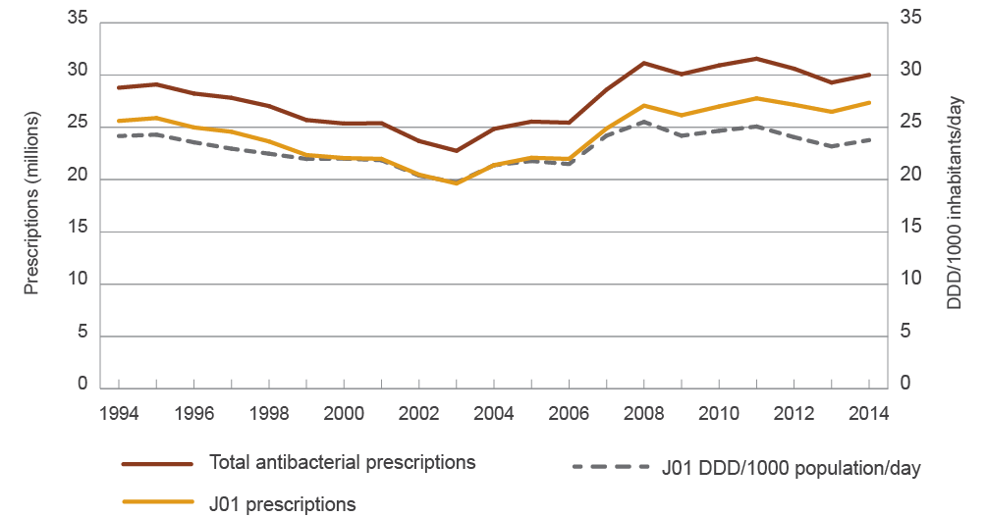

DDD = defined daily dose; PBS = Pharmaceutical Benefits Scheme; RPBS = Repatriation Pharmaceutical Benefits Scheme

Notes:

1. J01 is the ATC code for antibacterials for systemic use.

2. Before April 2012, includes estimates of under co-payment and private dispensing; after April 2012, includes actual under co-payment data, but no estimate from private dispensing. The DDD/1000 inhabitants/day exclude some items for which there is no DDD.

Source: Drug Utilisation Sub Committee database, October 2015

The 11 most commonly dispensed antimicrobials accounted for 84% of all antimicrobials dispensed in the community. Penicillins are the most commonly prescribed antimicrobial group.

### Patterns of use

In 2014, antimicrobials in the community were most often dispensed for very young people and older people – 57% of those aged 0–4 years, 60% of those aged 65 years or over and 74% of people aged 85 years or over were supplied at least one antimicrobial (Figure 3). These proportions have been consistent over several years. Children are prescribed more extended-spectrum penicillins, and older people are prescribed more cephalosporins, macrolides and β-lactamase inhibitor combinations than other age groups. All age groups use more antimicrobials during the winter months.

Figure 3 Antimicrobial use by age group, 2014

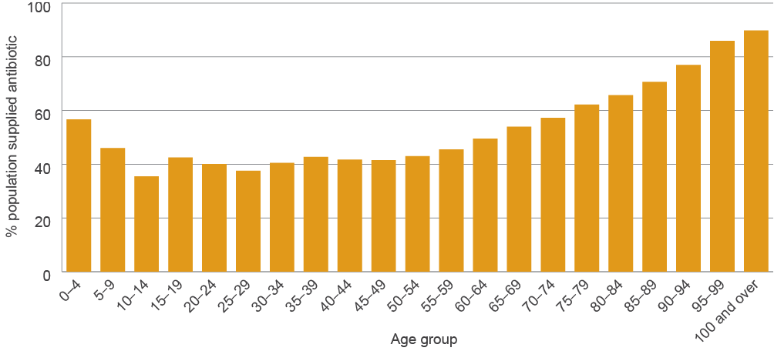

Notes:

1. Percentage of people supplied at least one PBS/RPBS antimicrobial in 2014; age standardised, based on estimated resident population by age at 30 June 2014

2. Includes actual under co-payment data, but no estimate from private dispensing

Source: Department of Human Services pharmacy claim database, October 2015

General practitioners generate the majority of prescriptions (88%). Other prescribers include dentists, optometrists, midwives and nurse practitioners.

The types of antimicrobials dispensed through the Aboriginal health services differ from other health services. This likely reflects the different types of infections that are prevalent in Aboriginal and Torres Strait Islander communities (e.g. trachoma and urethritis caused by Chlamydia trachomatis).

Different dispensing rates were also seen across states and territories, between major cities and other regions, between local areas, and across socioeconomic status. Generally, rates were highest in areas of lowest socioeconomic status, and decreased with increasing socioeconomic status. This is consistent with decreasing socioeconomic status being associated with poorer health and higher infection rates. However, there is insufficient evidence to identify the factors that are driving geographic patterns of antimicrobial prescribing in Australia.3

### Appropriateness of prescribing

Data on appropriateness of prescribing in primary care is sourced from the NPS MedicineWise MedicineInsight program4 and the Report on government services 2015.5

Thirty per cent of patients (352 318 patients) participating in the MedicineInsight program were prescribed systemic antimicrobials between 1 January and 31 December 2014. The rate of antimicrobial prescriptions (originals) per 100 general practitioner consultations has remained constant from 2009 to 2014, and shows a pattern of seasonal variation, with peaks in winter and troughs in summer.

High volumes of antimicrobials continue to be prescribed unnecessarily for upper respiratory tract infections. More than 50% of patients who were identified as having a cold or other upper respiratory tract infection had an antimicrobial prescribed when it was not indicated. A large proportion of patients with acute tonsillitis, acute or chronic sinusitis (sinus inflammation), acute otitis media (middle ear infection) or acute bronchitis received an antimicrobial, but antimicrobial treatment should be the exception for these conditions, not routine therapy. A large proportion of antimicrobials prescribed were not those recommended by guidelines.4

Reasons for inappropriate prescribing included the wrong antimicrobial, and for the wrong duration. Many repeat prescriptions were also given when they were not needed.

However, the trend for inappropriate prescribing for upper respiratory tract infections is decreasing. Nationally, the proportion of acute upper respiratory tract infection presentations for which systemic antimicrobials were prescribed by general practitioners decreased from 32.8% in 2011–12 to 29.0% in 2013–14. This reflects the overall decreasing trend in most states and territories (Figure 4).5

Figure 4 Percentage of patients with acute upper respiratory tract infections prescribed a systemic antimicrobial, by jurisdiction, rolling average 2006–14

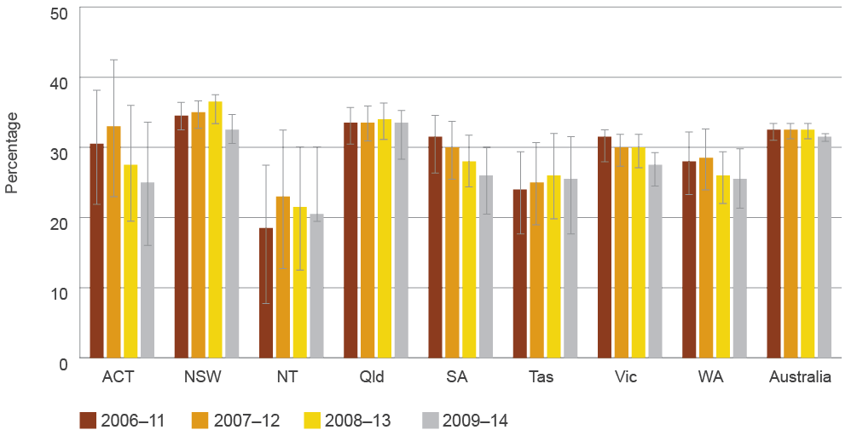

ACT = Australian Capital Territory; NSW = New South Wales; NT = Northern Territory; Qld = Queensland; SA = South Australia; Tas = Tasmania; Vic = Victoria; WA = Western Australia

Notes:

1. Error bars represent the 95% confidence interval associated with each point estimate.

2. Participation in the survey is voluntary. Data is not necessarily representative of the prescribing behaviour of nonparticipating general practitioners.

Source: Report on government services 2015, Table 10A.555

## Antimicrobial use in the community – residential aged care facilities

Data on AU in Australian residential aged care facilities has only recently become available as a result of a pilot study conducted in 2015 (the Aged Care National Antimicrobial Prescribing Survey, or acNAPS). acNAPS provides a snapshot of AU and the prevalence of infection in a sample of Australian residential aged care facilities and multipurpose services.

The prevalence of residents on antimicrobial therapy on any given day was 11.3%, and 7.9% if topical antimicrobials were excluded. The prevalence of residents with a suspected or confirmed infection was 4.5% and, of these, 72.4% were on antimicrobial therapy. This suggests some inappropriate use of antimicrobials. acNAPS will be available for all residential aged care facilities and multipurpose services to participate in from June 2016.

### Patterns of use

Prescribing was highest in Western Australia (26.9%) and lowest in Queensland (6.4%). There were no obvious reasons for this variation; the infection rates in each jurisdiction did not necessarily correlate with prescribing rates.

Prophylaxis accounted for 22.9% of the prescriptions – these were mainly for urinary tract infections (36.3%), and unspecified skin, soft tissue or mucosal infections (11.2%). Along with lower respiratory tract infections, these comprised most of the infections for which antimicrobials were prescribed for treatment.

### Appropriateness of prescribing

About one in five prescriptions were prescribed for residents who did not have any signs or symptoms of infection. For those who did have symptoms, only one-third met the standardised criteria for appropriate prescribing in residential aged care facilities (McGeer infection criteria).6 For these prescriptions, numbers were highest for skin, soft tissue, eye and oral infections, followed by respiratory tract infections and urinary tract infections (Figure 5).

Figure 5 Number of prescriptions that met McGeer criteria, by body system (where signs and symptoms of infection were recorded), 2015

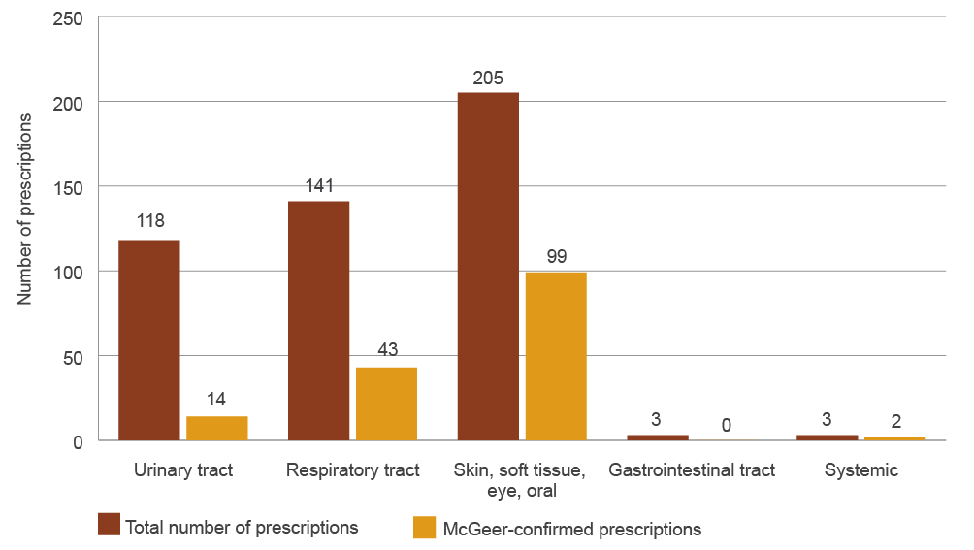

Note: Prescriptions are counted more than once if the resident has signs or symptoms of infection for more than one body system.

Source: Aged Care National Antimicrobial Prescribing Survey, 2015

This preliminary data points towards some unwarranted AU in residential aged care. However, more data is necessary from across Australia to provide a more complete picture of antimicrobial prescribing patterns in residential aged care facilities and multipurpose services.

# Antimicrobial resistance

Key messages

* Acinetobacter baumannii – rates of resistance are low overall (<5%), and higher in hospitals than in the community.
* Enterobacteriaceae – strains of Escherichia coli that produce extended-spectrum β-lactamases are now a problem in community infections, because they are often multidrug resistant.
* Enterococcus species – Australia has one of the highest rates of vancomycin resistance in Enterococcus faecium in the world. Rates of resistance to key antimicrobial agents are very low (<1%) in E. faecalis, but high (45–94.5%) in E. faecium.
* Mycobacterium tuberculosis – overall resistance rates have not changed significantly in the past decade. Multidrug resistance is low, but has been gradually increasing (1.7% in 2014); extremely drug-resistant strains are occasionally found but remain rare.
* Neisseria gonorrhoeae – rates of resistance to two main antimicrobials (benzylpenicillin and ciprofloxacin) remain steady at around 30%. Rates of resistance to two other key antimicrobials (azithromycin and decreased susceptibility to ceftriaxone) are low but gradually increasing.
* Neisseria meningitidis – rates of resistance to the four key antimicrobials used for treatment remain very low (0–2%).
* Pseudomonas aeruginosa – overall rates of resistance to key antimicrobials are 10% or less, with rates higher in public hospitals than in other settings.
* Salmonella species – rates of resistance to a key antimicrobial class (fluoroquinolones) are very low (1%) in nontyphoidal Salmonella species, but more than 12% in typhoidal Salmonella species.
* Shigella species – although data is limited, the presence of resistance to a key antimicrobial (ciprofloxacin) in almost 10.6% of Shigella sonnei isolates is of concern.
* Staphylococcus aureus – between 15.8% and 17.4% of isolates are methicillin-resistant S. aureus (MRSA). Community strains of MRSA now cause a significant proportion of infections in both the community and hospitals.
* Streptococcus agalactiae – no isolates were resistant to one key antimicrobial (benzylpenicillin), but resistance to another important antimicrobial (erythromycin) exceeded 20%. This means that protocols for prophylaxis may need to be reconsidered.
* Streptococcus pneumoniae – resistance (as defined for strains causing infections other than meningitis) was low (around 2%) for one key antimicrobial (benzylpenicillin), but high (21–26%) for other key antimicrobials.
* Streptococcus pyogenes – resistance to key antimicrobials used for treatment is absent or very low (3%).

Resistant bacteria – and the genes that cause resistance – can spread readily and rapidly between people in the community, primary care services, hospitals and residential aged care facilities. These bacteria can have a significant impact on patients, health services and the health system. Therefore, the resistant bacteria with the highest risk of harm to humans must be identified and monitored through surveillance, and managed appropriately.

Data from hospitals, residential aged care facilities and the community was reported for priority organisms. Priority organisms are those considered by the Commission to be of high public health importance and/or common pathogens where the impact of resistance is substantial, in both the hospital and community settings. A summary of these organisms and the percentage that are resistant to key antimicrobials used for treatment are shown in Table 1.

Table 1 Summary of antimicrobial resistance for priority organisms, 2014

| Organism | Main types of infection | Where seen | Important antimicrobials for treatment and % resistant, 2014 |
| --- | --- | --- | --- |
| Acinetobacter baumannii | Ventilator-associated pneumonia, severe burn infections | Intensive care units, burns units | * Ciprofloxacin: 4.1 * Gentamicin: 2.4 * Meropenem: 3.6 |
| Escherichia coli | Urinary tract infections, biliary tract infections, other intra-abdominal infections, septicaemia | Community, hospitals | * Amoxicillin–clavulanate: 18.2–21.1 * Ampicillin/amoxicillin: 42.3–51.3 * Cefazolin: 15.2–25.0 * Ceftriaxone: 5.1–12.4 * Ciprofloxacin: 6.2–8.7 * Gentamicin: 4.5–7.0 * Piperacillin–tazobactam: 5.3–9.4 * Trimethoprim: 21.0–29.4 * Multidrug resistant: 13.1 |
| Enterobacter cloacae | Urinary tract infections, other intra-abdominal infections, septicaemia | Hospitals | * Ceftriaxone: 23.8–28.5 * Piperacillin–tazobactam: 24.3–32.2 * Trimethoprim: 18.3–21.3 * Gentamicin: 7.2–7.8 * Ciprofloxacin: 3.7–5.2 * Meropenem: 1.1–2.6 * Multidrug resistant: 13.4 |
| Enterococcus faecalis | Urinary tract infections, biliary tract infections, other intra-abdominal infections, septicaemia, endocarditis (heart valve infections) | Community, hospitals | * Ampicillin: 0.3–0.6 * Vancomycin: 0.3–0.4 |
| Enterococcus faecium | Urinary tract infections, biliary tract infections, other intra-abdominal infections, septicaemia | Hospitals | * Ampicillin: 83.3–94.5 * Linezolid: 0.2–1.1 * Vancomycin: 45.7–49.9 |
| Klebsiella pneumoniae | Urinary tract infections, other intra-abdominal infections, septicaemia | Community | * Amoxicillin–clavulanate: 6.2–9.4 * Ceftriaxone: 4.3–6.6 * Ciprofloxacin: 4.5–6.2 * Gentamicin: 3.1–4.9 * Piperacillin–tazobactam: 7.6–8.9 * Trimethoprim: 12.3–16.6 * Multidrug resistant: 9.0 |
| Mycobacterium tuberculosis | Pulmonary tuberculosis, extrapulmonary tuberculosis | Community | * Ethambutol: 1.2 * Isoniazid: 8.5 * Pyrazinamide: 2.1 * Rifampicin: 2.4 * Multidrug resistant: 1.7 |
| Neisseria gonorrhoeae | Gonorrhoea | Community | * Azithromycin: 2.5 * Benzylpenicillin: 28.5 * Ceftriaxone: 5.4 (decreased susceptibility) * Ciprofloxacin: 36.4 |
| Neisseria meningitidis | Septicaemia | Community | * Benzylpenicillin: 15.8 (decreased susceptibility) * Ceftriaxone: 0.0 * Ciprofloxacin: 0.0 * Rifampicin: 2.1 |
| Pseudomonas aeruginosa | Urinary tract infections, burn infections, cystic fibrosis exacerbations | Community, hospitals | * Ceftazidime: 4.5 * Ciprofloxacin: 6.7 * Gentamicin: 5.3 * Meropenem: 4.0 * Piperacillin–tazobactam: 10.3 |
| Salmonella species (nontyphoidal) | Gastroenteritis, septicaemia | Community | * Ampicillin: 6.7–7.7 * Ceftriaxone: 0.6–1.9 * Ciprofloxacin: 0–1.1 |
| Salmonella Typhi/Paratyphi | Typhoid fever (septicaemia) | Community | * Ceftriaxone: 0 * Ciprofloxacin: 12.2 |
| Shigella sonnei | Bacillary dysentery | Community | * Ampicillin: 10.6 * Ceftriaxone: 3.1 * Ciprofloxacin: 9.4 |
| Shigella flexneri | Bacillary dysentery | Community | * Ampicillin: 57.1 * Ceftriaxone: 0 * Ciprofloxacin: 0 |
| Staphylococcus aureus | Skin, wound and soft tissue infections; bone and joint infections; device-related infections; septicaemia; endocarditis (heart valve infections) | Community, hospitals | * Benzylpenicillin: 83.1–88.7 * Clindamycin: 7.1–10.0 * Erythromycin (and other macrolides): 16.5–17.0 * Oxacillin (methicillin): 15.8–17.4 |
| Staphylococcus aureus (methicillin resistant) | Skin, wound and soft tissue infections; bone and joint infections; device-related infections; septicaemia; endocarditis (heart valve infections) | Community, hospitals | * Clindamycin: 14.2–19.6 * Fusidic acid: 4.6–5.9 * Linezolid: 0.1–0.3 * Rifampicin: 0.8–0.9 * Trimethoprim–sulfamethoxazole: 2.5–11.9 * Vancomycin: 0.0 |
| Streptococcus agalactiae | Skin and soft tissue infections, urinary tract infections, newborn septicaemia | Community | * Benzylpenicillin: 0.0 * Clindamycin: 17.1 * Erythromycin (and other macrolides): 22.7 * Trimethoprim: 17.2 |
| Streptococcus pneumoniae | Otitis media (middle ear infections), sinusitis, acute exacerbation of chronic obstructive lung disease, pneumonia, meningitis, septicaemia | Community | * Benzylpenicillin (outside the central nervous system): 2.0–2.3 * Erythromycin (and other macrolides): 21.1–25.9 * Tetracycline (and doxycycline): 21.1–25.6 |
| Streptococcus pyogenes | Skin, wound and soft tissue infections; septicaemia | Community | * Benzylpenicillin: 0.0 * Erythromycin (and other macrolides): 3.4 |

Multidrug resistant = resistant to three or more antimicrobial classes where all agents have been tested

Sources: Australian Group on Antimicrobial Resistance, National Neisseria Network, National Notifiable Diseases Surveillance System, OrgTRx, Sullivan Nicolaides Pathology

## Resistance trends of concern

In the *Enterobacteriaceae*, the resistance types of greatest concern are the extended-spectrum β-lactamases (ESBLs) and the plasmid-borne AmpC enzymes (which confer resistance to third-generation cephalosporins), and the carbapenemases (which confer resistance to carbapenems and almost all other β-lactams). ESBLs were found in 7–12% of *E. coli*, 4–7% of *K. pneumoniae* and about 3% of *E. cloacae* complex. Resistance to carbapenems was less than 0.5% in *E. coli* and *K. pneumoniae*, but 1–3% in *E. cloacae* complex. Carbapenemase-producing *Enterobacteriaceae* are almost always highly multidrug resistant, and infections caused by these bacteria require ‘last-line’ reserve agents that can be significantly toxic to patients.

Resistance to ceftriaxone in *Neisseria gonorrhoeae* is an emerging concern around the world. Resistance or decreased susceptibility to ceftriaxone can mean that this antimicrobial is no longer effective. Rates of reduced susceptibility to ceftriaxone and resistance to azithromycin are low in Australia (around 5% and 2%, respectively), but are slowly trending upwards.

*Shigella* species are an uncommon but important cause of gastroenteritis. The prevalence of resistance to two key antimicrobials (ceftriaxone and ciprofloxacin) was very low in both *Shigella* species; however, the presence of any resistance to ciprofloxacin in Australia is of concern, because these organisms have the capacity to cause outbreaks.

*Streptococcus agalactiae* is an important cause of bloodstream infection in newborns. The data revealed no resistance to benzylpenicillin, but resistance to erythromycin exceeded 20%. This is important, because an erythromycin resistance rate of 20% is the threshold at which protocols may need to be reconsidered and alternative agents used for treatment.

# International comparisons

Key messages

* AU in Australian hospitals can appear comparatively high or low, depending on the measure used. These comparative differences may reflect different healthcare practices (e.g. indications treated in hospitals or community primary care) in different countries.
* AU in the Australian community is higher than in many other countries.
* Rates of AMR in gram-negative organisms (Escherichia coli and Klebsiella pneumoniae) in Australia are lower than in other countries, but rates of AMR in gram-positive organisms (Staphylococcus aureus and Enterococcus faecium) are high to very high.
* Australia has low rates of resistance to fluoroquinolones compared with other countries, reflecting the restricted use of this antimicrobial class in Australia.

Many countries, particularly in Europe, have established systems for reporting country-wide data on AU and AMR. Comparing Australia’s national data with that from other countries provides a benchmark that can help to inform practices in Australia.

## Antimicrobial use in hospitals

AU in Australian hospitals is high compared with Denmark, Canada, Sweden, Norway and the Netherlands, but lower than England and Scotland (Figure 6). These countries are good comparators because they have high data capture, and they have near universal care in the public hospital system. However, because of some limitations in data collection, these comparisons are indicative only.

Figure 6 Antimicrobial use in Australian hospitals and other countries

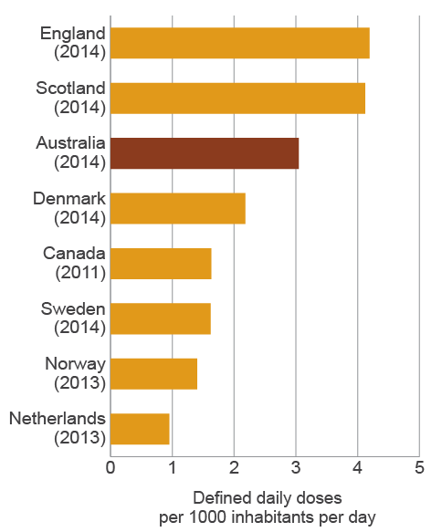

Sources: NAUSP (Australia), CIPARS (Canada), DANMAP (Denmark), ESPAUR (England), NethMAP (Netherlands), SAPG (Scotland), NORM (Norway), SWEDRES (Sweden)

## Antimicrobial use in the community

Figure 7 compares Australia’s AU with Norway, Denmark, Sweden, the Netherlands, England and Canada. These countries have been selected because their data is readily accessible and comparable. AU in the Australian community is higher than in any of these countries.

Figure 7 Antimicrobial use in the community in Australia and other countries

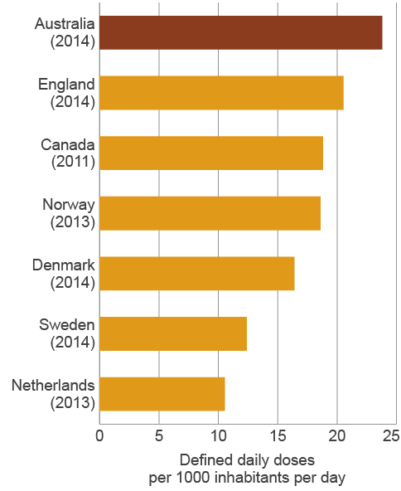

Sources: PBS (Australia), CIPARS (Canada), DANMAP (Denmark), ESPAUR (England), NethMAP (Netherlands), SWEDRES (Sweden)

Countries also have differing patterns of use of antimicrobial classes. Australia tends to use more β-lactamase-inhibitor combinations and cephalosporins, but fewer narrow-spectrum penicillins (β-lactamase-sensitive penicillins) than Scandinavian countries. Australia also uses far fewer fluoroquinolones than comparator countries – this likely stems from the conservative restrictions placed on their prescription on the PBS/RPBS in the 1990s.

## Antimicrobial resistance

Comparisons of AMR are available from other countries for four of the priority organisms: Escherichia coli, Klebsiella pneumoniae, Enterococcus faecium and Staphylococcus aureus.

Resistance to some key antimicrobials, including fluoroquinolones, is very low in Australia for E. coli (Figure 8) and K. pneumoniae compared with many European countries. These organisms are both gram-negative.

Figure 8 Combined resistance to some key antimicrobials in invasive isolates of Escherichia coli in Australia and European countries, 2014

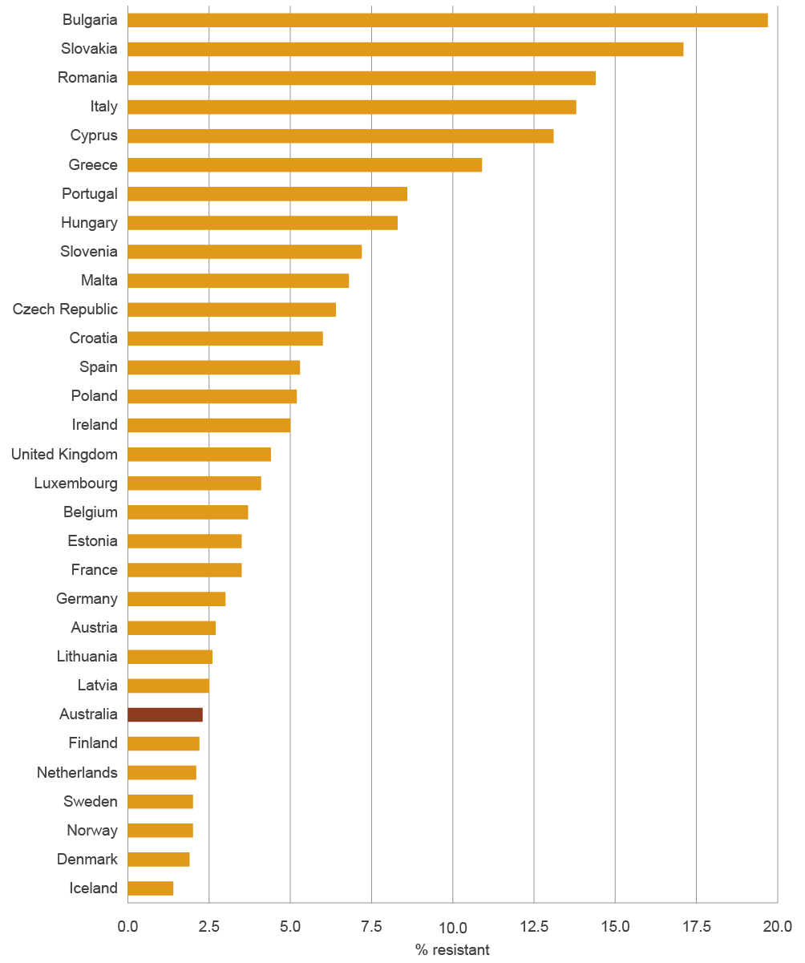

Sources: Australian Group on Antimicrobial Resistance, 2014; EARS-Net 2014 (Polish data is from 2013)

In contrast to the gram-negative pathogens discussed above (E. coli and K. pneumoniae), rates of resistance to methicillin in S. aureus and to vancomycin in E. faecium (both gram-positive bacteria) are high to very high in Australia compared with other countries (see Figure 9). The reasons for this are not clear, but it is likely that the drivers of resistance in gram-negative and gram-positive bacteria are different.

Figure 9 Vancomycin resistance in Enterococcus faecium in Australia and European countries, 2014

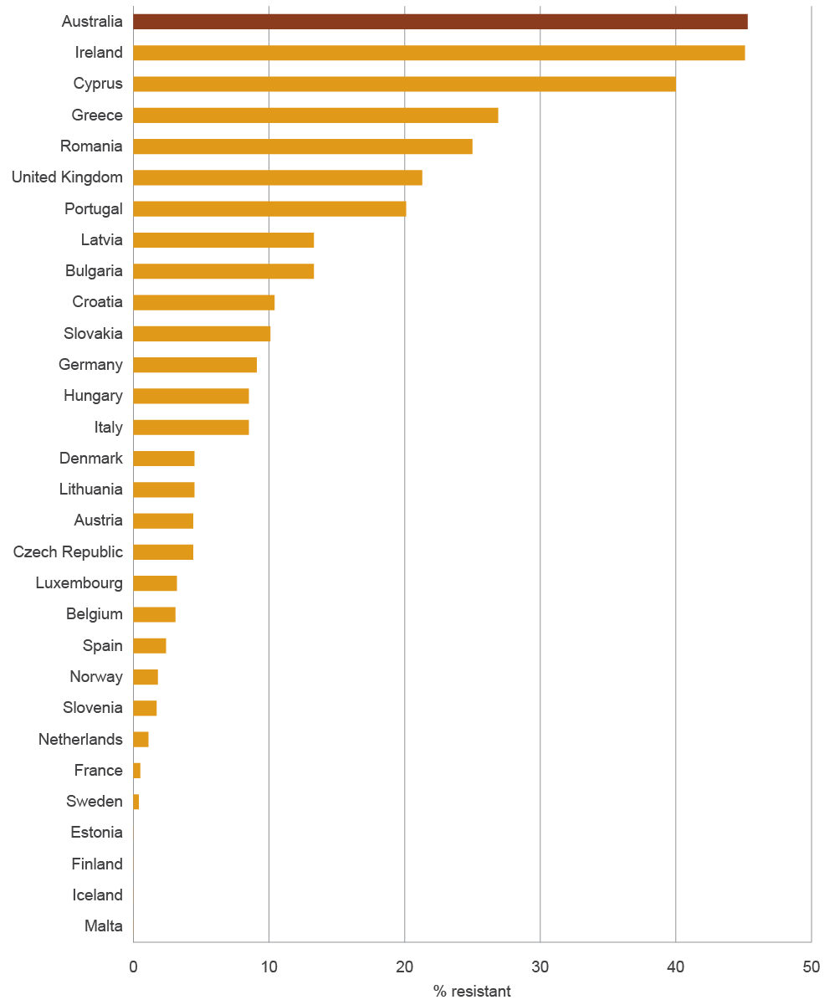

Sources: Australian Group on Antimicrobial Resistance, 2014; EARS-Net, 2014 (Polish data is from 2013)

# Using information for action

Key messages

* Effective surveillance systems should be more than just data collections – they should also provide meaningful and accessible information so that actions can be taken to prevent and contain AMR.
* AURA 2016 provides valuable data and comprehensive analyses of AMR, AU and appropriateness of prescribing in Australia, and sets a baseline that will allow trends in AMR and AU to be monitored over time.
* AURA 2016 highlights areas where additional work would improve understanding and inform further action. The Australian Commission on Safety and Quality in Health Care, in partnership with a number of organisations and the jurisdictions, is undertaking a range of activities to strengthen the AURA Surveillance System.
* A national alert system for critical antimicrobial resistances was established in March 2016.
* Future AURA reports will continue to improve and expand in line with the development of the AURA Surveillance System, the implementation of the National Antimicrobial Resistance Strategy, and the achievement of a better understanding of where investment in research and data collection is most valuable.

Under the National Safety and Quality Health Service Standards, Standard 3: Preventing and Controlling Healthcare Associated Infections requires healthcare organisations to monitor patterns of AU locally, and use this information to guide antimicrobial stewardship practices, as well as meet infection control requirements.7

Information from national surveillance can be used at every level in the health system to take action to ensure effective and efficient use of antimicrobials (Table 2).

Table 2 Uses and outcomes of national surveillance of antimicrobial use and resistance at different health system levels

| Level | Use of surveillance data | Impact or outcome |
| --- | --- | --- |
| Global | * Inform strategies to prevent and contain antimicrobial resistance, including the response to the Global Action Plan on Antimicrobial Resistance | * Coordinated efforts internationally; avoidance of duplication of effort and inefficient use of resources |
| National | * Inform policy and program development * Develop and revise guidelines * Inform public health priorities * Inform regulatory decisions * Coordinate, where necessary, the response to critical antimicrobial resistances | * Coordinated and integrated efforts across Australia * Increased awareness of antimicrobial resistance and One Health approach |
| State and territory | * Inform policy and program development * Develop and revise guidelines * Inform public health priorities * Inform regulatory decisions * Detect and respond to critical antimicrobial resistances and outbreaks | * Improved knowledge of local antimicrobial resistance profiles * Timely response to emerging resistance * Appropriate and effective use of antimicrobials |
| Healthcare services | * Inform clinical practice * Inform policy development * Develop local strategies to improve antimicrobial stewardship * Detect and respond to outbreaks of resistant organisms | * Appropriate and effective use of antimicrobials * Improved capacity for timely response to emerging resistance |
| Individual | * Raise awareness of appropriate use in the community | * Appropriate use of antimicrobials as prescribed * Decreased complications from unnecessary or inappropriate antimicrobial therapy |

AURA 2016 provides a baseline that will allow AU and AMR trends to be monitored over time. This will help to guide actions under the National Antimicrobial Resistance Strategy8 to ensure that prevention and containment activities are targeted to best effect. As successive reports are released, the impact of specific strategies can also be tracked.

AURA 2016 also shines a light on gaps in surveillance coverage; jurisdictional differences in data collection, analysis and reporting; and the use of different diagnostic systems for susceptibility testing as factors contributing to the currently fragmented picture of AMR and AU in Australia.

AURA 2016 provides guidance on future work in relation to surveillance, such as:

improving data analysis and interpretation at the national level

increasing data coverage across geographical areas (jurisdictional, urban, regional, rural and remote areas), patient settings (primary care, residential aged care and hospitals) and hospital types

improving data collection methods to allow better benchmarking and comparisons between hospitals

increasing participation in national data collection surveys such as NAPS, NAUSP and acNAPS

improving data collection and reporting of AMR in all jurisdictions

continuing to monitor emerging resistances and changes in patterns of resistance, and ensuring that they can be rapidly identified and contained to prevent outbreaks.

The Commission has established a national alert system for critical antimicrobial resistances. Although critical antimicrobial resistances are not currently widespread in Australia, outbreaks have the potential to spread, and cause great harm to patients and the healthcare system.

Other areas identified in AURA 2016 that warrant further consideration are:

assessing factors that drive variation in AU and prescribing across jurisdictions

improving appropriateness of prescribing in hospitals (particularly for surgical prophylaxis) and the community (particularly for upper respiratory tract infections)

advancing a response to the issue of inappropriate surgical prophylaxis

promoting the Antimicrobial Stewardship Clinical Care Standard in community and primary care.

As successive AURA reports are released, the impact of specific strategies can also be tracked. In addition, AMR and AU surveillance will be better integrated across jurisdictions and existing programs, to provide coordination of data and reports from a single, trusted source of information. Achieving these objectives will support the objectives of the National Strategy by informing strategic planning for coordinated and integrated action.

AURA 2016 is the first report of its kind in Australia. It is anticipated that regular reports will continue to be produced, with increasing capability to provide greater reach of surveillance, along with improved analyses and data reporting. In turn, this will result in the prevention and containment of AMR, and improved health outcomes for all Australians.

# References

1. Australian Commission on Safety and Quality in Health Care and SA Health. Antimicrobial use in hospitals: 2014 report of the National Antimicrobial Utilisation Surveillance Program. Sydney: ACSQHC, 2015.

2. Australian Commission on Safety and Quality in Health Care. Antimicrobial prescribing practice in Australian hospitals: results of the 2014 National Antimicrobial Prescribing Survey. Sydney: ACSQHC, 2015.

3. Australian Commission on Safety and Quality in Health Care and National Health Performance Authority. Australian atlas of healthcare variation. Sydney: ACSQHC, 2015.

4. NPS MedicineWise. MedicineInsight post market review report 3: antibiotics (unpublished). 2015.

5. Productivity Commission. Report on government services 2015. Canberra: Productivity Commission, 2015.

6. McGeer A, Campbell B, Emori TG, et al. Definitions of infection for surveillance in long-term care facilities. American Journal of Infection Control 1991;19:1–7.

7. Australian Commission on Safety and Quality in Health Care. National Safety and Quality Health Service Standards. Sydney: ACSQHC, 2012.

8. Australian Government Department of Health. First National Antimicrobial Resistance Strategy 2015–2019: responding to the threat of antimicrobial resistance. Canberra: DoH, 2015.