

Antimicrobial Use and Resistance in Australia

The A*ntimicrobial Use and Resistance in Australia (AURA) Report 2016: First Australian report on antimicrobial use and resistance in human health* highlights antimicrobial use and resistance as a critical and immediate challenge to health systems in Australia and around the world. AURA 2016 is a landmark report outlining the most comprehensive picture of antimicrobial resistance, antimicrobial use and appropriateness of prescribing in Australia to date, containing data on organisms that are considered a priority for Australia in terms of their impact on health.

Key ﬁndings from the report include:

* 10.7 million people in Australia (46% of the population) were prescribed antimicrobials in 2014.
* More than 40% of prescriptions for antimicrobials to prevent infection after surgery were inappropriate, due to incorrect duration, incorrect dose or dosing frequency.
* Antimicrobial use in hospitals in Australia has gradually declined since its peak in 2010. On any given day, 38.4% of hospital patients are prescribed antimicrobials.
* In residential aged care facilities, 11.3% of residents were on antimicrobial therapy, but only 4.5% had a suspected or conﬁrmed infection.
* Australia has one of the highest rates of vancomycin resistance in *Enterococcus faecium* compared to European countries. Rates of resistance to key antimicrobial agents are very low (<1%) in *E. faecalis*, but high (45-94.5%) in *E. faecium*.
* 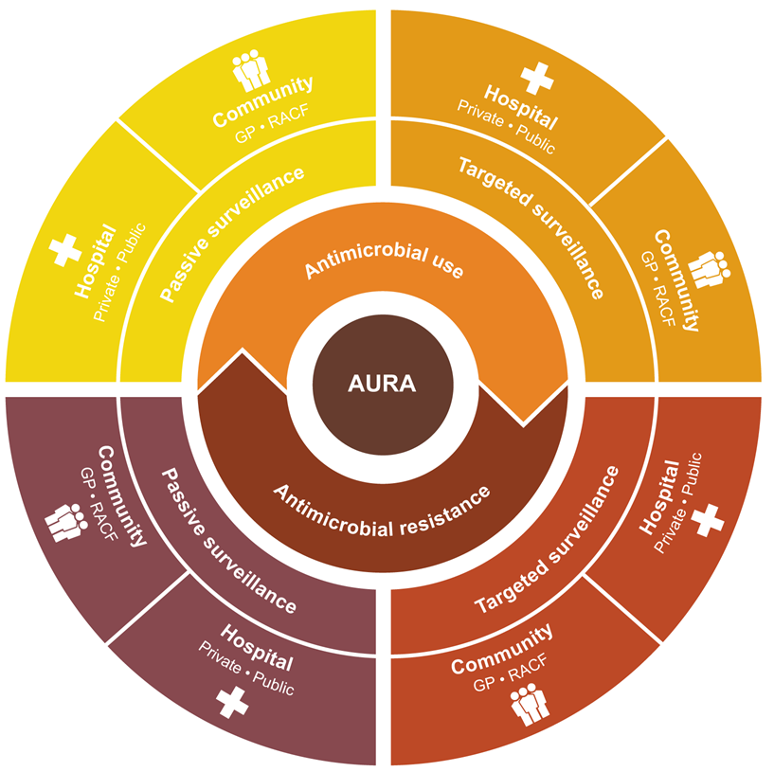Australia has a comparatively low rate of resistance to ﬂuoroquinolones, reﬂecting the restricted use of this antimicrobial class in Australia compared with that of many similar countries. Combined resistance to ﬂuoroquinolones, third-generation cephalosporins and aminoglycosides in *E. coli* was less than 2.5% in Australia.
* In the community, antimicrobials were most often dispensed for very young people and older people.

• In 2014, 57% of

those aged 0–4 years, 60% of those aged 65 years or over, and 74% of people aged 85 years or over were prescribed at least one antimicrobial.

* The 2014 Hospital National Antimicrobial Prescribing Survey found that 24.3% of prescriptions

were non-compliant with guidelines,

and 23.0% were inappropriate.

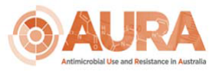

# AURA Surveillance System data sources:

Existing data collections partnering with AURA:

* + Australian Group on Antimicrobial Resistance
  + National Antimicrobial Prescribing Survey (NAPS) and the pilot of Aged Care NAPS
  + National Antimicrobial Utilisation Surveillance Program
  + Queensland Health OrgTRx System

Additional data sources used for AURA 2016 Report:

* + The National Neisseria Network
  + Office of Health Protection, National Notiﬁable Disease Surveillance Branch
  + Australian Mycobacterium Reference Laboratory Network
  + Pharmaceutical Beneﬁt Scheme and the Repatriation Pharmaceutical Beneﬁt Scheme
  + NPS MedicineWise MedicineInsight Program
  + Sullivan Nicolaides Pathology



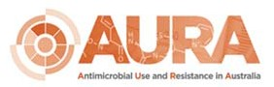

An infographic which shows:
In the community more than 50% of people with colds and upper respiratory infctions were prescribed antimicrobials unnecessarily;
In residential aged care around 20% of antimicrobial prescriptions were for people who had no signes of symptoms of infectin
In hospitals around 23% of antimicrobial prescriptions were considered appropriate.

# CARAlert System

|  |  |
| --- | --- |
| Organism | Critical resistance |
| *Enterobacteriaceae* | Carbapenemase-producing strains, or Ribosomal methylase-producing strains |
| *Enterococcus* species | Linezolid non-susceptible |
| *Mycobacterium tuberculosis* | MDR (at least rifampicin and isoniazid resistant) strains |
| *Neisseria gonorrhoeae* | Ceftriaxone non-susceptible, or azithromycin resistant strains |
| *Salmonella* species | Ceftriaxone non-susceptible strains |
| *Shigella* species | MDR strains |
| *Staphylococcus aureus* | Vancomycin, linezolid, or daptomycin non-susceptible |
| *Streptococcus pyogenes* | Penicillin reduced susceptibility |

## For more information about AURA and for copies of AURA publications visit:

[www.safetyandquality.gov.au/antimicrobial-use-and-resistance-in-australia/](http://www.safetyandquality.gov.au/antimicrobial-use-and-resistance-in-australia/)