Antimicrobial prescribing and infections in Australian residential aged care facilities
  - Results of the 2015 Aged Care National Antimicrobial Prescribing Survey pilot
May 2016
© Commonwealth of Australia 2016
Antimicrobial prescribing and infections in Australian residential aged care facilities: Results of the 2015 Aged Care National Antimicrobial Prescribing Survey pilot
ISBN 978-1-925224-45-0 (print), 978-1-925224-46-7 (online)
This report was prepared by:
Australian Commission on Safety and Quality in Health Care
Level 5, 255 Elizabeth Street
Sydney, New South Wales 2000
in collaboration with:
The Centre for Research Excellence – National Centre for Antimicrobial Stewardship
The Peter Doherty Institute for Infection and Immunity, a joint venture of the University of Melbourne and The Royal Melbourne Hospital
Level 5, 792 Elizabeth Street
Melbourne, Victoria 3000
Guidance Group
The Peter Doherty Institute for Infection and Immunity, a joint venture of the University of Melbourne and The Royal Melbourne Hospital
Level 5, 792 Elizabeth Street
Melbourne, Victoria 3000
Victorian Healthcare Associated Infection Surveillance System Coordinating Centre
The Peter Doherty Institute for Infection and Immunity, a joint venture of the University of Melbourne and The Royal Melbourne Hospital
Level 5, 792 Elizabeth Street
Melbourne, Victoria 3000
This report can be accessed on the National Centre for Antimicrobial Stewardship website and on the Australian Commission on Safety and Quality in Health Care website.
Disclaimer: The data presented in this report was correct at the time of publication.
This work is copyright. It may be reproduced in whole or in part for study or training purposes subject to the inclusion of an acknowledgement of the source. Requests and inquiries concerning reproduction and rights for purposes other than those indicated above require the written permission of the Australian Commission on Safety and Quality in Health Care, GPO Box 5480, Sydney, NSW 2001, or mail@safetyandquality.gov.au.
This publication is part of the work being conducted by the Australian Commission on Safety and Quality in Health Care to establish a national antimicrobial resistance and usage surveillance system. This work is being undertaken through the Antimicrobial Use and Resistance in Australia (AURA) project.
The Australian Commission on Safety and Quality in Health Care wishes to thank and gratefully acknowledge the important contribution to this report of the residential aged care facilities and multipurpose services that participated in the 2015 pilot Aged Care National Antimicrobial Prescribing Survey.
Suggested citation: National Centre for Antimicrobial Stewardship and Australian Commission on Safety and Quality in Health Care. Antimicrobial prescribing and infections in Australian residential aged care facilities: Results of the 2015 Aged Care National Antimicrobial Prescribing Survey pilot. Sydney: ACSQHC, 2016.
For further details about the Aged Care National Antimicrobial Prescribing Survey, visit the website,
send an email or phone (03) 9342 9415.
Front cover photo courtesy of DoseAid

Contents
Abbreviations v
Executive summary vi
Background 1
Antimicrobial resistance 1
Antimicrobial stewardship programs 1
Aged Care National Antimicrobial Prescribing Survey 2
Methods 3
Recruitment 3
Survey questions 4
Infection definitions 5
Results 7
Participating facilities 7
Surveyors 9
Resident data analyses 9
Prevalence of infections 10
Types of infections 10
Antimicrobial use 11
Key results 11
Prolonged duration of antimicrobial use 12
Mode of prescription 12
Most commonly prescribed antimicrobials 13
Most common indications for prescribing antimicrobials 14
Microbiology 16
Appropriateness of prescribing 17
Participant feedback 19
Conclusion 20
Appendix 1 RACF form 21
Glossary 26
References 29

Abbreviations
acNAPS Aged Care National Antimicrobial Prescribing Survey
AMR antimicrobial resistance
AMS antimicrobial stewardship
MPS multipurpose service
NCAS National Centre for Antimicrobial Stewardship
RACF residential aged care facility
RICPRAC Rural Infection Control Practice Group
VICNISS Victorian Healthcare Associated Infection Surveillance

Executive summary
Antimicrobial resistance (AMR) was recently stated by the World Health Organization to be one of the greatest threats to human health. AMR reduces the effective prevention and treatment of an increasing range of infections caused by bacteria, viruses, parasites and fungi. These include organisms causing common infections such as urinary tract infections and pneumonia.
Evidence shows a correlation between AMR and antimicrobial use. For this reason, frequent and inappropriate use of antimicrobials in residential aged care facilities (RACFs) is especially concerning. In RACFs with high antimicrobial use, there is an increased risk for all residents of acquiring an antimicrobial-resistant infection; this includes residents who are not receiving antimicrobial therapy, because of the potential for cross-transmission among residents.
Australia’s first National Antimicrobial Resistance Strategy (2015–2019) acknowledges that action is required in all settings where antimicrobials are used, if the level of AMR in Australia is to be successfully controlled.
Antimicrobial stewardship (AMS) programs have been introduced in many countries to optimise appropriate antimicrobial use to improve patient outcomes, ensure cost-effective therapy and reduce adverse sequelae of antimicrobial use, including AMR. A core element of AMS programs is surveillance of infections and antimicrobial use. Since 2013, Australian hospitals have been able to audit their antimicrobial use using a standardised national survey instrument, the National Antimicrobial Prescribing Survey.
The Aged Care National Antimicrobial Prescribing Survey (acNAPS) pilot was a collaborative project between the National Centre for Antimicrobial Stewardship (NCAS), the Guidance Group and the Victorian Healthcare Associated Infection Surveillance Coordinating Centre. The pilot was supported by funding from the Australian Commission on Safety and Quality in Health Care (the Commission) under the Antimicrobial Use and Resistance in Australia project.
The aim of the acNAPS pilot was to develop a sustainable and standardised survey instrument to monitor the prevalence of infections and antimicrobial use in Australian RACFs. The survey’s long-term aims are to support an AMS program by:
- monitoring the prevalence of infections and antimicrobial prescribing trends at a local, regional, state and national level
establishing acNAPS as an annual reporting mechanism for AMR in RACFs identifying priority areas for quality improvement interventions to increase the proportion of antimicrobials that are appropriately used.
Across Australia, 186 RACFs participated in the acNAPS pilot between June and August 2015. Individual facilities conducted a single-day (point prevalence) survey. All states, remoteness areas and provider types were represented. Of the participating RACFs, 69.9% were in Victoria. The majority of these Victorian RACFs had previously participated in similar state-based point prevalence surveys coordinated by the VICNISS Coordinating Centre and the Rural Infection Control Practice Group.
Infection control practitioners (57.5%), nurses (35.5%) and pharmacists (11.0%) were the main surveyors. All residents were assessed against the inclusion criteria – that is, on the survey day, they had signs or symptoms of a suspected or confirmed infection, and/or a current prescription for antimicrobial therapy. Data was collected from a range of sources (e.g. resident medical histories and medication charts) and submitted to NCAS through the online data entry portal.
Summary findings from the 2015 acNAPS pilot show that the prevalence of RACF residents with signs and symptoms of infection was 4.5%. The prevalence of residents prescribed one or more antimicrobials was 11.3%. In total, 975 antimicrobials were prescribed for 824 residents. The five most commonly prescribed antimicrobials were cephalexin (16.7%), clotrimazole (16.5%), amoxicillin–clavulanate (6.5%), trimethoprim (6.5%) and chloramphenicol (6.4%). Topical antimicrobials were frequently prescribed (37.1%). The five most common indications for antimicrobial prescribing were ‘unspecified’ (i.e. not otherwise classified) skin, soft tissue or mucosal infections (17.5%); urinary tract infections (16.7%); lower respiratory tract infections (11.8%); tinea (8.4%); and conjunctivitis (5.2%).
The 2015 acNAPS results identified three key areas for targeted quality improvement interventions:
- inadequate documentation
- 31.6% of prescriptions did not have an indication documented justifying their use
65.0% of prescriptions did not have a review or stop date documented
- use of antimicrobials for unspecified infections
17.5% of antimicrobials were being used for unspecified skin infections
- prolonged duration of prescriptions
31.4% of prescriptions had been prescribed for longer than six months; of these, only 51.0% had an indication documented, and only 2.0% had a review or stop date recorded.
Additional information regarding microbiology, and infection signs and symptoms was collected for a subset of prescriptions that had a known start date, were prescribed within six months of the survey date and were not prescribed for prophylaxis. Of these 548 prescriptions:
- only 23.9% had a microbiological specimen collected in the week before the antimicrobial start date
21.7% were prescribed for residents who did not have any documented signs or symptoms of infection in the week before the antimicrobial start date. For those prescriptions where signs or symptoms were documented, 66.4% did not meet the McGeer infection criteria (a set of internationally recognised infection definitions and criteria specifically developed for use in RACFs).
Participant feedback was positive. Most RACFs indicated that they would participate in the survey again and were satisfied with the amount of data that they were required to collect. Suggestions for improving the survey included:
- increasing the clarity of the data collection forms
enhancing the functionality of the online data entry portal.
Qualitative evaluation revealed that AMS, including collection and analysis of data on antimicrobial use and infection, remains a relatively new concept in Australian RACFs. Increased awareness of AMS, and improved access to AMS program implementation and decision support tools will be fundamental for successful AMS programs in RACFs. These tools will also improve the appropriateness of antimicrobial use in this setting. Furthermore, individual facility acNAPS reports, detailing local data, will need to:
- clearly identify areas for quality improvement
- facilitate the use of results for prescribing and cultural change
illustrate aggregate AMS performance.
The acNAPS pilot represents a significant step forward in raising awareness of the importance of AMS in RACFs. Although participating RACFs are now better placed to identify priority areas for local AMS interventions, a coordinated national effort will also assist in advancing AMS in these settings. Further collaboration with key aged care organisations and the Royal Australian College of General Practitioners is required to ensure that such initiatives are sustainable and appropriately tailored for the aged care sector.
All Australian RACFs and multipurpose services are strongly encouraged to participate in the 2016 acNAPS, which will take place between June and August 2016.

Background

Antimicrobial resistance
Antimicrobial resistance (AMR) has been declared by the World Health Organization (WHO) as one of the greatest threats to human health.1 The continuous development of new antimicrobials has, until recently, allowed the successful treatment of bacterial, viral, parasitic and fungal infections. However, with the decline in the number of new antimicrobials being developed,2 people who develop antimicrobial-resistant infections, including common infections such as urinary tract infections and pneumonia, are exposed to an increased risk of morbidity and mortality.
Evidence shows a strong correlation between AMR and antimicrobial use – numerous studies indicate that countries, regions and healthcare facilities with the highest levels of antimicrobial use also have the highest rates of AMR.3 In Australia, it is estimated that 38% of hospital inpatients are receiving an antimicrobial on any given day, with approximately 23% of these prescriptions being inappropriate.4 Although the prevalence of antimicrobial use in residential aged care facilities (RACFs) is lower (5–13%), international studies indicate that a higher proportion of these prescriptions (25–75%) are noncompliant with prescribing guidelines and are inappropriate.5-10 In RACFs with high antimicrobial use, there is an increased risk for all residents of acquiring an antimicrobial-resistant infection – this includes residents who are not receiving antimicrobial therapy – because of the potential for cross-transmission.11
In response to the WHO declaration, Australia’s first National Antimicrobial Resistance Strategy (2015–2019) was developed and endorsed by health and agriculture ministers, and the broader Australian Government in 2015. This strategy is an immediate call for action to improve the appropriateness of antimicrobial use in all settings. It details key objectives, and outlines the required actions to effectively monitor and contain AMR in Australia, including the development of national surveillance systems for AMR and antimicrobial use.
As part of these national responses, the Australian Commission on Safety and Quality in Health Care (the Commission) is establishing the Antimicrobial Use and Resistance in Australia Surveillance System, a nationally coordinated surveillance system to inform policy and strategy development to prevent and contain AMR across the hospital, aged care and community sectors.

Antimicrobial stewardship programs
Antimicrobial stewardship (AMS) programs are a coordinated and multidisciplinary approach to promoting appropriate antimicrobial use. Effective AMS programs have been proven to optimise patient and resident outcomes, improve the cost-effectiveness of therapy and reduce the adverse cycle of antimicrobial use contributing to AMR. Since 2013, the National Safety and Quality Health Service Standards, endorsed by health ministers, have required Australian hospitals – but not RACFs – to have an AMS program in place. Hospitals need to be able to demonstrate that antimicrobial use is monitored, performance of the program is evaluated and actions are taken to improve antimicrobial use.12
There are no specific Australian guidelines detailing the actions required to successfully implement and sustain AMS programs in RACFs. In September 2015, the United States Centers for Disease Control and Prevention (CDC) released the first publicly available The core elements of antibiotic stewardship for nursing homes.13 The CDC recommends that RACFs add new strategies from each of the seven core elements over time. The core elements include tracking (monitoring of antibiotic prescribing and resistance patterns) and reporting (regular reporting of information on antibiotic use and resistance to doctors, nurses and relevant staff).
In Australia, a national survey similar to the hospital National Antimicrobial Prescribing Survey (NAPS) was not available for Australian RACFs before the 2015 pilot of the Aged Care National Antimicrobial Prescribing Survey (acNAPS). The hospital NAPS, which has been in place since 2013, is a standardised auditing tool designed to assess the quantity and quality of antimicrobial prescribing in Australian hospitals. At a state level, between 2010 and 2014, the Victorian Healthcare Associated Infection Surveillance (VICNISS) Coordinating Centre and the Rural Infection Control Practice Group coordinated annual point prevalence surveys of infections and antimicrobial use in Victorian public sector RACFs.10 The Victorian surveys were based on the 2010 and 2013 European Centre for Disease Prevention and Control point prevalence surveys on infections and antibiotic use in long-term care RACFs.5 Similar state-based surveys have not been undertaken in other Australian states or territories.

Aged Care National Antimicrobial Prescribing Survey
The 2015 acNAPS pilot was a collaborative project between the National Centre for Antimicrobial Stewardship (NCAS), the Commission, the Guidance Group and the VICNISS Coordinating Centre. NCAS, the Guidance Group and VICNISS together employ infectious diseases physicians, infection control practitioners, epidemiologists, clinical microbiologists, specialist pharmacists and information technology officers who are able to provide expert guidance on AMS.
The aim of the acNAPS pilot was to develop and implement a sustainable and standardised quantitative survey instrument to monitor infections and antimicrobial use in Australian RACFs. The long-term aim of acNAPS is to support AMS in RACFs by:
- monitoring the prevalence of infections and antimicrobial prescribing at a local, regional, state and national level in a sustainable manner
- establishing acNAPS as an annual reporting mechanism for AMR in aged care
identifying priority areas for quality improvement interventions to increase the proportion of antimicrobials that are appropriately used.

Methods
To inform the development of the Aged Care National Antimicrobial Prescribing Survey (acNAPS) pilot, a major literature review was conducted and key stakeholders were consulted. The point prevalence survey of the Victorian Healthcare Associated Infection Surveillance (VICNISS) Coordinating Centre and the Rural Infection Control Practice (RICPRAC) Group was reviewed and modified, and used as the basis for the pilot acNAPS survey form. The acNAPS form included more detailed data fields about antimicrobial use than the VICNISS–RICPRAC survey form. Additional data fields about microbiological specimens were also included.
The data collection period ran from 22 June to 31 August 2015. During this period, 186 participating residential aged care facilities (RACFs) and multipurpose services (MPSs) conducted a single-day point prevalence survey. Surveyors included trained infection control practitioners, pharmacists and nurses who worked with senior clinical staff employed at participating RACFs. The supporting resources included a user guide, case examples and website instructions. Online training sessions were provided in addition to email and telephone assistance, where requested.
Data sources included resident histories, medication charts, microbiology reports and hospital discharge summaries. For some data fields, it was acceptable to ask a senior RACF clinician to provide the necessary detail. Data was submitted online to the National Centre for Antimicrobial Stewardship, through the acNAPS data entry portal.

Recruitment
All Australian RACFs and MPSs were eligible to participate in the 2015 pilot acNAPS. The aim was to recruit at least:
- the Victorian public sector RACFs that had previously participated in VICNISS–RICPRAC surveys
a small number of RACFs or MPSs across the various states and territories, remoteness areas and funding types.
Invitations to participate were advertised through:
- newsletters (of the Australasian College for Infection Prevention and Control, the Australian Association of Consultant Pharmacy, and the Pharmaceutical Society of Australia)
- a Commission communique to large RACF providers, peak aged care bodies (Leading Age Services Australia and Aged Care Services Australia Group) and New South Wales local health districts
- a discussion board (Aus-Pharmacist Group)
- an email to Victorian public health services (through VICNISS) and the Victorian Older Persons Nurse Practitioner Collaborative
- personal invitations to six large RACF providers
a presentation at a meeting of the Victorian Small Rural Health Service Directors of Nursing.

Survey questions
The survey questions were detailed on three data collection forms:
- RACF Form (Appendix 1)
- Resident Form – infections (Appendix 2)
Resident Form – antimicrobials (Appendix 3).
The RACF Form collected data about the facility’s characteristics, such as level of access to Therapeutic Guidelines: Antibiotic and summary demographics of all residents, including gender and age.
Residents were surveyed to determine whether they met the inclusion criteria. Residents were included if, on the survey day, they had:
- signs or symptoms of a suspected or confirmed infection (a Resident Form – infections was completed), and/or
a current prescription for antimicrobial therapy (a Resident Form – antimicrobials was completed).
Table 1 summarises the data fields in the infection and antimicrobial data collection forms.
Table 1 Survey questions in resident forms
Survey questions | Resident Form –  infections | Resident Form –  antimicrobials
Antimicrobial details, including name, dose, route and indication. All routes and formulations could be included | No | Yes
Antimicrobial quality measures, including level of documentation, whether the antimicrobial was for prophylaxis and the initial mode of prescription (e.g. telephone order or written by prescriber). For antimicrobials prescribed via a telephone order, information regarding subsequent clinical review by the prescriber | No | Yes
Presence of a urinary catheter and whether urinary dipstick tests had been undertaken | Yes | Yes, if the antimicrobial was for treatment and had a known start date that was <6 months before the survey day. Time period: 1 week prior to the antimicrobial start date
Whether microbiological specimens had been collected and reported | Yes
Whether the resident had exhibited any signs or symptoms of infection | Yes

Infection definitions
The criteria for an infection were based on the internationally recognised surveillance definitions from McGeer et al.7 These definitions were revised by Stone et al. in 2012.14 The definitions are largely based on signs and symptoms localising to a specific body system (gastrointestinal tract, respiratory tract, skin/soft tissue/mucosal, systemic, and urinary tract). For some definitions, additional microbiological or radiological evidence and use of devices (e.g. urinary catheters) were also assessed.
The McGeer criteria were used as a surrogate marker for appropriateness of prescribing of antimicrobials to support surveyors to make qualitative assessments of prescription compliance with antimicrobial guidelines (e.g. Therapeutic Guidelines: Antibiotic). Antimicrobials prescribed for residents with signs, symptoms and investigations that met McGeer criteria were deemed ‘appropriate’.
Limitations in methodology
The acNAPS pilot results discussed in this report require interpretation in the context of the following limitations in the survey methodology.
Sampling and selection bias
The results may not be generalisable to all Australian RACFs and MPSs because participation was voluntary, and the majority of facilities were from a single state (Victoria) with a history of participation in similar surveys. Additionally, most of the participating RACFs in Victoria were public facilities that are associated with acute healthcare facilities – this is not the case in other states and territories.
Infection definitions
The McGeer infection surveillance definitions have been designed to increase the likelihood that events captured are confirmed infections. Signs and symptoms of infection in older residents may be atypical, so failure to meet the definitions may not fully exclude the presence of a confirmed infection. In other words, the definitions have been designed for specificity at the expense of sensitivity – although they will detect very few false positives, some infections may be missed.
The McGeer definitions require microbiological confirmation for some infections; this means that these infections will not be confirmed unless specimens are taken.
Seasonal variation
The survey was conducted during winter. The results may have been different in another season.
Validation
Comprehensive validation and reliability testing is currently under way.

Results

Participating facilities
A total of 186 residential aged care facilities (RACFs) and multipurpose services participated in the 2015 pilot Aged Care National Antimicrobial Prescribing Survey (acNAPS). They represented all remoteness areas, provider types and jurisdictions, except the Australian Capital Territory and the Northern Territory (Table 2).
Table 2 Participating RACFs or MPSs by state, remoteness and provider type
Category |  | Number of RACFs (%)
State | NSW | 17.(9.1)
State | Qld | 7.(3.8)
State | SA | 8 (4.3)
State | Tas | 6 (3.2)
State | Vic | 130 (69.9)
State | WA | 18 (9.7)
Remotenessa | Major cities | 51 (27.4)
Remotenessa | Inner regional | 81 (43.5)
Remotenessa | Outer regional | 45 (24.2)
Remotenessa | Remote | 8 (4.3)
Remotenessa | Very remote | 1.(0.5)
Provider type | Not for profit | 37 (19.9)
Provider type | - charitable | 9
Provider type | - religious | 20
Provider type | - community based | 8
Provider type | Government | 141.(75.8)
Provider type | - state | 140
Provider type | - local | 1
Provider type | Private | 8.(4.3)
Total |  | 186
NSW = New South Wales; Qld = Queensland; RACF = residential aged care facility; SA = South Australia; Tas = Tasmania; Vic = Victoria; WA = Western Australia
a Australian Standard Geographic Classification Remoteness Areas
Sixty-eight RACFs (36.6%) responded to questions about their level of access to resources and pharmacy services. Of these:
- about half (54.4%) used an electronic clinical and administrative resident management system
- 14.7% did not have access to Therapeutic Guidelines: Antibiotic
- about one-third (32.4%) did not have electronic access to microbiology reports
about half (48.5%) did not have access to any of the three Quality Use of Medicines (QUM) services (education, surveying and medicines review). Only 17% had access to all three. The values for each of the QUM services individually were as shown in Table 3.
Table 3 Access of facilities to pharmacy services
Pharmacy service provided | Percentage (number) of facilities with access to service
Education | 35.3 (24)
Surveying | 33.8 (23)
Medicines review | 35.3 (24)
Table 4 summarises the data on risk factors for infection for all RACF residents in the acNAPS pilot on the survey day.
Table 4 Risk factors for infection for all residents present on the survey day (n = 7589)
Risk factor for infection | National total (%)
Age >85 years | 3968 (52.3)
Female | 4977 (65.6)
Admitted to hospital in previous 30 days | 277 (3.7)
Intravenous catheter present | 7 (0.1)
Indwelling urinary catheter present | 329 (4.3)

Surveyors
There were 118 surveyors across the 186 RACFs and MPSs. Most were infection control practitioners (47.5%), nurses (35.6%) or pharmacists (11.0%). About 40% worked in, or collected data from, more than one RACF (range 2 to 15 RACFs per surveyor).

Resident data analyses
Figure 1 is a summary flow chart of the resident data included in, and excluded from, the analyses of infection prevalence and antimicrobial use.
Figure 1 Inclusion and exclusion of resident data
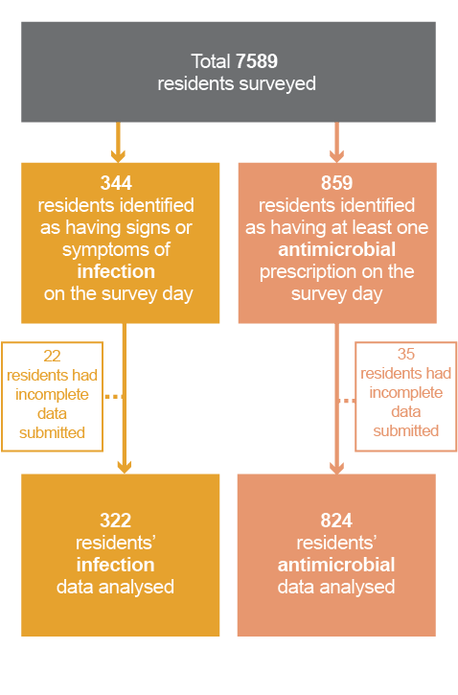

Prevalence of infections
Overall, 4.5% of residents (344 of 7589) were identified as having signs or symptoms of infection on the survey day. Victoria is the only Australian state that has a history of completing surveys similar in content to acNAPS. The prevalence was lower for Victorian facilities (3.7%; 172 of 4704) than for the non-Victorian facilities (6.0%; 172 of 2885). The result for Victorian sites was consistent with the 2014 Victorian Healthcare Associated Infection Surveillance (VICNISS) – Rural Infection Control Practice Group (RICPRAC) point prevalence survey result of 3.7%.15
Of the 344 residents identified as having signs or symptoms of infection, 22 had incomplete data entered into the online database. Hence, the remainder of this section describes the results only for the 322 residents with complete data.

Types of infections
The vast majority of residents’ signs or symptoms came from the respiratory, urinary, skin and soft tissue, eye, and oral body systems. The breakdown according to each McGeer body system is shown in Figure 2. Note that some residents displayed signs or symptoms from more than one body system, giving a total of 377 body systems. 15.9% of these signs and symptoms were present (or incubating) when the resident was admitted to the RACF or MPS.
Figure 2 Signs and symptoms of infection, by McGeer body system and association with RACF
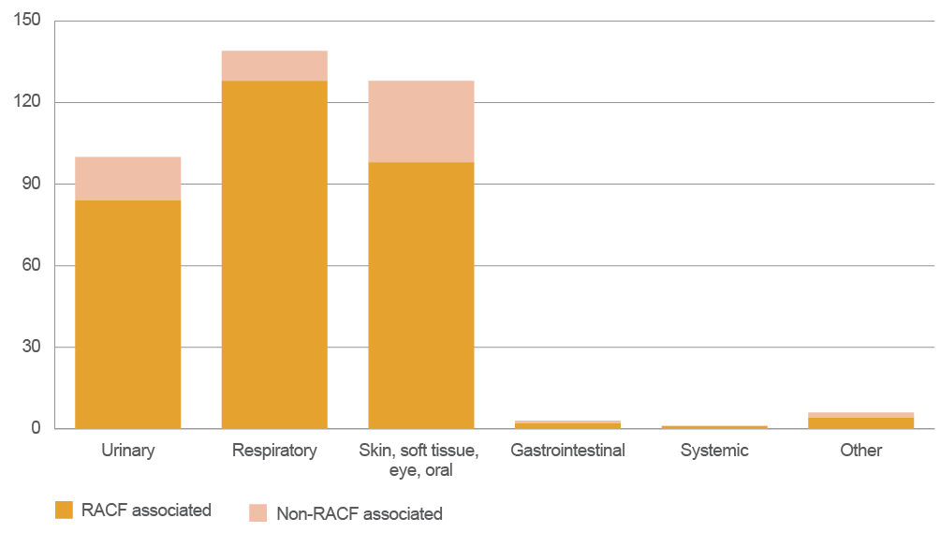
RACF = residential aged care facility

Antimicrobial use
On the survey day, 11.3% (859 of 7589) of residents were prescribed at least one antimicrobial. The value was lower for the Victorian sites (7.1%; 334 of 4704) and substantially higher for the non-Victorian sites (18.2%; 525 of 2885).
Excluding topical antimicrobials, the overall prevalence was 7.9% (601 of 7589). The value was lower for Victorian sites (6.4%; 301 of 4704 – slightly higher than the 2014 VICNISS–RICPRAC point prevalence survey result of 5.5%10) and higher for non-Victorian sites (10.4%; 300 of 2885).
Of the 859 identified residents, 35 had incomplete data entered into the online database. Hence, the remainder of this section describes the results only for the 824 residents with complete data.

Key results
There was a total of 975 antimicrobial prescriptions for 824 residents. Some residents were prescribed more than one antimicrobial.
The results of the two key quality indicators used are summarised in Table 5. The best-practice target of more than 95% for documentation of indication is based on the European Surveillance of Antimicrobial Consumption point prevalence survey, designed by the European Centre for Disease Control and Prevention.16 There is no published best-practice target for documenting a review or stop date. However, the Antimicrobial Stewardship Clinical Care Standard17 requires that all prescriptions have the intended duration and review plan documented in the health record. Hence, the same best-practice target of more than 95% was applied to this indicator.
Overall, 68.4% of all antimicrobial prescriptions had an indication documented, and 35.0% had a review or stop date documented. Both these results fall well short of the best-practice targets. Documentation of indication was lowest for topical antimicrobials (58.7%), and documentation of review or stop date was very low for prophylactic and topical antimicrobials (13.0% and 15.2%, respectively).

Prolonged duration of antimicrobial use
A substantial proportion of antimicrobials (31.4%; 306 of 975) had been prescribed for more than six months before the survey day. Of these, only half (51.0%; 156 of 306) had an indication documented, and only 2.0% (6 of 306) had a review or stop date documented.
These prescriptions comprised both topical (58.5%; 179 of 306) and systemic (41.5%; 127 of 306) antimicrobials. Prophylactic use accounted for 40.9% (125 of 306) of prescriptions, and treatment 59.2% (181 of 306) of prescriptions (Figure 3). The majority of the prolonged prophylaxis prescriptions were for systemic antimicrobials, where the most common indication was urinary tract infection (43.3%; 55 of 127). Conversely, the majority of the prolonged treatment prescriptions were for topical antimicrobials, where the primary indications were unspecified skin and soft tissue infections (52.3%; 80 of 153), and tinea (32.7%; 50 of 153).
Figure 3 Antimicrobials that had been prescribed for more than six months, by prophylaxis versus treatment and systemic versus topical routes
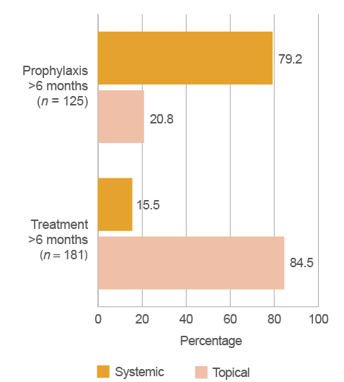

Mode of prescription
For antimicrobial prescriptions where a start date was specified, most (85.0%; 531 of 625) were written by the prescriber. Approximately 8% (51 of 625) were prescribed through a telephone order; of these, 68.6% (35 of 51) were prescribed for residents who had not been seen by the prescriber.
Table 5 Summary of key quality indicators, as a percentage of prescriptions for each category
Category |  | % indication documented  (best practice >95%) | % review or stop date documented  (best practice >95%)
All prescriptions (n = 975) |  | 68.4 | 35.0
Prophylaxis or treatment | Treatment (n = 752) | 68.5 | 41.5
Prophylaxis or treatment | Prophylaxis (n = 223) | 68.2 | 13.0
Route of administration | Systemic (n = 612) | 74.2 | 46.7
Route of administration | Topical (n = 363) | 58.7 | 15.2

Most commonly prescribed antimicrobials
The five most commonly prescribed antimicrobials were cephalexin, clotrimazole, amoxicillin–clavulanate, trimethoprim and chloramphenicol (Figure 4), accounting for approximately half of all prescriptions. Overall, more than one-third of all prescribing (37.2%; 363 of 975) was for topical antimicrobials.
Figure 4 The top 20 antimicrobials, as a percentage of total antimicrobial prescriptions (n = 975)
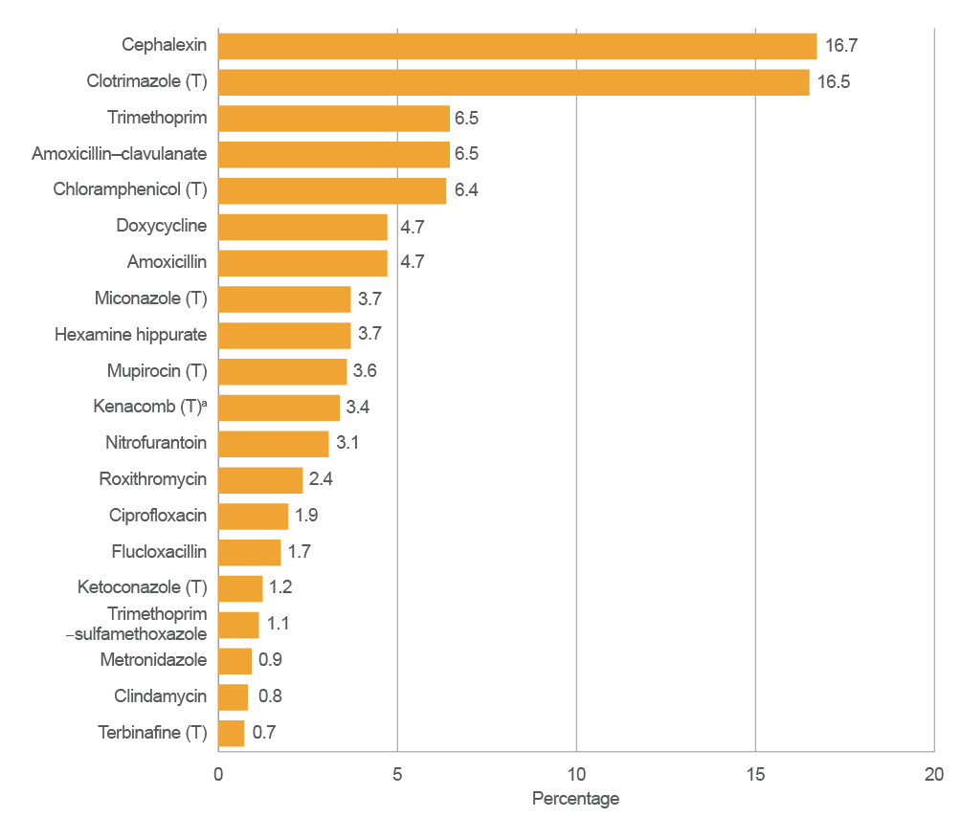
T = topical
a Kenacomb contains triamcinolone, neomycin, nystatin and gramicidin.

Most common indications for prescribing antimicrobials
The top five indications were unspecified (i.e. not otherwise classified) skin, soft tissue or mucosal conditions; urinary tract infection (cystitis); lower respiratory tract infection; tinea; and conjunctivitis. These indications accounted for more than half of all prescribing (Figure 5). The indication was unknown for 5.5% (54 of 975) of antimicrobial prescriptions.
Figure 5 indicates that almost 20% of the total indications were unspecified skin, soft tissue or mucosal conditions. This is concerning, particularly as the survey included a number of specific common skin, soft tissue and mucosal indications (such as cellulitis, oral candidiasis and wound infections). Although it is possible that these unspecified indications reflect poor levels of documentation, the reason is currently unclear and will be investigated in future surveys.
Figure 5 The 20 most common indications for antimicrobial prescribing,a as a percentage of total antimicrobial prescriptions (n = 975)
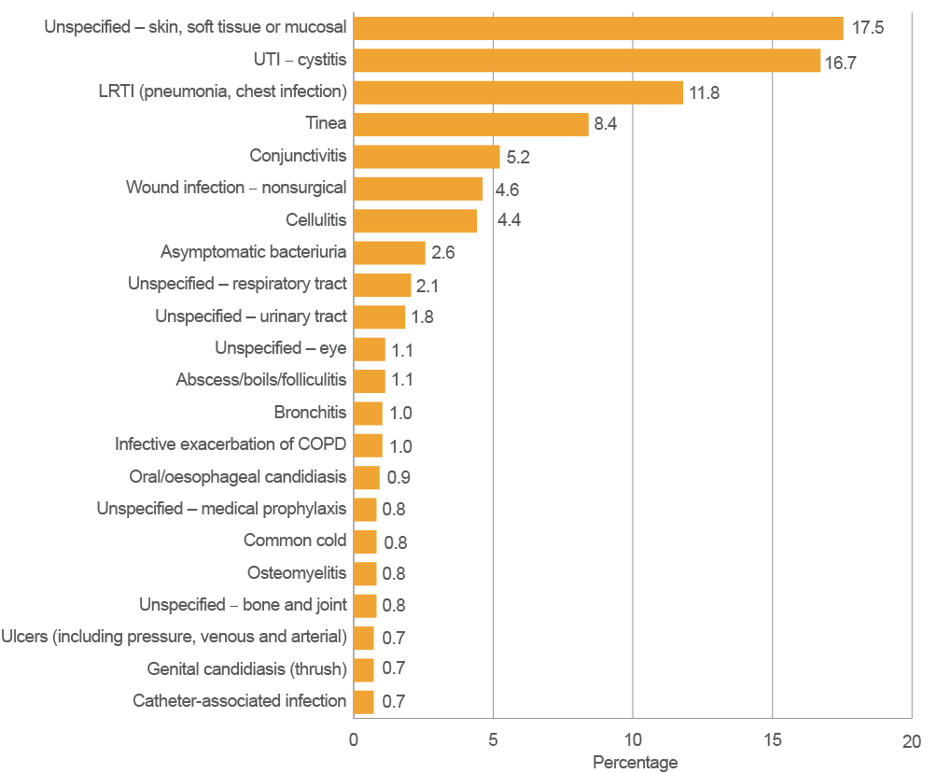
COPD = chronic obstructive pulmonary disease; LRTI = lower respiratory tract infection; UTI = urinary tract infection
a There are 22 indications shown because the 20th, 21st and 22nd indications have the same values.
Note: Prescriptions marked as ‘Unknown indication’ are not shown.
Overall, 22.9% of antimicrobials were prescribed for prophylaxis. A more detailed breakdown of the most common indications by treatment versus prophylaxis is shown in Figure 6. The distribution of treatment indications was reasonably consistent with the overall results shown in Figure 5; however, there was a larger proportion of urinary tract infections in the prophylaxis group (36.3%).
Figure 6 The 10 most common indications for treatment (n = 752) and prophylaxisa (n = 223)
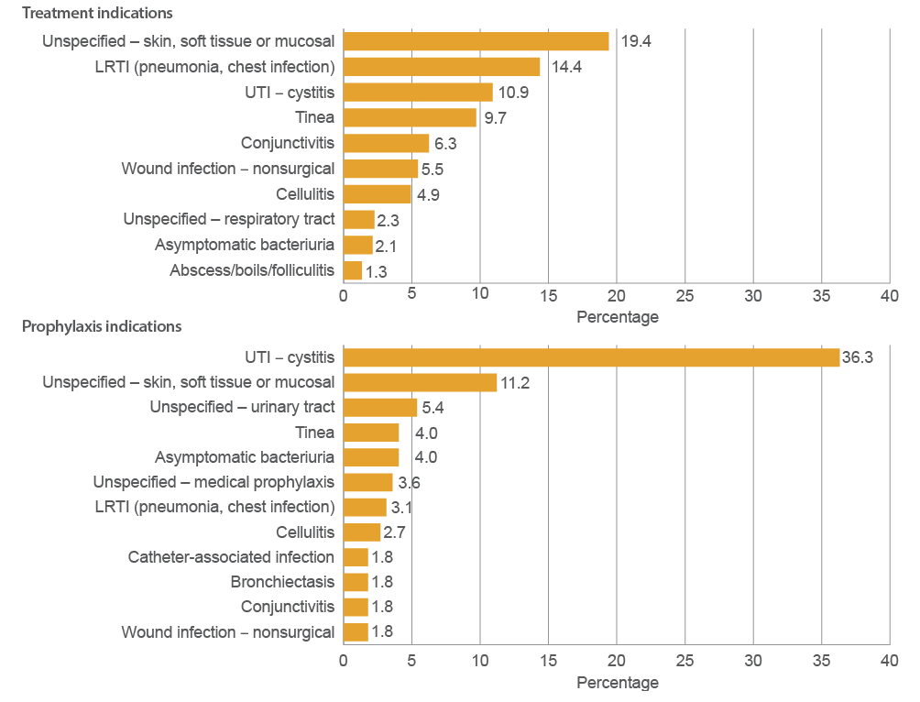
COPD = chronic obstructive pulmonary disease; LRTI = lower respiratory tract infection; UTI = urinary tract infection
a There are 12 prophylaxis indications shown because the 10th, 11th and 12th indications have the same values.
Note: Prescriptions marked as ‘Unknown indication’ are not shown.

Microbiology
Microbiology data was collected for a subset of prescriptions that were for treatment indications and had a known start date that was within six months of the survey date (548 from a total of 975).
About one-quarter (23.9%; 131 of 548) of these prescriptions were for residents who had a microbiological specimen collected during the week before the antimicrobial start date. Figure 7 shows the proportion of prescriptions where a specimen was taken, grouped by body system.
The majority (63.8%) of prescriptions for urinary tract infections had microbiological specimens taken. Of these urinary specimens, 17.9% were taken for residents with asymptomatic bacteriuria, where screening and treatment with antimicrobials is not recommended except under special circumstances.18 Conversely, all aged care residents with clinical signs or symptoms of a urinary tract infection should have urinary specimens taken.18
Generally, since microbiological specimens may not be required for skin, soft tissue, mucosal or eye infections, the low result in these categories is not unexpected. Similarly, it is difficult to comment on the significance of the respiratory tract result because elderly residents with respiratory tract infections can often display atypical symptoms, and taking microbiological specimens can be challenging in the aged care setting.

Appropriateness of prescribing
The McGeer infection criteria were used as a surrogate marker for appropriateness of prescribing, as they are considered to have high specificity for determining the presence of an infection. Data was collected on a subset of 548 of the 975 prescriptions: those that were for treatment, and those that were prescribed within six months of the survey date and had a known start date.
Approximately one in five prescriptions (21.7%; 119 of 548) were for residents with no signs or symptoms of infection during the week preceding the commencement of the antimicrobial. Therefore, it is likely that these antimicrobials were inappropriately prescribed.
For residents showing signs or symptoms of infections during the week before an antimicrobial was started, only one-third (33.6%; 158 of 470) of prescribing was for indications that met the McGeer infection criteria. Using McGeer infection criteria as a measure of appropriateness, about two-thirds of antimicrobial prescribing in this group of residents was therefore deemed inappropriate. Figure 8 shows the distribution of signs and symptoms, grouped according to the McGeer body systems. Since some residents displayed signs and symptoms from more than one body system, some prescriptions were counted more than once.
Figure 7 Percentage of antimicrobial prescriptions where a microbiological specimen was collected during the week before the antimicrobial start date, by McGeer body system
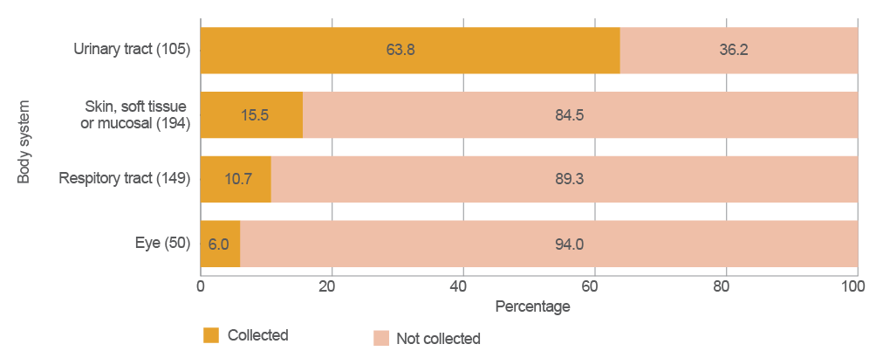
Note: Only body systems for which there were 30 or more antimicrobial prescriptions are shown.
Figure 8 Number of antimicrobial prescriptions for residents meeting McGeer criteria, by McGeer body system
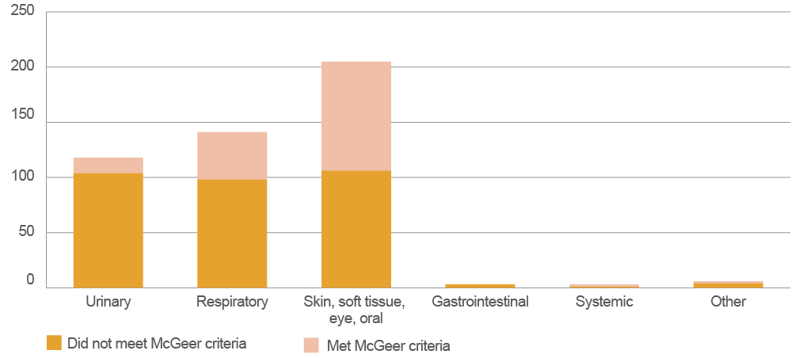

Participant feedback
All participating residential aged care facilities (RACFs) were invited to complete an online questionnaire seeking feedback on the 2015 pilot Aged Care National Antimicrobial Prescribing Survey (acNAPS). The response rate was 45.8% (54 surveyors from a total of 118). As well, a small number of participating RACFs (selected from a convenience sample) were visited across five states to obtain further qualitative feedback. A total of 19 participants were interviewed.
Overall, feedback was positive, with most surveyors (96.2%) indicating that they were willing to participate in the survey again. Most (90.6%) felt that the amount of data that was required to be collected was appropriate. Most RACFs (81.2%) completed data collection within one day. It took an average of 30 minutes to collect and enter data for each resident. The most common difficulty was limited documentation – including details of antimicrobial start dates, indications, and signs and symptoms of infection – and limited access to microbiology reports.
At a local level, the point prevalence nature of acNAPS resulted in small numbers of residents who met the McGeer infection criteria. Some respondents commented that this limitation affected the RACF’s ability to use the data locally, as the small numbers did not reflect the overall prescribing practices in that facility. One-quarter of respondents indicated that the results were either an overestimate or an underestimate of their usual antimicrobial use and prevalence of infection. However, they did acknowledge that there needed to be a balance between the limitations of the point prevalence survey method, and resource requirements and availability.
Most participants (90.9%; 40 of 44) who entered data through the online portal were satisfied with the website design and functionality. Suggestions for improvements included:
- improving the clarity of the data collection forms
enhancing the functionality of the online data portal.
Most of the participants who required support or training were satisfied with the level of support from the acNAPS team (97.1%; 34 of 35) and the online training sessions (94.6%; 35 of 37).
During the face-to-face interviews, participants were also asked to discuss issues regarding antimicrobial resistance, antimicrobial use and antimicrobial stewardship (AMS). Some commented that they did not perceive antimicrobial resistance to be a problem at their facility, but acknowledged that further improvements could be made in ensuring that antimicrobial therapy, particularly prophylaxis, was reviewed more frequently. Several participants mentioned that AMS is an unfamiliar concept to RACF staff, and that increased awareness of AMS, and access to guidelines and decision-making tools were required.

Conclusion
Across Australia, a total of 186 residential aged care facilities (RACFs) and multipurpose services (MPSs) participated in the 2015 pilot of the Aged Care National Antimicrobial Prescribing Survey (acNAPS). Analysis of the data collected on infection and antimicrobial use found the following:
- Antimicrobials were most commonly prescribed for infections of the skin and soft tissue, urinary tract and lower respiratory tract, and for tinea and conjunctivitis.
- Documentation about the indication for prescribing an antimicrobial and antimicrobial review or stop dates was often inadequate.
- Antimicrobial prescribing was often inappropriate. Although the surveyors did not directly assess inappropriateness of prescribing, some results indirectly suggested that many prescriptions may be unnecessary – for example, about one in five prescriptions were for residents without signs or symptoms of infection in the week before the antimicrobial was started.
- Treatment courses are unnecessarily prolonged. About one-third of antimicrobials were prescribed for more than six months, and half of these did not have an indication documented.
Topical antimicrobials are frequently used – they account for more than one-third (37%) of all prescriptions.
The participant feedback was positive. Importantly, most participants indicated that they would participate again in 2016. This suggests that, overall, the method of implementation and survey data requirements may be sustainable.
The acNAPS pilot proved to be a valuable survey for those participating, and represents a significant step towards recognition of the importance of antimicrobial stewardship (AMS) programs in RACFs. The National Centre for Antimicrobial Stewardship, the Guidance Group, the Victorian Healthcare Associated Infection Surveillance Coordinating Centre, and the Australian Commission on Safety and Quality in Health Care thank the RACFs and MPSs that participated in the 2015 acNAPS pilot, and urge other RACFs and MPSs to participate in acNAPS in the future.
By collecting data on infection and antimicrobial use, and interpreting their surveillance reports, facilities are better placed to identify priority areas for any AMS interventions and measure improvements in antimicrobial use. Such activities are important components of any AMS program that aims to improve patient and resident outcomes, ensure cost-effective therapy and reduce adverse sequelae of antimicrobial use, including the serious threat of antimicrobial resistance.
As acNAPS moves beyond the pilot phase, the acNAPS project team will revise the survey, based on the detailed feedback from the 2015 participants, an updated literature review and further consultation with key stakeholders, including the Royal Australian College of General Practitioners. The next acNAPS will take place between June and August 2016.

Appendix 1 RACF form
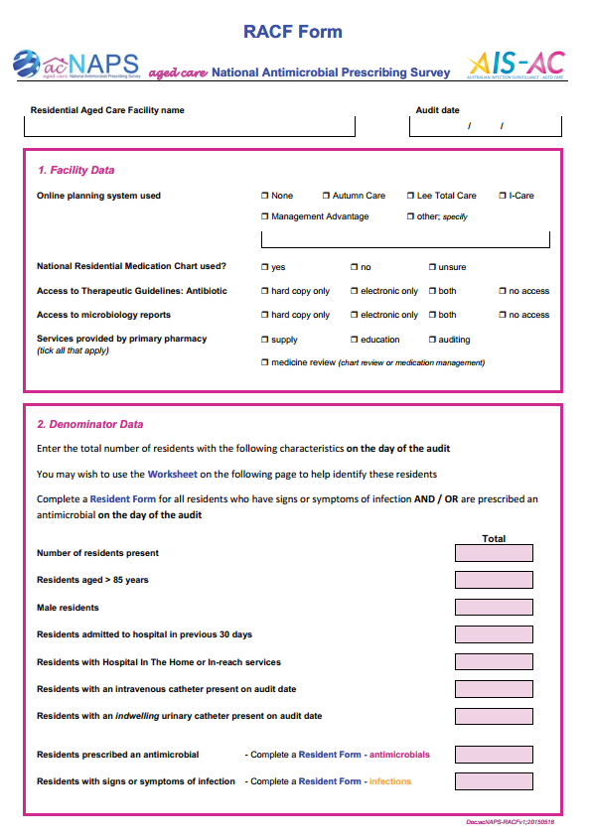

Appendix 2 Resident Form – infections
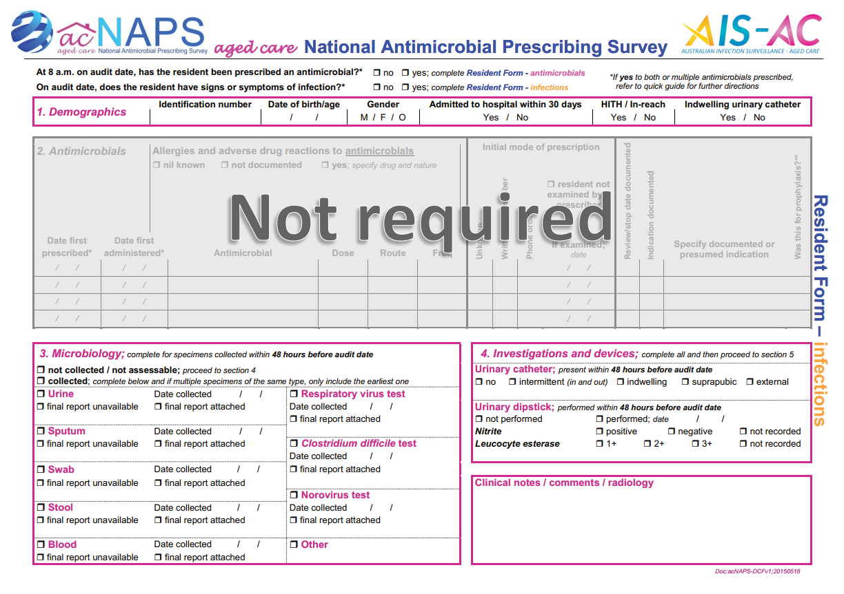
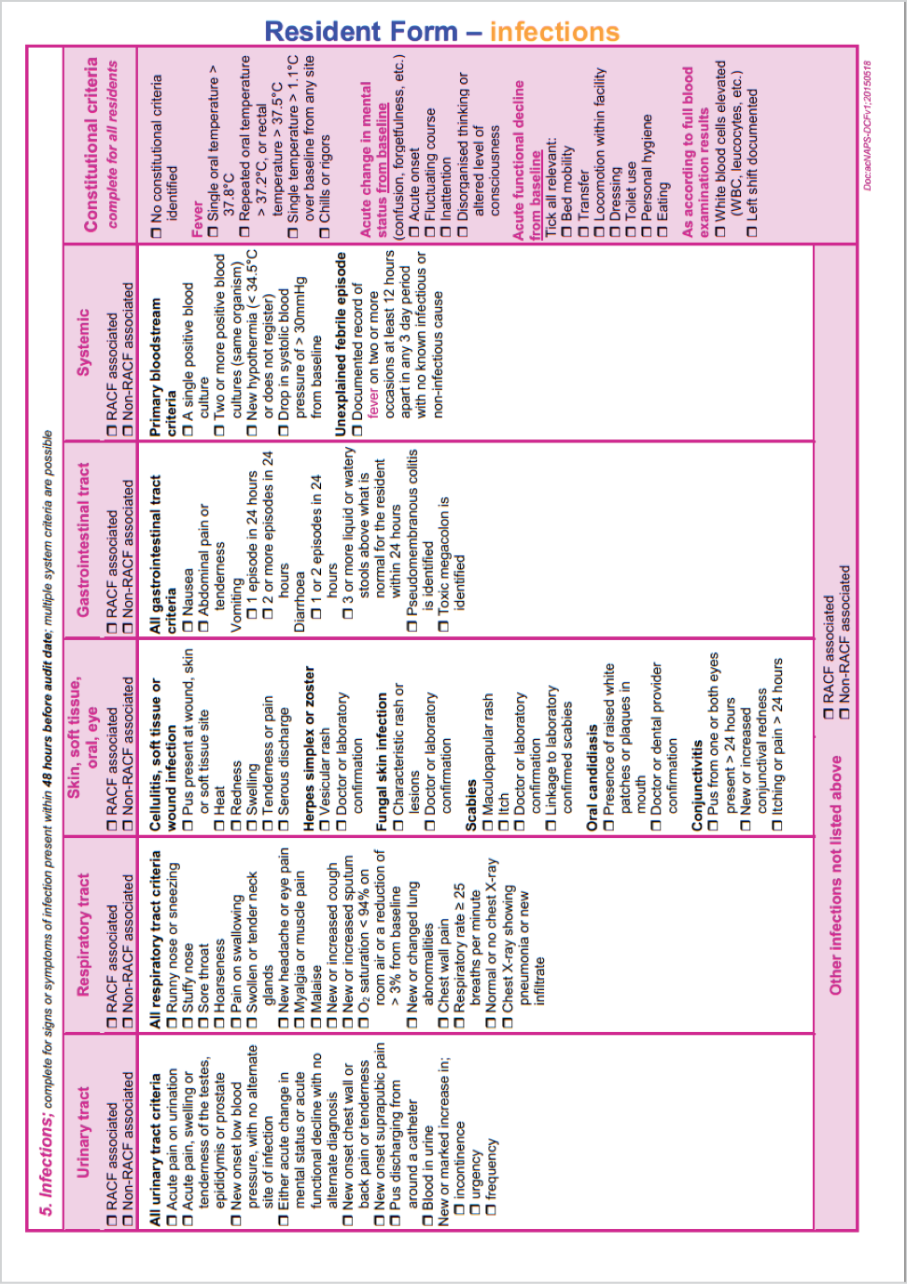

Appendix 3 Resident Form – antimicrobials
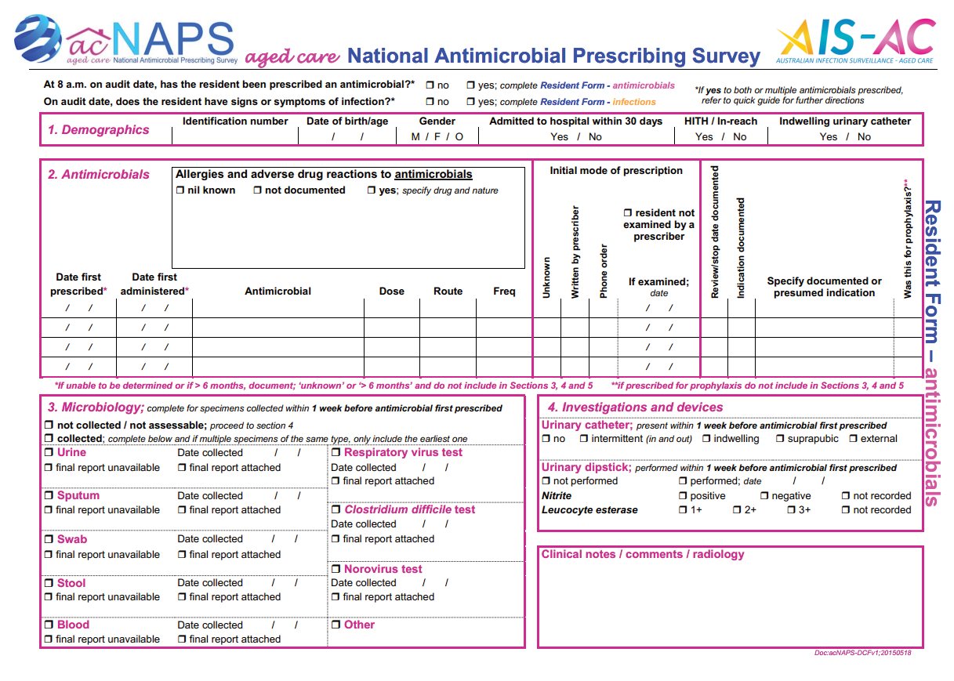
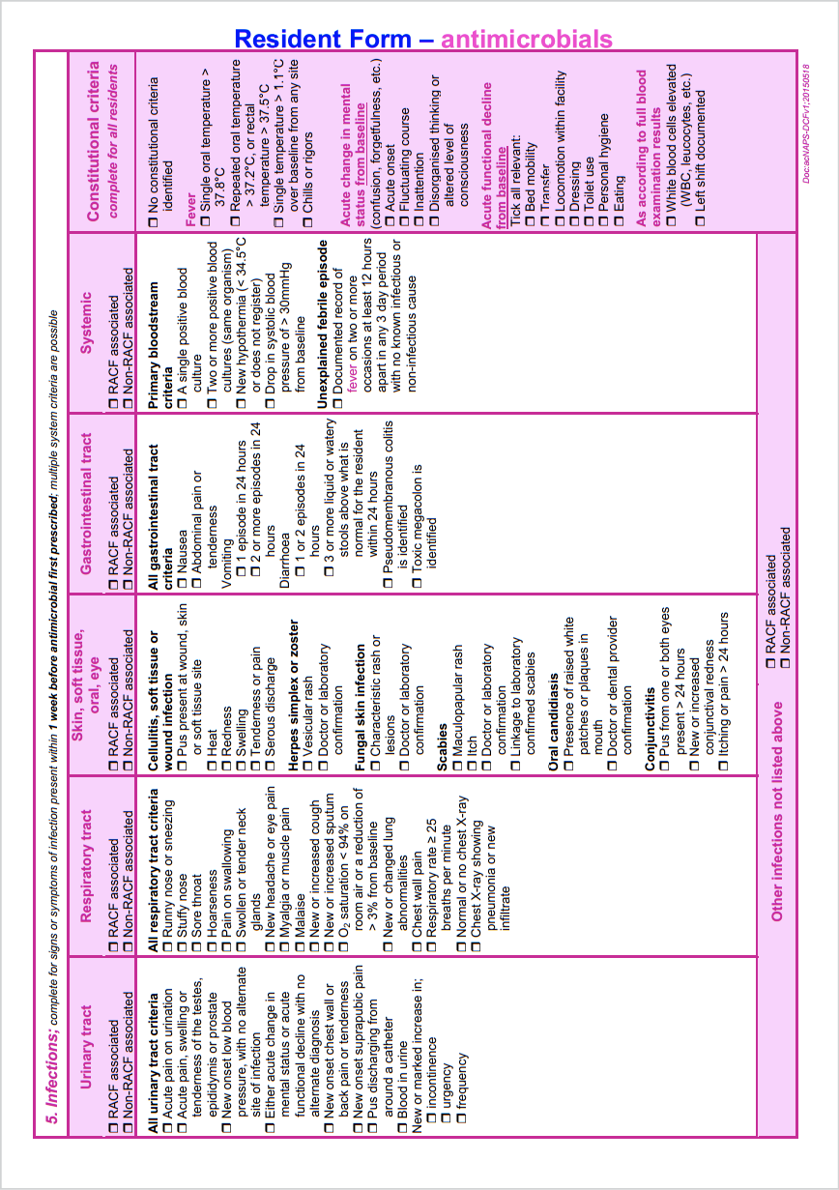

Glossary
Term | Definition
antimicrobial | A chemical substance that inhibits or destroys bacteria, viruses or fungi, and that can be safely administered to humans or other animals.
antimicrobial resistance | Failure of an antimicrobial to inhibit a microorganism at the antimicrobial concentrations usually achieved over time with standard dosing regimens.
antimicrobial stewardship | An ongoing effort by an organisation to optimise antimicrobial use to improve patient outcomes, ensure cost-effective therapy and reduce adverse sequelae of antimicrobial use, including antimicrobial resistance.
Australian Standard Geographic Classification Remoteness Areas | The remoteness area categories (major cities, inner regional, outer regional, remote and very remote) are defined in terms of ‘remoteness’ – the physical distance of a location from the nearest urban centre (access to goods and services), based on population size.
clinical indication | An infection that makes a particular treatment or procedure advisable.
Guidance Group | A group that has partnered with the National Centre for Antimicrobial Stewardship to develop and implement the antimicrobial stewardship (AMS) information technology tools required to sustain AMS improvement and surveillance within various healthcare settings.
McGeer criteria | A set of widely referenced, internationally recognised infection definitions that have been specifically developed for use in residential aged care facilities.
National Centre for Antimicrobial Stewardship | A collaboration that provides a coordinated approach to antimicrobial stewardship strategies across diverse healthcare settings, including tertiary hospitals, rural and regional health care, aged care, general practice, and the animal sector in Australia. See https://ncascre.wordpress.com.
National Safety and Quality Health Service (NSQHS) Standards | Standards developed by the Australian Commission on Safety and Quality in Health Care to drive the implementation of safety and quality systems, and improve the quality of health care in Australia. The 10 NSQHS Standards provide a nationally consistent statement about the level of care consumers can expect from health service organisations.
prevalence | The number of events of interest in a given population at a given point in time, usually expressed as a prevalence rate (i.e. as a proportion of the defined population size at that time).
prophylaxis | The use of treatment – for example, administration of an antibiotic – in advance of an actual infection or disease condition because such a condition is expected to occur if treatment is withheld.
Rural Infection Control Practice Group | A collaborative network of infection control consultants with regional responsibilities in the five nonmetropolitan Department of Health and Human Services regions of Victoria, and one representative from the Department of Health and Human Services.
Therapeutic Guidelines: Antibiotic | An evidence-based guideline, prepared by an expert group of experienced clinicians, that combines a consensus approach to best practice with critical appraisal of the evidence regarding the treatment and prophylaxis of infections in Australia.
Victorian Healthcare Associated Infection Surveillance (VICNISS) Coordinating Centre | The primary aim of the VICNISS Coordinating Centre is to work with Victorian healthcare facilities to reduce healthcare-associated infections.

References
1. World Health Organization. Antimicrobial resistance: no action today, no cure tomorrow. Geneva: WHO Press, 2011.
2. Boucher HW, Talbot GH, Benjamin DK Jr, Bradley J, Guidos RJ, Jones RN, et al. 10 × ‘20 progress – development of new drugs active against gram-negative bacilli: an update from the Infectious Diseases Society of America. Clin Infect Dis 2013;56(12):1685–94.
3. Boucher HW, Talbot GH, Bradley JS, Edwards JE, Gilbert D, Rice LB, et al. Bad bugs, no drugs: no ESKAPE! An update from the Infectious Diseases Society of America. Clin Infect Dis 2009;48(1):1–12.
4. Australian Commission on Safety and Quality in Health Care. Antimicrobial prescribing practice in Australian hospitals: results of the 2014 National Antimicrobial Prescribing Survey. Sydney: ACSQHC, 2015.
5. European Centre for Disease Prevention and Control. Point prevalence survey of healthcare-associate infections and antimicrobial use in European long-term care facilities, April–May 2013. Stockholm: ECDPC, 2014.
6. McClean P, Tunney M, Gilpin D, Parsons C, Hughes C. Antimicrobial prescribing in nursing homes in Northern Ireland: results of two point-prevalence surveys. Drugs Aging 2011;28(10):819-29.
7. McGeer A, Campbell B, Emori TG, Hierholzer WJ, Jackson MM, Nicolle LE, et al. Definitions of infection for surveillance in long-term care facilities. Am J Infect Control 1991;19:1–7.
8. Nicolle LE, Bentley DW, Garibaldi R, Neuhaus EG, Smith PW. Antimicrobial use in long-term-care facilities. SHEA Long-Term-Care Committee. Infect Control Hosp Epidemiol 2000;21(8):537–45.
9. Peron EP, Hirsch AA, Jury LA, Jump RLP, Donskey CJ. Another setting for stewardship: high rate of unnecessary antimicrobial use in a veterans affairs long-term care facility. J Am Geriatr Soc 2013;61(2):289–90.
10. Victorian Healthcare Associated Infection Surveillance Coordinating Centre. Aged Care Healthcare Associated Infection and Antimicrobial Use Point Prevalence Survey 2014. Melbourne: VICNISS Coordinating Centre, 2015.
11. Daneman N, Bronskill SE, Gruneir A, Newman AM, Fischer HD, Rochon PA, et al. Variability in antibiotic use across nursing homes and the risk of antibiotic-related adverse outcomes for individual residents. JAMA Intern Med 2015;175(8):1331–9.
12. Australian Commission on Safety and Quality in Health Care. National Safety and Quality Health Service Standards. Sydney: ACSQHC, 2011.
13. Centers for Disease Control and Prevention. The core elements of antibiotic stewardship for nursing homes. Atlanta: CDC, 2015.
14. Stone ND, Ashraf MS, Calder J, Crnich CJ, Crossley K, Drinka PJ, et al. Surveillance definitions of infections in long-term care facilities: revisiting the McGeer criteria. Infect Control Hosp Epidemiol 2012;33(10):965–77.
15. Victorian Healthcare Associated Infection Surveillance Coordinating Centre [cited 2015 November]. Available from: www.vicniss.org.au.
16. Ansari F, Erntell M, Goosens H, Davey P. The European Surveillance of Antimicrobial Consumption (ESAC) point-prevalence survey of antibacterial use in 20 European hospitals in 2006. Clin Infect Dis 2009;15(49):1496–504.
17. Australian Commission on Safety and Quality in Health Care. Antimicrobial Stewardship Clinical Care Standard. Sydney: ACSQHC, 2014.
18. Antibiotic Expert Groups. Therapeutic Guidelines: Antibiotic. Melbourne: Therapeutic Guidelines Limited, 2014.

