Australian Commission on Safety and Quality in Health Care logo 




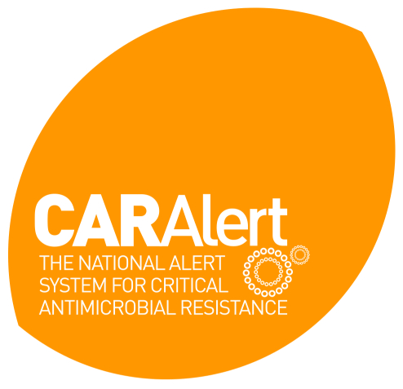

First Annual Report

March 2016–March 2017

Published by the Australian Commission on Safety and Quality in Health Care

Level 5, 255 Elizabeth Street, Sydney NSW 2000

Phone: (02) 9126 3600

Fax: (02) 9126 3613

Email: mail@safetyandquality.gov.au   
Website: www.safetyandquality.gov.au

ISBN: 978-1-925224-93-1

© Australian Commission on Safety and Quality in Health Care 2017

All material and work produced by the Australian Commission on Safety and Quality in Health Care is protected by copyright. The Commission reserves the right to set out the terms and conditions for the use of such material.

As far as practicable, material for which the copyright is owned by a third party will be clearly labelled. The Australian Commission on Safety and Quality in Health Care has made all reasonable efforts to ensure that this material has been reproduced in this publication with the full consent of the copyright owners.

With the exception of any material protected by a trademark, any content provided by third parties, and where otherwise noted, all material presented in this publication is licensed under a [Creative Commons Attribution-NonCommercial-NoDerivatives 4.0 International Licence](http://creativecommons.org/licenses/by-nc-nd/4.0/).

Creative Commons Licence

Enquiries regarding the licence and any use of this publication are welcome and can be sent to [caralert@safetyandquality.gov.au](mailto:caralert@safetyandquality.gov.au).

The Commission’s preference is that you attribute this publication (and any material sourced from it) using the following citation:

Australian Commission on Safety and Quality in Health Care. CARAlert First Annual Report March 2016–March 2017. Sydney: ACSQHC; 2017

**Disclaimer**

The content of this document is published in good faith by the Australian Commission on Safety and Quality in Health Care (the Commission) for information purposes. The document is not intended to provide guidance on particular healthcare choices. You should contact your health care provider on particular healthcare choices.

The Commission does not accept any legal liability for any injury, loss or damage incurred by the use of, or reliance on, this document.

**Table of Contents**

Summary 2

Introduction 3

Results 4

**Critical antimicrobial resistances reported by species and month** 4

Critical antimicrobial resistances by state and territory 6

Critical antimicrobial resistances by age group 7

Critical antimicrobial resistances by specimen type 9

Critical antimicrobial resistances by facility type 10

Carbapenemase-producing Enterobacteriaceae type by state and territory 10

Organism by carbapenemase-producing Enterobacteriaceae type 12

Other Critical Antimicrobial Resistance types 13

Conclusion 14

Glossary of Terms and Abbreviations 15

# Summary

The National Alert System for Critical Antimicrobial Resistances (CARAlert) was established as part of the Antimicrobial Use and Resistance in Australia (AURA) Surveillance System by the Australian Commission on Safety and Quality in Health Care (the Commission) in March 2016. CARAlert collects surveillance data on AURA priority organisms considered to have critical resistance to last-line antimicrobial agents.

The primary purpose of CARAlert is to provide timely communication of these organisms and resistance to the health departments in each state and territory in order to inform response strategies, as required.

This report provides data and analyses for the first 12 months of the operation of the CARAlert system from 17 March 2016 to 31 March 2017. During that period 1,064 results from 73 originating laboratories across Australia were entered into the database. From April 2016 to March 2017, there was an average of 86 entries per month (range 61–161).

Carbapenemase-resistant Enterobacteriaceae (CPE), either alone or in combination with ribosomal methyltransferases (RMT), were the most frequently recorded critical antimicrobial resistance (CAR) of all CARs reported until November 2016. From December 2016, azithromycin non-susceptible Neisseria gonorrhoeae were most frequently reported, and in March 2017 contributed to 62% of all CARs reported.

Seventy per cent of all CARs were from the three most populous states – New South Wales (34%), Victoria (21%) and Queensland (15%). Only two reports were received from the Northern Territory and five from Tasmania. CPE, as a proportion of all reported CARs, was lowest in South Australia (29%) and Western Australia (29%) and highest in Queensland (71%) and the Australian Capital Territory (68%).

The range of organisms with critical resistances to be included in the CARAlert data set will continue to be monitored and reviewed to ensure it provides the most useful data for actions to support effective infection prevention and control.

The relatively small number of individual CAR types currently recorded in the database means that it is not yet possible to draw conclusions of epidemiological significance from the analyses. Statistical methods for evaluating temporal and spatial trends will be implemented as the data collection matures over time. It is expected that this data will increasingly be useful to inform safety and quality improvement programs.

# Introduction

The Australian Commission on Safety and Quality in Health Care (the Commission) established the National Alert System for Critical Antimicrobial Resistances (CARAlert) in March 2016 as part of the Antimicrobial Use and Resistance in Australia (AURA) Surveillance System. Funding for AURA is provided by the Australian Government Department of Health. CARAlert collects surveillance data on priority organisms with critical resistance to last-line antimicrobial agents.

CARs are defined as resistance mechanisms, or profiles, known to be a serious threat to the effectiveness of last-line antimicrobial agents. CARs have been detected across Australia. They may result in significant morbidity and mortality in healthcare facilities, and in the community.

Primary responsibility for determining the appropriate clinical response to critical resistances lies with local health organisations and the state and territory health departments. The role of CARAlert includes collecting and analysing data to identify trends, and providing timely communication of information concerning critical resistances to states and territories to complement current local reporting of results. In addition to the publication of these summary reports, the states and territories receive weekly email reports of all CARAlerts, and designated staff have access to their own jurisdiction data via the CARAlert system. It is intended that states and territories will use the data to identify local problems and respond to potential and proven multi-site outbreaks of critical antimicrobial resistances (CARs).

The organisms reported under CARAlert are listed in Table 1. The CARs were drawn from the list of high priority organisms and antimicrobials which are the focus of the AURA Surveillance System. The scope of organisms and CARs will be regularly reviewed, based on the latest available evidence on critical resistances which emerge in Australia and overseas.

**Table 1 List of critical antimicrobial resistances**

| Species | Critical resistance |
| --- | --- |
| Enterobacteriaceae | Carbapenemase-producing strains, and/or  ribosomal methyltransferase-producing |
| Enterococcusspecies | Linezolid non-susceptible |
| *Mycobacterium tuberculosis* | Multidrug-resistant – at least rifampicin- and isoniazid-resistant |
| *Neisseria gonorrhoeae* | Ceftriaxone non-susceptible or azithromycin non-susceptible |
| *Salmonella* species | Ceftriaxone non-susceptible |
| *Shigella* species | Multidrug-resistant |
| *Staphylococcus aureus* | Vancomycin, linezolid or daptomycin non-susceptible |
| *Streptococcus pyogenes* | Penicillin reduced susceptibility |

Under existing testing processes, originating laboratories perform routine tests of an isolate to identify whether it is potentially a CAR. If suspected as a CAR, the isolate is referred to one of the 28 confirming laboratories currently participating in CARAlert.

The confirming laboratory advises the originating laboratory of the result of the test for reporting back to the general practice or hospital that cared for the patient from whom the specimen was collected. The results of these confirmatory tests are provided prior to the details of the resistance and organism are entered into the CARAlert web portal. Alerts are reported to the Commission and to nominated state and territory health personnel weekly.

Reporting from CARAlert is based on the date that the CAR was confirmed. The majority of CARs are submitted to the system within seven days of confirmation. However, some batch testing occurs for isolates referred to the National Neisseria Network (NNN) and the Australian Mycobacterium Reference Laboratory Network (AMRLN) laboratories. This may result in the outcome of confirmatory testing being entered into the CARAlert database up to two months following collection of the isolate. The Commission is working with confirming laboratories on strategies to improve timeliness of reporting to CARAlert.

# Results

This report provides the details of CARs submitted into the CARAlert system between 17 March 2016 and 31 March 2017.

Critical antimicrobial resistances reported by species and month

In the period 17 March 2016 to 31 March 2017, 1,064 results from 73 originating laboratories across Australia were entered in the CARAlert system. From April 2016 to March 2017, there was an average of 86 entries in the system per month (range 61-161). The proportion of CARs associated with specific priority organisms is shown in Figure 1. The number of CARs reported, by species and month, is shown in Figure 2.

Carbapenemase-producing Enterobacteriaceae (CPE) were the most frequently recorded CAR until November 2016, reported either alone or in combination with ribosomal methyltransferases (RMT). Since December 2016, azithromycin non-susceptible Neisseria gonorrhoeae have dominated the CARs entered and, in March 2017, contributed to 62% of all CARs reported.

**Figure 1 Critical antimicrobial resistances (CARs), as a percentage of all CARs, reported by month, 17 March 2016–31 March 2017**

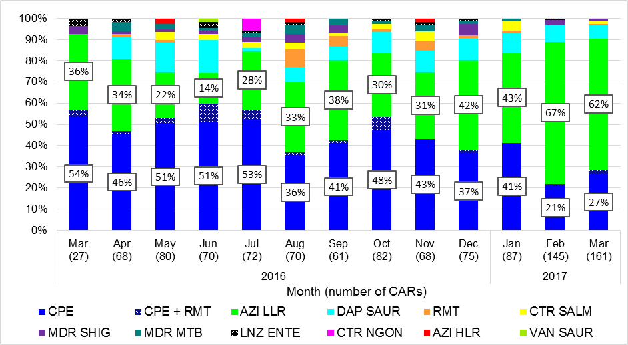

CPE = carbapenemase-producing-Enterobacteriaceae; RMT = ribosomal methyltransferase-producing Enterobacteriaceae; CPE+RMT = carbapenemase- and ribosomal methyltransferase-producing Enterobacteriaceae; LNZ ENTE = linezolid non-susceptible Enterococcus species; AZI LLR = azithromycin-resistant, low level resistance (LLR, MIC[1] < 256 mg/L) Neisseria gonorrhoeae; AZI HLR = azithromycin-resistant, high level resistance (HLR, MIC > 256 mg/L) Neisseria gonorrhoeae; CTR NGON = ceftriaxone non-susceptible Neisseria gonorrhoeae; DAP SAUR = daptomycin non-susceptible Staphylococcus aureus; VAN SAUR = vancomycin non-susceptible Staphylococcus aureus; CTR SALM = ceftriaxone non-susceptible Salmonella species; MDR SHIG = multidrug-resistant Shigella species; MDR MTB = multidrug-resistant Mycobacterium tuberculosis

**Figure 2 Critical antimicrobial resistances, number reported by species and month, 17 March 2016–31 March 2017**

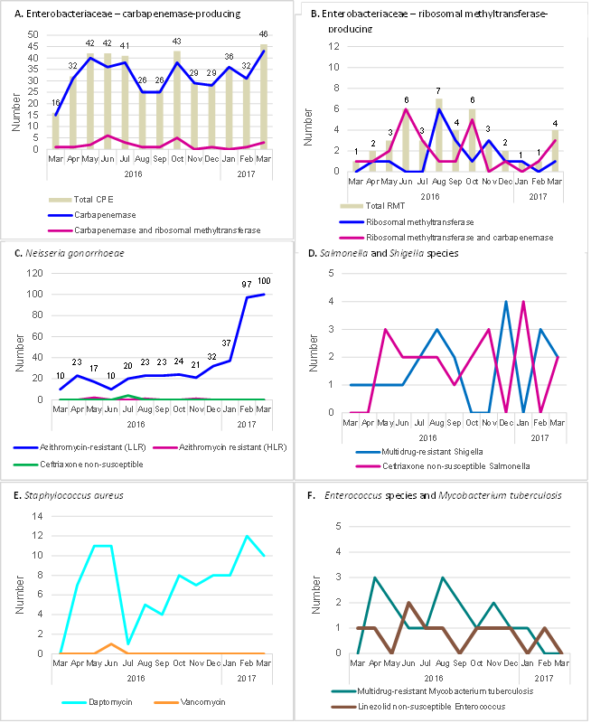

CPE = carbapenemase-producing-Enterobacteriaceae; RMT = ribosomal methyltransferase-producing Enterobacteriaceae; LLR = low level resistance; HLR  = high level resistance

# **Critical antimicrobial resistances by state and territory**

Seventy per cent of all CARs were from the three most populous states – New South Wales (34%), Victoria (21%) and Queensland (15%). Two reports were received from the Northern Territory and five from Tasmania. CPE, as a proportion of all reported CARs, was lowest in South Australia (29%) and Western Australia (29%) and highest in Queensland (71%) and the Australian Capital Territory (68%) as shown in Figure 3.

**Figure 3 Critical antimicrobial resistances, percentage reported by state and territory, March–December 2016**

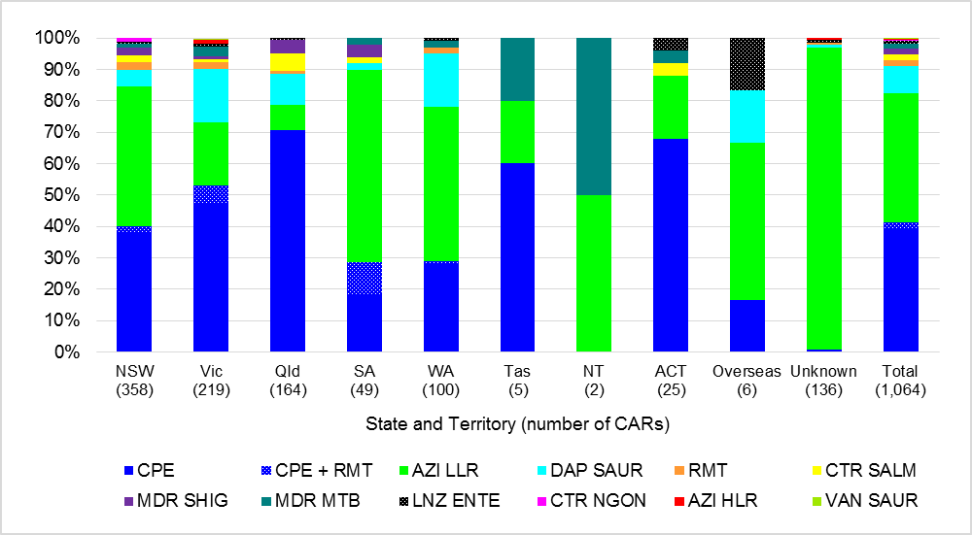

CPE = carbapenemase-producing-Enterobacteriaceae; RMT = ribosomal methyltransferase-producing Enterobacteriaceae; CPE+RMT = carbapenemase- and ribosomal methyltransferase-producing Enterobacteriaceae; LNZ ENTE = linezolid non-susceptible Enterococcus species; AZI LLR = azithromycin non-susceptible, low level resistance (LLR, MIC < 256 mg/L) Neisseria gonorrhoeae; AZI HLR = azithromycin non-susceptible, high level resistance (HLR, MIC > 256 mg/L) Neisseria gonorrhoeae; CTR NGON = ceftriaxone non-susceptible Neisseria gonorrhoeae; DAP SAUR = daptomycin non-susceptible Staphylococcus aureus; VAN SAUR = vancomycin non-susceptible Staphylococcus aureus; CTR SALM = ceftriaxone non-susceptible Salmonella species; MDR SHIG = multidrug-resistant Shigella species; MDR MTB = multidrug-resistant Mycobacterium tuberculosis

Batch testing of *N. gonorrhoeae* is common in Australia. For these isolates, the state and territory of residence is often not supplied, as isolates are collected from patients that attended sexual health clinics where postcode of residence is not always sought. Reports were analysed by date of collection, rather than date of confirmation, and where state and territory of residence was unknown, the state and territory of the originating laboratory was assigned (Figure 4).

An increase in azithromycin-resistant [LLR MIC < 256 mg/L] *N. gonorrhoeae* originating from South Australia in January 2016 was observed in CARAlert in March 2016. Reports from South Australia peaked in April 2016, then declined before re-emerging during the last quarter of 2016 and peaking again in March 2017. There has been a three-fold increase in numbers reported from both New South Wales and Western Australia throughout 2016. There was a sharp increase in the number of reports originating from Victoria from November 2016, with a peak in February 2017.

Four strains of *N. gonorrhoeae* with high-level azithromycin resistance (MIC ≥ 256 mg/L) were confirmed, three from Victoria, collected in April, May, and July 2016; and one in October 2016, from an unknown place of residence; the originating laboratory was located in South Australia. Four ceftriaxone non-susceptible strains, collected in July 2016 from New South Wales, were confirmed.

State or territory of residence was not available for another four reports (CPE, RMT, linezolid non-susceptible *Enterococcus* species and daptomycin non-susceptible *S. aureus*). These all originated from Victoria.

Four reports were from overseas residents, one daptomycin non-susceptible *S. aureus*, and three azithromycin-resistant (LLR, MIC < 256 mg/L) *N. gonorrhoeae*.

Daptomycin non-susceptible *S. aureus* were reported as follows: 41% (25/61) from Victoria, 21% (13/61) from Queensland and 20% (12/61) from Western Australia. Multidrug-resistant *Mycobacterium tuberculosis* were reported from patients from all states and territories except Queensland.

**Figure 4 Neisseria gonorrhoeae, number reported by state and territory* and month of collection, 17 March 2016–31 March 2017**

Figure 4 Neisseria gonorrhoeae, number reported by state and territory* and month of collection, 17 March 2016–31 March 2017


*Where state and territory of residence is unknown, the state of the originating laboratory has been assigned

## **Critical antimicrobial resistances by age group**

CARs were isolated from patients from birth to those aged greater than 80 years, with a median age of 40–49 years (Figure 5). Sixty-eight per cent (300/440) of CPE were from people aged 60 years and older. Azithromycin-resistant *N. gonorrhoeae* were the predominant CAR reported among the age groups 15–19 years; 20–29 years; 30–39 years; and 40–49 years. Only 2.3% (24/1,064) of all CARs were reported in children aged less than 15 years. CPE and ceftriaxone non-susceptible *Salmonella* species were common (67%) in this age group.

**Figure 5 Critical antimicrobial resistances by age group, 17 March 2016–31 March 2017**

**A. Number by age group**

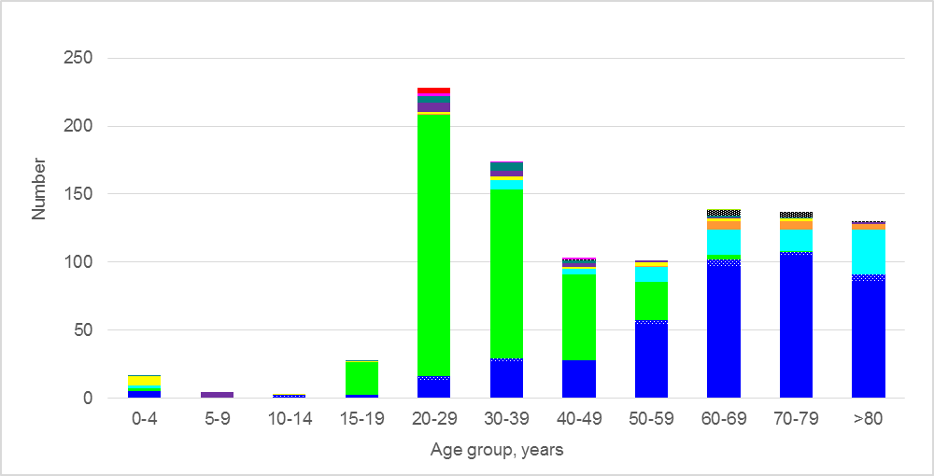

**B. Percentage by age group**

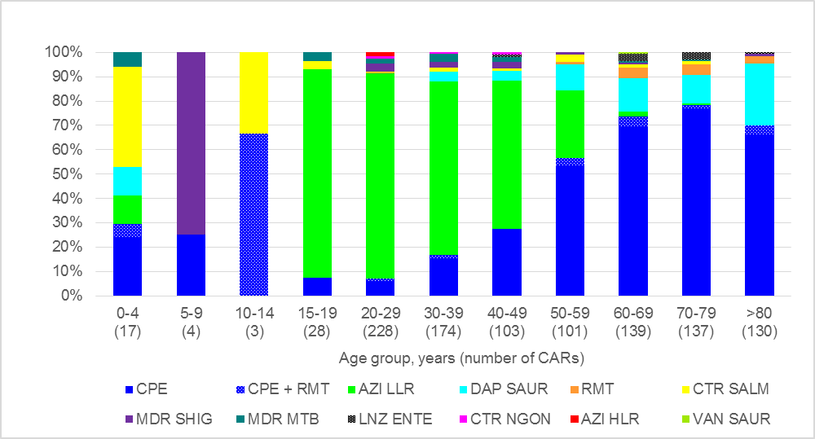

CPE = carbapenemase-producing-Enterobacteriaceae; RMT = ribosomal methyltransferase-producing Enterobacteriaceae; CPE+RMT = carbapenemase- and ribosomal methyltransferase-producing Enterobacteriaceae; LNZ ENTE = linezolid non-susceptible Enterococcus species; AZI LLR = azithromycin resistant, low level resistance (LLR, MIC < 256 mg/L) Neisseria gonorrhoeae; AZI HLR = azithromycin resistant, high level resistance (HLR, MIC > 256 mg/L) Neisseria gonorrhoeae; CTR NGON = ceftriaxone non-susceptible Neisseria gonorrhoeae; DAP SAUR = daptomycin non-susceptible Staphylococcus aureus; VAN SAUR = vancomycin non-susceptible Staphylococcus aureus; CTR SALM = ceftriaxone non-susceptible Salmonella species; MDR SHIG = multidrug-resistant Shigella species; MDR MTB = multidrug-resistant Mycobacterium tuberculosis

## Critical antimicrobial resistances by specimen type

Eighty-two per cent of all CARs were from clinical specimens (specimens collected for diagnostic purposes, rather than for screening). These include urine, wound, blood and another category which includes genital and respiratory specimens (Figure 6).

Sixty per cent (266/440) of CPE isolates were from clinical specimens; 61% (163/266) of these were from urine, and 7% (23/266) from blood cultures. Urine is an important specimen for certain CARs such as CPE and the urinary tract is a common site of infection. Other CARs reported from blood cultures include three daptomycin non-susceptible *S. aureus*, one linezolid non-susceptible *E.* *faecalis*, one ceftriaxone non-susceptible *Salmonella* species, and one ribosomal methyltransferase-producing *Enterobacteriaceae*.

**Figure 6 Critical antimicrobial resistances, number reported by specimen type, 17 March 2016–31 March 2017**

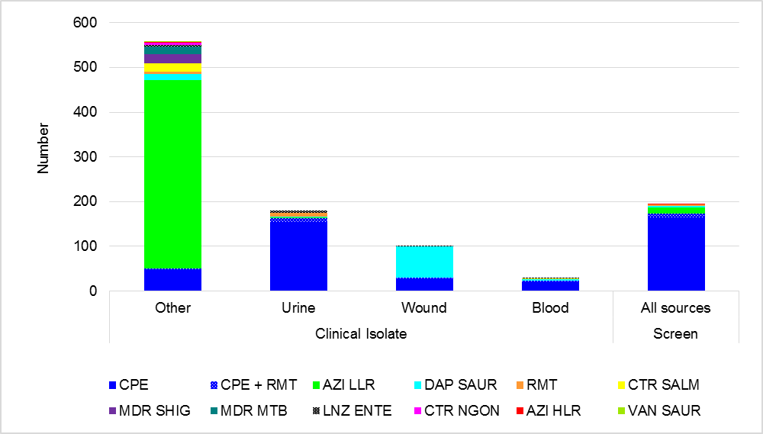

Other specimen type: not urine, wound, or blood (for example, genital, faecal, respiratory)

CPE = carbapenemase-producing-Enterobacteriaceae; RMT = ribosomal methyltransferase-producing Enterobacteriaceae; CPE+RMT = carbapenemase- and ribosomal methyltransferase-producing Enterobacteriaceae; LNZ ENTE = linezolid non-susceptible Enterococcus species; AZI LLR = azithromycin resistant, low level resistance (LLR, MIC < 256 mg/L) Neisseria gonorrhoeae; AZI HLR = azithromycin resistant, high level resistance (HLR, MIC > 256 mg/L) Neisseria gonorrhoeae; CTR NGON = ceftriaxone non-susceptible Neisseria gonorrhoeae; DAP SAUR = daptomycin non-susceptible Staphylococcus aureus; VAN SAUR = vancomycin non-susceptible Staphylococcus aureus; CTR SALM = ceftriaxone non-susceptible Salmonella species; MDR SHIG = multidrug-resistant Shigella species; MDR MTB = multidrug-resistant Mycobacterium tuberculosis

## Critical antimicrobial resistances by facility type

While most CARs were detected in either hospitalised patients or hospital outpatients (50%, 537/1,064), some were found in the community (37%, 393/1,064) and in aged care homes – see Figure 7. Facility type for azithromycin-resistant *N. gonorrhoeae* was difficult to obtain as most isolates are referred to a public health laboratory for confirmation, and as such may reflect the facility from which the isolate was sent rather than the facility that the patient attended.

**Figure 7 Critical antimicrobial resistances, number reported by facility type, 17 March 2016–31 March 2017**

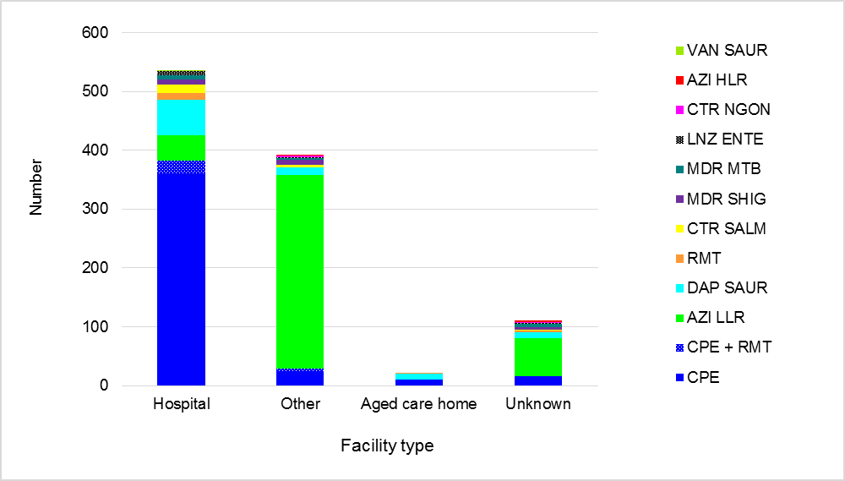

Other: Community (non-hospital and non-aged care home)

CPE = carbapenemase-producing-Enterobacteriaceae; RMT = ribosomal methyltransferase-producing Enterobacteriaceae; CPE+RMT = carbapenemase- and ribosomal methyltransferase-producing Enterobacteriaceae; LNZ ENTE = linezolid non-susceptible Enterococcus species; AZI LLR = azithromycin sistant, low level resistance (LLR, MIC < 256 mg/L) Neisseria gonorrhoeae; AZI HLR = azithromycin resistant, high level resistance (HLR, MIC > 256 mg/L) Neisseria gonorrhoeae; CTR NGON = ceftriaxone non-susceptible Neisseria gonorrhoeae; DAP SAUR = daptomycin non-susceptible Staphylococcus aureus; VAN SAUR = vancomycin non-susceptible Staphylococcus aureus; CTR SALM = ceftriaxone non-susceptible Salmonella species; MDR SHIG = multidrug-resistant Shigella species; MDR MTB = multidrug-resistant Mycobacterium tuberculosis

## **Carbapenemase-producing Enterobacteriaceae type by state and territory**

Seven different carbapenemase types were reported throughout Australia: IMP, NDM, OXA-48-like, KPC, VIM, SME, and OXA-23. Variation in distribution across Australia were noted, see Figure 8. Two carbapenemase types, IMP (65%, 286/440) and NDM (19%, 84/440), accounted for 84% of all Enterobacteriaceae with a confirmed carbapenemase.

IMP type carbapenemases comprised the majority (>70%) of CPE in New South Wales (81%, 116/143), Queensland (88%, 102/116) and the Australian Capital Territory (76%, 13/17). No IMP-producing Enterobacteriaceae were reported from South Australia. All the strains that have been genetically sequenced to date (41%, 118/286) are blaIMP-4.

NDM types were found in all states and territories where CPE were detected. NDM types contributed to 71% (10/14) of all types found in South Australia and 34% (39/116) of all types in Victoria. NDM+OXA-48-like (5/65) and NDM+KPC (n=2/65) were reported. Four different NDM genes were found in the strains sequenced to date: blaNDM‑5 (40%, 19/47), blaNDM-1 (40%, 19/47), blaNDM-4 (13%, 6/47), andblaNDM-7 (6%, 3/47).

Ribosomal methyltransferases were often detected among isolates containing NDM types (25%, 21/84; rmtB [15], armA [3], rmtC [1], rmtB+rmtF [1] and rmtB+rmtE [1]).

Klebsiella pneumoniae carbapenemase (KPC) types were mostly confined to Victoria (57%, 13/23), although there were reports from three other states (New South Wales, n=4; Queensland, n=2; and South Australia, n=2).

No CPE have been reported from the Northern Territory to date.

**Figure 8 Carbapenemase types as a proportion of all carbapenemases, number (A) and percentage (B) reported by state and territory, 17 March 2016–31 March 2017**

**A. Number by state and territory**

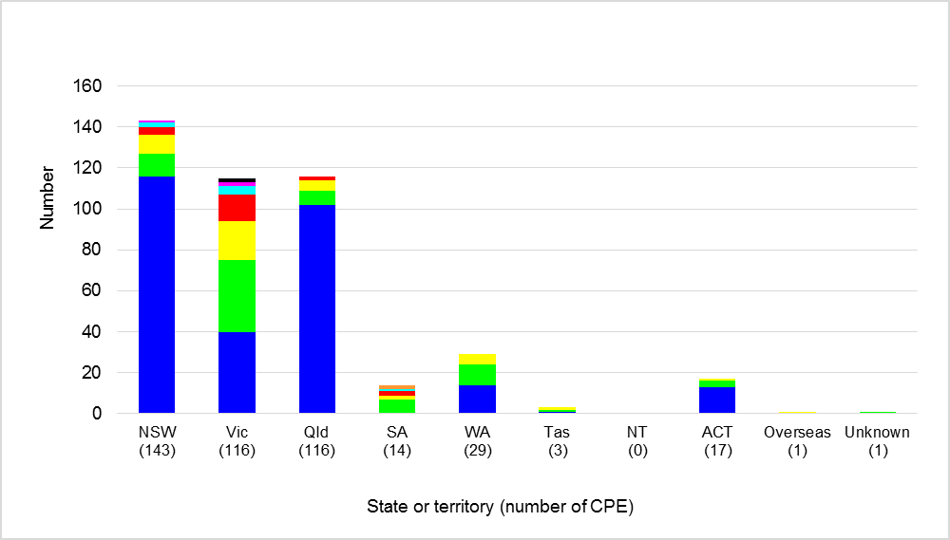

**B. Percentage by state and territory**

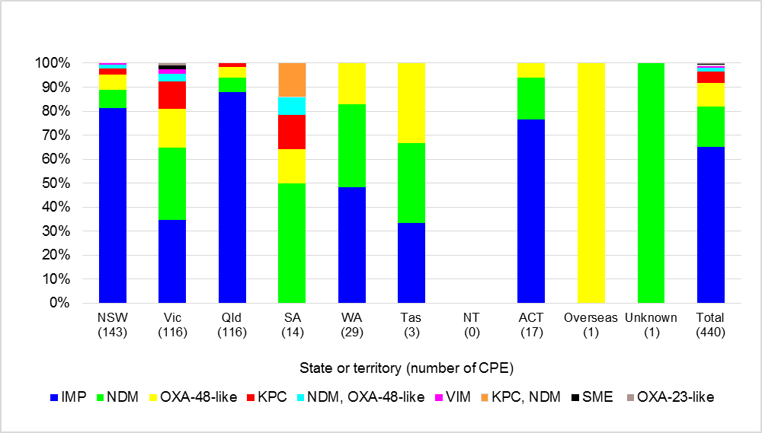

The distribution of carbapenemase types by state and territory and month of confirmation is shown in Figure 9. The sharp increase noted in October 2016 and March 2017 for Victoria reflects several isolates that were collected in the previous month. Of interest is the emergence of two Serratia marcescens with SME type in Victoria. There have been increasing numbers of SME carbapenemases reported globally, especially in the Americas. One E. coli with OXA-23-like carbapenemase was also reported from Victoria in January 2017.

**Figure 9 Carbapenemase types, number reported by month and state and territory, 17 March 2016–31 March 2017**

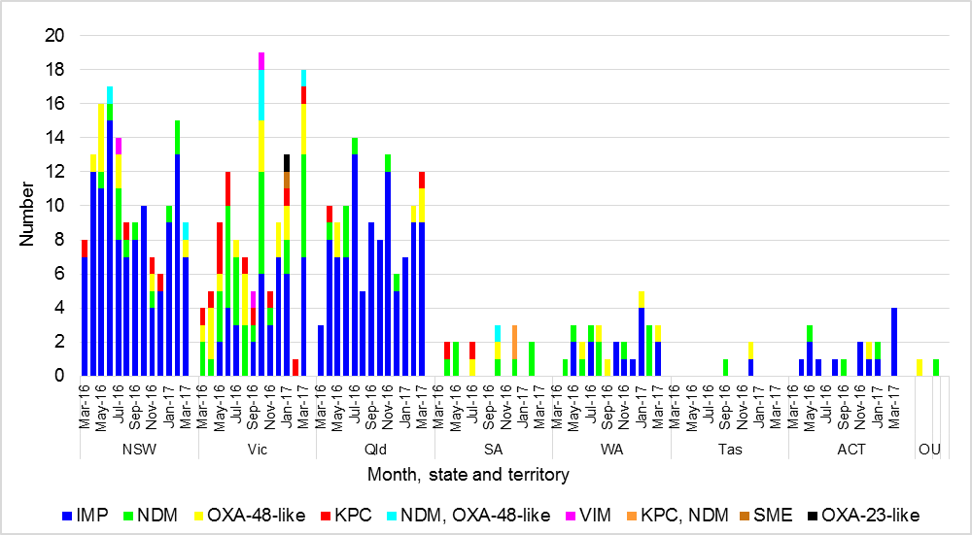

Note O=overseas U=unknown

## **Organism by carbapenemase-producing Enterobacteriaceae type**

Carbapenemases were found in 19 species of Enterobacteriaceae representing nine genera (Citrobacter, Enterobacter, Escherichia, Klebsiella, Morganella, Proteus, Providencia, Raoultella, Serratia). IMP type carbapenemases accounted for 65% (286/440) of all carbapenemases, and were found in 16 different species (Figure 10). Enterobacter cloacae complex accounted for 45% (130/286) of all IMP type carbapenemases and 31% (138/440) of all CPE. However, in Queensland 56% (65/116) of all CPE reported were E. cloacae complex containing IMP types. NDM and OXA-48-like carbapenemase types were found mainly in E. coli (58%, 49/84; 58%, 29/50, respectively); however, when both NDM and OXA-48-like or KPC types were found together, they were mainly in K. pneumoniae (78%, 7/9). One KPC (4%, 1/23) was found in Citrobacter farmeri, and one in Enterobacter cloacae complex

**Figure 10 Carbapenemase-producing Enterobacteriaceae, number reported by species (A) and carbapenemase type (B), 31 March 2016–31 March 2017**

**A. Species by carbapenemase type**

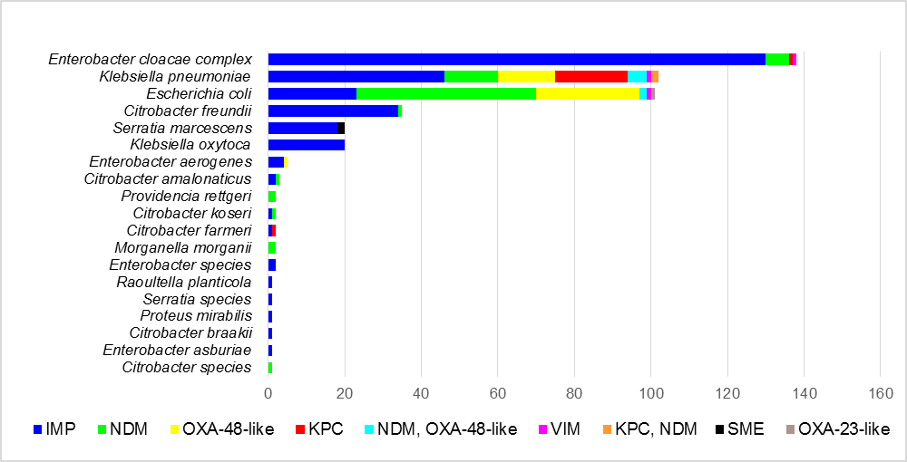

**B. Carbapenemase type by species**

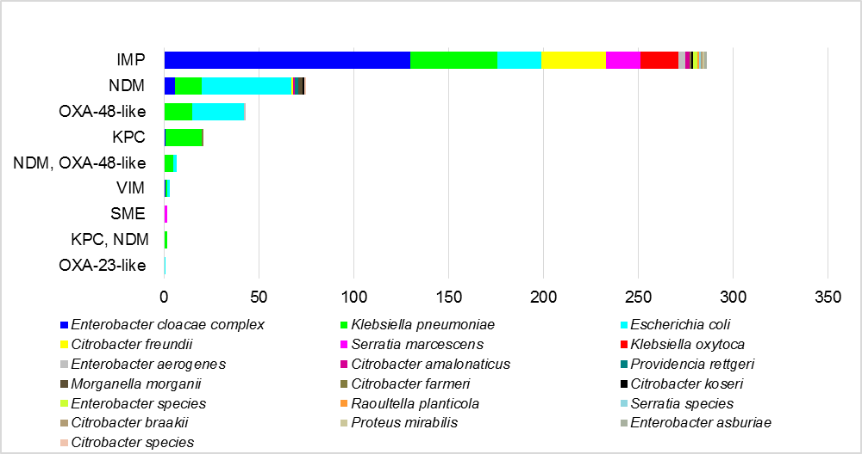

## **Other Critical Antimicrobial Resistance types**

Ceftriaxone non-susceptible N. gonorrhoeae were only reported from NSW, and contributed to 17% (4/24) of all N. gonorrhoeae reported to CARAlert in July 2016.

For S. aureus, 99% were daptomycin non-susceptible strains (92/93). One vancomycin non-susceptible (vancomycin-intermediate) strain was reported in June 2016 from Victoria. No linezolid non-susceptible S. aureus strains were reported.

Ribosomal methyltransferases were detected in 42 Enterobacteriaceae, representing seven different species; 57% (24/42) of which also had a carbapenemase. Ribosomal methyltransferases are not always associated with a carbapenemase gene. Five ribosomal methyltransferase genes were found: rmtB (55%; 23/42), either alone (21; 50%) or in combination with rmtE (1; 2.4%) or rmtF (1, 2.4%); armA (33%; 14/42); rmtC (10%; 4/42); and rmtF alone (1; 2%). Two isolates had multiple genes: *Providencia rettgeri* (*rmtB*, *rmtE*, and NDM) and *K. pneumoniae* (*rmtB*, *rmtF*, and NDM+OXA-48-like).

# Conclusion

CARAlert was established in 2016 to provide specific and more timely surveillance and reporting of CARs.

The IMP-type carbapenemase (mainly IMP-4) is now endemic on the eastern seaboard of Australia in several species of Enterobacteriaceae, particularly *E. cloacae*; this means that it is difficult to eliminate, and rigorous control measures are essential. There is no evidence that other carbapenemases have become established in Australia to date.

The number of CPE reported, and the endemicity of IMP-type carbapenemase, highlight the importance of implementing actions outlined within the Commission’s [Recommendations for the control of carbapenemase-producing Enterobacteriaceae: A guide for acute health facilities](https://www.safetyandquality.gov.au/our-work/healthcare-associated-infection/cpe-guide/). [2]

Azithromycin non-susceptible *N. gonorrhoeae* are common in Australia, and there were variations in numbers and time of reporting between and within states and territories during the reporting period.

The timely reporting of ceftriaxone or azithromycin non-susceptible *N. gonorrhoeae* data to CARAlert complement state and territory systems that monitor antimicrobial resistance as part of their sexually transmitted infection prevention and control strategies. As prevention and treatment are key components of effective control of sexually transmitted infections, the emergence of antimicrobial resistant *N. gonorrhoeae* at the same time as sustained increases in notifications may lead to treatment failures and continued transmission. The Commission will work with the states and territories to provide regular updates on the reporting of ceftriaxone or azithromycin non-susceptible *N. gonorrhoeae* through CARAlert, and promote consideration of these data for national and local treatment guidelines.

The Commission will continue to monitor records from CARAlert, and prepare summary reports on a regular basis. The Commission will also provide ad hoc reports to state and territory health departments as required.

The number of records in the database to date means that it is not yet possible to draw specific conclusions from the analyses. However, the data undergo regular epidemiological analysis, and statistical methods for evaluating temporal and spatial trends will be implemented as the data collection matures.

It is anticipated that the data will inform quality improvement initiatives and policies to reduce antimicrobial resistance.

The CARAlert Handbook is currently under review. During this process, all CARs will be examined for suitability to remain on the list and additional CARs will be considered for inclusion. These include colistin-resistance, carbapenemase-producing *Pseudomonas* species and *Acinetobacter* species. The CARAlert Handbook will be re-issued in the second half of 2017 after the review of CARs has been completed.

Enquiries regarding either this report or the CARAlert System should be submitted to [CARAlert@safetyandquality.gov.au](mailto:CARAlert@safetyandquality.gov.au).

# Glossary of Terms and Abbreviations

| **Term/Abbreviation** | **Definition** |
| --- | --- |
| Clinical specimen | Clinical specimens are collected for diagnostic purposes. They include urine, wound, blood and other (e.g. genital or respiratory) specimens |
| Screen specimen | Specimens taken for the purpose of screening for resistances |
| Confirming laboratory | The laboratory which performs the necessary confirmatory tests for a CAR. Confirming laboratories:   * Notify the originating laboratory of test outcomes through the usual communication channels, regardless of whether a CAR is confirmed or not * Enter data for each confirmed CAR into the CARAlert web-portal.   State and territory health authorities and the Public Health Laboratory Network have contributed to identification of confirming laboratories for the purpose of CARAlert. |
| Critical Antimicrobial Resistances (CARs) | CARs are resistance mechanisms, or profiles, known to be a serious threat to the effectiveness of last-line antimicrobial agents |
| Originating laboratory | The laboratory to which a specimen is initially referred by a general practice or hospital for routine testing of isolates.  If an originating laboratory identifies an isolate that may have the potential to be a CAR, it:   * Notifies the requesting clinician of the test results, and the suspected CAR * Sends the suspected isolate onto a confirming laboratory for confirmation. |
| MIC | Minimum inhibitory concentration |
| Abbreviation | Critical antimicrobial resistance |
| CPE | carbapenemase-producing Enterobacteriaceae |
| RMT | ribosomal methylase-producing Enterobacteriaceae |
| CPE+RMT | carbapenemase- and ribosomal methylase-producing Enterobacteriaceae |
| LNZ ENTE | linezolid non-susceptible Enterococcus species |
| AZI (LLR) | Azithromycin-resistant, low level resistance (LLR #, MIC < 256 mg/L) Neisseria gonorrhoeae |
| AZI (HLR) | Azithromycin-resistant, high level resistance (HLR *, MIC > 256 mg/L) Neisseria gonorrhoeae |
| CTR NGON | ceftriaxone non-susceptible Neisseria gonorrhoeae |
| DAP SAUR | daptomycin non-susceptible Staphylococcus aureus |
| VAN SAUR | vancomycin non-susceptible Staphylococcus aureus |
| CTR SALM | ceftriaxone non-susceptible Salmonella species |
| MDR SHIG | multidrug-resistant Shigella species |
| MDR MTB | multidrug-resistant Mycobacterium tuberculosis |

#LLR=low level resistance

*HLR=high level resistance

1. MIC=minimum inhibitory concentration
2. Australian Commission on Safety and Quality in Health Care. Recommendations for the control of carbapenemase-producing Enterobacteriaceae (CPE). A guide for acute care health facilities. Sydney: ACSQHC, 2017