Information for ward staff and
after-hours managers
Carbapenemase-producing
Enterobacteriaceae (CPE)

What is CPE?
Carbapenemase-producing Enterobacteriaceae (CPE) are multi-resistant gram-negative bacteria that are resistant to most, or even all, types of antibiotics. Common types of gram-negative bacteria include Escherichia coli, Klebsiella pneumoniae, Enterobacter cloacae and Proteus species.

Why respond to patients with CPE?
- Multi-resistant gram-negative bacteria, including CPE, place patients at greater risk of potentially untreatable infection and death
- The first documented outbreak of CPE in Australia in 2012 had a mortality rate of 40%
- Vulnerable patients with co-morbidities are at increased risk of developing an infection
- Gram-negative bacteria including CPE cause a range of infections including urinary tract infection, abdominal infection and bloodstream infection
- CPE are of particular concern because they are easily spread between patients and resistance may be transferred between different bacteria.
The strategies and actions outlined are based on the Australian Guidelines for the Prevention and Control of Infection in Healthcare and should be used in conjunction with the CPE Guide. State, territory, or local health networks may have more specific procedures that hospitals are required to follow. Refer to relevant departmental advice for information on notification policy.
For detailed information regarding the identification and management of CPE-colonised or infected patients and their contacts, refer to Recommendations for the control of carbapenemase-producing Enterobacteriaceae.
Figure 1 Management of CPE-positive patient
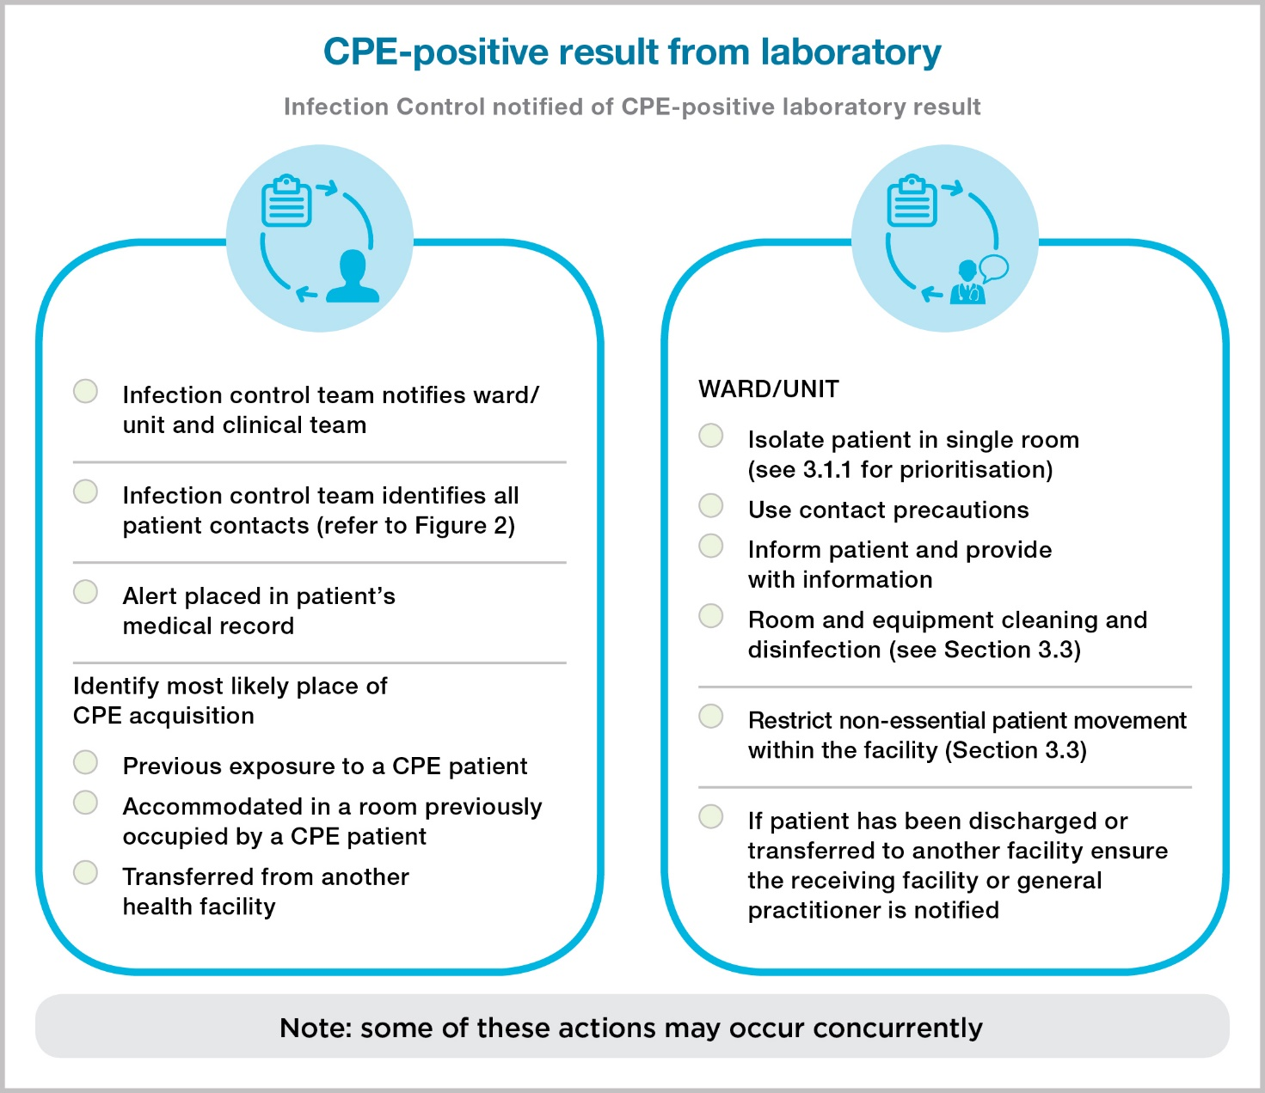
 | Hospital Management / Infection Prevention and Control (IP&C) | Ward response | CPE Guide section
Identification of CPE and CPE contacts | During office hours – contact IP&C for advice  After hours – contact on-call IP&C, Microbiology or Infectious Diseases | During office hours – contact IP&C for advice on patient placement  After hours – contact after hours nursing manager or hospital manager | Section 2 CPE screening and surveillance
Hospital outbreak management plan | Refer to hospital outbreak management (CPE) plan or policy for detailed information |  | Section 1.1 Health facility governance and management
Notification of cases | Seek advice or notification of hospital executive or health department as per state or territory requirement |  | Section 1.1 Health facility governance and management
Infection control precautions | Standard and transmission based (contact) precautions  - Prioritise isolation or cohorting  - Ensure appropriate resourcing (PPE, staffing, cleaning)  - Screening of contacts | Use standard and transmission based (contact) precautions for CPE patient:  - Isolation room  - Appropriate PPE  - Designated dedicated equipment.  (Refer to Figure 1) | Section 3  Management of CPE positive patient and CPE contact
Isolation / cohorting of CPE patients | A CPE contact is a person who has shared a room, bathroom, or toilet facilities with a confirmed case for more than 24 hours | Identify patient contacts –  CPE contacts should be managed with transmission based (contact) precautions, and isolated, or cohorted together until screening results are available  Isolation or cohorting of CPE contacts should be maintained until advice from IP&C (refer to Figure 2) | Section 2  Recommendations for the identification of CPE contact
Screening of contacts | Advice on management of CPE contacts – patients to be screened immediately and then weekly for the duration of admission  If a CPE contact has three negative screening results, review the need for screening to continue  If contact has been discharged, place alert/flag in history and screen if readmitted within 4 weeks | Screen all inpatient CPE contacts using rectal swabs or faeces. Urine specimens from catheterised patients can also be considered  CPE contacts to be screened immediately and then weekly for the duration of admission  CPE contacts that have been discharged should be screened if readmitted within 4 weeks  Screening of CPE contacts should continue until ceased by IP&C | Section 2.3 Identification of CPE contacts  Section 2.6 Timing and frequency of screening of contacts
Environmental and equipment cleaning | Allocate resources to support cleaning and disinfection requirements for CPE patients and contacts  A risk assessment of difficult to clean equipment should be undertaken  Liaise with Environmental Services to ensure that cleaning resources are provided | Room and equipment including frequently touched surfaces need to be cleaned and disinfected twice daily | Section 3.4  Cleaning and disinfection as part of contact precautions
 | Hospital Management / Infection Prevention and Control (IP&C) | Ward response | CPE Guide section
CPE Patient movement | Advise on alternative options to limit non-essential transport.  Undertake a risk assessment for patients that are required to leave the ward or isolation room | Limit non-essential movement or transport of the CPE patient (Radiology, Operating Theatres, outpatient clinics)  Where patients are required to leave the ward or isolation room, a risk assessment must be undertaken in consultation with IP&C | Section 3.3 Patient movement
Medical record alerts | Add alert to patient medical record for CPE patients  Add alert to patient medical record for CPE contacts if discharged before screened | Where applicable, add alert to patient medical record for CPE patients | Section 1.1 Health facility governance and management  Section 5.5 Reporting of suspected CPE
Hand Hygiene | Undertake hand hygiene auditing in high-risk areas and on wards during outbreaks | Promote hand hygiene for visitors and staff | Section 1.2  Strategies to prevent transmission of infection  Section 3.1 Management of CPE Patients
Readmission of CPE-positive patients | During office hours - contact IP&C for advice  After hours – contact on call for IP&C, Microbiology or Infectious Diseases | Check medical record for an alert  During office hours - contact IP&C for advice on patient placement and management  After hours – Contact after-hours nursing manager or hospital manager  Contact precautions should be used for all patients with a history of CPE unless cleared. Refer to IP&C for advice on clearance | Section 2.3 Screening strategy options  Section 2.7 Screening to determine clearance of CPE carriage
Education | Assess and coordinate staff education, including medical, nursing, allied health and environmental services  IP&C to provide patients with education on CPE | Provide patients with information for patients on CPE sheet | Section 1.1 Health facility governance and management

