Communicating with your healthcare provider:

improving the safety & quality of your care

# What does effective communication look like?

# family &

# carers

the

patient

**TWO-WAY COMMUNICATION**

**OPEN HONEST RESPECTFUL**

# healthcare

providers

# Why is it important?

# accuracy

information about your care is accurate and up to date

# inclusive

self-care

you know your care plan & how to manage

your care when you leave a health service

your goals and needs are discussed with your healthcare provider and included in your care plan

# participation

you are involved in decisions about your care

# informed

& aware

you, your family & carer are given information about your care & understand your treatment options

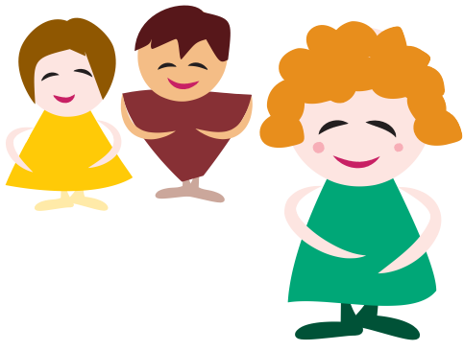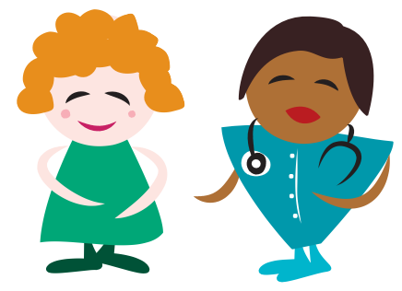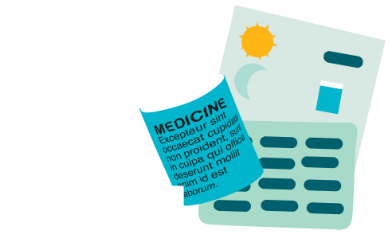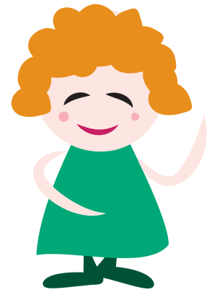

[www.safetyandquality.gov.au](http://www.safetyandquality.gov.au/)

