# Australian COmmission on Safety and Quality in Health Care logo with Radar imageOn the Radar

Issue 180

30 June 2014

*On the Radar* is a summary of some of the recent publications in the areas of safety and quality in health care. Inclusion in this document is not an endorsement or recommendation of any publication or provider.

Access to particular documents may depend on whether they are Open Access or not, and/or your individual or institutional access to subscription sites/services. Material that may require subscription is included as it is considered relevant.

*On the Radar* is available online, via email or as a PDF document from <http://www.safetyandquality.gov.au/publications-resources/on-the-radar/>

If you would like to receive *On the Radar* via email, you can subscribe on our website <http://www.safetyandquality.gov.au/> or by emailing us at H[Umail@safetyandquality.gov.auU](mailto:mail@safetyandquality.gov.au).   
You can also send feedback and comments to H[Umail@safetyandquality.gov.auU](mailto:mail@safetyandquality.gov.au).

For information about the Commission and its programs and publications, please visit <http://www.safetyandquality.gov.au>

You can also follow us on Twitter @ACSQHC.

**On the Radar**

Editor: Dr Niall Johnson [niall.johnson@safetyandquality.gov.au](mailto:niall.johnson@safetyandquality.gov.au)

Contributors: Niall Johnson

**Consultation on Exploring Healthcare Variation in Australia: Analyses Resulting from an OECD Study**

*Consultation now open*

The Australian results of an Organisation for Economic Co-operation and Development (OECD) study on healthcare variation were published in the *Exploring Healthcare Variation in Australia: Analyses Resulting from an OECD Study* discussion paper authored by the Australian Commission on Safety and Quality in Health Care (the Commission) and the Australian Institute of Health and Welfare. The paper is available at <http://www.safetyandquality.gov.au/publications/exploring-healthcare-variation-in-australia/>

The paper examines variation in the rates of several common procedures, selected by the OECD, including: knee surgery (knee arthroscopy and knee replacement); cardiac procedures (cardiac catheterisation, percutaneous coronary interventions and coronary artery bypass grafting; caesarean section; and hysterectomy. The procedures measured were undertaken in hospitals and day procedure centres, both public and private, during 2010-11. Variation was measured according to the Medicare Local area where patients lived, but the approach can be applied to any desired geographic scale.

The Commission is inviting comment and feedback on the paper. Consultation is open until 20 July 2014. Details about how to make a submission are included in the paper.

The contact person for this consultation is Mr Luke Slawomirski, Program Manager, Implementation Support. Mr Slawomirski can be contacted on (02) 9126 3600 or via email at [medicalpracticevariation@safetyandquality.gov.au](mailto:medicalpracticevariation@safetyandquality.gov.au)

**Journal articles**

*Measuring Low-Value Care in Medicare*

Schwartz AL, Landon BE, Elshaug AG, Chernew ME, McWilliams JM

JAMA Internal Medicine 2014 [epub].

|  |  |
| --- | --- |
| DOI | <http://dx.doi.org/10.1001/jamainternmed.2014.1541> |
| Notes | The questions of value in healthcare, how to measure it and how to improve it and so on are of interest to many. This paper adds to the literature on ‘low value care’ and attempts to estimate the scale of the problem of overuse of such care among the US Medicare population.  Applying a list of evidence-based low value interventions to a Medicare dataset of 2009 claims for 1 360 908 Medicare beneficiaries, revealed that possibly as many as 42% of beneficiaries had received at least one low value procedure (and  constituted 2.7% of overall annual spending).  The authors noted that “In this national study of selected low-value services, Medicare **beneficiaries commonly received care that was likely to provide minimal or no benefit** on average. Even when applying narrower versions of our limited number of measures of overuse, we identified low-value care affecting one-quarter of Medicare beneficiaries. These findings are consistent with the notion that **wasteful practices are pervasive** in the US health care system”. |

*CDC Central-Line Bloodstream Infection Prevention Efforts Produced Net Benefits Of At Least $640 Million During 1990–2008*

Scott RD, Sinkowitz-Cochran R, Wise ME, Baggs J, Goates S, Solomon SL, et al.

Health Affairs 2014;33(6):1040-1047.

|  |  |
| --- | --- |
| DOI | <http://dx.doi.org/10.1377/hlthaff.2013.0865> |
| Notes | This paper attempts to quantify the monetary impact of the efforts to reduce central line–associated bloodstream infections (CLABSI) in the USA. The authors developed a historical economic model to measure the net economic benefits of preventing these infections in US Medicare and Medicaid patients in critical care units for the period 1990–2008 (approximately 50,000 CLABSIs were avoided in these patients).  The authors report that the:   * estimated **net economic benefits ranged from $640 million to $1.8 billion** * net benefits per case averted ranging from $15,780 to $24,391 * per dollar rate of return on the CDC’s investments ranged from $3.88 to $23.85.   The authors argue that these suggest that investments in “programs targeting other health care–associated infections also have the potential to produce savings by lowering Medicare and Medicaid reimbursements.” |

*Escalation of Care in Surgery: A Systematic Risk Assessment to Prevent Avoidable Harm in Hospitalized Patients*

Johnston M, Arora S, Anderson O, King D, Behar N, Darzi A

Annals of Surgery 2014 [epub].

|  |  |
| --- | --- |
| DOI | <http://dx.doi.org/10.1097/SLA.0000000000000762> |
| Notes | Paper reporting on a study that sought to risk assess and analyse the escalation of care process in surgery so as to identify problems and provide recommendations for intervention. The study has four phases: ethnographic observations on surgical wards in 3 London hospitals; risk-assessment survey; a group consensus meeting of patient safety and clinical risk experts; and a multidisciplinary Healthcare-Failure-Mode-Effects-Analysis (HFMEA) where cause analysis was applied and interventions were recommended.  The authors report that “**Outdated communication technology**, **understaffing**, and **hierarchical barriers** were identified as root **causes of failure**. Participants recommended **interventions** based on these findings including **defined escalation protocols**, **human factors education**, **enhanced communication technology**, and **improved clinical supervision**. |

*Patient complaints in healthcare systems: a systematic review and coding taxonomy*

Reader TW, Gillespie A, Roberts J

BMJ Quality & Safety 2014 [epub].

|  |  |
| --- | --- |
| DOI | <http://dx.doi.org/10.1136/bmjqs-2013-002437> |
| Notes | Complaints are widely considered a potential resource for identifying risks and failings and for monitoring and improving safety and care. This study sought to review the literature on patient complaints, and use the research findings to develop a coding taxonomy for analysing patient complaints.  Using 59 studies covering 88,069 complaints the researchers found that the **most common issues** complained about were ‘**treatment**’ (15.6%) and ‘**communication**’ (13.7%).  To develop a patient complaint coding taxonomy, the researches established three conceptually distinct domains. The first domain related to complaints on the **safety and quality of clinical care** (representing 33.7% of complaint issues), the second to the **management of healthcare organisations** (35.1%) and the third to problems in **healthcare staff–patient relationships** (29.1%).  The authors hope is that “Rigorous analyses of patient complaints will help to identify problems in patient safety. To achieve this, it is necessary to standardise how patient complaints are analysed and interpreted. …we propose a coding taxonomy for supporting future research and practice in the analysis of patient complaint data.” |

*Automated and electronically assisted hand hygiene monitoring systems: a systematic review*

Ward MA, Schweizer ML, Polgreen PM, Gupta K, Reisinger HS, Perencevich EN

American Journal of Infection Control 2014;42(5):472-478.

|  |  |
| --- | --- |
| DOI | <http://dx.doi.org/10.1016/j.ajic.2014.01.002> |
| Notes | Encouraging appropriate hand hygiene is both a goal and a challenge when it comes to addressing healthcare associated infection. This paper reports on a systematic review that examined technologies for assisting hand hygiene monitoring, including automated counting systems, video monitoring, and fully automated monitoring systems. There is limited data about how accurate, effective, and valuable these strategies are in enhancing hand hygiene compliance. |

For information on the Commission’s work on healthcare associated infection, see <http://www.safetyandquality.gov.au/our-work/healthcare-associated-infection/>

*Unexpectedly long hospital stays as an indicator of risk of unsafe care: an exploratory study*

Borghans I, Hekkert KD, den Ouden L, Cihangir S, Vesseur J, Kool RB, et al.

BMJ Open. 2014;4(6).

|  |  |
| --- | --- |
| DOI | <http://dx.doi.org/10.1136/bmjopen-2013-004773> |
| Notes | This Dutch study examined the possibility of length of stay, particularly long stays, as an indicator of hospital quality of care.  The researchers developed an indicator based on finding that complications often prolong the patient's hospital stay and suggested that a higher percentage of patients with an **unexpectedly long length of stay** (UL-LOS) compared to the national average could indicate patient safety issues. The indicator was then examined using data from 61 Dutch hospitals that had a total of 1 400 000 clinical discharges in 2011. The authors report finding that **rates of unexpectedly long hospital stays varied widely between hospitals** and that they were **correlated with other quality measures**.  The authors suggest that their UL-LOS indicator is “a useful addition to other patient safety indicators by revealing variation between hospitals and areas of possible patient safety improvement.” |

*Clinical decision support for atypical orders: detection and warning of atypical medication orders submitted to a computerized provider order entry system*

Woods AD, Mulherin DP, Flynn AJ, Stevenson JG, Zimmerman CR, Chaffee BW

Journal of the American Medical Informatics Association. 2014;21(3):569-73.

|  |  |
| --- | --- |
| DOI | <http://dx.doi.org/10.1136/amiajnl-2013-002008> |
| Notes | This paper reports on an approach to enhancing computerised medication ordering. In this work the authors argue that that identifying atypical orders may have potential as a way of detecting and preventing prescribing errors.  In the system described here physicians/users were alerted to atypical orders during the prescribing of five medications: calcium, clopidogrel, heparin, magnesium, and potassium. The new orders were compared with historical ordering and atypical orders triggered an alert. This approach – of a learning system – aims to reduce the problem of alert fatigue and improve the specificity of alerts.  The authors report that percentage of atypical orders for the five medications decreased during the 92 days the alerts were active when compared to the same period in the previous year (from 0.81% to 0.53%). While the atypical order alerts were relatively few, they identified problems with frequencies as well as doses, and had a higher specificity than dose check alerts. |

For information on the Commission’s work on medication safety, see [www.safetyandquality.gov.au/our-work/medication-safety/](http://www.safetyandquality.gov.au/our-work/medication-safety/)

*BMJ Quality and Safety* online first articles

|  |  |
| --- | --- |
| URL | <http://qualitysafety.bmj.com/content/early/recent> |
| Notes | *BMJ Quality and Safety* has published a number of ‘online first’ articles, including:   * Parents’ perspectives on safety in **neonatal intensive care**: a mixed-methods study (Audrey Lyndon, Carrie H Jacobson, Kelly M Fagan, Kirsten Wisner, Linda S Franck) |

**Online resources**

*Using Patient and Caregiver Reports about Safety: A Community-based Demonstration*

<http://isqua.org/education/resource-centre/eric-schneider>

Webinar presentation by Eric Schneider of the RAND Corporation describing the development of a prototype consumer reporting hotline for patient safety events, Development included a review of current knowledge, focus groups with health consumers, input from a technical expert panel, and active participation by the pilot sites. The web-based and telephone hotline design incorporates protections to patient safety organizations as well as patients’ preferences regarding the disclosure of their reports.

*[USA] Sentinel Event Alert Issue 52: Preventing infection from the misuse of vials*

<http://www.jointcommission.org/sea_issue_52/>

The (US) Joint Commission has issued a sentinel event alert regarding infections caused by the misuse of vials. Re-use of single-dose vials has resulted in documented transmission of bacteria and hepatitis B and C viruses in the USA. This alert outlines recommendations and potential strategies for improvement, including resources related to the (USA) Centers for Disease Control and Prevention's (CDC) One & Only Campaign, which promotes using "**one needle, one syringe, only one time**." The report also emphasizes teaching safe practices and establishing safety culture. CDC has previously issued guidelines on appropriate use of single-dose vials.

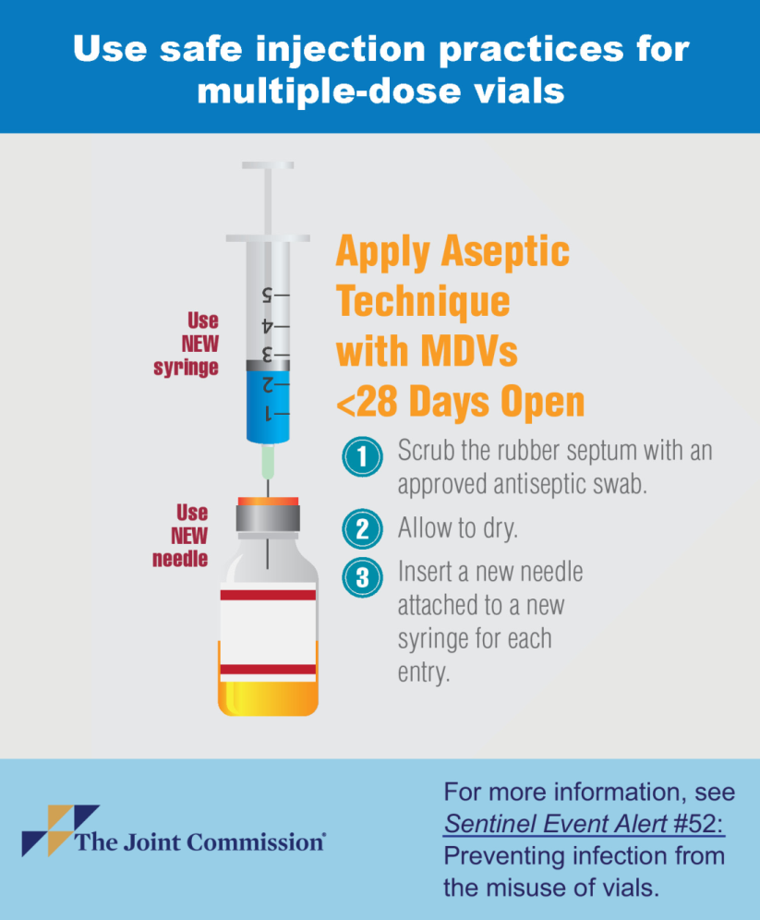

**Disclaimer**

*On the Radar* is an information resource of the Australian Commission on Safety and Quality in Health Care. The Commission is not responsible for the content of, nor does it endorse, any articles or sites listed. The Commission accepts no liability for the information or advice provided by these external links. Links are provided on the basis that users make their own decisions about the accuracy, currency and reliability of the information contained therein. Any opinions expressed are not necessarily those of the Australian Commission on Safety and Quality in Health Care.