
On the Radar
Issue 193
29 September 2014

On the Radar is a summary of some of the recent publications in the areas of safety and quality in health care. Inclusion in this document is not an endorsement or recommendation of any publication or provider.

Access to particular documents may depend on whether they are Open Access or not, and/or your individual or institutional access to subscription sites/services. Material that may require subscription is included as it is considered relevant.

On the Radar is available online, via email or as a PDF document from http://www.safetyandquality.gov.au/publications-resources/on-the-radar/

If you would like to receive On the Radar via email, you can subscribe on our website http://www.safetyandquality.gov.au/ or by emailing us at HUmail@safetyandquality.gov.auU.
You can also send feedback and comments to HUmail@safetyandquality.gov.auU.

For information about the Commission and its programs and publications, please visit http://www.safetyandquality.gov.au
You can also follow us on Twitter @ACSQHC.

On the Radar
Editor: Dr Niall Johnson niall.johnson@safetyandquality.gov.au
Contributors: Niall Johnson

Shared Decision Making Symposium: Developing tools and skills for clinical practice
Free live webcast on Thursday, 16 October 2014 (9.00am–1pm AEDT)

Co-hosted by the Australian Commission on Safety and Quality in Health Care and the University of Sydney’s Centre for Medical Psychology and Evidence-Based Decision Making (CeMPED) the symposium will include:
- Tools and skills for effective shared decision making
- Current implementation issues for clinical practice
- Presentations by International experts, Australian experts & panel discussion.
Time: 9.00am–1.00pm AEDT
Date: Thursday, 16 October 2014.
Webcast: The link for the webcast will be posted at http://www.safetyandquality.gov.au/our-work/shared-decision-making/
No registration is required, just click on the link.
Video: Missed out on the live webcast? Watch the video of the webcast at http://www.safetyandquality.gov.au/our-work/shared-decision-making/

For further information, please contact shannon.mckinn@sydney.edu.au
Reports

Dying in America: Improving Quality and Honoring Individual Preferences Near the End of Life
IOM (Institute of Medicine)
Washington D.C.: The National Academies Press; 2014. 630 p.
URL | http://www.iom.edu/Reports/2014/Dying-In-America-Improving-Quality-and-Honoring-Individual-Preferences-Near-the-End-of-Life.aspx
Notes | The (US) Institute of Medicine has published this consensus report on end of life care. The report reflects the views of its committee of experts in arguing that improving the quality and availability of medical and social services for patients and their families can not only enhance quality of life through the end of life, but may also contribute to a more sustainable care system. One of the risks of using such language is that some may try to claim that decisions about care are being made for economic reasons or that this is a form of rationing of care.
TRIM | D14-32700

Journal articles

Medication Errors: An Overview for Clinicians
Wittich CM, Burkle CM, Lanier WL
Mayo Clinic proceedings.89(8):1116-25.
DOI | http://dx.doi.org/10.1016/j.mayocp.2014.05.007
Notes | This review or summary article aims to provide clinicians with an overview of medication error. Areas covered in the article include:  - terminology and definitions  - incidence  - risk factors  - avoidance strategies (labelling and medication reconciliation), and  - disclosure and legal consequences (for the US context primarily).

For information on the Commission’s work on medication safety, see www.safetyandquality.gov.au/our-work/medication-safety/

Multiple medication use in older patients in post-acute transitional care: a prospective cohort study
Runganga M, Peel NM, Hubbard RE
Clinical Interventions in Aging, 9, 1453-1462. 2014;9:1453-62.
DOI | http://dx.doi.org/10.2147/CIA.S64105
Notes | Paper reporting a study investigating the extent of polypharmacy and potentially inappropriate medications in patients receiving post-discharge transitional home care. The study was a prospective observational study of 351 patients discharged home from hospital with support from six Transition Care Program (TCP) sites in two Australian states. Polypharmacy (5–9 drugs) was observed in 46.7% and hyperpolypharmacy (≥10 drugs) in 39.2% of patients. The authors observe that “ Efforts should be made to encourage regular medication reviews and rationalization of medications as part of discharge planning.” Such efforts may aid in addressing medication errors and/or adverse drug events in these patients.
The role of hospital managers in quality and patient safety: a systematic review
Parand A, Dopson S, Renz A, Vincent C.
BMJ Open. 2014 September 1, 2014;4(9).
DOI | http://dx.doi.org/10.1136/bmjopen-2014-005055
Notes | It is not uncommon to hear the refrain that patient safety (and quality) is everyone’s job or responsibility. However, for some roles it features prominently. This paper presents a systematic review on the role of hospital managers in relation to quality and safety. The literature is not extensive: from an initial scan of d 15 447 titles/abstracts the study focussed on just 19 articles.  The key messages from the review include:  - A dearth of empirical evidence on hospital managerial work and its influence on quality of care.  - Some evidence that Boards’/managers’ time spent, engagement and work can influence quality and safety clinical outcomes, processes and performance.  - Some variables associated with good quality performance were lacking in study hospitals.  - Many Board managers do not spend sufficient time on quality and safety.  - Greater focus on the contextual issues surrounding managers’ roles than on examining managerial activities.  - Research is required to examine middle and frontline managers, to take into consideration non-managers’ perceptions, and to assess senior managers’ time and tasks outside of the Boardroom. More robust methodologies with objective outcome measures would strengthen the evidence.  The authors also offer a model to summarise the evidence-based promotion of conditions and activities for managers to best affect quality performance:  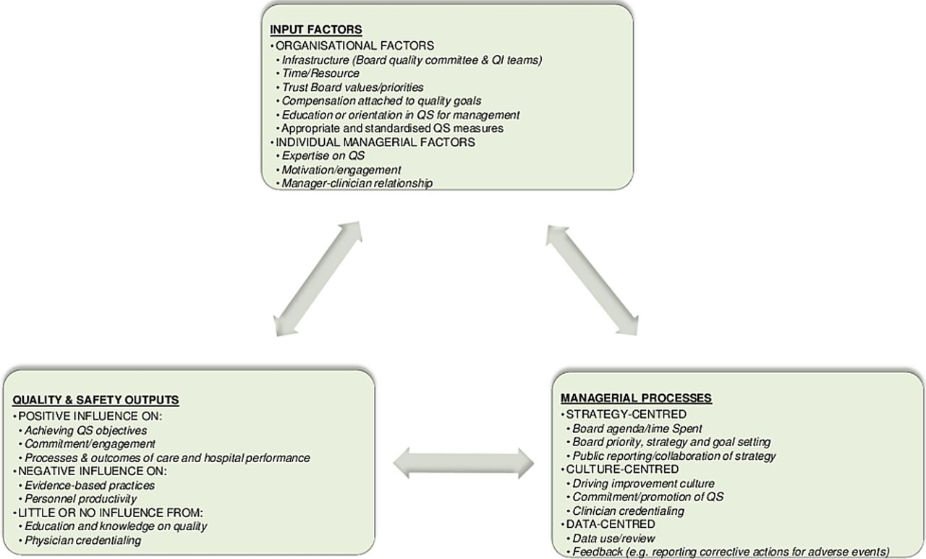

The preventive surgical site infection bundle in colorectal surgery: An effective approach to surgical site infection reduction and health care cost savings
Keenan JE, Speicher PJ, Thacker JM, Walter M, Kuchibhatla M, Mantyh CR
JAMA Surgery. 2014.
DOI | http://dx.doi.org/10.1001/jamasurg.2014.346
Notes | Paper describing the impact of a bundle of interventions aimed at preventing surgical site infections (an SSI bundle) in colorectal surgery. This retrospective study was conducted in a US academic tertiary referral centre covering the period 1 January 2008 to 31 December 2012 with the bundle implemented from 1 July 2011 and examined the impacts on 559 patients who underwent major elective colorectal surgery (346 (61.9%) and 213 (38.1%) before and after implementation).  The authors report that implementation of the bundle was associated with reduced superficial SSIs (19.3% vs 5.7%) and postoperative sepsis (8.5% vs 2.4%), but that no significant difference was observed in deep SSIs, organ-space SSIs, wound disruption, length of stay, or 30-day readmission.  The authors conclude “The preventive SSI bundle was associated with a substantial reduction in SSIs after colorectal surgery. The increased costs associated with SSIs support that the bundle represents an effective approach to reduce health care costs.”

For information on the Commission’s work on healthcare associated infection, see www.safetyandquality.gov.au/our-work/healthcare-associated-infection/

Transitional Care Interventions Prevent Hospital Readmissions For Adults With Chronic Illnesses
Verhaegh KJ, MacNeil-Vroomen JL, Eslami S, Geerlings SE, de Rooij SE, Buurman BM
Health Affairs. 2014 September 1, 2014;33(9):1531-9.
DOI | http://dx.doi.org/10.1377/hlthaff.2014.0160
Notes | Transitions between care are potentially risky times for patients. This paper reports on a systematic review of interventions focusing on transitions in the care of people with chronic conditions. The study sought to examine whether these interventions reduced or prevented readmissions. The review found that transitional care can be effective in reducing all-cause intermediate-term and long-term readmissions, but it was only high-intensity transitional care that had an impact on short-term readmissions. To reduce these short-term readmissions, the authors found, “transitional care should consist of high-intensity interventions that include care coordination by a nurse, communication between the primary care provider and the hospital, and a home visit within three days after discharge.”

Re-finding the ‘human side’ of human factors in nursing: Helping student nurses to combine person-centred care with the rigours of patient safety
Fawcett TN, Rhynas SJ
Nurse Education Today. 2014;34(9):1238-41.
DOI | http://dx.doi.org/10.1016/j.nedt.2014.01.008
Notes | This paper reflects on the “the centrality of both patient safety and person-centred care when preparing student nurses for their role.” Taking a human factors approach, the authors explore how nursing can be a matter of balancing best practice, risk identification management, autonomy and control.
The relationship between hospital systems load and patient harm
Pedroja AT, Blegen MA, Abravanel R, Stromberg AJ, Spurlock B
Journal of Patient Safety. 2014 Sep;10(3):168-75.
DOI | http://dx.doi.org/10.1097/PTS.0b013e31829e4f82
Notes | Paper reporting on an observational study that sought to develop a metric of Hospital Systems Load (a multi-dimensional measure of overall hospital workload) and then to investigate the relationship between system load and adverse events. The final system load metric included measures of census, length of stay, and turnover for the emergency department, inpatient units, and operating rooms. In exploratory analyses—based on a single year’s data from 2 Californian hospitals—this was correlated with several types of adverse events.

Chronic Care Model Strategies In The United States And Germany Deliver Patient-Centered, High-Quality Diabetes Care
Stock S, Pitcavage JM, Simic D, Altin S, Graf C, Feng W, et al.
Health Affairs. 2014 September 1, 2014;33(9):1540-8.
DOI | http://dx.doi.org/10.1377/hlthaff.2014.0428
Notes | This paper reports on the results of surveys of patients engaged in two different models of patient-centred diabetes care (as compared to the experiences of patients who received routine diabetes care in the same systems – the US and Germany). The authors report that those enrolled in the care models (that demonstrated Chronic Care Model features) were more likely to receive care that was patient-centred, high quality, and collaborative. The authors consider that these indicate that the application of the Chronic Care Model can deliver quality improvement, “regardless of the setting or distinct characteristics of the program”.

BMJ Quality and Safety online first articles
URL | http://qualitysafety.bmj.com/content/early/recent
Notes | BMJ Quality and Safety has published a number of ‘online first’ articles, including:  - Editorial: Finding patients before they crash: the next major opportunity to improve patient safety (David W Bates, Eyal Zimlichman)  - Impact of introducing an electronic physiological surveillance system on hospital mortality (Paul E Schmidt, Paul Meredith, David R Prytherch, Duncan Watson, Valerie Watson, Roger M Killen, Peter Greengross, Mohammed A Mohammed, Gary B Smith)  - Exploring new avenues to assess the sharp end of patient safety: an analysis of nationally aggregated peer review data (Derek W Meeks, Ashley N D Meyer, Barbara Rose, Yuri N Walker, Hardeep Singh)

Disclaimer
On the Radar is an information resource of the Australian Commission on Safety and Quality in Health Care. The Commission is not responsible for the content of, nor does it endorse, any articles or sites listed. The Commission accepts no liability for the information or advice provided by these external links. Links are provided on the basis that users make their own decisions about the accuracy, currency and reliability of the information contained therein. Any opinions expressed are not necessarily those of the Australian Commission on Safety and Quality in Health Care.

