
On the Radar
Issue 207
Tuesday 27 January 2015

On the Radar is a summary of some of the recent publications in the areas of safety and quality in health care. Inclusion in this document is not an endorsement or recommendation of any publication or provider.

Access to particular documents may depend on whether they are Open Access or not, and/or your individual or institutional access to subscription sites/services. Material that may require subscription is included as it is considered relevant.

On the Radar is available online, via email or as a PDF document from http://www.safetyandquality.gov.au/publications-resources/on-the-radar/

If you would like to receive On the Radar via email, you can subscribe on our website http://www.safetyandquality.gov.au/ or by emailing us at HUmail@safetyandquality.gov.auU.
You can also send feedback and comments to HUmail@safetyandquality.gov.auU.

For information about the Commission and its programs and publications, please visit http://www.safetyandquality.gov.au
You can also follow us on Twitter @ACSQHC.
On the Radar
Editor: Dr Niall Johnson niall.johnson@safetyandquality.gov.au
Contributors: Niall Johnson, Lucia Tapsall

Reports
Quality first: Managing workload to deliver safe patient care
British Medical Association
London: British Medical Association; 2015.
URL | http://bma.org.uk/practical-support-at-work/gp-practices/quality-first
Notes | This guidance from the British Medical Association aims to help GPs ease their workload pressures and find more time for direct patient care. It provides practical steps practices can take to address rising workloads. It includes chapters on:  - Re-assessing where clinical work is provided  - Enhanced services and other incentive schemes  - Bureaucracy reduction  - Patient partnership and self-empowerment  - New ways of working  - Working with other practices  - Viability of other roles  - List management  - Looking after your own health  - Useful resources including workload management checklist  - Template letters for practice use.
Journal articles

Patients’ expectations of the benefits and harms of treatments, screening, and tests: A systematic review
Hoffmann TC, Del Mar C
JAMA Internal Medicine. 2014 [epub].
DOI | http://dx.doi.org/10.1001/jamainternmed.2014.6016
Notes | In this systematic review — the first of its kind on patient and public expectations of the benefits and harms of medical interventions — Hoffmann and Del Mar report that the majority of patients overestimated the benefits and underestimated the harms of screening tests and treatment.  The over-use of medicine is identified as a concern; that is the overdiagnosis and overtreatment of many conditions, which can cause unnecessary harm to patients, drive up the cost of health care and place strain on the health system.  Overly optimistic expectations by patients and clinicians about the benefits of tests and treatments are a factor, as are assumptions that more treatment is better (and the resistance to having less). Poor numeracy, knowledge of risk and communication of harms are also identified, along with influences from outside the clinical encounter such as commercial sources, the media and pricing structures.  Evidence-informed discussions between patients and clinicians in a shared decision making process is advocated in order to provide patients with “the opportunity to develop realistic expectations to make informed decisions”. Tools such as patient decision aids can be used to facilitate these discussions and have been shown to reduce the uptake of interventions like major elective surgery. The authors support strategies to encourage the implementation of shared decision making into routine practice such as embedding within training for clinicians, workflow systems and culture.

For information on the Commission’s work on shared decision making, see www.safetyandquality.gov.au/our-work/shared-decision-making/

A qualitative study of decision-making and safety in ambulance service transitions
O'Hara R, Johnson M, Hirst E, Weyman A, Shaw D, Mortimer P, et al
Health Services and Delivery Research. 2014 2014/12/23;2(56).
DOI | http://dx.doi.org/10.3310/hsdr02560
Notes | Decisions made by front-line ambulance staff are often time-critical and based on limited information, but incorrect decisions can have serious consequences. The aim of this study was to qualitatively examine potential system-wide influences on decision-making in the ambulance service setting and to identify useful areas for future research and intervention.  From the interviews, digital diaries, observations, focus groups and workshops the authors report finding:  - nine types of decision ranging from emergency department conveyance and specialist emergency pathways to non-conveyance, and  - seven overarching system influences on decision-making and potential risk factors: meeting increasing demand for emergency care; impacts of performance regime and priorities on service delivery; access to appropriate care options; disproportionate risk aversion; education, training and professional development for crews; communication and feedback to crews; and ambulance service resources.
Advancing the science of measurement of diagnostic errors in healthcare: the Safer Dx framework
Singh H, Sittig DF
BMJ Quality & Safety. 2015;24(2):103-10.
DOI | http://dx.doi.org/10.1136/bmjqs-2014-003675
Notes | Diagnostic error has been attracting some attention in recent years. In this piece one of the key authors in this area has proposed a framework “to advance the science of measuring diagnostic errors (The Safer Dx framework).”  The author adopt a definition of diagnostic error as “missed opportunities to make a correct or timely diagnosis based on the available evidence, regardless of patient harm.”  It is hoped that the framework will “facilitate feedback and learning to help accomplish two short-term goals: (1) refine the science of measuring diagnostic error and (2) make diagnostic error an organisational priority…”  Questions as to whether the focus should be on detecting and measuring diagnostic error or on supporting clinicians in making better diagnoses may be one response.  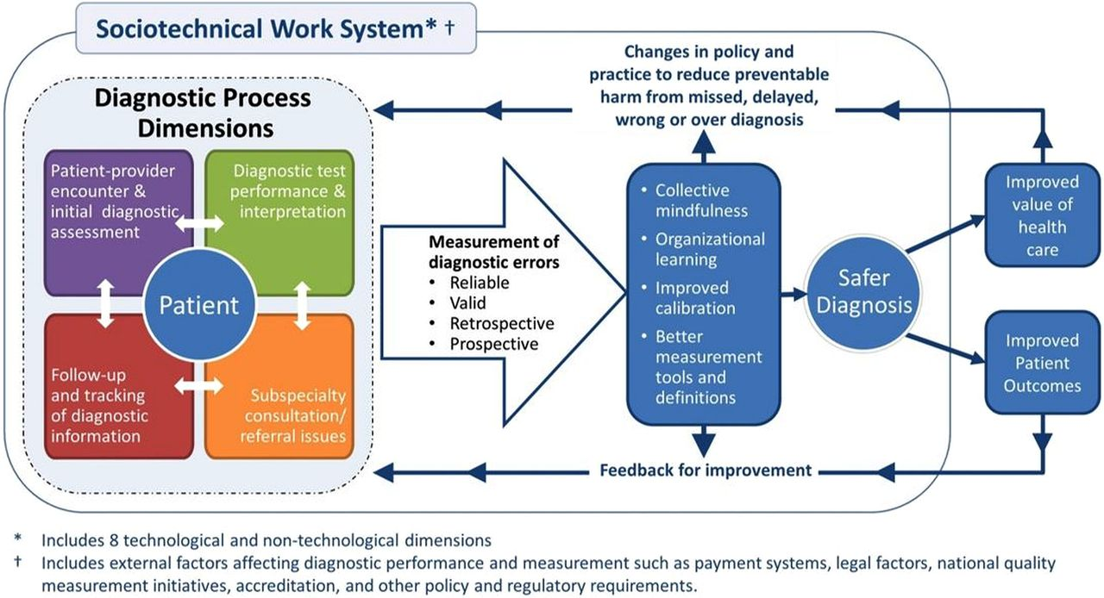

What are incident reports telling us? A comparative study at two Australian hospitals of medication errors identified at audit, detected by staff and reported to an incident system
Westbrook JI, Li L, Lehnbom EC, Baysari MT, Braithwaite J, Burke R, et al
International Journal for Quality in Health Care. 2015 [epub].
DOI | http://dx.doi.org/10.1093/intqhc/mzu098
Notes | This study in two Australian hospitals revealed that incident systems only captured a small fraction of medication errors – as revealed by audit and observation. The study involved the audit of 3,291 patient records and observation of 180 administering 7,451 medications.  The authors report 539 “clinically important prescribing errors” at a rate of 218.9/1000 were found, but only 13.0/1000 were reported. Some 78.1% of clinically important prescribing errors were not detected.  As they conclude, “Prescribing errors with the potential to cause harm frequently go undetected. Reported incidents do not reflect the profile of medication errors which occur in hospitals or the underlying rates. This demonstrates the inaccuracy of using incident frequency to compare patient risk or quality performance within or across hospitals. New approaches including data mining of electronic clinical information systems are required to support more effective medication error detection and mitigation.”

For information on the Commission’s work on medication safety, see www.safetyandquality.gov.au/our-work/medication-safety/

Systematic biases in group decision-making: implications for patient safety
Mannion R, Thompson C
International Journal for Quality in Health Care. 2014;26(6):606-12.
DOI | http://dx.doi.org/10.1093/intqhc/mzu083
Notes | We like to think that when we work together to collaboratively solve problems that this leads to better thinking and better solutions. In the paper the authors problematise this assumption by describing how group decision-making can have its own biases and risks, “be imperfect and result in organizational and clinical errors”.  Four systematic biases arising from group decision-making — ‘groupthink’, ‘social loafing’, ‘group polarization’ and ‘escalation of commitment’ — are all identified. For each the authors describe its antecedents, how it can impair group decisions, and outline possible remedial strategies.  Cultures that value openness, transparency, learning and mindfulness and similar aspects may appear to be better positioned to avoid the risks of these biases.

BMJ Quality and Safety
February 2015, Vol. 24, Issue 2
URL | http://qualitysafety.bmj.com/content/24/2
Notes | A new issue of BMJ Quality and Safety has been published. Many of the papers in this issue have been referred to in previous editions of On the Radar (when they were released online). Articles in this issue of BMJ Quality and Safety include:  - Editorial: Low value cardiac testing and Choosing Wisely (R Sacha Bhatia, Wendy Levinson, Douglas S Lee)  - Editorial: Improvement and evaluation (Robert L Wears)  - Editorial: What is a performance outlier? (David M Shahian, Sharon-Lise T Normand)  - A ‘work smarter, not harder’ approach to improving healthcare quality (Christopher William Hayes, Paul B Batalden, Donald Goldmann)  - Advancing the science of measurement of diagnostic errors in healthcare: the Safer Dx framework (Hardeep Singh, Dean F Sittig)  - A combined teamwork training and work standardisation intervention in operating theatres: controlled interrupted time series study (Lauren Morgan, Sharon P Pickering, Mohammed Hadi, Eleanor Robertson, Steve New, D Griffin, G Collins, O Rivero-Arias, K Catchpole, P McCulloch)  - Effectiveness of facilitated introduction of a standard operating procedure into routine processes in the operating theatre: a controlled interrupted time series (Lauren Morgan, Steve New, Eleanor Robertson, Gary Collins, Oliver Rivero-Arias, Ken Catchpole, Sharon P Pickering, Mohammed Hadi, Damian Griffin, Peter McCulloch)  - Better-than-average and worse-than-average hospitals may not significantly differ from average hospitals: an analysis of Medicare Hospital Compare ratings (Susan M Paddock, John L Adams, F Hoces de la Guardia)  - Self-reported patient safety competence among Canadian medical students and postgraduate trainees: a cross-sectional survey (Patricia Doyle, Elizabeth G VanDenKerkhof, Dana S Edge, L Ginsburg, D H Goldstein)  - Adverse events in patients with return emergency department visits (Lisa Calder, Anita Pozgay, Shena Riff, David Rothwell, Erik Youngson, Naghmeh Mojaverian, Adam Cwinn, Alan Forster)  - Use of non-indicated cardiac testing in low-risk patients: Choosing Wisely (Carrie H Colla, Thomas D Sequist, Meredith B Rosenthal, William L Schpero, Daniel J Gottlieb, Nancy E Morden)  - Driven to distraction: a prospective controlled study of a simulated ward round experience to improve patient safety teaching for medical students (Ian Thomas, Laura Nicol, Luke Regan, Jennifer Cleland, Drieka Maliepaard, Lindsay Clark, Kenneth Walker, John Duncan)  - Patient safety is not elective: a debate at the NPSF Patient Safety Congress (Patricia McTiernan, Robert M Wachter, Gregg S Meyer, Tejal K Gandhi)  - ‘Choosing Wisely’: a growing international campaign (Wendy Levinson, Marjon Kallewaard, R Sacha Bhatia, Daniel Wolfson, S Shortt, E A Kerr)

BMJ Quality and Safety online first articles
URL | http://qualitysafety.bmj.com/content/early/recent
Notes | BMJ Quality and Safety has published a number of ‘online first’ articles, including:  - Computerised physician order entry-related medication errors: analysis of reported errors and vulnerability testing of current systems (G D Schiff, M G Amato, T Eguale, J J Boehne, A Wright, R Koppel, A H Rashidee, R B Elson, D L Whitney, T-T Thach, D W Bates, A C Seger)  - Assessing patient safety competencies using Objective Structured Clinical Exams: a new twist on an old tool (Lynfa Stroud, Arpana R Vidyarthi)  - Real-time information on preventable death provided by email from frontline intensivists: results in high response rates with useful information (L Marjon Dijkema, Frederik Keus, Willem Dieperink, Iwan C C van der Horst, Jan G Zijlstra)

International Journal for Quality in Health Care online first articles
URL | http://intqhc.oxfordjournals.org/content/early/recent?papetoc
Notes | International Journal for Quality in Health Care has published a number of ‘online first’ articles, including:  - Frequency of ambulatory care adverse events in Latin American countries: the AMBEAS/PAHO cohort study (Dolors Montserrat-Capella, Manuel Suárez, Lidia Ortiz, José Joaquín Mira, Hernando Gaitán Duarte, and Ludovic Reveiz)  - A feasibility study of the provision of a personalized interdisciplinary audiovisual summary to facilitate care transfer care at hospital discharge: Care Transfer Video (CareTV) (Harvey H Newnham, Harry H Gibbs, Edward S Ritchie, Karen I Hitchcock, Vathy Nagalingam, Andrew Hoiles, Ed Wallace, Elizabeth Georgeson, and Sara Holton)

Online resources

Medical Devices Safety Update
Volume 3, Number 1, January 2015
https://www.tga.gov.au/publication-issue/medical-devices-safety-update-volume-3-number-1-january-2015
The Therapeutic Goods Administration (TGA) has released the latest edition of its medical device safety bulletin. Topics covered in this issue include:
- Safety though adverse event reporting – the TGA, in partnership with NPS MedicineWise, has launched two online learning modules to support health professionals in reporting adverse events
- Recommendations for avoiding or dealing with surgical implant tool breakages – TGA receives reports of surgical tools breaking while being used in association with implant surgery
- IRIS inSite pilot – a pilot project to study how communicating directly with health professionals in a hospital setting can improve the rate and quality of medical device adverse event reporting
- Clinical alarm issues as top hazard – Clinical alarm issues remain the top health technology hazard worldwide, followed by data integrity issues and IV line misconnections
- Recent safety alerts.

[UK] Quality Watch – Is care getting better? Latest data
http://www.qualitywatch.org.uk/indicators-results
The UK’s QualityWatch programme — operated by the Nuffield Trust and the Health Foundation — monitors more than 260 quality indicators to tell the story of how healthcare is changing over time in the NHS in England. The latest updates include new data on children's health, alcohol-related harm and hospital discharge.

[UK] Safe staffing for nursing in A&E departments
http://www.nice.org.uk/guidance/gid-accidentandemergencysettings/resources/accident-and-emergency-departments-guideline-consultation3
The UK’s National Institute for Health and Care Excellence (NICE) has released draft guidance for emergency departments to ensure there are enough nursing staff available to provide safe care at all times to patients. This latest guidance aims to ensure that A&E departments have the capacity to provide all necessary emergency care, as well as specialist input for children, older people or those with mental health needs.
NICE recommends that organisations consider minimum ratios when planning what nursing staff they need to fund in advance. Minimum ratios can also be used on a shift-by-shift basis to help work out what services can be made available at that time. These are based on the seriousness of a person’s condition and the level of care they need, for example:
- 2 registered nurses to 1 patient in cases of major trauma or cardiac arrest
- 1 registered nurse to 4 cubicles in either ‘majors’ or ‘minors’.

[USA] End-Stage Renal Disease Facilities Toolkit
http://www.ahrq.gov/professionals/quality-patient-safety/patient-safety-resources/resources/esrd/index.html
The US Agency for Healthcare Research and Quality (AHRQ) has developed a new resource called the AHRQ Safety Program for End-Stage Renal Disease Facilities Toolkit. The toolkit is intended to help prevent infection in people with end-stage renal disease.
Dialysis clinics can use this toolkit to prevent healthcare-associated infections in their patients. Available at no charge, the toolkit helps clinicians and other health care workers follow clinical best practices, create a culture of safety, use checklists and other audit tools, and engage patients and their families in infection prevention practices. This new resource has science-based, practical information—including educational videos—that reflects the experiences of the frontline providers who helped develop the toolkit.

[USA] Effective Health Care Program reports
http://effectivehealthcare.ahrq.gov/
The US Agency for Healthcare Research and Quality (AHRQ) has an Effective Health Care (EHC) Program. The EHC has released the following final reports and updates:
- Relationship Between Use of Quality Measures and Improved Outcomes in Serious Mental Illness http://www.effectivehealthcare.ahrq.gov/search-for-guides-reviews-and-reports/?pageaction=displayproduct&productID=2035

Disclaimer
On the Radar is an information resource of the Australian Commission on Safety and Quality in Health Care. The Commission is not responsible for the content of, nor does it endorse, any articles or sites listed. The Commission accepts no liability for the information or advice provided by these external links. Links are provided on the basis that users make their own decisions about the accuracy, currency and reliability of the information contained therein. Any opinions expressed are not necessarily those of the Australian Commission on Safety and Quality in Health Care.

