Electronic Medication Management Systems

Implementation Plan
2nd Edition

Responsible:
[Insert name of project manager]
Project manager
Address:
Telephone:
Fax:
Email:

Date:
Version:
Approved by:

© Commonwealth of Australia 2012
You may download, display, print and reproduce this material (retaining this notice, and any headers and footers) for your personal, non-commercial use or use within your organisation. You may alter the contents of this material to suit the purposes of your organisation. All other rights are reserved.
ISBN print 978-1-921983-21-4
ISBN online 978-1-921983-22-1
Suggested citation:
Australian Commission on Safety and Quality in Health Care. Electronic Medication Management Systems — Implementation Plan, 2nd edition, ACSQHC, Sydney, 2012.
This document can be downloaded from the ACSQHC web site: www.safetyandquality.gov.au
ACSQHC can be contacted at:
Australian Commission on Safety and Quality in Health Care
GPO Box 5480
Sydney NSW 2001
Tel: 02 9263 3633
Fax: 02 9263 3613
Email: mail@safetyandquality.gov.au
If calling from overseas:
Tel: +61 2 9263 3633
Fax: +61 2 9263 3613

Project sponsor
[Insert name of project sponsor]
Project manager
[Insert name of project manager]
Hospital(s) in scope
[Insert hospital(s)]
Version control
Document revision history
Version | Date | Prepared by | Comments

Distribution
Copy number | Release number | Date issued | Issued to

This is a managed document. For identification of amendments, each page contains a version date and a page number. Changes will only be issued as complete replacements covered by a release notice. This document has not been released for use until authorised by the last signatory.

Contents
Preface 8
Executive summary 10
1 Background and context 11
1.1 Background to the EMM project 11
1.2 The scope of the EMM system implementation 11
1.3 Strategic information and ICT context 11
1.4 Governance structure 12
2 EMM system implementation 13
2.1 Overview of the EMM system implementation 13
2.2 Project initiation 15
2.3 Implementation planning 15
2.3.1 Implementation planning study 16
2.3.2 Business process mapping and redesign 19
2.3.3 Policy development 19
2.3.4 Implementation sequence planning 19
2.3.5 Change management planning 20
2.3.6 Evaluation planning 22
2.3.7 Benefits management activities 25
2.3.8 Education and training 27
2.3.9 Project communications 29
2.3.10 Quality management 31
2.4 EMM system build and configuration activities 34
2.4.1 Design and acquisition of technical infrastructure 34
2.4.2 Software development 34
2.4.3 Building the technical environments 37
2.4.4 Non-functional testing 37
2.4.5 Configuration of EMM system content 38
2.4.6 Developing interfaces to key systems 38
2.4.7 User acceptance testing 39
2.5 EMM system implementation and go-live activities 41
2.5.1 Implementation checklist 41
2.5.2 Project control centre 44
2.5.3 Go-live roles and responsibilities 44
2.5.4 Pre and post-go-live tasks 44
2.5.5 Escalation strategy 45
2.5.6 Managing the transition in a staged implementation 45
2.5.7 Rollback and project suspension strategy 45
2.5.8 Project team exit strategy and transition to support 45
3 EMM project governance 47
3.1 EMM project board 48
3.2 Roles of senior stakeholders 48
3.3 EMM project team 48
3.4 EMM reference group 49
3.5 Specialty subgroups and project assurance teams 49
3.5.1 Drug and therapeutics committee 49
3.5.2 Pharmacy subgroup 49
3.5.3 Medical subgroup 50
3.5.4 Nursing and midwifery subgroup 50
3.5.5 Allied health subgroup 50
3.5.6 Safety and quality subgroup 51
3.5.7 Information and communications technology (ICT) subgroup 51
4 Project plan 52
4.1 Key phases and milestones 52
4.2 Budget 53
4.3 Risk management 55
4.4 Issue management 57
5 Ongoing operations 59
5.1 EMM ongoing operations 59
5.1.1 Post-implementation review 59
5.1.2 Ongoing monitoring, evaluation and refinement 59
5.1.3 Consolidation of education and training 60
5.1.4 Ongoing vendor support 60
5.1.5 Benefits measurement 60
Appendix 1 Example strategic context 61
Appendix 2 Example business context 62
Appendix 3 Business process maps 63
Appendix 4 Example stop/start/continue chart 64
Appendix 5 Terms of reference and minutes template 65
Appendix 6 Project status report template 67
Appendix 7 Clinical risk log 71

Tables
Table 2.1 Stakeholder analysis 21
Table 2.2 Evaluation framework 23
Table 2.3 Example of baseline indicators for paper-based charts and expected changes when using an EMM system 24
Table 2.4 Benefits register template 26
Table 2.5 Education and training template 28
Table 2.6 Communications plan template 30
Table 2.7 Quality register template 32
Table 2.8 Quality checklist 33
Table 2.9 Implementation timeline template 33
Table 2.10 Traceability matrix template 36
Table 2.11 User acceptance testing (UAT) script template 40
Table 2.12 Implementation planning checklist 42
Table 3.1 Roles matrix template 48
Table 3.2 EMM project team 48
Table 4.1 Phases and milestones template 53
Table 4.2 Budget and expenditure monitoring template 54
Table 4.3 Risk assessment matrix 55
Table 4.4 Risk register 56
Table 4.5 Issue register 58

Figures
Figure 2.1 EMM system implementation process flow 14
Figure 2.2 Example stakeholder map 21
Figure 3.1 Example project governance structure 47

Preface
Medication errors remain the second most common type of medical incident reported in hospitals, and of all medication errors, omission or overdose of medicines occurs most frequently. Reducing all errors will significantly improve patient safety and the quality use of medicines.
An electronic medication management (EMM) system enables prescribing, supply and administration of medicines to be completed electronically. EMM covers the entire hospital medication cycle including prescribing by doctors, review and dispensing of medication orders by pharmacists, and administration of medicines by nurses. EMM reduces medication errors through improved prescription legibility, dose calculation and clinical decision support. It enables best practice information to be more readily available to prescribers and improves linkages between clinical information systems. It can also improve efficiency in the medication management process, such as reducing the time required to locate paper medication charts or to supply non-imprest medicines.
EMM systems can reduce medication errors, but they also have the potential to adversely affect safety and quality of care if the system is poorly designed and implemented, and under-resourced. This risk is highlighted in a number of studies that show increased medication errors following poorly planned implementations of EMM systems. With many Australian hospitals planning to implement EMM systems, it is essential that this risk is minimised by considering the international literature and learning from the experiences of early Australian EMM system implementations.
Implementing an EMM system within a hospital is a major transformational project that substantially affects clinical service delivery, hospital departments and the work of clinicians. It requires extensive pre-implementation planning, including initial scoping, developing a business case, evaluating and selecting an EMM system product, and conducting a detailed implementation planning study. It is essential that the project is adequately resourced, that change is managed effectively, and that the project has the endorsement and full support of the hospital executive and senior clinical staff.
How to use this template
This document is the key planning tool for hospital EMM system implementation, and accompanies Electronic Medication Management Systems — A Guide to Safe Implementation, 2nd edition. This implementation plan is designed to be used as an electronic template. It provides the basis for a hospital’s EMM implementation plan, including appropriate heading structures and example tables. Hospitals should modify each section and table with their own data — instructional text and examples are provided in [square brackets and/or blue text] throughout the document.
Each hospital should develop a detailed baseline EMM implementation project plan and include this in Section 4, Project plan. The baseline plan is the project plan that is initially approved by the EMM project board. The phases of the plan and the tasks within each phase should be numbered for ease of cross-referencing (e.g. Phase 1 — Project initiation will include tasks 1.1, 1.2, 1.3, etc.). These phases and tasks in the project plan should be cross-referenced to sections throughout this template. Cross-referencing the project plan enables stakeholders to easily locate and understand the relationship between a section of the EMM planning template and the overall EMM implementation project plan.

Executive summary
[Write this section last.]
Aims and objectives
[List the aims and objectives of the EMM system implementation.]
Scope
[Outline the scope of the EMM implementation, including any key relationships and dependencies on other key systems. Outline what is not in scope. Critically consider Chapter 6 of the Guide to Safe Implementation when defining the EMM scope.]
Context
[Provide the rationale for why an EMM system is to be implemented and the expected benefits. Include the breadth of services that will be involved in the implementation process and any known complexities that will need to be addressed. Consider the products available in the EMM market and describe how the proposed project takes this into account to ensure strategic and business alignment, as well as value for money. Examples of strategic and business contexts are provided in appendices 1 and 2.]
Project outline
[Outline:
- phases, milestones and dates
- resources required to implement the system.]
End point
[Outline the end point or goal of the EMM system implementation.]

1 Background and context

1.1 Background to the EMM project
[Include relevant EMM background information here, including:
the business case approval process
any tender selection process
the outcome of the tender selection process
details of the selected EMM system.]

1.2 The scope of the EMM system implementation
[Provide a brief overview of the EMM implementation project, including:
phases, milestones and dates
project resources
whether there will be a pilot implementation
partner organisations; for example, any evaluation partner or change management partner
project dependencies; for example, other clinical systems, or information and communications technology (ICT) infrastructure projects that affect or will be affected by the EMM implementation
expected outcomes of the project.]

1.3 Strategic information and ICT context
[Include details on whether the EMM system is part of a larger clinical system implementation or a separate EMM solution, and the rationale for this decision.
Identify any relationships with other systems that include medication information and the nature of the relationships. For example:
where allergies and alerts are maintained
where diagnostic results are held
the existence of any specialised medication systems such as chemotherapy management systems
the relationship with the pharmacy dispensing system
the relationship with any medication reconciliation system
the relationships with any discharge referral or discharge summary systems.
Indicate whether the required ICT infrastructure is part of the EMM project or part of a separate project, and include a summary of the technology that will be required (e.g. wireless and mobile devices, fixed bedside devices, infotainment systems).]

1.4 Governance structure
[Provide a brief overview of the proposed governance structure for the project. Include details of:
the project sponsor
the project board members and their roles (e.g. senior user, senior supplier)
the relationship with the organisation’s management structures and other program management functions (where EMM is part of a larger program of work)
the relationship with the governance of other dependent projects.
Note that more detailed information on the project governance structure is included in Section 3 of this template.]

2 EMM system implementation

2.1 Overview of the EMM system implementation
[This section provides an overview of the activities that will be undertaken as part of the EMM system implementation.]
The electronic medication management (EMM) system implementation will typically consist of five stages:
1. Project initiation
2. Implementation planning
3. EMM system build and configuration activities
4. Implementation and go-live activities
5. Ongoing operations.
[If there are additional EMM implementation activities, include them here.]
The detailed content for each of these stages is outlined in Figure 2.1.

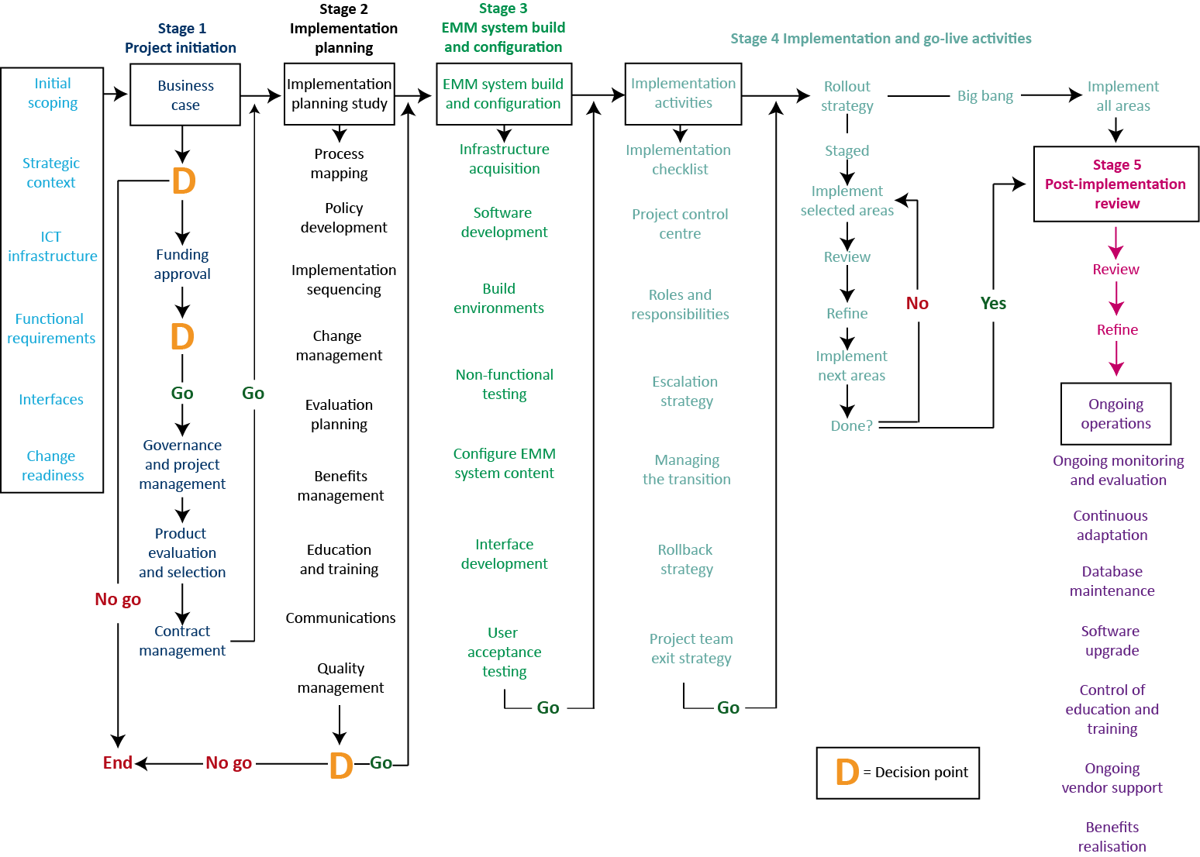
EMM = electronic medication management; ICT = information and communications technology
Figure 2.1 EMM system implementation process flow

2.2 Project initiation
[Usually, project initiation will have been completed before starting the EMM system implementation. If this is the case, record a summary of the business case approval process, the approved funding, the results of any tender or procurement process, and the selected EMM system supplier.
If the project initiation forms part of this implementation plan, provide details of the planned process for developing and approving the business case, and any tender or procurement plans. Not all elements of the EMM implementation plan can be completed until the EMM solution supplier is known. If this is the case, this template should be completed in two stages.
See Chapter 15 of the Guide to Safe Implementation for more details on project initiation.]

2.3 Implementation planning
A well-planned EMM system rollout is essential for the success of the project. EMM implementation planning consists of:
the implementation planning study (IPS)
business process mapping and redesign
policy development
implementation sequence planning
change management planning
evaluation planning
benefits management activities
education and training
project communications
quality management.

2.3.1 Implementation planning study
[The IPS is typically the first activity in EMM implementation. Sometimes the EMM system supplier will do the IPS and they may have their own IPS template. In this case, use the checklist below to ensure all the issues are adequately covered in the EMM supplier’s IPS template.
If developing the IPS inhouse, use the IPS checklist below to ensure all the issues are adequately covered in the IPS.
Cross-reference the IPS activities to the baseline EMM implementation project plan, to be incorporated into Section 4 of this template. For example, include cross-references such as ‘The IPS can be found in Stage 1, tasks 10–85 of the project plan’.
See Section 16.1 of the Guide to Safe Implementation for more details on the IPS.]
Implementation planning study (IPS) checklist
Typical IPS components comprise:
- the scope of the EMM implementation (e.g. all areas of the hospital or inpatients areas only)
- electronic medication reconciliation
- accessing the Pharmaceutical Benefits Scheme
- a detailed EMM system implementation plan, including
all implementation tasks
software development activities
configuration and build activities
any lead EMM system implementation
EMM system rollout plans
- resources required from the vendor and the hospital
- project structures — governance, relationships, escalation processes
- project controls, including
scope and change management
configuration management
quality management
risk management
issue management
- technical infrastructure requirements, including the number of environments (e.g. production, test, training, development) and an environment management plan
- capacity requirements (e.g. numbers of users, user concurrency, data capacity)
- a gap analysis of the functional requirements and a plan to fill the gaps through software development
- an analysis of the interfaces required and a plan to deliver the interfaces
- project team EMM system training
- the strategic context that diagrammatically illustrates and describes the relationships between EMM and other systems
- the business context that diagrammatically illustrates and describes the end-to-end scope of EMM, the scope of the EMM system implementation and how EMM will be managed at the boundaries to ensure medication safety
- goal-state process mapping
- EMM system acceptance criteria
- a traceability framework
- EMM system education, and a training strategy and plan
- a data migration strategy and plan (if required)
- a testing strategy and plan, including
user acceptance testing
non-functional testing
interface testing
integration (end-to-end) testing
stress and volume testing
- a software installation plan
- operational support and transition-to-support plan
- go-live support
- a list of all project deliverables
- contract payment milestones
- service level agreements with EMM vendors, and information and communications technology service providers
- legislative and policy requirements
- a responsibility matrix.

2.3.2 Business process mapping and redesign
[Identify the extent to which current-state and future-state EMM process mapping is to be undertaken, the timing of these activities and who will undertake them. Chapter 6 and Section 16.3 of the Guide to Safe Implementation include specific EMM processes that require consideration, although there may be others.
The EMM system supplier may lead or undertake future-state process mapping as part of the IPS. The advantage of supplier participation in this process is their in-depth knowledge of the chosen EMM system and how this system is used elsewhere.
The development of current-state process maps ensures a thorough understanding of what happens now, and provides useful material to assist in consensus building. The process maps are also useful in supporting EMM communication materials and change management strategies. Include the process maps and their supporting narrative in Appendix 3 of this template. It may be useful to summarise the changes in a stop/start/continue chart; an example chart is in Appendix 4 of this template.
Cross-reference the business process mapping and redesign activities to the baseline EMM implementation project plan in Section 4 of this template.]

2.3.3 Policy development
[Identify any EMM policies that need to be developed, the timing of these activities and who will undertake them. Outline the process for the policies to be endorsed by senior management, how the policies will be disseminated and how they will be referenced in the EMM communications material.
See Section 16.4 of the Guide to Safe Implementation for more details on policy development.
Cross-reference any policy development activities to the baseline EMM implementation project plan in Section 4 of this template.]

2.3.4 Implementation sequence planning
[Outline the proposed EMM implementation sequence, including any pilot wards, the duration of the pilots, and any evaluation and refinement activities before EMM rollout.
Consider the EMM implementation sequence carefully — the Guide to Safe Implementation considers a range of options. Provide the rationale for implementation sequence decisions so that stakeholders understand the basis for the EMM implementation rollout.
See Section 16.6 of the Guide to Safe Implementation for a range of options for implementation sequence planning.]

2.3.5 Change management planning
[Outline the approach to change management (e.g. Kotter’s eight-stage process; see Box 12.1 of the Guide to Safe Implementation) and whether change management activities will be undertaken inhouse or by a third-party organisation.
Develop a change management plan that considers:
stakeholder analysis
stakeholder engagement strategies
communication plans in relation to change management
change readiness assessments
numbers and identities of the EMM clinical champions and change agents
the responsibilities of each person or group in delivering the change management plans.
See Chapter 12 of the Guide to Safe Implementation for more detail on change management planning.
Templates supporting change management planning include the stakeholder analysis and stakeholder map (Table 2.1 and Figure 2.2), and the communications plan (see Section 2.3.9).
Cross-reference change management activities to the baseline EMM implementation project plan in Section 4 of this template.
Complete the following template for each stakeholder group in the hospital or organisation.]
Table 2.1 Stakeholder analysis
Stakeholder | Stake in the project | Potential impact on project | What does the project expect the stakeholder to provide? | Perceived attitudes and risks | Stakeholder management strategy | Responsibility
Senior medical staff | Medium | Critical | Use of EMM, and active encouragement and support for EMM use by junior medical staff | Risk of not using and influencing uptake and use by junior medical staff | Identify clinical champions to make the case with their peers  Involve CEO in negotiating required project outcome  Ensure an optimised fast and efficient EMM prescribing process  Emphasise downstream benefits | Director of Medicine  Chief executive  EMM system vendor  EMM project team
CEO = chief executive officer; EMM = electronic medication management
[Summarise the stakeholder analysis on the stakeholder map. It may be useful to colour-code stakeholders, showing advocates and supporters in green, blockers and critics in red, and others who are neutral in orange. The position of a stakeholder on the grid will determine the actions required to engage them.]
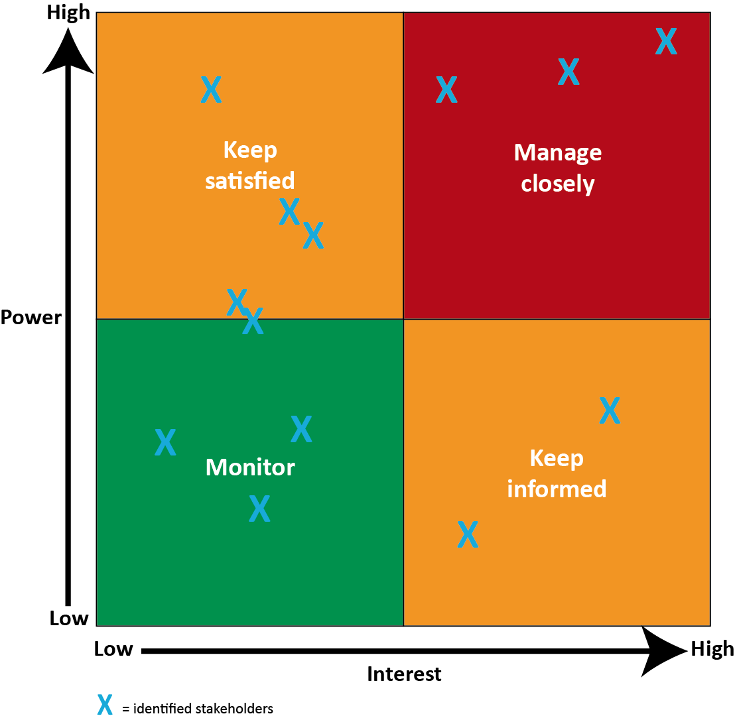
Figure 2.2 Example stakeholder map

2.3.6 Evaluation planning
[Wherever possible, include evaluation activities in the EMM plans to measure and compare medication safety before and after implementation of the EMM system.
Evaluation components should include:
an evaluation framework
expected outcomes following implementation of the EMM system
baseline indicators
evaluation activities
EMM implementation checkpoint reviews
post-implementation review planning.
See Section 16.7 of the Guide to Safe Implementation for more detail on evaluation planning.
Templates supporting evaluation include the evaluation framework (Table 2.2) and baseline indicators table (Table 2.3).
Cross-reference evaluation planning activities to the baseline EMM implementation project plan in Section 4 of this template.]

Table 2.2 Evaluation framework
Expected outcome | Indicator | Sub-indicators | Measure(s) | Potential data sources | Activity for data collection | Time points for measurement
Improved quality and safety in medicines use | Reduced AMEs | Prescribing errors by number, type, severity, patient volume, bed-days, total LOS | Number of prescribing errors by type and severity  Number of patients  Number of bed-days  Total LOS | Medication charts  Hospital issues and risk reporting (sentinel events)  Review of medication incidents and AMEs | Audit of medication charts for a defined time period  Review of sentinel events | Pre-implementation  Post-implementation  Ongoing monitoring
Improved quality and safety in medicines use | Reduced AMEs | Administration errors, etc.
Improved quality and safety in medicines use | Increased adherence to guidelines
AME = adverse medicine event; LOS = length of stay

Table 2.3 Example of baseline indicators for paper-based charts and expected changes when using an EMM system
Paper-based chart indicator | Expected changes in an EMM system
Whether error-prone abbreviations were present in the medication order | Error-prone abbreviations will not be configured in the EMM system, so this indicator will be 100%
Whether the indication was documented | Where recording of the indication is not mandatory, a report from the EMM system of the number of medication orders without indication recorded, sorted by prescriber, by specialty or by class of medicine, is to be used for follow-up education and training
Whether the medication order was clearly legible | Legibility will not be an issue in the EMM system, so this indicator will be 100%
Whether the prescriber and pharmacist had initialled the medication order | Prescriber signatures will be defaulted within the EMM system and a report will indicate the extent to which pharmacists have reviewed medication orders
Whether the nurse or midwife had initialled administration of the medicine | The signature of nurses and midwives administering medications will be defaulted within the EMM system
Whether the non-administering codes were used correctly | Correct use of non-administering codes will need to be checked against other information, such as progress notes in the medical record, in a post-implementation case note audit for patients
Whether allergies and adverse drug reactions were recorded | The EMM system can make recording allergy and adverse drug reaction information mandatory at the time of prescribing, so this indicator would be 100%  Where recording of the indication is not mandatory at the time of prescribing, a report from the EMM system of the number of patients without allergy and adverse drug reaction information recorded is to be used for follow-up education and training
Whether the number of medication charts identified was correct | The number of paper medication charts recorded in the EMM system is to be validated against the number of paper medication charts in the medical record
Whether telephone orders were validated or countersigned by the prescriber | Prescribers will ideally access the EMM system remotely, so telephone orders will no longer be required  The extent to which telephone orders are validated or countersigned by the prescriber will depend on the EMM system workflow facilities and whether the system supports telephone orders without subsequent validation or countersigning
Whether the patient medicines information in the discharge summary reflected medicines on admission, medicines prescribed during the admission and medicines on discharge, and listed reasons for any changes between admission and discharge | Alignment of patient medicines information in the EMM system and the discharge summary requires a case note audit, unless the EMM system is sufficiently integrated with discharge summary production
EMM = electronic medication management

2.3.7 Benefits management activities
[Benefits management is a critical area of EMM implementation. The benefits register is a key control document to recognise planned and unplanned benefits, determine when benefits are to be measured and identify who is responsible for measuring them. The benefits register should contain both quantitative and qualitative benefits.
The business case will include the benefits that were used to justify the investment in an EMM system and these benefits should be incorporated into the benefits register. The benefits register should be regularly updated as the expected benefits change, and should be reviewed and maintained in line with the project plan.
See Section 16.8 of the Guide to Safe Implementation for more detail on benefits management planning.
Complete the benefits register template (Table 2.4).
Cross-reference benefits management activities to the baseline EMM implementation project plan in Section 4 of this template.]

Table 2.4 Benefits register template
Benefit | Baseline measure | Likely value | Worst case | Best case | Responsibility and beneficiary group
Reduction in prescribing errors | Baseline measure to be collected before go-live for a one-month periodª | 20% | 0% | 40% | R = Pharmacy  B = Medical
Reduction in administration errors | Baseline measure before go-live from incident reporting system | 2% | 0% | 10% | R = Pharmacy  B = Nursing and midwifery
Elimination of time required rewriting medication charts | Average time required to rewrite medication chart | 10 minutes per chart | No time saving for patients on few or no medications | 30 minutes for patients on complex medication regimes | R = EMM system  B = Medical
Restarting admission medications on discharge | Implementation of admission medication functionality |  |  |  | R = EMM system  B = Medical
Populating the discharge medication script from the current medications list and admission medications list | Average time required to rewrite the discharge script |  |  |  | R = EMM system  B = Medical
B = beneficiary; R = measurement responsibility
a The hospital’s incident reporting system as an information source may be limited, recognising that most prescribing errors are identified and prevented by pharmacy before they become reportable

2.3.8 Education and training
[EMM implementation will affect most clinical staff in the hospital, and careful planning for education and training is essential to ensure a smooth implementation.
The education and training plans may be described in detail in a separate document — in this case, summarise the education and training plans here.
Education and training plans should include:
development, sign-off and production of the education and training materials
the availability and support of any online learning management system used to support EMM training
the approach to training; for example, vendor training or inhouse training
the types of training, including informal and formal, pre-implementation, EMM system and refresher training
the number of trainers required, the length of time they will be required and their skill sets, including clinical experience
identification and booking of training facilities, including dedicated training areas
development, availability and support of the ‘sandpit’ for consolidated learning
the timing of training in relation to EMM go-live
detailed costs, including expectations from the business regarding cross-charging for clinical time.
See Section 16.9 of the Guide to Safe Implementation for more detail on education and training.
Complete the education and training template in Table 2.5.
Cross-reference education and training activities to the baseline EMM implementation project plan in Section 4 of this template.]

Table 2.5 Education and training template
Education and training component | Requirement | Responsibility | Duration | Cost
Self-directed learning | Online learning management system and support for the EMM duration | Education and training lead | 3 months
 | Education materials for the online learning management system | Education and training team | 3 months
Sandpit | Build the sandpit environment | ICT service provider | 1 month
 | Remote access to the sandpit | ICT telecommunications manager | 1 month
Education and training collateral | Introductions  EMM overview  Medication safety  Expected benefits  Implementation challenges (managing expectations) | Education and training team | 1 month
 | EMM system training modules | Education and training team | 3 months
 | EMM demonstrations and presentations  (e.g. at grand rounds) | Education and training team | 2 months
 | Posters and fact sheets | Education and training team | 2 months (including production time)
 | Evaluation feedback and surveys | Education and training team | 1 month
Trainers | 4 people for 1 year | Education and training lead | 4 months to advertise and fill posts
Training facilities | 2 rooms for 1 year | Education and training lead | 3 months to identify and equip
Training schedule | Overview sessions for all staff | Education and training team | 1 hour
 | Role-based training | Education and training team | 3 hours
EMM = electronic medication management; ICT = information and communications technology

2.3.9 Project communications
[The stakeholder analysis (see Table 2.1) and proposed EMM project schedule will inform the communications plan.
See Section 16.10 of the Guide to Safe Implementation for more detail on project communications.
Complete the communications plan template in Table 2.6.
Cross-reference communication activities to the baseline EMM implementation project plan in Section 4 of this template.]

Table 2.6 Communications plan template
Target audience | Communication typeª | Stakeholder  (primary or secondary) | Responsibility | Key messages | Communication mode^{b} | Timing^{c} | Frequency^{d}
All staff | Project announcement | Both | Project team | EMM is coming soon | Posters | 3 months before go-live | Once
All clinical staff | Project announcement | Primary | Project clinicians | Medication safety | Posters, CEO newsletter | 3 months before go-live | Once
Prescribers | Project update | Primary | Lead medical staff | Medication safety | Grand rounds | 2 months before go-live | Monthly
CEO = chief executive officer; EMM= electronic medication management
a For example, project update, project announcement
b For example, email, phone, face to face, meetings
c Project stage or data range during which communication applies
d For example, daily, weekly, fortnightly, monthly, once

2.3.10 Quality management
[Describe the quality assurance process for project deliverables, including responsibilities for undertaking quality reviews. See Section 16.11 of the Guide to Safe Implementation for more detail on quality management.
Use the quality register in Table 2.7 to itemise planned and actual quality activities. As a minimum, review the deliverables identified in the EMM toolkit and complete a quality record for each deliverable. For each deliverable, identify the quality method, the reviewers, the approvers, the scheduled and actual review dates, and the outcome of the quality activity.
Use the quality checklist (Table 2.8) to manage quality deliverables and sign-off.
The PRINCE2 project management methodology includes a quality review technique that could be usefully applied to the EMM implementation.
Cross-reference quality management activities to the baseline EMM implementation project plan in Section 4 of this template.]

Table 2.7 Quality register template
Ref | Item | Quality method | Produced by | Reviewed by | Approved by | Results | Scheduled and actual quality activities
[X] | IPS | Document review | Project manager | Project team | Project board | Approved (and date) | Held dd/mm/yy
 | PAS interface specifications | Document review | PAS vendor | Interface lead | Technical project assurance team | Scheduled (and date) | Scheduled dd/mm/yy
 | EMM hardware | Capacity test | ICT service provider | Technical project assurance team | Senior user (technical) | Not yet scheduled | Unscheduled
[etc.]
EMM = electronic medication management; ICT = information and communications technology; IPS = implementation planning study; PAS = patient administration system
Table 2.8 Quality checklist
Quality management and project delivery sign-off | Complete
EMM business case | Yes | No | Partial | N/A
EMM system functional specifications | Yes | No | Partial | N/A
Tender documentation before its release | Yes | No | Partial | N/A
Contract with the selected EMM system vendor | Yes | No | Partial | N/A
IPS | Yes | No | Partial | N/A
Project control documents | Yes | No | Partial | N/A
Software development enhancement specifications | Yes | No | Partial | N/A
EMM system interface specifications | Yes | No | Partial | N/A
Change control requests | Yes | No | Partial | N/A
EMM process maps | Yes | No | Partial | N/A
New software configured, tested and determined as fit for purpose | Yes | No | Partial | N/A
EMM system build documentation | Yes | No | Partial | N/A
UAT strategy and plans | Yes | No | Partial | N/A
UAT scripts | Yes | No | Partial | N/A
Education and training materials | Yes | No | Partial | N/A
EMM communication strategy, plans and tools | Yes | No | Partial | N/A
Scope and content of the evaluation activities | Yes | No | Partial | N/A
Ongoing governance arrangements for EMM on completion of the implementation rollout | Yes | No | Partial | N/A
Service-level agreements between the EMM project and third parties | Yes | No | Partial | N/A
[insert other quality management and project delivery sign-off items as necessary]
EMM = electronic medication management; IPS = implementation planning study; N/A = not applicable; UAT = user acceptance testing
[Use the implementation timeline template in Table 2.9 to summarise and plan timelines for each stage.]
Table 2.9 Implementation timeline template
 | Timeline (weeks)
Task | 1 | 2 | 3 | 4 | 5 | 6 | 7 | 8 | 9 | 10 | 11 | 12 | 13 | 14
Implementation planning study
Business process mapping and redesign
EMM policy development
Implementation sequence planning
Change management planning
Evaluation planning
Benefits management planning
Development of training materials
[etc.]
EMM = electronic medication management

2.4 EMM system build and configuration activities
The EMM system build and configuration activities focus on delivering the technical elements of the EMM system. Activities include:
designing and acquiring technical infrastructure
developing software
building the technical environments
non-functional testing
configuring the EMM system content
developing interfaces with key support systems
user acceptance testing (UAT).
[See Chapter 17 of the Guide to Safe Implementation for more detail of EMM system build and configuration.]

2.4.1 Design and acquisition of technical infrastructure
[Describe each of the activities required to build the EMM technical infrastructure and the responsibilities for these activities. Explain how the technical infrastructure will be developed and validated by technical stakeholders to ensure that the proposed infrastructure aligns with the organisation’s other technical infrastructure services.
Include a diagram that itemises each of the components that make up the infrastructure, including centralised hardware, the use of multiple data centres (where available), resilient components, network connectivity and network resilience.
Where technical infrastructure needs to be acquired, identify responsibilities, timelines and the reporting relationships between this project and the EMM system implementation.
There are no specific templates for this component. See Section 17.1 of the Guide to Safe Implementation for more detail on technical infrastructure.
Cross-reference EMM design and technical infrastructure activities to the baseline EMM implementation project plan in Section 4 of this template.]

2.4.2 Software development
[In broad terms, describe the main areas where software development is required, and who is responsible for delivering each component of software.
Include any software elements to be delivered by other third-party suppliers of systems that will interface with the EMM system, as well as inhouse software development activities (e.g. developing interfaces between EMM and other inhouse systems).
It is important to demonstrate a tight relationship between the original requirements and the software deliverables. Explain how the requirements identified in the tender specifications or future-state process maps will be used to track the software development required. Describe how these requirements will be converted into technical specifications by the EMM supplier and subsequently validated by the EMM project team. Consider how these requirements will populate the traceability matrix and be used to develop the UAT scripts.
See Section 17.2 of the Guide to Safe Implementation for more detail on software development.
Complete the traceability matrix in Table 2.10 and keep it up to date as UAT and non-functional testing progresses.
Cross-reference software development activities to the baseline EMM implementation project plan in Section 4 of this template.]

Table 2.10 Traceability matrix template
Reference | Functional or non-functional | Requirement description | Design document reference | UAT reference | User acceptance validation | Comments
[X] | Functional | Interface with pharmacy dispensing system | [X] | Scripts 45–97 | Passed | Refer to UAT script documentation for details
[X] | Non-functional | Performance testing EMM hardware | Technical infrastructure design | Scripts 117–130
[X] | Non-functional | Replication failover | Technical infrastructure design | N/A | Passed | Failover test performed dd/mm/yy  Results reviewed and approved by technical project assurance team on dd/mm/yy
[etc.]
EMM = electronic medication management; N/A = not applicable; UAT = user acceptance testing

2.4.3 Building the technical environments
[List the number of different EMM environments that are required (e.g. production, training, test, sandpit environments).
For each environment, identify the assumptions and expectations regarding the size, use and support of each environment, and responsibilities for installation and ongoing operation. For example, ICT might build the training or sandpit environment, but it may be managed by the EMM training team.
It is particularly important that the environments are sized correctly, based on the expected volume of users and transactions, and to be clear if any of the environments need to be accessible from locations that are external to the organisation’s network.
Consider the following questions:
Will the training environment need to be refreshed and, if so, how often?
How will configuration changes be managed across production, training and sandpit environments?
What is the change control procedure that will ensure the environments are aligned and who has responsibility for managing this?
There are no specific templates for this component. See Section 17.3 of the Guide to Safe Implementation for more detail on building the technical environments.
Cross-reference building the technical environment activities to the baseline EMM implementation project plan in Section 4 of this template.]

2.4.4 Non-functional testing
[Non-functional testing is an activity that is often overlooked, but it is essential for identifying and measuring the technical expectations for the EMM system to ensure technical compliance and acceptance. Examples of non-functional test requirements include system performance measures, the use of active directory, single sign-on requirements and replication failover.
Explain how the technical requirements identified in the tender specifications will populate the traceability matrix and be used to develop the non-functional UAT scripts. It is important to demonstrate a tight relationship between the original requirements and the testing of the non-functional deliverables.
See Section 17.4 of the Guide to Safe Implementation for more detail on non-functional testing.
Update the traceability matrix template (Table 2.10, Section 2.4.2) with the non-functional requirements and the results of the non-functional testing.
Cross-reference non-functional testing activities to the baseline EMM implementation project plan in Section 4 of this template.]

2.4.5 Configuration of EMM system content
[Describe how the EMM configuration (EMM content) will be managed, including responsibilities. Describe how governance and quality assurance are involved in review and sign-off on configuration deliverables. Describe the change control process for updating the configuration records over time that ensures any changes are notified to those managing UAT scripts, education and training, communications and environment management.
List each of the areas of the EMM system that will require configuration, indicating responsibility for the content specification, its review, configuration within the EMM, and validation and sign-off.
It is important to expose EMM users to the configured content of the EMM through pre-implementation awareness activities before formal EMM training. Describe how this will occur.
There are no specific templates for this component. See Section 17.5 of the Guide to Safe Implementation for more detail on configuring the EMM system content.
Cross-reference EMM configuration activities to the baseline EMM implementation project plan in Section 4 of this template.]

2.4.6 Developing interfaces to key systems
[Interfacing between clinical systems is a specialised activity that will require collaboration between the EMM system supplier, third-party system suppliers and, possibly, inhouse technical teams.
This is an important area of the IPS and it may be sufficient to simply cross-reference the appropriate sections of the IPS here.
It is essential that interface planning includes the activities required to:
specify, review and sign-off the interface specifications
test each interface informally as well as formally once developed
implement formal change control procedures to document test outcomes, decisions and any changes to the interface
perform end-to-end testing of the interfaces.
Identify resources for testing the interfaces by third-party suppliers or inhouse teams supporting the following systems:
the patient registration system
the pharmacy dispensing system
the pathology results reporting system
any system managing allergies and alerts.
There may be additional specialist systems that require interfacing to the EMM system, including chemotherapy management, intensive care, high-dependency charting or monitoring systems.
There are no specific templates for this component. See Section 17.6 of the Guide to Safe Implementation for more detail on system interfaces.
Cross-reference interface development and testing activities to the baseline EMM implementation project plan in Section 4 of this template.]

2.4.7 User acceptance testing
[Outline the UAT process, the number of planned UAT cycles and the resources required to develop the test scripts and undertake the UAT process. Larger organisations may have established UAT documentation, in which case these should be used and cross-referenced here.
Ensure that the UAT scripts are cross-referenced in the traceability matrix, along with the outcome of the UAT process.
Table 2.11 is a template for developing the UAT scripts. See Section 17.7 of the Guide to Safe Implementation for more detail on UAT.
Cross-reference UAT activities to the baseline EMM implementation project plan in Section 4 of this template.]

Table 2.11 User acceptance testing (UAT) script template
Test script # 1
Description: New medication order
Script reference | Procedure | Expected result | Actual result | Pass/Fail |  | Criteria and reference | Comments
1.01 | Select patient | Patient record displayed | Patient record displayed | Pass | Fail | Enter patient hospital no.: B99999 (for patient Mr John Dow)
1.02 | Select the ‘new medication order’ function | Prescribing function displayed | Prescribing function displayed | Pass | Fail
1.03 | Select the required medicine by typing the first few letters of the medicine until the required medicine is displayed | Medicine requested displayed | Required medicine not in the list | Pass | Fail | Enter erythromycin | Check content of medicine entries in the database and rerun script

2.5 EMM system implementation and go-live activities
The following activities are required to ensure a smooth transition from an EMM project environment to EMM go-live:
developing an implementation checklist
establishing the project control centre
defining go-live roles and responsibilities
defining pre and post-go-live tasks
preparing an escalation strategy (if things go wrong)
managing the transition in a staged EMM implementation
developing a rollback and project suspension strategy
developing a project team exit strategy and transition to support.
[See Chapter 18 of the Guide to Safe Implementation for more detail on implementation and go-live activities.]

2.5.1 Implementation checklist
[The purpose of the implementation checklist is to ensure that all activities have been completed and passed their quality review cycle before starting go-live activities.
Complete and update the implementation template checklist in Table 2.12.
Cross-reference the implementation checklist activities to the baseline EMM implementation project plan in Section 4 of this template.]
Table 2.12 Implementation planning checklist
Stages and activities | Tasks | Achieved
Stage 1 — Project initiation and product selection
Initial scoping | Scope objectives of implementation
Initial scoping | Develop strategic context diagram indicating strategic scope and relationships to other systems
Initial scoping | Develop business context diagram indicating the business scope and how EMM will be managed at the boundaries
Initial scoping | Determine organisational change readiness
 | Sign off project scope
Business case | Conduct needs analysis
 | Identify options
 | Sign off business case
Funding approval | Sign off funding
Governance and management | Set up governance
 | Appoint project team
 | Develop project plan
 | Develop project schedule
 | Set up cost centre
Product evaluation and selection | Develop procurement plan
 | Determine single or multiple vendor
 | Develop EMM specifications
 | Establish tender evaluation panel
 | Develop tender
 | Evaluate tenders
 | Sign off tender approval
Contract management | Develop contract management plan
 | Monitor performance
 | Evaluate service provider
Stage 2 — Implementation planning
IPS | Sign off IPS
Business process mapping and redesign | Develop current-state maps
Business process mapping and redesign | Develop future-state maps
Business process mapping and redesign | Define how medication management will be managed at the boundaries of the EMM scope in ensuring medication safety
Policy development | Develop EMM policies
Implementation sequence planning | Develop implementation sequence plan
Change management planning | Conduct stakeholder analysis
 | Define engagement strategies
 | Conduct change readiness assessment
 | Address stakeholder concerns
 | Identify champions
Evaluation planning | Develop evaluation framework
 | Define expected outcomes
 | Define baseline indicators
 | Conduct evaluation activities
 | Conduct checkpoint and milestone reviews
 | Prepare post-implementation review
 | Sign off evaluation framework
Benefits management planning | Develop benefits management plan
Education and training planning | Plan education and materials
Education and training planning | Plan training and materials
Education and training planning | Develop training courses
Education and training planning | Identify training times and space
Education and training planning | Identify timing of training
Communications planning | Develop communications plan
Communications planning | Develop communication tools
Communications planning | Sign off communications plan
Quality management | Identify quality management processes
Quality management | Develop quality management tools
Final approval of checklist before build phase
Stage 3 — System build and configuration
Acquisition of technical infrastructure | Acquire technical infrastructure
Software development | Develop software
Technical environment building | Build technical environment
Non-functional testing | Complete non-functional testing
Configuration of system content | Configure system content
Development of interfaces | Develop interfaces
UAT | Develop test scripts
 | Conduct informal UAT process
 | Conduct break testing
 | Conduct formal UAT process
 | Conduct end-to-end testing
 | Develop traceability matrix
System configuration sign-off
Stage 4 — Implementation and go-live
System demonstration | Demonstrate system
Communication | Communicate implementation plans
Champion training | Train champions
Workforce training | Educate and train workforce
Project control centre | Establish project control centre
Go-live roles and responsibilities | Define go-live roles, responsibilities and tasks
Strategy development | Define escalation strategy
 | Define rollback and suspension strategies
 | Define project team exit strategy
 | Define transition to support
Go-live sign-off
Stage 5 — Ongoing operations
Post-implementation review | Conduct post-implementation review
Monitoring, evaluation and refinement | Develop risk protocols and tools
 | Develop issue protocols and tools
 | Develop error protocols and tools
 | Continually evaluate the system
 | Continually adapt the system
 | Develop process for database management and maintenance
 | Develop processes for software upgrades
 | Sign off changes to system
Education and training | Develop refresher training
 | Develop targeted training
Vendor support | Ensure ongoing vendor support
Benefits realisation | Monitor benefits realisation
Change management | Analyse stakeholders
 | Develop engagement strategies
 | Change readiness assessments
 | Address stakeholder concerns
 | Identify champions
Benefits management | Plan benefits management
EMM = electronic medication management; IPS = implementation planning study; UAT = user acceptance testing

2.5.2 Project control centre
[Outline the activities to be undertaken in setting up the project control centre.
There are no templates associated with this activity. See Section 18.2 of the Guide to Safe Implementation for more detail on the project control centre.
Cross-reference project control centre activities to the baseline EMM implementation project plan in Section 4 of this template.]

2.5.3 Go-live roles and responsibilities
[Outline the roles and responsibilities of the immediate project team and front-line clinical staff, including clinical champions and expert users during go-live.
There are no templates associated with this activity. See Section 18.3 of the Guide to Safe Implementation for more detail on go-live roles and responsibilities.]

2.5.4 Pre and post-go-live tasks
[Outline the activities to be undertaken to achieve all pre and post-go-live tasks. Example tasks include:
checking the installation and use of all devices, including printers
ensuring the availability of wireless connections wherever EMM will be used (so there are no ‘blackspots’)
producing the project team roster that ensures around-the-clock support during the go-live period
identifying clinical champions and expert users for each area
ensuring go-live communications materials are available.
There are no templates associated with this activity. See Section 18.4 of the Guide to Safe Implementation for more detail on pre and post-go-live tasks.
Cross-reference pre and post-go-live tasks to the baseline EMM implementation project plan in Section 4 of this template.]

2.5.5 Escalation strategy
[Outline the activities needed to develop, communicate and sign-off the escalation strategy so that all people are clear on their roles and responsibilities.
There are no templates associated with this activity. See Section 18.5 of the Guide to Safe Implementation for more detail on the escalation strategy.
Cross-reference escalation strategy activities to the baseline EMM implementation project plan in Section 4 of this template.]

2.5.6 Managing the transition in a staged implementation
[Outline the policy-related activities to manage the transition from paper to electronic medication charts. Ensure these activities are addressed in education, training and communication activities so that all clinical staff are clear about how to manage the transition from paper to EMM and vice versa.
There are no templates associated with this activity. See Section 18.6 of the Guide to Safe Implementation for more detail on managing the transition in a staged implementation.
Cross-reference transition activities to the baseline EMM implementation project plan in Section 4 of this template.]

2.5.7 Rollback and project suspension strategy
[Outline the activities needed to develop, communicate and sign-off the rollback and project suspension strategy so that everyone is clear on their roles and responsibilities.
There are no templates associated with this activity. See Section 18.7 of the Guide to Safe Implementation for more detail on rollback strategies.]
Cross-reference rollback and project suspension activities to the baseline EMM implementation project plan in Section 4 of this template.

2.5.8 Project team exit strategy and transition to support
[Outline the exit strategy for the project team and a plan for transitioning EMM to support. Larger organisations may have checklists or templates that require completion in the planning and execution of the transition to support.
There are no templates associated with this activity. See Section 18.8 of the Guide to Safe Implementation for more detail on the project team exit strategy and transition to support.
Cross-reference transition to support activities to the baseline EMM implementation project plan in Section 4 of this template.]

3 EMM project governance
Project governance is a key aspect for successful implementation of an electronic medication management (EMM) system. The complexity of EMM system implementation is reflected in the governance structure required for successful implementation. An example project governance structure is outlined in Figure 3.1.
[The rest of this section, including the figure, should be updated to include all aspects of the local governance structure. A template for terms of reference and minutes is provided in Appendix 5, and a project status report template is provided in Appendix 6. See Chapter 11 of the Guide to Safe Implementation for more detail on EMM project governance.]
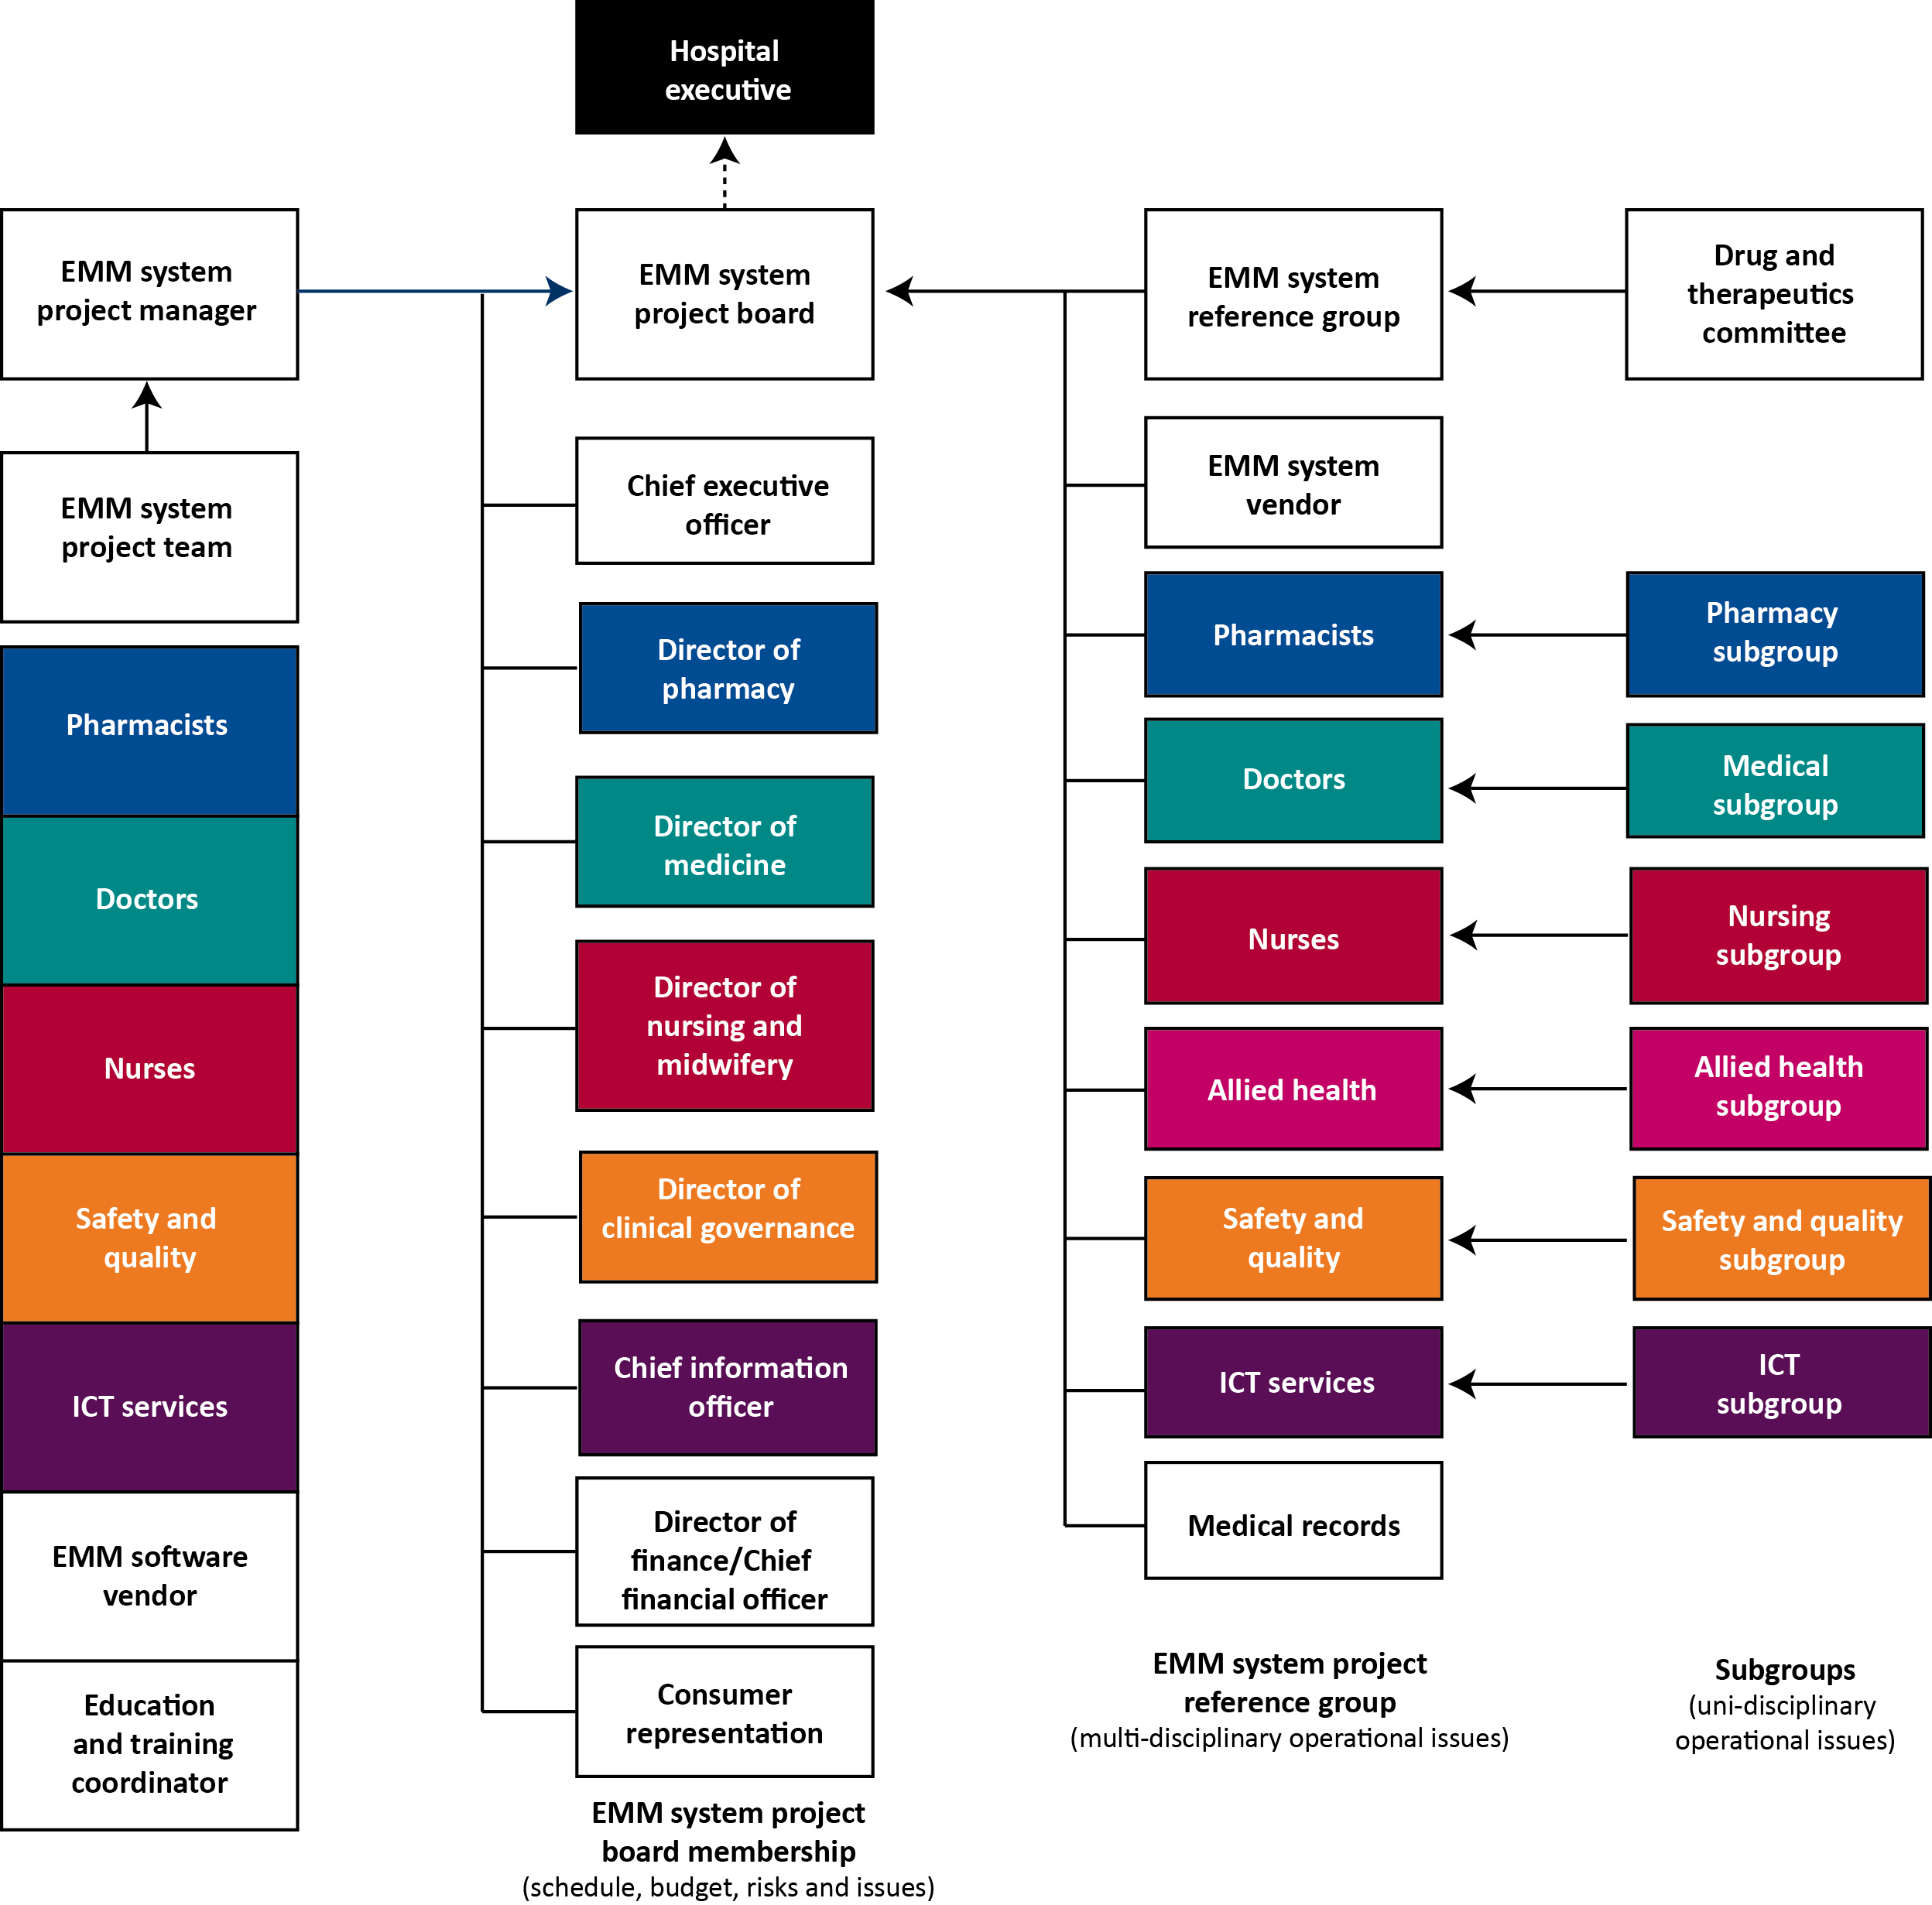
EMM = electronic medication management; ICT = information and communications technology
Figure 3.1 Example project governance structure
[Complete the roles matrix in Table 3.1 for each of the individuals and groups in the project governance structure.]
Table 3.1 Roles matrix template
Individual or group | Roles | Responsibilities
EMM project board | [insert a high-level view of the role of the individual or group] | [insert the individual’s responsibilities or a summary of a group’s terms of reference]
EMM reference group
[insert all relevant individuals and groups]
EMM = electronic medication management

3.1 EMM project board
[Outline:
structure
membership
roles
relationship with other groups within the EMM implementation governance structure
relationship with the hospital executive or any higher level program management governance structure
terms of reference
frequency of meetings.]

3.2 Roles of senior stakeholders
[Outline the detailed responsibilities of each project board member. PRINCE2 provides detailed descriptions of the roles and responsibilities of senior stakeholders.]

3.3 EMM project team
[Adapt and complete Table 3.2 with details of the project team.]
Table 3.2 EMM project team
Title | Name | Role
Project sponsor
Project manager
Project team member
Project team member
[etc.]

3.4 EMM reference group
[Outline:
structure
membership
roles
relationship with other groups within the EMM implementation governance structure
terms of reference
frequency of meetings.]

3.5 Specialty subgroups and project assurance teams

3.5.1 Drug and therapeutics committee
[Outline:
structure
membership
roles
relationship with other groups within the EMM implementation governance structure
terms of reference
frequency of meetings.]

3.5.2 Pharmacy subgroup
[Outline:
structure
membership
roles
relationship with other groups within the EMM implementation governance structure
terms of reference
frequency of meetings.]

3.5.3 Medical subgroup
[Outline:
structure
membership
roles
relationship with other groups within the EMM implementation governance structure
terms of reference
frequency of meetings.]

3.5.4 Nursing and midwifery subgroup
[Outline:
structure
membership
roles
relationship with other groups within the EMM implementation governance structure
terms of reference
frequency of meetings.]

3.5.5 Allied health subgroup
[Outline:
structure
membership
roles
relationship with other groups within the EMM implementation governance structure
terms of reference
frequency of meetings.]

3.5.6 Safety and quality subgroup
[Outline:
structure
membership
roles
relationship with other groups within the EMM implementation governance structure
terms of reference
frequency of meetings.]

3.5.7 Information and communications technology (ICT) subgroup
[Outline:
structure
membership
roles
relationship with other groups within the EMM implementation governance structure
terms of reference
frequency of meetings.]

4 Project plan
[A detailed project plan brings together all the components required to deliver and implement the EMM system.
Project planning is only useful within a reasonable planning horizon. Plans for the first stage of the EMM implementation — the implementation planning study — should be in sufficient detail to properly track project activities, dependencies and resources. Plans for subsequent stages will be less well defined initially, and will become more detailed over time.
Use the implementation planning checklist in Table 2.12 (Section 2.5.1) when developing the project plan to ensure all aspects of the EMM implementation are considered and incorporated. Number the phases and the tasks within each phase for ease of cross-referencing (e.g. Phase 1 — Project initiation will include tasks 1.1, 1.2, 1.3, etc.).
Include the full EMM implementation project plan in this section.]

4.1 Key phases and milestones
[Identify the main project phases and project milestones that are detailed in the project plan. The purpose of this section is to convey key aspects of the project plan to stakeholders without needing to refer to the detail of the project plan itself.
Complete the phases and milestones template in Table 4.1.]
Table 4.1 Phases and milestones template
Plan reference | Phases | Milestones | Expected date
1.1 | Project initiation phase | Confirm project governance arrangements | July 20xx
1.2 | Project initiation phase | Confirm project reporting arrangements | July 20xx
1.3 | Project initiation phase | Confirm change control arrangements | July 20xx
1.4 | Project initiation phase | Confirm delegated authorities | July 20xx
1.5 | Project initiation phase | Sign off work package descriptions | August 20xx
1.6 | Project initiation phase | Establish benefits register | September 20xx
1.7 | Project initiation phase | Sign off evaluation plans | September 20xx
1.8 | Project initiation phase | Sign off change management plans | September 20xx
1.9 | Project initiation phase | Sign off communication plans | October 20xx
1.10 | Project initiation phase | Establish risk register | October 20xx
1.11 | Project initiation phase | Establish issues register | October 20xx
1.12 | Project initiation phase | Develop baseline project plans | November 20xx
2.1 | Implementation planning study phase |  | January–March 20xx
3.1 | Software development phase |  | April–June 20xx
4.1 | Acquire technical infrastructure phase
[etc.]

4.2 Budget
[Complete the example template in Table 4.2 to identify the budget for the EMM system implementation in sufficient detail to be useful to stakeholders.
This high-level budget information will provide stakeholders with an overview of the key cost elements of the EMM implementation, such as the budgetary provision for training, the cost of the EMM project team and resources earmarked for change management.
These high-level costs should be substantiated with detailed spreadsheets providing cost breakdowns for all aspects of the EMM implementation.]

Table 4.2 Budget and expenditure monitoring template
Budget category | Budget item | Budget | Actual to date | Estimate to completion | At completion
EMM project team | Project manager
 | Project team
 | Project team facilities
EMM application software | EMM licenses
 | EMM application software
 | EMM software enhancements
Third-party software | Patient administration system interface
 | Pathology interface
 | Pharmacy dispensing interface
 | Discharge summary interface
EMM implementation (vendor) | IPS
 | EMM vendor implementation services
 | Interfaces and integration specialists
 | Inhouse ICT support
Inhouse costs | UAT
 | EMM training (including trainers and training collateral)
Hardware costs | Computers and mobile devices and telecommunications infrastructure (managed as a separate project)
 | Hardware infrastructure
[etc.]
Total
EMM = electronic medication management; ICT = information and communications technology; IPS = implementation planning study; UAT = user acceptance testing

4.3 Risk management
[Implementing an EMM system presents substantial risks that need to be managed. Risks are actively managed by the EMM project manager and are a key area for project board consideration.
See Section 11.6.4 of the Guide to Safe Implementation for more detail on risk management.
Use the risk assessment matrix in Table 4.3 to classify risks. A clinical risk log is also included in Appendix 7.]
Table 4.3 Risk assessment matrix
Impact | Likelihood
Impact | Low | Medium | High
High | Priority 3  Serious impact  Low likelihood | Priority 2  Serious impact  Medium likelihood | Priority 1  Serious impact  High likelihood
Medium | Priority 4  Medium impact  Low likelihood | Priority 3  Medium impact  Medium likelihood | Priority 2  Medium impact  High likelihood
Minimal | Priority 5  Minimal impact  Low likelihood | Priority 4  Minimal impact  Medium likelihood | Priority 3  Minimal impact  High likelihood

[Complete the risk register template in Table 4.4, incorporating any risks identified in the EMM business case. Maintain the risk register throughout the EMM project and escalate risks to the EMM project board as required.
The project budget should contain contingency to manage project risk. Contingency should not be universally applied across the project. Risk-based contingency should be applied to those parts of the project where risk has been identified. The risk-based contingency funding should only be used to mitigate the identified risks and should not be used for any other purpose without governance approvals.]

Table 4.4 Risk register
Risk | Impact | Category before mitigation | Probability before mitigation | Mitigation strategy | Category after mitigation | Probability after mitigation
Poor system performance | Poor uptake and use of an EMM system by clinicians | Medium | 40% | Predict performance metrics at the outset, based on expected user concurrency and transaction loads  Monitor performance with lead site implementations  Predict impact for remaining rollout  Budget for additional hardware to be available on stand-by arrangements | Low | 10%
Protracted implementation | Failure to achieve the required critical mass within a reasonable timeframe | High | 60% | Plan for a complete rollout within a reasonable timeframe (e.g. 12 months)  Communicate to stakeholders the importance of obtaining early critical mass  Select lead sites carefully to ensure support and avoid procrastination  Ensure responsive governance so issues identified at lead sites are dealt with quickly | Medium | 30%
[etc.]
EMM = electronic medication management

4.4 Issue management
[Issues will inevitably occur throughout the EMM implementation — these should be formally managed and escalated as appropriate. See Section 11.6.4 of the Guide to Safe Implementation for more detail on issue management.
Maintain the issue register template in Table 4.5 throughout the EMM project.]

Table 4.5 Issue register
Date | Issue description | Identified by | Priority | Reported to | Action(s) to be taken | Person(s) responsible for action(s)
dd/mm/yy | Push-back from medical staff due to additional time impost | Project manager | High | Project sponsor  Director of medical services (senior user) | Investigate complaints  Arrange meeting with relevant medical staff  Present the safety and quality case  Present the downstream benefits  Explain reduction in time required once emergency department is using EMM | Project manager in conjunction with the director of medical services and clinical champions (medical champions)
[etc.]
EMM = electronic medication management

5 Ongoing operations
Electronic medication management (EMM) is not a ‘set and forget’ system and, once implemented, its maintenance becomes a part of continuing hospital operations. The ongoing operation of the EMM system requires resources to ensure that it remains up to date, functional and safe.
This section outlines the requirements for ongoing operations of the EMM system.
[See Chapter 13 of the Guide to Safe Implementation for more detail on ongoing operations.]

5.1 EMM ongoing operations
EMM ongoing operations include:
post-implementation review (PIR)
monitoring, evaluation and refinement
consolidation of education and training
vendor support
benefits measurement.
[Insert details of any other ongoing operations that will occur following implementation of the EMM system.]

5.1.1 Post-implementation review
[A PIR will assess the success of the EMM implementation, identify lessons for subsequent projects and identify areas for improving the EMM implementation. For example, the PIR may identify that the expected benefits have not been realised, or a need for additional refresher training and software improvements that would increase the usefulness of the EMM.
In this section, outline any plans for a PIR including the timing and who will undertake the review. Some organisations may commission an independent PIR to ensure objectivity.
See Chapter 19 of the Guide to Safe Implementation for more detail on the PIR.]

5.1.2 Ongoing monitoring, evaluation and refinement
[Outline how the hospital will monitor, evaluate and refine the EMM system on an ongoing basis after implementation. This should include areas of ongoing evaluation, the evaluation methodology, timeline and responsibilities.
See Sections 13.2–13.5 of the Guide to Safe Implementation for more detail on ongoing monitoring and refinement.]

5.1.3 Consolidation of education and training
[Outline how the hospital will develop and implement plans to ensure education and training is consolidated after implementation, and how refresher education and training will be provided on an ongoing basis.
See Section 13.6 of the Guide to Safe Implementation for more detail on consolidating education and training.]

5.1.4 Ongoing vendor support
[Outline how the hospital will ensure ongoing vendor support and involvement in developing and refining the EMM system after implementation.
See Section 13.7 of the Guide to Safe Implementation for more detail on ongoing vendor support.]

5.1.5 Benefits measurement
[Outline how the hospital will measure and communicate the benefits of the implementation on an ongoing basis.
See Section 13.8 of the Guide to Safe Implementation for more detail on benefits measurement.]

Appendix 1 Example strategic context
Strategic context component | In EMM scope? | Explanation
Existing ICU / HDU systems | No | Manage at the boundaries — see business context
Existing chemotherapy systems | No | Manage at the boundaries plus interface at prescribing points — see business context
ED | Yes | EMM will be used for all ED presentations — not just admitted patients
Outpatient departments | Yes | EMM will be used in all outpatient departments
Diagnostic results | Yes | Results will be available at all points of the prescribing process within the EMM  Images will be available from within the EMM through hyperlinks (embedded within reports) to the hospital PACS system
Allergies | Yes | EMM will interface to the hospital’s clinical system to retrieve existing allergies and send medication allergies identified by EMM users
Discharge summaries | Yes | Discharge medicines will be available to the discharge summary — see business context
Pharmacy dispensing system | Yes | An interface will be built to electronically transfer non-imprest prescribed medicines to the pharmacy dispensing system
ED = emergency department; EMM = electronic medication management; HDU = high-dependency unit; ICU = intensive care unit; PACS = picture archiving and communications system

Appendix 2 Example business context
Business context component | In EMM scope? | Proposed management approach
Existing ICU / HDU system | No | ICU / HDU staff will update the EMM patient chart on commencement and suspension of the ICU / HDU stay, to alert EMM users of the existence and status of the ICH / HDU chart  On transfer from ICU / HDU to a receiving ward, medications applicable on transfer will be printed as part of the ICU / HDU handover process and re-entered onto the EMM chart by a prescriber on the receiving ward until the interface between the two systems has been thoroughly tested and implemented
Existing chemotherapy system | No | Chemotherapy unit staff will update the EMM patient chart on commencement and cessation of the period of chemotherapy treatment to alert EMM users of the existence and status of the chemotherapy chart  The chemotherapy system will enquire on the EMM system and retrieve other medicines information at the following stages:  - whenever the chemotherapy medicine is changed  - before each batch of chemotherapy medicine being manufactured
ED | Yes | In the event that a non-admitted patient is subsequently admitted, the ED treating doctor will update the EMM system with the prescribed medicines from the paper chart and sign the paper chart to confirm this has been done
Electronic discharge summaries | No | Discharge medicines will be sent to the discharge summary system for incorporation into the discharge summary as soon as the EMM system generates the discharge script  If the discharge medicines require subsequent changing, the prescriber will make the changes within the EMM system and the updated discharge script will be re-sent to the discharge summary system  The pharmacists will request that all changes to discharge medicines discussed with the prescriber are updated by the prescriber within the EMM system before they are dispensed by pharmacy
ED = emergency department; EMM = electronic medication management; HDU = high-dependency unit; ICU = intensive care unit

Appendix 3 Business process maps
[Insert current-state and future-state business process maps here.]

Appendix 4 Example stop/start/continue chart
Process | STOP —What do you need to stop doing? | START — What do you need to start doing? | CONTINUE — What do you need to continue doing?
ED presentations | STOP using paper medication charts | START using the EMM system for all ED presentations
On admission | STOP using paper medication charts | START reviewing the ED medicines on admission | CONTINUE medication reconciliation on admission using the EMM system
On admission | STOP recording current medicines in the progress notes. Mark the progress notes as ‘for medicines information refer to EMM’ or use stickers if they are available | START recording current medicines on the EMM system, ceasing or changing medicines as required
On discharge | STOP making changes to discharge medicines via the telephone | START making ALL changes to discharge medicines via the EMM system | CONTINUE medication reconciliation on discharge via the EMM system
On discharge | STOP finalising the discharge summary until the discharge medicines are finalised | START finalising the discharge summary only after the discharge medicines are finalised | CONTINUE to develop the discharge summary as you do now, but do not finalise it until the discharge medicines are finalised
On discharge |  | START providing the patient with a ‘take-home’ discharge medicines list on discharge
ED = emergency department; EMM = electronic medication management

Appendix 5 Terms of reference and minutes template
Committee name | EMM project board
Reporting to (sponsor) | The CEO and executive team through the project sponsor
Chairperson | Project sponsor
Project coordinators | Project manager
Members
Direct report
Responsibility | The role of the project board is to effect the implementation of [insert purpose].  The project board is responsible to the hospital executive (or program executive where EMM forms part of a larger program of work) for the determination of objectives listed below (adapted from PRINCE2).
Objectives | - Provide accountability for the success of the EMM implementation  - Provide direction to the project  - Delegate day-to-day management within defined tolerances  - Facilitate the integration of the project team with the functional units of the hospital  - Provide resources and authorise the release of funds  - Ensure effective decision making  - Provide visible and sustainable support for the project manager  - Ensure effective communication within the project team and with external stakeholders
Reporting | Issues that either affect other areas of the hospital’s business or are outside of the EMM project’s defined scope should be referred to the hospital executive (or program executive) for decision making
Frequency of meetings | Meetings will be held at regular intervals and reflect the EMM implementation work program (meetings may be time based or milestone based as required by the project sponsor)
Agenda | Attendance and apologies  Approval of minutes  Actions arising  Project report (schedule, expenditure, risks and issues)  New business |  | Minutes
Approval (sponsor) |  |  | Signed:
CEO = chief executive officer; EMM = electronic medication management

Appendix 6 Project status report template
Project status report
Date: | Reporting period: [insert date of reporting period]
Hospital: | Project name or number:
Report author: | Title: Team leader
Program status: Green  Choose status from:  - green — as per schedule  - amber — within tolerances (±5%)  - red — exceeded tolerances (overdue, over budget, etc.). | Project summary:
  This period | Green
  Last period | Amber
  Previous period | Red
Achievements and comments
Milestone summary
Milestone |  | Due date | Revised date |  | Status | Responsible team member
Major tasks in progress
Task |  |  |  |  | Date due | Responsible team member
Major tasks completed since last report
Task |  |  |  |  | Date | Responsible team member
Major tasks running late or not started
Task |  |  |  |  | Date | Responsible team member
Major tasks due next period
Task |  |  |  |  | Date | Responsible team member
High-priority risks
Description |  | Impact |  | Likelihood | Outcome or mitigation
High-priority issues
Description |  | Logged |  | Status | Actions
Project expenditure (as per project budget and expenditure template)
Other

Appendix 7 Clinical risk log
This risk log is incorporated courtesy of WA Health.

Project Name
Patient Safety Assessment

Date: 9 Feb 2011

Version No: 1.0

Project Name
Patient Safety Assessment

Purpose: This Document documents the risks to Patient Safety potentially created by this project and the steps taken to review and mitigate those risks.

Approval

I, the undersigned, have reviewed and approve this document.

Position/Title | Name | Signature | Date
Document Control

Reviewer List:
Position/Title | Name

Document History:
Ver # | Version Date | Author | Description
0.1 | 9/02/2011 | A Smith | Initial Draft

Table of Contents

1 Introduction 76
1.1 Purpose/Scope of Patient Safety Assessment 76
1.2 Structure of the Document 76
2 Scope 77
2.1 Problem Definition 77
3 Clinical Safety Management System 78
4 Hazard Assessment Approach 79
5 Workshop Attendance 80
6 Hazard Identification 81
7 Estimation of Risk 82
8 Clinical Risk Evaluation 83
9 Hazard Log 84
10 PSA Quality Assurance and Document Approval 85
11 Appendix A Health Risk Matrix 86
12 Appendix B Hazard Log 87
13 Appendix C List of Participants at Patient Safety Risk Assessment Workshop 88
14 Appendix D Risk Assessment Workshop Supporting Presentation Information 89

Introduction

Purpose/Scope of Patient Safety Assessment
This document

Structure of the Document
The document

Scope

Problem Definition
The purpose of this section in the PSA is to provide a summary of any supporting or background information pertinent to the safety assessment of the health IT software product.
This may, for example, include any of the following:
Background information allowing the scope of the safety assessment to be clearly identified;
High level information and references to any additional technical material when relevant;
Diagrams, flowcharts or any pictorial representations that will furnish the reader with a concise background on the subject matter area;
Previous safety evidence from similar systems / previous assessments;
Historical evidence / foreseeable of misuse of similar systems.

Clinical Safety Management System
The DoHWA should have in place a Clinical Safety Management System (CSMS) which documents the processes and procedures with regard to clinical safety activities that will be used throughout the lifecycle. These processes should include the methodology / criteria used for the following:
Clinical hazards identification;
Clinical risk analysis;
Clinical risk evaluation;
Clinical risk control;
Clinical risk acceptance.
Within the PSA, the Project Manager shall confirm processes exist within the CSMS for the conduction of a hazard assessment and PSA and all associated activities. The Project Manager shall also confirm that the PSA for the health IT software product has been prepared in accordance with the processes specified in the DohWA CSMS.
Any deviations/departures from the processes within the CSMS shall be highlighted and justified within the PSA.

Hazard Assessment Approach
This section shall provide an overview of the process undertaken to perform the hazard assessment for the health IT software product and to populate the associated Hazard Log.
This should include details of the hazard assessment workshop together with a summary of activities undertaken.
The PSA should include a set of approved minutes from the hazard assessment workshop which includes dates, locations, agenda etc. Any information or briefing material utilised at the hazard assessment workshop should also be included in Appendix D.
Any post workshop activities that have been used to update the contents of the Hazard Log should also be described in this section.
If a hazard assessment workshop is not deemed necessary and read-across to a previous assessment has been used, then a clear justification for this approach shall be presented within the PSA.

Workshop Attendance
It is essential that appropriate persons perform the risk management activities. They should have knowledge of the health IT software product, its applications and the environment in which it will be used. These must include an appropriate Accredited Clinician.
Typical attendees at the hazard assessment workshop may include:
Appropriate Accredited Clinicians (Mandatory);
Subject Matter Experts / Specialists;
Message Analysts;
Technical Architects;
Health Care Professionals / Health and Social Care Professionals / End Users;
Programme Manager;
Quality Assurance;
Safety Engineering Resource/Function.
The PSA should document the details of the hazard assessment workshop attendees plus any other individuals who have contributed to the assessment / Hazard Log. These details should include names, role, dates of relevant experience, organisation etc.; see Appendix B.

Hazard Identification
The Project Manager is required to identify Clinical Hazards to patients associated with a health software product under both normal and fault conditions.
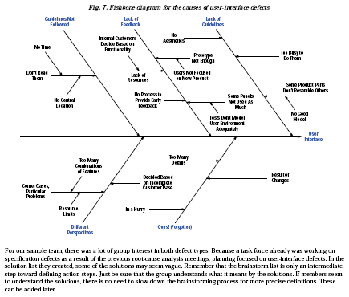
Figure 1an example of a fishbone diagram

Many techniques exist for hazard identification e.g. Fish-Bone diagram, SWIFT, FFA etc. Whichever technique is used the following three key areas must be assessed to determine Patient Safety Risk:
End to End Clinical Process;
Message Risk;
Technical Risk.
The PSA shall document the output from this phase by recording the list of potential Clinical Hazards within the Hazard Log with a line entry for each hazard identified together with a description, any existing controls and possible impact on patient safety; see Appendix B.
The PSA should provide a clear description of the processes undertaken and also include any supporting evidence which describes how the list of Clinical Hazards has been derived e.g. fishbone diagrams, FFA Tables, SWIFT output; see Appendix B.
The PSA should also confirm that the three Patient Safety Risk areas listed above have been assessed and considered in the Hazard Log. If any of the risk areas have not been considered then clear justification shall be advanced to warrant any exclusion.

Estimation of Risk
This is the process where each Clinical Hazard identified through the process described in section 6 is assessed and values assigned to the likelihood of occurrence of harm to a patient and the consequence of that harm. The Project Manager shall define the hazard risk matrix to be used for the assessment together with the categories of likelihood and consequence in the clinical risk management plan.
An example of a hazard risk matrix together with definition of terminology used with respect to likelihood and consequence can be found in Appendix A.
The outcome of this process is a set of likelihood and consequence values agreed by workshop attendees. The PSA shall document these values by providing entries in the Hazard Log along with justification where current controls/mitigations or other data has been used to underpin these values.
The PSA should document the hazard risk matrix used together with definition of the associated terminology used within the matrix.
The PSA should also document and reference any further activities that took place post the initial hazard workshop which were used to finalise the initial Hazard Log e.g. papers, meetings interviews etc.

Clinical Risk Evaluation
This is the process where each identified Clinical Hazard which has been quantified under the process described in section 7 is assessed with regard to its clinical risk acceptability.
Clinical Risk is judged against criteria set out in the hazard risk matrix mapped onto the differing values of likelihood / consequence. The example hazard risk matrix in provided in Appendix A shows four levels of risk categories from low through to high. It should be noted that the mapping of risk categories to be used and the boundary for tolerable clinical risk should be defined by the Project Manager within the clinical risk management plan.
The PSA shall provide a statement of acceptability with regard to each individual Clinical Hazard either documented within the report or included in the included Hazard Log.
The PSA shall highlight any Clinical Hazards that are not acceptable from a clinical risk viewpoint and require additional controls to reduce risk to acceptable levels. Recommendation of possible risk reduction activities may be included in the PSA. The risk reduction activities/controls will be further elaborated within the Safety Case and Safety Closure Reports.

Hazard Log
As part of the PSA, an initial Hazard Log must be presented. At this stage of the lifecycle the Hazard Log should include the following:
Hazard Number;
Hazard Name;
Hazard Description;
Existing controls;
Description of Patient safety impact;
Initial Hazard risk rating.
An example of the preferred Hazard Log table proforma is shown within Appendix B.
The initial Hazard Log will be updated throughout the lifecycle and the remaining fields populated. An up-to-date Hazard Log will be presented within the Safety Case and in the Safety Closure report.

PSA Quality Assurance and Document Approval
Four layers of quality assurance are required for a PSA:
1. Review by NHS CFH Safety Engineer.
2. An accredited Clinical Safety Lead, the relevant NHS CFH technical architects and the project manager or equivalent are required to review the document and formally sign off the contents.
3. Relevant heads must make contact with the Clinical Safety Group (CSG) at NHS CFH. They will provide regular briefings and establish a dialog with the Clinical Safety Officer (CSO) prior to conducting the safety assessment. This process provides the opportunity to seek the view and recommendations of CFH CSO prior to formal presentation of the PSA to the CSG.
Note: Under no circumstances will the PSA move into the final stages of quality checks until an accredited Clinical Lead is prepared to sponsor the document.
4. Formal approval of the document will be through the CSG chaired by the CFH CSO.

Appendix A Health Risk Matrix
Risk for a given hazard is determined from the intersection of the selected consequence and likelihood classes, Table A-1.

Appendix B Hazard Log
Hazard Log
Hazard Number | Hazard Name | Hazard Description | Existing Controls | Patient Safety Impact Description | Initial Hazard Risk Rating |  |  | Additional Controls |  |  |  | Residual Hazard Risk Rating |  |  | Summary of Actions | Owner | Status
 |  |  |  |  | Consequence | Likelihood | Rating | Design | Test | Training | Business Process Change | Consequence | Likelihood | Rating

Appendix C List of Participants at Patient Safety Risk Assessment Workshop

Appendix D Risk Assessment Workshop Supporting Presentation Information

Contact details:
Australian Commission on Safety and Quality in Health Care
Level 7, 1 Oxford Street
Darlinghurst NSW 2010
Phone: 02 9126 3600
Email: mail@safetyandquality.gov.au

