**Fifth Learning Workshop**

The final learning workshop for the National Patient Blood Management Collaborative (NPBMC) teams was held on Friday 10 February 2017 with discussion focused on the activity report and on progress with the evaluation and business case. Professor Debra Rowett from the Repatriation General Hospital in South Australia presented on the benefits of educational visiting, also known as academic detailing, in enhancing GP knowledge and awareness using an evidence-based approach. Greg Thompson from the Central Coast Local Health District, Professor James Isbister and Professor Anne Duggan, from the Australian Commission on Safety and Quality presented on a range of means to enhance opportunities for sustainability.

As at the end of January 2017 there were 11 268 patient episodes for elective gastrointestinal, gynaecological and orthopaedic surgical procedures entered into the qiConnect web portal by the 12 NPBMC teams since January 2015. Of these:

* By gender, 32.8% were male and 67.2% were female
* By age:
* 35.7% were aged 70 years and over
* 27.2% were in the 60-69 age group
* 17.3% were in the 50-59 age group
* 13.8% were in the 40-49 age group
* 6.1% were aged under 40 years
* By indigenous status, 4.6% identified as Aboriginal and/or Torres Strait Islander
* By anaemia:
* 77.9% of patient episodes were assessed in hospitals; 11.3% in specialist rooms; 4.4% in general practice and 6.4% unknown
* Of those patients found to be anaemic, 81.9% were managed in hospital, 13.6% in general practice and 4.5% unknown
* By iron deficiency:
* 73.7% of patient episodes were assessed in hospitals; 16.9% in specialist rooms and 9.4% other
* Of those patients found to be iron deficient, 81.2% were managed in hospitals; 15.5% in primary care and 3.4% unknown
* Diagnosis rates by test and treatment type:
* Gastrointestinal 34% tested and diagnosed with anaemia; 44% tested and diagnosed with iron deficiency and the percentage of all patients with a positive diagnosis was 38%
* Orthopaedics: 8% tested and diagnosed with anaemia; 17% tested and diagnosed with iron deficiency and the percentage of all patients with a positive diagnosis was 15%
* Gynaecology: 12% tested and diagnosed with anaemia; 44% tested and diagnosed with iron deficiency and the percentage of all patients with a positive diagnosis was 21%.

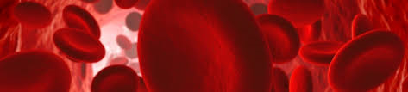**Figure 1: Total patient procedures by test, by health service, as at end of January 2017**

**Overview of Collaborative Activity to May 2016**

A total of 11 268 patient procedures had been recorded by NPBMC sites as at the end of January 2017. Across NPBMC sites, a haemoglobin level was recorded for 10320 procedures (92%), and 4859 procedures (43%) were accompanied by iron studies. Patients for whom iron studies had been recorded usually also had a haemoglobin level recorded.

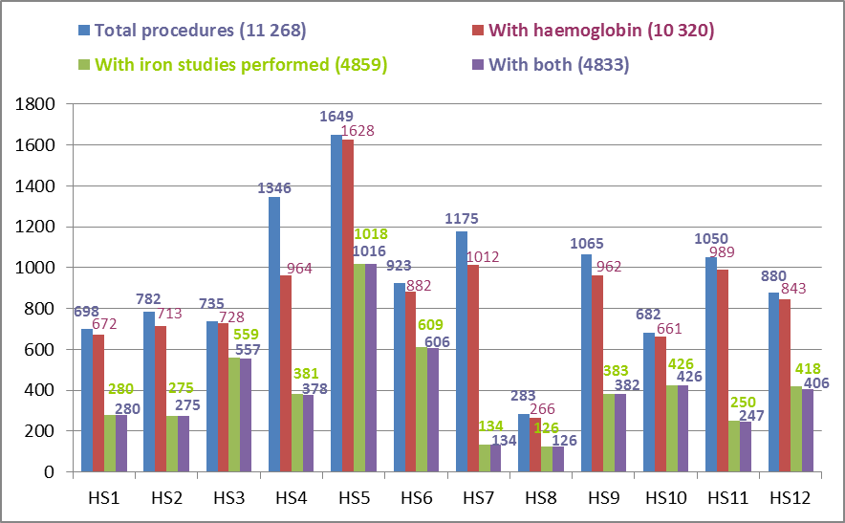

**Figure 2: Total procedures by surgical stream, by health service, as at end of January 2017**

Ten out of 12 NPBMC sites were recording data for all three surgical streams (gastrointestinal, orthopaedic and gynaecology). The majority of procedures recorded up to the end of January 2017 were for orthopaedic surgery.

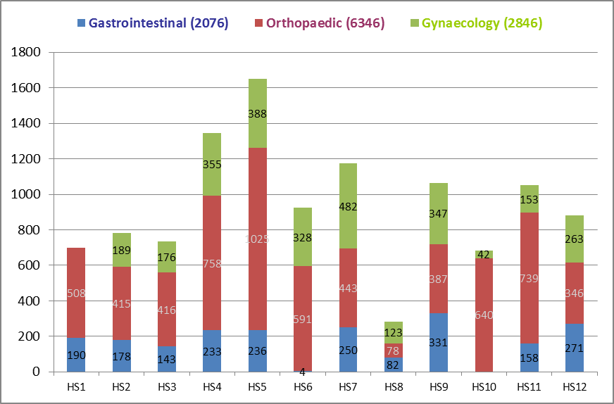

**Total 11 268**

**Figure 3: Percentage of patients receiving pre-operative assessment for anaemia, by health service, as at end of January 2017**

The percentage of patients in whom a pre-operative haemoglobin level had been recorded varied across participating NPBMC sites from 72% to 99%. There has been an increase of 6% of patients having pre-operative assessment since the beginning of the Collaborative in May 2015.

The percentage of patients in whom a pre-operative haemoglobin level had been recorded varied across participating NPBMC sites from 72% to 99%. There has been an increase of 6% of patients having pre-operative assessment since the beginning of the Collaborative in May 2015.


**Figure 4: Percentage of patients receiving pre-operative assessment for iron deficiency, by health service, as at end of January 2017**

There was greater variability in the percentage of patients in whom pre-operative iron studies was recorded, from 11% to 76%. This high variation is currently under examination as there is a need to increase provision of pre-operative iron studies in order to determine whether an intervention may be required to promote better patient care.

There was greater variability in the percentage of patients in whom pre-operative iron studies was recorded, from 11% to 76%. This high variation is currently under examination as there is a need to increase provision of pre-operative iron studies in order to determine whether an intervention may be required to promote better patient care.


ANAEMIA

**Figure 5: Percentage of patients assessed for anaemia, by month, to December 2016**

Patients undergoing major surgical procedures are at increased risk of haemorrhage. Pre-operative assessment of patients’ haemoglobin levels assists clinicians to identify and manage patients in whom anaemia is a risk factor for adverse surgical outcomes. The percentage of patients assessed for anaemia each month has increased over the duration of the Collaborative, from 90% in May 2015 to 96% in December 2016. This trend-line has been truncated at December 2016 due to low numbers entered into qiConnect for January 2017. This will be updated in the next bulletin, when more data is available for January 2017.

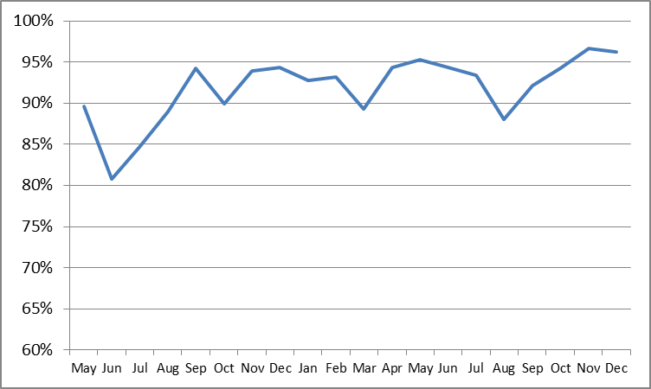

**Figure 6: Percentage of patients managed for anaemia, by month to December 2016**

The data shows that rates of anaemia management have varied between 19% and just over 40% throughout the life of the Collaborative. This trend-line has been truncated at December 2016 due to low numbers entered into qiConnect for January 2017. This will be updated in the next bulletin, when more data is available for January 2017.

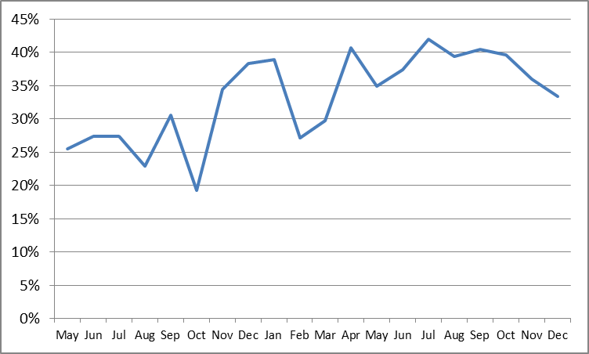

IRON DEFICIENCY

A patient’s iron stores can be assessed safely and inexpensively with a simple blood test. Patients who undergo major surgery lose varying amounts of blood as a result of their surgery preoperatively. Blood loss can decrease haemoglobin levels, which for some patients results in anaemia. Knowledge of the patient's iron stores assists clinicians to identify patients who need iron replacement to support haemoglobin production post-operatively.

**Figure 7: Percentage of patients assessed for iron deficiency, by month, May 2015 to December 2016**

Rates of pre-operative assessment of iron deficiency have significantly increased from 21% to 64% from May 2015 to December 2016. This trend-line has been truncated at December 2016 due to low numbers entered into qiConnect for January 2017; this will be updated in the next bulletin.

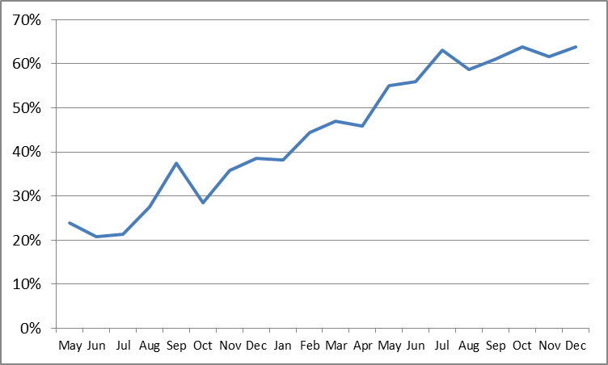

**Figure 8: Percentage of patients managed for iron deficiency, by month, May 2015 to December 2016**

The data shows an increase from 38% to 72% of patients managed for iron deficiency between May 2015 and December 2016. This trend-line has been truncated at December 2016 due to low numbers entered into qiConnect for January 2017; this will be updated for the next bulletin.

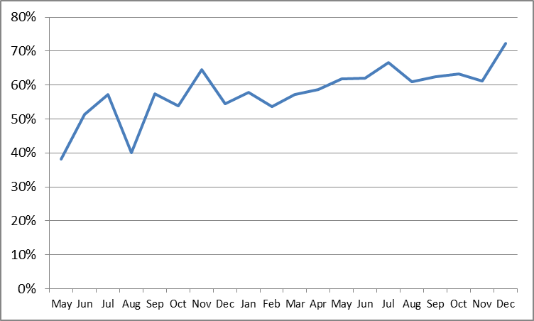

ANAEMIA

Recording of patient assessment for anaemia varies with the type of surgery; this aspect of recording will be further assessed. Rates are highest for patients undergoing orthopaedic surgery and lowest for those undergoing gynaecological surgery. Recording of assessment for anaemia has improved in all surgical streams over the duration of the Collaborative. The target is for 100% of patients to have an assessment for anaemia recorded in their patient record.

**Figure 9: Percentage of patients assessed for anaemia, by surgical stream, by quarter**

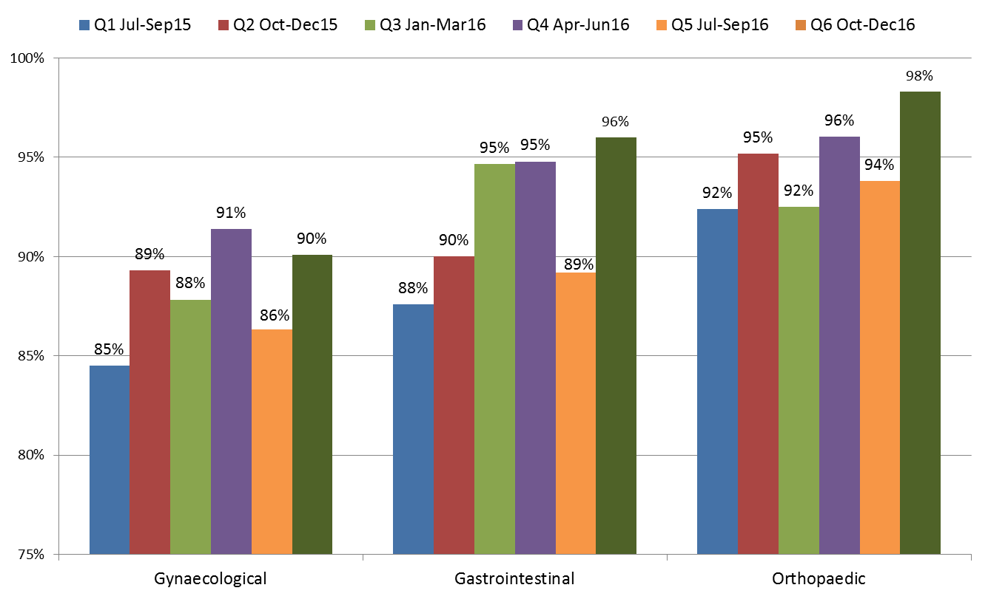

**Figure 10: Percentage of patients who were managed for anaemia by surgical stream, by quarter**

Management of patients with anaemia has improved in the gynaecological and gastrointestinal surgical streams but not in the orthopaedic stream. A large percentage of patients diagnosed with anaemia in each surgical stream have no management recorded, particularly in orthopaedics.

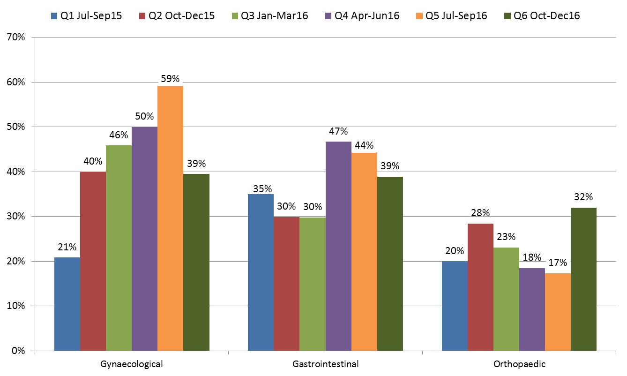

**IRON DEFICIENCY**

**Figure 11: Percentage of patients assessed for iron deficiency, by surgical stream, by quarter**

Recording of patient assessment for iron deficiency has improved in each surgical stream from July 2015 to January 2017.

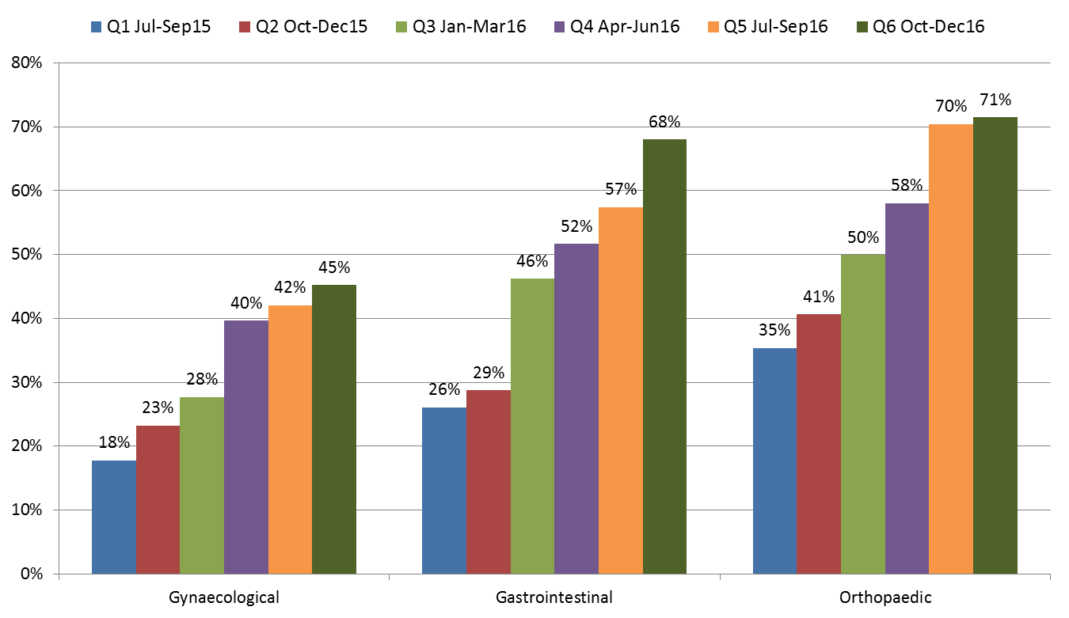

**Figure 12: Percentage of patients who were managed for iron deficiency by surgical stream, by quarter**

Recorded management of patients who were diagnosed with iron deficiency does not vary greatly across surgical streams from July 2015 to January 2017, except for gynaecology, which has recorded an increase in the most recent quarter.

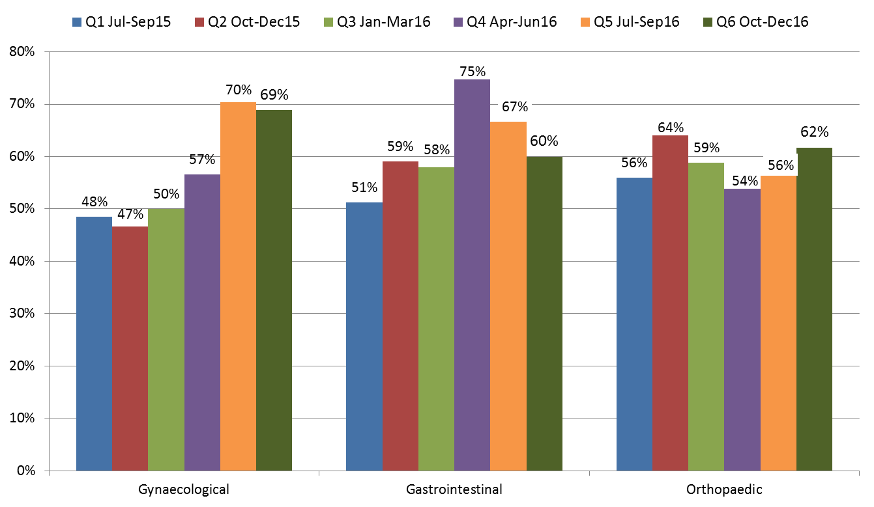

**For further information:**

**Website:** www.safetyandquality.gov.au/national-priorities/pbm-collaborative/

**Email:** pbmcollaborative@safetyandquality.gov.au **Twitter:** @ACSQHC **Phone:** 02 9126 3600