Implementation Guide
for Surveillance of Central Line
Associated Bloodstream Infection

Acknowledgements
Members of the HAI Technical Working Group for the CLABSI Guide
Irene Wilkinson South Australia
Christine Cope South Australia
Brett Mitchell Tasmania
Annie Wells Tasmania
Lisa Hall Queensland
John Marquess Queensland
Rebecca McCann Western Australia
Allison Peterson Western Australia
Paul Curtis New South Wales
Paul Smollen New South Wales
Judy Brett Victoria
Bernadette Kennedy Victoria
Theresa Williams Victoria
Leon Worth Victoria
Louise Cooley Public Health Laboratory Network
Julie Gallard Infection Prevention and Control Professional
Rosie Lee Infection Prevention and Control Professional
Gabrielle Hanlon ANZICS
Neville Board ACSQHC
Marilyn Cruickshank ACSQHC
Sue Greig ACSQHC
Cate Quoyle ACSQHC
Kylie Willows ACSQHC

© Commonwealth of Australia 2015
This work is copyright. It may be reproduced in whole or in part for study training purposes subject to the inclusion of an acknowledgment of the source. It may not be reproduced for commercial usage or sale. Reproduction for purposes other than those indicated above, requires written permission from the Australian Commission on Safety and Quality in Health Care.
Contents
Acknowledgements Inside front cover
Case definition 2
Introduction 3
General information on CLABSI surveillance 3
Definition of a central line and associated terminology 4
Classification of CLABSI 5
Date of CLABSI event 5
Healthcare Associated Infection 5
HAI – non-inpatient 5
Surveillance settings 6
1. ICU patients 6
2. High Dependency Unit patients 6
3. Haemodialysis patients 6
4. Haematology and oncology patients 6
5. Hospital-wide bloodstream infection surveillance 6
Applying the CLABSI definition
for surveillance 7
1. Determining focus of infection 7
2. Timing of CLABSI 7
3. Potential contaminant organisms 7
4. Interpreting Criterion 1 and Criterion 2 8
5. Interpreting “sameness” of potential contaminant organisms 8
6. CLABSI criteria re-occurring within 14 days 9
7. Mucosal Barrier Injury as a potential source of bloodstream infection 9
Specimen Collection Considerations 10
Determining location of attribution 10
Transfer Rule 10
Calculation of CLABSI rate 11
Denominator 11
Collection of line day denominator data 11
Tracking method 11
Tally method 11
Validation of data 12
Appendix 1:
Flowchart for determining if a blood culture is a CLABSI 13
Appendix 2:
Examples of Application of case definitions for CLABSI surveillance 14
Appendix 3:
Definition of Mucosal Barrier Injury (MBI) related Bloodstream Infections (BSI) 16
Appendix 4:
Examples illustrating the MBI related criteria for neutropenia 17
Appendix 5:
Validation of CLABSI data 18
Appendix 6:
Comparison of CLABSI surveillance definitions between the national (ACSQHC) Implementation Guide and the Centres for Disease Control National Hospital Safety Network (NHSN) 19
Appendix 7:
Comments and feedback on the Guide 21
References 21

Case definition
 | Central Line Associated Blood Stream Infection (CLABSI)
A Central Line Associated Blood Stream Infection (CLABSI) is a laboratory-confirmed bloodstream infection in a patient where the central line was in place for > 2 calendar days (48 hours)* on the date of the event, with day of device placement being Day 1.
and
The central line was in place on the date of event or the day before. If the central line was in place for > 2 calendar days (48 hours) and then removed, the CLABSI criteria must be fully met on the day of discontinuation or the next day. See also Timing of CLABSI under Notes applying to CLABSI definition, page 7.
The CLABSI must meet one of the following criteria:

Criterion 1
Patient has a recognised pathogen cultured from one or more blood cultures
and
Organism cultured from blood is not related to an infection at another site

Criterion 2
Patient has at least one of the following signs or symptoms: fever (> 38°C), chills, or hypotension
OR
Patient < 1 year of age has at least one of the following signs or symptoms: fever (> 38°C core), hypothermia (< 36°C core), apnoea or bradycardia
and
Organism cultured from blood is not related to an infection at another site
and
The same (matching) potential contaminant organism^ is cultured from two or more blood cultures drawn on separate occasions.
Criterion elements must occur within a timeframe that does not exceed a gap of 1 calendar day (24 hours)* between any two elements e.g. positive blood cultures and fever.
The same (matching) potential contaminant organisms represent a single element. The collection date of the first positive blood culture should be used to determine the date of the event.
Notes:
* The Centers for Disease Control (CDC) /National Hospital Safety Network (NHSN) use “calendar days” terminology i.e. > 2 calendar days with device placement being Day 1; some Australian jurisdictions use “48 hours” terminology. Jurisdictions must be consistent in the terminology that is used.
^ The CDC/NHSN uses the term “common commensal”.
The CDC/NHSN definitions can be viewed at: http://www.cdc.gov/nhsn/pdfs/pscmanual/4psc_clabscurrent.pdf.
Examples of potential contaminant organisms include: diphtheroids [Corynebacterium spp.], Bacillus [not B. anthracis] spp., Propionibacterium spp., coagulase negative staphylococci [including S epidermidis], viridans group streptococci, Aerococcus spp., and Micrococcus spp. See complete list of NHSN common commensals at: http://www.cdc.gov/nhsn/PS-Analysis-resources/

Introduction
This Implementation Guide for the Surveillance of Central Line Associated Bloodstream Infection (CLABSI) has been produced by the Healthcare Associated Infection (HAI) Technical Working Group of the Australian Commission on Safety and Quality in Health Care (the Commission), and endorsed by the Commission’s HAI Advisory Committee. State surveillance units, the Commission and the Australian and New Zealand Intensive Care Society (ANZICS) have representatives on the Technical Working Group and have provided input into this document. (See acknowledgements on inside front cover).
It is one of several resources that have been developed to promote consistency in reporting of CLABSI data and thereby support accurate national reporting and benchmarking. The Guide was initially developed as an adjunct to the
ANZICS CLABSI Prevention Project to provide information for jurisdictional or other surveillance bodies regarding the submission of data to the ANZICS national CLABSI surveillance program.
Other resources to assist with the implementation of CLABSI surveillance can be accessed through the ANZICS CLABSI website: www.clabsi.com.au
The Guide is intended to be used by staff in Australian hospitals to support the implementation of standardised CLABSI surveillance in adult and paediatric intensive care units (ICU) and other patient groups where central lines are regularly used for patient care. The endorsed case definition is outlined on page 2.
This Guide has been developed to standardise surveillance activities and is not intended to replace or inform clinical assessment of infections for patient management.

General information on the CLABSI
surveillance definition
The CLABSI surveillance case definition was endorsed by the HAI Advisory Committee of the Commission and all Australian jurisdictions through the Commission’s Inter-Jurisdictional Committee in 2011. The case definition is aligned with the US Centers for Disease Control and Prevention (CDC) National Healthcare Safety Network (NHSN) 2014 surveillance definitions,¹ with slight variation to suit the Australian health system. Appendix 6 outlines the variation from the US Centers for Disease Control and Prevention (CDC) National Healthcare Safety Network (NHSN).

Central line  An intravascular access device or catheter that terminates at or close to the heart or in one of the great vessels. The line may be used for infusion, withdrawal of blood, or haemodynamic monitoring.  A central line may be inserted centrally or peripherally in the patient. Neither the location of the insertion site nor the type of device is used to determine if a line qualifies as a central line. The device must terminate in one of the great vessels (listed below) or in or near the heart to qualify as a central line.  The following are considered great vessels for the purpose of central line associated bloodstream infection (CLABSI): aorta, pulmonary artery, superior vena cava, inferior vena cava, brachiocephalic veins, internal jugular veins, subclavian veins, external iliac veins, common iliac veins, femoral veins.  Examples of central lines:  Tunnelled and non-tunnelled central venous catheters, implanted ports, pulmonary artery catheters, dialysis or haemofiltration catheters in a great vessel and peripherally inserted central catheters. An introducer is considered a central line if the tip is situated in a great vessel.  Exclusions:  - The following devices are not considered central lines: extracorporeal membrane oxygenation (ECMO), femoral arterial catheters, intra-aortic balloon pump (IABP) devices and haemodialysis reliable outflow (HeRO) dialysis catheters.  - Pacemaker wires and other solid or  non‑lumen devices inserted into central blood vessels or the heart are not considered central lines, because fluids are not infused, pushed, nor withdrawn through such devices. |  | Permanent central lines  - Tunnelled catheters, including certain dialysis catheters. These central lines have a short length of the central line “tunnelled” subcutaneously between the skin insertion site and the point where the catheter enters the blood vessel.  - Implanted catheters (including ports). These are tunnelled beneath the skin and have a subcutaneous port accessed with a needle.

Temporary central lines
Non-tunnelled, non-implanted intravascular access catheters. These intravascular devices are usually short term.

Infusion
The introduction of a solution into a blood vessel via a catheter lumen. This may include continuous infusions such as hydration or nutritional fluids or medications, or it may include intermittent infusions such as flushes or IV antimicrobial administration, or blood, in the case of transfusion or haemodialysis.

Element
For surveillance purposes an element refers to a specific component of infection and includes: positive blood culture(s); fever (>38°C), chills and hypotension, hypothermia, apnoea and bradycardia. To meet Criterion 2, the matching (same) potential contaminant blood cultures represent a single element.

Classification of CLABSI
The classification of a CLABSI event requires strict application of the case definition by staff in the facility responsible for CLABSI surveillance. A clinical and microbiological review is required in collaboration with clinical teams and clinical microbiologists/infectious diseases physicians where necessary.
The methodology to assist with classification is outlined in the flow chart, Appendix 1.

Date of CLABSI event
The date of the CLABSI event is the date the first positive blood culture was collected. For potential contaminant organisms, this is the date the first potential contaminant blood culture was collected (refer to Appendix 6).

Healthcare Associated Infection (HAI)
The definition of Healthcare Associated Infection (HAI) underpins the CLABSI definition. A HAI may be either an inpatient or non-inpatient event.
The CDC/NHSN define an infection as a HAI if the elements of the infection criterion were not present on admission but were present on or after the third calendar day of admission (or > 2 calendar days) where the day of admission is considered the first day. All elements used to meet the infection criterion must occur within a timeframe that does not exceed a gap of 1 calendar day between elements.
Surveillance within Australian hospitals has traditionally used a 48 hour period to define healthcare associated infections, i.e. infections that are not present on admission; and develop greater than 48 hours after admission; or within 48 hours of discharge or transfer to another facility.
In order to maintain consistency with surveillance definitions for other infection indicators used in Australia, the use of “48 hours” terminology has been added in parentheses in this Guide. Comparative reviews by Australian jurisdictions in 2014 have identified minimal difference in outcomes when either “calendar days” or “48 hours” have been used in the application of the CLABSI definition. Jurisdictions may choose to use either terminology in the application of the definition for CLABSI surveillance, though the application of the chosen terminology must be applied consistently.

HAI – non-inpatient
The CDC/NHSN HAI definition does not define non-inpatient HAIs, but in Australia these have been defined as infections that are: present on admission or develop less than 48 hours after admission; and related to the receipt of healthcare, such as previous surgery, or the presence of invasive medical devices (e.g. a central line). This definition may be used by jurisdictions where CLABSI surveillance is undertaken outside of inpatient areas, such as the haematology/oncology outpatient setting (see Surveillance Settings).
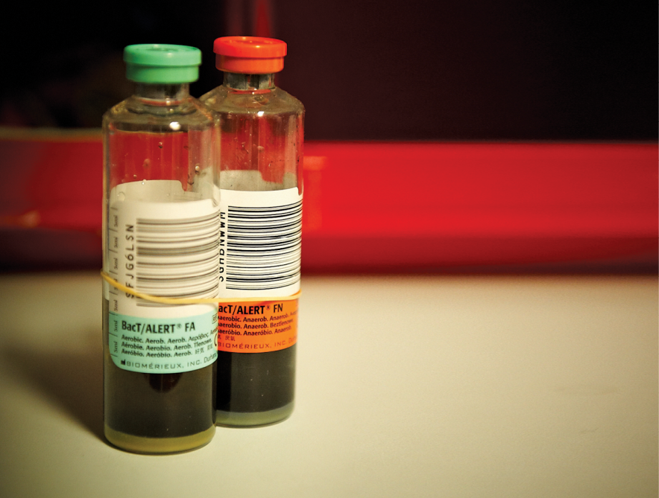

Surveillance settings
CLABSI surveillance can be conducted in any setting where appropriate data can be collected.

1. ICU patients
Surveillance of ICU CLABSI can be stratified by the type of ICU e.g. adult, paediatric or neonatal ICUs. This document provides guidance for data collection in adult and paediatric ICUs only. Neonatal CLABSI data are collected by the Australian and New Zealand Neonatal Network. For further information see: http://www.npesu.
unsw.edu.au/data-collection/australian-new-zealand-neonatal-network-anznn
Where there is a paediatric ICU (PICU)
co‑located with an adult ICU (i.e. there are dedicated PICU beds), the paediatric cohort (age under 16 years) should be reported as a separate PICU data set.
Where paediatric patients are admitted to an adult ICU on an ad-hoc basis, data from these patients should be reported with the data from adult patients.

2. High Dependency Unit patients
Patients designated as high dependency/
step‑down should be included in ICU surveillance data if they are co-located within ICU and treated by the same nursing and medical staff.

3. Haemodialysis patients
Inpatients receiving haemodialysis through a central line should be included in CLABSI surveillance if they are admitted to the ICU or any other patient location where CLABSI surveillance is conducted.
For additional surveillance of haemodialysis access associated bloodstream infections in haemodialysis units, refer to the definitions and denominator requirements outlined in the CDC/NHSN Dialysis Event Protocol http://www.cdc.gov/nhsn/PDFs/pscManua
l/8pscDialysisEventcurrent.pdf or member organisations may refer to the Australian Council on Healthcare Standards (ACHS).

4. Haematology and oncology patients
Central lines are essential for the care of haematology and oncology patients who are also at high-risk for CLABSI.
These patients are regularly discharged home with central lines in situ and the CLABSI definition used in this Guide is applicable to the surveillance of both inpatient and non‑inpatient CLABSI events.

5. Hospital-wide bloodstream infection surveillance
The CLABSI definitions should also be used by jurisdictions that undertake hospital-wide bloodstream infection (BSI) surveillance to enable standard categorisation of the source of BSI.

Applying the CLABSI definition for surveillance

1. Determining focus of infection
The CLABSI definition requires that the BSI is not related to an infection at another site.
If an infection at a site other than the central line is considered the likely source of the BSI, the clinical assessment and/or diagnostic investigation must fulfil the surveillance definitions for “infection at another site”.
For more information and guidance on determining “infection at another site”, refer to:
- The CDC National Healthcare Safety Network (NHSN) surveillance definitions for specific types of infections, Appendix 1: Secondary Bloodstream Infection Guide. Available at: http://www.cdc.gov/nhsn/PDFs/
pscManual/17pscNosInfDef_current.pdf
- Examples of application of the case definition for CLABSI surveillance in Appendix 2.
If a patient with both peripheral and central lines develops a BSI that can clearly be attributed to the peripheral line (e.g. pus at the insertion site and matching pathogen from pus and blood), it should not be reported as a CLABSI.
Note: Patients suspected or known to have accessed their own IV lines are not excluded from CLABSI surveillance. A facility must implement prevention efforts to protect the line.

2. Timing of CLABSI
Classification as a CLABSI event requires that a central line was in place for > 2 calendar days (48 hours) on the date of the event or the day before (within the previous 24 hours), with the day of central line placement being Day 1;
- If the central line was in place for > 2 calendar days (48 hours) and removed, the CLABSI criteria must be fully met on the day the line was removed or the next day (within 24 hours of central line removal).
- If a patient is admitted or transferred to a health facility with a central line in place and that is the patient’s only central line, the day (time) of first access as an inpatient is considered Day 1. “Access” is defined as line placement, infusion or withdrawal through the central line.
Examples
- A patient in ICU had a central line inserted/
accessed on June 1 (0700hrs). On June 3 (1100hrs), the central line is still in place and the patient has a positive blood culture that is positive for S.aureus. This is a CLABSI because the line was in place for > 2 calendar days (48 hours) on the date of the event.
- A patient has a central line inserted on June 1 (0800hrs). On June 3 (1200hrs) the central line is removed and on June 4 (0900hrs) the patient has a blood culture collected that is positive for S.aureus. This is a CLABSI because the line was in place for > 2 calendar days (48 hours) and the central line was in place the day before the date of the event.
- A patient has a central line inserted on May 30 (0600hrs). On June 3 (1000hrs) the central line is removed and on June 4 (1100hrs) the patient spikes a fever of 38°C. Two blood culture sets collected on June 6 (2000hrs) are positive for
S. epidermidis. This is not a CLABSI because the central line was not in place on the day of or the day before the time that Criterion 2 was met.

3. Potential contaminant organisms
Organisms that can be considered as potential contaminants of blood cultures include those species that are part of the normal skin flora, such as diphtheroids [Corynebacterium spp.], Propionibacterium spp., coagulase-negative staphylococci [including S. epidermidis], viridans group streptococci, Aerococcus spp., Micrococcus spp. and may include other bacteria that can be found transiently on the skin such as Bacillus spp.[not B. anthracis], Pseudomonas spp. [other than P. aeruginosa], Xanthomonas spp., Ralstonia spp.
CDC/NHSN uses the term “common commensals” for potential skin contaminants. The NHSN organism lists, including a complete list of common commensals may be accessed at: http://www.cdc.gov/nhsn/PS-Analysis-resources/

Applying the CLABSI definition for surveillance (continued)
Any organism that is considered a potential contaminant and is not on the NHSN commensal list should be reviewed in liaison with a clinical microbiologist/infectious diseases physician.

4. Interpreting Criterion 1 and Criterion 2
In criterion 1, the term “recognised pathogen” includes any organism that is not considered a potential contaminant organism. Examples of recognised pathogens associated with health care acquisition include, but are not limited to: Staphylococcus aureus, Enterococcus spp., Enterobacter spp., Escherichia coli, Klebsiella spp., Proteus spp., Providencia spp., Pseudomonas aeruginosa, Streptococcus spp. and Candida spp.
In Criterion 2, the phrase “two or more blood cultures drawn on separate occasions” means that:
- blood from at least two blood draws were collected on the same day or consecutive calendar days (e.g. blood draws on Monday and Tuesday would be acceptable for blood cultures drawn on separate occasions, but blood draws on Monday and Wednesday would be too far apart in time to meet this criterion);
- preparation and decontamination of two separate sites for drawing blood is recommended, e.g. different venepuncture sites, a combination of venipuncture and lumen withdrawal.
- at least one bottle from each blood draw is reported by the laboratory as having grown the same potential skin contaminant (i.e. a positive blood culture).
For paediatric patients: a blood culture may consist of a single bottle due to volume constraints. Therefore, to meet Criterion 2, each bottle from two or more single bottle blood draws would have to be culture positive with the same potential contaminant organism.

5. Interpreting “sameness” of potential contaminant organisms²
If potential contaminant organisms are identified to the species level from one culture and a companion culture is identified with only a descriptive name (e.g. to the genus level), then it is assumed that the organisms are the same (see examples in Table 1).
Table 1: Examples of how to report speciated and unspeciated common potential contaminant organisms
Culture Report | Companion Culture Report | Report as
S. epidermidis | Coagulase-negative staphylococci | S. epidermidis
Bacillus spp. (not anthracis) | B. cereus | B. cereus
S. salivarius | Strep viridans | S. salivarius
For the purposes of surveillance only genus and species identification is required to determine the sameness of organisms. If additional comparative methods (e.g. susceptibility profile) are available, these should be used in consultation with a clinical microbiologist/infectious diseases physician.

Applying the CLABSI definition for surveillance (continued)

6. CLABSI criteria re‑occurring within 14 days
If the CLABSI criteria are met again within 14 days and the same organism(s) is identified, a clinical review should be undertaken to determine if the positive blood culture is the same event, or a new event. The clinical review should include consultation with a clinical microbiologist or infectious diseases physician with consideration of the following: the presence of a new line or existing central line, resolution of signs and symptoms of the original infection, negative blood cultures and completion of antimicrobial therapy. If a new central line has been inserted and the CLABSI criteria are met again, the event should be classified as a new CLABSI. If the new CLABSI event occurs more than 14 days after the previous event, then the CLABSI is always classified as a new event.

7. Mucosal Barrier Injury as a potential source of bloodstream infection
Oral and gastrointestinal mucosal barriers may break down as a result of chemotherapy and radiation treatment regimens. This Mucosal Barrier Injury (MBI) can range from inflammation to ulceration and enables translocation of bacteria from the oral cavity or intestinal tract into the bloodstream and may cause a bloodstream infection. MBI-related BSI may occur in patients who are either:
- severely neutropenic*, or
- a recipient of allogeneic haemopoietic stem cell transplant with either gastrointestinal graft versus host disease (GI GVHD) or diarrhoea.
* Neutropenia is defined as at least 2 separate days with values of total white blood cell count (WBC) or absolute neutrophil count (ANC) < 500 cells/mm3 (0.5 x 109/L) within a 7 day time period which includes the date of the BSI (Day 1), the 3 calendar days before and the 3 calendar days after. For examples refer to Appendix 4.
The CDC/NHSN has developed a definition of MBI-related BSI (refer to Appendix 3) and a list of organisms usually associated with mucosal barrier injury. The list of MBI organisms can be accessed at http://www.cdc.gov/nhsn/PS-Analysis-resources/.
A BSI that is caused by a MBI-related organism (with no other organism isolated and not related to an infection at another site) in a neutropenic or allogeneic haemopoietic stem cell transplant patient with a central line and GI GVHD or diarrhoea, should not be reported as a CLABSI. The likely source of the BSI is due to MBI and not the central line.

Resources for application of mucosal barrier injury definitions
- A list of MBI organisms can be accessed at: http://www.cdc.gov/nhsn/PS-Analysis-resources/ See NHSN organism lists
- For information on analysing MBI data refer to http://www.cdc.gov/nhsn/PS-Analysis-resources/PDF/MBIAnalysis.pdf

Specimen collection considerations
Ideally, blood specimens for culture should be obtained from two to four blood draws from separate venepuncture sites, not through an intravascular catheter. These blood draws should be performed simultaneously or over a short period of time
(i.e. within a few hours of each other).
Although blood cultures drawn through central lines can have a higher rate of contamination than blood culture collected through peripheral venepuncture, all positive blood cultures, regardless of the sites from which they were collected, must be included when conducting CLABSI surveillance.¹
When drawing blood for culture, aseptic technique must be used, i.e. by using sterile gloves, ensuring the skin or cannula end and culture bottle top are disinfected with 70% alcohol and allowed to dry before access.
Catheter tip cultures are not a substitute for blood cultures in the determination of CLABSI. The presence or absence of a positive tip culture does not affect the surveillance definition. Catheters can become colonised by an organism that originates from a different body site. Catheters may have luminal colonisation which may not be detected by usual laboratory culture procedures. In addition, catheters may be contaminated at the time of removal.
Purulent phlebitis confirmed with a positive
semi‑quantitative culture of a catheter tip, but with either negative blood culture or no blood culture taken is not a BSI and should not be reported this way.

Determining location of attribution
The CLABSI is attributed to the inpatient location where the patient was assigned on the date of the CLABSI event unless the Transfer Rule is applicable.

The Transfer Rule
If all elements of a CLABSI are present on the day of transfer or the next day (within 48 hours) of transfer from one location to another in the same facility or a new facility, the CLABSI is attributed to the transferring location. Receiving facilities should share information about CLABSIs with the transferring facility to enable all CLABSIs to be reported. This is called the Transfer Rule. Examples of the Transfer Rule are shown below (also refer to example 8, Appendix 2 Examples of application of case definitions for CLABSI surveillance.
- A patient with a central line is transferred from ICU to Ward B. A positive BSI obtained on Ward B, 30 hours after transfer meets the criteria for a CLABSI. This is attributed to the transferring location, ICU.
- A patient with a central line is transferred from ward A to another hospital. On day 4 following transfer the patient becomes febrile and blood cultures taken in the new facility are positive and meet the criteria for a CLABSI. This is attributed to the new facility, NOT ward A.

Calculation of CLABSI rate
CLABSI rate calculation
Numerator: | Number of CLABSI | x 1.000
Denominator: | Number of central line days

Denominator
The denominator that is utilised for CLABSI surveillance is central line days and these can be calculated either by tally or tracking methodologies, depending on the population under surveillance.

Collection of line day denominator data
The same time period should be used for the collection of the denominator and numerator.
Central line days may be calculated by the following methods:

Tracking method
- This method is useful for patient groups that have central lines in situ both as inpatients and non-inpatients e.g. haematology and oncology patients.
- Track each patient with a central line by recording the date of insertion and the date of removal. Count the number of days each patient had one or more central lines in place during the surveillance period and add together the counts for all patients.

Tally method
- This method is useful for inpatient patient groups e.g. ICU patients.
- Count the number of patient line days (i.e patients with one or more central lines in place) each day at approximately the same time.
- If a facility is unable to do the tally count every day due to limited resources, a monthly calculation extrapolated from sampling allows for a reasonable estimate of monthly line day data:
Step 1: Count the number of patients with one or more central lines in place on a minimum of 3 non-consecutive days per week.
Step 2: Calculate a daily average line day count by dividing the total central line days counted for the month by the number of days on which the count was done within that month.
Step 3: Multiply the daily average central line day count by the number of days within the month (e.g. 28, 30, 31).
- When denominator data are available from electronic databases, these sources may be used as long as the counts are not substantially different from manually collected counts (plus or minus 5%) and are validated for a minimum of 3 months.
- Irrespective of how many central lines a patient has on any one day, only one line day is counted for that patient. For example:
  - a patient with both a subclavian central line for infusions and a femoral dialysis catheter is only counted as one line day.
  - If a patient has a centrally inserted central line and a peripherally inserted central catheter (PICC) count as a single line‑day only.
In addition to overall CLABSI rates, jurisdictions may elect to report device specific CLABSI (e.g. tunnelled/non-tunnelled or implanted) or centrally inserted and peripherally inserted central lines.
Note: CDC/NHSN is evaluating the simplification of surveillance methods and the accuracy of sampling to estimate central line-days data in a range of hospital patient settings.
Available at: http://www.ncbi.nlm.nih.gov/
pubmed/23388355

Validation of data
Jurisdictional surveillance units should have Quality Assurance (QA) processes in place to validate data submitted to the ANZICS CLABSI surveillance program for national benchmarking, especially in relation to consistency with the CLABSI definition.
For further information on validation methodologies:
- see Appendix 5 Validation of CLABSI Data
- refer to the CDC/NHSN Validation and Guidance Toolkit (2012) Validation of CLABSI in ICUs http://www.cdc.gov/nhsn/PDFs/CLABSI/toolkit-2012/2012-CLABSI-Validation-toolkit-
chapter1-3.pdf

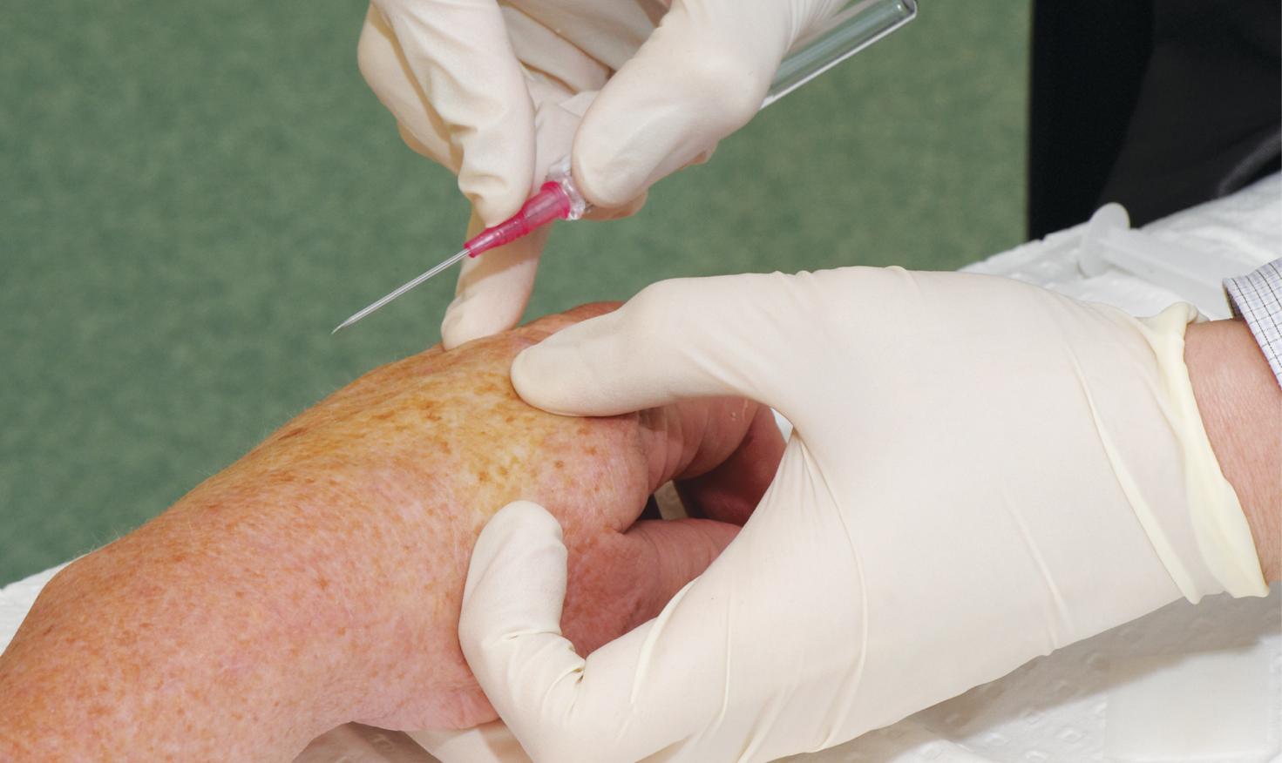

Appendix 1: Flowchart for determining if a blood culture is a CLABSI
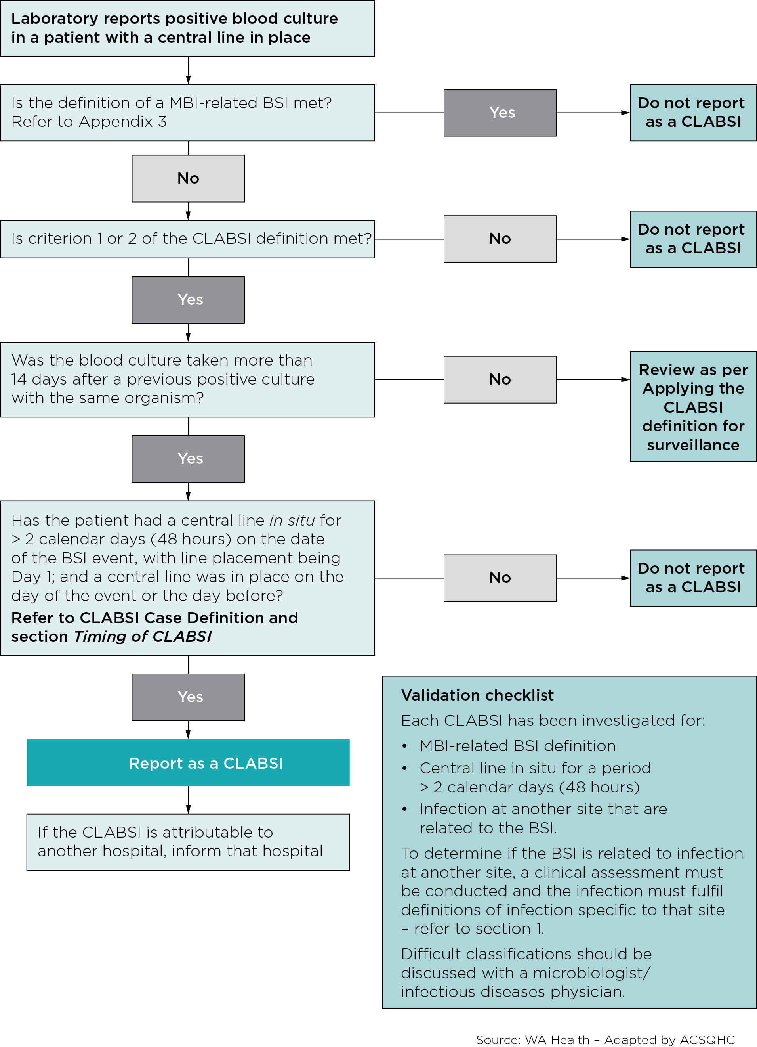

Appendix 2: Examples of application of case definitions for CLABSI surveillance
This section presents simple scenarios that demonstrate the application of CLABSI surveillance definitions. Complex cases and potentially contentious classifications are not included here and these should always be discussed with clinical staff and a clinical microbiologist/infectious diseases physician or the jurisdictional surveillance unit.

Note
- To assist with determining if the BSI is related to an “infection at another site” you may refer to the CDC/NHSN surveillance definitions for specific types of infections, Appendix 1: Secondary Bloodstream Infection Guide. What is the meaning of the statement “not related to infection at another site” in relation to a positive blood culture? Available at: http://www.cdc.gov/nhsn/PDFs/
pscManual/17pscNosInfDef_current.pdf
- Several of the infection criteria do not require an organism to be cultured and it is necessary to use clinical judgement to determine if the BSI organism is a likely pathogen from another site.
- If a CLABSI develops on the day of transfer or the next day (within 48 hours of transfer) from a unit or facility to another unit or facility, the CLABSI will be attributed to the transferring unit or facility. Surveillance personnel should inform any transferring facility of a CLABSI that has developed within 48 hours of transfer. Refer to Transfer Rule on page 10.

Examples
- Patient in ICU with a central line in place is transferred to the surgical ward. On the next day, the patient meets the criteria for a CLABSI. This is reported as a CLABSI for the ICU.
- Patient in ICU has central line inserted/accessed on June 1. On June 3, the central line is still in place and the patient has blood culture collected that is positive for S. aureus. This is a CLABSI because the central line was in place for > 2 calendar days (48 hours) on the date of event.
- Patient has a central line inserted on June 1. On June 3, the central line is removed and on June 4 the patient has a blood culture collected that is positive for S. aureus. This is a CLABSI because the central line was in place for > 2 calendar days (48 hours) (June 1, 2, and 3) and was in place the day before the date of event.
- Patient has a central line inserted on May 30. On June 3, the central line is removed and on June 4 patient spikes a fever of 38.3°C. Two blood culture sets collected on June 5 are positive for S. epidermidis. This is a healthcare associated bloodstream infection but it is not a CLABSI because the central line was not in place the date of the BSI event (June 5) or the day before (June 4); and CLABSI Criterion 2 was not met on the day the line was removed (June 3) or the next day (June 4).
- After 15 days in a ward a patient with a central line in place for 10 days is febrile 39°C and has a blood culture collected that is positive for S. epidermidis. The next day, coagulase-negative staph (CNS) is identified in another blood culture and from the CVC insertion site swab. S. epidermidis is a common skin contaminant and was isolated in 2 blood cultures (from separate blood draws) on the same or consecutive days and meets the criteria for the “same” organism i.e. identified to species (S. epidermidis) and genus (CNS) levels. This is reported as a CLABSI and attributed to the Ward.

Appendix 2: Examples of application of case definitions for CLABSI surveillance (continued)
- Patient without a central line is transferred from the medical ward on hospital day 3 to ICU. Later that day a central line is inserted. The next day, blood cultures are collected and a recognised pathogen is cultured. This would be considered a BSI and attributed to the medical ward. This does not fit the criteria for a CLABSI because the central line was not in place > 2 days (48 hours) on the date of the event. (This may be a CLABSI, though it does not fit the surveillance definition).
- Patient with a central line in place is transferred from the medical ward to the ICU. After 4 days in the ICU and with the central line still in place, all elements of the criteria for a CLABSI are met. This is reported as a CLABSI for the ICU.
- After a two week hospital stay, a patient on the urology ward of Hospital A has his central line removed and is discharged home a few hours later. The ICP from Hospital B calls two days later, to report that this patient has been admitted to Hospital B with sepsis and meets the CLABSI criteria. This CLABSI should be reported by Hospital A and the CLABSI should be attributed to the urology ward from Hospital A.

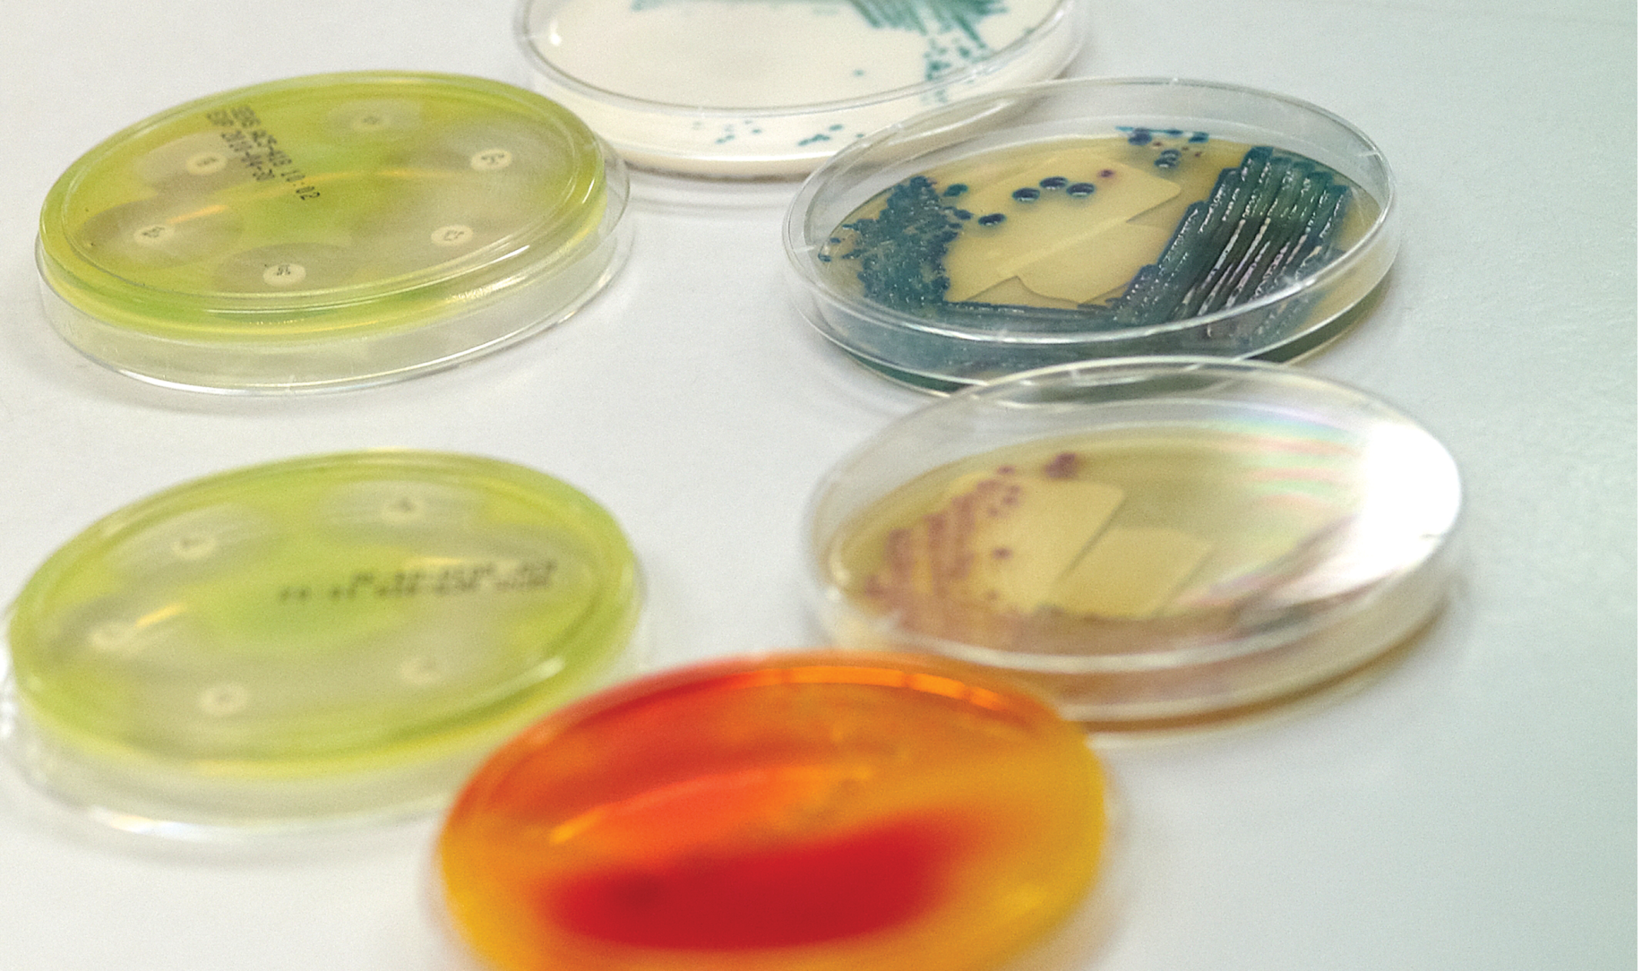

Appendix 3: Definition of Mucosal Barrier Injury (MBI) related Bloodstream Infections (BSI)
MBI-related BSI^  Criterion 1 | Patient of any age meets Criterion 1 for Central Line Associated Bloodstream Infection (CLABSI), with at least one blood culture growing any of the following intestinal organisms with no other organisms isolated: Bacteriodes spp., Candida spp., Clostridium spp., Enterococcus spp., Fusobacterium spp., Peptostreptococcus spp., Prevotella spp., Veillonella spp., or Enterobacteriaceae.  and  patient meets at least one of the following:  - Is an allogeneic hematopoietic stem cell transplant recipient within the past year with one of the following documented during same hospitalisation as positive blood culture:  - Grade III or IV Gastrointestinal Graft Versus Host Disease (GI GVHD).  - ≥ 1 litre diarrhoea in a 24-hour period (or ≥ 20 mL/kg in a 24-hour period for patients < 18 years or age) with onset on or within 7 calendar days before the date the positive blood culture was collected.  - Is neutropenic, defined as at least 2 separate days with values of absolute neutrophil count (ANC) or total white blood cell count (WBC) < 500 cells/mm3 on or within 3 calendar days before the date the positive blood culture was collected (Day 1).
MBI-related BSI^  Criterion 2 | Patient of any age meets Criterion 2 for CLABSI when the blood cultures are growing only viridans group streptococci with no other organisms isolated  and  patient meets as least one of the following:  - Is an allogeneic hematopoietic stem cell transplant recipient within the past year with one of the following documented during same hospitalisation as positive blood culture:  - Grade III or IV Gastrointestinal Graft Versus Host Disease (GI GVHD).  - ≥ 1 litre diarrhoea in a 24-hour period (or ≥ 20 mL/kg in a 24-hour period for patients < 18 years of age) with onset on or within 7 calendar days before the date the positive blood culture was collected.  - Is neutropenic, defined as at least 2 separate days with values of absolute neutrophil count (ANC) or total white blood cell count (WBC) < 500 cells/mm³ on or within 3 calendar days before the date the positive blood culture was collected (Day 1).
Comments | - In MBI-related BSI Criterion 1 and 2, “No other organism isolated” means there is not isolation in a blood culture of another recognised pathogen (e.g. Staphylococcus aureus) or potential contaminant (e.g. coagulase negative staphylococci) other than organisms listed in MBI-related BSI Criterion 1 and 2 that would otherwise meet the CLABSI criteria. If this occurs, the infection should not be classified as MBI-related BSI.  - Grade III/IV GI GVHD is defined as follows:  - In adults: ≥ 1 L diarrhoea/day or ileus with abdominal pain  - In paediatric patients: ≥ 20 ml/kg/day of diarrhoea
 | Table from NHSN Central Line Associated Bloodstream Infection (CLABSI) Event (2014)

Appendix 4: Examples illustrating the MBI-related criteria for neutropenia
 |  | Day  -7 | Day  -6 | Day  -5 | Day  -4 | Day  -3 | Day  -2 | Day  -1 | Day  1* | Day  2 | Day  3 | Day  4
Pt. A | WBC | 100 | 800 | 400 | 300 | ND | ND | 320 | 400  +BC* w/Candida spp. x1 | ND | 550 | 600
Pt. B | ANC | ND | 410 | 130 | ND | ND | 120 | 110 | ND  + BC* w/viridans strep x2 and fever >38°C | 110 | 300 | 320
Pt. C | WBC | 100 | 800 | 400 | 300 | ND | ND | ND | 600  +BC* w/Candida spp. x1 | 230 | ND | 400

ND = not done; WBC = total white blood cell count; ANC = absolute neutrophil count;
BC = blood culture
* Day the positive blood specimen was collected
Patient A meets MBI-related BSI Criterion 1, sub-Criterion 2: Positive blood culture with intestinal organism (Candida spp) and neutropenia (2 separate days of WBC < 500cells/mm- occurring on the date the positive blood culture was collected [Day 1] or during the 3 days before or the 3 days after that date). In this case, the Day 1 value = 400, and Day -1 value = 320.
Patient B meets MBI-related BSI Criterion 2, sub-Criterion 2: At least 2 positive blood cultures with viridans group streptococci (in this case, 2 positive), and fever > 38°C and neutropenia (2 separate days of ANC < 500cells/mm³ occurring on the date the positive blood culture was collected [Day 1] or during the 3 days before or the 3 days after that date). In this case, the Day -1 value =110 and Day -2 value = 120. Note: any two of Days -2, -1, 2, 3 and 4 could be used to meet this requirement since WBC or ANC under 500 were present on those days.
Patient C meets MBI-related BSI Criterion 1, sub-Criterion 2: Positive blood culture with intestinal organism (Candida spp) and neutropenia (2 separate days of WBC < 500cells/mm³ occurring on the date the positive blood culture was collected [Day 1] or during the 3 days before or the 3 days after that date).

Appendix 5: Validation of CLABSI data
Accurate and reproducible data concerning CLABSI rates are important for setting infection prevention priorities and measuring the impact of prevention activities. To ensure uniform application of the CLABSI case definition, appropriate education and training must be available to staff responsible for CLABSI surveillance in each jurisdiction. Health care facilities and jurisdictional bodies should also assume responsibility for validation of CLABSI data, including the numerator (identified cases) and denominator (Central line days). Relevant validation metrics include the following:⁷
- Intrinsic validation – automated processes built into data collection tools that control the values and types of data that are entered into the system.
- Internal validation – surveillance methods are assessed by staff at individual health care facilities. For example, if using electronic data collection to determine CLABSI denominators (Central line days), periodic checks should be performed to ensure that electronic data counts are within 5% of manual data collection.
- External validation – an agency outside the reporting health care facility (e.g. health department) conducts audit of CLABSI surveillance methods. For example, assessment of the ability to correctly apply CLABSI case-definitions,⁸ including the ability to differentiate between CLABSI and bloodstream infections due to other causes.⁶
A detailed ICU CLABSI validation toolkit has been published by the CDC/NHSN.⁷ This is relevant to Australian health care facilities and jurisdictional bodies wishing to formulate validation processes and determine the scope and frequency of validation activities.

Appendix 6: Comparison of CLABSI surveillance definitions between the national Implementation Guide produced by the Commission and the Centres for Disease Control, National Hospital Safety Network (NHSN)
 | CDC/NHSN Laboratory Confirmed Bloodstream Infection (2014) | National Implementation Guide for surveillance of CLABSI produced by the Commission
Case Definition | There are 3 criteria for laboratory confirmed bloodstream infection (LCBI). LCBI Criterion 1 and 2 may be used for patients of any age, including those patients ≤ 1 year of age. | There are 2 criteria for central line associated bloodstream infection (CLABSI). Criterion 1 and Criterion 2, may be used for patients of any age, including patients < 1 year. The Guide contains specific signs and symptoms of CLABSI for patients < 1 year.
CLABSI reoccurring within 14–days | There is no definitive 14 day ruling for CLABSI events.  The CDC/NHSN recommendation is to use clinical information to determine if original infection has resolved before reporting a second. | If CLABSI criteria are met again within 14 days and the same organism is identified, a clinical review should be undertaken. If the original CLABSI has resolved; a new central line has been inserted; and the CLABSI criteria are met again, the event should be classified as a new CLABSI.  If the CLABSI occurs after 14 days then it is always classified as a new event.
Common Commensals | The term common commensal is used and a list of commensals provided. | The term potential contaminant organisms is used. There is a link to the CDC/NHSN list of commensals.
Criterion 2 sameness of organisms | Only genus and species identification is utilised to determine the sameness of organisms. No additional comparative methods should be used e.g. morphology or antibiograms. | The NHSN definition for sameness of organism is used, though susceptibility profile may be used if available; and only in consultation with a clinical microbiologist/infectious diseases physician.  Any organism that is considered a potential contaminant and is not on the NHSN commensal list should be reviewed in liaison with a clinical microbiologist/infectious diseases physician.
Date of (CLABSI) event | The date of the last element used to meet the BSI criterion. | The date of the CLABSI event is the date the first positive blood culture was collected. For potential contaminant organisms, this is the date the first potential contaminant blood culture was collected.
table continued on next page

Appendix 6: (continued)
 | CDC/NHSN Laboratory Confirmed Bloodstream Infection (2014) | National Implementation Guide for surveillance of CLABSI produced by the Commission
Healthcare Associated Infection (HAI) | A HAI is a localised or systemic condition resulting from the presence of an infectious agent or its toxin that was not present on admission (POA) to the health care facility. An infection is considered a HAI if all the elements of a CDC/NHSN site-specific infection criterion were first present together on or after the 3rd hospital day (day of admission is Day 1). An element of the infection criterion may be present in the first 2 days, but must also be present on or after Day 3. All elements used to meet the infection criterion must occur within a timeframe that does not exceed a gap of 1 calendar day between any two elements.  If all of the elements of an infection definition are present during the two calendar days before the day of admission, the first day of admission (Day 1) and/or the day after admission (Day 2) and are documented in the medical chart, the infection would be considered present on admission and therefore not a HAI. | CDC/NHSN definition of HAI and POA adopted for inpatient HAI. Traditionally a 48 hour period has been used in Australia to define an inpatient and  non‑inpatient HAI. As per AICA definitions “48 hours” terminology has been added in parentheses.  Definition of non-inpatient HAI has been added.
Infection present on admission (POA) | If all of the elements of an infection are present during the two calendar days before the day of admission, the first day of admission (Day 1) and/or the day after admission (Day 2) and these are documented in the medical chart, the infection would be considered POA. | Definition of the term infection present on admission is not specifically outlined.
Mucosal Barrier Injury (MBI) Bloodstream Infection | Use the terminology Mucosal Barrier Injury laboratory – Confirmed Bloodstream Infection. | The term MBI-related BSI is used.  MBI-related BSI are not classified as CLABSI and there is no requirement for jurisdictions to report MBI-related BSI.
Mucosal Barrier Injury BSI | There are 3 criteria for Mucosal Barrier Injury LCBI (MBI-LCBI). LCBI criteria 1 and 2 and MBI-LCBI criteria 1 and 2 may be used for patients of any age, including those patients ≤ 1 year of age. | There are 2 criteria for Mucosal Barrier Injury related BSI (MBI-related BSI). Criterion 2 and Criterion 3 for MBI related BSI have been merged into one criterion. MBI-related BSI Criterion 1 and 2 may be used for patients of any age, including those patients ≤ 1 year of age.

Appendix 7: Comments and feedback on the Guide
Comments and feedback on the Guide may be
provided to the Australian Commission on Safety
and Quality in Health Care Healthcare Associated
Infection Technical Working Group.
HAI@safetyandquality.gov.au

References
- Centers for Disease Control and Prevention (CDC), National Healthcare Safety Network (NHSN) Patient Safety Manual www.cdc.gov/nhsn/TOC_PSCManual.html
Chapter 2: Identifying HAI www.cdc.gov/nhsn/PDFs/pscManual/2PSC_IdentifyingHAIs_NHSNcurrent.pdf
Chapter 4: Device-associated Module CLABSI
www.cdc.gov/nhsn/PDFs/pscManual/4PSC_CLABScurrent.pdf
Chapter 17: Definition of HAI and Criteria for Specific Types of Infections www.cdc.gov/nhsn/PDFs/pscManual/17pscNosInfDef_current.pdf
- Centers for Disease Control and Prevention (CDC), National Healthcare Safety Network (NHSN) Patient Safety Common/commensals http://www.cdc.gov/nhsn/PS-Analysis-resources/
- Friefeld A., Bow E., Sepkowitz K., Boeckh M., Ito J., Mullen C., Raad I., et al. Clinical Practice Guideline For the Use of Antimicrobial Agents in Neutropenic Patients with Cancer: 2010 Update by the Infectious Diseases Society of America. CID 2011;52(4):e56–e93.
- Madani T., Clinical Infections and Bloodstream Isolates Associated with Fever in Patients Undergoing Chemotherapy for Acute Myeloid Leukemia. Infection 2000; 28:367–373.
- Poutsiaka D., Munson D., Price L., Chan G., Syndman D., Blood Stream Infection and Acute Graft Versus Host Disease (GVHD) and Hematopoietic Stem Cell transplantation are associated. Bone Marrow Transplant. 2011 February; 46(2): 300–307.
- Worth, L., Brett, J., Bull, A., McBryde, E., Russo, P., Richards, M. (2009) Impact of revising the National Nosocomial Infection Surveillance System definition for catheter-related bloodstream infection in ICU: Reproducibility of the National Healthcare Safety Network case definition in an Australian cohort of infection control professionals, Am J Infect Control 2009;37:643–8.
- National Healthcare Safety Network (NHSN) Validation Guidance and Toolkit 2012.
Validation for Central Line-Associated Bloodstream Infection (CLABSI) in ICU.
http://www.cdc.gov/nhsn/toolkit/validation-clabsi/ (accessed April 2014).
- McBryde ES, Brett J, Russo PL, Worth LJ, Bull AL, and Richards MJ. Validation of statewide surveillance system data on central line-associated bloodstream infection in intensive care units in Australia. Infect Control Hosp Epidemiol. 2009; 30(11):1045–9.



