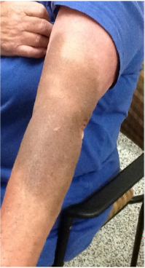Learning Workshop 4 was held via webinar on Friday 23 September 2016 and focussed on IV iron infusions and potential adverse events. Dr Pradeep Jayasuriya, a member of the Commission’s Patient Blood Management (PBM) Project Reference Group, and a GP who established Australia’s first community-based iron infusion centre in Belmont, Western Australia, presented on common GP concerns. Discussion included the need for patient consent, referral pathways for investigation, dosage regimens and IV cannulation experience.

One potential adverse event of administering IV iron is skin staining from paravenous leakage of iron solutions. Staining may be permanent, but the length and duration of staining appears to be related to volume of the drug extravagated. The carboxymaltose product information notes a frequency of 1-10/1000; the Belmont Clinic (WA) experience is nil after 1500.

Sue Ireland from South Australia (SA) Health advised of initial results of a review of IV iron infusion incidents associated with the use of ferric carboxymaltose in SA public hospitals. The data provided is based on voluntary reporting of incidents on the Safety Learning System (SLS) by hospital staff associated with ferric carboxymaltose administration. A comparison with the incident rate of other IV iron products is yet to be completed.

Figure 1: Skin Stain



SA Health’s Bloodsafe eLearning Australia is an award winning transfusion practice website providing PBM education. The BloodSafe Resource Centre contains valuable resources including:

* Videos include important information on how to safely administer IV Iron in primary care; an introduction to the principles and benefits of PBM; a discussion about PBM and transfusion between a surgeon and patient; intraoperative PBM strategies to minimise blood loss in cardiothoracic surgery; and, a guide to assessing the patient with GI bleeding.
* Tools include a protocol for administering IV ferric carboxymaltose, a checklist for prescribers from WA Health; a prescribing checklist for IV iron from NPS MedicineWise and consumer information.
* The iron deficiency anaemia (IDA) app, available for download for iOS and Android, provides the IDA algorithm which is an educational tool designed to increase the understanding of the diagnosis, investigation and management of IDA.

For further information go to www.bloodsafeelearning.org.au.

There was also discussion of the patient pathway and a review being undertaken by the Collaborative project coordinators on patient management to examine why the Collaborative data is showing high rates for assessment with lower rates of management. The results will be examined and potential strategies to improve management developed at the next project coordinator workshop in November 2016.

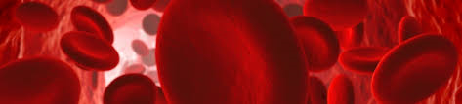**Figure 1: Total patient procedures by test by health service, May 2015 to August 2016**

**Overview of Collaborative Activity to May 2016**

A total of 8405 patient procedures have been recorded by NPBMC sites between May 2015 and August 2016. Across NPBMC sites, 7686 (91%) have a haemoglobin recorded and 3198 (37%) have iron studies recorded. Patients for whom iron studies have been recorded usually also have a haemoglobin recorded.

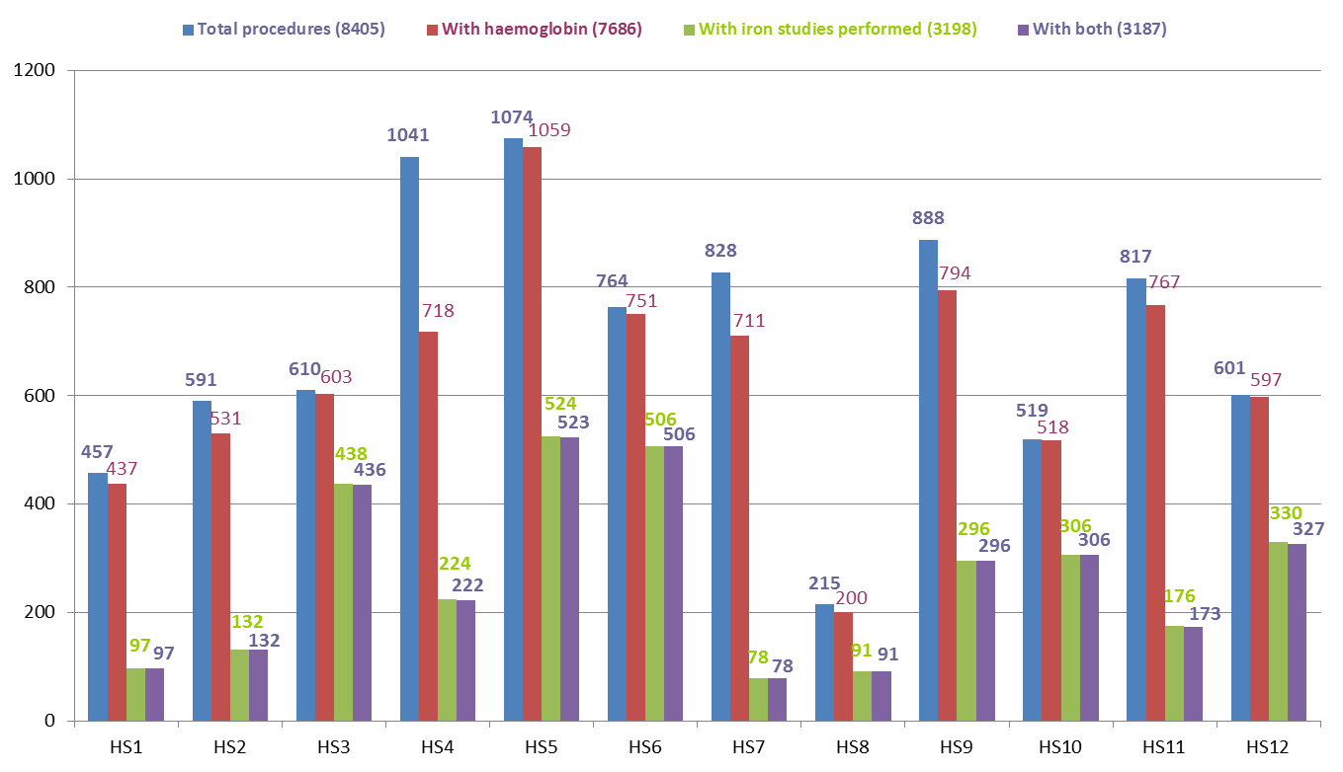

**Figure 2: Total procedures by surgical stream by health service, May 2015 to August 2016**

Ten out of 12 NPBMC sites are recording data for all three surgical streams (gastrointestinal, orthopaedic and gynaecology). The majority of procedures recorded from May 2015 to August 2016 were for orthopaedic surgery.

This chart shows that Ten out of 12 NPBMC sites are recording data for all three surgical streams (gastrointestinal, orthopaedic and gynaecology).


**Figure 3: Percentage of patients receiving pre-operative assessment for anaemia by health service, as at end of August 2016**

The percentage of patients in whom a pre-operative haemoglobin was recorded varied across participating NPBMC sites from 69% to 100%.

This chart shows the percentage of patients in whom a pre-operative haemoglobin was recorded varied across participating NPBMC sites from 69% to 100% across the 12 Collaborative sites with an average of 91%



**Figure 4: Percentage of patients receiving pre-operative assessment for iron deficiency by health service, as at end of August 2016**

There was greater variability in the percentage of patients in whom pre-operative iron studies were recorded, from 9% and 72%.

This chartshows there was greater variability in the percentage of patients in whom pre-operative iron studies were recorded from 9% and 72% across the 12 Collaborative sites with an average of 38%


ANAEMIA

**Figure 5: The total percentage of patients assessed for anaemia each month is steadily increasing**

Patients undergoing major surgical procedures are at increased risk of haemorrhage. Pre-operative assessment of the patient's haemoglobin levels assists clinicians in identifying and managing patients in whom anaemia is a risk factor for adverse surgical outcomes. The percentage of patients assessed for anaemia each month has increased over the duration of the Collaborative from 90% in May 2015 to 100% in August 2016.

The trend line graph shows the percentage of patients assessed for anaemia each month has increased over the duration of the Collaborative from 90% in May 2015 to 100% in August 2016.


**Figure 6: Those patients confirmed as anaemic who have been managed**

The data shows that rates of anaemia management have varied between 19% and 52% over the term of the Collaborative to August 2016.

This trend line graph shows that rates of anaemia management have varied between 19% and 52% over the term of the Collaborative to August 2016.


IRON DEFICIENCY

A patient's iron stores can be assessed safely and inexpensively with a simple blood test. Patients who undergo major surgery lose varying amounts of blood as a result of their surgery. This decreases their haemoglobin levels, which in some patients results in anaemia. Patients use their iron stores to produce haemoglobin. Knowledge of the patient's iron stores assists clinicians to identify patients who need iron replacement to support haemoglobin production post-operatively.

**Figure 7: The percentage of patients assessed for iron deficiency is increasing**

Rates of pre-operative assessment of iron deficiency have steadily increased over the duration of the Collaborative.

This trendline graph shows the rates of pre-operative assessment of iron deficiency have steadily increased over the duration of the Collaborative.


**Figure 8: Those patients confirmed as iron deficient who have been managed**

The data shows that between 38% and 62% of patients were managed for iron deficiency from May 2015 to August 2016.

This trendline graph shows that between 38% and 62% of patients were managed for iron deficiency from May 2015 to August 2016.


ANAEMIA

Recording of patient assessment for anaemia varies with the type of surgery; this aspect will be further assessed. Rates are highest for patients undergoing orthopaedic surgery and lowest for those undergoing gynaecological surgery. Recording of assessment for anaemia has improved in all surgical streams over the duration of the Collaborative. The target is for 100% of patients to have an assessment for anaemia recorded in their patient record.

**Figure 9: Percentage of patients with anaemia who were assessed by surgical stream by quarter**

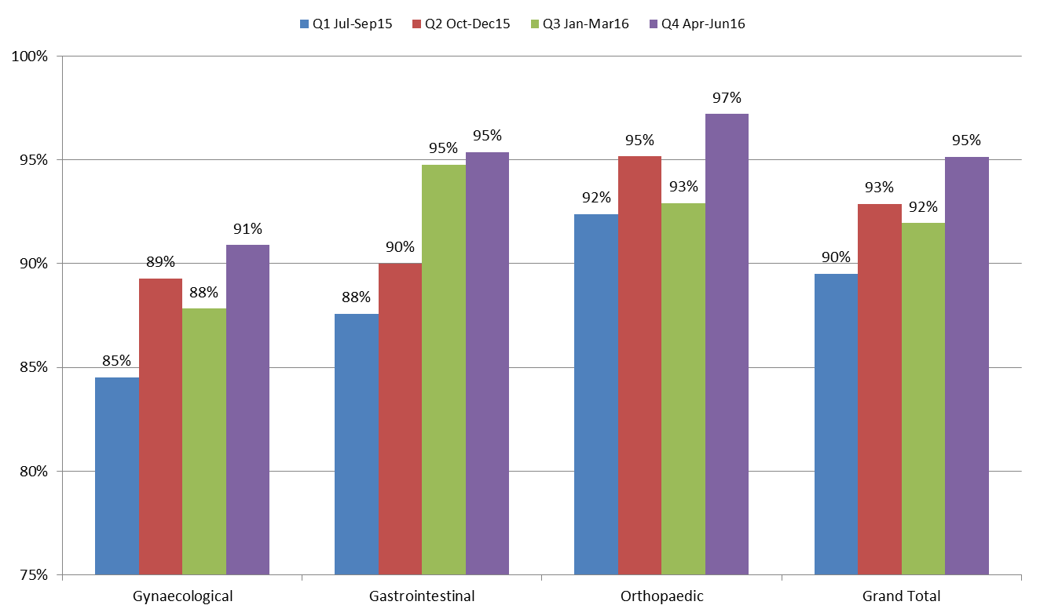

**Figure 10: Percentage of patients with anaemia who were managed by surgical stream by quarter**

Management of patients with anaemia has improved in the gynaecological and gastrointestinal surgical streams but not in the orthopaedic stream. A large percentage of patients diagnosed with anaemia in each surgical stream have no management recorded, particularly in orthopaedics, where over 81% of patients with anaemia in the last quarter had no management recorded.

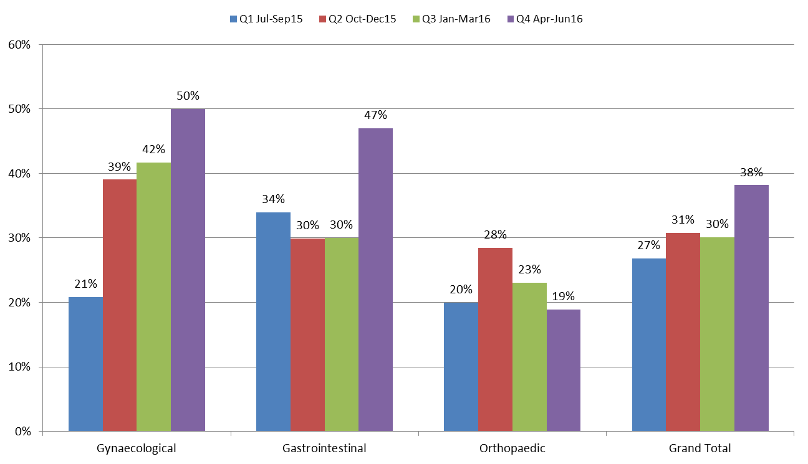

**IRON DEFICIENCY**

**Figure 11: Percentage of patients assessed for iron deficiency by surgical stream by quarter**

Recording of patient assessment for iron deficiency has improved in each surgical stream from May 2015 to August 2016. Rates are highest for patients undergoing orthopaedic surgery and lowest for those undergoing gynaecological surgery. Although recording of assessment for iron deficiency has improved in all surgical streams over the duration of the Collaborative, the overall percentage is well below 100%. This may, in part, be due to some sites only performing iron studies on patients in whom anaemia has been identified, whereas other sites perform iron studies on all patients in these surgical streams.

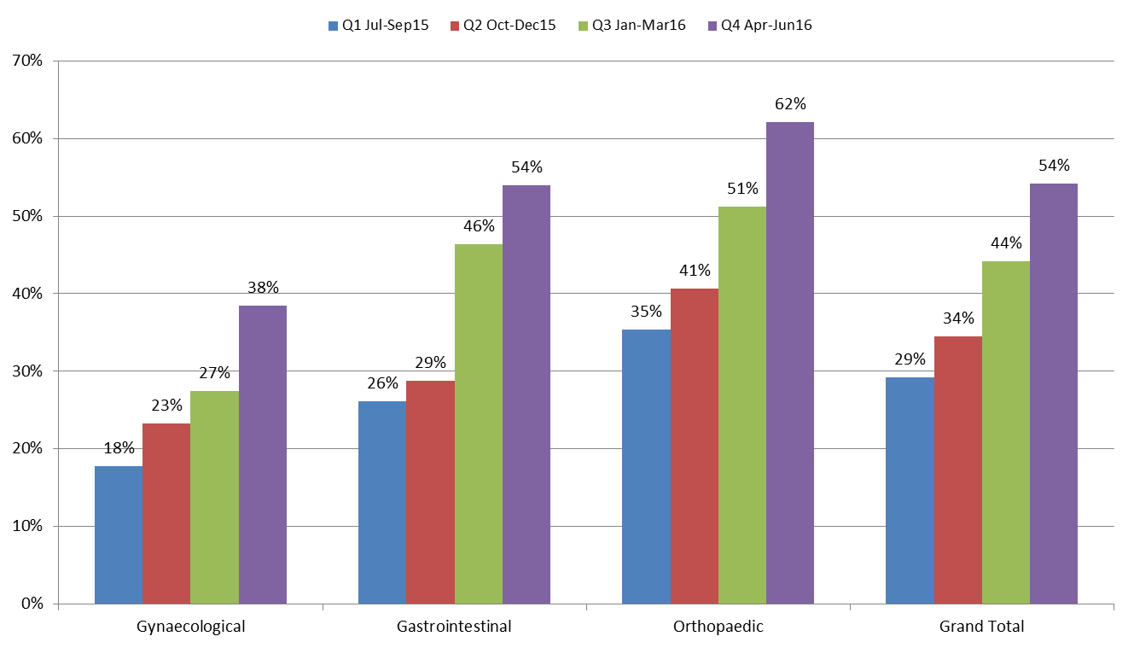

**Figure 12: Percentage of patients managed for iron deficiency by surgical stream by quarter**

Recorded management of patients who were diagnosed with iron deficiency does not vary greatly across surgical streams from May 2015 to August 2016.

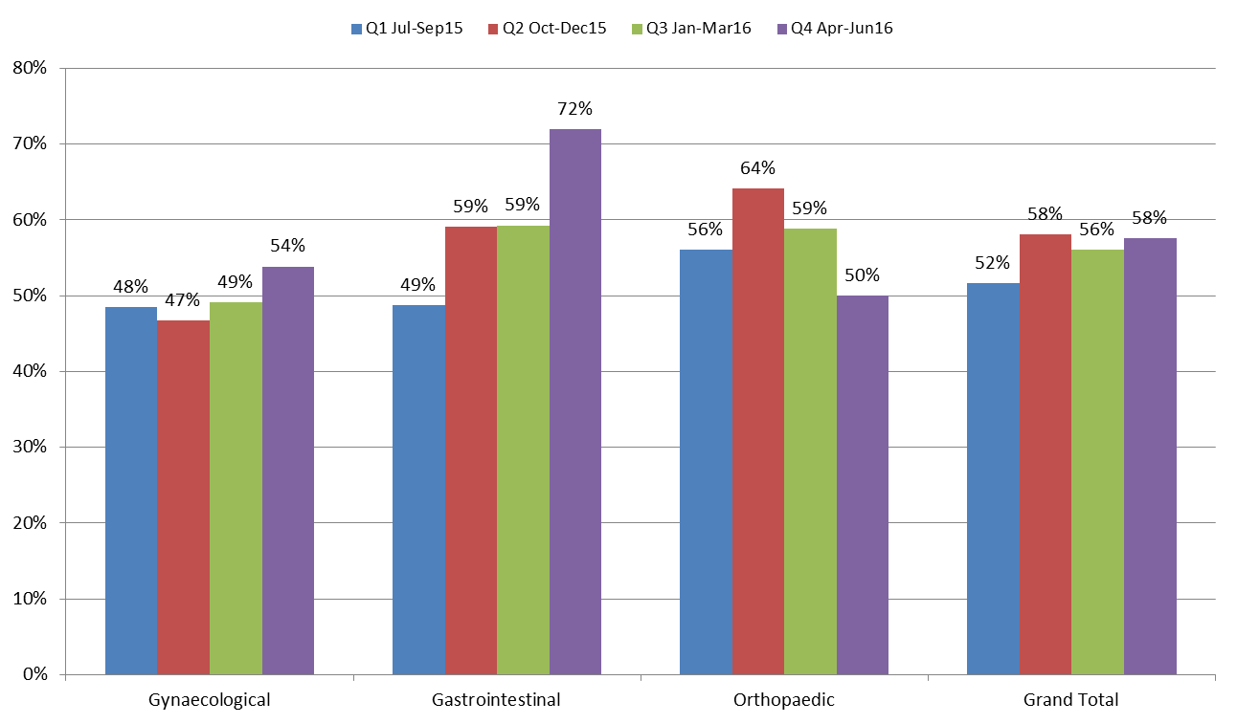

**For further information:**

**Website:** www.safetyandquality.gov.au/national-priorities/pbm-collaborative/

**Email:** pbmcollaborative@safetyandquality.gov.au **Twitter:** @ACSQHC **Phone:** 02 9126 3600