

## Information Bulletin



**July 2016**

The ***National Patient Blood Management Collaborative*** (NPBMC) focuses on improving the management of anaemia for patients having elective surgery in the surgical areas of: gastrointestinal, gynaecological and orthopaedics. The Collaborative, funded by the Commonwealth Department of Health, started in April 2015 with 12 participating health services from across Australia and will run to April 2017. The Collaborative will support improvements in the management of anaemia for elective surgery patients. It encompasses the patient journey from the time that the need for surgery is identified, through inpatient care, and then subsequent care back in the community

### PROJECT COORDINATOR’S WORKSHOP

On Monday 27 June 2016 the Collaborative health service project coordinators attended a workshop at the Commission’s office in Sydney, which was an opportunity for teams to discuss key issues around quality improvement with other teams and Commission project team. These regular workshops also target barriers to improvement and are an opportunity to problem solve.

There was a session on assessment of the Plan, Do, Study, Act (PDSA) cycles, with the Improvement Foundation presenting various strategies which could be used, including how to use the data to inform PDSA development and implement change. A session was also held to identify the PDSAs that need to be planned and implemented over the next six months.

As the Collaborative moves into the evaluation phase, there is an increased focus on using the monthly and aggregate data to inform quality improvements. It is important to embed assessment of the data to develop sustainable patient blood management (PBM) processes.

The challenges highlighted by health services include:

* Improving documentation
* Engaging senior management
* Getting the team in the same room at the same time
* Acting on low iron results
* Great involvement of Primary Health Networks
* Engaging practice managers in GP practices
* Interpretation of results to improve practice
* How to ensure sustainability of PBM strategies
* Getting buy-in from medical staff across the hospital.

### ACTIVITY REPORTING

As at 30 June 2016 the Collaborative health service teams had collected data on **7185** patient episodes, consisting of gastrointestinal (19%), gynaecological (25%) and orthopaedic (56%) elective surgical procedures.

Of these procedures, 91% of patients had received a haemoglobin test, 35% had iron studies and 35% had both. This equates to 1 in 10 patients having a haemoglobin test and 1 in 3 having an assessment for iron deficiency, prior to surgery.

Across the health services, pre-surgical assessment of patients for anaemia ranged from 65% to 100%, and for iron studies, the range was much greater— between 9% to 67%.

Due to the timeliness of histopathology results, completion of documentation, and coding to ensure identification of the diagnostic related groups (DRG) to be collected, there is a data lag of up to two months for some sites. As such, data from the most recent quarter will change as updated data is entered into the system.

Teams have completed 255 PDSAs since the Collaborative commenced.

### UPCOMING EVENTS—2016

August: PBM Project Reference Group

September: Learning Workshop Webinar

October: Project Coordinator’s Workshop

December: PBM Project Reference Group

# Overview of Collaborative Activity to June 2016

##### Figure 1: Total patient procedures by test by health service, May 2015 to June 2016

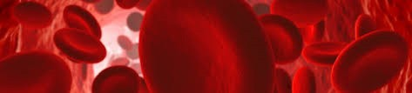

A total of 7185 patient procedures have been recorded by NPBMC sites between May 2015 and June 2016. The total number of patient procedures recorded ranges between 186 and 983. Across sites, 6549 (91%) have a haemoglobin recorded and 2543 (35%) have iron studies recorded. Patients for whom iron studies have been recorded usually also have a haemoglobin recorded.

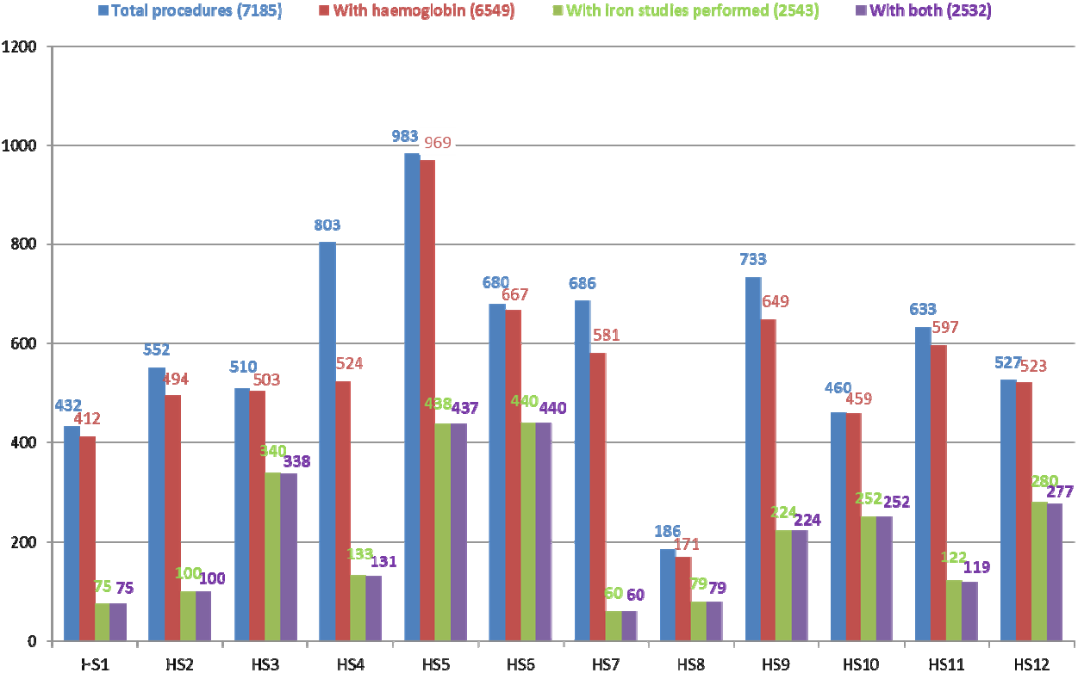

HS = Health Service

##### Figure 2: Total procedures by surgical stream by health service, May 2015 to June 2016

Ten out of 12 NPBMC sites are recording data for all three surgical streams (gastrointestinal, orthopaedic and gynaecology). The majority of procedures recorded were for orthopaedic surgery.

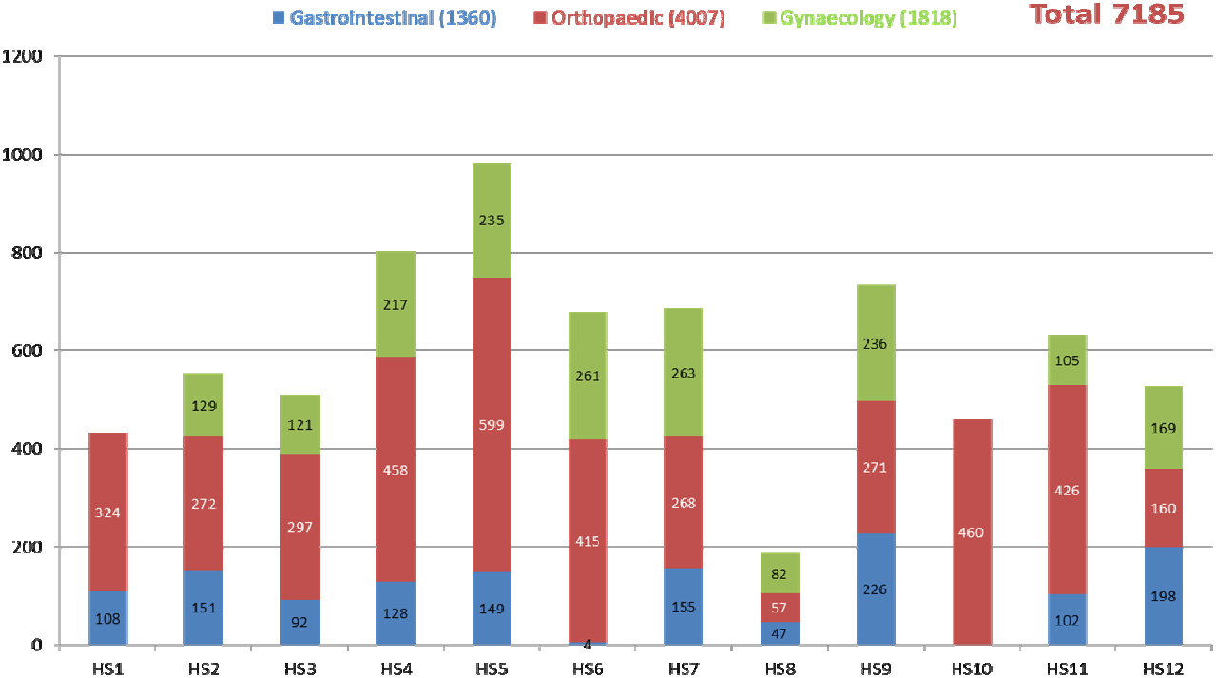

##### Figure 3: Percentage of patients receiving pre-operative assessment for anaemia by health service, as at end of June 2016

The percentage of patients in whom a pre- operative haemoglobin was recorded varies across participating sites from 65% to 100%.

##### Figure 4: Percentage of patients receiving pre-operative assessment for iron deficiency by health service, as at end of June 2016

There was greater variability in the percentage of patients in whom pre-operative iron studies were recorded, ranging between 9% and 67%.

##### Figure 5: Number of patients who received transfusions, by month service by quarter

The number of patients who received transfusions has decreased over the duration of the Collaborative, from a peak of over 50 in July 2015 to fewer than 10 in

June 2016

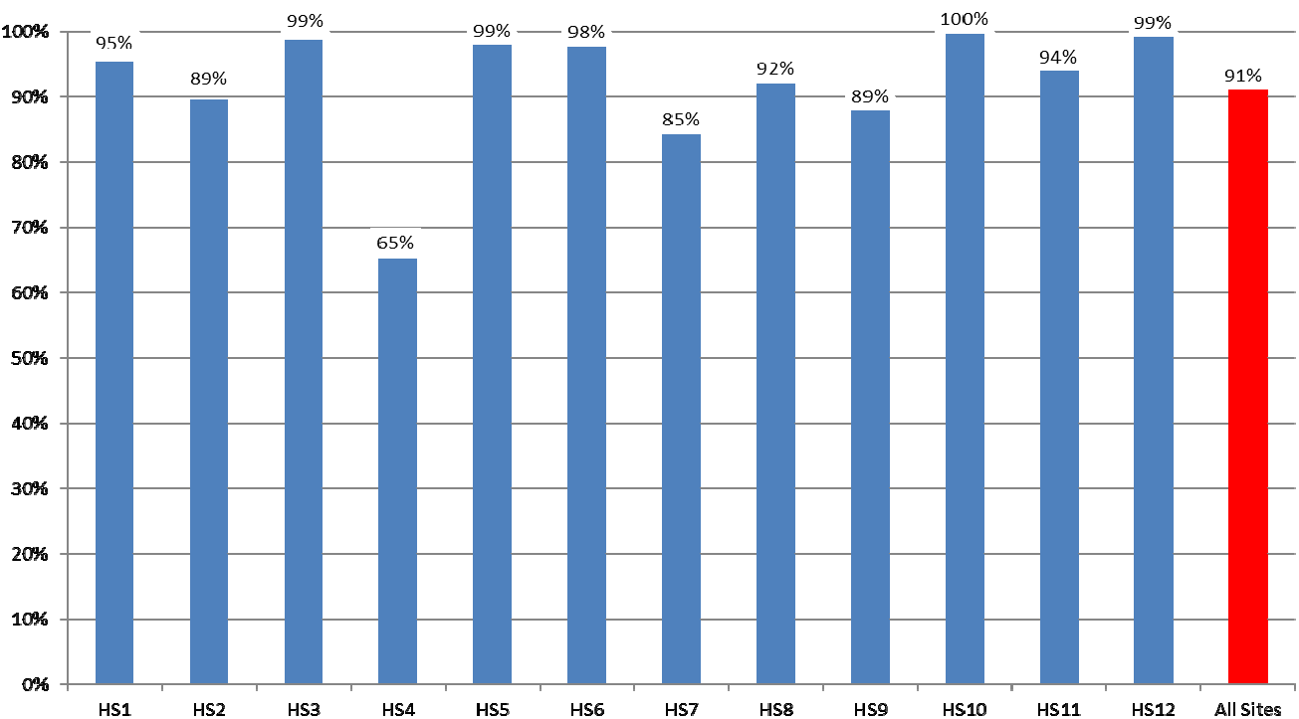

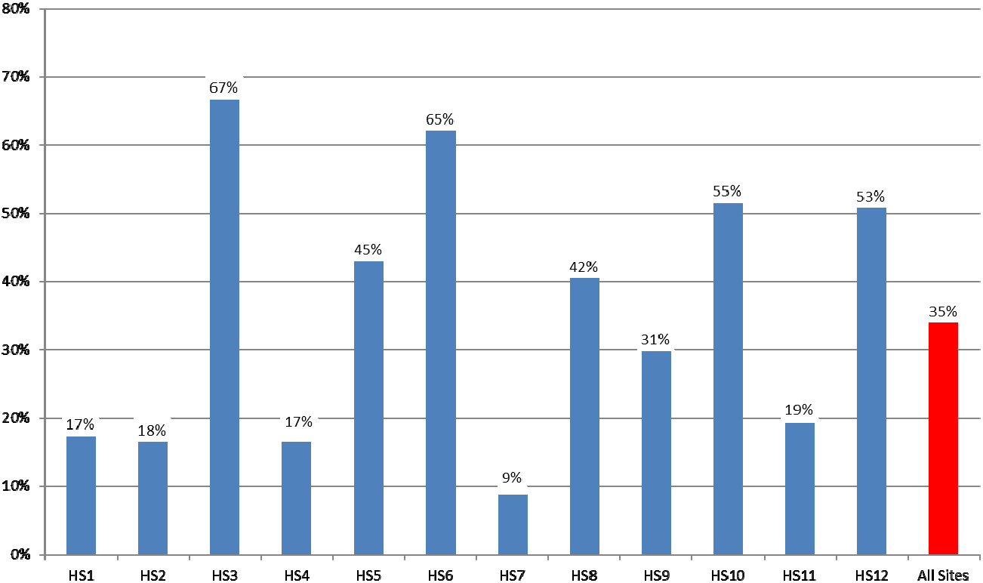

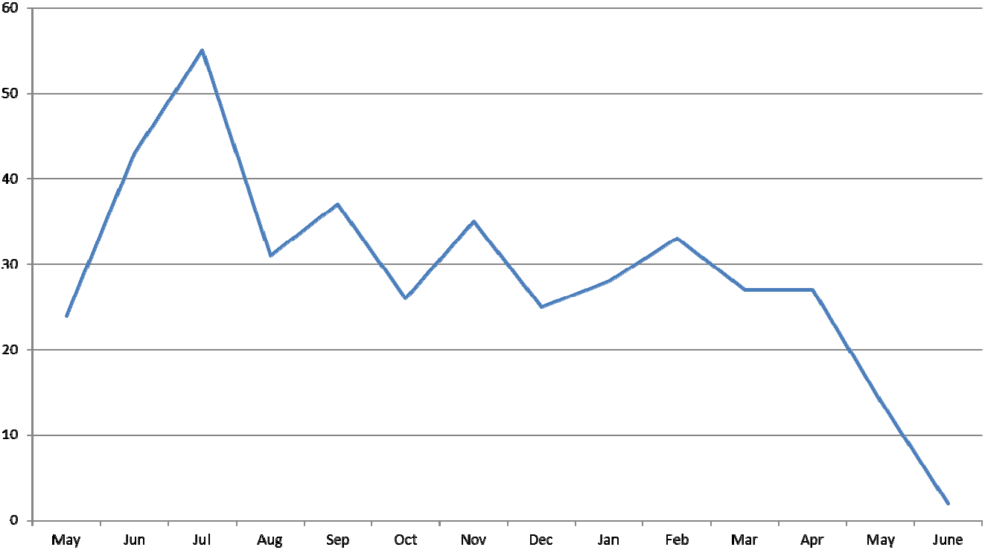

2015 2016

***ANAEMIA***

##### Figure 6: The total percentage of patients assessed for anaemia each month is steadily increasing

Patients undergoing major surgical procedures are at increased risk of haemorrhage. Preoperative assessment of the patient's haemoglobin levels assists clinicians to identify and manage patients in whom anaemia is a risk factor for adverse surgical outcomes. The percentage of patients assessed for anaemia each month has increased over the duration of the Collaborative from 90% in May 2015 to 98% in June 2016.

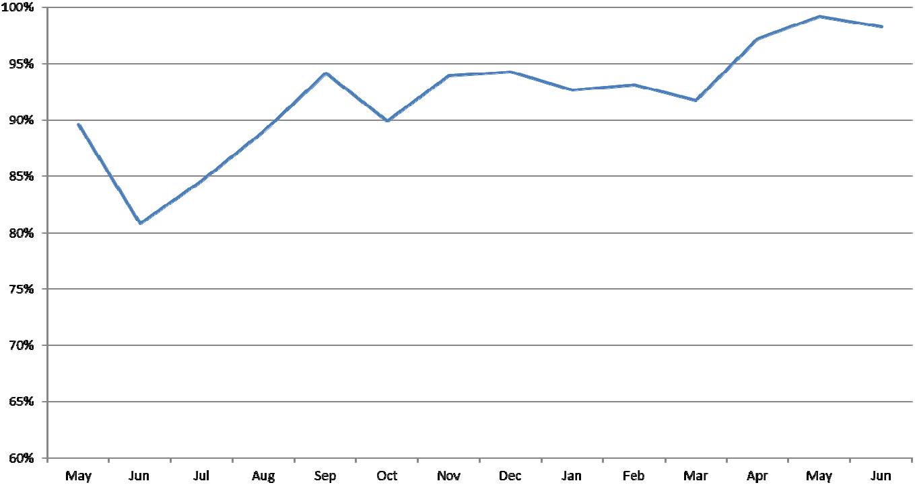

2015 2016

##### Figure 7: Those patients confirmed as anaemic who have been managed

Assessment of the haemoglobin of patients in the three surgical streams (gastrointestinal, gynaecology and orthopaedics) identifies approximately 25% as having anaemia. Rates of anaemia each month have varied between 20% and 45% of patients tested over the duration of the Collaborative.

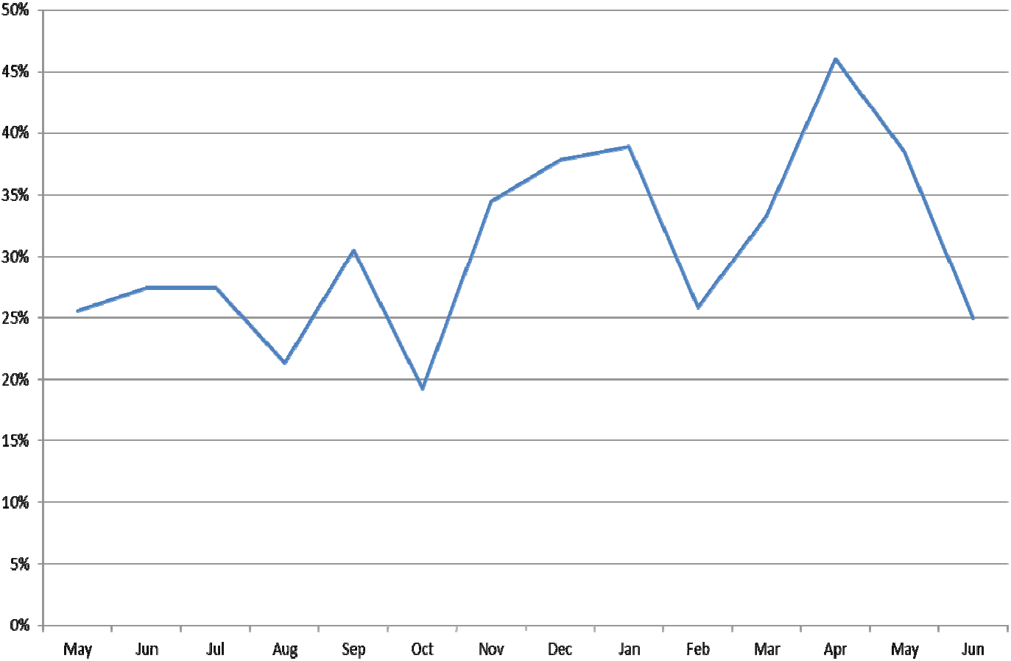

2015 2016

#### IRON DEFICIENCY

##### Figure 8: The percentage of patients assessed for iron deficiency is increasing

A patient's iron stores can be assessed safely and inexpensively with a simple blood test. Patients who undergo major surgery lose varying amounts of blood as a result of their surgery. This decreases their haemoglobin levels, which in some patients results in anaemia. Patients use their iron stores to produce haemoglobin. Knowledge of the patient's iron stores assists clinicians to identify patients who need iron replacement to support haemoglobin production postoperatively. Rates of pre-operative recording of iron deficiency have increased over the duration of the Collaborative, from 20% of patients in June 2015 to over 70% of patients in June 2016.

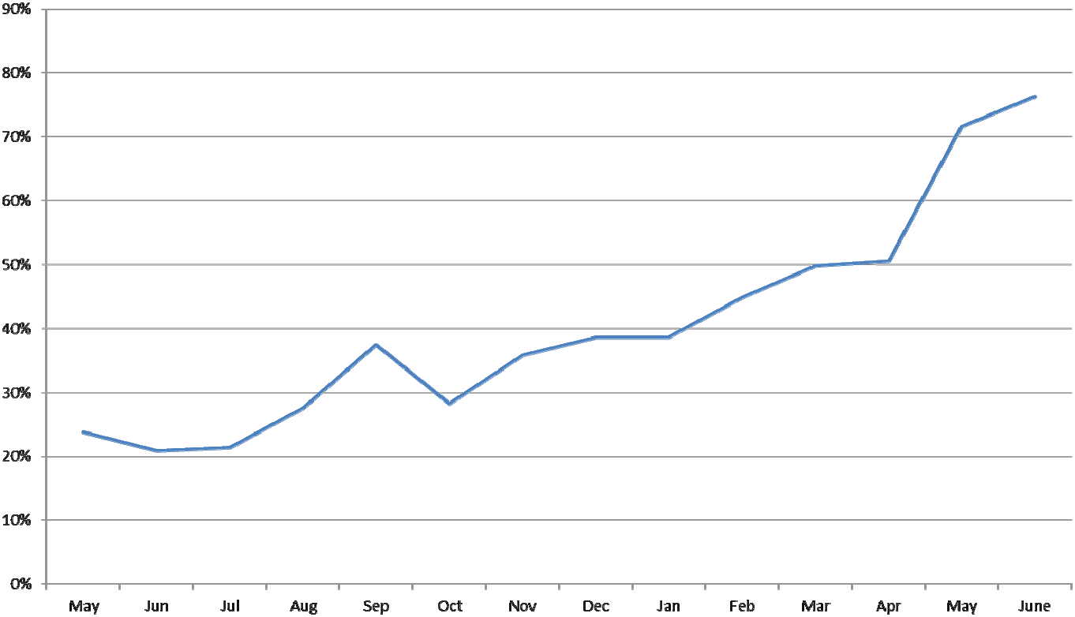

2015 2016

##### Figure 9: Those patients confirmed as iron deficient who have been managed

Assessment for iron deficiency enables clinicians to identify that between 40% and 65% of patients are iron deficient.

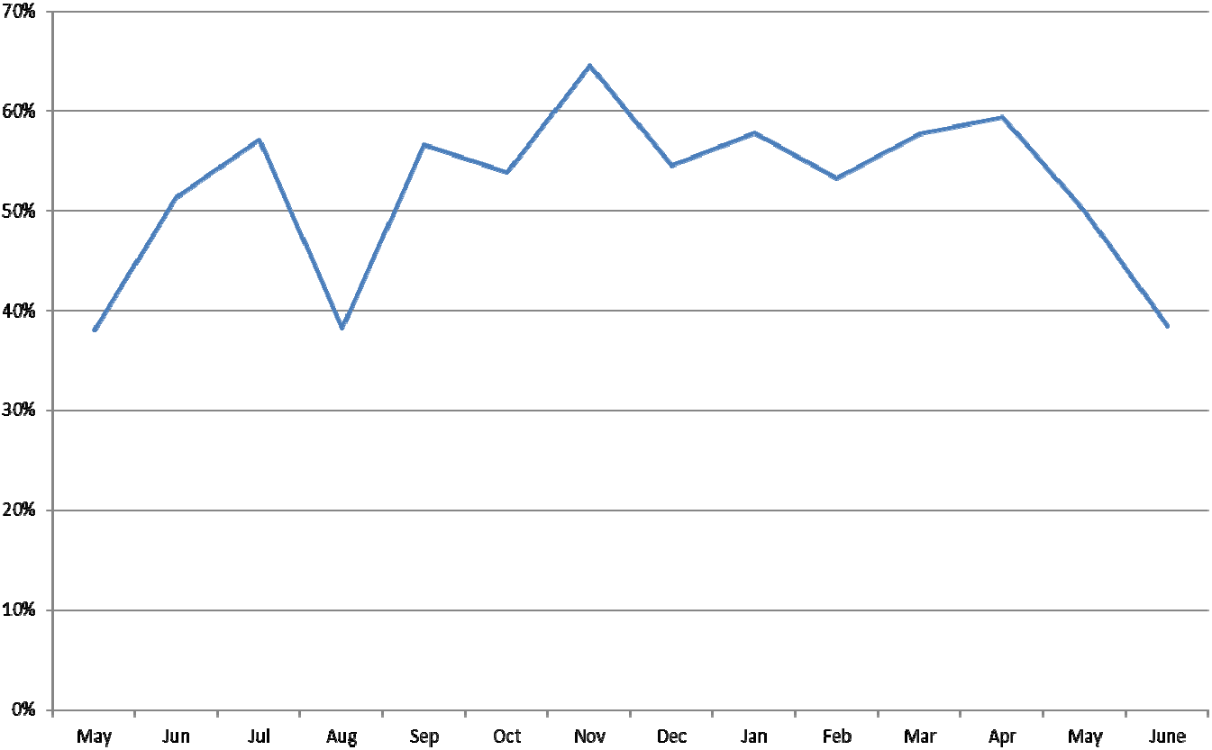

2015 2016

#### ANAEMIA

##### Figure 10: Percentage of patients with anaemia who were assessed by surgical stream by quarter

Recording of patient assessment for anaemia varies according to type of surgery. Rates are highest for patients undergoing orthopaedic surgery and lowest for those undergoing gynaecology surgery. Recording of assessment for anaemia has improved in all surgical streams over the duration of the Collaborative and was over 95% for all three streams in the most recent quarter. The target is for 100% of patients to have an assessment for anaemia recorded in their patient record.

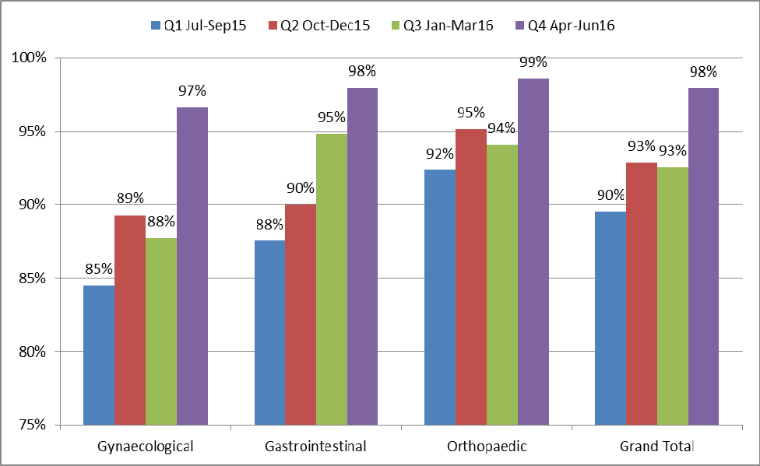

##### Figure 11: Percentage of patients with anaemia who were managed by surgical stream by quarter

Management of patients who were identified with anaemia has improved in the gynaecological and gastrointestinal surgical streams but not in the orthopaedic stream. A large percentage of patients diagnosed with anaemia in each surgical stream have no management recorded, particularly in orthopaedics, where over 80% of patients with anaemia in the last quarter had no management recorded.

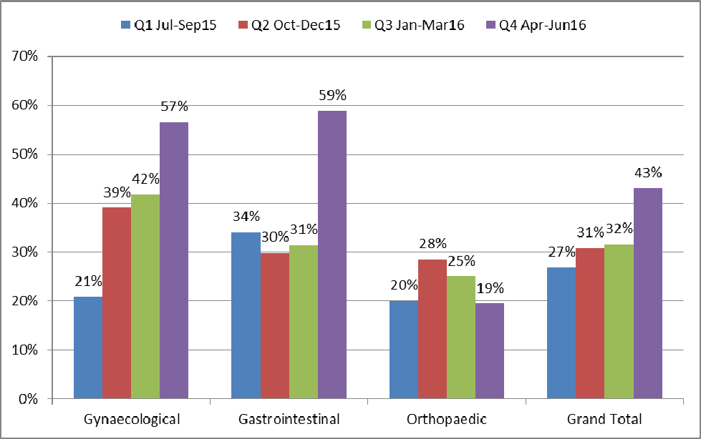

#### IRON DEFICIENCY

##### Figure 12: Percentage of patients assessed for iron deficiency by surgical stream by quarter

Recording of patient assessment for iron deficiency has improved in each surgical stream over time. Rates are highest for patients undergoing orthopaedic surgery and lowest for those undergoing gynaecology surgery. Although recording of assessment for iron deficiency has improved in all surgical streams over the duration of the Collaborative, the overall percentage is well below 100%. This may in part be due to some sites only performing iron studies on patients in whom anaemia has been identified, whereas other sites aim to perform iron studies on all patients in these surgical streams.

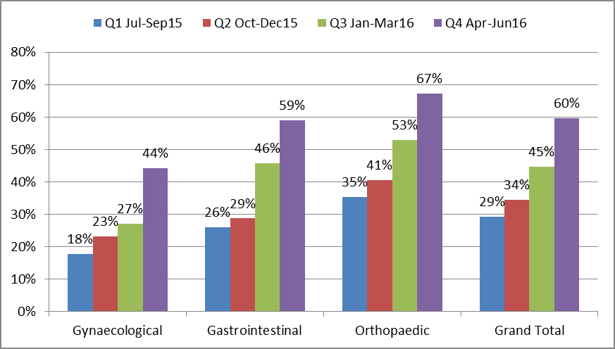

##### Figure 13: Percentage of patients managed for iron deficiency by surgical stream by quarter

Recorded management of patients who were diagnosed with iron deficiency do not vary greatly across surgical streams and have remained between 47% and 66% of patients per quarter over time.

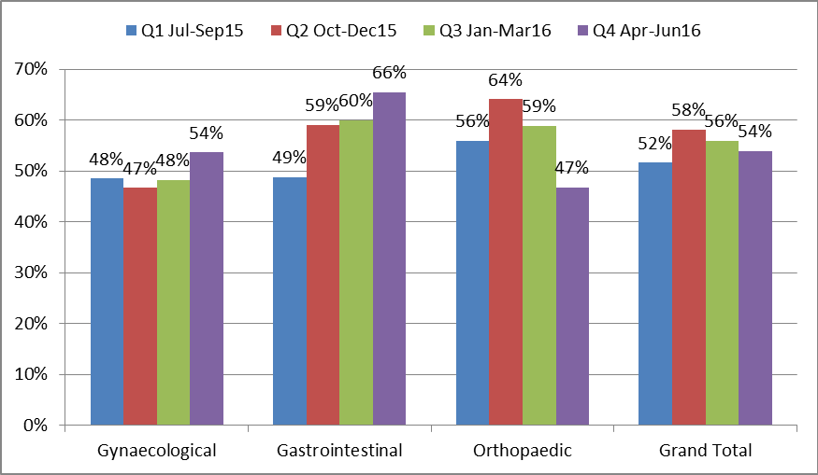

**For further information:**

**Website:** [www.safetyandquality.gov.au/national-priorities/pbm-collaborative/](http://www.safetyandquality.gov.au/national-priorities/pbm-collaborative/)

**Email:** [pbmcollaborative@safetyandquality.gov.au](mailto:pbmcollaborative@safetyandquality.gov.au) **Twitter:** @ACSQHC **Phone:** 02 9126 3600