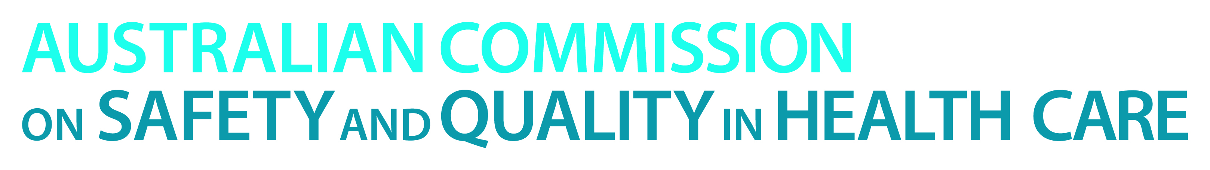

TRIM: D14-30491

3 September 2014

**Commission and jurisdiction partners receive award for excellence at APAC Forum**

We are very pleased to announce the Australian Commission on Safety and Quality in Health Care’s (the Commission) success at the APAC Forum - Asia Pacific’s premier healthcare conference.

The Commission and the Australian, state and territory health departments received the award for National Partnership in the Implementation of Improved Safety Systems for Patients for implementation of the National Safety and Quality Health Service (NSQHS) Standards.

The NSQHS Standards were endorsed by health ministers in 2011 with the aim of protecting the public from harm and to improve the quality of health service provision.

Development of the NSQHS Standards involved consumers, clinicians, all health departments, and health service managers from across the health system. Implementation of the NSQHS Standards became mandatory for all hospitals and day procedure services from 1 January 2013 and involved complex planning and system change.

Feedback from those responsible for implementing the NSQHS Standards at the local level indicates a high degree of support from clinicians and acceptance across service providers in the health system. This success is an outcome of the strength of the collaboration between the Commission, health departments, private health sector and key health care professional and consumer groups.

As of 30 June 2014, 1,034 public and private hospitals and day procedure services had been assessed against the NSQHS Standards. Early indications show a reduction in adverse events.

The award was accepted last night at the APAC Forum in Melbourne by:

* Professor Dorothy Jones, Chair of the Australian Commission for Safety and Quality in Health Care Inter Jurisdictional Committee
* Margaret Banks representing the Australian Commission on Safety and Quality in Health Care
* Michele McKinnon representing SA Health.

*Media inquiries can be directed to Lisa Parcsi, Communications Manager, by calling (02) 9126 3605 or email lisa.parcsi@safetyandquality.gov.au*

**- Ends -**