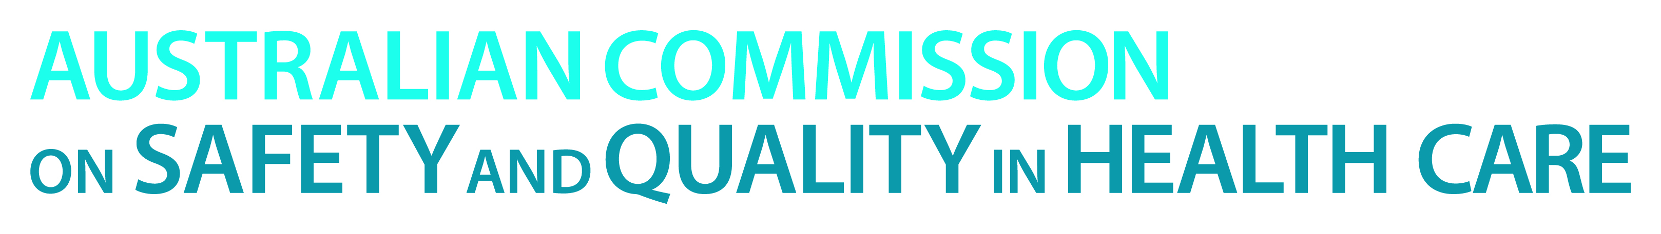

TRIM: D14-29298

**Addressing health literacy through a new national approach**

Almost 60% of Australians have a low level of individual health literacy. This is important to the safety, quality and effectiveness of health care, according to the *National Statement on Health Literacy* (national statement) released today by the Australian Commission on Safety and Quality in Health Care (the Commission).

Low levels of individual health literacy contribute to poorer health outcomes, increased risk of an adverse event and higher healthcare costs. People with low levels of health literacy may not understand their medication instructions, be able to interpret nutrition labels on food, or be able to understand the risks associated with different treatment options enough to make an informed choice.

The Commission has been working with healthcare professionals, consumers, policy makers and researchers to explore the role that health literacy plays in safe and high-quality care and to develop a national approach as a basis for coordinated and collaborative action.

The *National Statement on Health Literacy* proposes a coordinated approach to health literacy based on:

* embedding health literacy into systems
* ensuring effective communication
* integrating health literacy into education.

This has now been endorsed by Australian, state and territory Health Ministers as the national approach to health literacy.

According to Professor Villis Marshall, Chair of the Commission, addressing health literacy is critical to effective partnerships with consumers. Improving health literacy contributes to a greater sense of empowerment, better quality of care and can also lead to improved outcomes for people and their families.

“This National Statement highlights that there are lots of ways that we can make it easier for people to understand the health system and their health choices. Healthcare providers, managers, policy makers and consumers can all take action to address health literacy.”

Professor Marshall encourages healthcare organisations and providers to think about health literacy when designing and delivering health care, including how services are organised and how information is prepared and provided.

“Patients should not be afraid to ask for more information or for information to be provided in different ways so that they can make informed decisions and act on them. Patients should let their healthcare providers know when something is not easy to understand, and to seek support when they need it,” says Professor Marshall.

*Download:*

* [*Health literacy: Taking action on safety and quality*](http://www.safetyandquality.gov.au/publications/health-literacy-taking-action-to-improve-safety-and-quality)
* [*National Statement on Health Literacy*](http://www.safetyandquality.gov.au/publications/health-literacy-national-statement)

**Australian Commission on Safety and Quality in Health Care**

The Commission is a government agency that leads and coordinates national improvements in safety and quality in health care across Australia. The Commission aims to support health care professionals, organisations and policy makers who work with patients and carers.

*Media inquiries can be directed to Lisa Parcsi, Communications Manager, by calling (02) 9126 3605 or email lisa.parcsi@safetyandquality.gov.au*

**- Ends -**