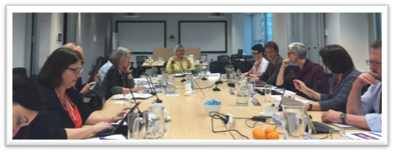
PROJECT REFERENCE GROUP

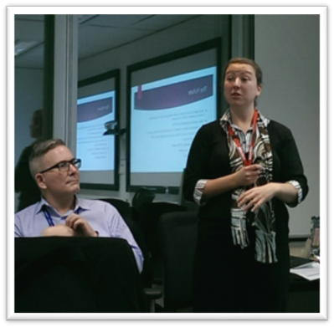
The Australian Commission on Safety and Quality in Health Care’s Patient Blood Management (PBM) Project Reference Group (PRG) met on 4 August 2016 to discuss overall activity to date, development of the evaluation and business case, and the progress of the National Patient Blood Management Collaborative (NPBMC).
Meeting of the PBM PRG on 4 August 2016

Three of the NPBMC teams presented to the group, sharing their successes and challenges, and showcasing the resources which have been developed and implemented as part of the Collaborative. The presentations offered an opportunity to consider how locally developed initiatives could be shared with other sites. The PRG will next meet in December 2016.

LEARNING WORKSHOP WEBINAR

The next NPBMC learning workshop will be a webinar on Friday 23 September 2016 and will focus on potential adverse events from administration of IV iron.
Liz McGill (Prince of Wales Hospital) and
Paul Morgan (Mater Hospital) presenting at the August meeting of the PBM PRG

IRON DEFICIENCY ANAEMIA (IDA)

One of the focus areas arising from the NPBMC is the management of Iron Deficiency Anaemia. A recent infographic published in the Annals of Surgery clearly shows the benefits of managing iron deficiency anaemia:

Impact of treating Iron Deficiency Anaemia before major abdominal surgery
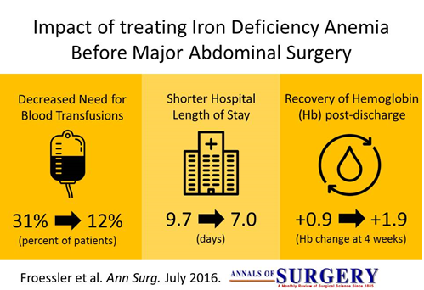
Froessler et al. Ann Surg. July 016
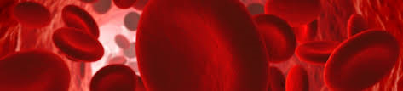
Figure 1: Total patient procedures by test and by health service, May 2015 to July 2016
Overview of Collaborative Activity to May 2016
A total of 7790 patient procedures have been recorded by NPBMC sites between May 2015 and July 2016. Across NPBMC sites, 7109 (91%) have a haemoglobin recorded and 2863 (37%) have iron studies recorded. Patients for whom iron studies have been recorded usually also have a haemoglobin recorded.

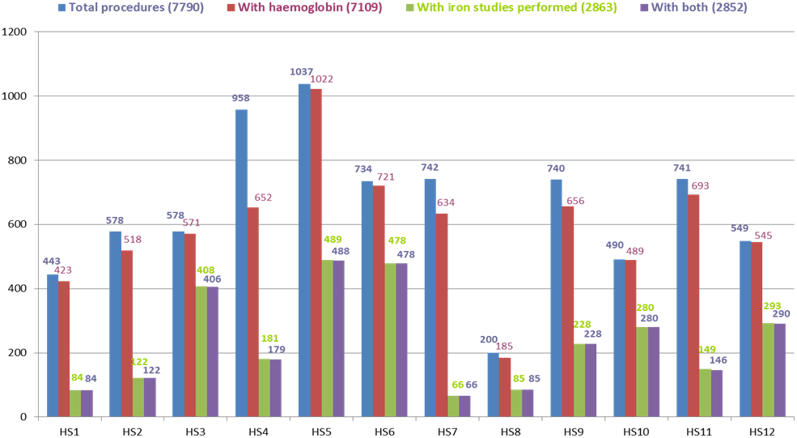

Figure 2: Total procedures by surgical stream and by health service, May 2015 to July 2016
Ten out of 12 NPBMC sites are recording data for all three surgical streams (gastrointestinal, orthopaedic and gynaecology). The majority of procedures recorded from May 2015 to July 2016 were for orthopaedic surgery.

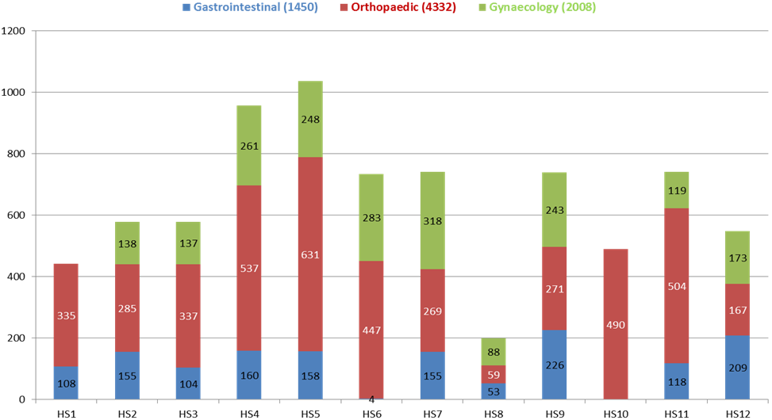

Figure 3: Percentage of patients receiving pre-operative assessment for anaemia by health service, as at end of July 2016
The percentage of patients in whom a pre-operative haemoglobin was recorded varied across participating NPBMC sites from 68% to 100%.

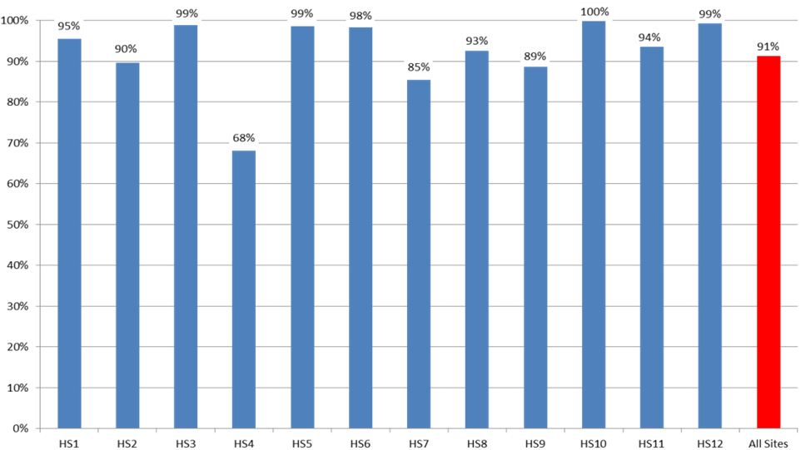

Figure 4: Percentage of patients receiving pre-operative assessment for iron deficiency by health service, as at end of July 2016
There was greater variability in the percentage of patients in whom pre-operative iron studies were recorded from 9% and 71%.

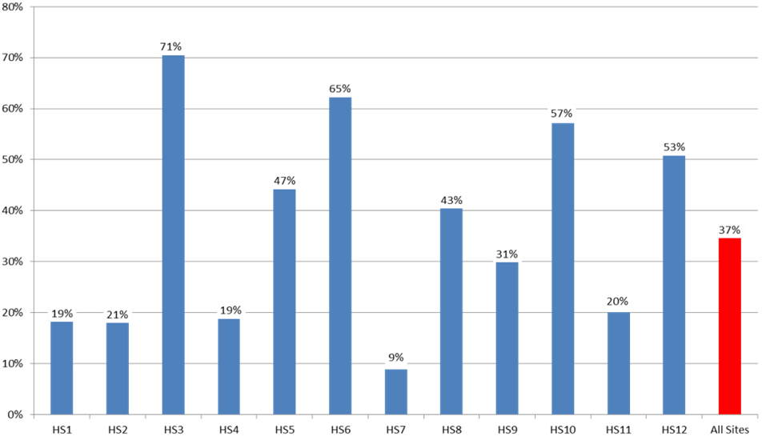

Anaemia

Figure 5: The total percentage of patients assessed for anaemia each month
Patients undergoing major surgical procedures are at increased risk of haemorrhage. Pre-operative assessment of the patient's haemoglobin levels assists clinicians in identifying and managing patients in whom anaemia is a risk factor for adverse surgical outcomes. The percentage of patients assessed for anaemia each month has increased over the duration of the Collaborative from 90% in May 2015 to 96% in July 2016.

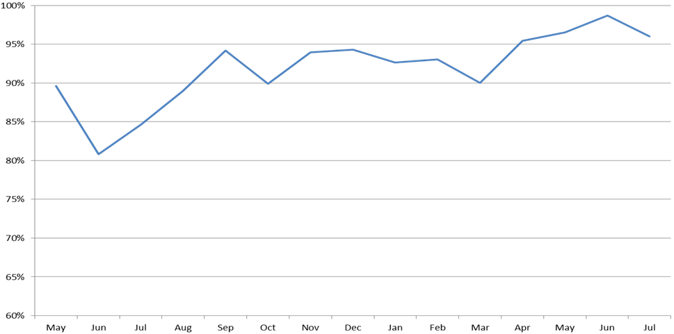

Figure 6: Percentage of patients with anaemia who were managed per month
The data shows that rates of anaemia management have varied between 20% and 45% from May 2015 to June 2016.

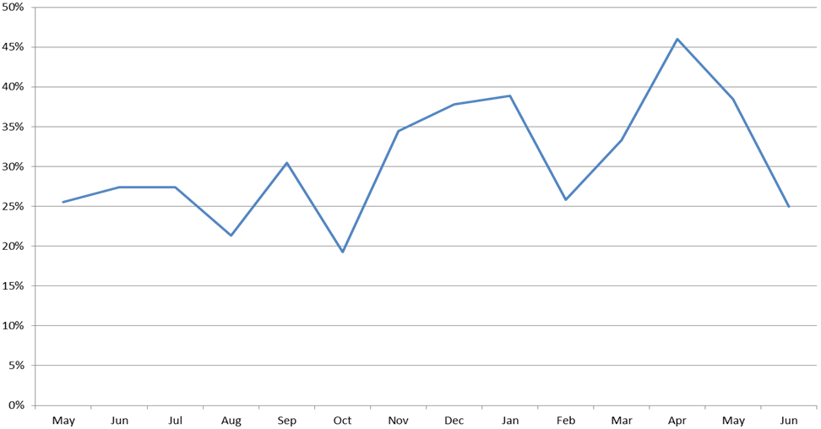

Iron Deficiency

A patient's iron stores can be assessed safely and inexpensively with a simple blood test. Patients who undergo major surgery lose varying amounts of blood as a result of their surgery. This decreases their haemoglobin levels, which in some patients results in anaemia. Patients use their iron stores to produce haemoglobin. Knowledge of the patient's iron stores assists clinicians to identify patients who need iron replacement to support haemoglobin production post-operatively.

Figure 7: The percentage of patients assessed for iron deficiency per month
Rates of pre-operative assessment of iron deficiency have steadily increased over the duration of the Collaborative.

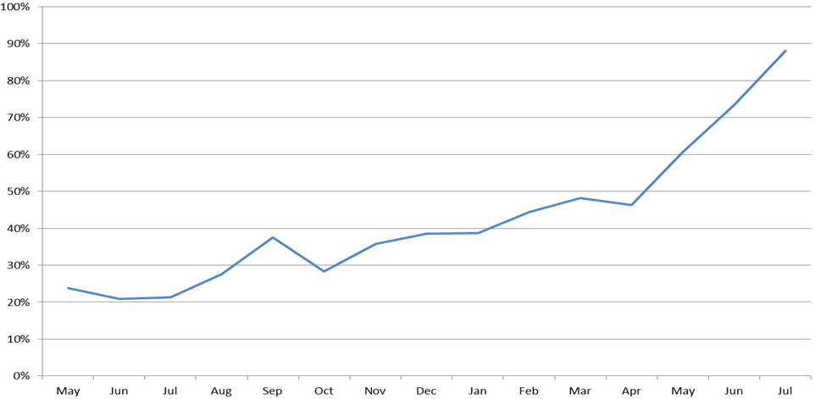

Figure 8: Percentage of patients with iron deficiency who were managed per month
The data shows that between 38% and 69% of patients were managed for iron deficiency from May 2015 to July 2016.

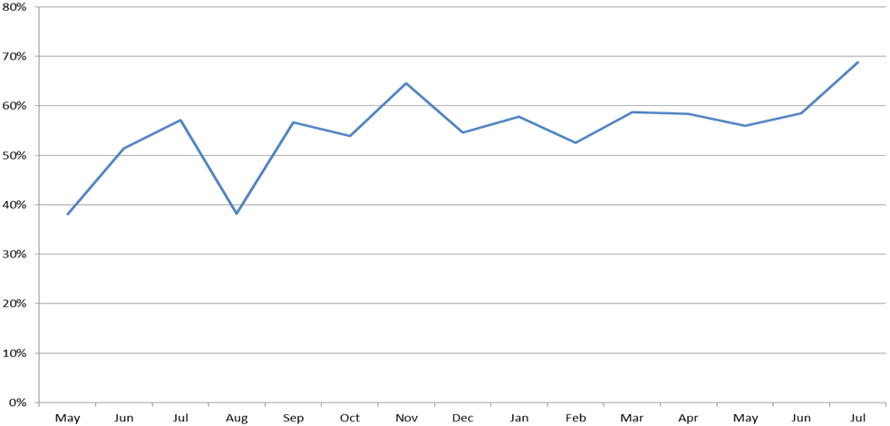

Anaemia

Recording of patient assessment for anaemia varies according to the type of surgery. Rates are highest for patients undergoing orthopaedic surgery and lowest for those undergoing gynaecological surgery. Recording of assessment for anaemia has improved in all surgical streams over the duration of the Collaborative, and was over 95% for all three streams in the most recent quarter. The target is for 100% of patients to have an assessment for anaemia recorded in their patient record.

Figure 9: Percentage of patients who were assessed for anaemia by surgical stream by quarter
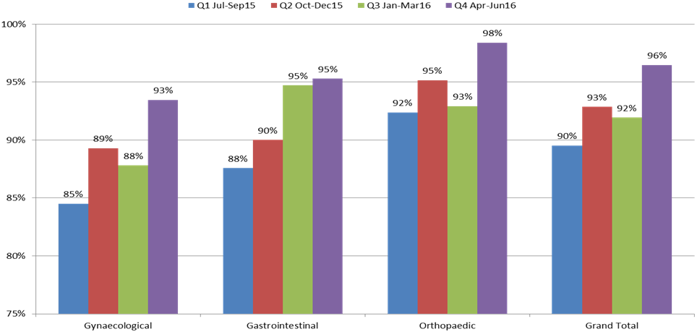

Figure 10: Percentage of patients with anaemia who were managed by surgical stream by quarter
Management of patients with anaemia has improved in the gynaecological and gastrointestinal surgical streams but not in the orthopaedic stream. A large percentage of patients diagnosed with anaemia in each surgical stream have no management recorded, particularly in orthopaedics, where over 85% of patients with anaemia in the last quarter had no management recorded.

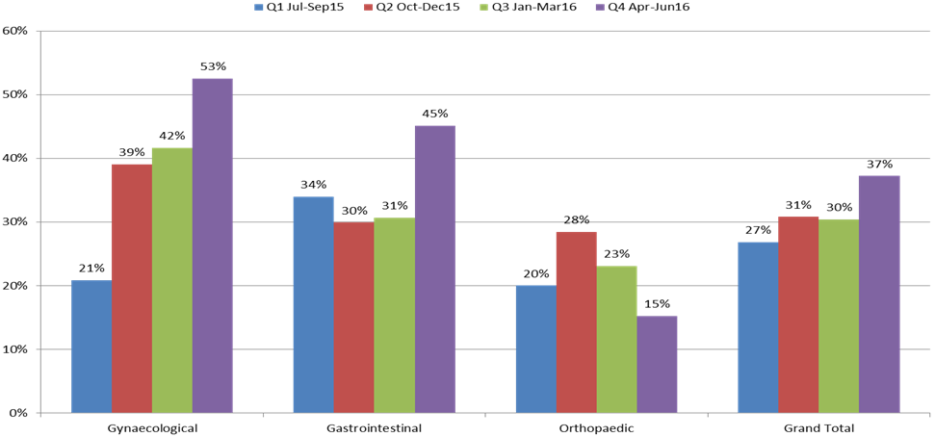

Iron deficiency

Figure 11: Percentage of patients assessed for iron deficiency by surgical stream by quarter
Recording of patient assessment for iron deficiency has improved in each surgical stream from May 2015 to July 2016. Rates are highest for patients undergoing orthopaedic surgery and lowest for those undergoing gynaecological surgery. Although recording of assessment for iron deficiency has improved in all surgical streams over the duration of the Collaborative, the overall percentage is well below 100%. This may, in part, be due to some sites only performing iron studies on patients in whom anaemia has been identified, whereas other sites perform iron studies on all patients in these surgical streams.

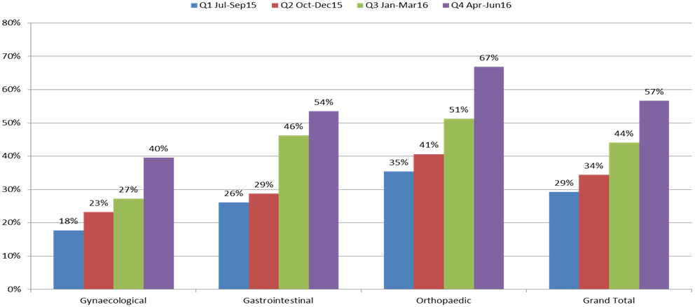

Figure 12: Percentage of patients managed for iron deficiency by surgical stream by quarter
Recorded management of patients who were diagnosed with iron deficiency does not vary greatly across surgical streams and has remained between 47% and 67% of patients per quarter from May 2015 to July 2016.

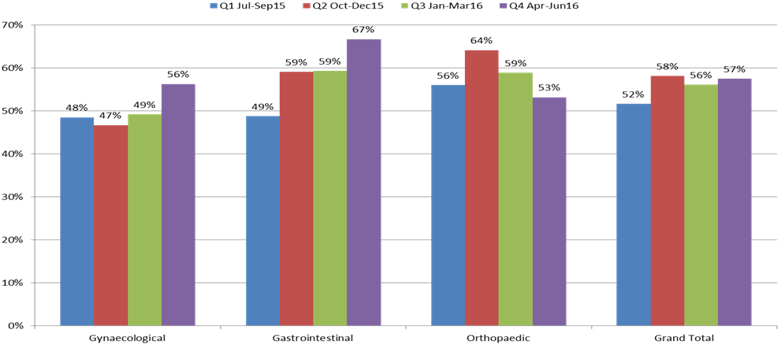

For further information:
Website: www.safetyandquality.gov.au/national-priorities/pbm-collaborative/
Email: pbmcollaborative@safetyandquality.gov.au Twitter: @ACSQHC Phone: 02 9126 3600

