**Joondalup Site Visit**

The Commission’s National Patient Blood Management (PBM) Collaborative project team undertook a site visit to Joondalup Health Campus in Western Australia in October 2016. Dr Kelly Shaw presented at Grand Rounds on Friday 14 October to promote the work of the Collaborative to date and Dr Steve Ward, Haematologist and Clinical Lead of the Joondalup Collaborative team presented on screening and managing iron deficiency.

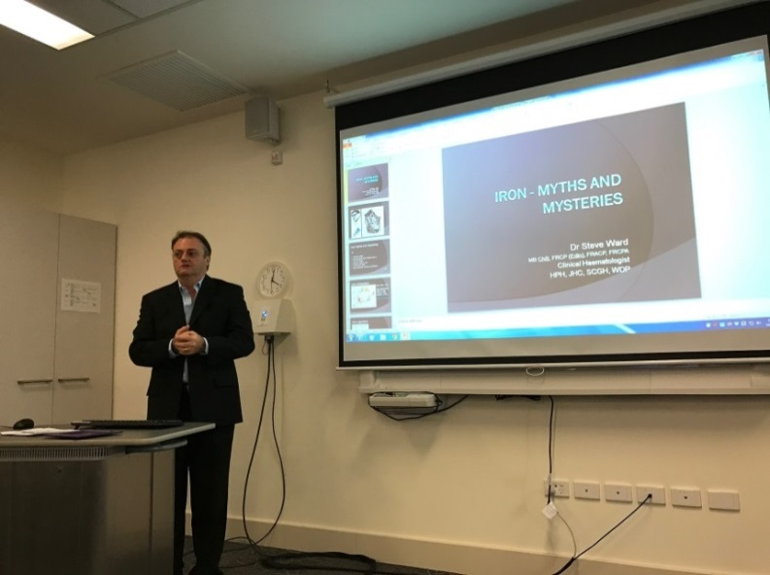

Figure Dr Steve Ward, Haematologist

Both also presented at a Study Day for GPs on Saturday 15 October 2016 where there were presentations from Linda Campbell PBM Clinical Nurse Consultant at Sir Charles Gairdner Hospital (SCGH) in Perth and Dr Pradeep Jayasuriya, a Perth GP, on the practice experience of iron infusions in primary care. In addition to GPs, primary health care nurses also attended.

**The Sir Charles Gairdner Hospital Experience**

The visit also provided an opportunity for the project team to meet Linda Campbell who has established a telephone clinic to log patients that have an intervention arranged by the PBM CNC. Although this is primarily oral or IV iron, at times patients are referred back to their own GP for follow-up of abnormal results, for example, suspected haemochromatosis. The hospital has a catchment area of >500km and through good networking and negotiation, some patients are referred to off-site health centres for IV iron rather than attending a tertiary hospital which can be a significant distance from their home. WA Health supports GP anaemia management via workshops and the use of iron infusions by GPs and preoperative anaemia management has seen significant growth in 2016. There are multiple benefits to referring patients back to their GP/Off-site for IV iron:

* GPs are treating their own patients for iron deficiency
* There is always a demand for appointments in the infusion lounge, off site referral reduces some of the demand on that area.
* IV iron close to home is convenient, as it allows patients to be dropped off and collected by family member following infusion.
* Good relationships and improved communication between the hospitals and GPs and patients. The GP is informed about pre op work up which can be educative for subsequent patients being referred for surgery, and it keeps patients informed about their own treatment and progress to surgery.

The SGCH PBM phone clinic has been established as a Tier 2 clinic for activity based funding (ABF) purposes. If you would like more information about how this funding model may be of assistance to your health service visit the links below and talk to your health service ABF team

* [Tier 2 Non-Admitted Services Compendium 2016-17 (October 2015)](https://www.ihpa.gov.au/sites/g/files/net636/f/publications/tier_2_non-admitted_services_compendium_2016-17.pdf)
* [Tier 2 Non-Admitted Services National Index 2016-17 (publication details)](https://www.ihpa.gov.au/publications/tier-2-non-admitted-services-national-index-2016-17)

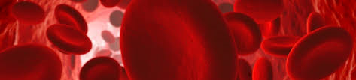**Figure 1: Total patient procedures by test by health service as at end of September 2016**

**Overview of Collaborative Activity to May 2016**

A total of 8758 patient procedures have been recorded by NPBMC sites up to September 2016. Across NPBMC sites, 8023 (92%) have a haemoglobin recorded and 3452 (39%) have iron studies recorded. Patients for whom iron studies have been recorded usually also have a haemoglobin recorded.

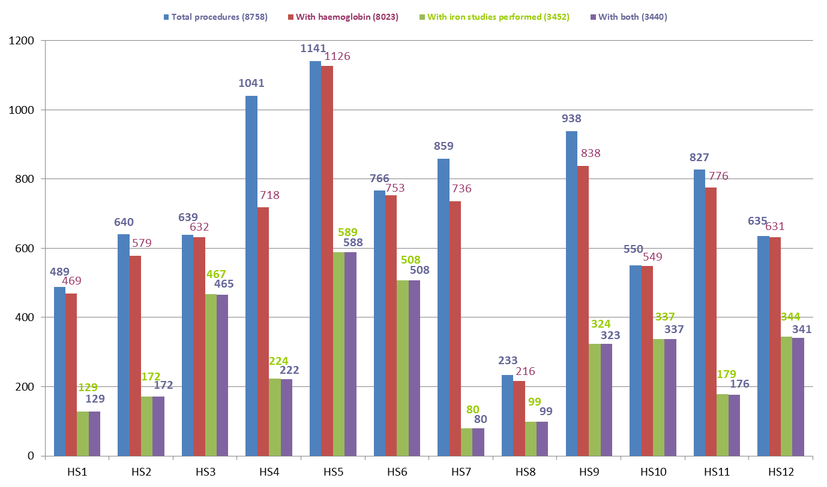

**Figure 2: Total procedures by surgical stream by health service, May 2015 to September 2016**

Ten out of 12 NPBMC sites are recording data for all three surgical streams (gastrointestinal, orthopaedic and gynaecology). The majority of procedures recorded up to the end of September 2016 were for orthopaedic surgery.

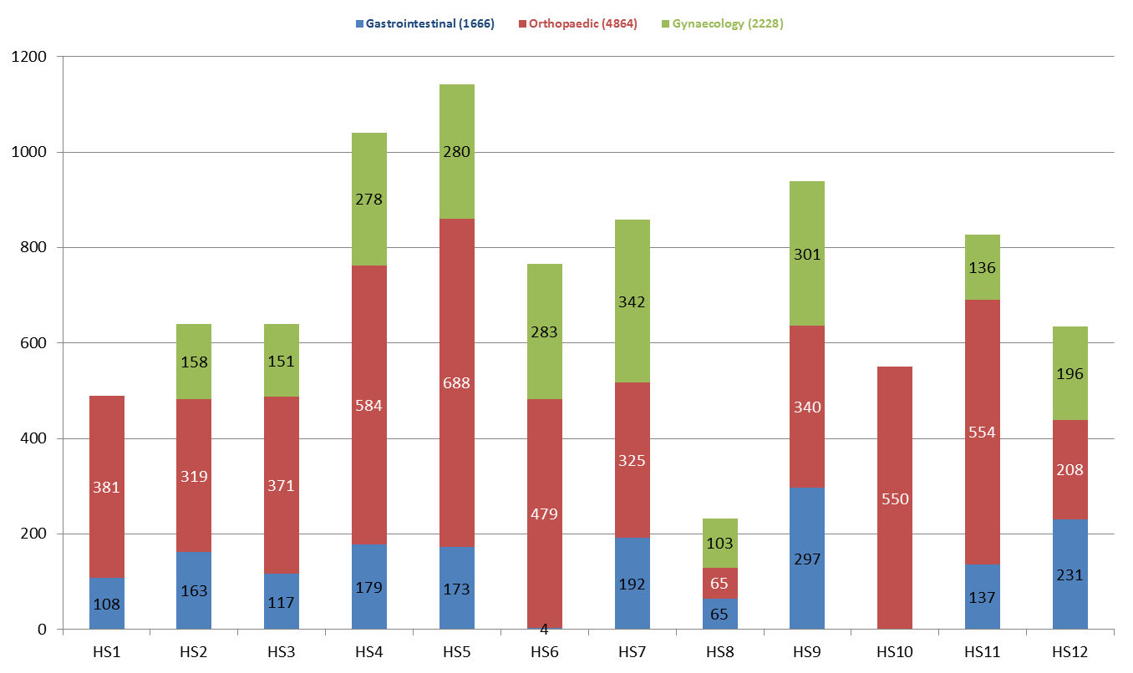

**Figure 3: Percentage of patients receiving pre-operative assessment for anaemia by health service, as at end of September 2016**

The percentage of patients in whom a pre-operative haemoglobin was recorded varied across participating NPBMC sites from 69% to 100%.

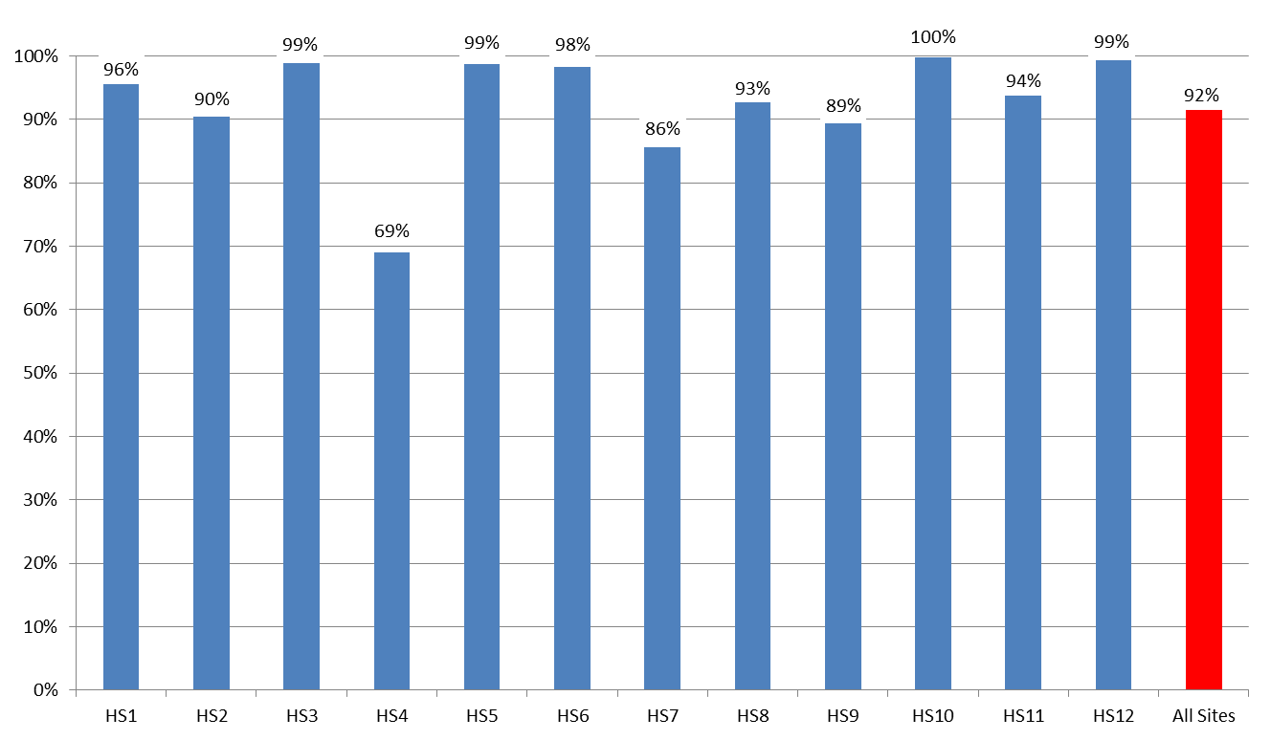

**Figure 4: Percentage of patients receiving pre-operative assessment for iron deficiency by health service, as at end of September 2016**

There was greater variability in the percentage of patients in whom pre-operative iron studies were recorded, from 9% and 72%.

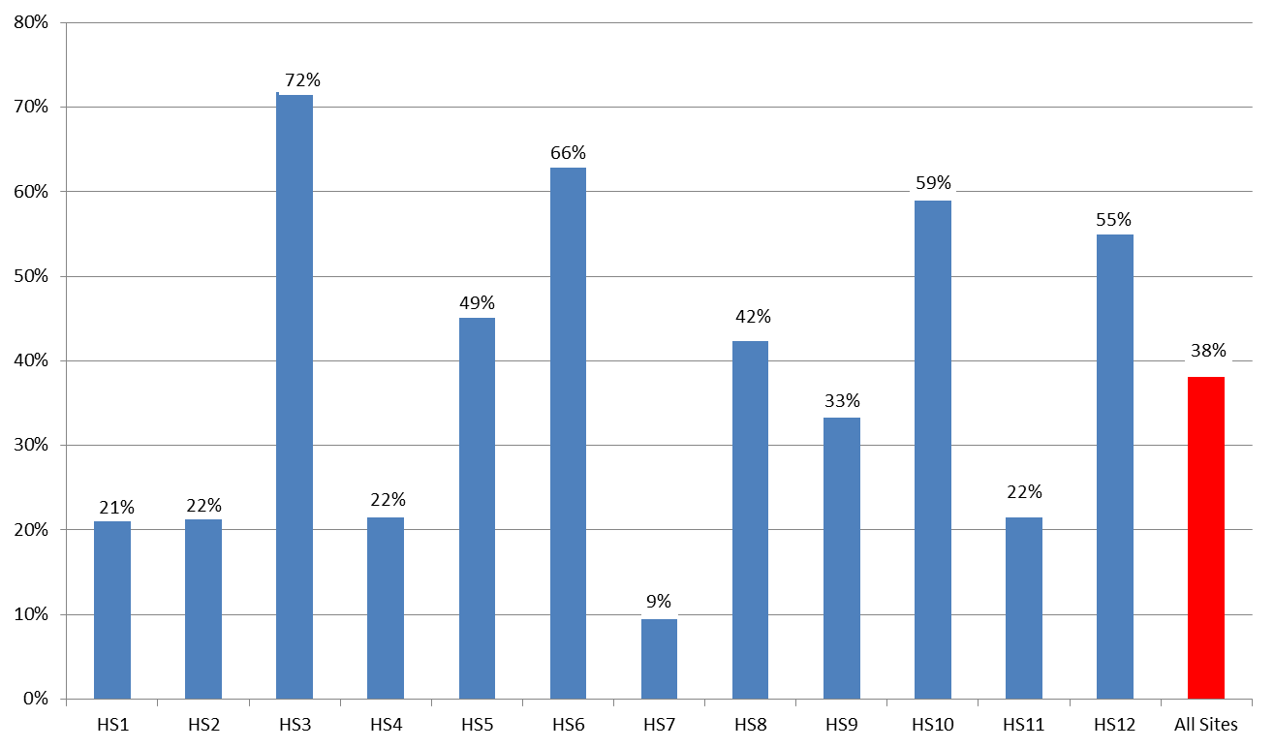

ANAEMIA

**Figure 5: Percentage of patients assessed for anaemia each month is steadily increasing**

Patients undergoing major surgical procedures are at increased risk of haemorrhage. Pre-operative assessment of the patient's haemoglobin levels assists clinicians in identifying and managing patients in whom anaemia is a risk factor for adverse surgical outcomes. The percentage of patients assessed for anaemia each month has increased over the duration of the Collaborative from 90% in May 2015 to 98% in September 2016.

This graph shows a trend line for the total percentage of patients assessed for anaemia each month has increased over the duration of the Collaborative from 90% in May 2015 to 98% in September 2016.


**Figure 6: Percentage of patients confirmed as anaemic who have been managed**

The data shows that rates of anaemia management have varied between 19% and 71% over the term of the Collaborative to September 2016.

This trendline graph shows that rates of anaemia management have varied between 19% and 71% over the term of the Collaborative to September 2016.


IRON DEFICIENCY

A patient's iron stores can be assessed safely and inexpensively with a simple blood test. Patients who undergo major surgery lose varying amounts of blood as a result of their surgery. This decreases their haemoglobin levels, which in some patients results in anaemia. Patients use their iron stores to produce haemoglobin. Knowledge of the patient's iron stores assists clinicians to identify patients who need iron replacement to support haemoglobin production post-operatively.

**Figure 7: Percentage of patients assessed for iron deficiency is increasing**

Rates of pre-operative assessment of iron deficiency have steadily increased over the duration of the Collaborative.

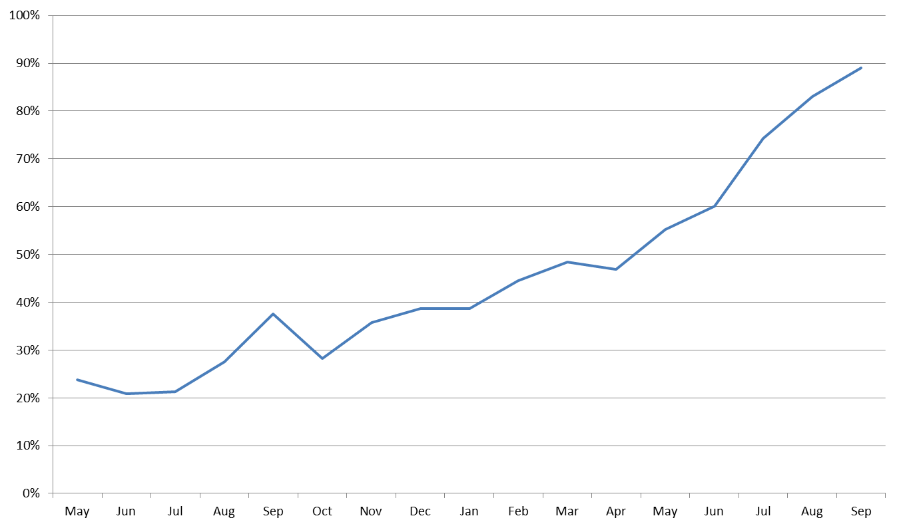

**Figure 8: Percentage of patients confirmed as iron deficient who have been managed**

The data shows that between 38% and 65% of patients were managed for iron deficiency from May 2015 to September 2016.

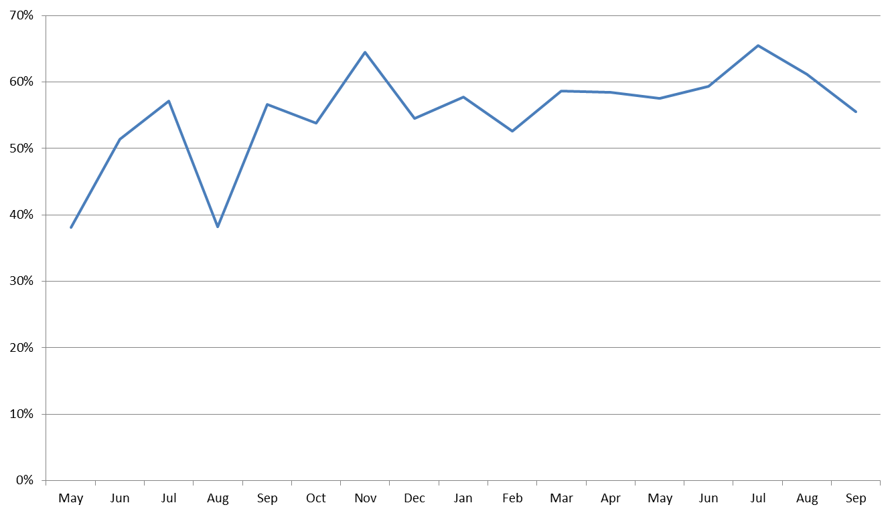

ANAEMIA

Recording of patient assessment for anaemia varies with the type of surgery; this aspect will be further assessed. Rates are highest for patients undergoing orthopaedic surgery and lowest for those undergoing gynaecological surgery. Recording of assessment for anaemia has improved in all surgical streams over the duration of the Collaborative. The target is for 100% of patients to have an assessment for anaemia recorded in their patient record.

**Figure 9: Percentage of patients who were assessed for anaemia by surgical stream by quarter**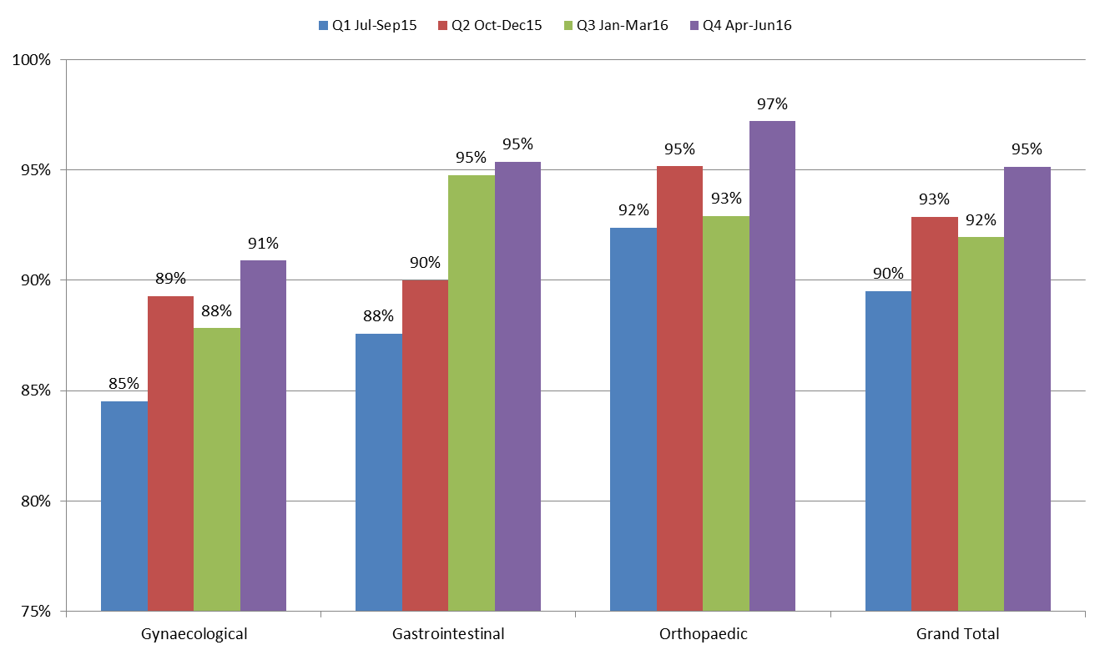

**Figure 10: Percentage of patients with anaemia who were managed by surgical stream by quarter**

Management of patients with anaemia has improved in the gynaecological and gastrointestinal surgical streams but not in the orthopaedic stream. A large percentage of patients diagnosed with anaemia in each surgical stream have no management recorded, particularly in orthopaedics, where over 81% of patients with anaemia in the last quarter had no management recorded.

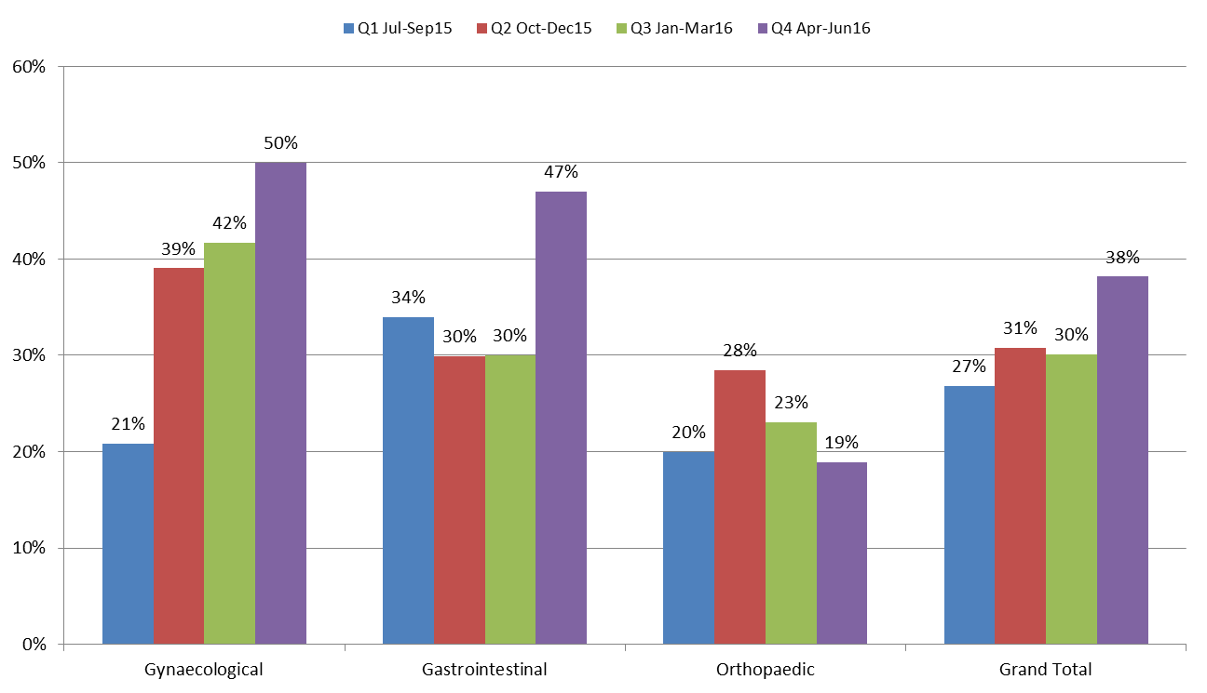

**IRON DEFICIENCY**

**Figure 11: Percentage of patients assessed for iron deficiency by surgical stream by quarter**

Recording of patient assessment for iron deficiency has improved in each surgical stream from July 2015 to September 2016.

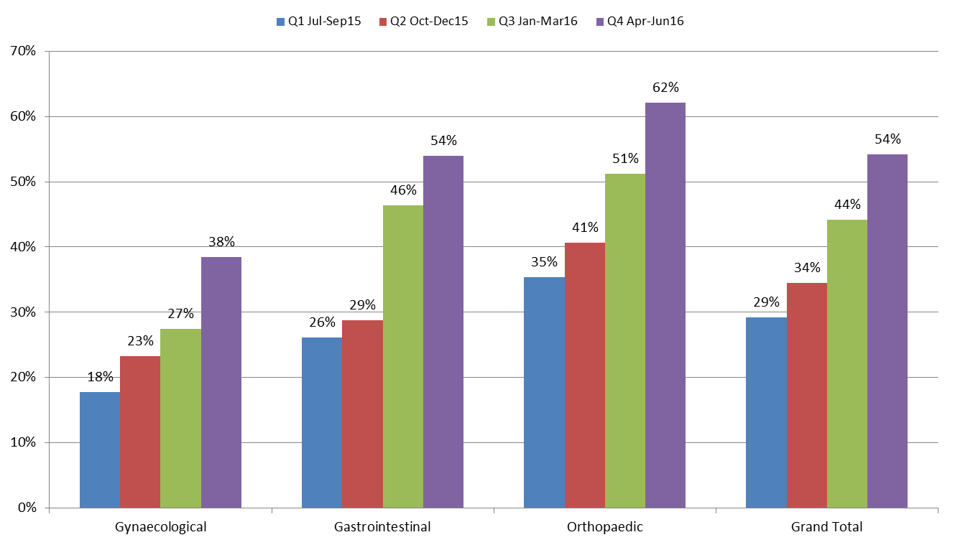

**Figure 12: Percentage of patients managed for iron deficiency by surgical stream by quarter**

Recorded management of patients who were diagnosed with iron deficiency does not vary greatly across surgical streams from July 2015 to September 2016.

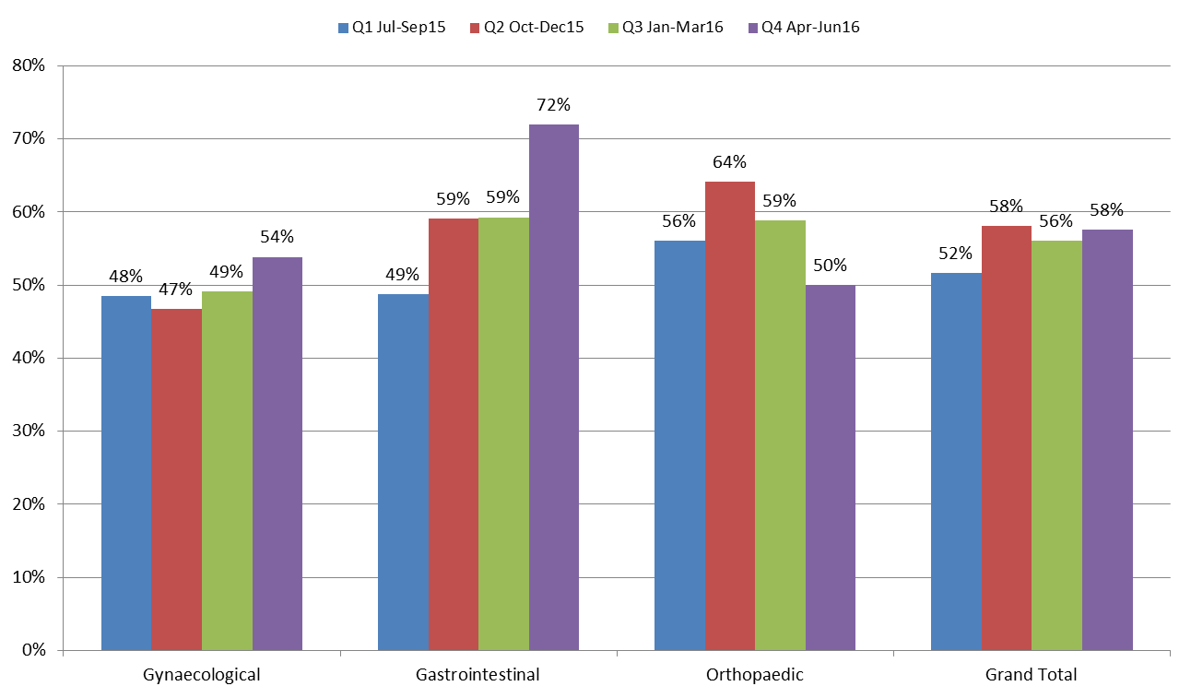

**For further information:**

**Website:** www.safetyandquality.gov.au/national-priorities/pbm-collaborative/

**Email:** pbmcollaborative@safetyandquality.gov.au **Twitter:** @ACSQHC **Phone:** 02 9126 3600