Data collection by the twelve health services for the National Patient Blood Management Collaborative (NPBMC) is now complete.

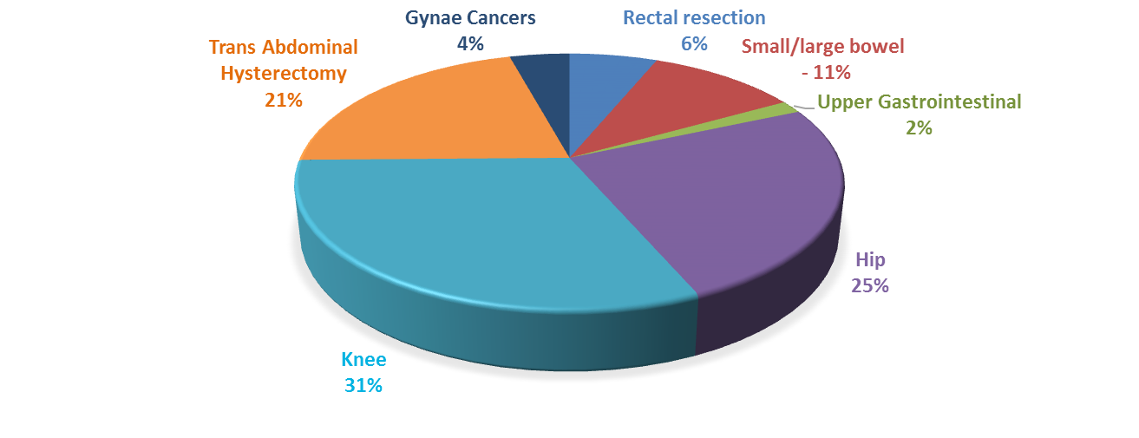

**Figure 1: Type of procedure performed**

A total of 12,648 patient episodes for the selected elective surgical procedures were collected for the NPBMC which is a great achievement by the teams. Of the total procedures, 18.4% were for gastrointestinal procedures, 56.3% for orthopaedics and 25.3% for gynaecology. The types of procedures in these categories are shown in Figure 1.

Health service teams used the Model for Improvement (MFI) framework to design and test local change ideas, and MFI cycles, (incorporating the Plan, Do, Study, Act cycle) were submitted to an online web portal for review and to monitor progress. The ideas and examples from this work may be drawn upon for future efforts to improve patient blood management and support important clinical initiatives.

A total of 384 MFI cycles were submitted during the NPBMC which is another excellent achievement by the teams. Analysis of the proportion of MFI cycles categorised by Change Principle indicates:

* 42% (163) PDSA cycles related to the first Change Principle: *Implement a systematic and proactive approach to pre-operative optimisation of haemoglobin and iron stores for patients*
* 30% (116) PDSA cycles were on the second Change Principle: *Ensure patients receive integrated and coordinated care for the assessment and management of anaemia and iron deficiency pre-operatively*
* 17% (65) of the PDSA cycles were on the third Change Principle: *Enhance knowledge of evidence based best practice in PBM*
* 10% (40) were on the foundational Change Principle: *Building and maintaining the team*.

Planning is underway for the NPBMC Showcase which will be held on Friday 2 June 2017. Health service teams will present on key achievements and share how the Collaborative made a difference to their hospital and patients; share key learnings in implementing this quality improvement process; and, provide key messages for other health services to consider when commencing a change management process for patient blood management (PBM). There will also be opportunities for interactive discussion on topics such as the importance of treating iron deficiency and anaemia and the Collaborative’s impact on PBM from primary health and hospital perspectives. Lead clinicians, project reference group members and clinical experts will be part of these sessions.

**Outcomes of the Collaborative included:**

* **Improved assessment and management of anaemia and iron deficiency across participating sites**
* **Improved integration of care between primary and acute service systems**
* **Reduced red cell transfusions for both patients and number of units.**

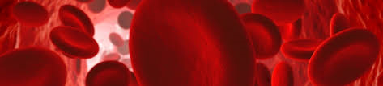**Figure 1: Total patient procedures by test, by health service, as at end of March 2017**

**Overview of Collaborative Activity to May 2016**

A total of 12,648 patient procedures had been recorded by NPBMC sites by at the end of March 2017. Across NPBMC sites, a haemoglobin level was recorded for 11,584 procedures (91%), and 5809 procedures (46%) were accompanied by iron studies. Patients for whom iron studies had been recorded usually also had a haemoglobin level recorded.

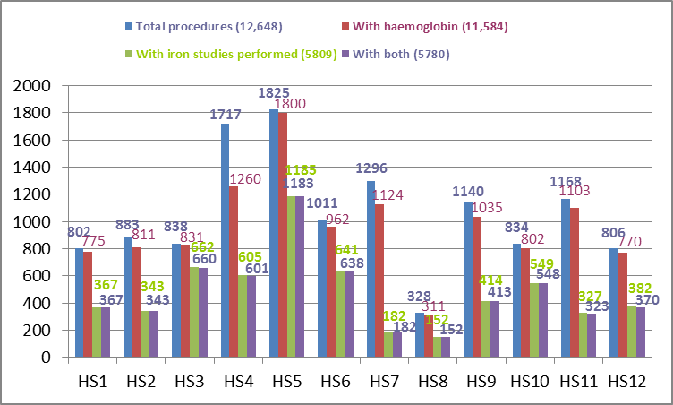

**Figure 2: Total procedures by surgical stream, by health service, as at end of March 2017**

Ten out of 12 NPBMC sites recorded data for all three surgical streams (gastrointestinal, orthopaedic and gynaecology). The majority of procedures recorded up to the end of March 2017 were for orthopaedic surgery.

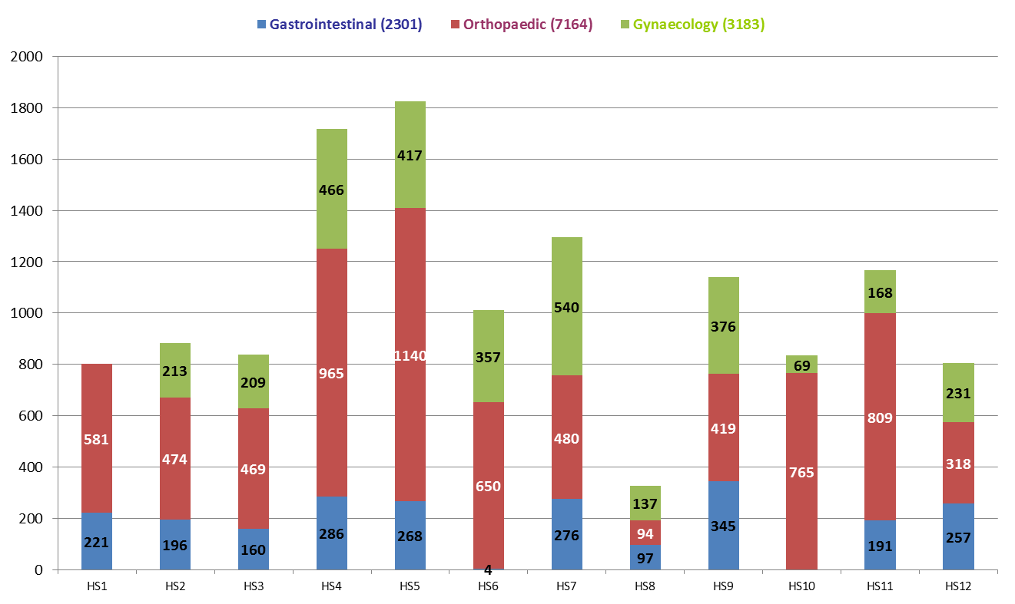

**Figure 3: Percentage of patients receiving pre-operative assessment for anaemia, by health service, as at end of March 2017**

The percentage of patients in whom a pre-operative haemoglobin level had been recorded varied across participating NPBMC sites from 73% to 99%.

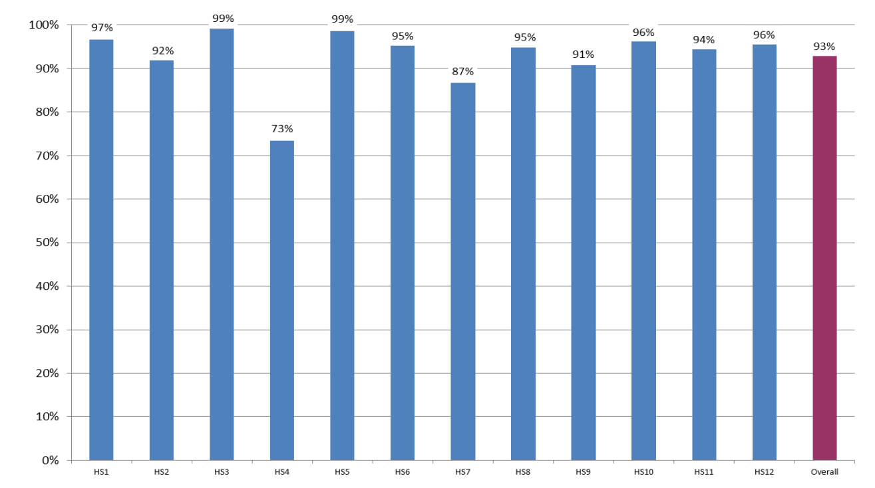

**Figure 4: Percentage of patients receiving pre-operative assessment for iron deficiency, by health service, as at end of March 2017**

There was greater variability in the percentage of patients who were recorded as having pre-operative iron studies, from 14% to 79%. This high variation is currently under examination as there is a need to increase provision of pre-operative iron studies in order to determine whether an intervention may be required to promote better patient care.

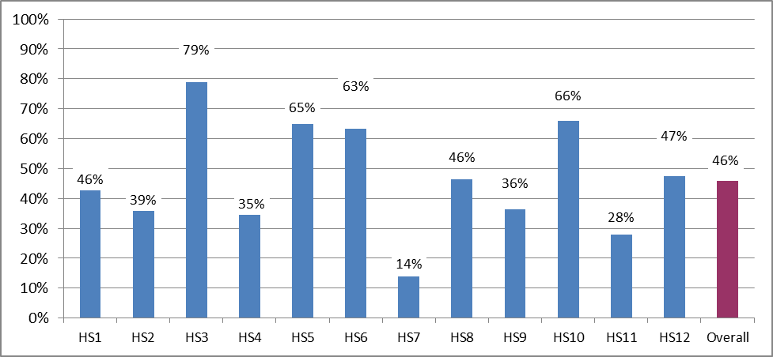

ANAEMIA

**Figure 5: Percentage of patients assessed for anaemia, by month, to March 2017**

Patients undergoing major surgical procedures are at increased risk of haemorrhage. Pre-operative assessment of patients’ haemoglobin levels assists clinicians to identify and manage patients in whom anaemia is a risk factor for adverse surgical outcomes. The actual percentage of patients assessed for anaemia was just under 90% in May 2015 and nearly 99% in March 2017. The average is a truer figure, which sits at 88% in May 2015 and 95% in March 2017.

This figure shows the actual percentage of patients assessed for anaemia was just under 90% in May 2015 and nearly 99% in March 2017. The average is a truer figure, which sits at 88% in May 2015 and 95% in March 2017. 


**Figure 6: Percentage of patients managed for anaemia, by month, to March 2017**

Data shows that rates of anaemia management have varied between 23% to just over 40% over the life of the Collaborative. This jumps up to 60% in January 2017. The average is more representative and sits at 22% in May 2015 and 49% in March 2017. *Note: Insufficient data received in March 2017 to continue trend.*

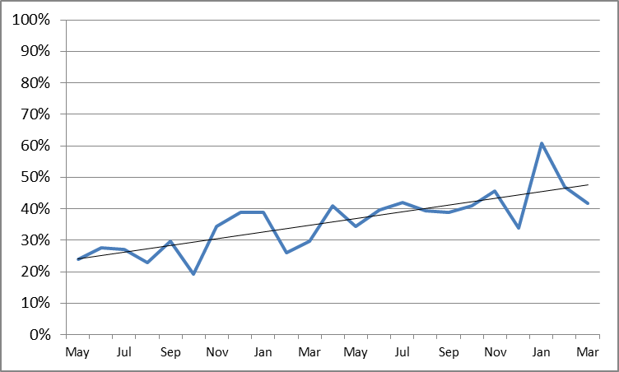

IRON DEFICIENCY

A patient’s iron stores can be assessed safely and inexpensively with a simple blood test. Patients who undergo major surgery may lose varying amounts of blood as a result of their surgery. Blood loss can decrease haemoglobin levels, which for some patients results in anaemia. Knowledge of the patient's iron stores assists clinicians to identify patients who need iron replacement to support haemoglobin production post-operatively.

**Figure 7: Percentage of patients assessed for iron deficiency, by month, May 2015 to March 2017**

Actual rates of pre-operative assessment of iron deficiency have greatly increased, from 22% in May 2015 to 74% in March 2017. Although variation occurs in the early months of 2017 due to low numbers being entered into qiConnect, these figures remain close to the average over that time.

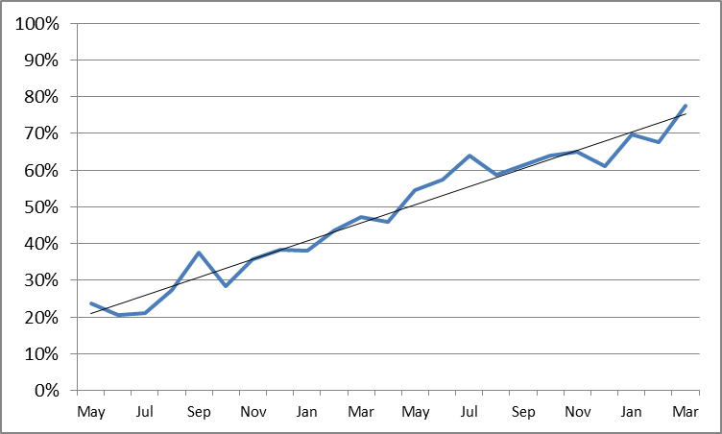

**Figure 8: Percentage of patients managed for iron deficiency, by month, May 2015 to March 2017**

Data shows an increase from 40% to just over 60% of patients managed for iron deficiency between May 2015 and March 2017. Variation occurs in the early months of 2017 due to low numbers being entered into the web portal. An average of 49% in May 2015 and 71% in March 2017 are more representative figures.This figure shows an increase from 40% to just over 60% of patients managed for iron deficiency between May 2015 and March 2017. 


ANAEMIA

Recording of patient assessment for anaemia varies with the type of surgery; this aspect of recording will be further assessed. Rates are highest for patients undergoing orthopaedic surgery and lowest for those undergoing gynaecological surgery. Recording of assessment for anaemia has improved in all surgical streams over the duration of the Collaborative.

**Figure 9: Percentage of patients assessed for anaemia, by surgical stream, by quarter**

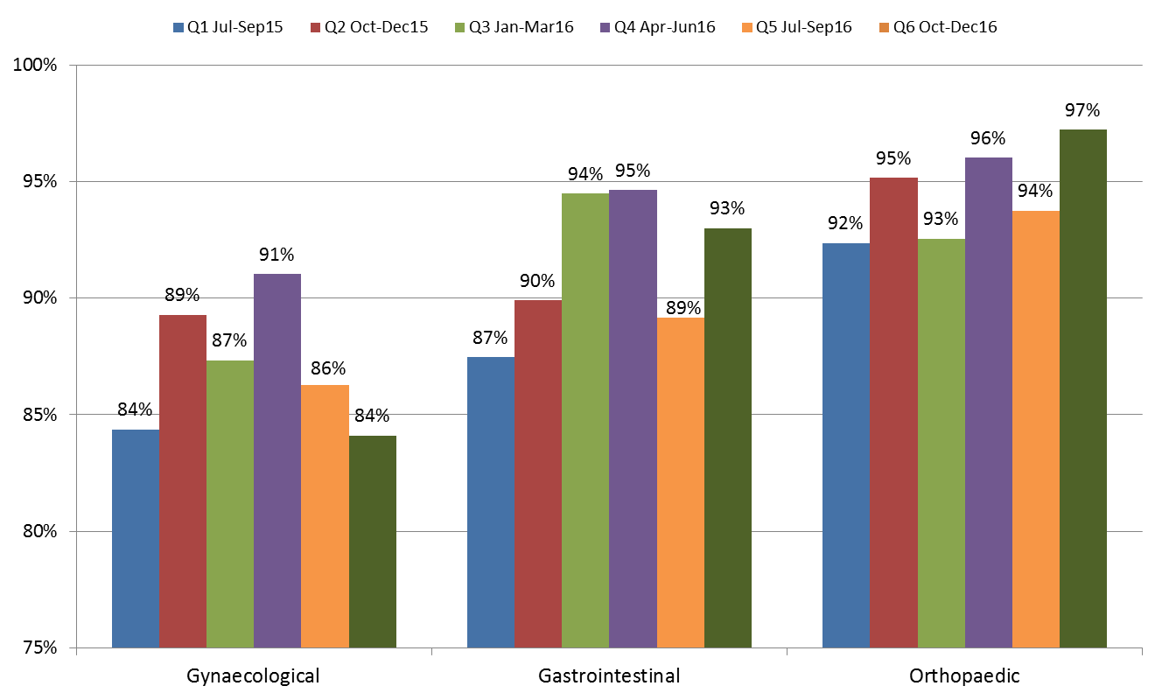

**Figure 10: Percentage of patients managed for anaemia by surgical stream, by quarter**

Management of patients with anaemia has improved in the gynaecological and gastrointestinal surgical streams but not in the orthopaedic stream. An area for attention has been highlighted - a large percentage of patients diagnosed with anaemia in each surgical stream have no management recorded, particularly in orthopaedics.

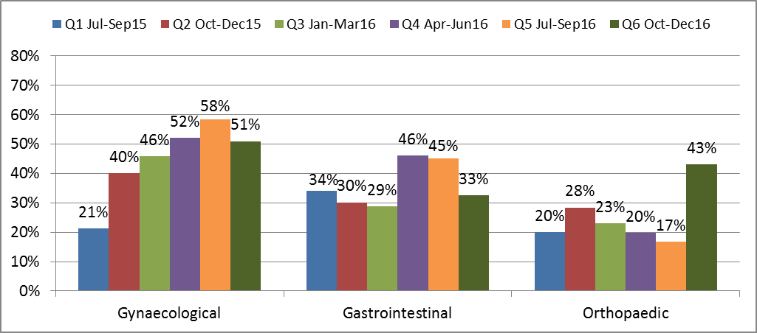

**IRON DEFICIENCY**

**Figure 11: Percentage of patients assessed for iron deficiency, by surgical stream, by quarter**

Recording of patient assessment for iron deficiency has improved in each surgical stream from July 2015 to December 2016.

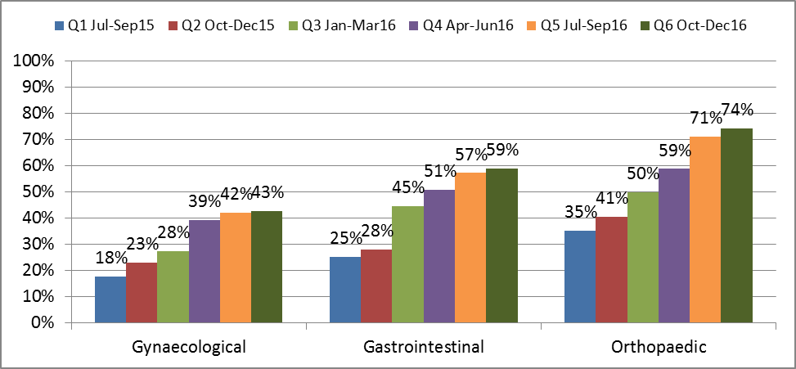

**Figure 12: Percentage of patients who were managed for iron deficiency by surgical stream, by quarter**

Recorded management of patients who were diagnosed with iron deficiency does not vary greatly across surgical streams from July 2015 to December 2016, except for gynaecology, which has recorded an increase in the most recent quarter.

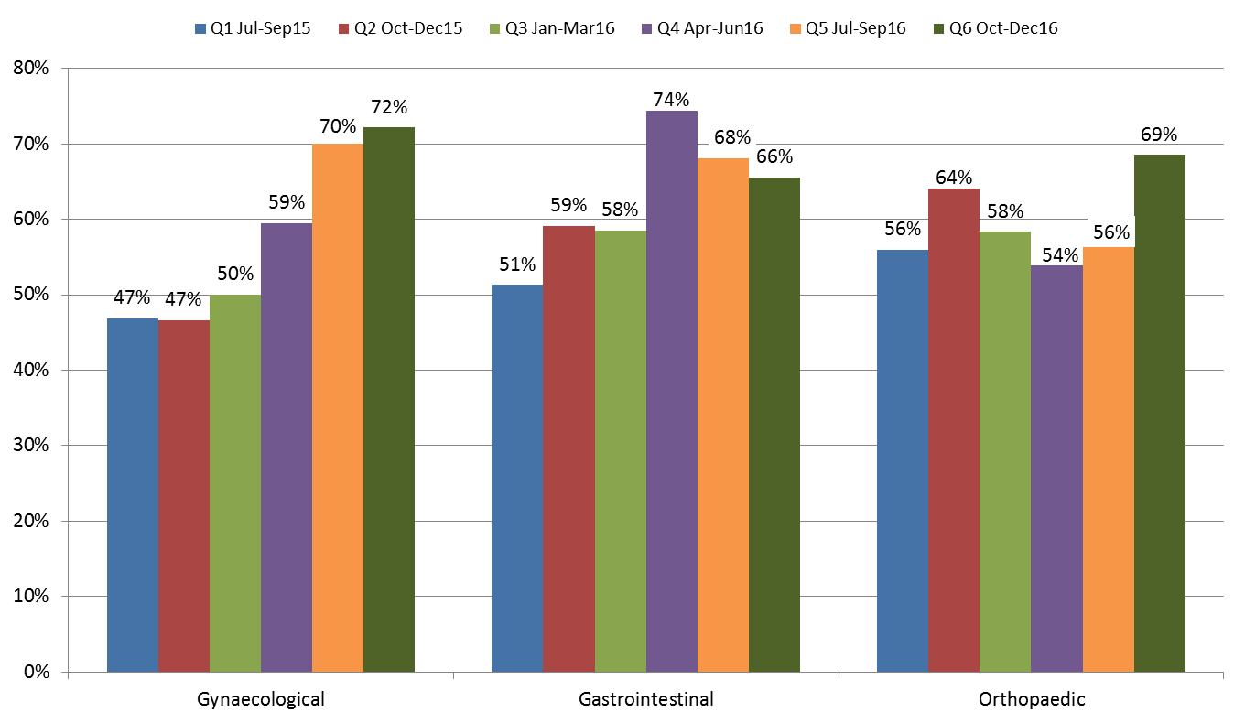

**Figure 13: Number of patients who received transfusions, and number of units transfused, by month, May 2015 to February 2017**

Collaborative data shows a steady reduction in the number of patients who received transfusions, as well as the number of units transfused. Variation occurs in the early months of 2017 due to low numbers being entered into qiConnect.

**Collaborative data shows a steady reduction in the number of patients who received transfusions, as well as the number of units transfused. Variation occurs in the early months of 2017 due to low numbers being entered into qiConnect.
**

**For further information:**

**Website:** www.safetyandquality.gov.au/national-priorities/pbm-collaborative/

**Email:** pbmcollaborative@safetyandquality.gov.au **Twitter:** @ACSQHC **Phone:** 02 9126 3600