The **National Patient Blood Management Collaborative** focuses on improving the management of anaemia for patients having elective surgery in the surgical areas of: gastrointestinal, gynaecological and orthopaedics. The Collaborative, funded by the Commonwealth Department of Health, started in April 2015 with 12 participating health services from across Australia and will run to April 2017. The Collaborative will support improvements in the management of anaemia for elective surgery patients. It encompasses the patient journey from the time that the need for surgery is identified, through inpatient care, and then subsequent care back in the community.

# **Canberra Iron Symposium - 30 April 2016**

The Canberra Hospital and Health Service in collaboration with the Australian Red Cross Blood Service convened the ‘Iron Symposium from Primary to Tertiary Care’ to build on knowledge of transfusion practice and blood management through presentations and discussions around national evidence-based PBM guidelines. PBM may be needed across the whole of the clinical patient spectrum. Safe and appropriate practice is essential to ensure the best patient outcome. Sound knowledge, from a strategic practical approach to management are essential. The Symposium was convened to equip the target audience of GPs, Obstetricians, and Nurses and Midwives with strategies to manage anaemia and transfusion issues. Sessions included iron deficiency causes, prevalence and impact, investigation of iron deficiency, iron deficiency in the perioperative settings and iron deficiency in general practice. Presenters included the Canberra Project Coordinator, Maria Burgess and Lead Clinician Dr Philip Crispin. The Symposium was interactive, well attended with over 120 registrations and was a great success. [Resources from the day are available online.](http://resources.transfusion.com.au/cdm/search/searchterm/Practice%20improvement%20tool!Canberra/field/type!descri/mode/all!all/conn/and!and/order/nosort)

# **Site Visit to North Coast - 11 May 2016**

Kathy Meleady and Dr Kelly Shaw visited the Lismore Hospital on 11 May 2016. The visit also included meeting with the St Vincent’s Private Hospital which are collecting data as part of the NPBMC network. A meeting with the Primary Health Network discussed the Collaborative, anaemia, iron deficiency, the role of general practice in PBM patient care, and improved linkages between the LHD and PHN to optimise patient’s blood prior to surgery. There was also a presentation to Medical Heads of Department and Junior Medical Officers, providing a national overview as well as promoting the work being done locally. For example the development of resources including the Flow Chart - When to administer a pre-operative iron infusion, Blue Form - Bed Management, Fax - Perioperative Iron infusion, PBM Pre-Op Assessment Form for Notes, GP Letter, Iron Carboxymaltose Infusion Chart for GPs, Pre-operative Anaemia Article in GP Speak. It is hoped the visit encourages broader participation in the PDSA process to implement positive change.

# **Site Visit to Royal Darwin Hospital - 16 May 2016**

Kathy and Kelly next visited Darwin to present the national overview to 40 clinicians at Grand Rounds which included presentations from Executive Sponsor, Dr Brian Spain and Julie Domanski, Project Coordinator. Ms Domanski presented on work progressing to date, and resources including Fit for Surgery Letter to Patients; Fit For Surgery Poster for Clinical Staff and for Patients; NPBMC Information Sheet and Letter to GPs; PBM Letter to Darwin Private Hospital Surgeons; PBM Letter to Surgeons; PBM Pathology Request; Pre-operative Anaemia Screening Pathway; Pre-operative Anaemia Screening Tool; Pre-operative Screening List; and Pre-operative Screening OPD Pathway. The visit also included discussion with the local Collaborative team on future PDSAs and the Outpatient’s staff.

# **Overview of Collaborative Activity to May 2016**

As at 31 May 2016 the Collaborative health service teams have collected data on over **6,600 patient episodes** consisting of 19% gastrointestinal, 25% gynaecological and 56% orthopaedic elective surgical procedures. Of the total procedures 91% received a haemoglobin test, 34% had iron studies and 34% had both. Across the sites pre-surgical assessment of patients for anaemia ranged from 65% to 100% and for iron studies the range was 9% to 65%.

**Figure 1: Total patient procedures by test by health service, May 2015 to May 2016**

Graph shows total procedures, procedures with haemoglobin testing, procedures with iron studies performed, and procedures with both tests performed.

**Figure 2: Total procedures by surgical stream by health service, May 2015 to May 2016**

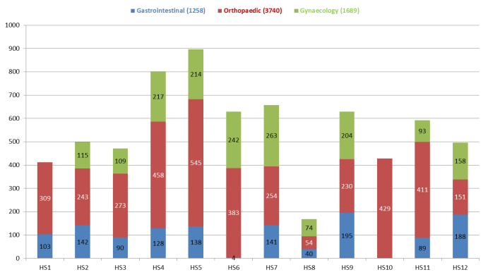

*Note: Not all Collaborative health services are participating in all three surgical areas, with some collecting data for only one or two.*

# **Overview of Collaborative Activity to May 2016 continued**

**Figure 3: Percentage of patients receiving pre-operative assessment for anaemia by health service as at end of May 2016**

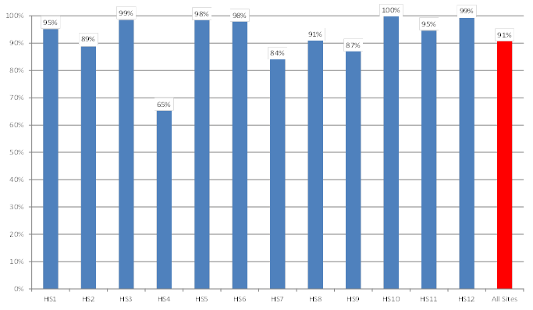

*Note: For some teams there is a lag in receiving coded data - percentages will improve as more data becomes available.*

**Figure 4: Percentage of patients receiving pre-operative assessment for anaemia per month, May 2015 to May 2016**

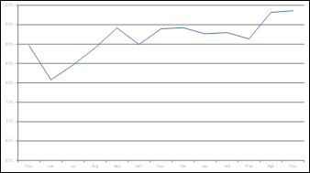

**Figure 5: Percentage of patients receiving pre-operative assessment for iron deficiency per month, May 2015 to May 2016**

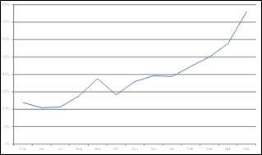

# ****Collaborative Project Coordinator Wins Hesta Nurse of the Year Award for 2016****

**Joondalup’s Project Coordinator, Angie Monk, who developed a leading Blood Management Program for patients undergoing major surgery, was named Nurse of the Year at the 2016 HESTA Australian Nursing Awards in May 2016. An extract from the Hesta Press Release is below:**

**“A Blood Management Consultant at Ramsay Health Care’s Joondalup Campus, Ms Monk was recognised for her advocacy and leadership in developing the innovative program that improved outcomes and recovery for patients undergoing surgery involving significant blood loss. She also consults on blood management to the Glengarry and Attadale Rehabilitation Hospitals.**

**The first Blood Management Consultant to be appointed to the WA private sector, the judges recognised the leading role Angie has played in advocating for improved practices and her instrumental role in delivering extensive education and training to colleagues and other health professionals. The award is another accolade for Ms Monk in a distinguished 40-year career in nursing and midwifery that has seen her nationally recognised as a true pioneer in her field.**

**Ms Monk paid tribute to her fellow nursing finalists saying: “We’re all nurses working across a range of different areas but we all provide care and we can and do make a difference, we’re the backbone of the health care service,” she said. “Over 40 years of nursing I’ve never had one day that I regretted being a nurse and midwife, it’s been an honour to work with patients and to provide best practice care.”**

**Ms Monk described blood management as an ‘emerging paradigm of healthcare’, saying health professionals were continuing to find new ways to improve patient outcomes by screening and treating iron deficiency pre-operatively. “It is vital to reduce patient’s exposures to blood products because it had been shown that blood transfusions are an independent risk of morbidity and mortality,” she said. “It’s also very important to use blood efficiently because we have a growing demand for blood products and a diminishing number of donors and a Patient Blood Management Program reduces the need for transfusions.”**

**Her ground-breaking work includes developing a range of innovative initiatives to ensure that patients are also better prepared for major surgery involving potential large blood loss. HESTA CEO, Debby Blakey said Angie exemplified the finest qualities of the nursing profession, and was an innovator and leader in her chosen field of expertise. “Angie stood out for being instrumental in leading innovation and improved practices that provide the highest quality care to patients,” Ms Blakey said. “We congratulate Angie on her achievement and we’re proud that her life-changing work has received the national acknowledgement and recognition that it so richly deserves.”**

**Congratulations Angie! It is fantastic news and it is great to have you, and other dedicated clinicians devoted to improving patient care, on the NPBM Collaborative team**

# ****Shared Resources and Evaluation****

**The Commission Project Team will meet with the National Blood Authority to examine ways to more broadly disseminate the resources prepared by Collaborative teams to promote improvements for non-participating hospitals.**

**The Commission has engaged KP Health to provide the technical expertise to undertake the evaluation and business case for the Department of Health, which will provide the basis for considering next steps. Outcomes from the Collaborative will be evaluated utilising data and information of successful change in practice to improve PBM, obtained through the Collaborative as well as other literature and reports.**