

National Standard for User-applied Labelling of Injectable Medicines, Fluids and Lines
  - Audit tool user guide

© Commonwealth of Australia 2016
This work is copyright. It may be reproduced in whole or in part for study or training purposes subject to the inclusion of an acknowledgement of the source. Requests and inquiries concerning reproduction and rights for purposes other than those indicated above requires the written permission of the Australian Commission on Safety and Quality in Health Care, GPO Box 5480, Sydney, NSW 2001 or mail@safetyandquality.gov.au
ISBN 978-1-925224-54-2 (online)
Suggested citation
Australian Commission on Safety and Quality in Health Care. National Standard for User-applied Labelling of Injectable Medicines, Fluids and Lines: audit tool user guide. Sydney: ACSQHC, 2016.
Acknowledgement
The Commission wishes to acknowledge WA Health, SA Health and the Victorian Therapeutic Advisory Group Quality Use of Medicines Group for initial development of audit tools for user-applied labelling. The involvement and willingness of all concerned to share their experience and expertise is greatly appreciated.
The National Standard for User-applied Labelling of Injectable Medicines, Fluids and Lines: audit tool user guide, and other materials that support the National Standard for User-applied Labelling of Injectable Medicines, Fluids and Lines (Labelling Standard) are available on the Commission website at www.safetyandquality.gov.au.

Contents
Contents iii
Introduction 1
Audit scope 2
Sample selection 2
Audit inclusions 3
Audit exclusions 3
Data collection 4
Data collection forms 4
Suggested data collection methodology 4
‘In place’ audit 5
Preparation observed audit 5
Data collection items: all wards 6
Patient information 6
Container labelling 6
Section A Bags, bottles, syringe infusions and boluses 6
Section B Bags and bottles 8
Section C Syringe infusions or boluses 8
Conduit labelling 9
Section D Administration lines and catheters 9
Section E Burettes 10
Section F Locked catheters 11
Section G Sodium chloride flush 11
Additional data collection items: open-practice environment – intensive 12
Section H Invasive monitoring lines 12
Additional data collection items: closed-practice environment 12
Section I Sterile field containers 12
Electronic data entry 13
Demographic data 13
Data entry 13
References 15
Appendix 1 Data collection forms 16
Appendix 2 Data entry form 23

Introduction
The National Standard for User-applied Labelling of Injectable Medicines, Fluids and Lines (the Labelling Standard)¹ sets out the minimum requirements for labelling medicines and fluids that have been removed from their original packaging. Health services seeking accreditation under the Australian Health Service Safety and Quality Accreditation scheme are required to provide evidence of Labelling Standard implementation.
Implementing relevant action items in the National Safety and Quality Health Service (NSQHS) Standards² will assist clinicians to safely prescribe, dispense and administer injectable medicines. Implementation of the Labelling Standard, as part of Medication Safety Standard 4, is a mandatory requirement for meeting the NSQHS Standards.
Health services seeking accreditation are required to undertake regular assessments of injectable medicines management procedures in all clinical areas to identify risks and take action to reduce these risks. This audit tool user guide is for use by people conducting an audit of compliance with the Labelling Standard in healthcare facilities. It is accompanied by Microsoft Excel spreadsheets for data collection and data entry. Sample sizes for each area are indicated, as well as definitions for each hospital type. Detailed information about data collection and entry is also provided.

Audit scope

Sample selection
A random sample of inpatients should be selected from each clinical area, as detailed in Table 1. At least one ward/unit of each type should be included if there are multiple wards/units within the inclusion list. Where possible, include one or more closed-practice environments, such as endoscopy, radiology, operating room and cardiac catheter laboratory. An audit should be conducted at each hospital where there are multiple hospitals within a network.
To reduce the risk of an individual staff member’s practices affecting data, it is recommended that patients under the care of different staff members are included in the audit.
Table 1 Sample sizes and data collection form by clinical area
Clinical area | Target sample size  (no. of patients)ª | Data collection form
Medical ward (including subacute) | 6 | Open-practice environment
Surgical ward | 6 | Open-practice environment
Paediatric ward | 6 | Open-practice environment
Emergency department | 6 | Open-practice environment: intensive
Intensive care unit | 4 | Open-practice environment: Intensive
Operating theatre | 6 | Closed-practice environment
Recovery room | 6 | Open-practice environment
Day treatment unit (including oncology) | 6 | Open-practice environment
Palliative care | 4 | Open-practice environment
Endoscopy suite | 4 | Closed-practice environment
Radiology | 4 | Closed-practice environment
Delivery suite | 4 | Open-practice environment
Cardiac catheter laboratory | 4 | Closed-practice environment
Neonatal intensive care unit | 4 | Open-practice environment: Intensive
Special care nursery | 4 | Open-practice environment
a Suggested target to be adjusted according to size of health facility

Audit inclusions
Two types of data collection should be undertaken in this audit:
‘in place’ data of containers and conduits (burettes and administration lines) that are already attached to patients and have associated user-applied labelling evident at that point in time
‘preparation observed’ data of containers, syringes and sodium chloride flushes, which is captured during preparation and administration.
The following inclusions apply:
medicines administered via all parenteral routes, including subcutaneous and intramuscular administration
administration lines for items excluded from audit (e.g. prefilled syringes and fluid bags)
- in the perioperative area
- labelling of the container of any medicine or fluid on the perioperative sterile field
labelling of the container of any medicine or fluid not administered via a syringe for the purposes of anaesthesia (see exclusions below).
If the data collection team identifies any errors during the data collection that have the potential to cause patient harm, the team should immediately notify the patient’s treating nurse and record the incident according to the hospital’s incident reporting procedure.

Audit exclusions
The following situations are excluded from the audit:
preparation and administration of a SINGLE medicine in one uninterrupted process, where the syringe does not leave the hands of the person who prepared it and that same person administers the medicine immediately, including syringes drawn up for immediate emergency use
injectable medicines drawn up in syringes for use during anaesthesia; these should comply with International Standard ISO 26825:2008 (the Anaesthetic Labelling Standard)³
fluid bags and bottles for infusion where no additional medicines are added – this includes intravenous fluids (e.g. 0.9% sodium chloride), premixed infusions (e.g. potassium, heparin) and peritoneal dialysis fluids. Unlabelled bags or bottles identified during the ‘in place’ data collection are assumed to not require labelling. Burettes are assumed to not contain additives if unlabelled at the time of viewing
labelling of infusion pumps, syringe drivers, etc.
syringes prefilled for bolus use and infusions labelled by external manufacturers or hospital pharmacy departments.

Data collection

Data collection forms
Three Excel spreadsheets are available for data collection (see Appendix 1): ‘Open-practice environment’, ‘Open-practice: Intensive’ and ‘Closed-practice environment’ (see Table 1 for each applicable area). Each is divided into sections as follows:
Section A – Bags, bottles, syringe infusions and boluses
Section B – Bags and bottles
Section C – Syringe infusions or boluses
Section D – Administration lines and catheters
Section E – Burettes
Section F – Locked catheters
Section G – Sodium chloride flush.
The ‘Open-practice: intensive’ form includes Sections A–G, plus an additional Section H – Invasive monitoring lines. The ‘Closed-practice environment’ form includes Sections A–H, plus an additional Section I – Sterile field containers. The forms are designed to be printed as duplex (double-sided). Each form allows data collection of ‘in place’ containers and conduits, and ‘preparation observed’ data.
Where possible, it is recommended that the preparation of items requiring labelling is captured. This will be the only available data for syringe boluses and flushes. When preparation is not able to be observed, such as an infusion already running, it will only be possible to collect ‘in place’ data.
One data collection form should be allocated per patient. Multiple data points for each container and conduit may be completed in the one form. Each item requiring labelling is one data point. For example, a system containing a bag (with additives) and a line is considered as two separate data points. The audit team should only complete the areas of the data collection form that apply to the items requiring labelling for each patient.
Multiple forms can be used if an individual patient has conduits, containers and syringe boluses in excess of the recording space on one form.

Suggested data collection methodology
For general ward areas, including medical, surgical, day units and palliative care, it is estimated that the data collection for two ward areas will take up to one day. The methodology below is to assist with efficient data collection. When one data point is captured for the patient, check the patient for other containers and lines (including invasive monitoring lines) and include them in data collection.
The following are suggested steps for planning data collection:
1. Print multiple copies of the double-sided data collection form applicable to the area in which data will be collected. Alternatively, for facilities that are able to capture data directly, create and name multiple electronic data collection forms in folders according to ward and clinical area.
2. Select one ward within this area to audit at a time.
3. Review the medication charts when arriving in the ward to determine which patients will be receiving injectable medicines and the time when they will be administered. It may be practical to review the charts in two ward areas initially, to maximise data collection in the allocated time.
4. Devise a timetable for viewing the preparation of additives on the wards.

‘In place’ audit
This part of the audit can be completed while viewing the charts in step 3, above. Examples of the injectable systems that may be seen when conducting the ‘in place’ audit and which parts of the form to complete are shown in Table 2.
Table 2 Examples of ‘in place’ audit data collection
Injectable system | Container labelling | Conduit labelling
Bag or bottle with additive | Complete Sections A and B | An administration line will be used; complete Section D
Syringe infusion | Complete Sections A and C | An administration line will be used; complete Section D
Burette | Not required | Complete Section E
Locked catheter | Not required | Complete Section F
Sodium chloride flush | Not required | Complete Section G
Invasive monitoring line | Not required | Complete Section H
Sterile field containers | Complete Section I | Not required

Preparation observed audit
When prioritising which injectables to observe, the first priority should be bolus syringes. The second priority should be bags/bottles with additives, syringe infusions and burettes. Complete the following steps:
Select a patient who will receive an injectable medicine that requires preparation by a nurse.
Continuously observe the labelling practice of the nurse from the time the medications are prepared to the time they are administered to the patient.
If the product is a syringe bolus, complete Sections A and C. If an administration line is used, complete Section D. If a sodium chloride flush is used, complete Section G.
If a syringe bolus is not observed during preparation, but it is labelled and included in the audit (e.g. observed administered only, or in a kidney dish waiting to be administered), this should be classified as ‘in place’, not ‘preparation observed’.

Data collection items: all wards

Patient information
Patient identifier | Record hospital identifying number (e.g. UR(N), MRN). This is optional, but may reduce the risk of capturing the same patient data twice.
Patient audit number | Assign a number to each patient at the site of data collection. If there are multiple sites within a network, number sequentially.
Clinical area type | Circle the type of area in which data is collected.
Patient type | Circle the type of patient (adult, paediatric or neonate).

Container labelling
Complete Section A for bags, bottles, syringe infusions and boluses; Section B for bags and bottles; and Section C for syringe infusions and boluses.

Section A Bags, bottles, syringe infusions and boluses
Item | Assessment | Response options
Type of container | Circle appropriate container type: Bag, Bot (bottle with additive), SyrI (syringe infusion) or Bolus (syringe bolus). For audit purposes, a syringe bolus is an injection given over a short period of time that does not leave the hands of the administrator. A syringe infusion will be considered anything remaining with the patient for the administration time (e.g. spring infusers or drivers). | Bag/Bot/SyrI/Bolus
Type of data | Data collected is ‘in place’ (IP) or ‘preparation observed’ (P). | IP/P
Labelled | A label is on the container. | Yes/No
Patient name | First and last name of patient are written on the label (Yes or No). Surname plus or minus an initial is on the label (Int). | Yes/No/Int
Patient identifier | A legible identifying number is on the label (e.g. UR(N), MRN). | Yes/No
Date of birth | A legible date of birth is on the label. | Yes/No
Name of medicine(s) added | The name of the medicine is recorded on the label. If multiple medicines or additives are in the one bag, bottle or syringe, ALL of the medicines must be recorded to meet the criteria for a Yes. | Yes/No
Correct medicine | The medicine on the label matches the medicine ordered on the medication chart. | Yes/No
Name of medicine(s) correct | The name of the medicine(s) is exactly as written on the label. | Yes/No
Amount(s) of medicine(s) added | The amount and units of each medicine are identified on the label (Yes or No). Units are present on the label but an unacceptable abbreviation is used (Int). Acceptable handwritten abbreviations for units include microg, mg, g, IU and mmol.⁴ | Yes/No/Int
Total volume of fluid | The approximate total volume of fluid in the bag/bottle or syringe AND units (mL) are documented. Approximate volumes are acceptable considering overage of bag and differing practices when adding small volumes. | Yes/No
Concentration | Concentration is documented as units/mL (e.g. mg/mL). Ratios are not acceptable. | Yes/No
Diluent | The name of the diluent is recorded on the label (Yes or No). The name of the diluent is recorded but with unacceptable terms (e.g. abbreviations) (Int). | Yes/No/Int
Date prepared | The date is recorded on the label (day/month is acceptable; e.g. 18/6). | Yes/No
Time prepared | The time of preparation is documented in 24-hour time, or using am or pm. | Yes/No
Prepared by signature | The signature of the nurse who prepared the container is recorded. | Yes/No
Checked by signature | The signature of the nurse who checked the container is recorded. | Yes/No/NA
Correct route label | The label is the appropriate colour for the route (IntraTHECAL, IntraVENOUS, EPIDURAL, Subcutaneous, REGIONAL, Intra-ARTERIAL, Enteral, Inhalation, Miscellaneous) | Yes/No
Route indicated by wording (miscellaneous labels only) | The route is identified on the label in handwriting AND this route does not have dedicated label of its own (i.e. the route is not IntraTHECAL, IntraVENOUS, EPIDURAL, Subcutaneous, REGIONAL, Intra-ARTERIAL, Enteral or Inhalation) (Yes or No). Examples of appropriate use of miscellaneous labels include the intraosseous and intraperitoneal routes.  The route is indicated on the label but uses unacceptable abbreviations (Int).⁴ | Yes/No/Int
Graduations visible | The syringe graduations are visible with labelling in place (Yes). The syringe graduations are obscured (No). The syringe is not labelled (NA). | Yes/No/NA

Section B Bags and bottles
Item | Assessment | Response options
Type of fluid visible | The name/type of base fluid is not obscured by the additive label. | Yes/No
Label on front | The label is placed on the front of the bag or bottle. | Yes/No
Batch number of base fluid visible | The batch number is not obscured by the additive label. | Yes/No
Expiry date of base fluid visible | The expiry date of the base fluid is not obscured by the additive label. | Yes/No
Graduations visible | The bag/bottle graduations are visible with labelling in place (Yes). The bag/bottle graduations are obscured (No). The bag/bottle is not labelled (NA). | Yes/No/NA

Section C Syringe infusions or boluses
Item | Assessment | Response options
Diluent used | The diluent used is documented on the label (Yes or No). No diluent is used or it is unclear whether a diluent is required (NA). | Yes/No/NA
Graduations visible | The syringe graduations are visible with labelling in place (Yes). The syringe graduations are obscured (No). The syringe is not labelled (NA). | Yes/No/NA

Conduit labelling

Section D Administration lines and catheters
Item | Assessment | Response options
Labelled | A label is on the line. | Yes/No
Correct route label | The label is the appropriate label for the route (IntraTHECAL, IntraVENOUS, EPIDURAL, Subcutaneous, REGIONAL, Intra-ARTERIAL, Miscellaneous). | Yes/No
Route indicated by wording (miscellaneous labels only) | The route is identified on the label AND this route does not have a dedicated label of its own (i.e. the route is not IntraTHECAL, IntraVENOUS, EPIDURAL, Subcutaneous, REGIONAL or Intra-ARTERIAL) (Yes or No). The route is indicated on the label using unacceptable abbreviations (Int).⁴ | Yes/No/Int
Commenced: Date | The date the line commenced is indicated on the label. | Yes/No
Commenced: Time | The time the line commenced is indicated on the label. | Yes/No
Medicine label if dedicated continuous infusion | A dedicated continuous infusion medicine line is labelled with a medicine label (Yes or No). The line is a maintenance line for intermediate infusions (NA). | Yes/No/NA
Correct medicine label if continuous infusion | The medicine label on a continuous infusion is the correct name and colour, or the correct medicine name is completed on a black and white label if there is no dedicated medicine line label. | Yes/No
Name of medicine(s) correct | The name of the medicine(s) is exactly as written on the label (Yes or No). The name of the diluent is recorded but with unacceptable terms (e.g. abbreviations) (Int). | Yes/No/Int

Section E Burettes
Item | Assessment | Response options
Type of data | Data collected is ‘in place’ (IP) or ‘preparation observed’ (P). | IP/P
Labelled | A label is on the burette. | Yes/No
Patient name | The full first and last name of patient are written on the label (Yes or No). The surname only, with or without an initial is on the label (Int). | Yes/No/Int
Patient identifier | A legible identifying number is on the label (e.g. UR(N), MRN). | Yes/No
Date of birth | A legible date of birth is on the label. | Yes/No
Name of medicine(s) added | The name of the medicine(s) is on the label. If multiple medicines or additives are in the one burette, ALL of the medicines must meet the criteria for a Yes. | Yes/No
Name of medicine(s) correct | The name of the medicine(s) is exactly as written on the label. | Yes/No
Amount(s) of medicine(s) added | The amount and units of each medicine are identified on the label (Yes or No). Units are present on the label but an unacceptable abbreviation is used (Int). Acceptable handwritten abbreviations for units include microg, mg, g, IU and mmol.³ | Yes/No/Int
Volume of fluid added to burette | The total volume of fluid added to the burette and units (e.g. mL) are documented. | Yes/No
Concentration | Concentration is documented as units/mL (e.g. mg/mL). Ratios are not acceptable. | Yes/No
Date prepared | The date is recorded on the label (day/month is acceptable; e.g. 18/6). | Yes/No
Time prepared | The time of preparation is documented in 24-hour time, or using am or pm. | Yes/No
Prepared by signature | The signature of the nurse who prepared the conduit is recorded. | Yes/No
Checked by signature | The signature of the nurse who checked the conduit is recorded. | Yes/No/NA
Correct route label | The label is blue and states ‘Burette label for intravenous use only’. | Yes/No
Correct adhesive | The label has an adhesive that allows it to peel off after use. | Yes/No
Burette graduations visible | Graduations on the burette are not obscured by the label. | Yes/No

Section F Locked catheters
Item | Assessment | Response options
Labelled | The locked catheter is labelled. | Yes/No
Correct label | The label is a blue ‘Catheter Lock’ label. | Yes/No
Name of medicine added | The name of the medicine is on the label. | Yes/No
Date prepared | The date is recorded on the label (day/month is acceptable; e.g. 18/6). | Yes/No
Volume of arterial lumen | The volume of fluid in the arterial lumen is documented in mL. | Yes/No
Final amount of medicine in arterial lumen | The amount of medicine in the arterial lumen is documented. | Yes/No
Volume of venous lumen | The volume of fluid in the venous lumen is documented in mL. | Yes/No
Final amount of medicine in venous lumen | The amount of medicine in the venous lumen is documented. | Yes/No

Section G Sodium chloride flush
Item | Assessment | Response options
Labelled | The sodium chloride 0.9% flush is labelled. Select No for sodium chloride 0.9% syringe flushes observed in preparation that should be labelled but are not. | Yes/No
Labelled with ‘Sodium chloride 0.9%’ | The flush is labelled with ‘sodium chloride 0.9%’ (Yes or No). The flush is labelled but unacceptable terms are used (e.g. normal saline, N. Saline, NS and NaCl 0.9%) (Int). | Yes/No/Int

Additional data collection items: open-practice environment – intensive

Section H Invasive monitoring lines
Item | Assessment | Response options
Labelled | A label is on the line. | Yes/No
Correct route label | The label is the appropriate colour for the route (e.g. IntraVENOUS, Intra-ARTERIAL) | Yes/No
Route indicated by wording (miscellaneous labels only) | The route is identified on the label AND this route does not have dedicated label of its own (i.e. the route is not IntraTHECAL, IntraVENOUS, EPIDURAL, Subcutaneous, REGIONAL or Intra-ARTERIAL) (Yes or No). The route is indicated on the label using unacceptable abbreviations (Int).³ | Yes/No/Int
Commenced: Date | The date the line commenced is indicated on the label. | Yes/No
Commenced: Time | The time the line commenced is indicated on the label. | Yes/No

Additional data collection items: closed-practice environment
Closed-practice environments include operating rooms and cardiac catheter laboratories.

Section I Sterile field containers
Item | Assessment | Response options
Labelled | A label is on the container. | Yes/No
Name of medicine(s) added | The name of the medicine is recorded on the label. If multiple medicines or additives are in the one container, ALL of the medicines must meet the criteria for a Yes. | Yes/No
Name of medicine(s) correct | The name of the medicine(s) is exactly as written on the label (Yes or No). The name of the diluent is recorded but with unacceptable terms (e.g. abbreviations) (Int). | Yes/No/Int
Concentration | The container contains adrenaline and the concentration is documented as it appears on the manufacturer’s original label (Yes or No). The container contains a medicine other than adrenaline (NA). | Yes/No/NA
Colour appropriate for class of medicine | Where a colour is specified in the standard, the label is the correct colour for the medicine (e.g. blue for opioids) (Yes). Where a colour is specified in the standard, the label is the incorrect colour for the medicine (No). Where a colour is not specified in the standard, the label is black text on a white background (Yes). | Yes/No
Non-injectable medicines | The correct medicine label is used, including a red watermarked St Andrew’s Cross. | Yes/No

Electronic data entry

Demographic data
It may be helpful to record demographic information pertaining to the hospital. Suggested inclusions in the spreadsheet labelled ‘Demographic info’ are hospital contact details and hospital type (see Table 3). For multiple hospitals within one network, it is suggested that demographic details AND data entry are completed for each hospital separately and saved as separate spreadsheets.
Table 3 Hospital classifications
Hospital classification | Definition
A1 | Major teaching hospitals
A2 | Major teaching hospitals with a lesser range of specialised services than Category A1 hospitals
B | Medium-sized suburban and regional/rural base hospitals
C | General hospitals in suburban and rural areas, which are generally smaller than Category B hospitals
D | Area hospitals with 500–1000 inpatients per year
E | Local hospitals with less than 500 inpatients per year
M | Multipurpose services (MPSs) that manage Commonwealth and state aged care, hospital and other healthcare services’ funds. MPSs are established in remote or isolated rural communities who are unable to maintain viable, separate aged care, hospital and other community services
Z | Subacute hospitals

Data entry
Suggested inclusions in the spreadsheet labelled ‘Data entry’ (Appendix 2):
Clinical area – Populate the data collection sheet with the acceptable key letter(s) indicated in Table 4.
Patient type – Select adult (A), paediatric (P) or neonate (N).
Patient audit number – Populate with the number assigned to the individual patient. Patient identifying numbers (e.g. UR(N)) are not required.
It may be helpful to allocate one row for each data point and only fill in the section in the row applicable to that data point (e.g. the first bag with additives for patient 1), then move onto the row below for the second data point (e.g. the first administration line for patient 1). Cells outside of the applicable area may be left blank. For example, when filling in one row for data collected about a bag label, leave all other areas in the row blank and move onto the row below for entering data about an administration line label. Cells can be populated with options as indicated in each column in the spreadsheet.
Table 4 Clinical areas
Clinical area | Key
Medical ward (including subacute) | M
Surgical ward | S
Emergency department | ED
Intensive care unit | I
Recovery room | RR
Operating theatres | OT
Day treatment unit | DT
Endoscopy suite | E
Radiology | Ra
Delivery suite | DS
Cardiac catheter laboratory | CL
Palliative care | PC
Special care nursery | SC
Neonatal intensive care unit | N

References
1. Australian Commission on Safety and Quality in Health Care. National Standard for User-applied Labelling of Injectable Medicines, Fluids and Lines. Sydney: ACSQHC, 2015.
2. Australian Commission on Safety and Quality in Health Care. National Safety and Quality Health Service Standards. Sydney: ACSQHC, 2012.
3. International Standard ISO 26825:2008 Anaesthetic and respiratory equipment – user-applied labels for syringes containing drugs used during anaesthesia – colours, design and performance (the Anaesthetic Labelling Standard).
4. Australian Commission on Safety and Quality in Health Care. Recommendations for terminology, abbreviations and symbols used in the prescribing and administration of medicines. Sydney: ACSQHC, 2011.

Appendix 1 Data collection forms
The data collection forms are also available as an Excel spreadsheet on the Commission website.
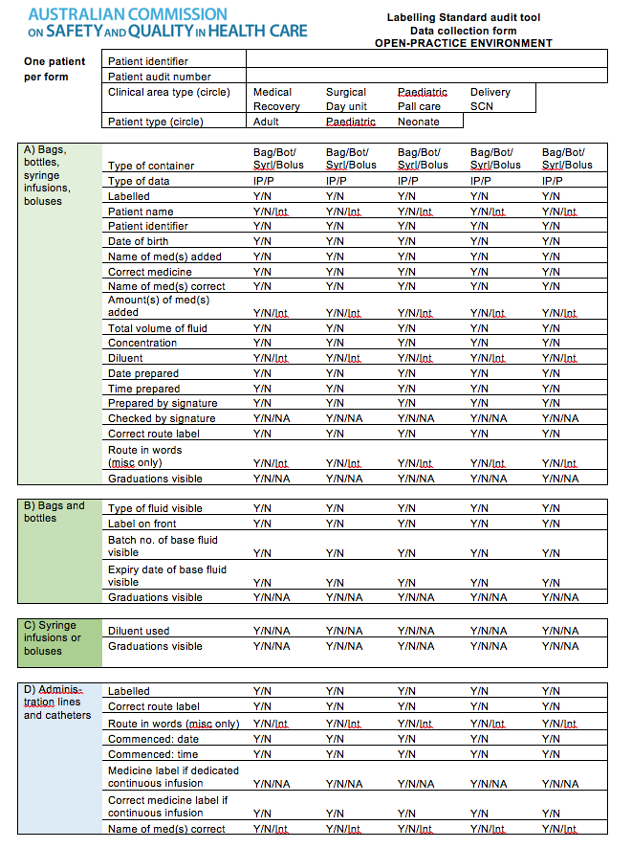
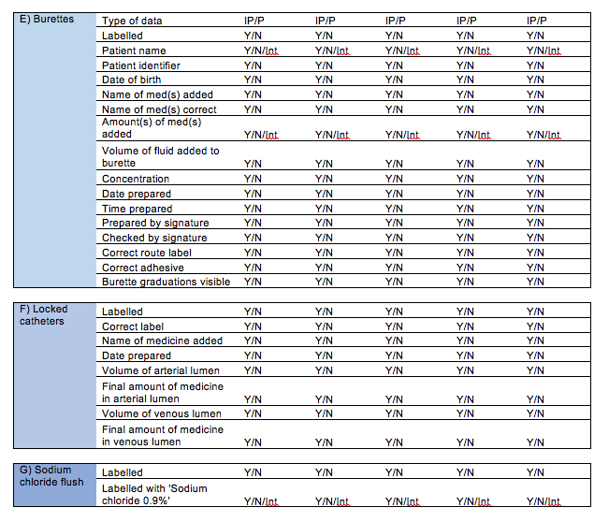
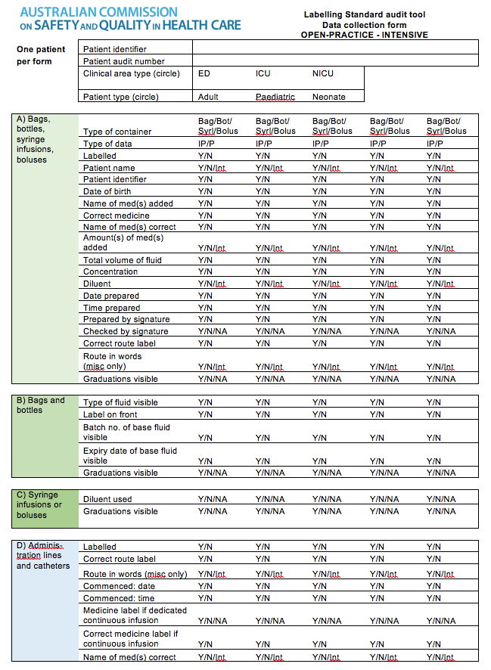
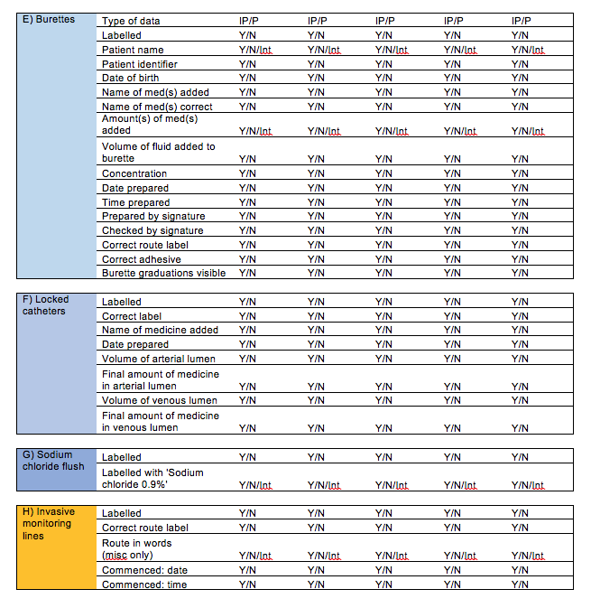
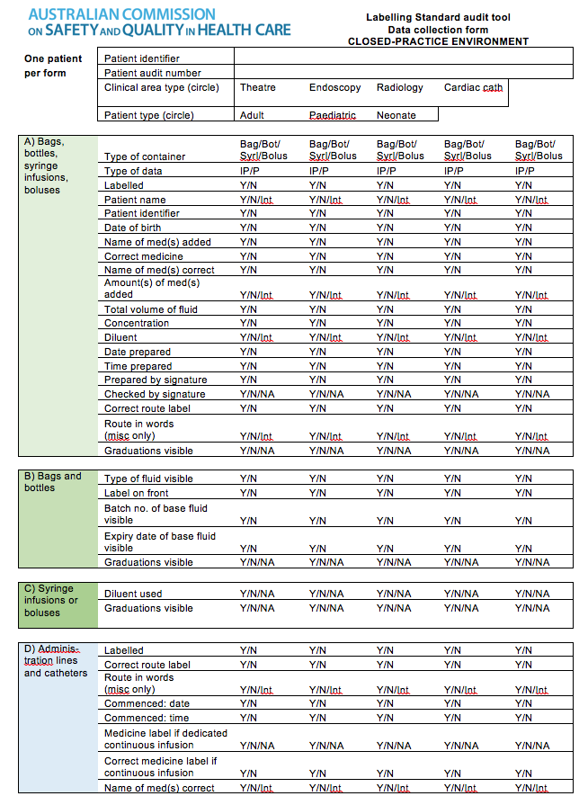
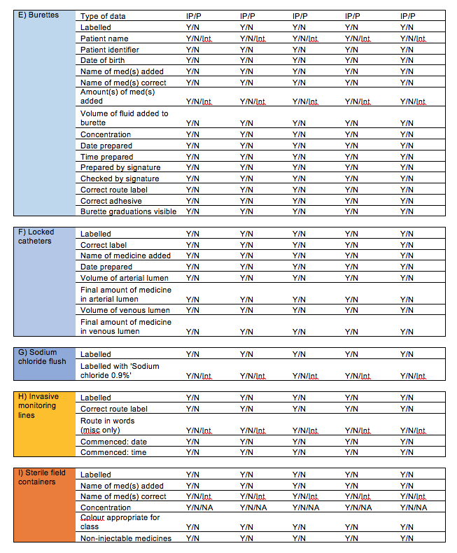

Appendix 2 Data entry form
The data entry form is available as an Excel spreadsheet on the Commission website.
