
On the Radar
Issue 221
4 May 2015

On the Radar is a summary of some of the recent publications in the areas of safety and quality in health care. Inclusion in this document is not an endorsement or recommendation of any publication or provider. Access to particular documents may depend on whether they are Open Access or not, and/or your individual or institutional access to subscription sites/services. Material that may require subscription is included as it is considered relevant.

On the Radar is available online, via email or as a PDF document from http://www.safetyandquality.gov.au/publications-resources/on-the-radar/

If you would like to receive On the Radar via email, you can subscribe on our website http://www.safetyandquality.gov.au/ or by emailing us at HUmail@safetyandquality.gov.auU.
You can also send feedback and comments to HUmail@safetyandquality.gov.auU.

For information about the Commission and its programs and publications, please visit http://www.safetyandquality.gov.au
You can also follow us on Twitter @ACSQHC.

On the Radar
Editor: Dr Niall Johnson niall.johnson@safetyandquality.gov.au
Contributors: Niall Johnson, Amanda Mulcahy

Reports

Duty of Candour: Governance for Surgeons and Employers
Royal College of Surgeons of England
London: Royal College of Surgeons of England; 2015. p. 36.
URL | http://www.rcseng.ac.uk/news/rcs-launches-first-professional-guide-on-duty-of-candour
TRIM | D15-11370
Notes | The Royal College of Surgeons of England has launched this best practice guide on how to implement the principles of duty of candour in everyday practice. The guide outlines the steps that surgeons should take on an individual level, to ensure that the principles of the duty of candour are at the forefront of everyday work. It reflects the profession’s commitment towards creating greater openness and transparency in the NHS. This guide expands on the principles of the College’s Good Surgical Practice and aims to support surgeons to meet their professional and legal duties.  As the RCS notes. “Every surgeon has a duty to maintain a relationship of trust with their patient. This is founded on honesty and openness.”  The guidance document outlines the following considerations for surgeons and their employers:  - How to nominate an individual to carry out the disclosure discussion  - The process for apologising and understanding liability  - Details on timing, location and persons to notify should an error occur  - How to ensure that the patient is well supported  - How to facilitate an open dialogue with patients  - What documentation is required  - What to do if the error occurred in a different organisation  - The support that should be available for surgeons and surgical teams who have been involved in harm  - How to report the incident and ensure lessons are learnt  - Ensuring that there is a culture of openness, focusing on patient safety.

For information on the Commission’s work on open disclosure, including the Australian Open Disclosure Framework, see www.safetyandquality.gov.au/our-work/open-disclosure/

Uses and abuses of performance data
Shaw J, Taylor R, Dix K
London: Dr Foster; 2015. p. 41.
URL | http://www.drfoster.com/updates/recent-publications/uses-and-abuses-of-performance-data-in-healthcare/
Notes | Dr Foster—recently acquired by Telstra Health—has been at the forefront of public reporting on health performance in the UK. This report suggests that efforts to improve standards of patient care in the British NHS are being undermined by performance measures that encourage ‘gaming’ and sap professional motivation. The report includes a series of recommendations to tackle practices that distort the reliability of the information used to manage the standards of care delivered to patients. It also discusses how better healthcare data from English hospitals has led to greater transparency.  The report makes five key recommendation::  - Make data quality as important as hitting targets – By initiating a long term audit programme to tackle misreporting and incomplete or inaccurate data recording.  - Measure the context not just the indicator – Keeping performance measures under constant review, perhaps by multi-disciplinary specialist groups, including Royal Colleges and patient organisations.  - Avoid thresholds and consider the potential to incentivise ‘gaming’ in design of metrics – Performance measures should be assessed according to the likelihood they will encourage abuse. Thresholds should be avoided wherever possible.  - Be more open – Making data underlying performance management widely available and promoting ongoing assessment of the degree to which metrics are being gamed.  - Apply measures fairly – In order to recognise legitimate mitigating factors such as resources and pressures outside the control of the organisation.

Vital Signs: Core Metrics for Health and Health Care Progress
Institute of Medicine
Blumenthal D, Malphrus E, McGinnis JM, editors
Washington, DC: The National Academies Press; 2015. 380 p.
URL | http://www.iom.edu/Reports/2015/Vital-Signs-Core-Metrics.aspx
TRIM | D15-11782
Notes | The apparently burgeoning volume of reporting, performance measures, indicators, etc. have given rise to a degree of ‘indicator fatigue’ and the like. The US Institute of Medicine (to be renamed as the National Academy of Medicine as of 1 July 2015) have released this. Stemming from a committee the IoM convened, the report proposes a streamlined set of 15 standardised measures, with recommendations for their application at every level and across sectors. The committee argues that this streamlined set of measures could provide consistent benchmarks for health progress and improve system performance in the highest-priority areas.  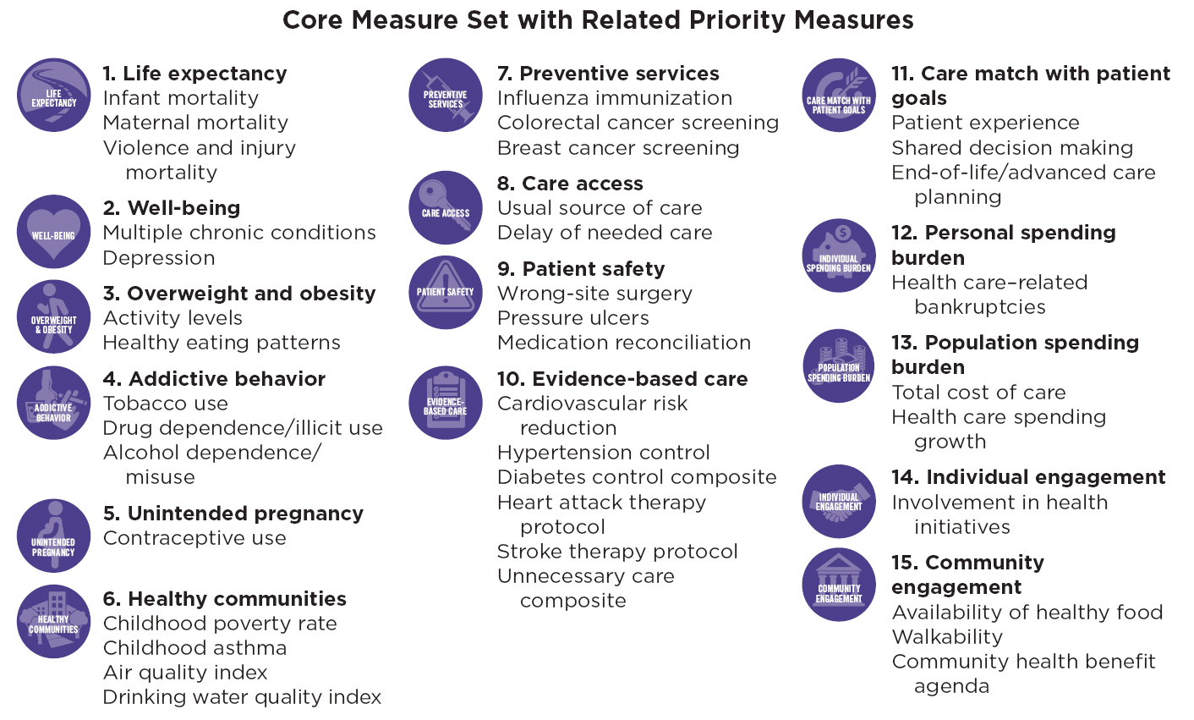

Journal articles

Patient Safety and End-of-Life Care: Common Issues, Perspectives, and Strategies for Improving Care
Dy SM
American Journal of Hospice and Palliative Medicine. 2015 April 15, 2015.
DOI | http://dx.doi.org/10.1177/1049909115581847
Notes | Review article drawing together recent work on patient safety and end-of-life care and discussing areas of commonality and overlap and strategies, such as team training and standardisation of care. The author applies the overlapping concepts to a key example area: improving documentation of patient preferences for life-sustaining treatment. The authors suggest that this “synthesis demonstrates how end-of-life issues should be incorporated into patient safety initiatives. In addition, evaluating overlap and comparable issues between patient safety and end-of-life care and comparing different perspectives and improvement strategies can benefit both fields.”

For information on the Commission’s work on end-of-life care in acute hospitals, see http://www.safetyandquality.gov.au/our-work/recognising-and-responding-to-clinical-deterioration/end-of-life-care-in-acute-hospitals/

The association of hospital prevention processes and patient risk factors with the risk of Clostridium difficile infection: a population-based cohort study
Daneman N, Guttmann A, Wang X, Ma X, Gibson D, Stukel T
BMJ Quality & Safety. 2015 [epub].
DOI | http://dx.doi.org/10.1136/bmjqs-2014-003863
Notes | Canadian population-based retrospective cohort study of all patients admitted to 159 acute care hospitals between April 2011 and March 2012 in Ontario, Canada.  Of the 653,896 admissions, C. difficile infections complicated 2341 (3.6 per 1000 admissions).  From their survey of prevention practices, the authors report that implementation of selected prevention practices was variable across the 159 hospitals. Isolation of all patients at onset of diarrhoea was reported by 43 (27%), auditing of antibiotic stewardship compliance by 26 (16%), auditing of cleaning practices by 115 (72%), on-site diagnostic testing by 74 (47%), vancomycin as first-line treatment by 24 (15%) and reporting rates to senior leadership by 52 (33%). The authors report that “None of these processes were associated with a significantly reduced risk of C. difficile after adjustment for baseline C. difficile rates, structural hospital characteristics and patient-level factors. Patient-level factors were strongly associated with C. difficile risk, including age, comorbidities, non-elective and medical admissions.”

For information on the Commission’s work on healthcare associated infection, see www.safetyandquality.gov.au/our-work/healthcare-associated-infection/

Pressure injury in Australian public hospitals: a cost-of-illness study
Nguyen K-H, Chaboyer W, Whitty JA
Australian Health Review. 2015 [epub].
DOI | http://dx.doi.org/10.1071/AH14088
Notes | Pressure injuries are a major contributor to the care needs of patients within hospitals. Standard Eight of the National Safety and Quality Healthcare Service Standards is aimed at preventing patients from developing pressure injuries and effectively managing them when they do occur. They are largely preventable, are an adverse outcome of healthcare and are costly to the system. In this study, Nguyen et al estimate the number of cases and costs associated with pressure injuries in public hospitals in Australia. Of total public hospital expenditure in 2012–13, 1.9% is attributed to treatment for pressure injuries at a total of A$983 million. Furthermore, the severe cases (stage III and IV pressure injuries) were 12% of the injuries but accounted for 30% of the total cost. The study suggests that there is still quality improvement work to be done to prevent this largely avoidable injury. It shows an opportunity cost perspective on pressure injury prevention and management, demonstrating the potential to reduce economic waste and improve quality of care.

For information on the National Safety and Quality Health Service Standards, see http://www.safetyandquality.gov.au/our-work/accreditation-and-the-nsqhs-standards/

American Journal of Medical Quality
May/June 2015; 30 (3)
URL | http://ajm.sagepub.com/content/30/3?etoc
Notes | A new issue of the American Journal of Medical Quality has been published. Articles in this issue of the American Journal of Medical Quality include:  - The Association Between Skilled Nursing Facility Care Quality and 30-Day Readmission Rates After Hospitalization for Heart Failure (Owolabi Ogunneye, Michael B Rothberg, Jennifer Friderici, Mara T. Slawsky, Vijay T. Gadiraju, and Mihaela S. Stefan)  - Explaining Racial Disparities in Anticoagulation Control: Results From a Study of Patients at the Veterans Administration (Sowmya R Rao, Joel I Reisman, Nancy R Kressin, Dan R Berlowitz, Arlene S Ash, Al Ozonoff, Donald R Miller, Elaine M Hylek, Shibei Zhao, and Adam J Rose)  - A Simple Framework for Complex System Improvement (Sally Kraft, Pascale Carayon, Jennifer Weiss, and Nancy Pandhi)  - Weaving Quality Improvement and Patient Safety Skills Into All Levels of Medical Training: An Annotated Bibliography (Eugene Mochan and David B Nash)  - The Human Side of Lean Teams (Sarah B Wackerbarth, Jamie R Strawser-Srinath, and Joseph C Conigliaro)  - NPITxt, a 21st-Century Reporting System: Engaging Residents in a Lean-Inspired Process (Pushpa V Raja, Michael C Davis, Alicia Bales, and Nasim Afsarmanesh)  - The Impact of Tort Reform and Quality Improvements on Medical Liability Claims: A Tale of 2 States (Kenneth D Illingworth, Steven H Shaha, Tony H Tzeng, Michael S Sinha, and Khaled J Saleh)  - Operative Volume in Colon Surgery: A Matched Cohort Analysis (Matthew Z Wilson, David I Soybel, and Christopher S Hollenbeak)  - The Relationship of Hospital Charges and Volume to Surgical Site Infection After Total Hip Replacement (Rebecca Boas, Kelsey Ensor, Edward Qian, Lorraine Hutzler, James Slover, and Joseph Bosco  - The “I” in I CARE: Out of the Ashes of Dystopia, a Phoenix Will Rise (Maher Roman)  - Use of a Transition of Care Coordinator to Improve Ambulatory Follow-up After Hospital Discharge (Ruben Rhoades, Caitlin Dietsche, Rebecca Jaffe, Cara Reynolds, Michael Latreille, Albert Crawford, and L Ward)  - House Staff Perceptions of How Handoff Quality Influences Code Blue and Rapid Response Team Events (Deana Miller, Aaron Mitchell, Rebecca Sadun, Judy Milne, and Joel Boggan)  - Clinical Laboratories Accreditation Program of the Brazilian Society of Clinical Pathology/Laboratory Medicine (PALC/SBPC-ML): 15-Year Experience (Wilson Shcolnik, Carla Chaves, Carlos Eduardo dos Santos Ferreira, Cesar Sanches, Erlo Roth, Louise Fabri, Lucia Villela, Luisane Maria Falci Vieira, and Paula Tavora)

Patient Experience Journal
Volume 2, Issue 1 (2015)
URL | http://pxjournal.org/journal/vol2/iss1/
Notes | A new issue of the Patient Experience Journal has been published. Articles in this issue of the Patient Experience Journal include:  - The patient experience movement moves on (Jason A Wolf)  - Patient experience established: One year later (Geoffrey A Silvera and Jason A Wolf)  - Reframing the work on patient experience improvement (J Cornwell)  - The power of patient ownership: The path from engagement to equity (Zal Press and Dawn Richards)  - Meaningful and effective patient engagement: What matters most to stakeholders (Mandy Bellows, Katharina Kovacs Burns, Karen Jackson, Brae Surgeoner, and Jennifer Gallivan)  - Patient partnership in quality improvement of healthcare services: Patients’ inputs and challenges faced (Marie-Pascale Pomey, Hassiba Hihat, May Khalifa, Paule Lebel, André Néron, and Vincent Dumez)  - So much more than a “pair of brown shoes”: Triumphs of patient and other stakeholder engagement in patient-centered outcomes research (Amanda Brodt, M.P.P.; Christine K. Norton, M.A.; and Amy Kratchman)  - The Children’s Hospital of Philadelphia Family Partners Program: Promoting child and family-centered care in paediatrics (Amy Kratchman, Darlene Barkman, Kathy Conaboy, Anna de la Motte, Rachel Biblow, and Katherine Bevan)  - Considering shared power and responsibility: Diabetic patients’ experience with the PCMH care model (Olena Mazurenko, Sheila Bock, Catherine Prato, and Margarita Bondarenko)  - Patient satisfaction reported by in-visit and after-visit surveys (Rukiya Wongus, Nicholas H Schluterman, Sharon Feinstein, Nihkolle McGirt, Deborah R Greenberg, and David B Schwartz)  - Measuring patient experience in a safety net setting: Lessons learned (Nina Shabbat, Katy Dobbins, Sonja Seglin, and Kristin Davis)  - Weighting patient satisfaction factors to inform health care providers of the patient experience in the age of social media consumer sentiment (Blaine Parrish, Amita N Vyas, and Grace Douglass)  - Patient centered infertility care: The health care provider’s perspective (Alana Streisfield, Nurun Chowdhury, Rebecca Cherniak, and H Shapiro)  - Patient complaints as predictors of patient safety incidents (Helen L Kroening, Bronwyn Kerr, James Bruce, and Iain Yardley)  - Cancer patients’ experiences of error and consequences during diagnosis and treatment (Henriette Lipczak, Liv H Dørflinger, Christine Enevoldsen, Mette M Vinter, and Jeanne L Knudsen)  - Usefulness of a patient experience study to adjust psychosocial oncology and spiritual care services according to patients’ needs (Lynda Belanger, Francois Rainville, Martin Coulombe, and Annie Tremblay)  - Building national consensus on experiences of care (Anna Baranski, Neil Churchill, and Sophie Staniszewska)  - Variations in the patients’ hospital care experience by states’ strategy for Medicaid expansion: 2009-2013 (Edmund Becker; Kenton Johnson; J Bae; J M Hockenberry; A C Avgar; S Liu; I Wilson; and A Milstein)  - Health information technology: A key ingredient of the patient experience (Matthew Werder)  - The patient portal and abnormal test results: An exploratory study of patient experiences (Traber Giardina, Varsha Modi, Danielle Parrish, and Hardeep Singh)  - Creating and integrating a new patient experience leadership role: A consultative approach for partnering with executive and clinical leaders (Denise M Kennedy)

BMJ Quality and Safety online first articles
URL | http://qualitysafety.bmj.com/content/early/recent
Notes | BMJ Quality and Safety has published a number of ‘online first’ articles, including:  - The association of hospital prevention processes and patient risk factors with the risk of Clostridium difficile infection: a population-based cohort study (N Daneman, A Guttmann, X Wang, X Ma, D Gibson, TA Stukel)  - A qualitative study of the variable effects of audit and feedback in the ICU (Tasnim Sinuff, John Muscedere, Linda Rozmovitz, Craig M Dale, Damon C Scales)  - Role of cognition in generating and mitigating clinical errors (Vimla L Patel, Thomas G Kannampallil, Edward H Shortliffe)

International Journal for Quality in Health Care online first articles
URL | http://intqhc.oxfordjournals.org/content/early/recent?papetoc
Notes | International Journal for Quality in Health Care has published a number of ‘online first’ articles, including:  - Improving clinician–carer communication for safer hospital care: a study of the ‘TOP 5’ strategy in patients with dementia (Karen Luxford, Anne Axam, Fiona Hasnip, John Dobrohotoff, Maureen Strudwick, Rebecca Reeve, Changhao Hou, and Rosalie Viney)  - Attitudes towards vital signs monitoring in the detection of clinical deterioration: scale development and survey of ward nurses (Wenqi Mok, Wenru Wang, Simon Cooper, Emily Neo Kim Ang, and Sok Ying Liaw)

Online resources

[USA] Effective Health Care Program reports
http://effectivehealthcare.ahrq.gov/
The US Agency for Healthcare Research and Quality (AHRQ) has an Effective Health Care (EHC) Program. The EHC has released the following final reports and updates:
- Management of Postpartum Hemorrhage http://www.effectivehealthcare.ahrq.gov/search-for-guides-reviews-and-reports/?pageaction=displayproduct&productID=2078
- Discontinuation of Disease-Modifying Treatment for Multiple Sclerosis http://www.effectivehealthcare.ahrq.gov/search-for-guides-reviews-and-reports/?pageaction=displayproduct&productID=2076

Disclaimer
On the Radar is an information resource of the Australian Commission on Safety and Quality in Health Care. The Commission is not responsible for the content of, nor does it endorse, any articles or sites listed. The Commission accepts no liability for the information or advice provided by these external links. Links are provided on the basis that users make their own decisions about the accuracy, currency and reliability of the information contained therein. Any opinions expressed are not necessarily those of the Australian Commission on Safety and Quality in Health Care.

