
On the Radar
Issue 227
15 June 2015

On the Radar is a summary of some of the recent publications in the areas of safety and quality in health care. Inclusion in this document is not an endorsement or recommendation of any publication or provider. Access to particular documents may depend on whether they are Open Access or not, and/or your individual or institutional access to subscription sites/services. Material that may require subscription is included as it is considered relevant.

On the Radar is available online, via email or as a PDF document from http://www.safetyandquality.gov.au/publications-resources/on-the-radar/

If you would like to receive On the Radar via email, you can subscribe on our website http://www.safetyandquality.gov.au/ or by emailing us at HUmail@safetyandquality.gov.auU.
You can also send feedback and comments to HUmail@safetyandquality.gov.auU.

For information about the Commission and its programs and publications, please visit http://www.safetyandquality.gov.au
You can also follow us on Twitter @ACSQHC.
On the Radar
Editor: Dr Niall Johnson niall.johnson@safetyandquality.gov.au
Contributors: Niall Johnson

Acute Stroke Clinical Care Standard
Australian Commission on Safety and Quality in Health Care
Sydney: ACSQHC; 2015.
URL | http://www.safetyandquality.gov.au/our-work/clinical-care-standards/acute-stroke-clinical-care-standard/
Notes | The Australian Commission on Safety and Quality in Health Care, in collaboration with consumers, clinicians, researchers and health organisations, has developed the Acute Stroke Clinical Care Standard and resources to guide and support its implementation.  The Acute Stroke Clinical Care Standard aims to ensure that a patient with suspected stroke receives optimal treatment during the acute phase of care, starting from the onset of symptoms. This includes recognition of a stroke, rapid assessment, early treatment and early initiation of an individualised rehabilitation plan.  The additional resources include an Indicator Specification (a set of suggested indicators to assist with local implementation of the Acute Stroke Clinical Care Standard. Clinicians and health services can use the indicators to monitor the implementation of quality statements, and support improvement as needed), fact sheets for clinicians and consumers, and supporting evidence sources.  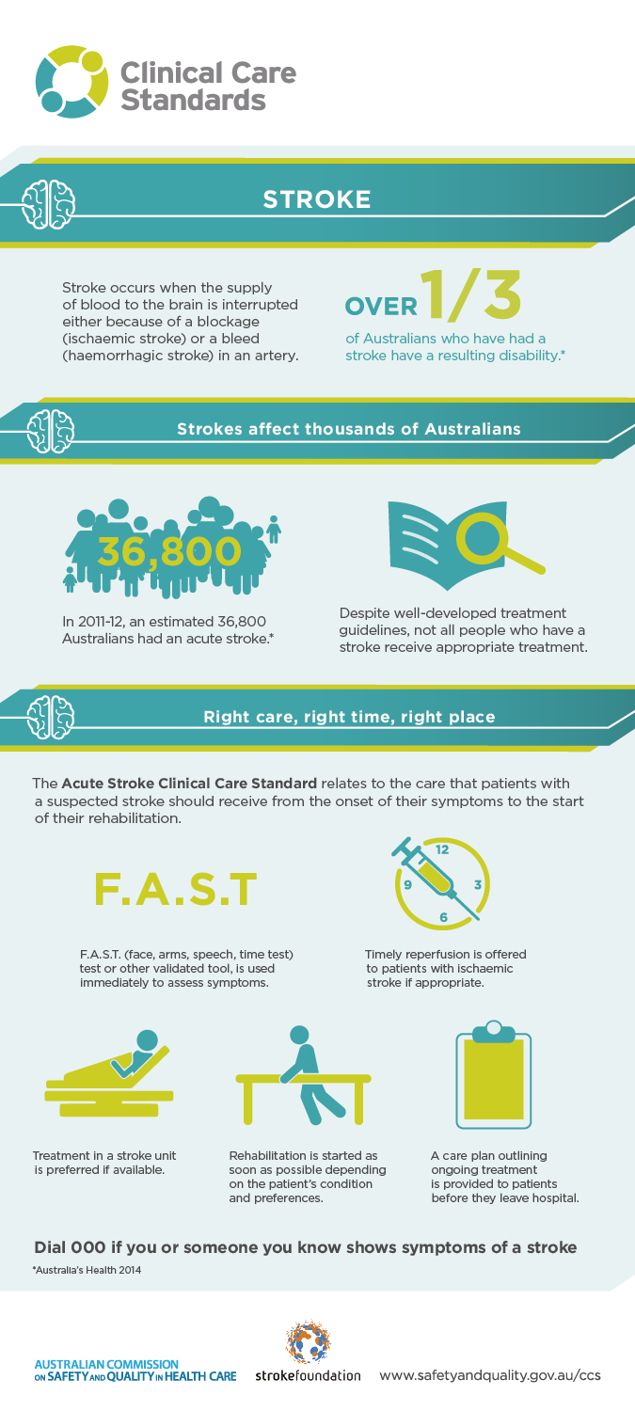

Journal articles

Pursuing the Triple Aim: The First 7 Years
Whittington JW, Nolan K, Lewis N, Torres T
The Milbank Quarterly. 2015;93(2):263-300.

The Quadruple Aim: care, health, cost and meaning in work
Sikka R, Morath JM, Leape L
BMJ Quality & Safety. 2015 [epub].
DOI | Whittington et al http://dx.doi.org/10.1111/1468-0009.12122  Sikka et al http://dx.doi.org/10.1136/bmjqs-2015-004160
Notes | Paper tracing the development and significance of the ‘Triple Aim’. The Triple Aim was proposed in 2008 by researchers at the [US] Institute for Healthcare Improvement (IHI). The Triple Aim offers strategic organising principles for health care organisations (and communities) to improve the individual experience of care and the health of populations and to reduce the per capita costs of care for populations. In this article the authors describe the three major principles that guided those working with the IHI on the Triple Aim: creating the right foundation for population management, managing services at scale for the population, and establishing a learning system to drive and sustain the work over time.  The second paper (Sikka et al) seeks to extend the triple aim by adding a fourth aim. This conception argues that the triple aim can only be achieved by an engaged and productive workforce. This, the authors suggest, should be explicitly recognised by acknowledging “the importance of physicians, nurses and all employees finding joy and meaning in their work. This ‘Quadruple Aim’ would add a fourth aim: improving the experience of providing care.”

Patient safety in ambulance services: a scoping review
Fisher J, Freeman K, Clarke A, Spurgeon P, Smyth M, Perkins G, et al
Health Services and Delivery Research. 2015 2015/05/19;3(21).
DOI | http://dx.doi.org/10.3310/hsdr03210
Notes | Some aspects of safety and quality apply across almost all forms and settings of care. However, different forms and settings of care can have their particular safety and quality issues. This (278 page) study reports on a review of patient safety in (UK) ambulance services. The authors suggest that given the rising complexity and scope of ambulance services, operators and staff need to focus more on patient safety than the operational and logistical aspects.  Among their conclusions the authors suggest that “Development of new models of working must include adequate training and monitoring of clinical risks. Providers and commissioners need a full understanding of the safety implications of introducing new models of care, particularly to a mobile workforce often isolated from colleagues, which requires a body of supportive evidence and an inherent critical evaluation culture. …Areas requiring further work include the safety surrounding discharging patients, patient accidents, equipment and treatment, delays in transfer/admission to hospital, and treatment and diagnosis, with a clear need for increased reliability and training for improving handover to hospital.”

Reducing Surgical Errors: Implementing a Three-Hinge Approach to Success
Landers R
AORN Journal. 2015;101(6):657-65.
DOI | http://dx.doi.org/10.1016/j.aorn.2015.04.013
Notes | Whereas safety in ambulance services may not have attracted a great deal of attention, surgery is one setting that has been a focal point. Surgical errors can have an array of causes and their impact can be extremely serious. This commentary describes what is dubbed a ‘three hinge” approach for use in implementing a safety program emphasising the use of a safe surgery checklist and reporting requirements for ambulatory surgery centres. The ‘three hinges’ are:  - the assignment of a change agent (apparently the ideal is an RN with a doctorate in nursing practice  - team cohesiveness, and  - continuous quality monitoring.

Association between weekend discharge and hospital readmission rates following major surgery Cloyd JM, Chen J, Ma Y, Rhoads KF
JAMA Surgery. 2015 [epub].
DOI | http://dx.doi.org/10.1001/jamasurg.2015.1087
Notes | The issue of after-hours or weekend care and the potential for lapses in the safety and quality of care has been debated at some length. Admission to hospital at these times has repeatedly been seen to be linked to poorer outcomes. This paper looks at another aspect, at the other end of the patient’s hospital journey, the point of discharge. Specifically the study sought to examine whether weekend discharge is with an increased rate of 30- and 90-day hospital readmission. This was done by comparing readmission rates between patients discharged on a weekend with those discharged on a weekday for patients who underwent abdominal aortic aneurysm repair, colectomy, total hip arthroplasty, and pancreatectomy in California in 2012 From 128,057 patients, 29,883 (23.3%) were discharged on a weekend. The authors report from their study that “Weekend discharge after major surgery is not associated with higher 30- or 90-day readmission rates.”

Health Affairs
June 2015; Vol. 34, No. 6
URL | http://content.healthaffairs.org/content/34/6.toc
Notes | A new issue of Health Affairs has been published. Articles in this issue of Health Affairs include:  - Markets, Prices, And Incentives (Alan R. Weil)  - Medicare Payment Policy Creates Incentives For Long-Term Care Hospitals To Time Discharges For Maximum Reimbursement (Yan S Kim, Eric C Kleerup, P A Ganz, N A Ponce, K A Lorenz, and J Needleman)  - Concentration In Orthopedic Markets Was Associated With A 7 Percent Increase In Physician Fees For Total Knee Replacements (Eric Sun and Laurence C Baker)  - Extreme Markup: The Fifty US Hospitals With The Highest Charge-To-Cost Ratios (Ge Bai and Gerard F. Anderson)  - Prevention Program Lowered The Risk Of Falls And Decreased Claims For Long-Term Services Among Elder Participants (Marc A Cohen, Jessica Miller, Xiaomei Shi, Jasbir Sandhu, and Lewis A Lipsitz)  - Readmissions To New York Hospitals Fell For Three Target Conditions From 2008 To 2012, Consistent With Medicare Goals (Kathleen Carey and Meng-Yun Lin)  - Hospitals In ‘Magnet’ Program Show Better Patient Outcomes On Mortality Measures Compared To Non-‘Magnet’ Hospitals (Christopher R Friese, Rong Xia, Amir Ghaferi, John D Birkmeyer, and M Banerjee)  - Physician Characteristics Strongly Predict Patient Enrollment In Hospice (Ziad Obermeyer, Brian W. Powers, Maggie Makar, Nancy L. Keating, and David M. Cutler)

BMJ Quality and Safety online first articles
URL | http://qualitysafety.bmj.com/content/early/recent
Notes | BMJ Quality and Safety has published a number of ‘online first’ articles, including:  - Expanding the scope of Critical Care Rapid Response Teams: a feasible approach to identify adverse events. A prospective observational cohort (Andre Carlos Kajdacsy-Balla Amaral, Andrew McDonald, Natalie G Coburn, Wei Xiong, K G Shojania, R Fowler, M Chapman, N Adhikari)  - Reliable implementation of evidence: a qualitative study of antenatal corticosteroid administration in Ohio hospitals (Heather C Kaplan, Susan N Sherman, Charlena Cleveland, Linda M Goldenhar, C M Lannon, J L Bailit)  - Making sense of the shadows: priorities for creating a learning healthcare system based on routinely collected data (Sarah R Deeny, Am Steventon)  - “It's easier to stick a tube in”: a qualitative study to understand clinicians’ individual decisions to place urinary catheters in acute medical care (Catherine Murphy, Jacqui Prieto, Mandy Fader)

International Journal for Quality in Health Care online first articles
URL | http://intqhc.oxfordjournals.org/content/early/recent?papetoc
Notes | International Journal for Quality in Health Care has published a number of ‘online first’ articles, including:  - Towards excellence in cardiac surgery: experience from a developing country (Aamir Saifuddin, Syed Shahabuddin, Shazia Perveen, Shumaila Furnaz, Hasanat Sharif)  - Processes and outcomes of ischemic stroke care: the influence of hospital level of care (Yu-Chi Tung, Jiann-Shing Jeng, Guann-Ming Chang, Kuo-Piao Chung)  - Engaging staff to improve quality and safety in an austere medical environment: a case–control study in two Sierra Leonean hospitals (Michael A Rosen, Adaora M Chima, John B Sampson, Eric V Jackson Jr, Rahul Koka, Megan K Marx, Thaim B Kamara, O U Ogbuagu, Benjamin H Lee)  - Perceptions regarding medication administration errors among hospital staff nurses of South Korea (Mi-Ae You, Mi-Hyeon Choe, Geun-Ok Park, Sang-Hee Kim, Youn-Jung Son)  - Patient safety and quality of care in developing countries in Southeast Asia: a systematic literature review (Reema Harrison, Adrienne Wai Seung Cohen, and Merrilyn Walton)

Online resources

[USA] Patient Safety Primers
http://psnet.ahrq.gov/primerHome.aspx
The Patient Safety Primers from the (US) Agency for Healthcare Research and Quality (AHRQ) discuss key concepts in patient safety. Each primer defines a topic, offers background information on its epidemiology and context, and provides links to relevant materials. AHRQ have released a new primer:
- Missed nursing care — missed nursing care is a subset of the category known as error of omission. It refers to needed nursing care that is delayed, partially completed, or not completed at all. Missed nursing care is problematic because nurses coordinate, provide, and evaluate many interventions prescribed by others to treat illness in hospitalised patients. Nurses also plan, deliver, and evaluate nurse-initiated care to manage patients’ symptoms and responses to care. Thus, missed nursing care not only constitutes a form of medical error that may affect safety, but has been deemed to be a unique type of medical underuse. http://psnet.ahrq.gov/primer.aspx?primerID=29

Disclaimer
On the Radar is an information resource of the Australian Commission on Safety and Quality in Health Care. The Commission is not responsible for the content of, nor does it endorse, any articles or sites listed. The Commission accepts no liability for the information or advice provided by these external links. Links are provided on the basis that users make their own decisions about the accuracy, currency and reliability of the information contained therein. Any opinions expressed are not necessarily those of the Australian Commission on Safety and Quality in Health Care.

